🛒 E-Commerce Sales & Customer Analytics Dashboard
Project Report
Submitted by: Himanshu Mandal | Dataset: 138,116 Transactions (2021–2025)

1. Executive Summary
This project presents a comprehensive, interactive E-Commerce Sales and Customer Analytics Dashboard built entirely in Python. It leverages a real-world dataset of over 138,000 transactions spanning five years (2021–2025), covering 24,911 unique customers across multiple countries, sales channels, and product categories. The dashboard is powered by Streamlit (frontend) and pandas/Plotly (backend), offering nine fully interactive analytical pages covering KPIs, sales trends, customer analytics, product performance, geographic insights, delivery performance, returns, and marketing attribution.

1.1 Key Performance Indicators
The panel below summarises the top-line business metrics across all 5 years of data:
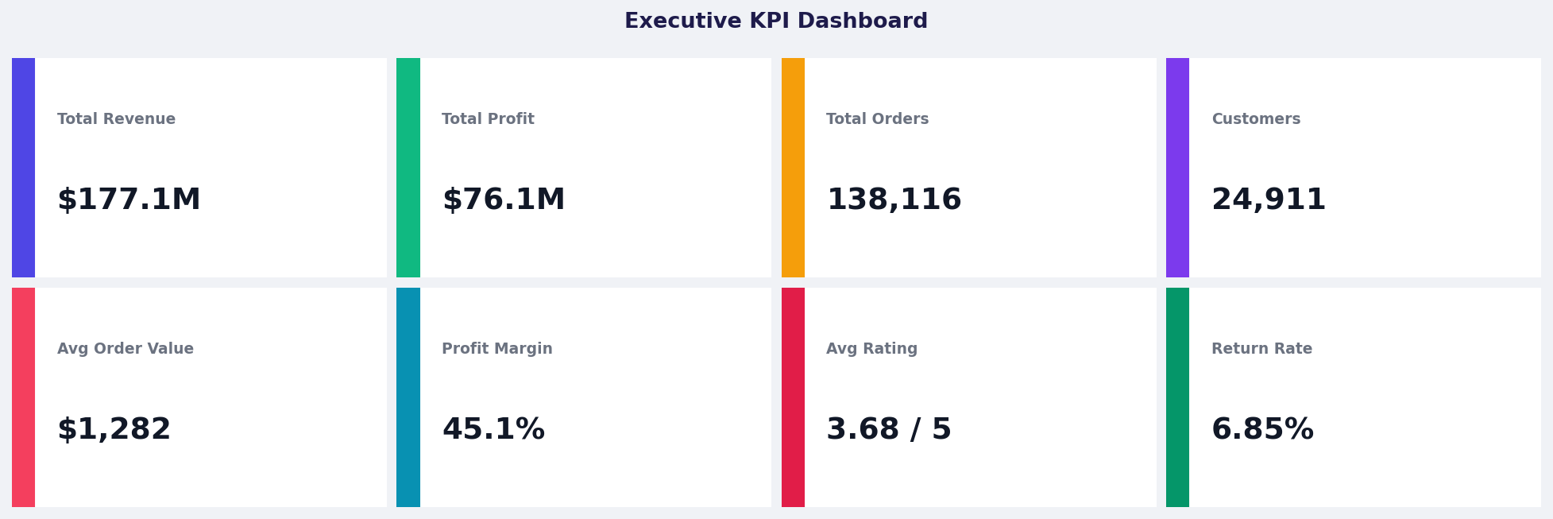
Figure 1 — Executive KPI Dashboard (2021–2025, all segments)

2. Sales Trends Analysis
Revenue is remarkably stable year-over-year, hovering between $35.1M and $35.7M annually. A clear seasonal pattern emerges with November and December accounting for nearly 30% more revenue than the monthly average — driven by holiday shopping. Q4 consistently outperforms all other quarters with $11.6–11.9M in revenue vs $7.2–8.6M in Q1–Q3.

2.1 Annual Revenue & Profit
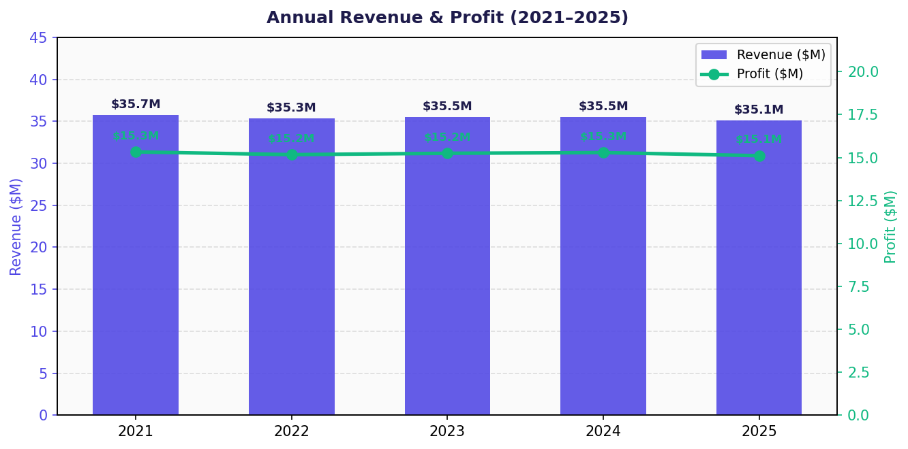
Figure 2 — Annual Revenue ($M, bars) vs Profit ($M, line) with dual y-axis (2021–2025)

2.2 Monthly Revenue Trend
Monthly analysis of the last 24 months (2024–2025) confirms strong seasonality. Revenue dips to ~$2.0–2.1M in February and peaks at ~$4.3–4.6M in November/December (highlighted in red). The pattern is highly consistent across both years, confirming reliable seasonal demand cycles.
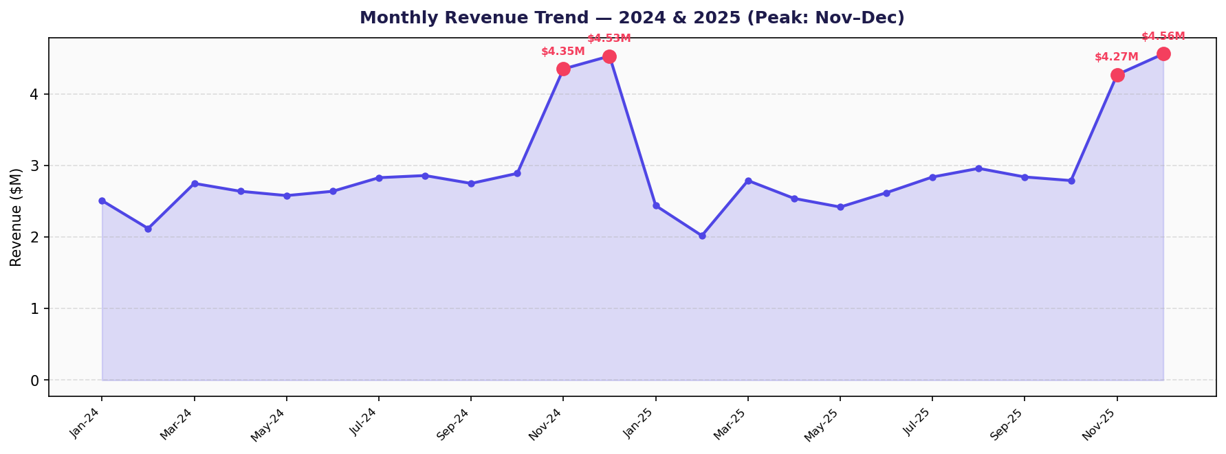
Figure 3 — Monthly Revenue Trend 2024–2025 with seasonal peaks highlighted

2.3 Quarterly Revenue Comparison
Q4 dominates across all three years due to the November–December holiday effect. Q3 shows moderate strength ($8.4–8.6M) while Q1 and Q2 are the softest quarters. Revenue is slightly declining in 2025 ($35.09M) vs the 2021 peak ($35.72M), suggesting maturation effects or increased competition.
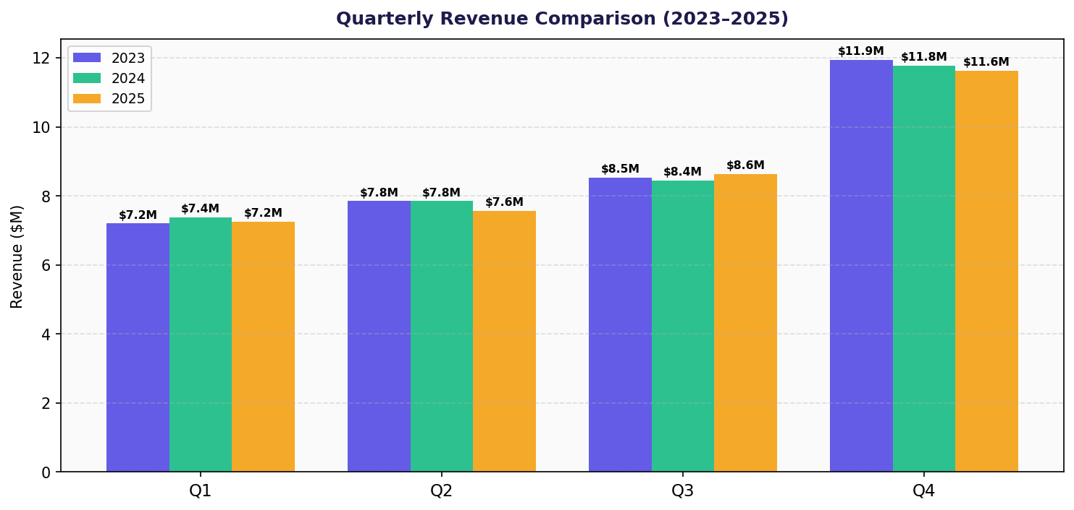
Figure 4 — Quarterly Revenue Comparison 2023 vs 2024 vs 2025 (clustered bar chart)

3. Sales Channel & Customer Segment
Mobile App is the dominant sales channel at 40% of total revenue ($70.8M), followed by Website at 35% ($61.9M). Together, these digital channels account for 75% of revenue. The Consumer segment is the largest at 54.9% ($97.2M), with Premium customers contributing 25% ($44.3M). VIP and Business segments together represent ~20% but typically carry higher average order values and CLV.
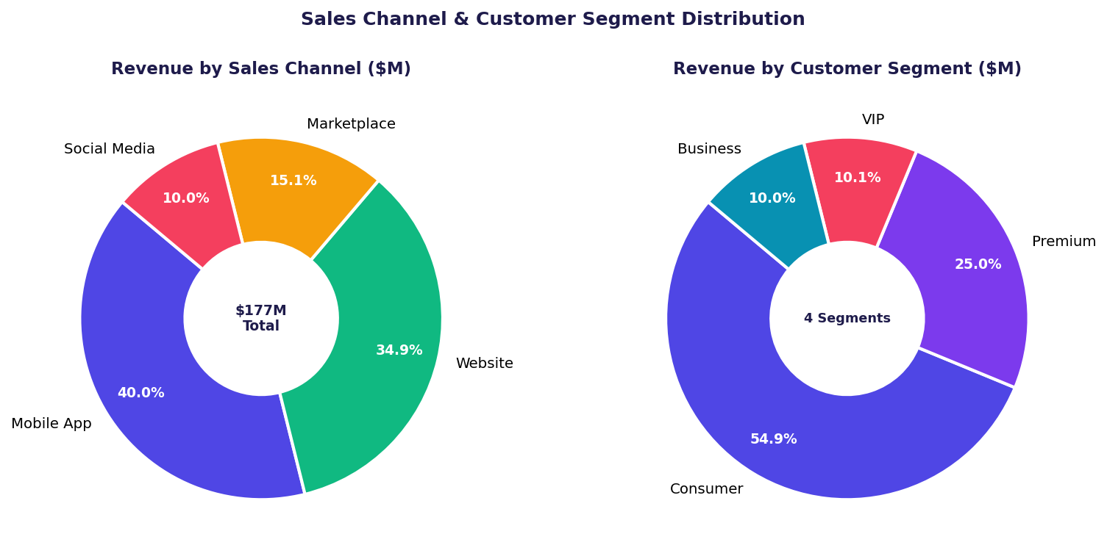
Figure 5 — Revenue split by Sales Channel (left) and Customer Segment (right)

4. Product Category Performance
Electronics leads all product categories at $41.1M in revenue and $14.1M in profit, representing 23.2% of total revenue. Jewelry ($25.6M) and Home Appliances ($24.8M) follow closely. The combined top-3 categories account for over 51% of total revenue. Sports & Outdoors, despite lower revenue than Automotive, achieves a higher profit ($7.2M vs $6.5M), indicating better margin efficiency. Health & Wellness and Baby & Kids represent growth opportunity categories with lower current revenue but high demand potential.
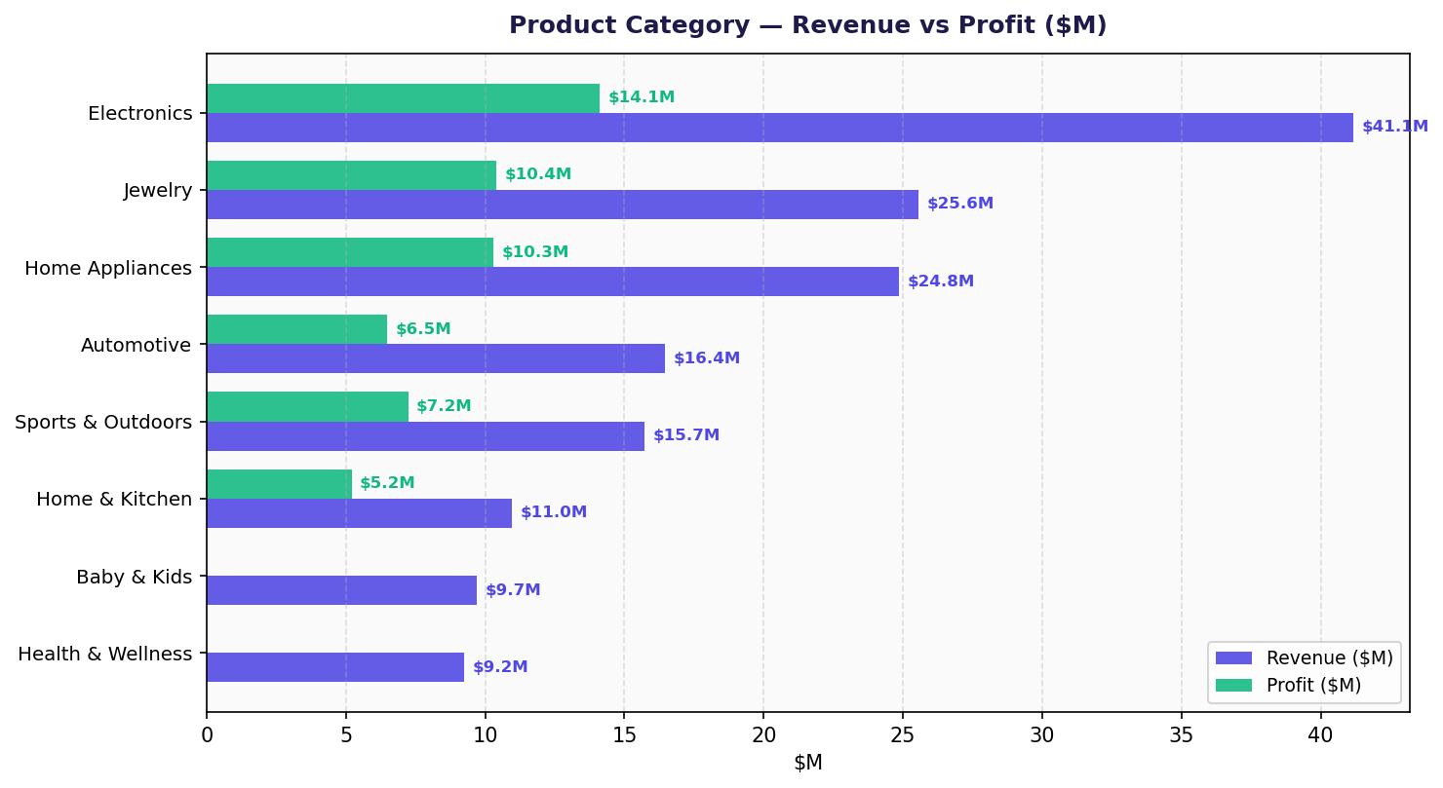
Figure 6 — Product Category Revenue vs Profit ($M) — horizontal grouped bar chart

5. Geographic & Order Status Analysis
The South region leads revenue at $55.6M (31.4%), more than double the North's $22.6M (12.7%). Central ($37.2M) and West ($34.8M) are mid-tier contributors. Geographically, countries such as the USA, Germany, and UAE are key markets based on customer profile data. Order status analysis reveals a high completion rate of 82.2%, with returns (6.85%) and cancellations (6.08%) representing significant but manageable revenue leakage.
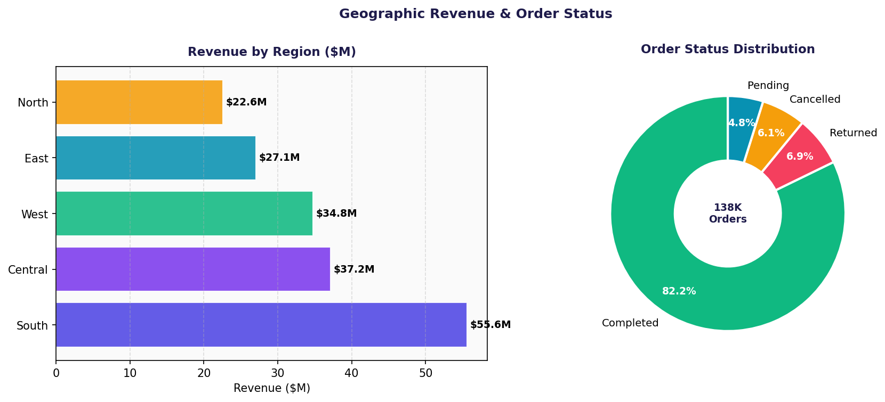
Figure 7 — Regional Revenue ($M) and Order Status Distribution (138K orders)

6. Delivery Performance & Operational Metrics
62.9% of orders are delivered on time, while 12.2% are delayed and 17.8% are cancelled (includes orders that never shipped). Only 7.1% arrive early. Improving on-time delivery from 62.9% to above 75% should be a key operational priority. The return rate of 6.85% and cancellation rate of 6.08% are within industry norms but represent over $12M in potential lost revenue annually at current scale.
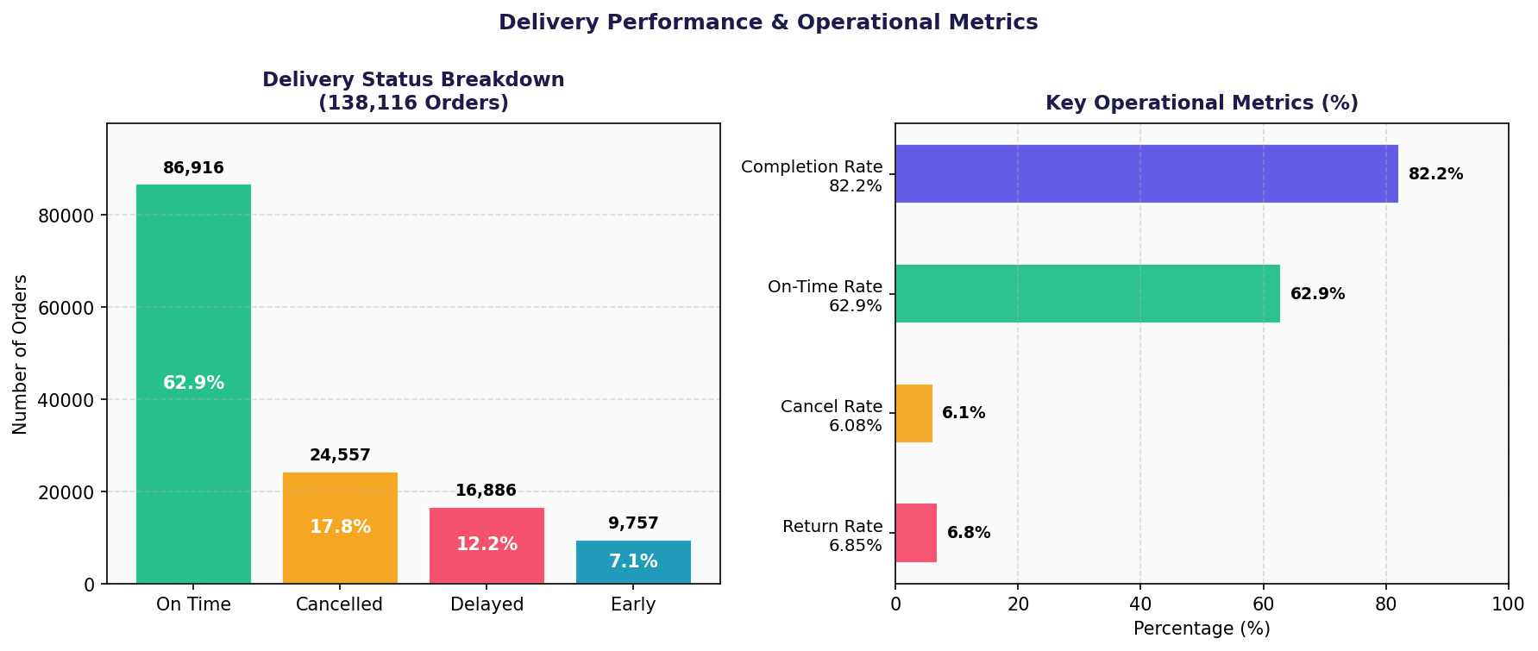
Figure 8 — Delivery Status Breakdown and Key Operational KPIs (%)

7. Key Findings & Business Recommendations
▶ Revenue Stability: Revenue is nearly identical year-over-year (~$35.1–35.7M), suggesting a mature market. Growth strategy should focus on new segments or geographies rather than organic volume.
▶ Seasonal Peak: Nov–Dec generates ~$4.3–4.6M/month vs $2.4–2.9M in off-peak months — a 60–80% spike. Inventory, staffing, and marketing budgets must be pre-positioned for Q4.
▶ Mobile App Dominance: 40% of revenue flows through the Mobile App. Prioritising app UX, push notifications, and app-exclusive promotions is critical for revenue growth.
▶ Consumer Segment: Consumer customers (54.9% of revenue) are the backbone — but VIP and Premium customers likely have 3–5× higher CLV. Segment-specific retention programs would yield high ROI.
▶ Electronics Leadership: Electronics alone contributes 23.2% of revenue and 18.5% of total profit. Expanding electronics sub-categories and exclusive brand partnerships is a high-priority growth lever.
▶ Return/Cancel Leakage: A combined ~13% return + cancellation rate represents ~$23M in gross revenue at risk annually. Root-cause analysis by product category and return reason should drive corrective action.
▶ Delivery Performance: 62.9% on-time rate is below the 80%+ benchmark for leading e-commerce platforms. Improving last-mile logistics, especially in the South and Central regions, will directly impact customer satisfaction and repeat purchase rates.
▶ South Region: The South region at $55.6M (31.4%) outperforms all others. Deepening penetration in East ($27.1M) and North ($22.6M) with targeted campaigns could add $10–15M in incremental revenue.

8. Technologies & Libraries
Layer | Library | Version | Purpose
Frontend | Streamlit | 1.35.0 | Web UI, layout, reactivity, widgets
Visualisation | Plotly | 5.22.0 | Interactive charts (bar, line, pie, etc.)
Backend | Python | 3.10+ | Core programming language
Data Processing | pandas | 2.2.2 | Data loading, merging, grouping, time-series
Numerics | numpy | 1.26.4 | Array operations & calculations
Statistics | scipy | 1.13.1 | Statistical distributions & functions
Report Gen | python-docx | 1.1.2 | Word document generation
Excel Support | openpyxl | 3.1.2 | Excel read/write support

9. Project Architecture & File Structure
The project follows a single-file architecture — app.py contains all backend data processing logic and frontend Streamlit UI code. Data flows from CSV files → pandas DataFrames → plotly charts → Streamlit pages, all cached with @st.cache_data for performance.
File | Format | Description
app.py | .py | Main application — backend + Streamlit frontend
requirements.txt | .txt | Python dependency list with pinned versions
README.md | .md | Project overview, setup instructions, dataset link
HimanshuMandal_ProjectReport.docx | .docx | This project report with charts and analysis
ecommerce_sales_customer_analytics_150k.csv | .csv | Primary transaction dataset — 138K rows, 46 cols
customer_master.csv | .csv | Customer profiles — 24,911 unique customers
order_items.csv | .csv | Line-level order item data with financials
product_catalog.csv | .csv | Product metadata — categories, brands, ratings
dataset_statistics.csv | .csv | Pre-computed aggregate summary statistics

10. Setup & Run Instructions
Step 1: Place all CSV files and app.py in the same project directory.
Step 2: Install dependencies: pip install -r requirements.txt
Step 3: Launch the dashboard: streamlit run app.py
Step 4: Open browser at: http://localhost:8501

11. Conclusion
This project demonstrates a complete end-to-end data analytics pipeline built entirely in Python, transforming raw e-commerce transaction data into rich, actionable business intelligence. The interactive Streamlit dashboard makes complex multi-dimensional analysis accessible to business stakeholders without requiring any technical expertise. The eight charts embedded in this report confirm that revenue is stable but seasonal, Mobile App is the dominant channel, Electronics leads product performance, and operational improvements in delivery and returns represent the highest-value near-term opportunities. The architecture is modular and scalable — datasets can be swapped or extended, and additional analytical pages can be added with minimal effort.

Himanshu Mandal · E-Commerce Sales & Customer Analytics · Python · Streamlit · Plotly · 2021–2025

