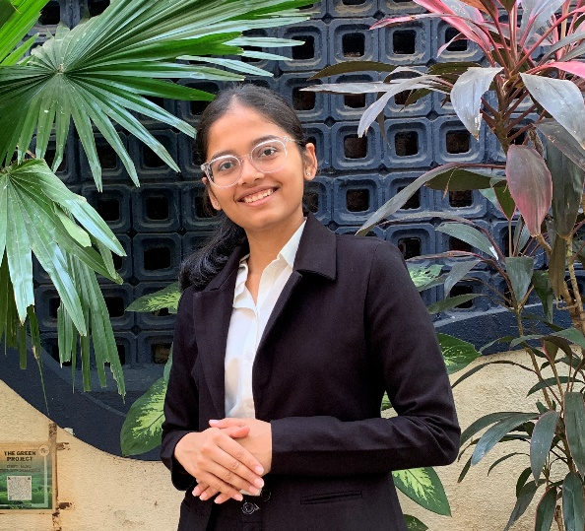
SUMMARY

9820026755
krishamjetani@gmail.com
Mumbai -India
I am a web developer currently in my third year of college. I know HTML, CSS, and PHP, and have built small projects during my studies. I am hardworking and always trying to improve my skills. I am excited to work on real-life projects and learn more in a frontend, backend, or full-stack role.




BSC-IT, NAGINDAS KHANDWALA COLLEGE (2023)
- Academic Marks (Sem-1)-9.64 CGPA
- Academic Marks (Sem-2)-9.50 CGPA
- Academic Marks (Sem-3)-9.86 CGPA
- Academic Marks (Sem-3)-9.77 CGPA
- Involved in Fest, Competition, Head of The Event & HOD of Marketing and Sponsorship
12th, The Bombay Suburban Grain Dealers’ Junior College (2022)
- Academic Marks-80.33%
10th, St.Xavier’s High School(2020)
- Academic Marks-74.60%
- Involved in Sports & Competition

HOBBIES
- TYPING
- SPORTS
- E-SPORTS
- TRAVELING

SKILLS
- HTML
- CSS
- JAVASCRIPT
- PHP
- SQL
- DATA ENTRY
- MS EXCEL
- PL/SQL
- Java
- BootStrap

English
Hindi
Gujrati

LANGUAGES
EDUCATION
KRISHA JETANI

