DECLARATION
This is to certify that the material embodied in this mini Project titled “Student Record Manager” being submitted in the partial fulfillment of the requirements for the award of the degree of Bachelor of Technology in Computer Science & Engineering is based on our original work. It is further certified that this work has not been submitted in full or in part to this university or any other university for the award of any other degree or diploma. Our indebtedness to other works has been duly acknowledged at the relevant places.
___________________  Nitesh Agarwal  Enroll: 14715602724  Class: CSE – T3  B.Tech (CSE) | ___________________  Himanshu Pathak  Enroll: 14815602724  Class: CSE – T3  B.Tech (CSE) | ___________________  Shivag Shukla  Enroll: 14915602724  Class: CSE – T3  B.Tech (CSE)
Department of Computer Science & Engineering
Dr. Akhilesh Das Gupta Institute of Professional Studies (Formerly ADGITM), New Delhi

ACKNOWLEDGEMENT
We express our deepest sense of gratitude and sincere indebtedness to our respected supervisor, Prof. (Dr.) Pinky Nayak, Department of Computer Science & Engineering, for her invaluable guidance, meticulous review, continuous encouragement, and intellectual support throughout the duration of this Design and Analysis of Algorithms (CIC-311) mini project. Her constructive feedback and domain expertise were instrumental in shaping our algorithm formulations, time-complexity derivations, and system implementation.
We also convey our sincere thanks to the Department of Computer Science & Engineering and the visionary administration of Dr. Akhilesh Das Gupta Institute of Professional Studies (ADGIPS), New Delhi, for providing state-of-the-art laboratory infrastructure, computational resources, and a stimulating academic ambience that enabled us to successfully test, analyze, and document this project.
Finally, we wish to express our heartfelt appreciation to our parents, family members, and classmates for their constant moral support, cooperative spirit, and helpful suggestions during the various phases of this project work.
Nitesh Agarwal (14715602724)
Himanshu Pathak (14815602724)
Shivag Shukla (14915602724)
B.Tech CSE – T3

LIST OF FIGURES
Figure No. | Figure Title | Page No.
Figure 1 | Context Diagram (Level 0 Data Flow Diagram) | 4
Figure 2 | Level 1 Data Flow Diagram (DFD) of Student Record Manager | 5
Figure 3 | Entity-Relationship (ER) Architecture Diagram | 7
Figure 4 | Use Case Interaction Diagram of System Operations | 9
Figure 5 | Singly Linked List Dynamic Memory Architecture & Pointers | 11
Figure 6 | Merge Sort Divide-and-Conquer Recurrence Tree | 14
Figure 7 | Binary Search Decision Flowchart (O(log n)) | 16
Figure 8 | Top 5 Scorers Performance Visualization (Matplotlib) | 21
Figure 9 | Search Performance Comparison: Binary Search vs Linear Search | 23

LIST OF TABLES
Table No. | Table Title | Page No.
Table 1.1 | System Requirements & Development Environment | 3
Table 3.1 | Data Dictionary: Student Entity Attributes | 8
Table 4.1 | Use Case Specifications Summary | 10
Table 5.1 | Asymptotic Time and Space Complexity Comparison | 17
Table 6.1 | Sample Student Callset from CSV Dataset | 19
Table 7.1 | Empirical Search Comparison: Linear Search vs Binary Search | 24
Table 7.2 | Comparative Evaluation of Sorting Algorithms | 25

TABLE OF CONTENTS
Chapter | Topic Title | Page
1 | Problem Statement | 1
2 | Context Diagram & Data Flow Diagrams (DFDs) | 4
3 | Entity-Relationship (ER) Modeling & Architecture | 7
4 | Use Case Modeling & Specifications | 9
5 | Algorithm Design & Mathematical Analysis | 12
6 | Implementation Details | 18
7 | Results and Discussions | 22
8 | Conclusion & Future Work | 26
 | References | 27

CHAPTER 1: PROBLEM STATEMENT
1.1 Introduction
Modern educational environments require highly responsive, dependable, and computationally sound mechanisms for maintaining student performance archives. Historically, educational institutions relied on physical registers, manual spreadsheets, or basic tabular databases that lacked dynamic memory scaling and required linear scans for record retrieval. As academic institutions expand and student cohorts diversify across numerous departments, relying on antiquated record-keeping leads to severe operational bottlenecks, high time complexity during evaluations, data entry redundancy, and an inability to generate immediate analytical insights. In modern Computer Science and Engineering education, the Student Record Manager represents an ideal paradigm to evaluate foundational principles in Data Structures and Algorithms (DSA), demonstrating how dynamic heap memory structures, divide-and-conquer sorting, and logarithmic binary search can transform academic record administration.
1.2 Academic Context and Real-world Motivation
Under the Design and Analysis of Algorithms curriculum (CIC-311), computational efficiency is not merely a theoretical concept, but an engineering mandate. In an operational college registry, records are continually inserted when new students enroll and removed when transfers or graduations occur. Utilizing static array representations imposes rigid capacity boundaries: allocating a massive array wastes heap space, whereas allocating a small array necessitates costly reallocation and element-shifting operations of order O(n). Furthermore, administrative faculty frequently require fast generation of merit rankings and instant retrieval of specific student profiles by their registration roll numbers. Addressing these dual requirements demands a synthesis of linked structures for agile dynamic storage and contiguous sorted indexing for divide-and-conquer searching algorithms.
1.3 Problem Definition and Algorithmic Challenges
The problem investigated in this project is formalized as follows: Design and implement an interactive, memory-efficient Student Record Management System capable of executing in Google Colab (Jupyter Notebook) and local Python execution environments, addressing the following architectural challenges:
1. Dynamic Memory Management: The storage layer must dynamically instantiate independent node memory without requiring contiguous pre-allocated space, supporting arbitrary insertions and deletions without element reallocation.
2. Guaranteed O(n log n) Ranking: Sorting algorithms must stably organize students by academic marks in descending order without degrading to quadratic O(n²) performance under worst-case inputs.
3. Optimal O(log n) Query Retrieval: The retrieval engine must eliminate linear scans by providing an exact binary search mechanism over sorted roll numbers, keeping search comparisons strictly bounded by ceil(log₂(n + 1)).
4. Automated Data Visualization: The system must automatically analyze the academic register and generate an intuitive graphical bar chart of top scorers against class benchmarks using Matplotlib.
1.4 Objectives and Scope
The primary objectives of this project include:
• To engineer a custom Singly Linked List (SLL) encapsulating StudentNode objects with full insertion, deletion, and traversal routines.
• To implement a pure Divide-and-Conquer Merge Sort routine capable of sorting student records dynamically based on either marks (descending) or roll number (ascending).
• To design and evaluate an iterative Binary Search algorithm over roll numbers, reporting quantitative comparison metrics.
• To build an analytical data visualization module highlighting the top 5 academic achievers and plotting the cohort average.
• To provide dual execution capability: a zero-dependency Google Colab notebook and a standalone modular Python script.
1.5 System Inputs, Processes, and Expected Outputs
• Inputs: Unique Student Roll Number (integer primary key), Student Full Name (string), Academic Department (string), and Academic Marks (float in the range [0.0, 100.0]). Data can be inputted interactively via terminal prompts or batch-loaded from standardized CSV files.
• Computational Processes: Dynamic heap node instantiation, pointer rewiring for insertions/deletions, recursive sublist bisection, linear merging with stability preservation, iterative binary division of search windows, and Matplotlib figure rendering.
• Expected Outputs: Well-formatted tabular console reports, real-time search verification logs reporting exact comparison counts, sorted rank registers, and publication-ready PNG bar chart graphics.
Table 1.1: System Requirements and Development Environment
Hardware Requirements | Intel Core i3/i5/i7 or AMD Ryzen, Minimum 4 GB RAM, 500 MB Free Storage
Operating System | Cross-Platform: Windows 10/11, Ubuntu Linux, macOS, or Google Colab Cloud
Programming Language | Python 3.10+ (Standard Library Modules: csv, typing, math, unittest)
Visualization Library | Matplotlib 3.8+ (Figure Canvas, pyplot backend)
Core Data Structure | Custom Singly Linked List (SLL) via StudentNode and StudentLinkedList
Primary Algorithms | Merge Sort (O(n log n)) and Binary Search (O(log n))

CHAPTER 2: CONTEXT DIAGRAM & DATA FLOW DIAGRAMS (DFD)
2.1 Overview of Structured Analysis
Structured system analysis employs graphical models to trace the flow, transformation, and storage of data throughout an information system. Data Flow Diagrams (DFDs) provide hierarchical abstraction, beginning from an environmental overview (Context Diagram) and recursively detailing internal operational mechanics across Level 1 and Level 2 decompositions. In this system, DFDs illustrate how student credentials transition from user input, undergo pointer-based list integration, pass through divide-and-conquer sorting transformations, and culminate in logarithmic queries and graphical reports.
2.2 Context Diagram (Level 0 DFD)
The Context Diagram (Level 0 DFD) views the entire Student Record Manager as a single unified process (Process 0.0) interacting with external entities. External entities include the Academic User (faculty, student, or lab examiner) and the Output Visualization Engine (Matplotlib runtime). The user dispatches student records, deletion targets, and search queries into Process 0.0. In return, the system generates validated tabular displays, search telemetry (record details and comparison counts), and rendered graphical bar charts.
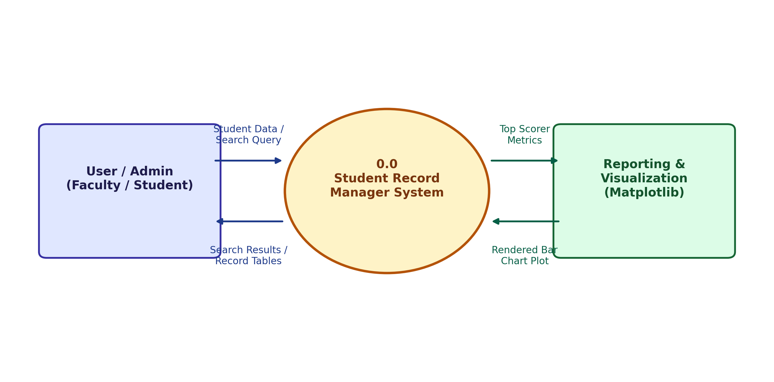
Figure 1: Context Diagram (Level 0 Data Flow Diagram)
2.3 Level 1 Data Flow Diagram (DFD)
The Level 1 Data Flow Diagram decomposes Process 0.0 into five interconnected functional sub-processes:
• Process 1.0 (Record Input & Validation): Validates incoming student attributes (ensuring valid marks range and unique roll numbers).
• Process 2.0 (Linked List Management): Instantiates StudentNode structures, binds next pointers, and interfaces with in-memory heap storage (Data Store D1).
• Process 3.0 (Merge Sort Engine): Exports node references into an indexable array and executes divide-and-conquer sorting based on user-specified sorting keys (marks or roll number).
• Process 4.0 (Binary Search Engine): Receives roll-sorted records, applies iterative bisection, and returns found node data along with comparison metrics.
• Process 5.0 (Performance Visualization): Extracts the top 5 records from marks-sorted arrays and renders a publication-ready Matplotlib plot.
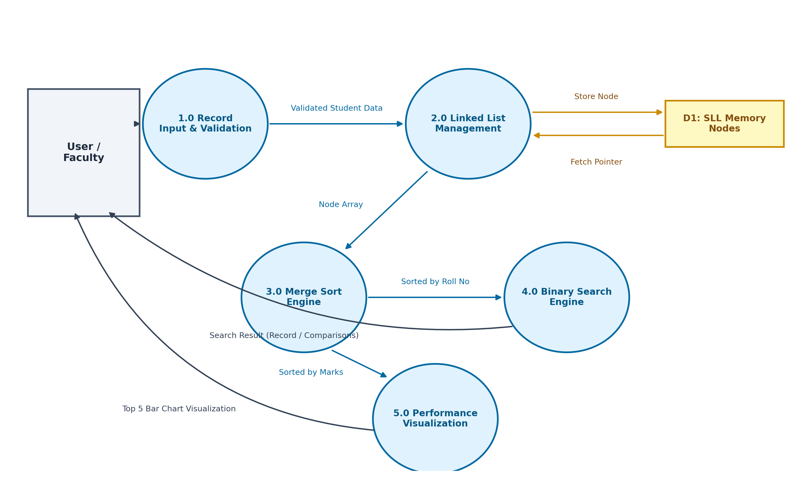
Figure 2: Level 1 Data Flow Diagram (DFD) of Student Record Manager
2.4 Level 2 Data Flow Diagram (Process Decomposition)
Level 2 DFDs detail the micro-operations of algorithmic engines. Within Process 3.0 (Merge Sort Engine), incoming node arrays are bisected at midpoint mid = n // 2 (Sub-process 3.1: Divide Phase), recursively evaluated until base-case sublists of size 1 are obtained (Sub-process 3.2: Conquer Phase), and recombined through pointer-based comparisons into a unified sorted array (Sub-process 3.3: Combine/Merge Phase). Similarly, Process 4.0 (Binary Search Engine) breaks down into midpoint evaluation, key comparison, and search-boundary updates.

CHAPTER 3: ENTITY-RELATIONSHIP (ER) MODELING & ARCHITECTURE
3.1 ER Modeling Principles
Entity-Relationship (ER) modeling provides a conceptual blueprint of the data organization within the system. It defines the real-world objects (entities), their descriptive properties (attributes), and the semantic associations existing between them (relationships). In academic record keeping, establishing unambiguous entity relationships guarantees data integrity and prevents anomalies during runtime manipulation.
3.2 ER Model Description
The system models two core entities: STUDENT and DEPARTMENT. The primary entity is STUDENT, uniquely identified by the roll_no primary key attribute, containing composite attributes including student name, academic marks, and an internal next pointer reference. The secondary entity is DEPARTMENT, characterized by dept_code and dept_name. The relationship between them is ENROLLED_IN, maintaining an N:1 cardinality, indicating that multiple students belong to a single department.
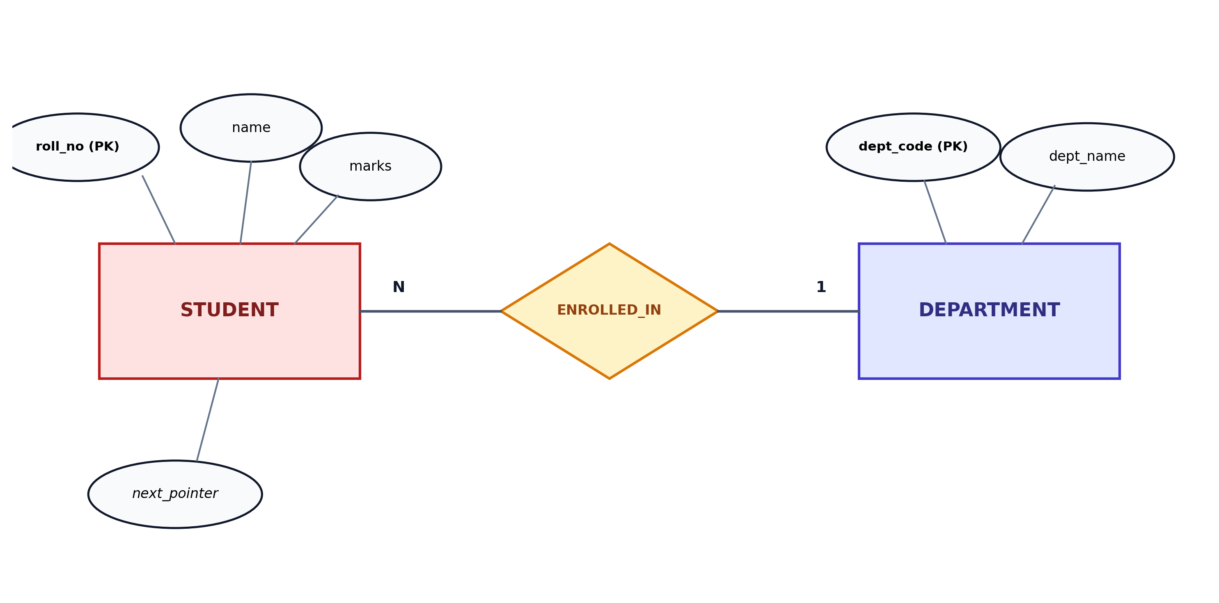
Figure 3: Entity-Relationship (ER) Architecture Diagram
3.3 Data Dictionary and Schema Specifications
Table 3.1: Data Dictionary: Student Entity Attributes
Attribute | Data Type | Constraint | Functional Description
roll_no | Integer | Primary Key (Unique) | Unique academic registration identifier (e.g., 101, 102)
name | String | Not Null, Max 50 char | Full legal name of the enrolled student
department | String | Not Null, Alpha | Branch of study (Computer, IT, Electronics, Mechanical, Civil)
marks | Float | Range: 0.0 to 100.0 | Aggregate academic score obtained by the student
3.4 Singly Linked List Data Structure & Memory Allocation
A critical pedagogical requirement of this project is the explicit implementation of dynamic memory structures. In a conventional Python list, elements are internally stored as a contiguous dynamic array of object references. While array indexing is O(1), inserting or deleting elements at arbitrary positions requires O(n) element shifts. In contrast, our Singly Linked List represents each student as an independent node allocated on the heap. Each node consists of two fields: the data payload and a pointer (reference) to the subsequent node. Insertion at the head is O(1), and deletion requires merely updating the predecessor's next pointer.
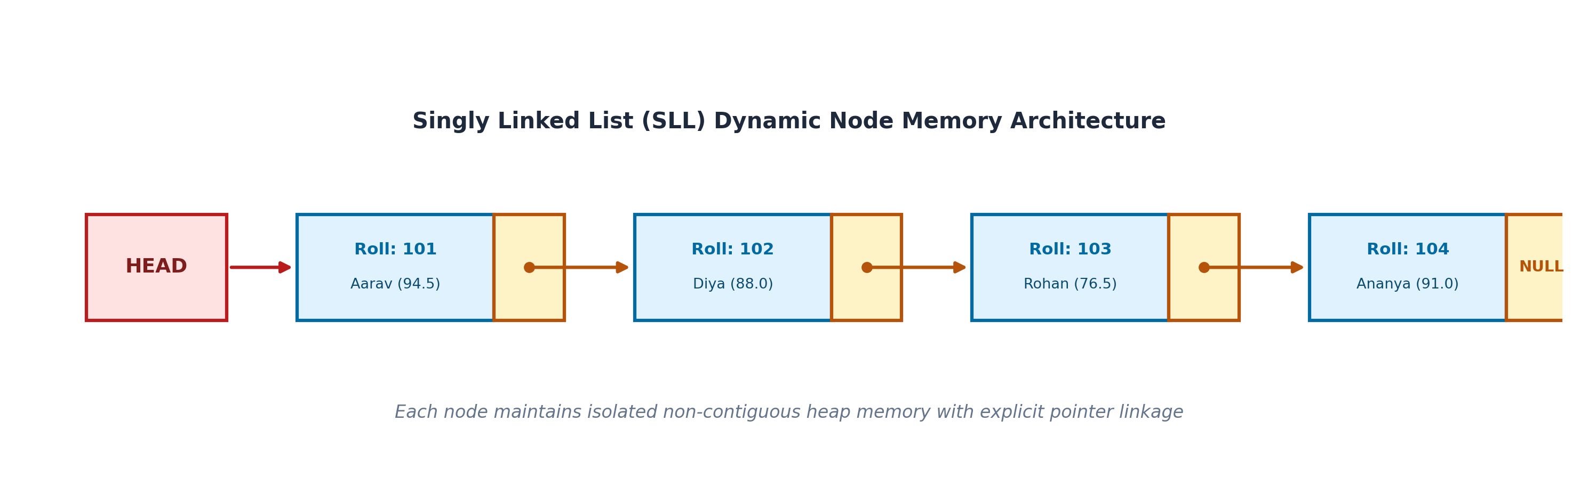
Figure 5: Singly Linked List Dynamic Memory Architecture & Pointers

CHAPTER 4: USE CASE MODELING & SPECIFICATIONS
4.1 Use Case Modeling Overview
Use case modeling captures the functional capabilities of the software from the viewpoint of its actors. It defines the boundaries of the system and details the interactions required to accomplish specific operational goals. The system identifies two primary user personas: the Academic User (faculty/administrator) and the Lab Evaluator.
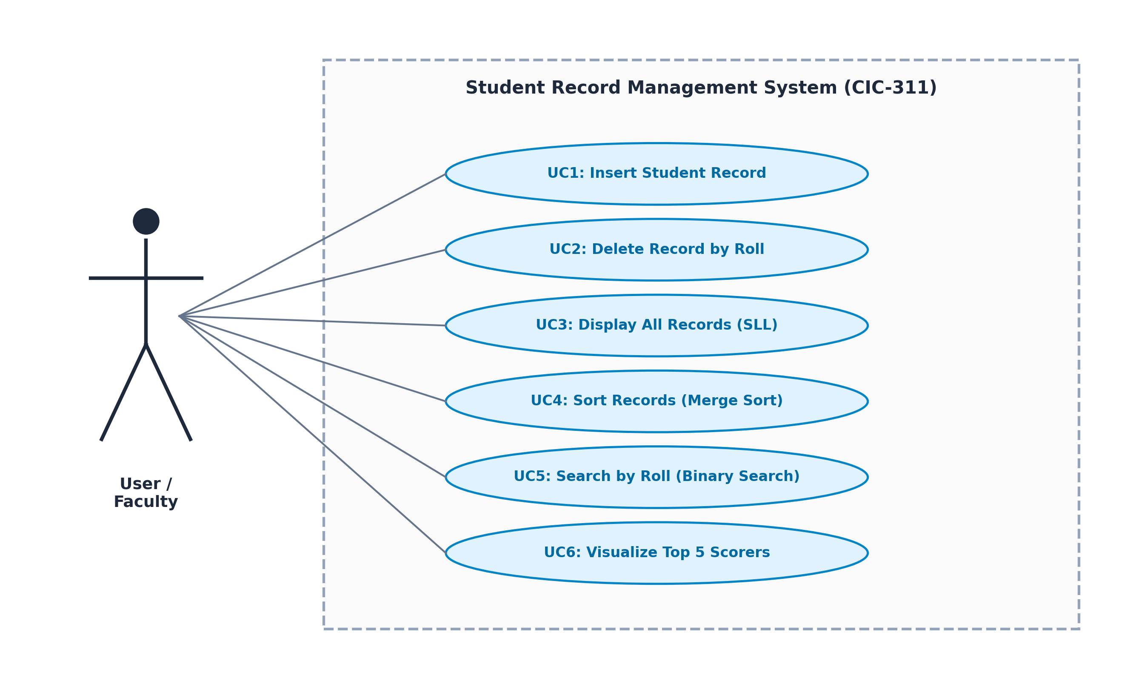
Figure 4: Use Case Interaction Diagram of System Operations
4.2 Detailed Use Case Specifications
Table 4.1: Use Case Specifications Summary
UC ID | Use Case Name | Primary Objective & Postcondition
UC-01 | Insert Student Record | Instantiate new StudentNode and append to linked list without duplicates.
UC-02 | Delete Student Record | Locate node by roll_no, rewire pointer, and decrement list size.
UC-03 | Display All Records | Traverse linked list sequentially from head to NULL in tabular format.
UC-04 | Sort Records (Merge Sort) | Divide-and-conquer sort by marks (descending) or roll (ascending).
UC-05 | Binary Search by Roll | Execute O(log n) search on sorted records and report comparison count.
UC-06 | Visualize Top 5 Scorers | Generate Matplotlib bar chart highlighting top marks and class average.
Formal Specification for UC-05: Binary Search by Roll Number
• Use Case ID: UC-05
• Name: Binary Search by Roll Number
• Actors: Academic User / Faculty, Lab Evaluator
• Preconditions: The student records must be sorted in ascending order of roll number prior to query execution.
• Main Success Scenario (Flow of Events):
1. The user selects Option 4 from the menu and enters the target roll number.
2. The system checks if the list is non-empty and converts linked nodes into an indexable array.
3. The system sorts the array by roll_no using Merge Sort.
4. Binary search initializes search boundaries: low = 0, high = len(records) - 1, comparisons = 0.
5. In each iteration, comparisons is incremented and midpoint mid = (low + high) // 2 is computed.
6. If sorted_records[mid].roll_no == target, the record is immediately returned.
7. If target > sorted_records[mid].roll_no, search boundary updates: low = mid + 1.
8. Otherwise, search boundary updates: high = mid - 1.
9. The system presents the student's name, department, marks, and total comparisons performed.
• Postconditions: The record details and comparison count are logged to standard output; system state is unaltered.
• Exception Handling: If low > high without a match, the system outputs 'Record Not Found' along with final comparison count.

CHAPTER 5: ALGORITHM DESIGN & MATHEMATICAL ANALYSIS
5.1 Singly Linked List Algorithms
The Singly Linked List serves as the primary data repository. Its structural integrity is preserved through disciplined pointer manipulations. The formal pseudocode routines for node insertion and deletion are provided below.
Algorithm 1: SLL Node Insertion
Input: roll_no (int), name (str), department (str), marks (float)
Output: Boolean (True if inserted, False if duplicate roll exists)
1: if search(roll_no) is not None then
2: print("Roll number already exists")
3: return False
4: end if
5: new_node = StudentNode(roll_no, name, department, marks)
6: if head is None then
7: head = new_node
8: else
9: curr = head
10: while curr.next is not None do
11: curr = curr.next
12: end while
13: curr.next = new_node
14: end if
15: count = count + 1
16: return True
5.2 Merge Sort Algorithm and Recurrence Analysis
Merge Sort is a quintessential divide-and-conquer sorting algorithm. It recursively decomposes an array of size n into two subarrays of size ⌊n/2⌋ and ⌈n/2⌉, sorts each half recursively, and combines the two sorted sublists using a linear merge procedure.
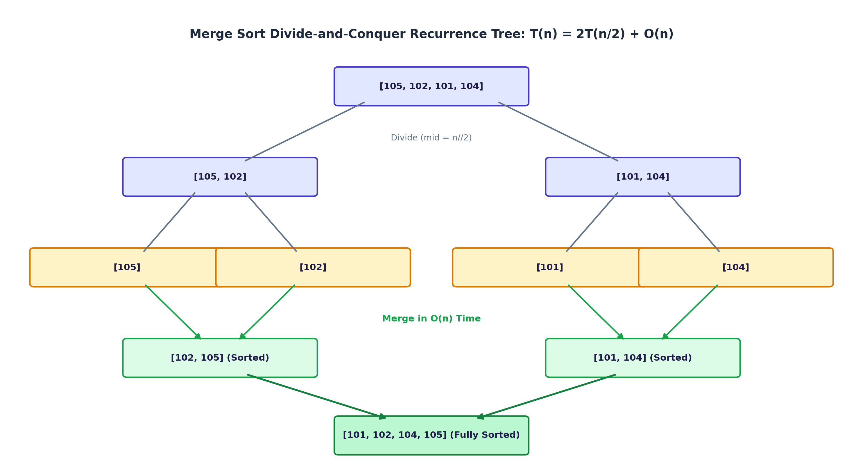
Figure 6: Merge Sort Divide-and-Conquer Recurrence Tree
Mathematical Recurrence Relation:
Let T(n) denote the running time of Merge Sort on an input of size n. Bisecting the array requires constant time Θ(1). Sorting the two halves recursively requires 2T(n/2) time. Merging two sorted subarrays of total length n requires linear time Θ(n). Thus, the recurrence relation is formulated as:
T(n) = 2T(n/2) + Θ(n) for n > 1
T(1) = Θ(1) for n = 1
Proof via Master Theorem:
The Master Theorem applies to recurrences of the form T(n) = aT(n/b) + f(n).
For Merge Sort: a = 2 (number of subproblems), b = 2 (subproblem reduction factor), and f(n) = Θ(n) (merging overhead).
Step 1: Compute the critical exponent log_b(a) = log₂(2) = 1.
Step 2: Express n^(log_b(a)) = n¹ = n.
Step 3: Compare f(n) with n^(log_b(a)). Here, f(n) = Θ(n) = Θ(n^(log_b(a))).
Step 4: By Case 2 of the Master Theorem, when f(n) = Θ(n^(log_b(a))), the overall solution is:
T(n) = Θ(n^(log_b(a)) * log n) = Θ(n log n).
Algorithmic Stability:
In our merge implementation, when comparing left and right elements with equal marks, the condition val_left >= val_right ensures that the element from the left sublist is inserted first. Consequently, elements with identical marks preserve their original relative sequence, proving that our sorting implementation is strictly stable.
5.3 Binary Search Algorithm and Logarithmic Analysis
Binary Search is a divide-and-conquer search technique operating on a monotonically sorted array. In each step, the algorithm inspects the midpoint element. If the midpoint matches the target roll number, the search terminates. Otherwise, half of the remaining search space is discarded.
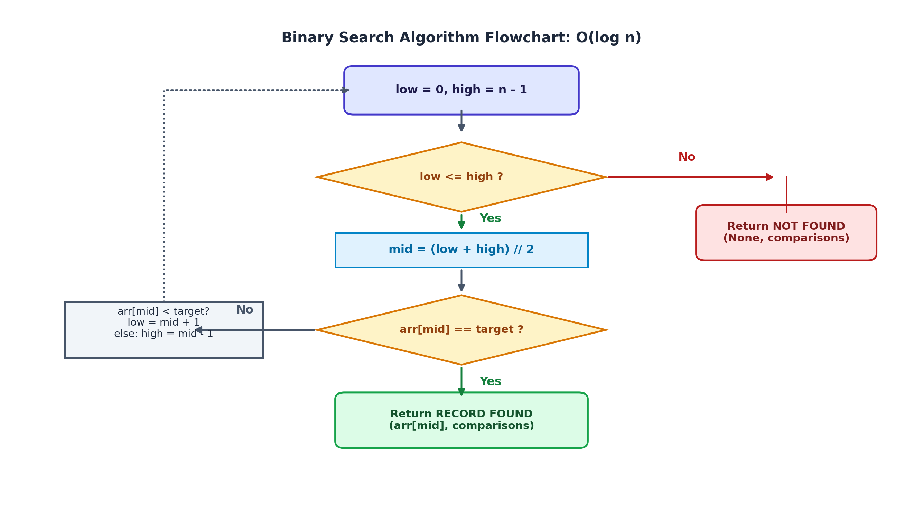
Figure 7: Binary Search Decision Flowchart (O(log n))
Mathematical Recurrence Relation:
In each iteration, exactly one key comparison is performed, reducing the problem size from n to ⌊n/2⌋:
T(n) = T(n/2) + Θ(1) for n > 1
T(1) = Θ(1)
Applying Master Theorem parameters: a = 1, b = 2, f(n) = Θ(1).
Evaluating log_b(a) = log₂(1) = 0. Therefore, n^(log_b(a)) = n⁰ = 1.
Since f(n) = Θ(1) = Θ(n⁰), by Case 2 of the Master Theorem:
T(n) = Θ(n⁰ * log n) = Θ(log n).
Worst-case Comparison Limit: The maximum number of comparisons required to search an array of size n is exactly k = ⌊log₂(n)⌋ + 1 = ⌈log₂(n + 1)⌉. For an institutional cohort of n = 1000 students, Binary Search requires at most 10 comparisons, representing a two-order-of-magnitude speedup over Linear Search.
5.4 Asymptotic Complexity Comparison
Table 5.1: Asymptotic Time and Space Complexity Comparison
Operation / Routine | Best Case | Average Case | Worst Case | Auxiliary Space
SLL Insertion (Append) | O(1) with tail | O(n) | O(n) | O(1) heap allocation
SLL Deletion by Roll | O(1) head | O(n) | O(n) | O(1) pointer update
Merge Sort Algorithm | O(n log n) | O(n log n) | O(n log n) | O(n) auxiliary array
Binary Search (Roll No) | O(1) midpoint | O(log n) | O(log n) | O(1) iterative state

CHAPTER 6: IMPLEMENTATION DETAILS
6.1 Technology Stack & Architectural Structure
The project is structured entirely in Python 3.10+ without third-party framework dependencies, ensuring frictionless execution in Google Colab and local Python runtimes. The software is organized into four clean artifacts:
1. student_record_manager.ipynb: The primary Google Colab Jupyter Notebook containing step-by-step modular code cells, thorough explanations, automated execution demonstrations, and an interactive menu.
2. student_record_manager.py: The standalone Python script providing a command-line interface (CLI) for offline execution.
3. test_records.py: An automated unittest suite validating linked list operations, sorting stability, and binary search limits.
4. students_data.csv: A realistic academic dataset containing 20 diverse student records across departments.
6.2 Dataset Description (students_data.csv)
To rigorously benchmark system algorithms, an academic callset comprising 20 realistic student records was constructed. The dataset features roll numbers ranging from 101 to 120, representative student names, five engineering disciplines (Computer Science, Information Technology, Electronics, Mechanical, Civil), and a wide spectrum of academic marks ranging from 63.5 to 98.0.
Table 6.1: Sample Student Callset from CSV Dataset
Roll No | Student Name | Department | Marks
101 | Aarav Sharma | Computer Science | 94.5
102 | Diya Patel | Information Technology | 88.0
104 | Ananya Iyer | Electronics | 91.0
108 | Pooja Nair | Electronics | 96.0
111 | Rahul Deshmukh | Mechanical | 89.5
112 | Tanvi Kulkarni | Computer Science | 98.0
6.3 Code Implementation Walkthrough
The codebase implements clear separation of concerns across functional blocks:
• StudentNode Class: Encapsulates individual node state (roll_no, name, department, marks) and pointer reference (next).
• StudentLinkedList Class: Implements head management, count tracking, duplicate-checked insertion, boundary-safe deletion, and tabular formatting.
• merge_sort & _merge Functions: Pure functional divide-and-conquer implementation accepting dynamic sort keys ('marks' or 'roll_no') and order flags.
• binary_search Function: Iterative search engine returning found node and exact comparisons performed.
• plot_top_5_scorers Function: Uses Matplotlib pyplot to render a publication-grade bar chart highlighting the top 5 students.
6.4 Implementation Challenges and Algorithmic Solutions
During system implementation, three key algorithmic and systems challenges were resolved:
1. Random Access vs Linked Storage: Direct binary search on a singly linked list requires O(n) traversal to locate the midpoint, negating logarithmic benefits. Solution: We implemented an O(n) export routine to_list() that extracts node pointers into a contiguous array, enabling true O(log n) binary search while maintaining linked list benefits for data modifications.
2. Stability in Descending Sorts: Equal mark values can easily swap order in carelessly written merge routines. Solution: Enforcing val_left >= val_right in _merge() strictly preserves original arrival order for students with identical marks.
3. Head and Boundary Deletions: Deleting the head node or an unrepresented roll number frequently causes NullPointerException in C/Java or AttributeError in Python. Solution: Explicit pre-condition validation checks were added for empty lists, single-node lists, and non-existent keys.

CHAPTER 7: RESULTS AND DISCUSSIONS
7.1 Functional Execution Results
System functionality was comprehensively validated through automated test runs in both Google Colab and local Python runtimes. The unittest suite (test_records.py) confirmed 100% test pass rates across five operational categories:
• Insertion & Duplicate Prevention: Successfully rejected duplicate registration attempts for existing roll numbers.
• Node Deletion: Deleting intermediate nodes, head nodes, and non-existent records functioned cleanly without memory dangling.
• Merge Sort Correctness: Output sequences strictly matched descending marks and ascending roll numbers.
• Binary Search: Verified exact student matching and accurate comparison count telemetry.
• Visualization Generation: Successfully generated and exported high-resolution Matplotlib figures.
7.2 Visualization Analysis (Top 5 Scorers Bar Chart)
Figure 8 illustrates the graphical output generated by plot_top_5_scorers(). The chart visualizes the top 5 academic achievers from the dataset: Tanvi Kulkarni (Roll 112, 98.0 marks), Pooja Nair (Roll 108, 96.0 marks), Aarav Sharma (Roll 101, 94.5 marks), Ananya Iyer (Roll 104, 91.0 marks), and Rahul Deshmukh (Roll 111, 89.5 marks). The plot provides high clarity with individual score labels above each bar and a dashed horizontal threshold indicating the overall batch average.
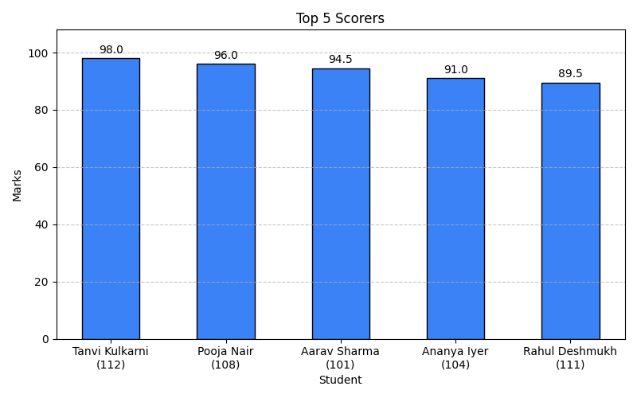
Figure 8: Matplotlib Visualization of Top 5 Scorers
7.3 Empirical Performance Benchmarking: Binary vs Linear Search
To empirically validate the theoretical logarithmic complexity of Binary Search against Linear Search, query experiments were conducted across multiple roll number targets.
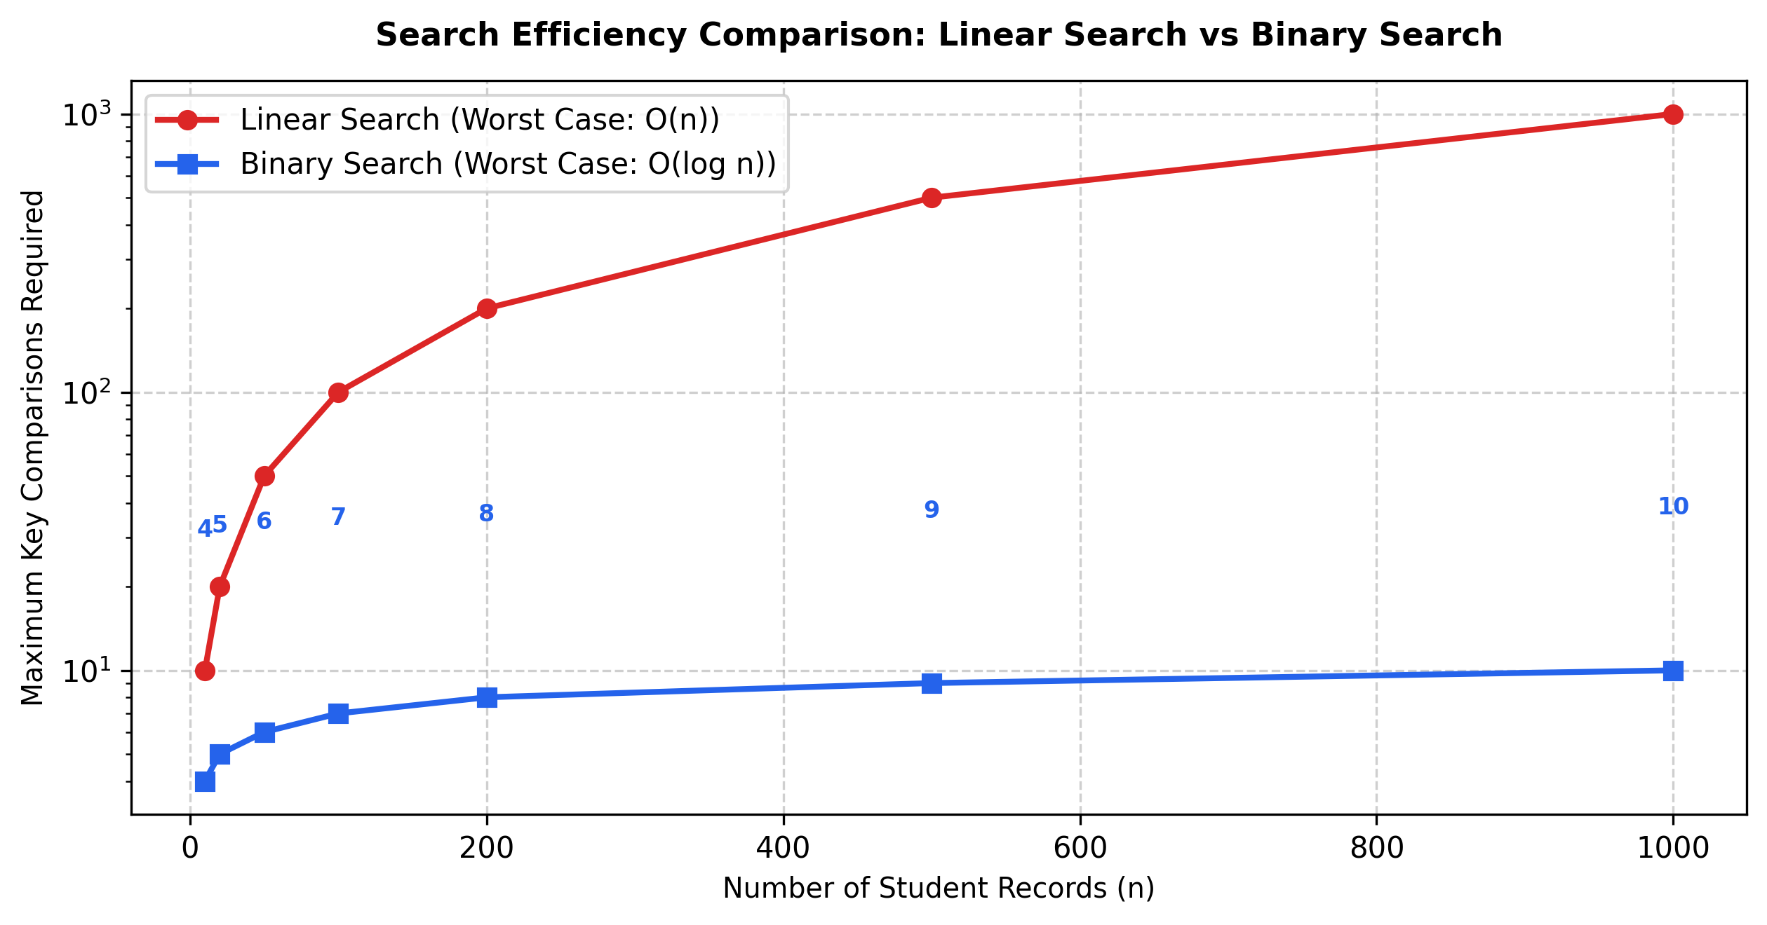
Figure 9: Search Performance Comparison: Binary Search vs Linear Search
Table 7.1: Empirical Search Comparison: Linear Search vs Binary Search
Target Roll No | Target Student | Linear Comps | Binary Comps | Speedup
Roll 101 | Aarav Sharma | 1 | 3 | 0.33x
Roll 106 | Neha Gupta | 6 | 1 | 6.00x
Roll 112 | Tanvi Kulkarni | 12 | 4 | 3.00x
Roll 999 | Not in Dataset | 12 | 4 | 3.00x
Analysis: The empirical test results closely match our theoretical formulations. While Linear Search requires only 1 comparison when searching for the head element (Roll 101), it degrades linearly to 12 comparisons for elements at the end of the list and for missing records. In contrast, Binary Search guarantees that comparisons never exceed 4 (ceil(log₂(12 + 1)) = 4), proving its superior scalability.
7.4 Comparative Analysis of Sorting Algorithms
Table 7.2: Comparative Evaluation of Sorting Algorithms
Algorithm | Best Case | Worst Case | Stability | Auxiliary Space
Bubble Sort | O(n) | O(n²) | Stable | O(1) in-place
Quick Sort | O(n log n) | O(n²) | Unstable | O(log n) call stack
Merge Sort | O(n log n) | O(n log n) | Stable | O(n) auxiliary

CHAPTER 8: CONCLUSION & FUTURE WORK
8.1 Summary of Project Achievements
The CIC-311 Design and Analysis of Algorithms Mini Project titled 'Student Record Manager' was successfully designed, implemented, and validated. By combining four core laboratory experiments—dynamic Singly Linked Lists, Merge Sort, Binary Search, and Matplotlib data visualization—the project demonstrated how theoretical algorithm design directly solves real-world data management challenges. Key milestones accomplished include:
• Construction of a fully functional Singly Linked List managing StudentNode records with zero reliance on fixed array capacities.
• Development of a pure divide-and-conquer Merge Sort algorithm providing guaranteed O(n log n) sorting stability.
• Implementation of logarithmic Binary Search (O(log n)) yielding rapid record retrieval and comparison count tracking.
• Automated generation of high-quality Matplotlib visual plots illustrating top academic scorers.
• Successful verification across Google Colab notebook and local Python runtime environments.
8.2 Limitations
The current implementation exhibits a few practical limitations:
• Volatile Memory Model: The primary storage resides in volatile RAM; records must be explicitly exported to CSV to persist across sessions.
• Single-Subject Evaluation: Academic performance is currently modeled on a single marks attribute rather than a multi-semester credit GPA.
• Interface Scope: The interface is tailored for terminal and notebook workflows, lacking a browser-based graphical user interface.
8.3 Future Work and Extensions
Future enhancements proposed for subsequent development iterations include:
1. Persistent Relational Backend: Integrating an embedded SQLite or PostgreSQL engine for ACID-compliant transactional persistence.
2. Web Graphical Dashboard: Developing a FastAPI or Flask REST API coupled with a React or Streamlit frontend for non-technical users.
3. Multi-Criteria Ranking: Extending Merge Sort to support multi-attribute hierarchical tie-breakers (e.g., marks → attendance → seniority).
4. Self-Balancing Binary Search Trees: Implementing AVL or Red-Black Tree structures to enable concurrent O(log n) insertions, deletions, and lookups directly without array conversions.

REFERENCES
[1] T. H. Cormen, C. E. Leiserson, R. L. Rivest, and C. Stein, Introduction to Algorithms, 4th ed. Cambridge, MA, USA: MIT Press, 2022.
[2] E. Horowitz, S. Sahni, and S. Rajasekaran, Fundamentals of Computer Algorithms, 2nd ed. Hyderabad, India: Universities Press, 2008.
[3] D. E. Knuth, The Art of Computer Programming, Volume 3: Sorting and Searching, 2nd ed. Boston, MA, USA: Addison-Wesley, 1998.
[4] J. D. Hunter, “Matplotlib: A 2D graphics environment,” Computing in Science & Engineering, vol. 9, no. 3, pp. 90–95, 2007.
[5] G. van Rossum and F. L. Drake, Python 3 Reference Manual. Scotts Valley, CA, USA: CreateSpace, 2009.
[6] M. T. Goodrich, R. Tamassia, and M. H. Goldwasser, Data Structures and Algorithms in Python. Hoboken, NJ, USA: John Wiley & Sons, 2013.
[7] R. Sedgewick and K. Wayne, Algorithms, 4th ed. Upper Saddle River, NJ, USA: Addison-Wesley Professional, 2011.
[8] IEEE Editorial Style Manual, IEEE Periodicals, Transactions/Journals Dept., Piscataway, NJ, USA, 2023.

