**EST Practical Activity Report**

Submitted for

**ENGINEERING DESIGN-II (UTA024)**

Submitted by:

Nitish (102303239)

Angad Dhawan (102303240)

Arnav Goyal (102303242)

Harith Khanna (102303243)

Himanshu Sardana (102303244)

**BE Second Year Batch – 2C21**

Submitted to:

**Dr. Sandeep Kaur**



**Computer Science and Engineering Department**

**Thapar Institute of Engineering & Technology, Patiala**

**Jan-June 2025**

**DECLARATION**

We declare that this project report is based on our own work carried out during the course of our study in our Engineering-design II Computer Lab under the supervision of Mr. Rajesh Kumar Chaudhary.

We assert that the statements made and conclusions drawn are an outcome of our own research work.

We further certify that the work contained in this report is original and has been done by us under the general supervision of our supervisor.

We have followed the guidelines provided by the University in writing this report.

We also declare that this project is the outcome of our own effort, that it has not been submitted to any other university for the award of any degree.

**INDEX**

|  |  |  |
| --- | --- | --- |
| **S. No.** | **Name of Experiments** | **Page No.** |
| **1** | Introduction to Arduino Micro-Controller. |  |
| **2** | To make a circuit of blinking an LED using Arduino Uno and breadboard. |  |
| **3** | To blink multiple LEDs using Arduino Uno and breadboard. |  |
| **4** | Write a program to design a pattern of sequence of multiple LED’s using for loop in Arduino. |  |
| **5** | Write a program to demonstrate sending data from the  computer to the Arduino board and control brightness of LED. |  |
| **6** | *Serial Communication:*  WAP to print following pattern using for loop.  **********************************************  Roll_No.______________________________________ ***************************************  Name:________________________________________ *************************************** Branch:____________________________________  *************************************** |  |
| **7** | WAP to show dimmer effect where LED 1 should display values between 1-50  LED 2 = 51-100  LED 3 = 101-150  LED 4 = 151-200  LED 5 = 201-255 |  |
| **8** | Write a program to change the intensity of the given LED’s for the sequence 35214 in for both forward and reverse order. |  |
| **9** | Write a program to demonstrate control of DC Motor using forward, backward, left, right turn motion and clock- wise/anti clock- wise rotation. |  |
| **10** | Write a program to read values of IR Sensor using digital read and convert buggy into normal line follower robocar. |  |
| **11** | To demonstrate the use of ultrasonic sensor by integrating line follower robocar with obstacle avoidance capability. |  |
| **12** | Write a program to read the pulse width of the gantry transmitter and trigger the stop_buggy function by detecting individual gantry. |  |
| **13** | Write a program to demonstrate Xbee module communication between Buggy and PC. |  |
| **14** | Bronze Challenge: Single buggy around track twice in clockwise direction, under full supervisory control. Buggy can detect an obstacle, Parks safely. Prints state of the track and buggy at each gantry stop. |  |

**EXPERIMENT-1**

**OBJECTIVE:** Introduction to Arduino Micro-Controller.

**SOFTWARE USED:** Tinkercad Simulator

**HARDWARE USED:**

|  |  |  |  |  |
| --- | --- | --- | --- | --- |
| |  | | --- | | **Sr. No** | | **Name of Components** | |  | | --- | | **Value** | |
| **1** | Arduino Uno Micro-Controller | **1** |

**LOGIC/CIRCUIT DIAGRAM:**

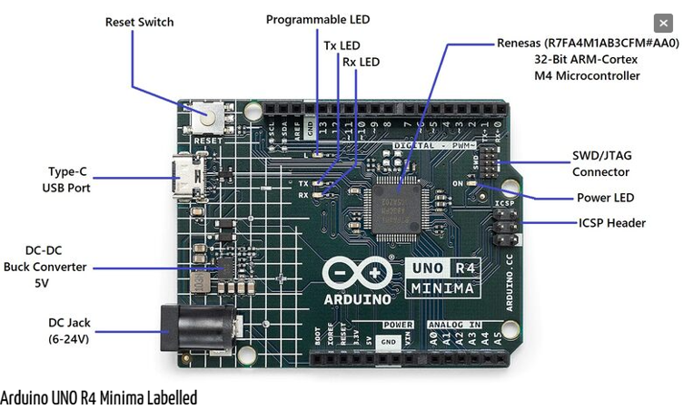

**THEORY:**

The Arduino UNO R4 Minima, with the model number R7FA4M1AB3CFM#AA0, is a versatile development board packed with a multitude of features. It is the first UNO board featuring a 32-bit microcontroller from Renesas. It is faster, has more memory and has a number of built-in features such as a DAC, RTC and HID. The UNO R4 Minima is a 5 V only board. The UNO R4 Minima features a microcontroller based on the Renesas (Arm® Cortex®-M4) with an operating voltage of 5 V. It has 14 digital I/O, 6 analog inputs with up to 14-bit resolution, a clock speed of 48 MHz, and 32 kB SRAM, 256 kB flash memory & 8 kB of EEPROM. It features a DAC for audio projects, RTC for accurate time tracking and HID for emulating a keyboard/mouse. The barrel jack plug (VIN) supports voltages at up to 24V, making it compatible with common higher voltage adapters.

Here’s a comprehensive overview of its specifications:

**1. Microprocessor**:

* **Core**: 48 MHz Arm® Cortex®-M4 microprocessor.
* **Special Feature**: Equipped with a floating point unit (FPU) for enhanced computational capabilities.

**2. Power**:

* **Operating Voltage**: 5 V.
* **Input Voltage (VIN)**: Recommended range is 6-24 V.
* **Power Source**: Can be powered via a USB-C® at 5 V.
* **Protection**: Features Schottky diodes for overvoltage and reverse polarity protection.
* **Connection**: Barrel jack connected directly to the VIN pin.

**3. Memory**:

* **Flash Memory**: 256 kB.
* **SRAM**: 32 kB.
* **Data Memory (EEPROM)**: 8 kB.

**4. Pins**:

* **Digital Pins**: 14x GPIO pins labeled D0-D13.
* **Analog Input Pins**: 6x pins labeled A0-A5.
* **PWM Pins**: 6x pins specifically D3, D5, D6, D9, D10, and D11.

**5. Peripherals**:

* **Touch Sensing**: Capacitive Touch Sensing Unit (CTSU)
* **USB Module**: USB 2.0 Full-Speed Module (USBFS)
* **ADC**: Up to 14-bit resolution ([**ADC Usage Guide**](https://how2electronics.com/14-bit-adc-usage-guide-in-arduino-uno-r4-minima/))
* **DAC**: Up to 12-bit resolution ([**DAC Usage Guide**](https://how2electronics.com/12-bit-dac-usage-guide-in-arduino-uno-r4-minima/))
* **Additional Feature**: Operational Amplifier (OPAMP)

**6. Communication**:

* **UART**: Available on pins D0 and D1.
* **SPI**: Accessible via pins D10-D13 and the ICSP header.
* **I2C**: Available on pins A4, A5, SDA, and SCL.
* **CAN**: Available on pins D4 and D5, but an external transceiver is required for operation.

**7. Special Features**:

* **Real-time Clock (RTC)**: Ensures accurate timekeeping.
* **Memory Protection Unit (MPU)**: Provides enhanced security for memory sections.
* **Digital Analog Converter (DAC)**: Allows for precise analog operations.

With its robust set of features, the Arduino UNO R4 Minima is well-suited for a wide range of applications, from simple DIY projects to complex industrial applications. Whether you’re a beginner or an experienced developer, this board offers the tools and flexibility needed to bring your ideas to life.

**DISCUSSIONS**

In this experiment, we get to know about basics of Arduino Uno Microcontroller and its various functions and components.

**Signature of faculty member**

**EXPERIMENT-2**

**OBJECTIVE:** Write a program to blink a single LED using Arduino and breadboard.

**SOFTWARE USED:** Tinkercad Simulator.

**HARDWARE USED:**

|  |  |  |
| --- | --- | --- |
| **Sr No.** | **Name of the Component** | **Value** |
| 1. | Arduino Uno Board | 1 |
| 2. | Breadboard | 1 |
| 3. | Jumper Wires | 2 |
| 4. | LED | 1 |
| 5. | Resistor | 220 ohm |

**THEORY:**

**Resistor:** Resistors are used in virtually all electronic circuits and many electrical ones. Resistors, as their name indicates resist the flow of electricity and this function is key to the operation most circuits.

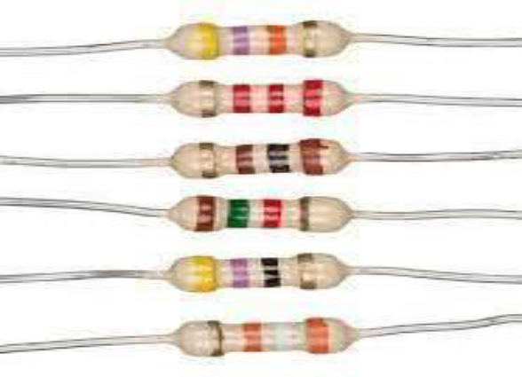

**LED:** A light-emitting diode (LED) is a semiconductor light source that emits light when current flows through it. Electrons in the semiconductor recombine with electron holes, releasing energy in the form of photons (Energy packets).

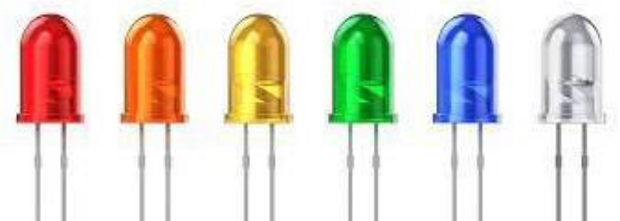

**Arduino Uno Board:** The **Arduino Uno** is an open-source microcontroller board based on the Microchip ATmega328P microcontroller and developed by Arduino.cc.

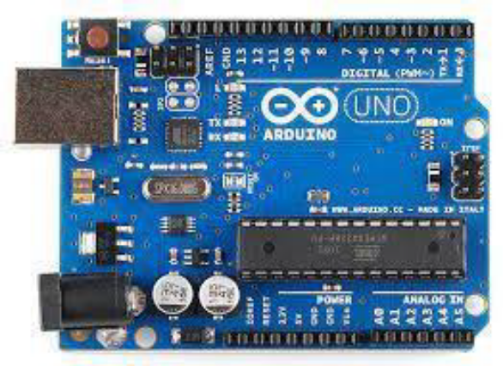

**Breadboard:** A breadboard is used to place components (resistor, capacitor, LED’s etc.) that are wired together. It is used to make temporary circuits.

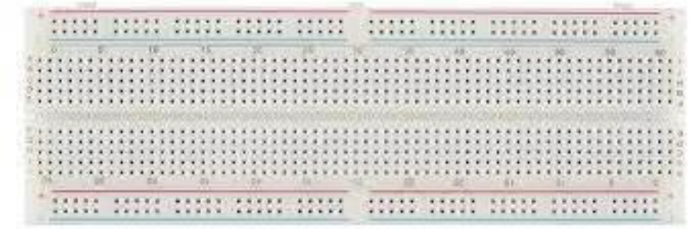

**Jumper Wires:** A jumper wire is an electric wire that connects remote electric circuits used for printed circuit boards.

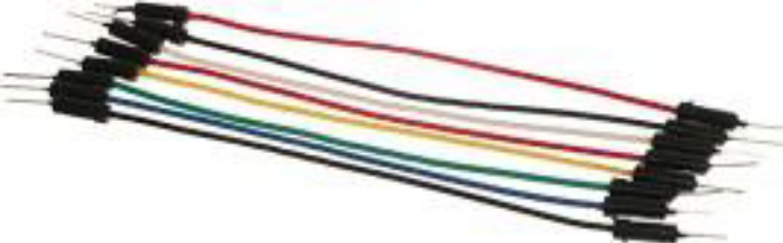

**TINKERCAD DIAGRAM:**

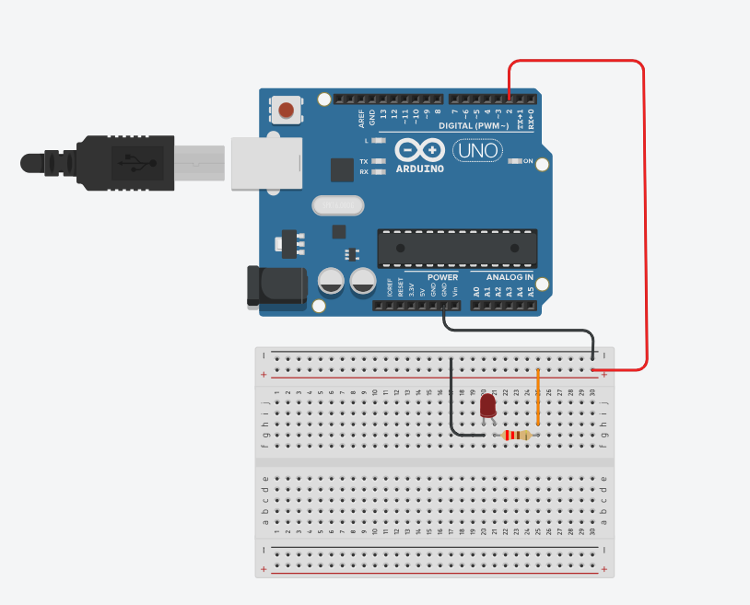

**CODE:**

void setup() {

pinMode(2, OUTPUT);

}

void loop() {

digitalWrite(2, HIGH);

delay(1000);

digitalWrite(2, LOW);

delay(1000);

}

**RESULTS:**

In this experiment, we learnt how to blink an LED using Arduino Uno.

PASTE HERE THE PHOTOGRAPH OF THE FINAL OUPUT OF THE EXPERIMENT U HAD TAKEN AFTER THE EXECUTION.

**Signature of faculty member**

**EXPERIMENT-3**

**OBJECTIVE:** To blink multiple LEDs using Arduino Uno and breadboard

**SOFTWARE USED:** Tinkercad Simulator.

**HARDWARE USED:**

|  |  |  |
| --- | --- | --- |
| **Sr No.** | **Name of the Component** | **Value** |
| 1. | Arduino Uno Board | 1 |
| 2. | Breadboard | 1 |
| 3. | Jumper Wires | 11 |
| 4. | LED | 5 |
| 5. | Resistor | 220 ohm (x5) |

**TINKERCAD DIAGRAM:**

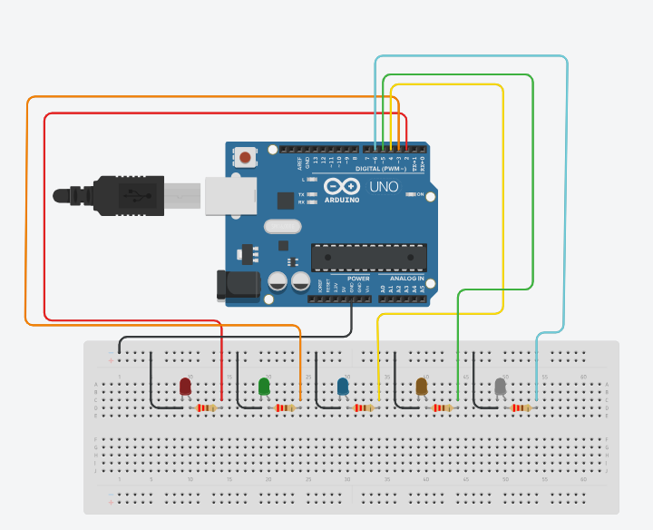

**CODE:**

void setup()

{

for(int i = 2; i <= 6; i++) {

pinMode(i, OUTPUT);

}

}

void loop()

{

for(int i = 2; i <= 6; i++) {

for(int j = 2; j <= 6; j++) {

digitalWrite(j, LOW);

}

digitalWrite(i, HIGH);

delay(1000);

}

}

**RESULTS:**

**EXPERIMENT-4**

**OBJECTIVE:** Write a program to design a pattern of sequence of multiple LED’s using for loop in Arduino.

**SOFTWARE USED:** Tinkercad Simulator.

**HARDWARE USED:**

|  |  |  |
| --- | --- | --- |
| **Sr No.** | **Name of the Component** | **Value** |
| 1. | Arduino Uno Board | 1 |
| 2. | Breadboard | 1 |
| 3. | Jumper Wires | 11 |
| 4. | LED | 5 |
| 5. | Resistor | 220 ohm (x5) |

**TINKERCAD DIAGRAM:**



**CODE:**

void setup() {

for(int i = 2; i <= 6; i++) {

pinMode(i, OUTPUT);

}

}

void loop() {

for(int i = 2; i <= 6; i += 2) {

digitalWrite(i, HIGH);

delay(1000);

digitalWrite(i, LOW);

}

for(int i = 3; i <= 6; i += 2) {

digitalWrite(i, HIGH);

delay(1000);

digitalWrite(i, LOW);

}

for(int i = 5; i >= 3; i -= 2) {

digitalWrite(i, HIGH);

delay(1000);

digitalWrite(i, LOW);

}

for(int i = 6; i >= 3; i -= 2) {

digitalWrite(i, HIGH);

delay(1000);

digitalWrite(i, LOW);

}

}

**RESULTS:**

**EXPERIMENT-5**

**OBJECTIVE:** Write a program to demonstrate sending data from the computer to the Arduino board and control brightness of LED.

**SOFTWARE USED:** Tinkercad Simulator.

**HARDWARE USED:**

|  |  |  |
| --- | --- | --- |
| **Sr No.** | **Name of the Component** | **Value** |
| 1. | Arduino Uno Board | 1 |
| 2. | Breadboard | 1 |
| 3. | Jumper Wires | 3 |
| 4. | LED | 1 |
| 5. | Resistor | 220 ohm (x1) |

**TINKERCAD DIAGRAM:**

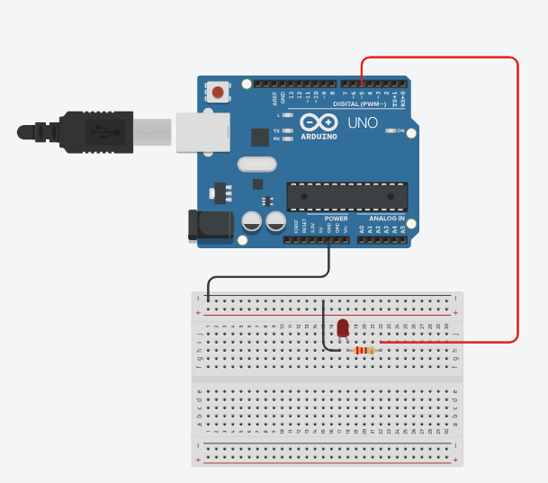

**CODE:**

void setup()

{

pinMode(5, OUTPUT);

Serial.begin(9600);

}

void loop()

{

if(Serial.available() > 0) {

int x = Serial.parseInt();

analogWrite(5, x);

Serial.println("Brightness set to: " + (String)x);

delay(1000);

}

}

**RESULTS:**

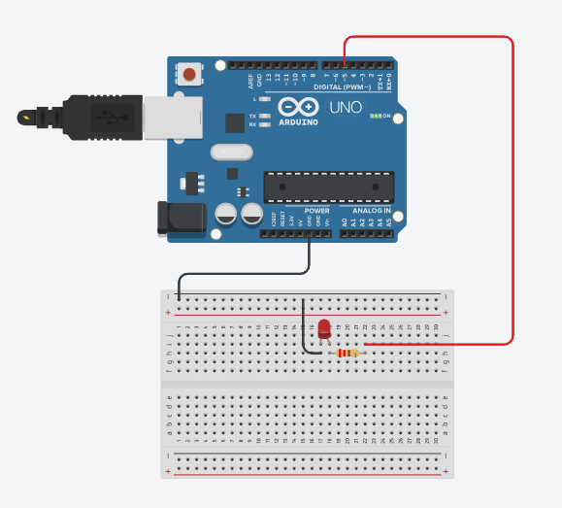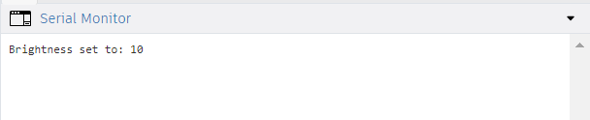

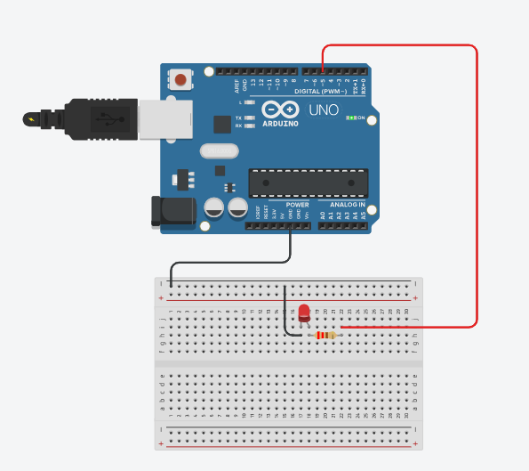 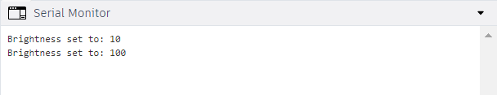

**EXPERIMENT-6**

**OBJECTIVE:** WAP to print following pattern using for loop. ********************************************** Roll_No.______________________________________

***************************************

Name:________________________________________

***************************************

Branch:___________________________________

**********************************************

**SOFTWARE USED:** Tinkercad Simulator.

**HARDWARE USED:**

|  |  |  |
| --- | --- | --- |
| **Sr No.** | **Name of the Component** | **Value** |
| 1. | Arduino Uno Board | 1 |

**TINKERCAD DIAGRAM:**

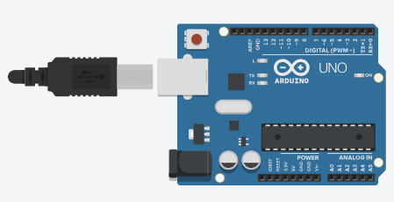

**CODE:**

void setup()

{

Serial.begin(9600);

}

void loop()

{

Serial.println("*****************************");

Serial.println("Name: Himanshu Sardana");

Serial.println("*****************************");

Serial.println("Roll No.: 102303244");

Serial.println("*****************************");

Serial.println("Branch: COE");

Serial.println("*****************************");

delay(500);

exit(0);

}

**EXPERIMENT-7**

**OBJECTIVE** WAP to show dimmer effect where LED 1 should display values between 1-50

LED 2 = 51-100

LED 3 = 101-150

LED 4 = 151-200

LED 5 = 201-255

**SOFTWARE USED:** Tinkercad Simulator.

**HARDWARE USED:**

|  |  |  |
| --- | --- | --- |
| **Sr No.** | **Name of the Component** | **Value** |
| 1. | Arduino Uno Board | 1 |
| 2. | Breadboard | 1 |
| 3. | Jumper Wires | 11 |
| 4. | LED | 5 |
| 5. | Resistor | 220 ohm (x5) |

**TINKERCAD DIAGRAM:**

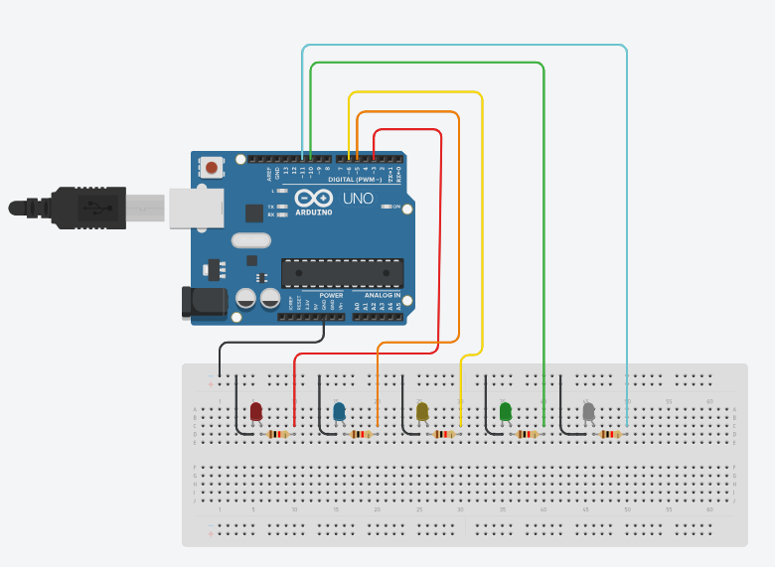

**CODE:**

void setup()

{

pinMode(3, OUTPUT);

pinMode(5, OUTPUT);

pinMode(6, OUTPUT);

pinMode(10, OUTPUT);

pinMode(11, OUTPUT);

}

void loop()

{

for(int i = 0; i <= 50; i++) {

analogWrite(3, i);

delay(50);

}

for(int i = 51; i <= 100; i++) {

analogWrite(5, i);

delay(50);

}

for(int i = 101; i <= 150; i++) {

analogWrite(6, i);

delay(50);

}

for(int i = 151; i <= 200; i++) {

analogWrite(10, i);

delay(50);

}

for(int i = 201; i <= 251; i++) {

analogWrite(11, i);

delay(50);

}

}

**EXPERIMENT-8**

**OBJECTIVE:** Write a program to change the intensity of the given LED’s for the sequence 35214 in for both forward and reverse order.

**SOFTWARE USED:** Tinkercad Simulator.

**HARDWARE USED:**

|  |  |  |
| --- | --- | --- |
| **Sr No.** | **Name of the Component** | **Value** |
| 1. | Arduino Uno Board | 1 |
| 2. | Breadboard | 1 |
| 3. | Jumper Wires | 11 |
| 4. | LED | 5 |
| 5. | Resistor | 220 ohm (x5) |

**TINKERCAD DIAGRAM:**

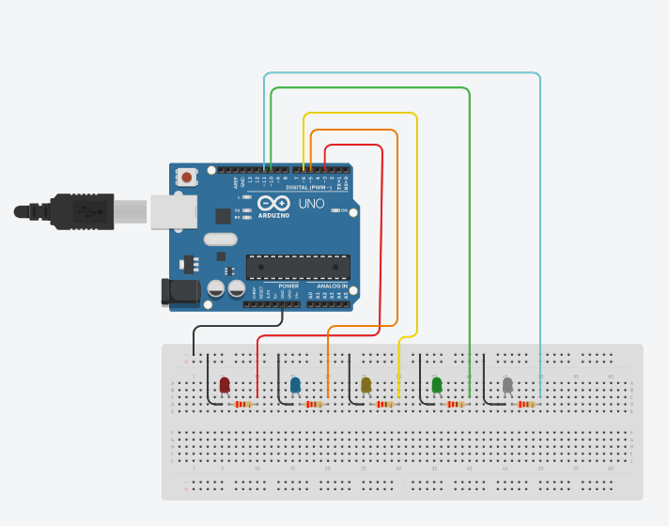

**CODE:**

void setup()

{

pinMode(3, OUTPUT); // 1

pinMode(5, OUTPUT); // 2

pinMode(6, OUTPUT); // 3

pinMode(10, OUTPUT); // 4

pinMode(11, OUTPUT); // 5

}

// 3 5 2 1 4

int leds[] = {3, 5, 6, 10, 11};

void loop()

{

for(int i = 0; i <= 50; i++) {

for(int j = 0; j <= 4; j++) {

analogWrite(leds[j], 0);

}

analogWrite(6, i);

delay(50);

}

for(int i = 51; i <= 100; i++) {

for(int j = 0; j <= 4; j++) {

analogWrite(leds[j], 0);

}

analogWrite(11, i);

delay(50);

}

for(int i = 101; i <= 150; i++) {

for(int j = 0; j <= 4; j++) {

analogWrite(leds[j], 0);

}

analogWrite(5, i);

delay(50);

}

for(int i = 151; i <= 200; i++) {

for(int j = 0; j <= 4; j++) {

analogWrite(leds[j], 0);

}

analogWrite(3, i);

delay(50);

}

for(int i = 201; i <= 251; i++) {

for(int j = 0; j <= 4; j++) {

analogWrite(leds[j], 0);

}

analogWrite(10, i);

delay(50);

}

// Reverse

for(int i = 0; i <= 50; i++) {

for(int j = 0; j <= 4; j++) {

analogWrite(leds[j], 0);

}

analogWrite(10, i);

delay(50);

}

for(int i = 50; i <= 100; i++) {

for(int j = 0; j <= 4; j++) {

analogWrite(leds[j], 0);

}

analogWrite(3, i);

delay(50);

}

for(int i = 101; i <= 150; i++) {

for(int j = 0; j <= 4; j++) {

analogWrite(leds[j], 0);

}

analogWrite(11, i);

delay(50);

}

for(int i = 151; i <= 200; i++) {

for(int j = 0; j <= 4; j++) {

analogWrite(leds[j], 0);

}

analogWrite(5, i);

delay(50);

}

for(int i = 201; i <= 251; i++) {

for(int j = 0; j <= 4; j++) {

analogWrite(leds[j], 0);

}

analogWrite(6, i);

delay(50);

}

}