Breast Cancer Diagnosis Decision Dashboard
From Raw Data to Business Decisions with Python, Machine Learning and Streamlit
Project Report
AICTE | IBM SkillsBuild Data Analytics with AI Internship 2026
BharatCares
Submitted by: [Your Name]
Institution: [Your Institution] | Branch: [Your Branch]

1. Introduction
Data analytics is only valuable when it ends in a decision. This project follows the business-intelligence path of Data, Information, Insight, Decision and Action. It converts a clinical measurement dataset into KPIs, trends, drivers, risks, opportunities and a recommended action, and delivers them through an interactive dashboard.
The project is built as a single Python file that contains the data layer, the machine-learning back-end and the Streamlit front-end, so that it is easy to run, review and maintain.

2. Problem Statement
Hospitals must decide which patients need urgent specialist review. A missed malignant case is far more costly than an unnecessary follow-up. The goal is to (a) understand what separates malignant from benign cases, (b) predict malignancy risk from cell-nucleus measurements, and (c) present the findings so that a non-technical decision maker can act on them.

3. Objectives
- Clean and explore the dataset and report headline KPIs.
- Show trends and identify the key drivers of malignancy.
- Train and compare four classification models, selecting on recall.
- Translate results into risk, opportunity and recommended action.
- Deliver everything in a simple multi-page dashboard with a patient risk predictor.

4. Dataset
The Breast Cancer Wisconsin (Diagnostic) dataset contains 569 patient samples. Each record has 30 numeric features computed from a digitised image of a fine-needle aspirate of a breast mass. Every measurement (radius, texture, perimeter, area, smoothness, compactness, concavity, concave points, symmetry, fractal dimension) is given as a mean, a standard error and a worst value.
Property | Detail
Source (Kaggle) | kaggle.com/datasets/uciml/breast-cancer-wisconsin-data
Source (UCI) | archive.ics.uci.edu/dataset/17
Rows x columns | 569 x 32 (30 features, diagnosis label, malignant flag)
Missing values / duplicates | 0 / 0
Target | Malignant (212 cases, 37.3%) or Benign (357 cases, 62.7%)
Access in code | sklearn.datasets.load_breast_cancer (offline)

This dataset is different from the learning dataset used in the masterclasses.

5. Methodology

5.1 Business-intelligence framework
Level | Question answered | Where in the project
KPIs | What is happening? | Executive Overview page
Trends | Where is it heading? | Malignancy rate by tumour size
Drivers | Why is it happening? | Permutation importance, correlation map
Risk | What could go wrong? | Missed cancers and false alarms
Opportunity | Where can we gain? | Early triage using measurements
Action | What should we do? | Escalation threshold and audit

5.2 Data preparation
The data is checked for duplicates and missing values (none found). The target is relabelled into business-readable text and a binary flag. An 80/20 stratified train-test split keeps the malignant share the same in both sets. Scaling is applied inside pipelines for the models that need it (Logistic Regression and SVM), which prevents data leakage.

5.3 Modelling
Four models were trained: Logistic Regression, Support Vector Machine, Random Forest and Gradient Boosting. Each was evaluated with 5-fold stratified cross-validation on the training set and then on the held-out test set. Because missing a cancer is the costliest error, models are ranked by recall first and ROC-AUC second. Drivers are measured with permutation importance on the test set.

5.4 Technology stack
Layer | Tools
Back-end / data | Python, pandas, NumPy
Machine learning | scikit-learn
Visualisation | Matplotlib, Seaborn
Front-end | Streamlit

6. Results and Analysis

6.1 Executive overview: KPIs
KPI | Value
Total cases | 569
Malignancy rate | 37.3%
Selected model | Logistic Regression
Cancers caught (recall) | 92.9% (39 of 42 on the test set)
Precision | 97.5%
ROC-AUC | 0.996
Missed cancers / false alarms (test set) | 3 / 1

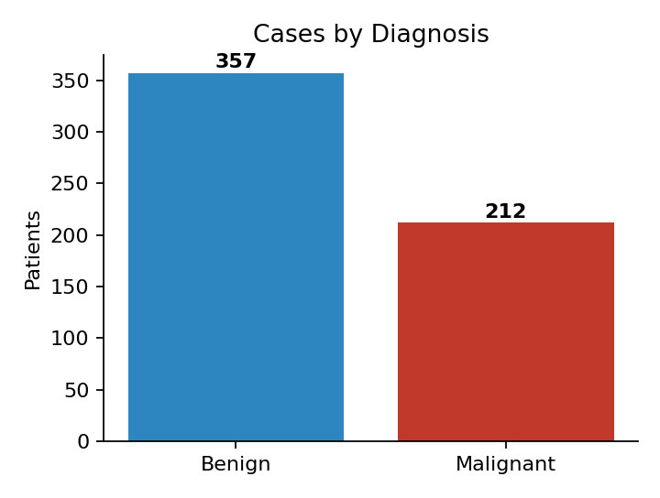
Figure 1: Cases by diagnosis (Executive Overview page)

6.2 Trend
The malignancy rate rises steeply as mean tumour radius grows. Malignant tumours have a mean radius of 17.5 versus 12.2 for benign, and a mean area of 978 versus 463, about 2.1 times larger.
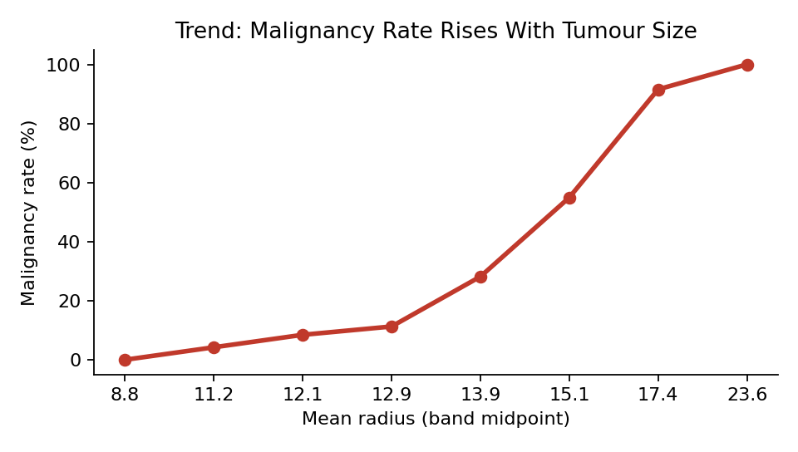
Figure 2: Malignancy rate by tumour radius band

6.3 Drivers
Distributions of key measurements separate the two classes clearly, and the correlation heat map shows that size, concavity and concave-point features are strongly related to malignancy. Permutation importance ranks worst symmetry, worst texture and worst concavity as the top three drivers of the selected model, followed by mean concave points.
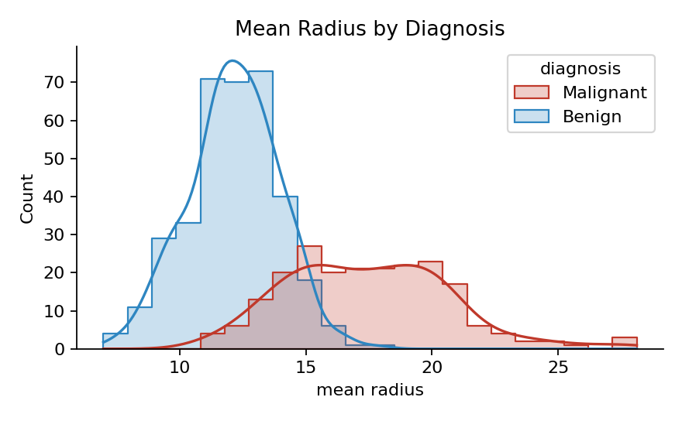
Figure 3: Distribution of mean radius by diagnosis
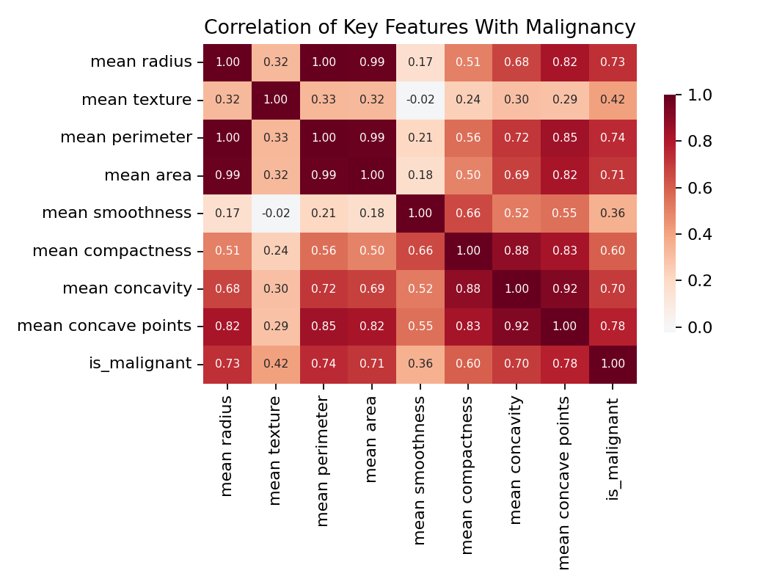
Figure 4: Correlation of key features with malignancy
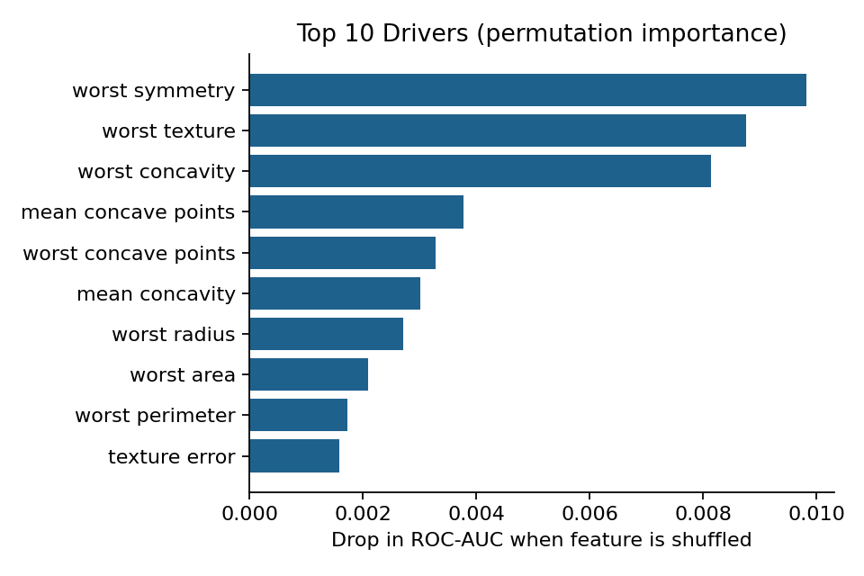
Figure 5: Top 10 drivers (permutation importance)

6.4 Model performance
Model | Accuracy | Precision | Recall | F1 | ROC-AUC
Logistic Regression | 0.965 | 0.975 | 0.929 | 0.951 | 0.996
Support Vector Machine | 0.974 | 1.000 | 0.929 | 0.963 | 0.995
Random Forest | 0.974 | 1.000 | 0.929 | 0.963 | 0.994
Gradient Boosting | 0.965 | 1.000 | 0.905 | 0.950 | 0.995

All models perform strongly and are close to each other. Logistic Regression is selected because it has the best recall-then-AUC ranking, the highest cross-validated recall (0.953), and is simple to explain to clinicians.
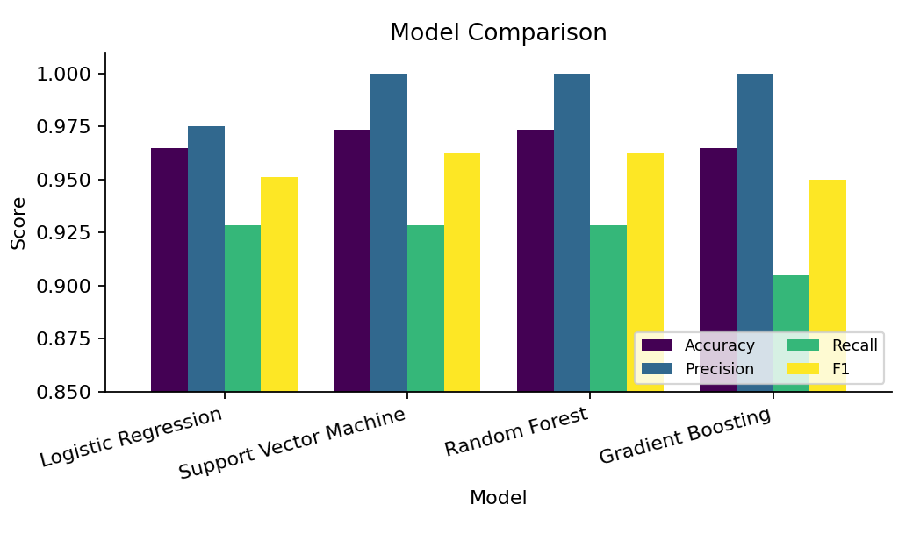
Figure 6: Model comparison
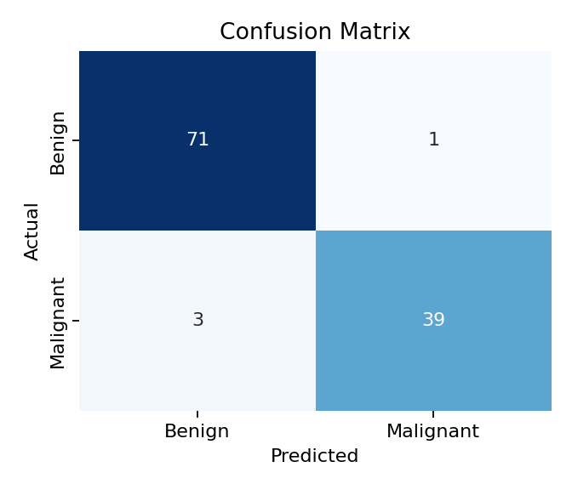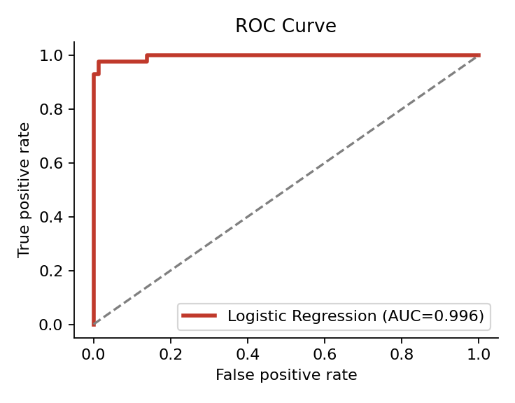
Figure 7: Confusion matrix (left) and ROC curve (right) of the selected model

7. Risk, Opportunity and Action
Category | Finding
Risk | 3 malignant cases were missed and 1 false alarm occurred on the test set of 114 patients. A missed cancer is the costliest error, so recall is the decision metric.
Opportunity | Cell-nucleus measurements (worst symmetry, worst texture, worst concavity) separate the classes strongly, so a quick, low-cost screening aid can prioritise high-risk patients.
Action | Use the model as a second-opinion triage tool. Send every patient above the alert threshold for urgent specialist review, lower the threshold when missing a case is unacceptable, and audit all missed cases monthly.

8. Dashboard Description
The Streamlit dashboard has five pages, selected from a sidebar. It is launched with: streamlit run YourName_BreastCancerDiagnosis.py
Page | Content
1. Executive Overview | Seven KPI cards, key fact banner, class balance chart and size trend chart.
2. Data & Drivers | Feature selector with distribution plot, driver chart, correlation heat map and data preview.
3. Model Performance | Model comparison table, confusion matrix, ROC curve and metric chart.
4. Risk, Opportunity, Action | Colour-coded risk, opportunity and action messages plus the top five drivers.
5. Patient Risk Predictor | Sliders for the six most important measurements and an alert threshold; returns a malignancy probability and triage result.

Example predictor output (threshold 0.40): an average patient receives a malignancy probability of 38.6% and a Benign triage result, while a patient with measurements at the 95th percentile of the six key drivers receives about 100% and a Malignant result.
The figures in Section 6 are the charts generated by these dashboard pages.

9. Limitations
- Only 569 samples, so results on the small test set (114 patients) have wide uncertainty; one case changes recall by about 2.4 points.
- Data comes from a single source; performance on other hospitals or imaging equipment is not guaranteed.
- Features are measurements already extracted from images, not the raw images.
- The tool supports decisions and must not replace clinical judgement.

10. Future Scope
- Tune models and the alert threshold with a cost-sensitive objective.
- Validate on external datasets and add probability calibration.
- Add explainability per patient and deploy the dashboard on a hospital intranet.

11. Conclusion
The project shows the full path from data to action. Facts (37.3% malignancy, larger and more irregular nuclei in malignant cases) become insights (drivers and risk), and then a concrete recommendation: use a recall-focused model as a triage aid, escalate high-risk patients and audit missed cases. A simple, clear dashboard serves decision makers better than a complex one, which was the guiding principle of the project.

12. Project Files and Links
Item | Name / Link
Code file | YourName_BreastCancerDiagnosis.py
Requirements | requirements.txt
README | README.md
Dataset | https://www.kaggle.com/datasets/uciml/breast-cancer-wisconsin-data
GitHub repository | [Paste your GitHub repository link here]

