

TRAFFIC SIGN IDENTIFICATION PROJECT

Submitted by:

HIMANSHU SHARMA

**ACKNOWLEDGMENT**

One of the pleasant aspects of preparing a project report is the opportunity to thank those who have contributed to make this project possible.

We are extremely thankful to Mr.Tushar Saraswat, whose active interest in the project & insight helped us to formulate, redefine implement our approach to the project.

We are also thankful to our institute & Other seen unseen hands which have given us direct & indirect help in completion of this project.

* **Himanshu Sharma**

**INTRODUCTION**

In today’s world as the number of vehicles are increasing so are the road accidents and according to reports, India is on 1st spot in most number of accidents in a country. This is caused due to many reasons such as poor enforcement of laws, carelessness etc. One of the reason is that people don’t recognize or follow traffic sign boards. So we have made a traffic sign recognizer which can inform the driver of the vehicle about the traffic sign coming ahead and to follow it. This can reduce the road accidents.

In the world of Artificial Intelligence and advancement in technologies, many researchers and big companies like Tesla, Uber, Google, Mercedes-Benz, Toyota, Ford, Audi, etc are working on autonomous vehicles and self-driving cars. So, for achieving accuracy in this technology, the vehicles should be able to interpret traffic signs and make decisions accordingly.

**Motivation for the Problem Undertaken**

Traffic signs are an integral part of our road infrastructure. They provide critical information, sometimes compelling recommendations, for road users, which in turn requires them to adjust their driving behaviour to make sure they adhere with whatever road regulation currently enforced. Without such useful signs, we would most likely be faced with more accidents, as drivers would not be given critical feedback on how fast they could safely go, or informed about road works, sharp turn, or school crossings ahead. In our modern age, around 1.3M people die on roads each year. This number would be much higher without our road signs.

Naturally, autonomous vehicles must also abide by road legislation and therefore recognize and understand traffic signs.

**Analytical Problem Framing**

Convolutional neural networks are a part of deep learning and extensively used in image recognition. These convolutional neural networks consist of several layers.

* First a Conv2D layer is used for feature extraction with the help of filters. Number of filters are generally in power of 2 like 32, 64 or 128. An activation function is used in this layer. Generally, ReLU (Rectified Linear Unit) activation function is used. ReLU function is defined as maximum (0, x).
* Next is the max pooling layer which is used reduce the dimensions of the image. This is done to reduce the computation power required for processing the image. Third is dropout layer. This dropout layer is used to prevent overfitting and to reduce the complexity of the model. In this layer some neurons are removed randomly.
* The combination of first 3 layers is called feature learning phase. These 3 layers are used multiple times to improve the training.
* Fourth is the flatten layer which converts the 2-D data into a long 1-D vector of features for a fully connected layer that can be fed into the neural network.
* The last layer is the dense layer which is used as a output layer. The last layer has number of nodes same as the number of classes. The last dense layer uses SoftMax activation function. Softmax function gives the probability value (between 0 and 1) so that the model can predict which class has the highest probability.
* standard computer vision methods were employed to detect and classify traffic signs, but these required considerable and time-consuming manual work to handcraft important features in images. Instead, by applying deep learning to this problem, we create a model that reliably classifies traffic signs, learning to identify the most appropriate features for this problem by itself.

**Hardware and Software Requirements and Tools Used**

In this project dataset is too large for processing or modelling, that’s why we use good hardware configuration like as above 4GB RAM, above or equal core i3 processor and also need good storage HDD. In way of software, we use any operating system which support python language for coding.

**Model/s Development and Evaluation**

For building the we will use sequential model from keras library. Then we will add the layers to make convolutional neural network. In the first 2 Conv2D layers we have used 32 filters and the kernel size is (5,5).

In the MaxPool2D layer we have kept pool size (2,2) which means it will select the maximum value of every 2 x 2 area of the image. By doing these dimensions of the image will reduce by factor of 2. In dropout layer we have kept dropout rate = 0.25 that means 25% of neurons are removed randomly.

We apply these 3 layers again with some change in parameters. Then we apply flatten layer to convert 2-D data to 1-D vector. This layer is followed by dense layer, dropout layer and dense layer again. The last dense layer outputs 43 nodes as the traffic signs are divided into 43 categories in our dataset. This layer uses the softmax activation function which gives probability value and predicts which of the 43 options has the highest probability.

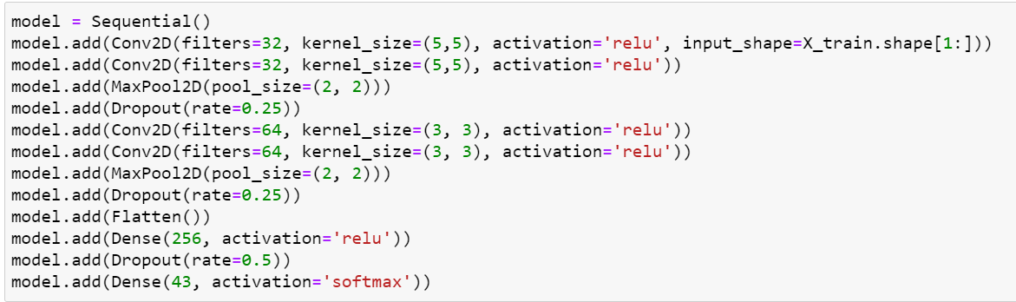

**Interpretation of the Results**

We will compile the model and apply it using fit function. The batch size will be 32. Then we will plot the graphs for accuracy and loss. We got average validation accuracy of 93.3% and average training accuracy of 86.2%.

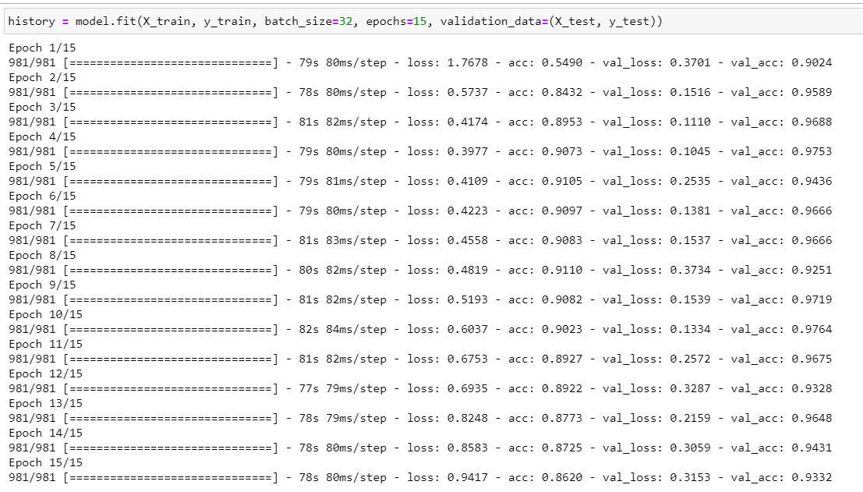

**CONCLUSION**

So we got to know about convolutional networks and how they can be used in image recognition. We made a traffic sign recognizer with the use of convolutional neural networks and got an accuracy of 86.20% on validation set and 88.6% on test set.