**Task1:**

**1 What is no-sql database?**

**Solution:** NoSQL is an approach to [database](https://searchsqlserver.techtarget.com/definition/database) design that can accommodate a wide variety of data models, including key-value, document, columnar and graph formats. NoSQL, which stand for "not only [SQL](https://searchsqlserver.techtarget.com/definition/SQL)," is an alternative to traditional relational databases in which data is placed in tables and data [schema](https://searchsqlserver.techtarget.com/definition/schema) is carefully designed before the database is built. NoSQL databases are especially useful for working with large sets of distributed data.

**2 How does data get stored in NoSQl database?**

**Solution:** There are various NoSQL Databases. Each one uses a different method to store data. Some might use column store, some document, some graph, etc., Each database has its own unique characteristics.

**3 what is column family in hbase?**

**Solution:** Columns in Apache HBase are grouped into column families. All column members of a column family have the same prefix.

**4 How many maximum number of columns can be added to HBase table?**

**Solution:** There is no compulsion on number of column in hbase but there will be performance related issue.

**6.How does data get managed in HBase?**

**Solution:** NoSQL databases are designed for scalability where unstructured data is spread across multiple nodes. When data volumes increase you just need to add another node to accommodate the growth. The lack of structure in NoSQL databases relaxes stringent requirements of consistency enforced in relational databases to improve speed and agility. HBase, MongoDB and Cassandra are the three major options that provide NoSQL capabilities. The options differ in the features they provide, so the decision on which to use is informed by the workload that will be handled.

**7.What happens internally when new data gets inserted into HBase table?**

**Solution:** To write data to HBase, you use methods of the HTableInterface class. You can use the Java API directly, or use HBase Shell, Thrift API, REST API, or another client which uses the Java API indirectly. When you issue a Put, the coordinates of the data are the row, the column, and the timestamp. The timestamp is unique per version of the cell, and can be generated automatically or specified programmatically by your application, and must be a long integer

**Task2:**

1. **Create an HBase table named 'clicks' with a column family 'hits' such that it should be able to store last 5 values of qualifiers inside 'hits' column family.**

**Solution:**

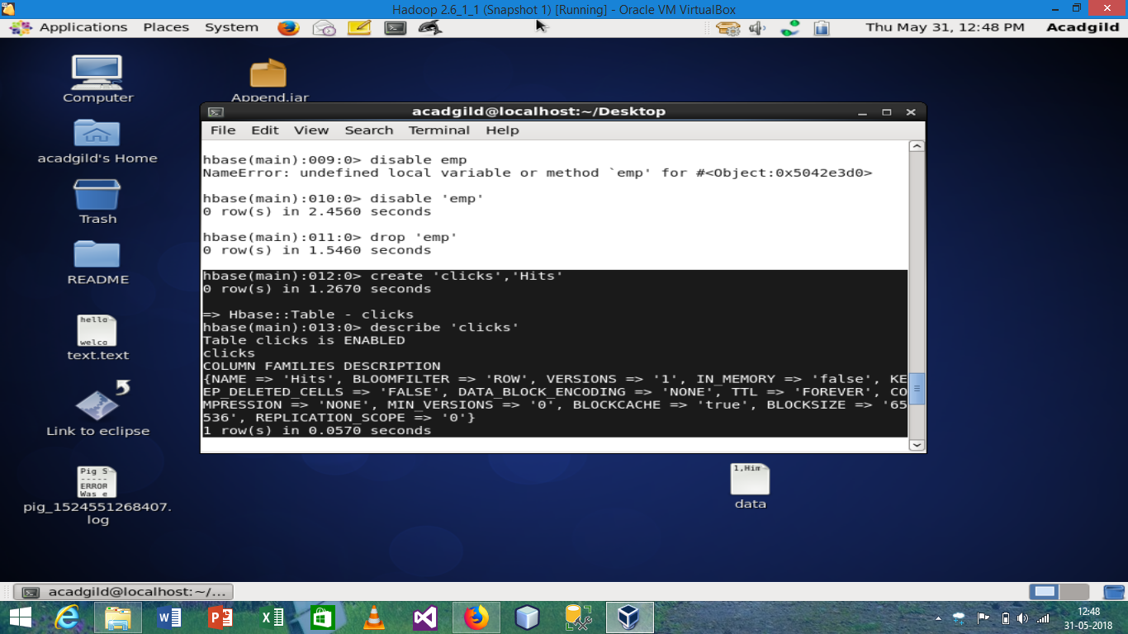

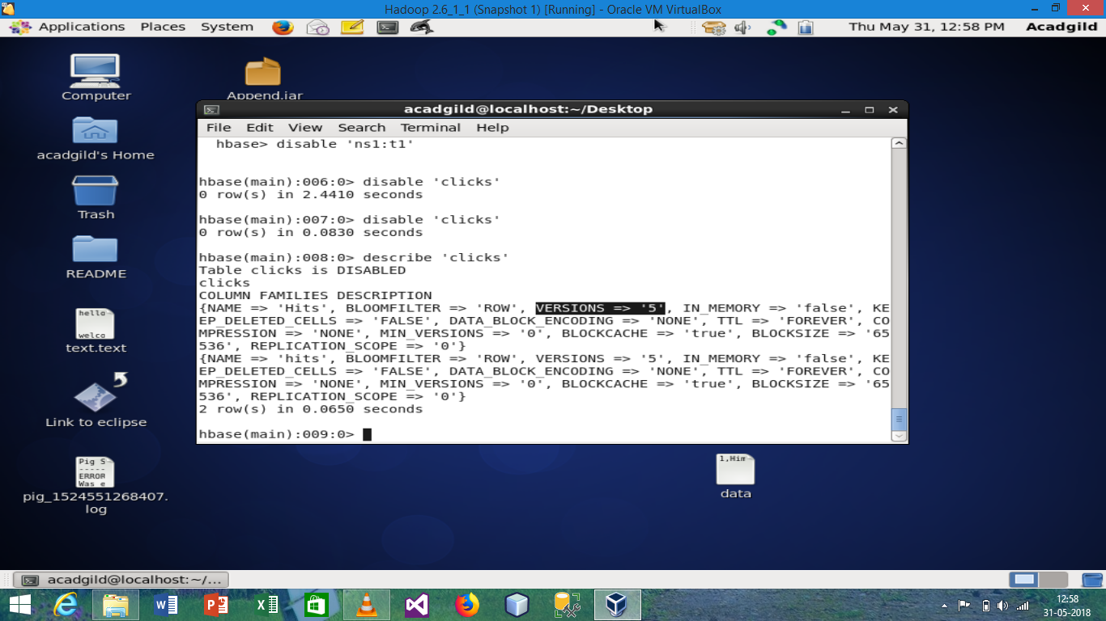

**2. Add few records in the table and update some of them. Use IP Address as row-key. Scan the table to view if all the previous versions are getting displayed.**

**Solution:**

