**Task - Streaming twitter data**

**Solution:**

To stream data from twitter first you need to create a twitter account after creating twitter account, after creating twitter account you need to create an application so that you can stream the data using this application. Screen shot of this application is given below

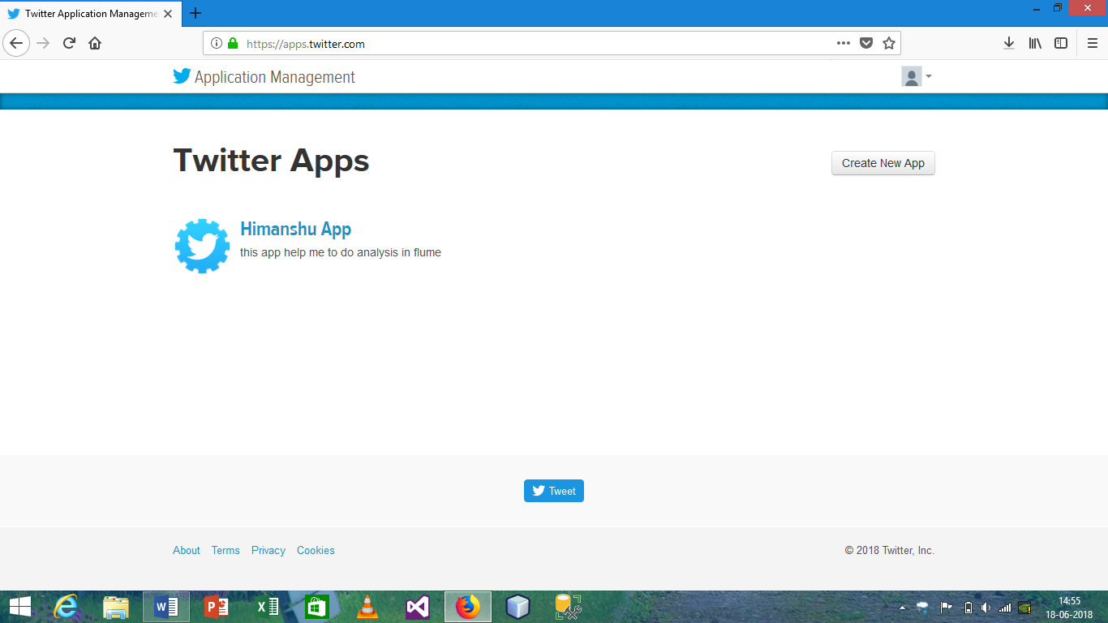

Not after creating application open this application copy consumer key and secret key and also generate access token for the application.

Also create a directory using this command

**Hadoop fs –mkdir –p /user/flume/twitter**

And mention this location in flume.conf

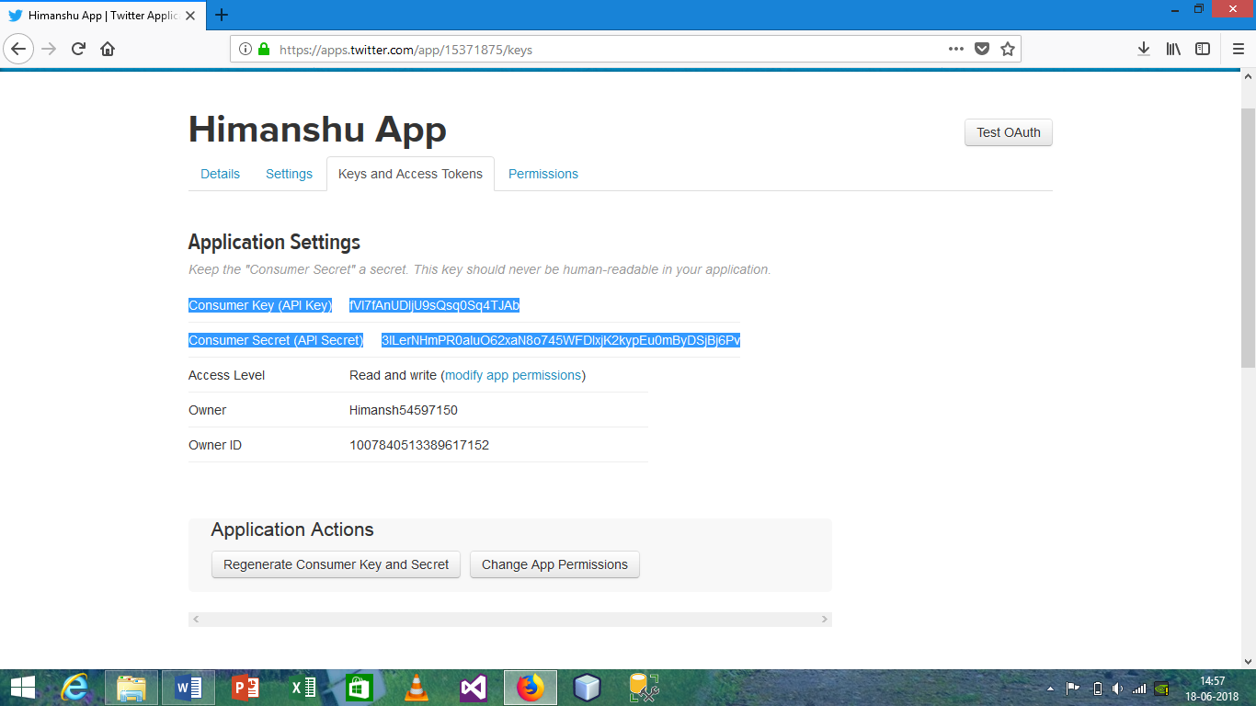

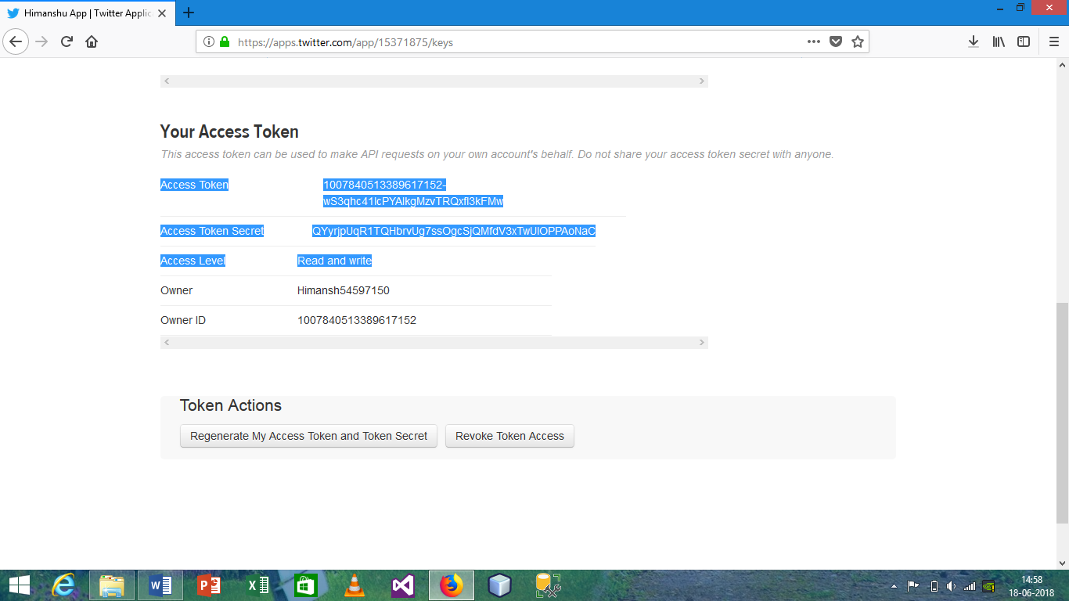

After copy all these data paste it into the newly created file which is present under flume conf directory named as flume.conf. change must be similar as shown in figure, keys may varies.

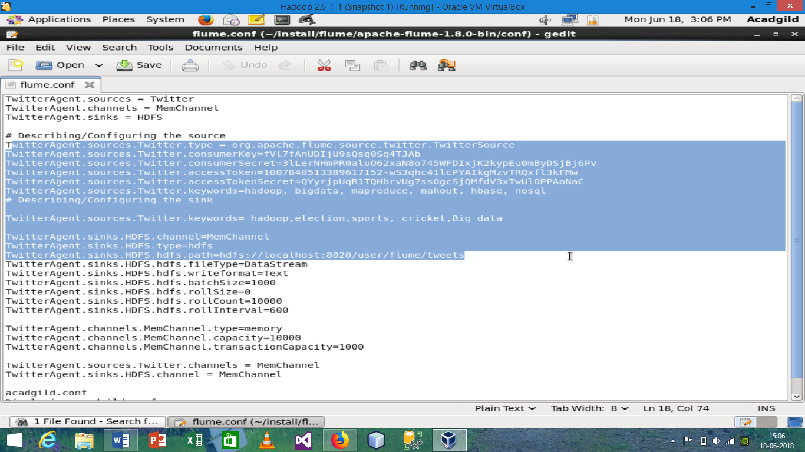

Now after doing this all we will create the flume agent

**flume-ng agent -n TwitterAgent -f <location of created/edited conf file>**

**after running this command streaming will be start and file is created inside the /user/flume/tweet**

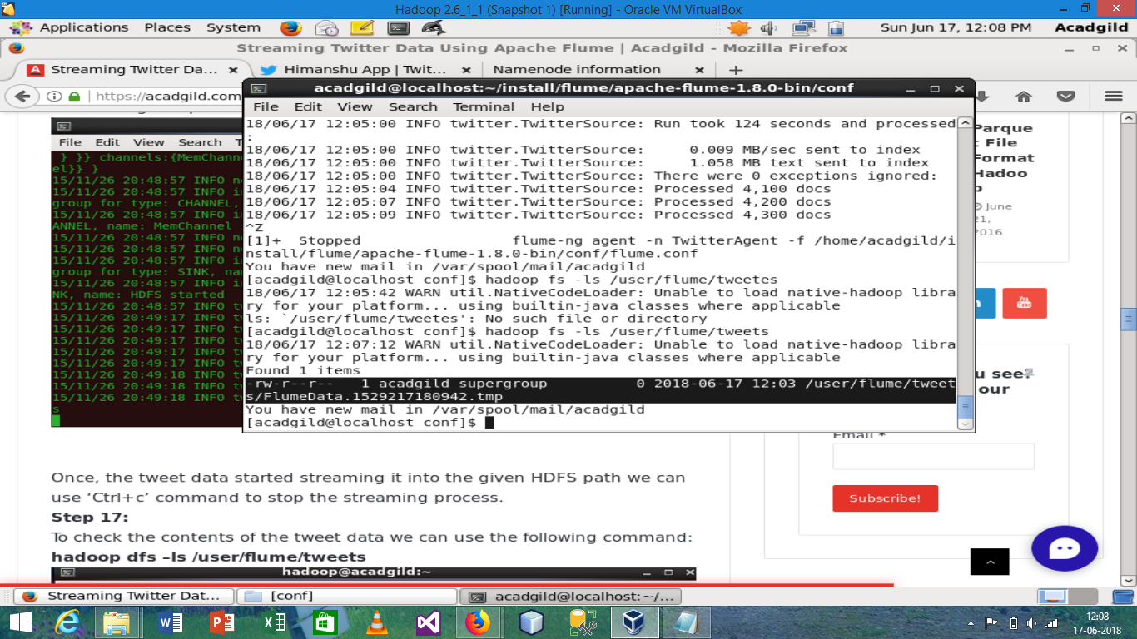

Open this file to see the data