AWS Multi-VPC Architecture & Peering Connection Report
Comprehensive Technical Documentation for EWB Tech Academy Internship Final Submission
Author / Student: Himanshu Singh | Course / Program: AWS Cloud Intern
Organization: EWB AWS Internship | Submission Date: October 30, 2026

1. Executive Summary
This project demonstrates the complete design, deployment, and validation of a multi-VPC cloud infrastructure in Amazon Web Services (AWS). It combines the creation of custom Virtual Private Clouds (VPCs), public and private subnet hierarchies, Internet Gateways (IGW), NAT Gateways, custom Route Tables, Security Groups, EC2 instances, and a cross-VPC Peering Connection.
By implementing VPC Peering, instances in isolated private networks can securely communicate using private IPv4 addresses without traversing the public internet. This report outlines the complete end-to-end setup and verification steps required for the EWB Tech Academy final project submission.
2. Architecture Overview & Network Design
The overall infrastructure comprises two distinct, non-overlapping VPC networks within AWS:
2.1 Network Topology Specifications
Component | VPC ID / Name | IPv4 CIDR Block | Subnet Type | Subnet CIDR
VPC 1 (Primary) | VPC-1-Primary | 28.0.0.0/16 | Public Subnet | 28.0.1.0/24
VPC 1 (Primary) | VPC-1-Primary | 28.0.0.0/16 | Private Subnet | 28.0.2.0/24
VPC 2 (Target) | VPC-2-Target | 28.200.0.0/16 | Private Subnet | 28.200.0.0/24
Internet Gateway | IGW-VPC-1 | Attached to VPC 1 | Public Route Table | 0.0.0.0/0 -> IGW
VPC Peering | PCX-VPC1-VPC2 | Peers VPC 1 & VPC 2 | Both Route Tables | Cross-CIDR -> PCX

3. Step-by-Step Implementation Guide
Step 1: Create VPCs & Configure Subnets
- 1. Create VPC 1: In VPC Dashboard -> 'Create VPC' -> Select 'VPC only'. Name tag: VPC-1-Primary, CIDR: 28.0.0.0/16.
- 2. Create VPC 2: In VPC Dashboard -> 'Create VPC' -> Select 'VPC only'. Name tag: VPC-2-Target, CIDR: 28.200.0.0/16.
- 3. Public Subnet (VPC 1): Subnets -> Create Subnet -> Select VPC-1-Primary -> Name: Public-Subnet-1 -> CIDR: 28.0.1.0/24.
- 4. Enable Auto-Assign Public IP: Right-click Public-Subnet-1 -> Edit subnet settings -> Check 'Enable auto-assign public IPv4 address'.
- 5. Private Subnet (VPC 1): Subnets -> Create Subnet -> Select VPC-1-Primary -> Name: Private-Subnet-1 -> CIDR: 28.0.2.0/24.
- 6. Private Subnet (VPC 2): Subnets -> Create Subnet -> Select VPC-2-Target -> Name: Target-Private-Subnet -> CIDR: 28.200.0.0/24.
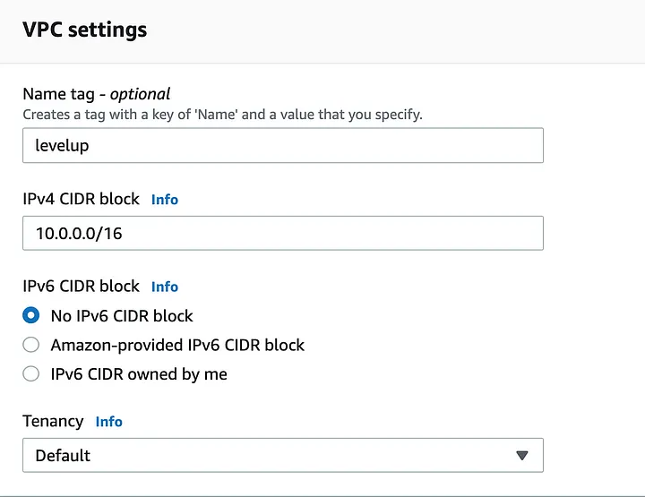
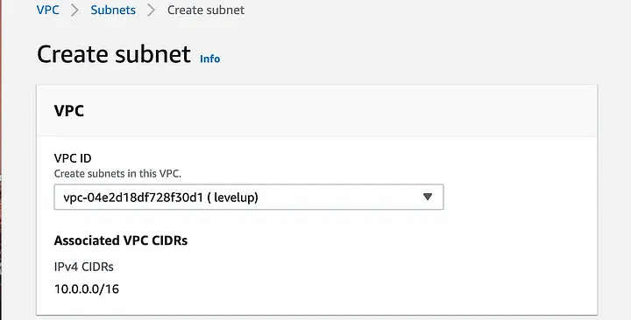
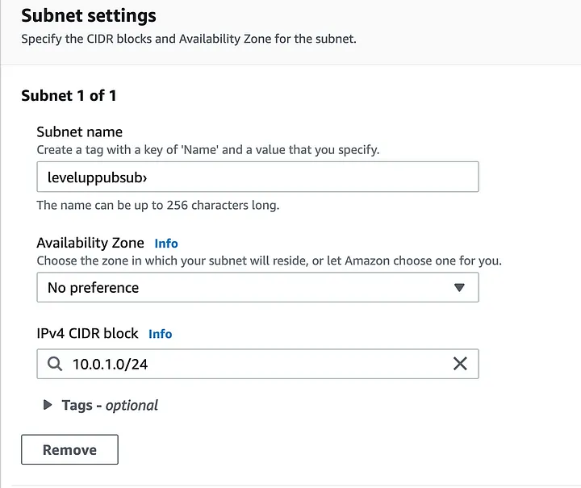
Step 2: Internet Gateway & Route Tables Configuration
- 1. Internet Gateway: Internet Gateways -> Create Internet Gateway -> Name: IGW-VPC-1. Actions -> Attach to VPC -> Select VPC-1-Primary.
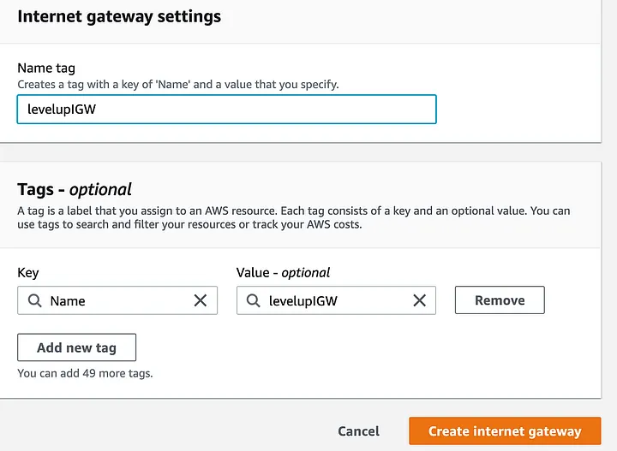
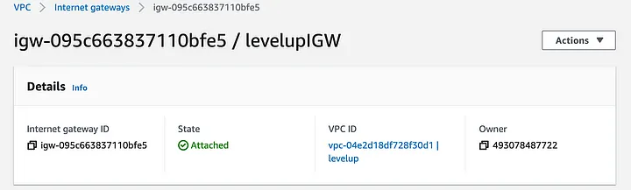
- 2. Public Route Table: Route Tables -> Create Route Table -> Name: Public-RT-VPC1 -> Select VPC-1-Primary. Edit Routes -> Add Route: 0.0.0.0/0 targeting IGW-VPC-1. Associate with Public-Subnet-1.
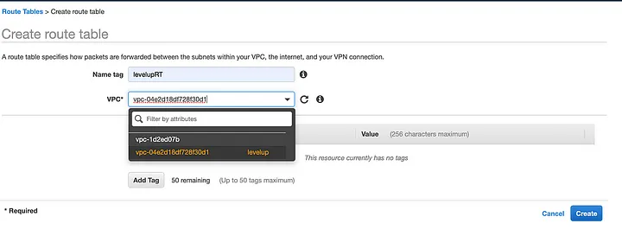
- 3. Private Route Tables: Create Private-RT-VPC1 for VPC 1 and Private-RT-VPC2 for VPC 2. Associate with their respective private subnets.
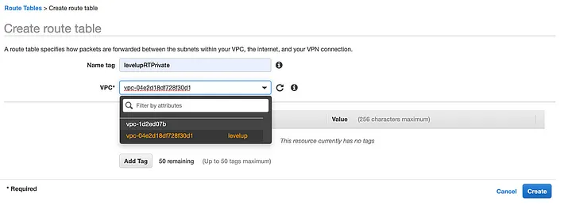
Step 3: Establish VPC Peering Connection
- 1. Initiate Peering Request: Peering Connections -> Create Peering Connection -> Name: PCX-VPC1-VPC2. Requester: VPC-1-Primary -> Accepter: Select VPC-2-Target (Same account/region or another region/account).
- 2. Accept Request: Select PCX-VPC1-VPC2 (Status: Pending Acceptance) -> Actions -> Accept Request. Status updates to Active.
- 3. Update Route Tables for Peering: Edit routes in Public-RT-VPC1 and Private-RT-VPC1: Add 28.200.0.0/16 targeting PCX-VPC1-VPC2. Edit routes in Private-RT-VPC2: Add 28.0.0.0/16 targeting PCX-VPC1-VPC2.
Step 4: EC2 Instance Deployment & Security Groups
- 1. Public Bastion EC2 (VPC 1): Launch Amazon Linux 2 EC2 in Public-Subnet-1. Enable Auto-assign Public IP. User Data script optional (yum install httpd -y). SG rules: Allow SSH (Port 22) from My IP and HTTP (Port 80) from Anywhere.
- 2. Private EC2 (VPC 2): Launch Amazon Linux 2 EC2 in Target-Private-Subnet (VPC 2). SG rules: Allow All ICMP - IPv4 from 28.0.0.0/16 and SSH (Port 22) from 28.0.0.0/16.
4. Testing & Verification Workflow
To confirm full connectivity across the multi-VPC peered network, execute the following jump-host verification procedure:
- 1. Public SSH Access: SSH into the Public Bastion EC2 instance in VPC 1 using its public IP address: ssh -i keypair.pem ec2-user@<PUBLIC_IP>
- 2. Key Transfer / Bastion Authentication: Upload or create the SSH keypair on the Bastion Host and restrict permissions: chmod 600 keypair.pem
- 3. Cross-VPC SSH Access: SSH from the Bastion host into the Private EC2 instance in VPC 2 using its private IP address: ssh -i keypair.pem ec2-user@28.200.0.X
- 4. ICMP Ping Test: Run a ping test across the VPC Peering connection: ping 28.200.0.X. Successful replies confirm operational routing and security group rules.


