**Customer Attribute Module**

In the era of globalisation, it is required to import their profile picture as an additional information along with general and login information. Profile picture is necessary to identify a customer as well as can be used by different social media.

Profile Image module is developed for how a customer would be able to upload their profile image in either of customer sign up or other pages.

Process to add profile image:

1. We can use profile image as an attribute in customer module. Just create a new attribute and make visible it for front end and admin both depends on your requirement.
2. After creating as an attribute, It will be visible on customer account create and edit page.
3. When we create a customer, the profile image will be placed in media/customer directory.
4. Path of this profile picture is being updated to DB.
5. Now you can view this picture at customer edit page at front end and admin both. If a customer wants to change his profile picture, One can do easily by repeating above steps.
6. By default this filed is optional. Admin can set it mandatory.
7. For each customer, there would be only one profile image at media/customer folder and DB .

The screen shots of this module are shown as follows:

**Customer Registration Form(Frontend) :**

In addition to personal and login information, additional attributes are given to provide additional informations. In this additional informatios, a customer can upload their profileimage as well as coverimage in any format.

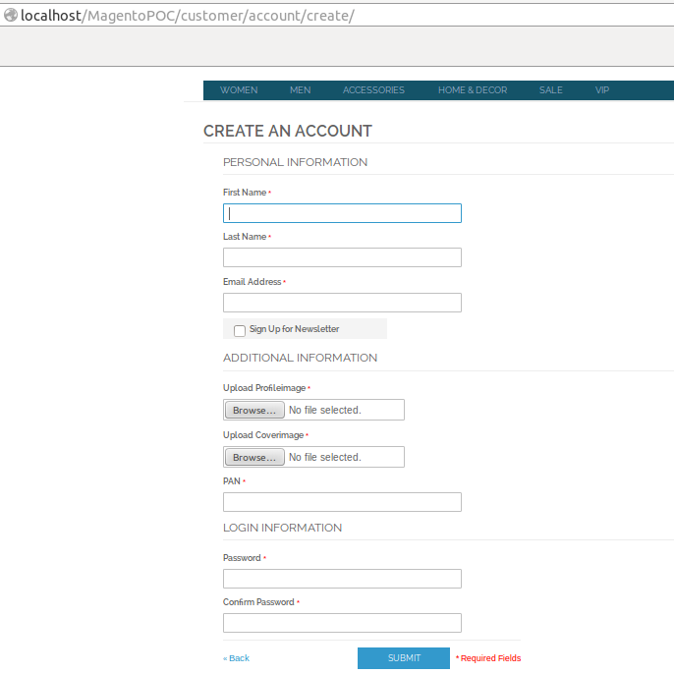

**Customer Edit Form(Frontend) :**

In addition to personal and login information, a customer can change their profile as well as cover image and that change will reflect at all.

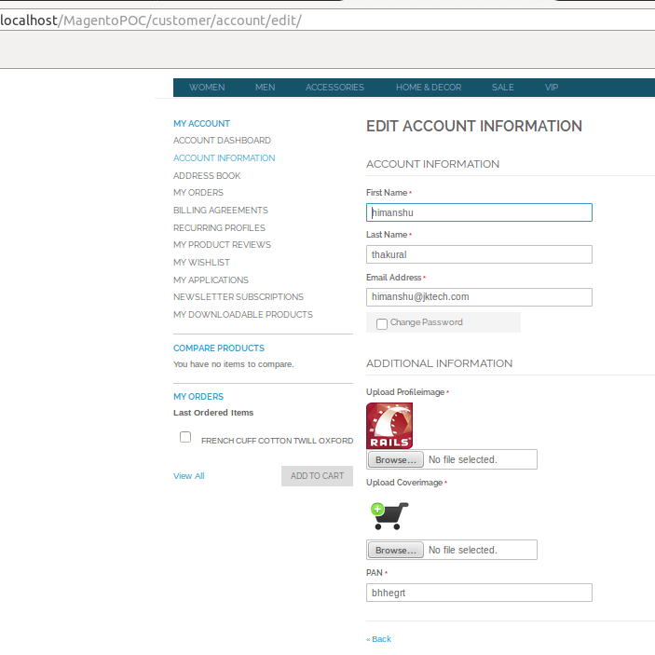

**Customer Registration Form(Admin):**

By using admin panel, customer can be registered with additional attributes as profile and cover image in image form and that will be save in directory.

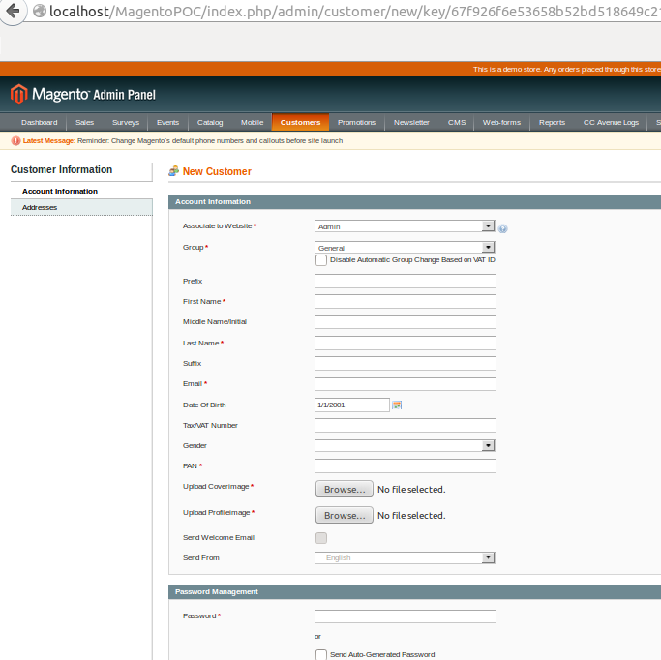

**Customer Edit Form(Admin):**

Similar to customer edit form, admin can edit the informations of a customer. On this page, respective images of a customer will be shown.

