**Quiz Application**

**ARTIFICIAL INTELLIGENCE**

**PROJECT REPORT**

***By***

**Himanshu Trehan**

**Riya Sharma**

**Wasim Ahamad**

**Rupesh Kumar**

**Section-K18SP**

**Roll No. 61,60,35,52**



**Department of Intelligent Systems**

**School of Computer Science Engineering**

**Lovely Professional University, Jalandhar**

***APRIL-2019***

**Student Declaration**

This is to declare that this report has been written by us. No part of the report is copied from other sources. All information included from other sources have been duly acknowledged. We aver that if any part of the report is found to be copied, we will take full responsibility for it.

Himanshu Trehan

Roll no.-61

(11914950)

Riya Sharma

Roll no.60

(11813098)

Wasim Ahmed

Roll no. 35

(11915647)

Rupesh Kumar

Roll no. 52

(11810941)

Date-12-April-2020

**BACKGROUND AND OBJECIVES OF PROJECT ASSIGNED**

**1.1 Introduction**

The Name of the PROJECT is “Quiz Application”. The project is made using python Programming language. The Project is made for learning Purpose .The project is made using the python Libraries like Tkinter GUI and Json etc and functions. The Project is made on GUI(Graphic User Interface).Using the Tkinter Libraries in Python. In this project they Test their Knowledge and get scores.There are near about 10 question in Data(json file) and Random Function in Python is used to pick the questions From the json file and the questions cannot be repeated

**1.2 Motivation**

The Project is Made for the for make their future better .The motivation for making the project is Test the ability of the student.

1

**DESCRIPTION OF PROJECT**

The project is made using python Programming language. The Project is made for Testing Purpose .The project is made using the python Libraries, and function.The Project is made on GUI(Graphic User Interface).Using the Tkinter Libraries in Python. In this project we have Question file (json fie) which includes the question and the options of the Question.

We uses Radio buttons in the MCQ so you select the option after you select the option this is your final answer and at the end the score will display and they pick the image intelligently according to your score and shown to the user

**WORK DISTRIBUTION**

**1.Coding (Using Tkinter**)- Coding part of the project is done by Himanshu Trehan. The Starting page, the questions and show results are made by Himanshu.

2.Designing- The designing part (Layout) and the images for the project is chosen by Riya Sharma.

3.Questions Part- Questions and their answers are added by Rupesh Kumar.

4.Json file(data)- The File handling part Json file is done by Wasim Ahamad.

**Working of Project**

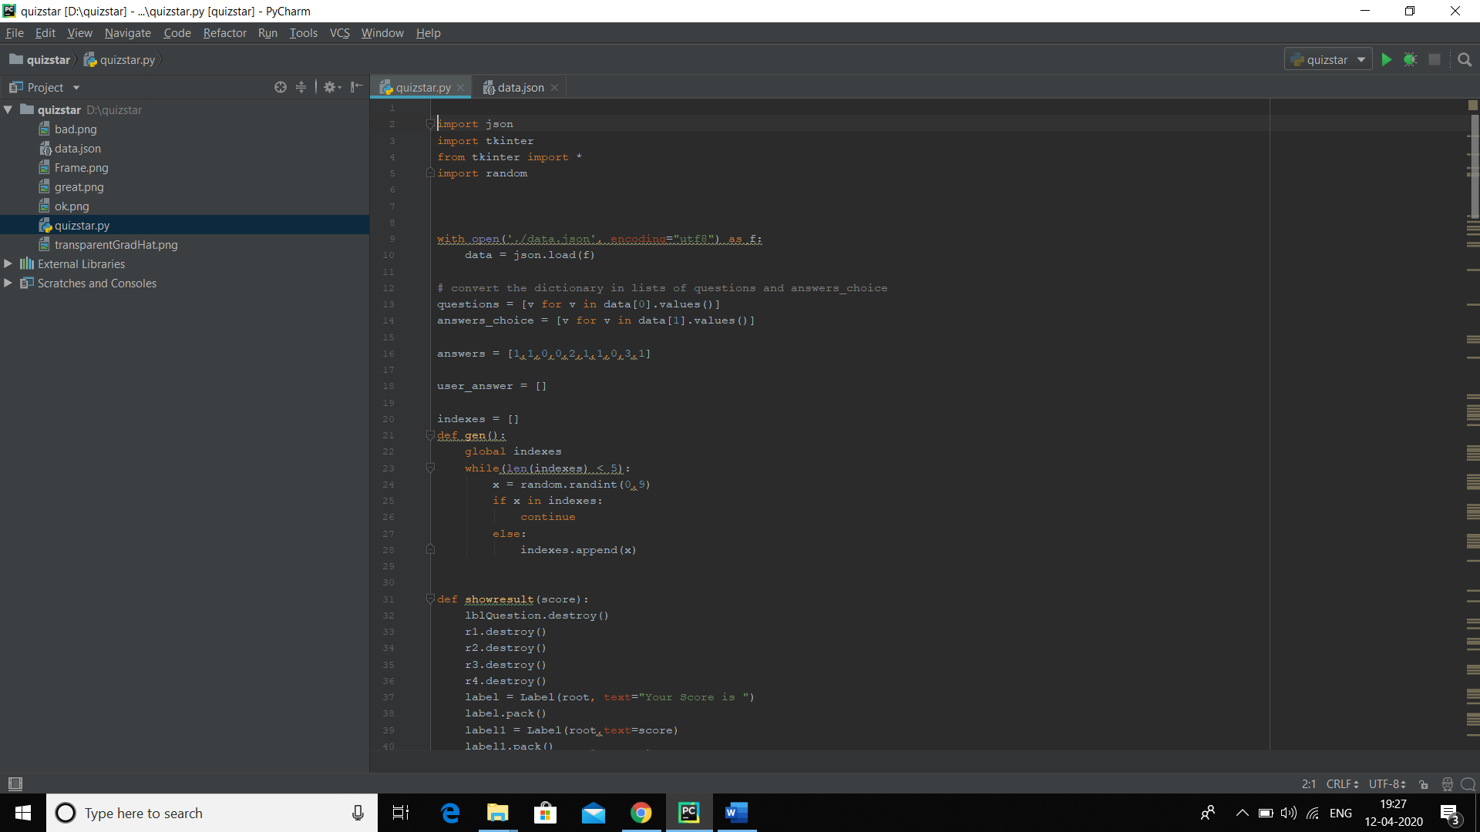

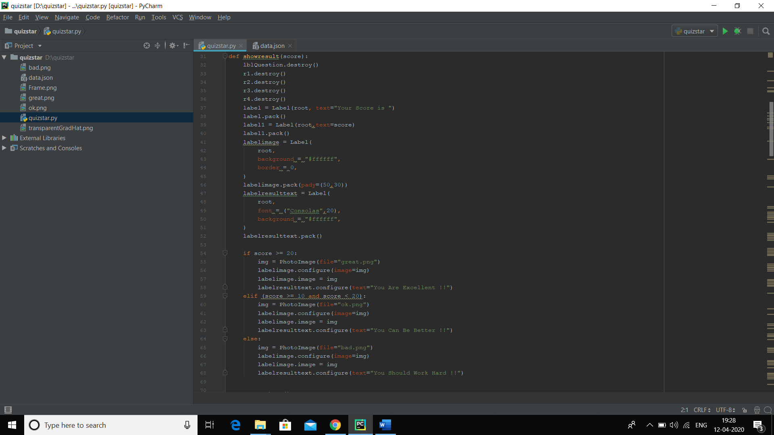

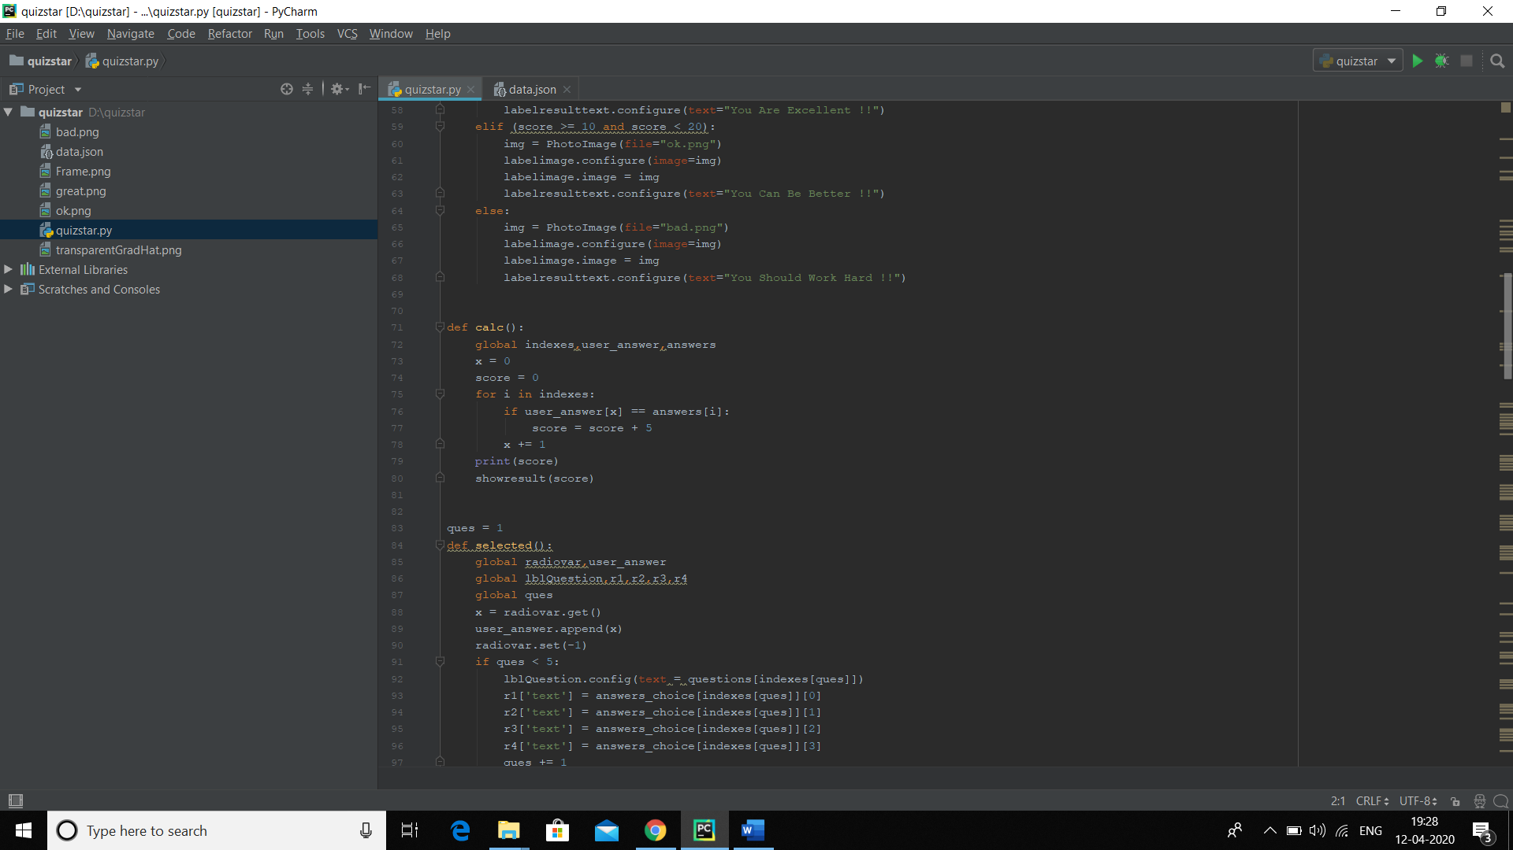

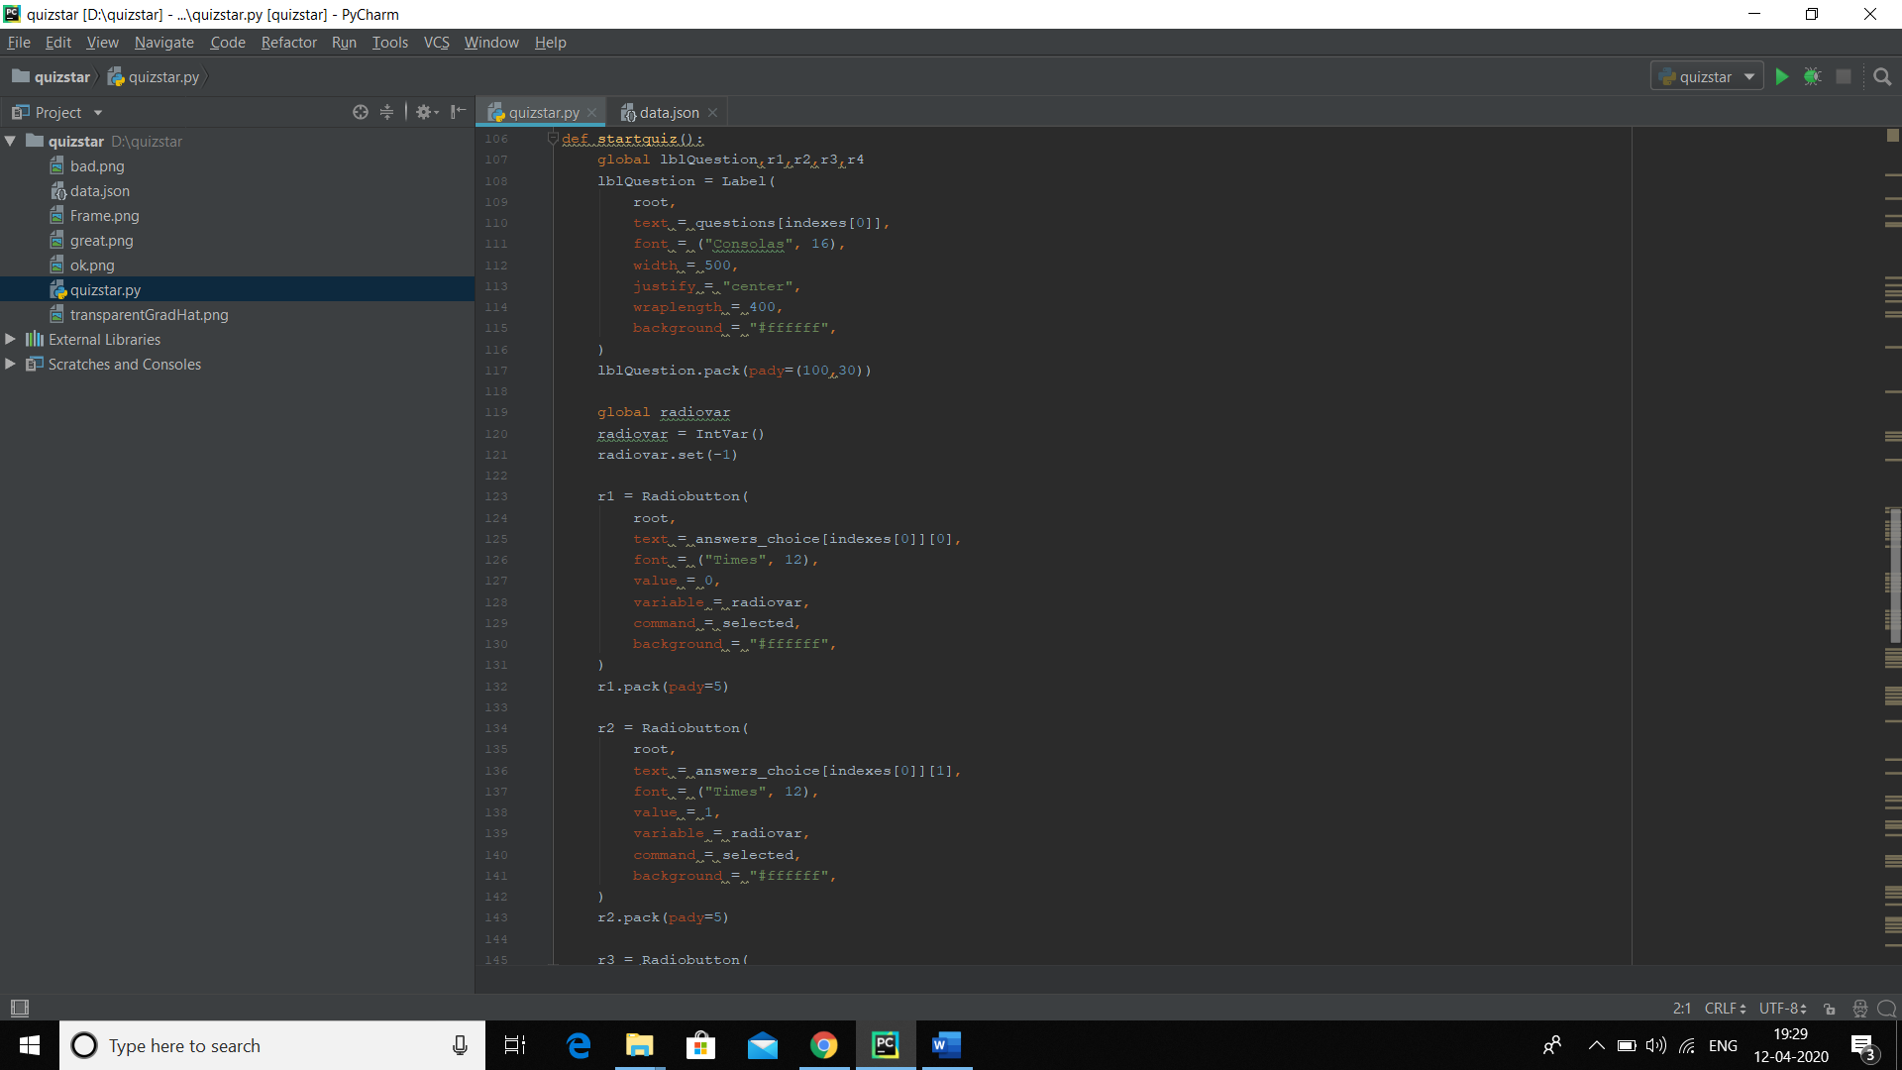

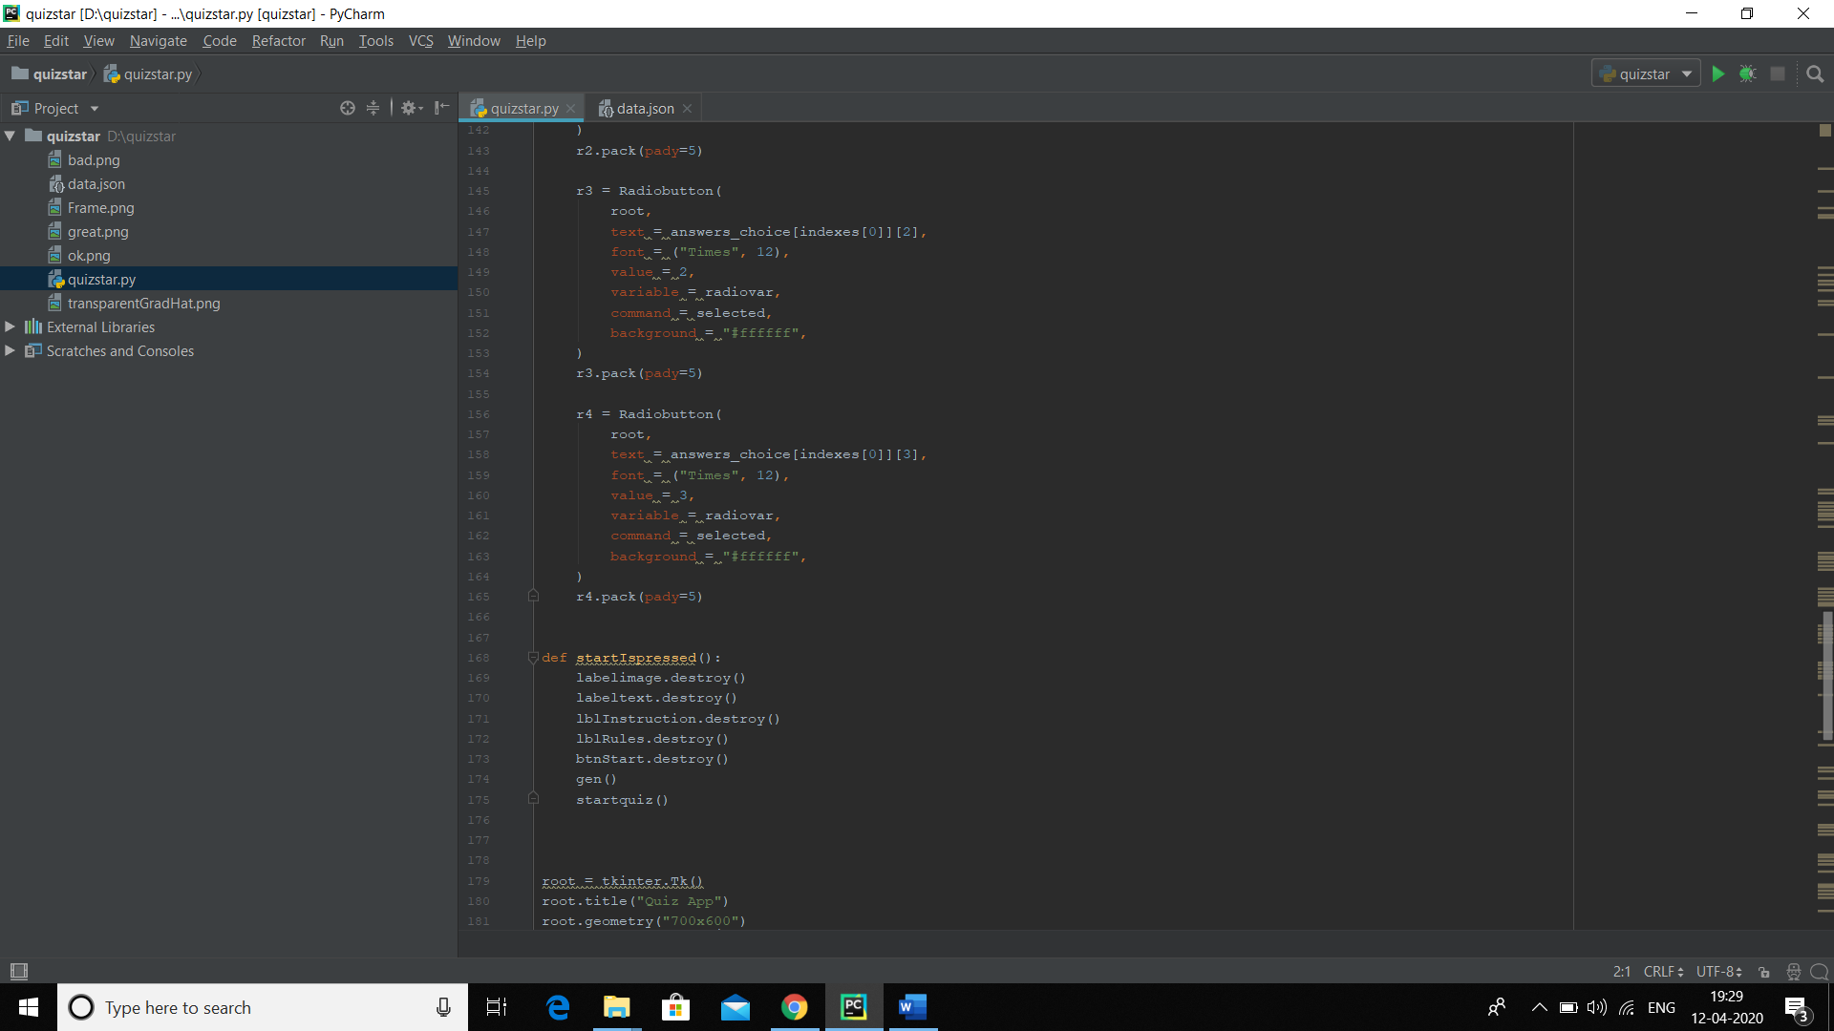

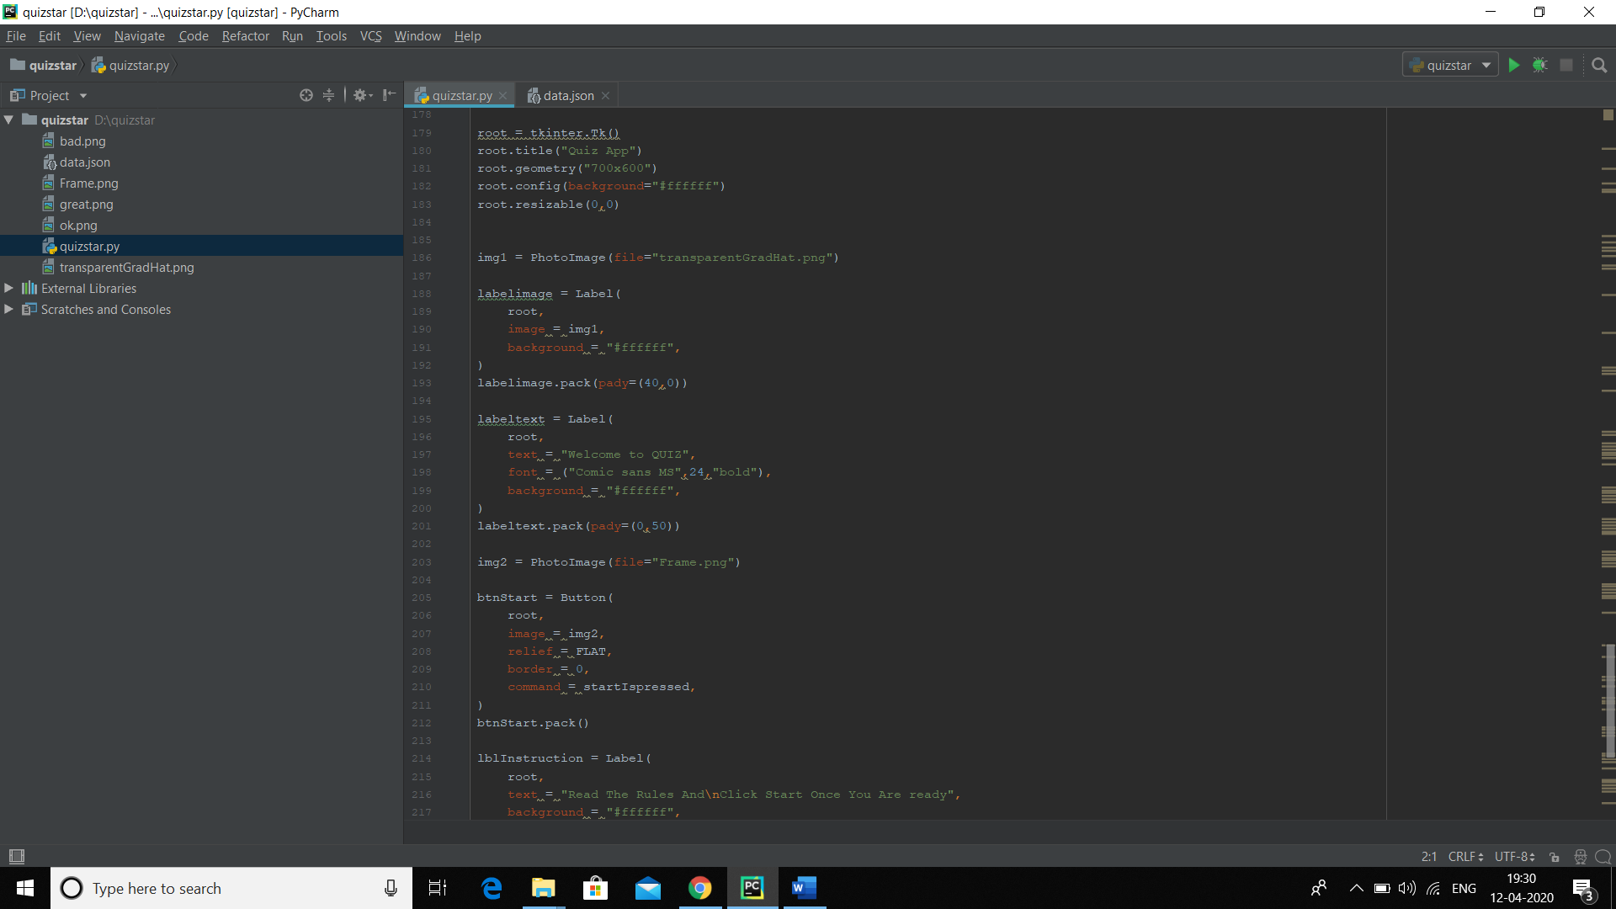

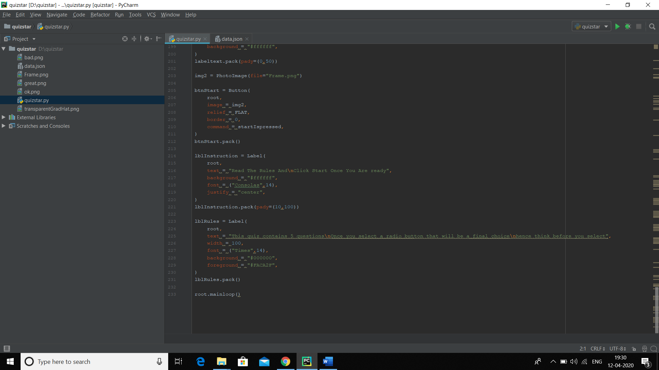

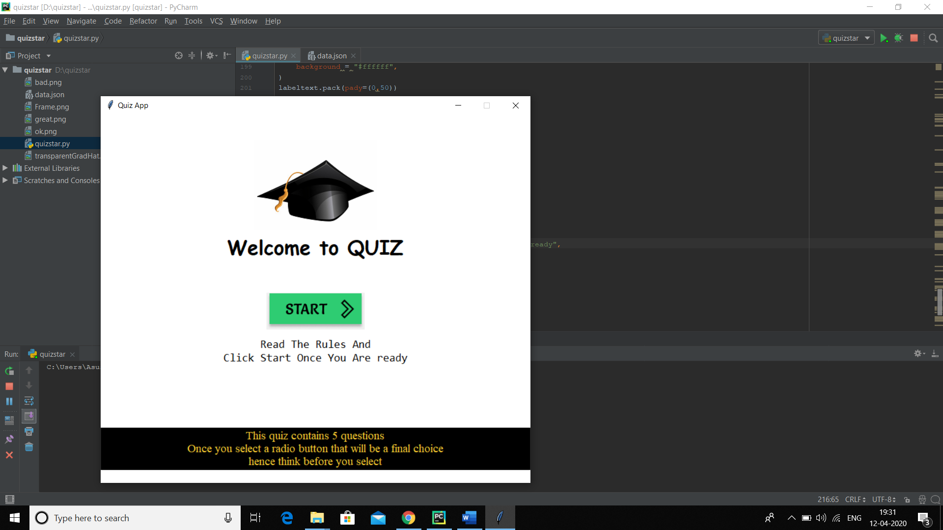

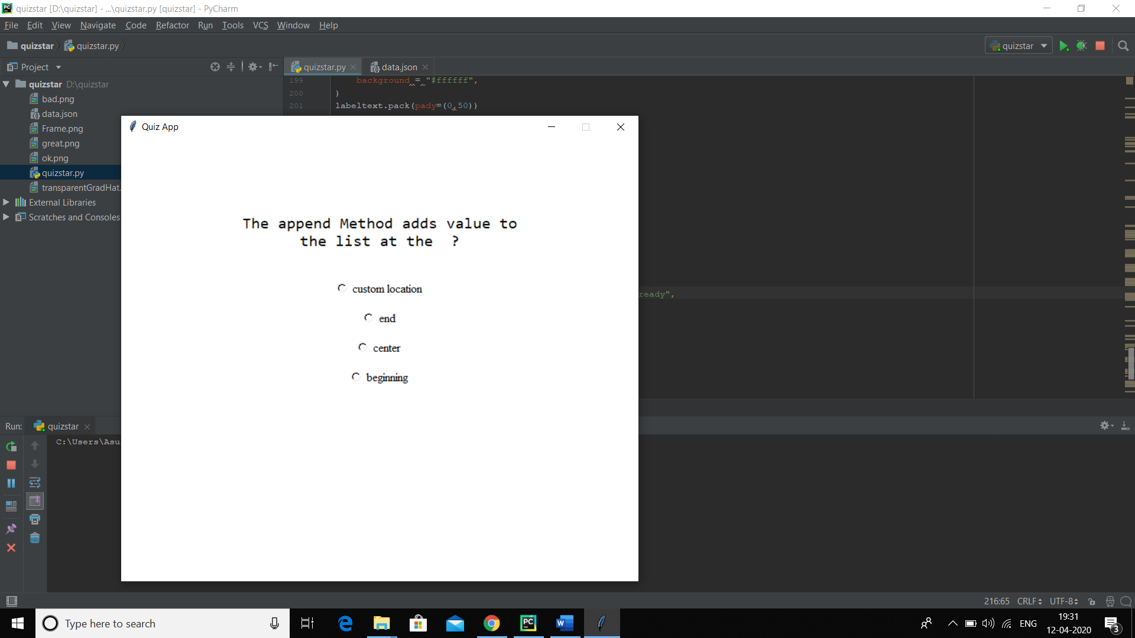

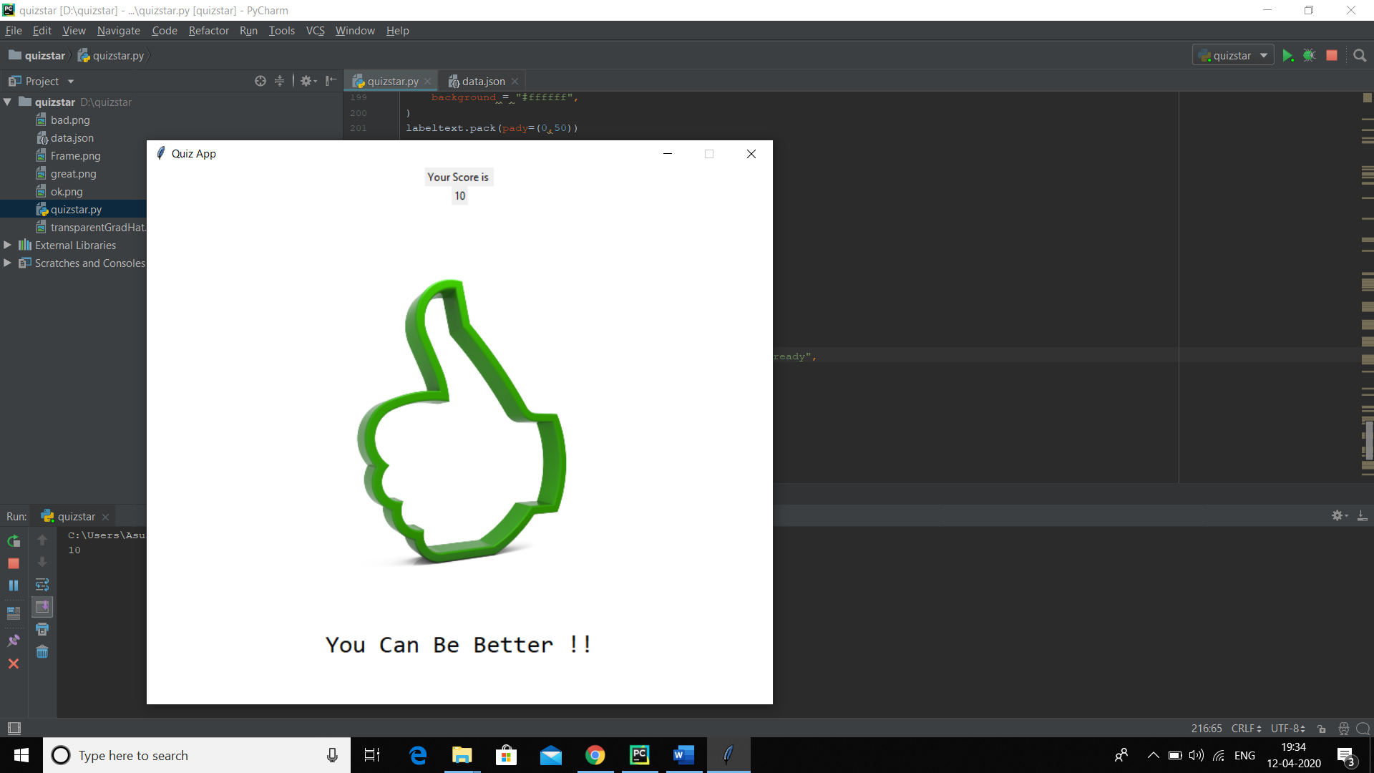

**TECHNOLOGY AND FRAMEWORK USED**

In this project we use Python Programming language and Pycharm for making the project **PyCharm** is a Python IDE with complete set of tools for Python development. In addition, the IDE provides capabilities for professional Web development using the Django framework. Code faster and with more easily in a smart and configurable editor with code completion, code folding and split windows support.