ENROLLMENT NUMBER: 202504104610136 | DIVISION : A | SET -B

Q1 Answer The Following

A. What is Docker? Explain the components of Docker. Also write step-by-step instructions
to containerize an application, convert it into a Docker image, execute the container, and
stop the running container.

Docker is an open-source software platform that helps developers build, package, and run applications inside containers.
A container is a small package that includes:
- Application code
- Required libraries
- Dependencies
- System tools

Main Components of Docker
1. Docker Engine
This is the main part of Docker.
It runs and manages containers on your system.

2. Docker Client
It is the command-line tool used to give instructions to Docker.
Example commands:
- docker build
- docker run
- docker stop

3. Docker Images
A Docker image is like a blueprint of an application.
It contains everything needed to run the application.
Images are used to create containers.

4. Docker Containers
A container is a running version of a Docker image.
It is lightweight and runs the application in an isolated environment.

5. Dockerfile
A Dockerfile is a text file that contains instructions to create a Docker image.

6. Docker Hub
Docker Hub is an online storage place where Docker images are stored and shared.

Step-by-Step: How to Containerize an Application

Step 1: Create Your Application
First, create your application files (for example: a simple Node.js or Python app).
Step 2: Create a Dockerfile
Create a file named Dockerfile in your project folder.
In this file, write instructions such as:
Which base image to use
Copy project files
Install dependencies
Run the application
Step 3: Build Docker Image
Open terminal in the project folder and run:
docker build -t myapp .
This command creates a Docker image named myapp.
Step 4: Run the Container
To run the container, use:
docker run -d -p 3000:3000 --name mycontainer myapp
Now the application will start inside a container.
Step 5: Check Running Containers
docker ps
This shows the list of running containers.
Step 6: Stop the Running Container
docker stop mycontainer
This command stops the container.
Step 7: Remove Container (Optional)
docker rm mycoStep-by-Step: How to Containerize an Application

Q2 Answer The Following.

Create a project using your Enrolment Number and Set Name(0001_A) as the project
name. This practical is strictly limited to UI design only, and no backend or database
functionality is required. The application should be developed using your preferences
based, (HTML/CSS, ASP.Net, Laravel, Python) and optional JavaScript may be used for
basic interactions. The user interface must be clean, well-structured, and visually
attractive, with proper use of colours, fonts, and layout.
The Faculty Application UI. In this phase,
➢ Design a Faculty Login page that includes Faculty ID and Password fields with a
Login button.
➢ After successful login, create a Faculty Dashboard page where the faculty can add
elective subjects (Course, Semester, Subject code, name, propose) and view the
list of available subjects.
➢ The dashboard should also display how many students have selected each
particular subject. This display is for UI purposes only, and no backend logic is
required.
Complete all the tasks in your project folder using your Enrolment Number as the
project name. After completing the project, create a new repository on GitHub and push
the entire project to the repository using Git commands. Mention the GitHub repository
URL in your backup file. This step is mandatory.

Login.html

<!DOCTYPE html>
<html lang="en">
<head>
<meta charset="UTF-8">
<title>Faculty Login</title>
<meta name="viewport" content="width=device-width, initial-scale=1">

<!-- Bootstrap 5 CDN -->
<link href="https://cdn.jsdelivr.net/npm/bootstrap@5.3.2/dist/css/bootstrap.min.css" rel="stylesheet">
<link href="css/style.css" rel="stylesheet">
</head>
<body class="bg-light">

<div class="container">
<div class="row justify-content-center align-items-center vh-100">
<div class="col-md-5">
<div class="card shadow-lg p-4">
<h3 class="text-center mb-4 text-primary">Faculty Login</h3>

<form action="dashboard.html">
<div class="mb-3">
<label class="form-label">Faculty ID</label>
<input type="text" class="form-control" placeholder="Enter Faculty ID" required>
</div>

<div class="mb-3">
<label class="form-label">Password</label>
<input type="password" class="form-control" placeholder="Enter Password" required>
</div>

<div class="d-grid">
<button type="submit" class="btn btn-primary">Login</button>
</div>
</form>

</div>
</div>
</div>
</div>

</body>
</html>

Dashboard.html

<!DOCTYPE html>
<html lang="en">
<head>
<meta charset="UTF-8">
<title>Faculty Dashboard</title>
<meta name="viewport" content="width=device-width, initial-scale=1">

<!-- Bootstrap 5 CDN -->
<link href="https://cdn.jsdelivr.net/npm/bootstrap@5.3.2/dist/css/bootstrap.min.css" rel="stylesheet">
<link href="css/style.css" rel="stylesheet">
</head>
<body>

<!-- Navbar -->
<nav class="navbar navbar-dark bg-primary">
<div class="container-fluid">
<span class="navbar-brand mb-0 h1">Faculty Dashboard</span>
<a href="login.html" class="btn btn-light btn-sm">Logout</a>
</div>
</nav>

<div class="container mt-4">

<!-- Add Elective Subject Form -->
<div class="card shadow-sm mb-4">
<div class="card-header bg-secondary text-white">
Add Elective Subject
</div>
<div class="card-body">
<form>
<div class="row">
<div class="col-md-3 mb-3">
<label class="form-label">Course</label>
<input type="text" class="form-control" placeholder="BCA / BSc IT">
</div>

<div class="col-md-2 mb-3">
<label class="form-label">Semester</label>
<input type="number" class="form-control" placeholder="1-6">
</div>

<div class="col-md-3 mb-3">
<label class="form-label">Subject Code</label>
<input type="text" class="form-control" placeholder="IT501">
</div>

<div class="col-md-4 mb-3">
<label class="form-label">Subject Name</label>
<input type="text" class="form-control" placeholder="Artificial Intelligence">
</div>
</div>

<div class="mb-3">
<label class="form-label">Subject Proposal</label>
<textarea class="form-control" rows="3" placeholder="Write subject description..."></textarea>
</div>

<button type="submit" class="btn btn-success">Add Subject</button>
</form>
</div>
</div>

<!-- Subject List Table -->
<div class="card shadow-sm">
<div class="card-header bg-dark text-white">
Available Elective Subjects
</div>
<div class="card-body">
<table class="table table-bordered table-hover text-center">
<thead class="table-primary">
<tr>
<th>Course</th>
<th>Semester</th>
<th>Subject Code</th>
<th>Subject Name</th>
<th>Students Selected</th>
</tr>
</thead>
<tbody>
<tr>
<td>BCA</td>
<td>5</td>
<td>IT501</td>
<td>Artificial Intelligence</td>
<td><span class="badge bg-success">45</span></td>
</tr>
<tr>
<td>BSc IT</td>
<td>6</td>
<td>IT602</td>
<td>Cyber Security</td>
<td><span class="badge bg-info">38</span></td>
</tr>
<tr>
<td>BCA</td>
<td>4</td>
<td>IT404</td>
<td>Cloud Computing</td>
<td><span class="badge bg-warning text-dark">52</span></td>
</tr>
</tbody>
</table>
</div>
</div>

</div>

</body>
</html>

Login Output :

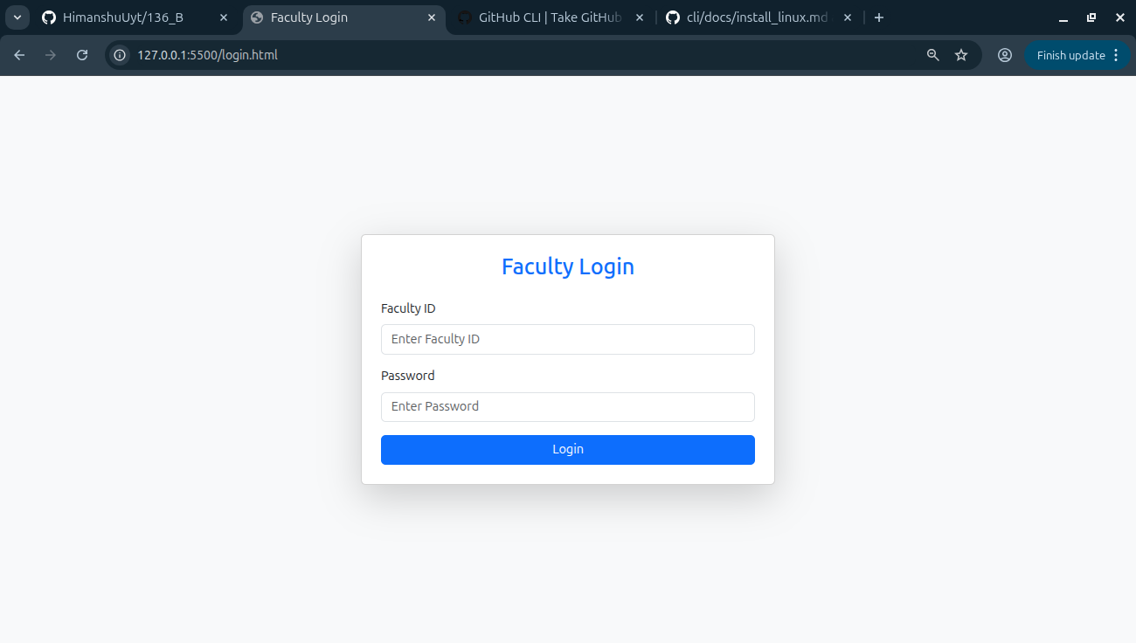

Login Data :

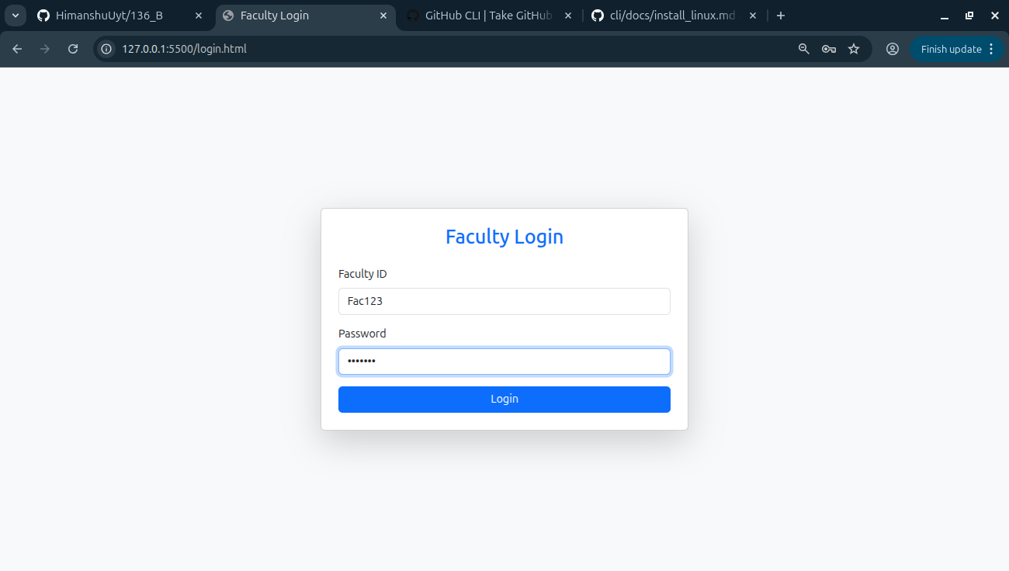

Dashboard Output :

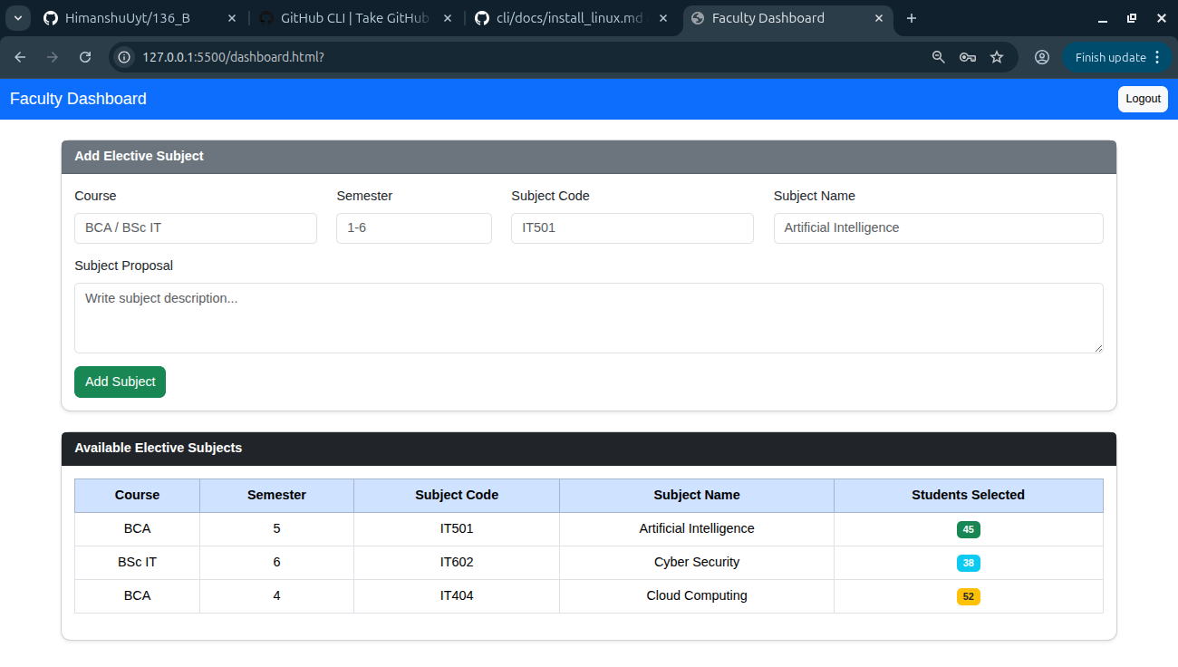

GitHub Prompt -1

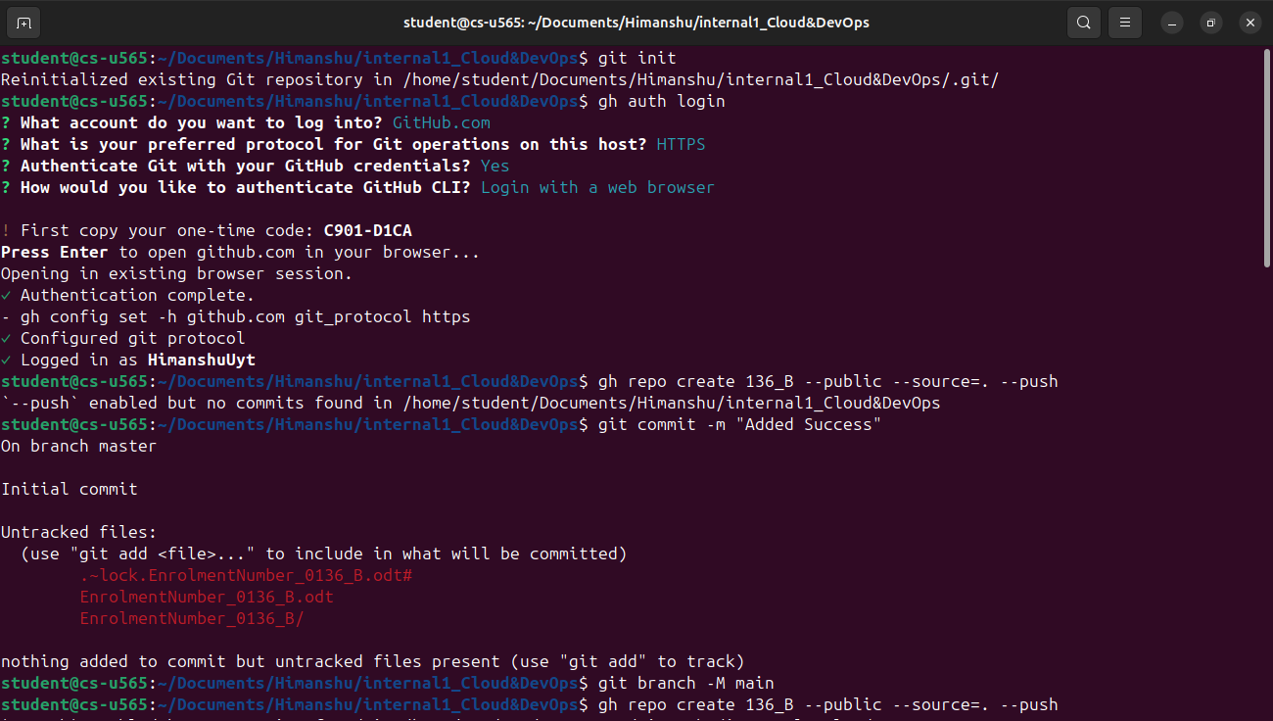

GitHub Prompt -2

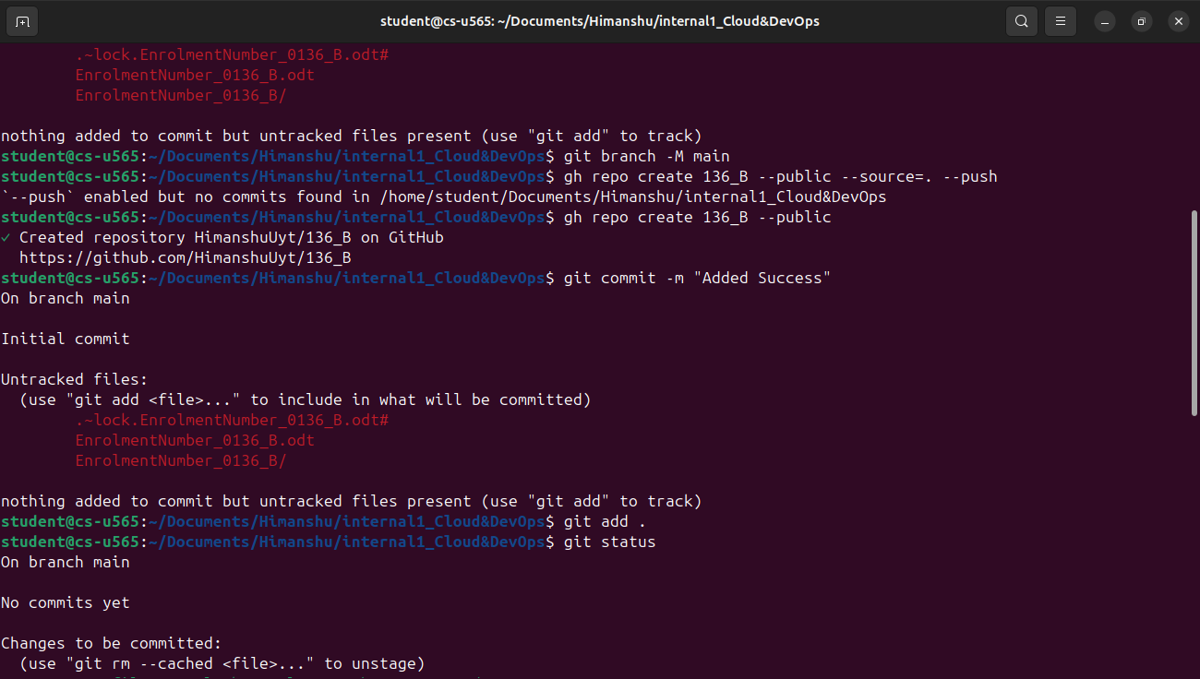

GitHub Prompt -3

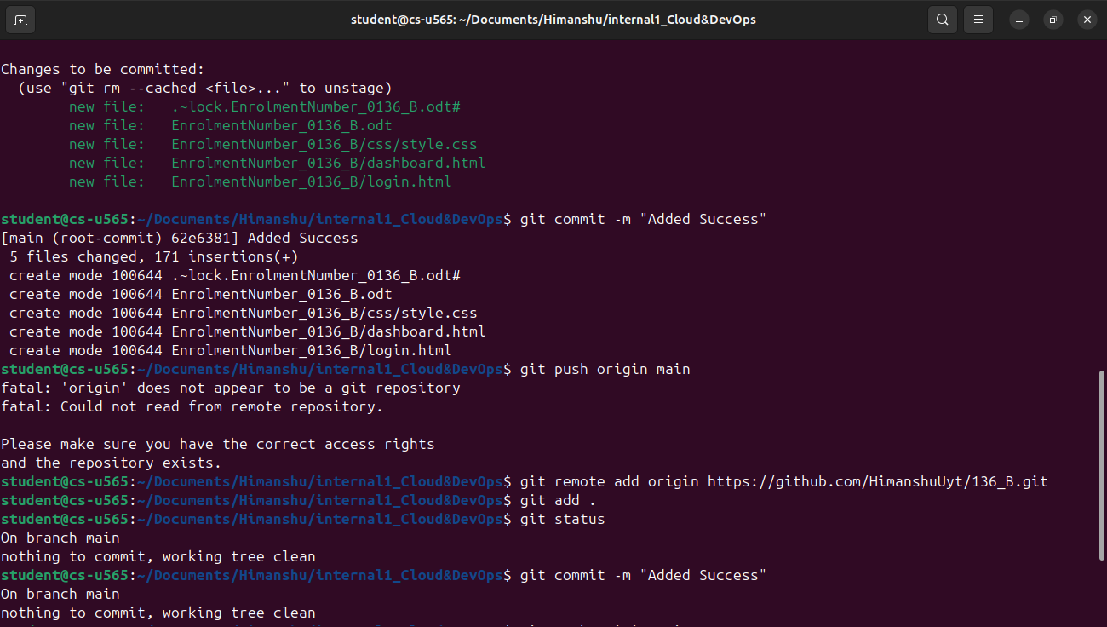

GitHub Prompt -4

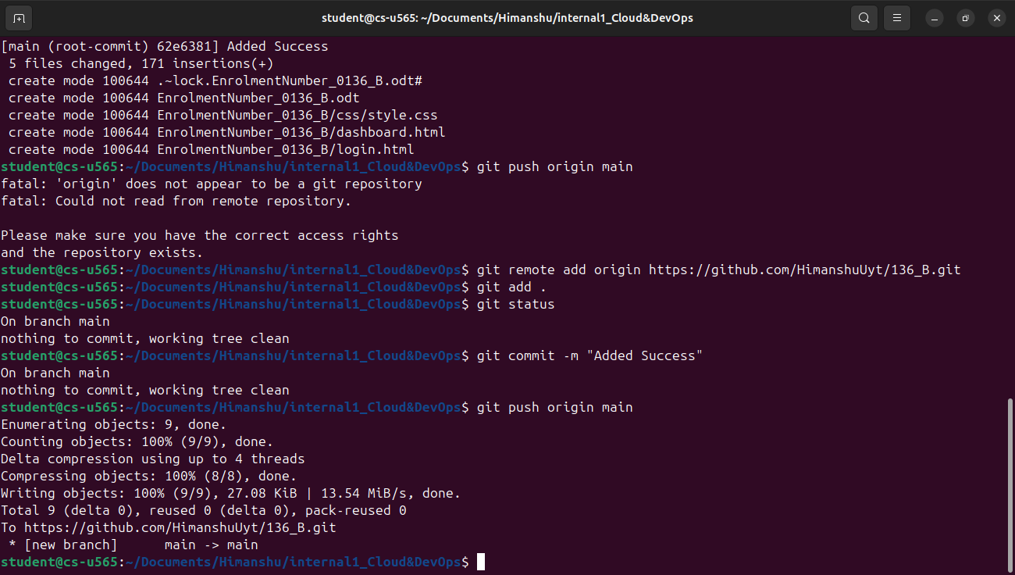
GitHub URL : https://github.com/HimanshuUyt/136_B.git

