**Q23 Design a system that automatically turns on the lights inside an almirah whenever it is opened and turns off the lights after 100 ms if there is enough light in room.**

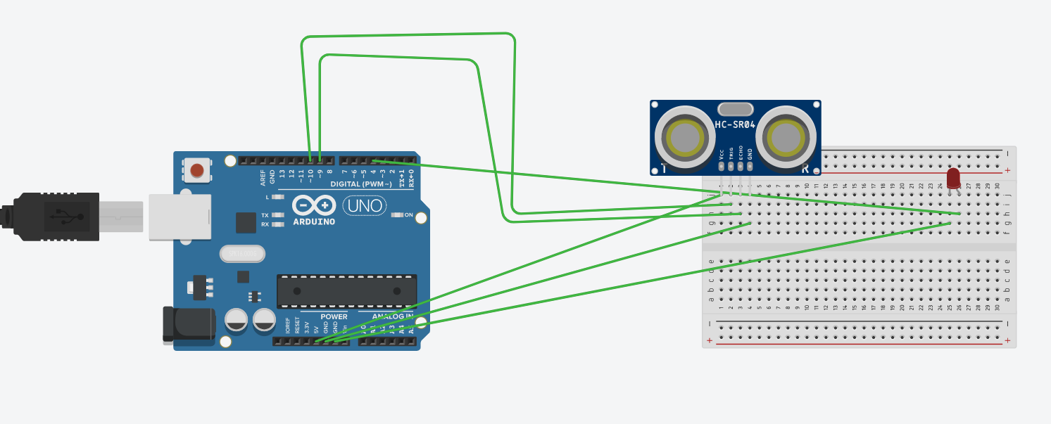

**Theory**

Here we need one ultrasonic hardware to detect the distance between the wall of a;mirah. As the door of almirah opens sensor of ultrasonic detect change in distance.

**Problems and Troubleshoting**

Difficult to sync code and ultrasonic hardware.

**Precautions**

Use wisely all hardware.

**Learning outcomes**

Here I learn more about ultrasonic hardware and this will help for future project based on this type of problems.