STRIDE Threat Model Study
Mapping Microservice Data Flows and Structural Threats using OWASP Threat Dragon
Field | Details
Project Name | STRIDE Threat Model
Student Name | Himanshu Rawat
Email ID | himanshurawat9520@gmail.com
Program Name | IBM SkillsBuild Bootcamp (Cybersecurity)
Submission Date | 22 October 2026

1. Abstract / Summary
This project applies the STRIDE threat modelling methodology to an e-commerce platform built from microservices. The system was modelled as a Data Flow Diagram in OWASP Threat Dragon, with 17 elements across two trust boundaries. A Python analyzer parses the exported model, checks STRIDE-per-element coverage, scores risk and generates charts and reports. In total 62 threats were identified, of which 38 remain open and 20 are high-severity open threats that need priority remediation.

2. Problem Statement
Microservice architectures multiply the number of network hops, trust boundaries and authentication points. Security flaws such as broken object-level authorization, token forgery, unencrypted internal traffic and weak payment-callback validation are often found only after deployment, when fixing them is costly. Teams need a structured, repeatable way to find design-level threats early, and a way to measure how complete that analysis is.

3. Objectives
- Model the data flows, processes, data stores and trust boundaries of a microservice e-commerce system.
- Systematically identify threats in all six STRIDE categories for every DFD element.
- Document severity, status and mitigation for each threat in OWASP Threat Dragon.
- Automate analysis with Python: threat table, coverage-gap detection and residual-risk scoring.
- Produce visual outputs (DFD, charts, heatmap) and a prioritised list of open threats.

4. System Architecture & Workflow

4.1 Target system
A customer reaches the API Gateway over the internet. Inside the cluster, the gateway forwards requests to the Auth Service (backed by Users DB) and the Order Service (backed by Orders DB). The Order Service calls the Payment Service and emits events to the Notification Service. An external payment provider sends webhook callbacks to the Payment Service.
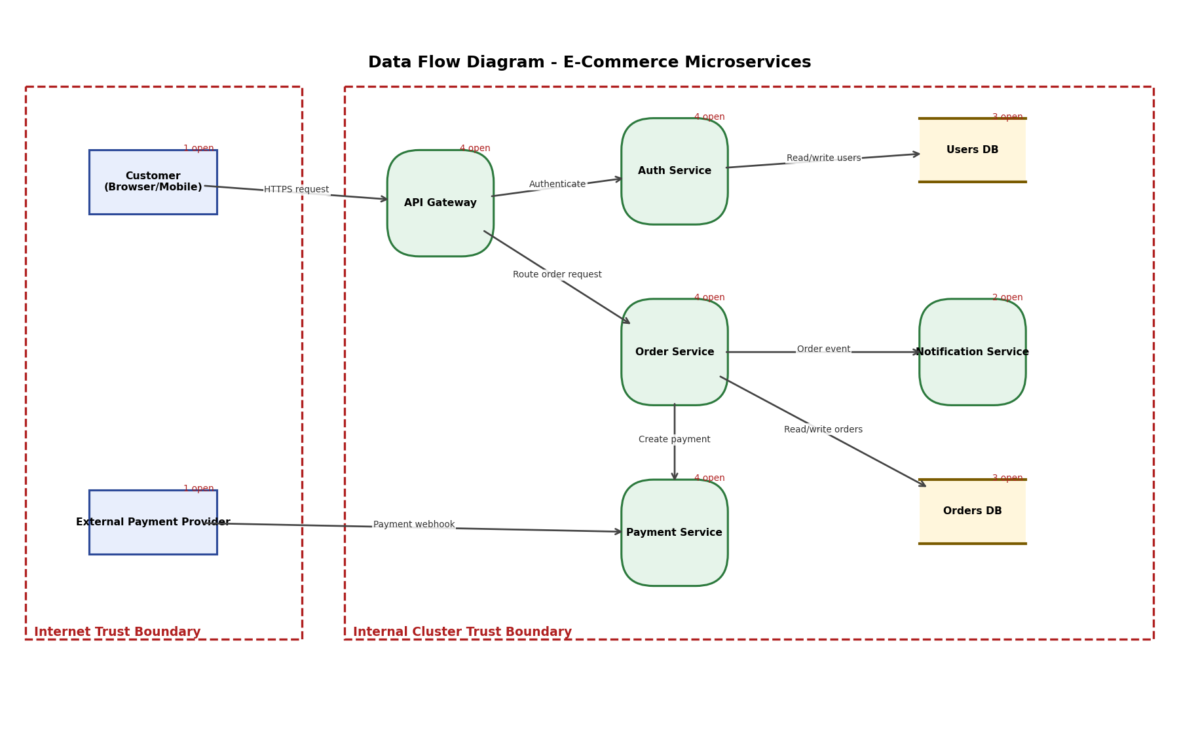
Figure 1: Data Flow Diagram with trust boundaries (rendered from the Threat Dragon model)

4.2 Workflow
- Define scope and draw the DFD in OWASP Threat Dragon (actors, processes, stores, flows, trust boundaries).
- Apply STRIDE-per-element: Actors (S, R); Processes (S, T, R, I, D, E); Data stores (T, R, I, D); Data flows (T, I, D).
- Record each threat with title, severity, status (Open/Mitigated), description and mitigation; save as JSON.
- Run stride_analyzer.py: parse JSON, flatten to a table, detect coverage gaps, compute inherent and residual risk.
- Review charts, heatmap and the Top-10 list; plan remediation for open high-severity threats.

4.3 Risk scoring
Each threat receives an inherent score from its severity (High = 9, Medium = 5, Low = 2). Mitigated threats keep 20% of that score as residual risk; open threats keep 100%. This is a simple prioritisation model, not a formal quantitative risk calculation.

5. Tools & Technologies Used
Category | Tool / Technology
Threat modelling | OWASP Threat Dragon (v2 JSON), STRIDE methodology
Language | Python 3
Libraries | pandas 3.0.2, matplotlib 3.10.8
IDE | VS Code
Version control | Git and GitHub (public repository)
Documentation | Markdown (README), Microsoft Word (report)

6. Key Features & Screenshots

6.1 Features
- Model parser: reads actors, processes, stores, flows and boundaries from Threat Dragon JSON.
- Threat table: exports all 62 threats to CSV with severity, status and mitigation.
- Coverage-gap detector: applies STRIDE-per-element rules and lists categories nobody analysed.
- Risk scoring: inherent versus residual score with Top-10 open threats.
- Visuals: DFD render, STRIDE distribution, status/severity and heatmap charts.

6.2 Results
Metric | Value
Elements analysed | 17 (2 actors, 5 processes, 2 data stores, 8 data flows)
Total threats | 62
Open / Mitigated | 38 / 24
High-severity still open | 20
Inherent risk -> residual | 397 -> 295.4 (26% reduction)
Coverage gaps | 3 elements (Order Service, Notification Service, Authenticate flow)

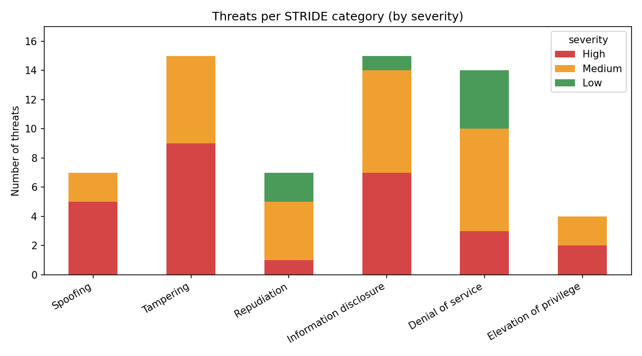
Figure 2: Threats per STRIDE category by severity
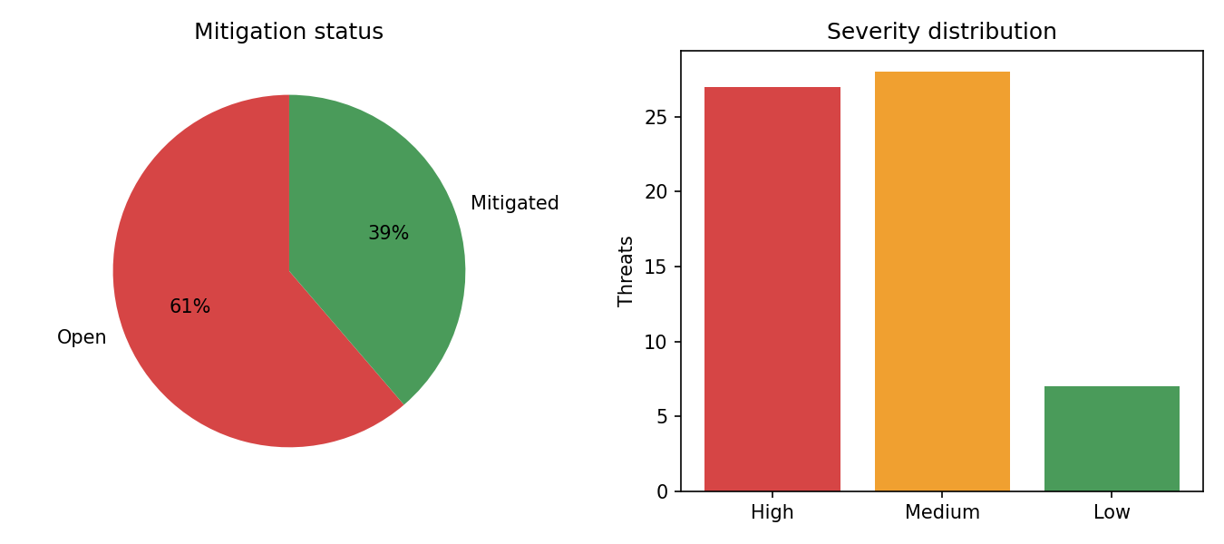
Figure 3: Mitigation status and severity distribution
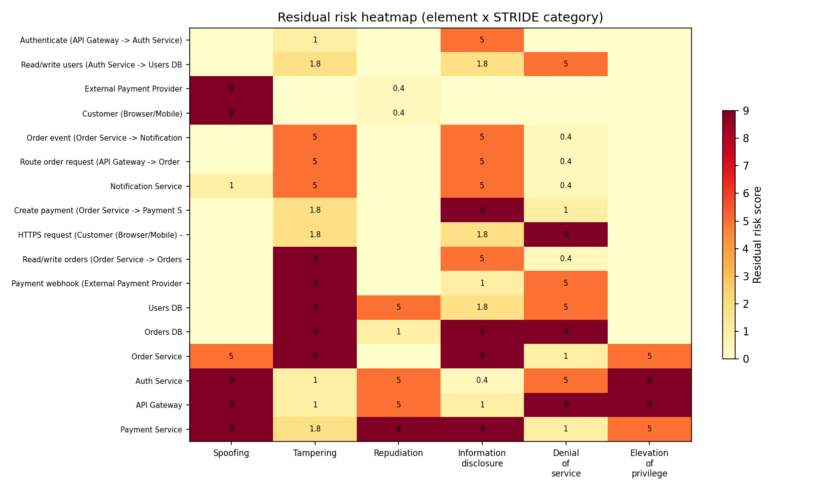
Figure 4: Residual risk heatmap (element x STRIDE category)

6.3 Top open threats
# | Element | STRIDE | Threat
5 | API Gateway | Spoofing | Stolen or forged JWT accepted
10 | API Gateway | Elevation of privilege | Route abuse reaches admin APIs
16 | Auth Service | Elevation of privilege | Role claim tampering
18 | Order Service | Tampering | Order price/quantity tampering
3 | External Payment Provider | Spoofing | Forged payment webhooks

6.4 Key findings and recommended mitigations
- Identity: validate JWT signature, expiry and audience; fetch roles server-side; enforce MFA.
- Internal traffic: two flows (gateway to Order Service, Order Service to Orders DB) are unencrypted; adopt mTLS or a service mesh.
- Authorization: enforce object-level checks in the Order Service to prevent BOLA.
- Payments: verify webhook HMAC signatures, use idempotency keys and scrub card data from logs.
- Resilience and auditing: WAF with rate limiting, immutable backups and centralised audit logging.

7. Conclusion & Future Scope
STRIDE gave a structured way to examine every element of the system, and the Python analyzer made the results measurable: 62 threats were found, and the gap report shows where the analysis itself is incomplete. The main residual risks are concentrated in identity handling, unencrypted internal traffic and the payment path.
Future scope:
- Add likelihood and impact (DREAD or CVSS-style) scoring for finer prioritisation.
- Run the analyzer in a GitHub Actions pipeline so every model change is checked automatically.
- Add a Streamlit dashboard for interactive filtering.
- Map threats to MITRE ATT&CK and OWASP ASVS controls.
- Extend the model with a CI/CD pipeline and cloud infrastructure diagram.

8. References
- OWASP Threat Dragon: https://owasp.org/www-project-threat-dragon/
- Microsoft STRIDE threat model overview
- Shostack, A. Threat Modeling: Designing for Security. Wiley, 2014
- OWASP API Security Top 10

