**Blockchain Basics**

**Definition (100–150 words):**  
 A blockchain is a decentralized, distributed digital ledger that securely records data across many computers in a network. Each record, or "block," contains a set of transactions and is linked to the previous block through a cryptographic hash, forming a continuous chain. This design ensures that once data is recorded, it cannot be altered retroactively without the consensus of the network. Blockchains are transparent and tamper-resistant, making them ideal for use cases where trust, security, and decentralization are important. The technology eliminates the need for intermediaries, as all participants in the network share a synchronized copy of the ledger and validate transactions using consensus mechanisms.

**Real-Life Use Cases:**

1. **Supply Chain Management** – Blockchain helps track the origin and journey of goods, ensuring transparency and authenticity (e.g., food traceability).
2. **Digital Identity** – Blockchain enables secure and user-controlled digital identities, reducing fraud and improving privacy.

### **Block Anatomy**

**Block Diagram:**

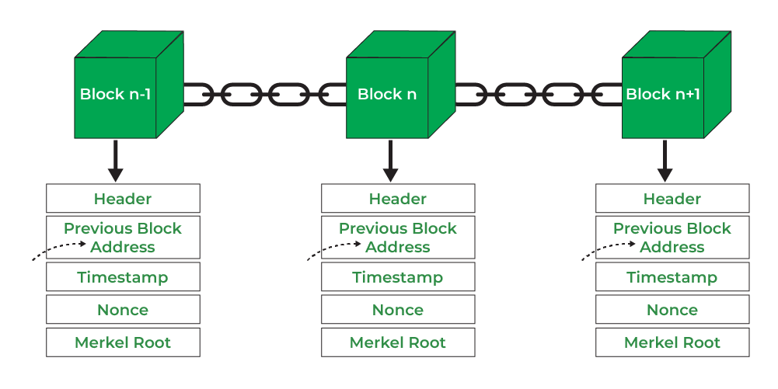

**Merkle Root Explanation (with example):**  
 A Merkle root is a single hash that summarizes all transactions in a block. Transactions are hashed in pairs, and the resulting hashes are then hashed again in pairs until one final hash (Merkle root) is produced.  
 *Example:* If a block contains four transactions (Tx1, Tx2, Tx3, Tx4), their hashes are combined:  
 H12 = hash(Tx1 + Tx2)  
 H34 = hash(Tx3 + Tx4)  
 Then, Merkle Root = hash(H12 + H34)  
 This structure allows quick and secure verification of individual transactions without checking the entire block, maintaining data integrity efficiently.

**Consensus Conceptualization**

**Proof of Work (PoW):**  
 Proof of Work is a consensus mechanism where miners solve complex mathematical problems to validate transactions and create new blocks. This process requires significant computational power and energy, making it costly to attack the network. PoW ensures network security by making it expensive and time-consuming to alter any part of the blockchain.

**Proof of Stake (PoS):**  
 Proof of Stake selects validators based on the amount of cryptocurrency they "stake" or lock up in the network. Instead of solving puzzles, validators are chosen randomly with weight given to their stake. It consumes far less energy than PoW and encourages honest behavior, as malicious actions can lead to loss of staked assets.

**Delegated Proof of Stake (DPoS):**  
 Delegated Proof of Stake allows token holders to vote for a small number of delegates (validators) who are responsible for validating transactions and producing blocks. This system is more democratic and efficient, as it reduces the number of active validators, leading to faster block times while maintaining decentralization through community voting.