**Business Problem**

In recent years, City Hotel and Resort Hotel have seen high cancellation rates. Each hotel is now dealing with a number of issues as a result, including fewer revenues and less than ideal hotel room use. Consequently, lowering cancellation rates is both hotels' primary goal in order to increase their efficiency in generating revenue, and for us to offer thorough business advice to address this problem.

The analysis of hotel booking cancellations as well as other factors that have no bearing on their business and yearly revenue generation are the main topics of this report.



**Assumptions**

1. No unusual occurrences between 2015 and 2017 will have a substantial impact on the data used.

2. The information is still current and can be used to analyze a hotel's possible plans in an efficient manner.

3. There are no unanticipated negatives to the hotel employing any advised technique. 4. The hotels are not currently using any of the suggested solutions.

5. The biggest factor affecting the effectiveness of earning income is booking cancellations.

6. Cancellations result in vacant rooms for the booked length of time. 7. Clients make hotel reservations the same year they make cancellations.

Research Question

1. What are the variables that affect hotel reservation cancellations?

2. How can we make hotel reservations cancellations better?

3. How will hotels be assisted in making pricing and promotional decisions?

Hypothesis

1. More cancellations occur when prices are higher.

2. When there is a longer waiting list, customers tend to cancel more frequently.

3. The majority of clients are coming from offline travel agents to make their reservations.

**Analysis and Findings**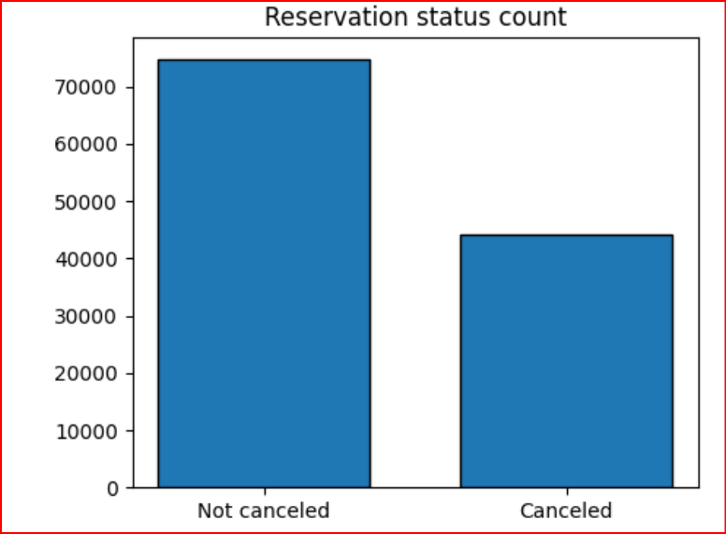

**The accompanying bar graph shows the percentage of reservations that are canceled and those that are not it is obvious that there are still a significant number of reservations that have not been canceled. There are still 37% of clients who canceled their reservation, which has a significant impact on the hotel' earnings.**

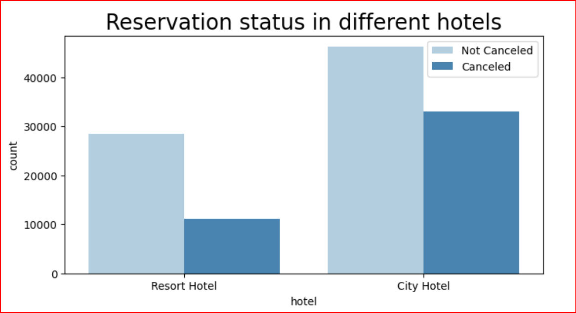

In comparison to resort hotels, city hotels have more bookings. It's possible that resort hotels are more expensive than those in cities

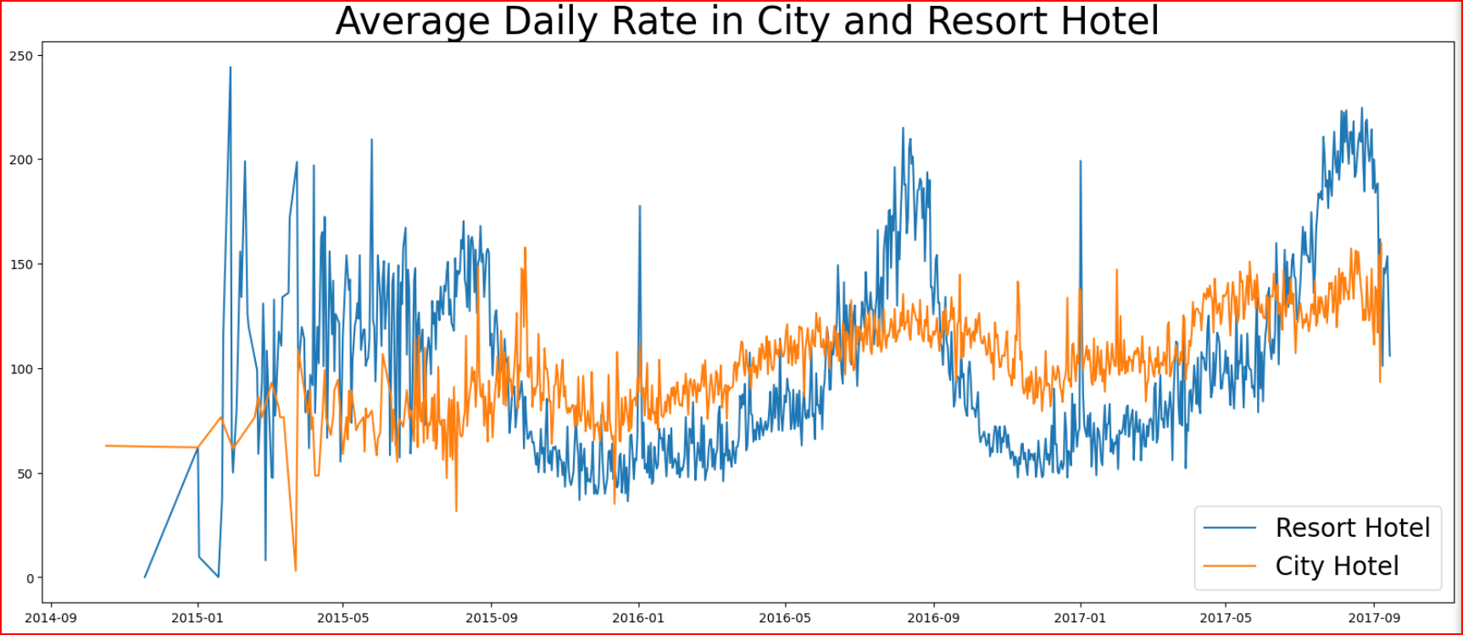

**The line graph above shows that, on certain days, the average daily rate for a city hotel is less than that of a resort hotel, and on other days, it is even less. It goes without saying that weekends and holidays may see a rise in resort hotel rates.**

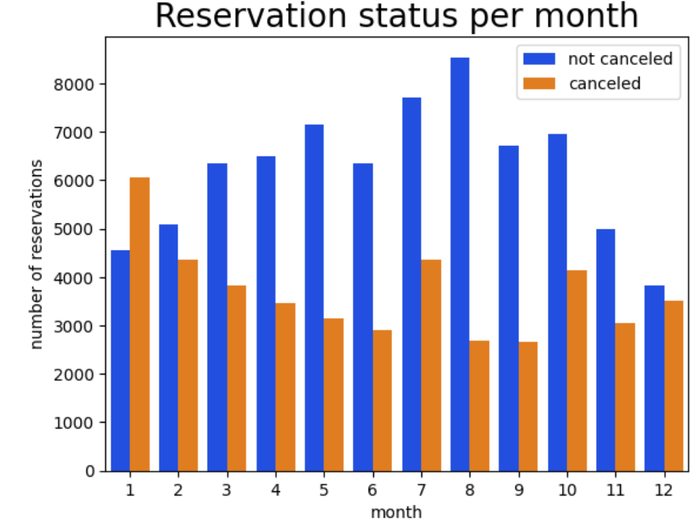

**We have developed the grouped bar graph to analyze the months with the highest and lowest reservation levels according to reservation status. As can be seed, both the number of confirmed reservations and the number of canceled reservations are largest in the month of August. whereas January is the month with the most canceled reservations**

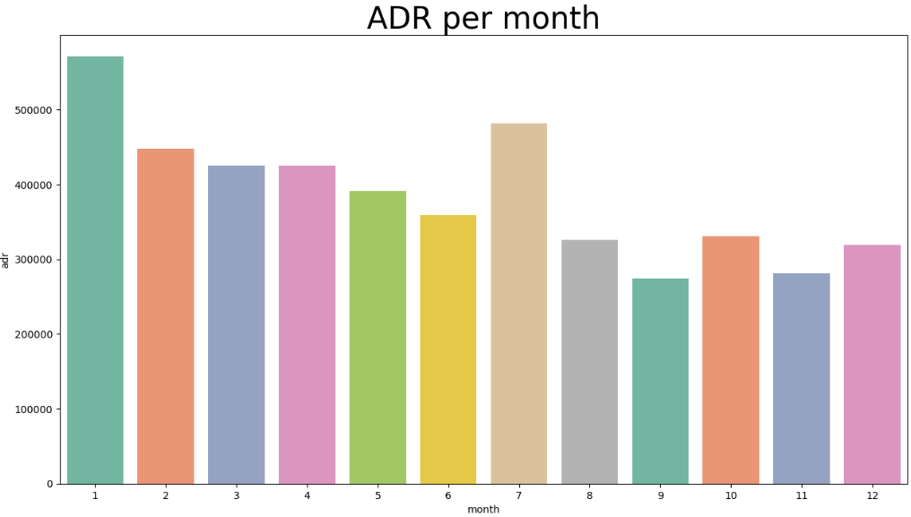

This bar graph demonstrates that cancellations are most common when prices are greatest and are least common when they are lowest. Therefore, the cost of the accommodation is solely responsible for the cancellation.

**Now, let's see which country has the highest reservation canceled. The top country is Portugal with the highest number of cancellations.** 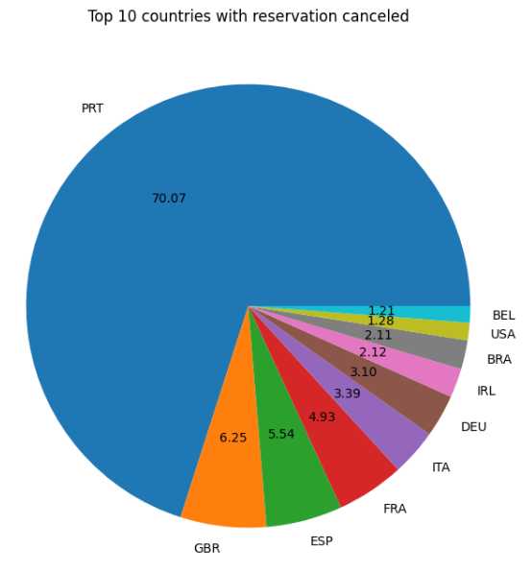

**Let's check the area from where guests are visiting the hotels and making reservations Is it coming from Direct or Groups, Online or Offline Travel Agents? Around 46% of the clients come from online travel agencies, whereas 27% come from groups. Only 4% of clients book hotels directly by visiting them and making reservations**

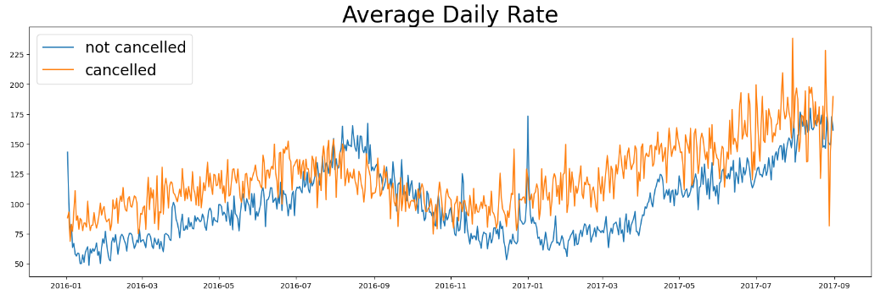

**As seen in the graph, reservations are canceled when the average daily rate is higher than when it is not canceled. It clearly proves all the above analysis, that the higher price leads to higher cancellation.**

**Suggestions**

1. Cancellation rates rise as the price does. In order to prevent cancellations of reservations, hotels could work on their pricing strategies and try to lower the rates for specific hotels based on locations. They can also provide some discounts to the consumers.

2. As the ratio of the cancellation and not cancellation of the resort hotel is higher in the resort hotel than the city hotels. So the hotels should provide a reasonable discount on the room prices on weekends or on holidays.

3. In the month of January, hotels can start campaigns or marketing with a reasonable amount to increase their revenue as the cancellation is the highest in this month.

4. They can also increase the quality of their hotels and their services mainly in Portugal to reduce the cancellation rate

--------------------------------------------------------------------------------------------------------------------------

Summary of the Given Transcript-Business Case Study on Hotel Booking Analysis

Business Problem

A city hotel and a resort hotel have been seeing high cancellation rates in recent years. This has led to a number of issues, including decreased revenue and increased idle hotel rooms. The top priority is to identify the factors that are directly or indirectly affecting the increasing cancellation rates of customers.

Assumptions

* No unusual occurrences between 2015 and 2017 will have a substantial impact on the data.
* The data is uniform and organized in a manner that can be used for analysis.
* The information is still current and can be used to analyze the hotel's possible plans in an efficient manner.
* There are no unanticipated negatives to the hotel employing any advice technique.
* Clients make hotel reservations and cancellations in the same year.
* The biggest factor affecting the effectiveness of earning income is booking cancellations.
* Cancellations result in vacant rooms for the book length of time.

Research Questions

* What are the variables that affect hotel reservation cancellation?
* How can we make hotel reservation cancellations better?
* How will hotels be assisted in making pricing and promotional decisions?

Hypotheses

* More cancellations occur when the price is higher.
* When there is a longer waiting list, customers tend to cancel more frequently.
* Customers who cancel their reservations are more likely to be first-time guests.
* Customers who cancel their reservations are more likely to be booking during peak season.

Business Advice

* Offer discounts and promotions to attract customers and reduce cancellations.
* Reduce lead times and improve booking processes.
* Provide excellent customer service to ensure that customers have a positive experience and are less likely to cancel their reservations.
* Implement a loyalty program to reward customers for staying at the hotel and reduce the likelihood of them canceling their reservations in the future.

Conclusion

By understanding the factors that affect hotel reservation cancellation and taking steps to address them, hotels can reduce cancellations and improve their bottom line.

share

more_vert

The transcript is summarizing the findings of an analysis of hotel booking cancellations using Python. The analysis found that:

* 62% of reservations are not canceled, while 37% are canceled.
* City hotels have a higher cancellation rate than resort hotels.
* Resort hotels have more fluctuations in ADR than city hotels.
* January has the highest cancellation rate and August has the lowest.
* ADR is highest in January and lowest in August.
* Portugal has the highest cancellation rate, followed by GBR and ESP.
* Online travel agents generate the most traffic, followed by offline travel agents.

The analysis also made the following hypotheses:

* Cancellations are more likely when prices are high.
* Cancellations are more likely in city hotels.
* Cancellations are more likely in January and December.
* Cancellations are more likely in Portugal.
* Cancellations are more likely from offline travel agents.

The analysis confirmed all of these hypotheses.

Overall, the analysis found that cancellations are a significant problem for the hotel industry. The hotel can reduce cancellations by offering discounts and promotions during off-peak seasons, focusing on improving customer service in city hotels, and marketing to online travel agents.

Sure. The given transcript is analyzing hotel booking cancellations using Python. It explores the data to identify factors that affect cancellations and to develop recommendations for reducing them.

Key findings:

* Cancellations are more likely when prices are high. This is supported by the findings that the average daily rate (ADR) is highest in January, when cancellations are also highest.
* City hotels have a higher cancellation rate than resort hotels. This may be due to the fact that city hotels are often more expensive and offer fewer amenities than resort hotels.
* Cancellations are more likely in January and December. This is likely due to the fact that these months are peak season for travel, and customers may be more likely to cancel if they find a better deal elsewhere.
* Portugal has the highest cancellation rate, followed by GBR and ESP. This may be due to a number of factors, such as economic conditions, travel restrictions, or the popularity of these destinations with budget travelers.
* Online travel agents generate the most traffic, followed by offline travel agents. This suggests that the hotel should focus its marketing efforts on online travel agents.

Recommendations:

* Offer discounts and promotions during off-peak seasons. This will make the hotel more attractive to customers and reduce the likelihood of cancellations.
* Focus on improving customer service in city hotels. This includes providing excellent customer service from the moment a guest books a reservation to the moment they check out.
* Market to online travel agents. This will help the hotel reach a wider audience and generate more bookings.

By following these recommendations, the hotel can reduce cancellations and improve its bottom line.

In addition to the above, the transcript also highlights the importance of data analysis in identifying and addressing business problems. By using Python to analyze its booking data, the hotel was able to identify the factors that were contributing to its high cancellation rate. This information can then be used to develop targeted strategies for reducing cancellations.

Certainly, here's an interview response that briefly explains your project:

"In our recent project, we tackled a pressing business problem faced by City Hotel and Resort Hotel. Both establishments were grappling with a significant issue – high cancellation rates, which were adversely affecting their revenues and room utilization. Our primary objective was to assist these hotels in reducing cancellation rates to enhance revenue generation and operational efficiency.

To address this challenge, we conducted an extensive analysis that encompassed hotel booking cancellations and various factors influencing their yearly revenue. We made several key assumptions to ensure the validity of our findings, including the absence of major disruptions between 2015 and 2017, the current relevance of the data, and the absence of unexpected negative consequences from our proposed solutions.

Our research revolved around three central research questions: What variables influence hotel reservation cancellations? How can we improve the cancellation rates of hotel reservations? How can hotels benefit from our insights in making pricing and promotional decisions?

We formulated hypotheses such as higher prices correlating with more cancellations, longer waiting lists leading to higher cancellations, and a significant proportion of clients booking through offline travel agents.

Our analysis unveiled some noteworthy findings. For instance, the data revealed that 37% of clients had canceled their reservations, significantly impacting hotel earnings. City hotels exhibited more bookings compared to resort hotels, possibly due to differences in pricing. Additionally, we observed fluctuations in average daily rates, with weekends and holidays often resulting in higher resort hotel rates.

By visualizing our findings, we were able to pinpoint specific trends. For instance, August had the highest number of confirmed and canceled reservations, while January witnessed the most cancellations. Furthermore, our analysis demonstrated a strong correlation between higher accommodation costs and increased cancellations.

Taking all these insights into account, we offered several practical suggestions to address the high cancellation rates:

1. Implement pricing strategies to reduce cancellations, potentially offering discounts or incentives based on locations.

2. Consider providing discounts on room prices during weekends and holidays to mitigate cancellations, particularly in resort hotels.

3. Run targeted marketing campaigns in January to boost revenue during the month with the highest cancellation rate.

4. Enhance the quality of services, especially in Portugal, to reduce cancellations and improve guest satisfaction.

In summary, our project focused on addressing high cancellation rates for City Hotel and Resort Hotel, with the goal of optimizing revenue generation and operational efficiency through data-driven insights and strategic recommendations."

This response concisely summarizes the project's context, objectives, methodology, findings, and recommendations.------Reading 2+