Freeze write-up

1. Realize that the program is compiled python
2. Discover pyinstaller (https://github.com/pyinstaller/pyinstaller)
3. Extract the segments using the pyinstaller archive viewer `pyi-archive_viewer`

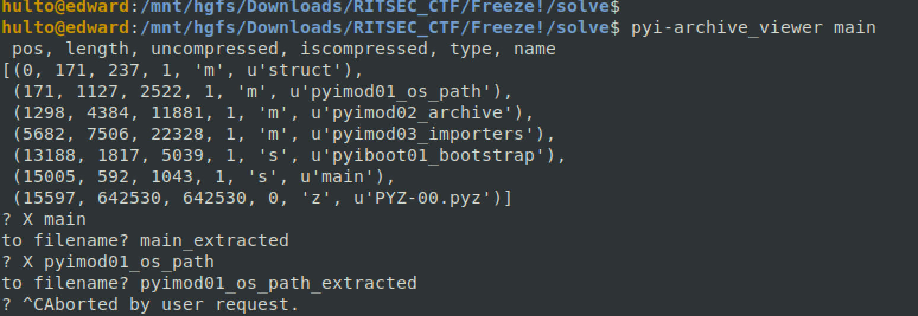

1. Add the header that all the sections have to the section you want to decompile. ("03F30D0A 70796930")



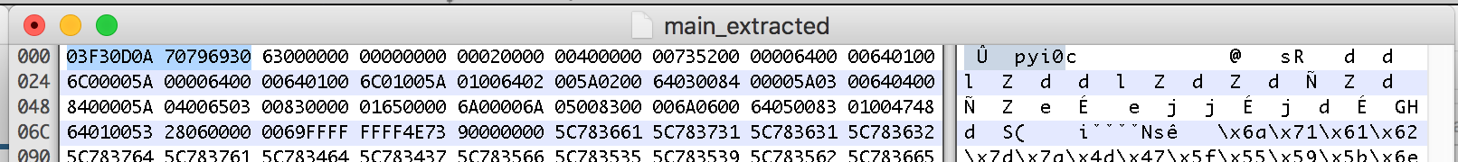

1. Use uncompyle 2 (https://github.com/wibiti/uncompyle2) to decompile the package

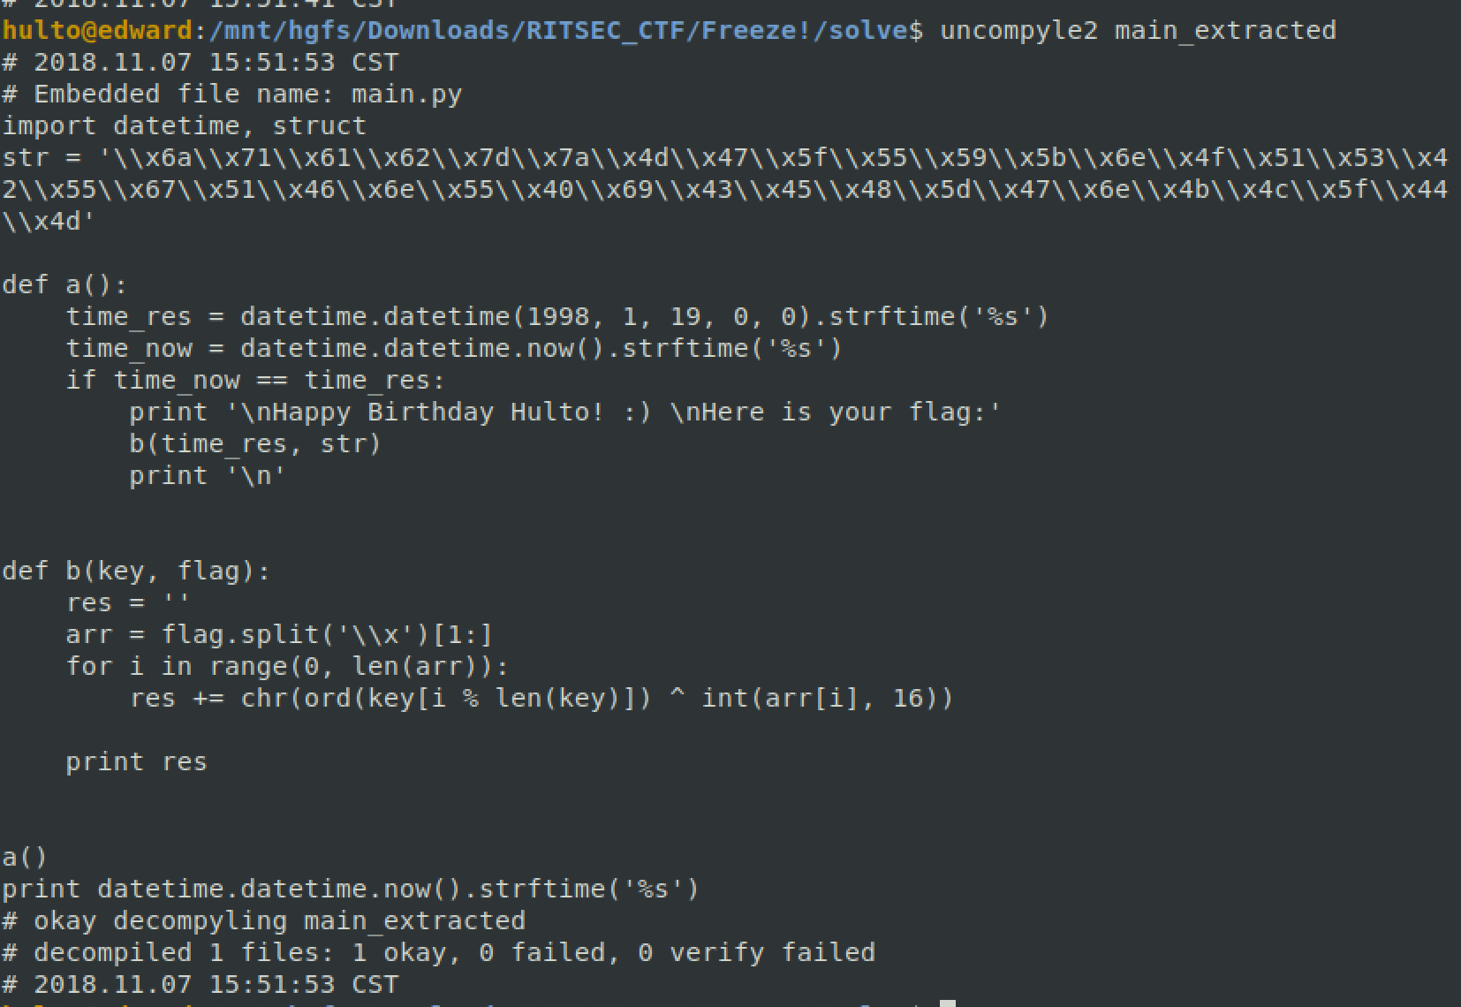

1. View the source code
2. Either run the program using libfaketime LD_PRELOAD library or calculate the time and decrypt the string



Flag:

**RITSEC{Woman!_Wh3re_is_my_sup3r_su1t!}**