Write Up for Medium 2

!! Warning !!

Here be spoilers, this is your final warning

Note

The intention of these write ups is to provide an insight into the intended strategy for solving the challenge. If you used a differing method to solve the challenge, feel free to message @1cysw0rdk0 or @Simon on slack. Write ups may not be provided or complete for all challenges, and may or may not include scripts used to create or solve the challenge.

Step 1:

Looking at the file, nothing immediately grabs our attention. Binwalking over the png file shows nothing suspicious. However, we notice that even for that incredibly high resolution photograph of a stegosaurus, that file is far too large.

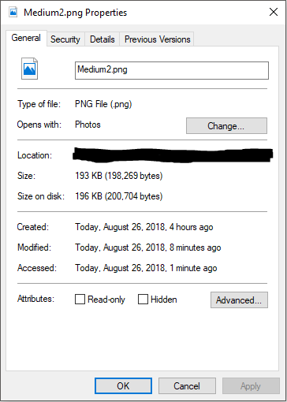

Step 2:

So if the file has hidden data, but no extra files stored in it, maybe there’s more to the image than we can see. After some research, I figured out how to change the metadata for the image using a hex editor.

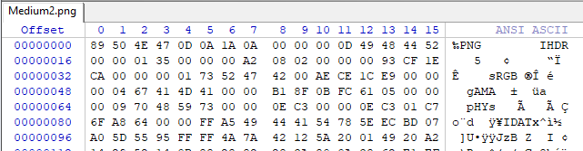

Step 3:

The next step is to try and find and overwrite the metadata for the image, which isn’t as hard as it sounds. To overwrite the height on the image, which is what is needed for this challenge, simply convert the current height of the image into its hex representation, and search the file for it.

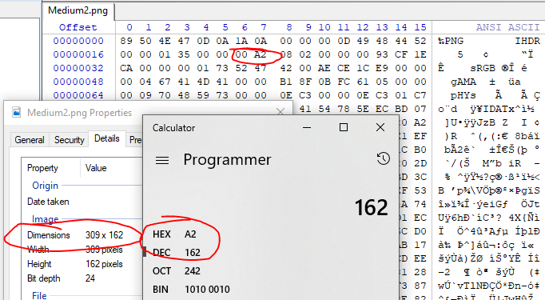

Simply modifying this entry will change the height of the image displayed.

Step 4:

Extend the image far enough down, and the flag will appear at the bottom of the image. 