Write Up for the Piet Challenge

!! Warning !!

Here be spoilers, this is your final warning

Note

The intention of these write ups is to provide an insight into the intended strategy for solving the challenge. If you used a differing method to solve the challenge, feel free to message @1cysw0rdk0 or @oneNutW0nder on discord. Write ups may not be provided or complete for all challenges, and may or may not include scripts used to create or solve the challenge.

What am I supposed to do with this?

This image is given:

**\*\*\* NOTE \*\*\***

This image will probably not work because scaling matters in Piet. Please use the image provided by the challenge.

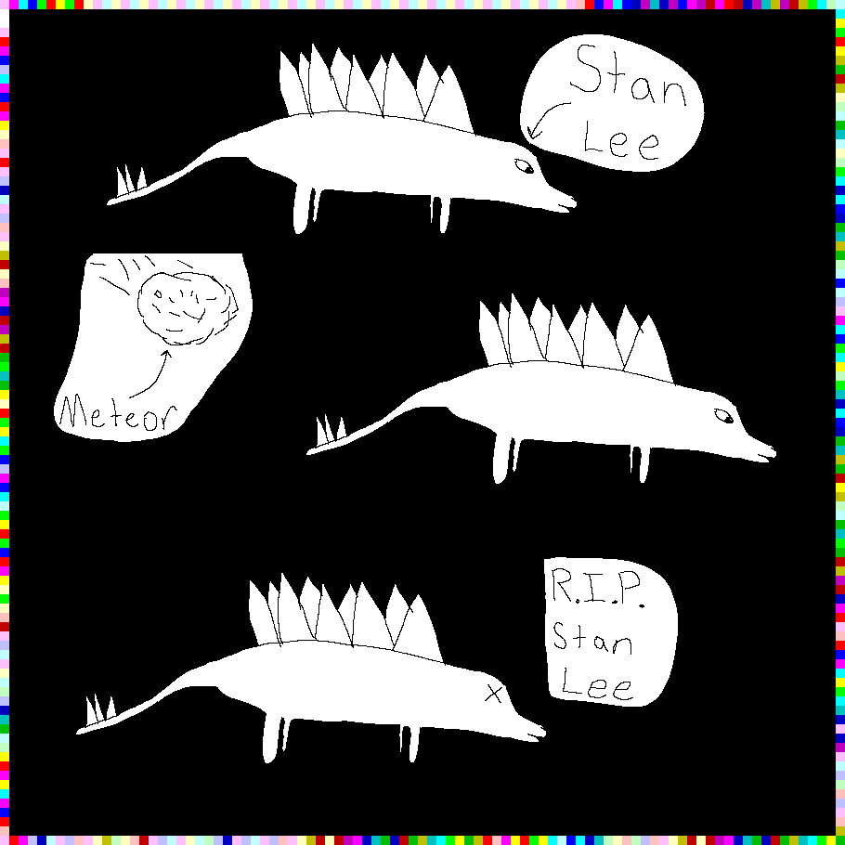

The image above is both a tribute to the great Stan Lee, and also a Piet script. Piet is an esoteric language that is extremely complex. The script lies in the colored pixel blocks (codels) around the outside of the image. Unfortunately, I do not know how to code in Piet, so the program is broken. To fix it you have to remove all of the black from the image. This is because the black drawing does not conform to the codel size of 10 for this image. This is effectively the same as making syntactic errors in any other programming languages. Uses half a codel is not allowed.

Once the black is removed your image will look like the one posted below. When you run this using an interpreter online you will get the flag.

