Write Up for Hard 2

!! Warning !!

Here be spoilers, this is your final warning

Note

The intention of these write ups is to provide an insight into the intended strategy for solving the challenge. If you used a differing method to solve the challenge, feel free to message @1cysw0rdk0 or @oneNutW0nder on discord. Write ups may not be provided or complete for all challenges, and may or may not include scripts used to create or solve the challenge.

Hard 2

The flag for Hard 2 has been encoded in the blue vales of each RGB pixel. Each letter of the flag is in one B value with a +13 shift applied to it.

Step 1:

You are given this image:



As you can see, it seems like there is a yellow hue. This combined with the hint should point you to look at RGB values. Specifically the blue values.

Step 2:

Using a quick script to look at the blue RGB values (decode.py) we see this:

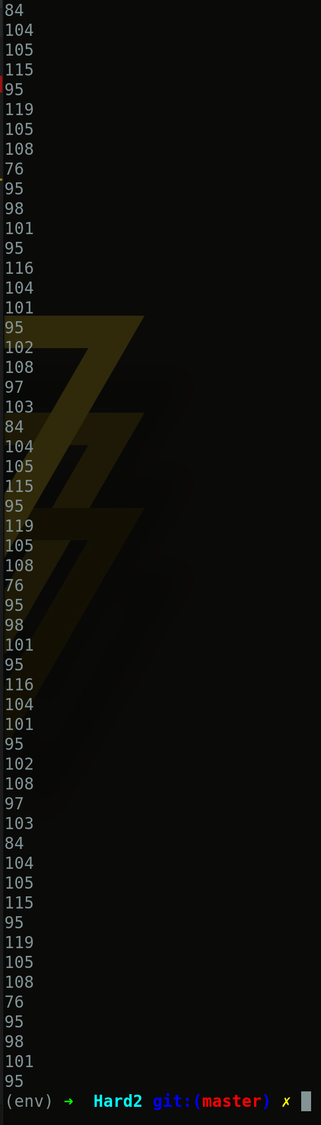 This is the output of only the blue values.

\*\*\* NOTE \*\*\*

This screenshot is without the +13 shift!

As you can see, the values repeat after some time. Also, all

values are well within ASCII ranges. With this information lets

try printing these values:



Printing the ASCII values gives us this repeating

string.

\*\*\* NOTE \*\*\*

For the real challenge you will need to subtract

13 from each value to obtain the flag.