Write Up for music.png

!! Warning !!

Here be spoilers, this is your final warning

Note

The intention of these write ups is to provide an insight into the intended strategy for solving the challenge. If you used a differing method to solve the challenge, feel free to message @1cysw0rdk0 or @oneNutW0nder on discord. Write ups may not be provided or complete for all challenges, and may or may not include scripts used to create or solve the challenge.

Step 1: Similar to the “Check out this cool filter” (Misc. 200) challenge, this image has encoded characters in the RGB values. This time however, the R, G, and B values have all been changed. This is what the image looks like encoded:



Obviously there is something going on in this image. If you grab the RGB values and print them as ASCII characters you will get the text depicted in the image of step 2. Line 1 comes from the Red values, line 2 from the Green values, and line 3 from the Blue values. These lines repeat throughout the image so you will have to find the point at which they repeat which is not that difficult if you look closely.

Step 2: After finding the 3 strings in the RGB values you get these three lines.

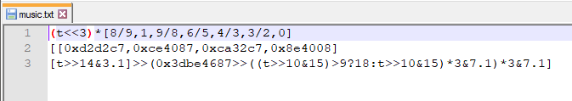

Looking at this text, we see only one “variable”, t. Incrementing this t value gives us outputs which form a pattern. When these 8 bit integers are used as a raw 8-bit audio track, a familiar song is played. Several applications, both online and standalone apps, will allow audio to be played in this format. The flag is simply the title of the song → RS{never_gonna_give_you_up}