**Exploratory Data Analysis**

**Business Questions To Answer**

Generic Question

1. How many unique cities does the data have?

SELECT COUNT(DISTINCT city) FROM sales;

1. In which city is each branch?

SELECT DISTINCT city,

branch FROM sales;

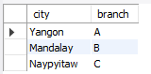

Product

1. **How many unique product lines does the data have?**

SELECT DISTINCT product_line

FROM sales;

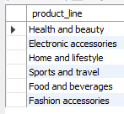

1. **What is the most common payment method?**

SELECT payment_method,

COUNT(payment_method) AS most_common_payment_method

FROM sales

GROUP BY payment_method

ORDER BY COUNT(payment_method) DESC;

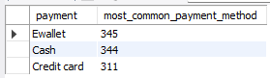

1. **What is the most selling product line?**

SELECT product_line,

SUM(quantity) AS product_line_sales

FROM sales

GROUP BY product_line

ORDER BY SUM(quantity) DESC;

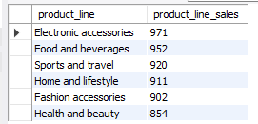

1. **What is the total revenue by month?**

SELECT month_name,

round(SUM(total), 2) AS revenue

FROM sales

GROUP BY month_name

ORDER BY SUM(total) DESC;

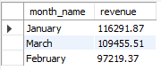

1. **What month had the highest COGS?**

SELECT month_name,

SUM(cogs) AS cogs

FROM sales

GROUP BY month_name

ORDER BY SUM(cogs) DESC;

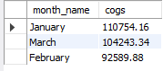

1. **What product line had the highest revenue?**

SELECT product_line,

SUM(total) AS revenue

FROM sales

GROUP BY product_line

ORDER BY SUM(total) DESC;

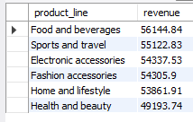

1. **What is the city with the highest revenue?**

SELECT city,

SUM(total) AS revenue

FROM sales

GROUP BY city

ORDER BY SUM(total) DESC;

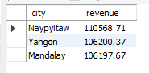

1. **Fetch each product line and add a column to those product line showing "Good", "Bad". Good if its greater than average sales?**

SELECT

product_line,

ROUND(AVG(total),2) AS avg_sales,

(CASE

WHEN AVG(total) > (SELECT AVG(total) FROM sales) THEN "Good"

ELSE "Bad"

END)

AS Remarks

FROM sales

GROUP BY product_line;

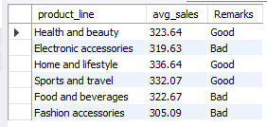

1. **Which branch sold more products than average product sold?**

SELECT

branch,

ROUND(AVG(quantity),2) AS Avg_Qut_sold

FROM sales

GROUP BY branch

HAVING AVG(quantity) > (SELECT AVG(quantity) FROM sales);



1. **What is the most common product line by gender?**

SELECT product_line,

gender,

COUNT(gender)

FROM sales

GROUP BY product_line, gender

ORDER BY COUNT(gender) DESC;

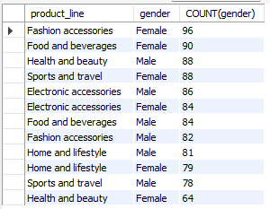

1. **What is the average rating of each product line?**

SELECT product_line,

ROUND(AVG(rating),2) AS Rating

FROM sales

GROUP BY product_line

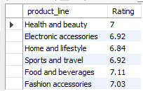

1. **What product line has highest profit?**

SELECT product_line,

ROUND(SUM(gross_income),2) AS Profit

FROM sales

GROUP BY product_line

ORDER BY profit DESC;

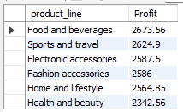

**Sales**

1. **Number of sales made in each time of the day per weekday?**

SELECT

time_of_day,

COUNT(*) AS Total_sales

FROM sales

WHERE day_name = "Sunday"

GROUP BY time_of_day

ORDER BY Total_sales DESC;

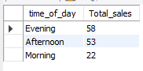

**Note – By changing day_name we can get total sales count for different days.**

1. **Which of the customer types brings the most revenue?**

SELECT customer_type,

SUM(total) AS Total_revenue

FROM sales

GROUP BY customer_type

ORDER BY Total_revenue DESC;



### Customer

1. **How many unique customer types does the data have?**

SELECT DISTINCT customer_type

FROM sales;



1. **How many unique payment methods does the data have?**

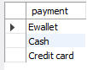

1. **What is the most common customer type?**

SELECT customer_type,

COUNT(*) AS COUNT

FROM sales

GROUP BY customer_type;

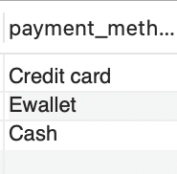

1. **Which customer type buys the most?**

SELECT customer_type,

sum(quantity) AS sum_of_quantity

FROM sales

GROUP BY customer_type

ORDER BY sum(quantity) DESC;



1. **What is the gender of most of the customers?**

SELECT gender,

COUNT(*) AS COUNT

FROM sales

GROUP BY gender

ORDER BY COUNT DESC;

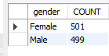

1. **What is the gender distribution per branch?**

SELECT branch,

gender,

COUNT(gender)

FROM sales

Group BY branch, gender

ORDER by branch;

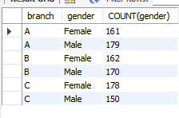

1. **What type of customer gives better ratings?**

SELECT customer_type,

ROUND(AVG(rating),2) AS rating

FROM sales

GROUP BY customer_type

