SUPERSTORE SALES
DATA ANALYSIS PROJECT REPORT
Exploratory Data Analysis • Power BI Dashboard • Business Insights
Dataset: Superstore Sales (2015–2018)
9,800 order line items • 4,922 unique orders • 793 customers across the U.S.
Prepared as part of the end-to-end Sales Analytics project (EDA → Dashboard → Report)

Executive Summary
This report presents the findings of an end-to-end sales analytics project built on the Superstore dataset, covering 9,800 order line items placed between January 2015 and December 2018. The project followed a three-stage workflow: exploratory data analysis (EDA), an interactive Power BI dashboard, and this consolidated report summarizing key business insights and recommendations.
Across the four-year period, the business generated $2.26M in total sales from 4,922 unique orders, at an average of roughly $459 per order. Sales grew strongly in the second half of the period after a slight dip in 2016, with 2018 finishing 20.3% higher than 2017. Technology was the top-earning category despite Office Supplies generating the highest order volume, and the West and East regions together accounted for the majority of revenue.

1. Project Overview

1.1 Objective
The goal of this project was to analyze historical retail sales transactions to understand revenue drivers, customer segments, regional performance, and seasonal trends, and to package these findings into a reusable, interactive dashboard and a written report suitable for stakeholders.

1.2 Workflow
- Exploratory Data Analysis (EDA) – cleaning, profiling, and initial visualization of the raw dataset (stored separately in the project's GitHub repository).
- Power BI Dashboard – an interactive report (supersales_store_data_analysis.pbix) built on the cleaned dataset for ongoing self-service analysis.
- Project Report (this document) – a narrative summary of key findings, insights, and recommendations for a non-technical audience.

2. Dataset Overview
Source table | train
Rows (order line items) | 9,800
Unique orders | 4,922
Date range | January 3, 2015 – December 30, 2018
Key fields | Order Date, Ship Date, Ship Mode, Segment, Region, State, City, Category, Sub-Category, Product Name, Sales, delivery_time
Granularity | One row per product line within an order

3. Key Performance Indicators
$2.26M  Total Sales | 4,922  Total Orders | 3.96 days  Avg. Delivery Time

4. Findings by Dimension

4.1 Category & Sub-Category
Category | Sales | % of Total | Line Items
Technology | $827,456 | 36.6% | 1,813
Furniture | $728,659 | 32.2% | 2,078
Office Supplies | $705,422 | 31.2% | 5,909
Technology generates the most revenue despite having the fewest line items, reflecting a much higher average sale value ($456 vs. $119 for Office Supplies). Office Supplies drives the highest order frequency, acting as a volume/traffic category rather than a margin driver. Phones and Chairs are the top-selling sub-categories, at $327.8K and $322.8K respectively.

4.2 Customer Segment
Segment | Sales | % of Total | Orders
Consumer | $1,148,061 | 50.8% | 5,101
Corporate | $688,494 | 30.4% | 2,953
Home Office | $424,982 | 18.8% | 1,746
Consumer is the dominant segment, contributing just over half of all sales — consistent with the dashboard's pie chart breakdown.

4.3 Region & State
Region | Sales | % of Total
West | $710,220 | 31.4%
East | $669,519 | 29.6%
Central | $492,647 | 21.8%
South | $389,151 | 17.2%
California ($446.3K) and New York ($306.4K) are by far the top two states, together contributing about a third of all sales — unsurprising given they anchor the West and East regions respectively. Texas and Washington round out the top four.

4.4 Shipping
Ship Mode | Sales | Orders | Avg. Delivery (days)
Standard Class | $1,340,831 | 5,859 | 5.01
Second Class | $449,914 | 1,902 | 3.25
First Class | $345,572 | 1,501 | 2.18
Same Day | $125,219 | 538 | 0.04
Standard Class dominates both sales and order volume, but also carries the longest average delivery time at exactly 5 days — more than double First Class. This is a reasonable trade-off customers are choosing (lower cost, slower delivery), but it's worth monitoring if delivery speed becomes a competitive factor.

4.5 Yearly Trend
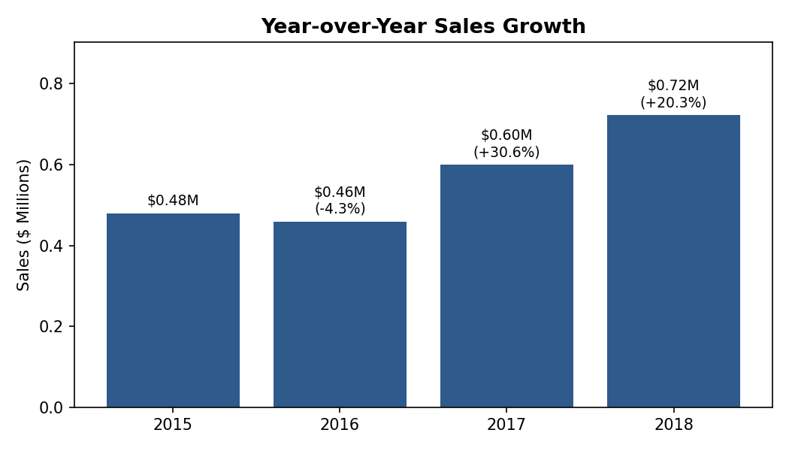
Figure 1: Year-over-year sales growth, 2015–2018.
Sales dipped slightly in 2016 (−4.3%) before rebounding sharply: +30.6% in 2017 and +20.3% in 2018. The four-year trend shows accelerating growth, with 2018 sales roughly 50% higher than the 2016 low point.

4.6 Seasonality
Aggregating all four years by calendar month reveals a clear seasonal pattern: sales are lowest in February and climb steadily through the year, peaking sharply in September and November–December. This end-of-year surge (Sept, Nov, Dec combined make up over 42% of a typical year's sales) aligns with back-to-school and holiday shopping cycles and should inform inventory and staffing planning.

4.7 Top Products
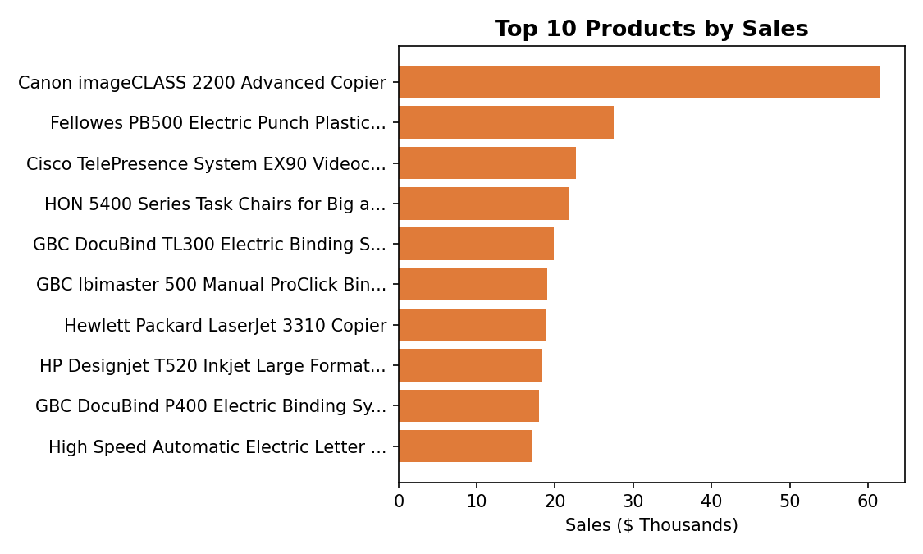
Figure 2: Top 10 products by total sales.
The Canon imageCLASS 2200 Advanced Copier is the single highest-earning product at $61.6K, more than double the next closest item. High-value office equipment (copiers, binding machines, videoconferencing units) dominates the top of the list, consistent with Technology's high average sale value noted in section 4.1.

5. Power BI Dashboard
An interactive Power BI dashboard ("Superstore Sales Dashboard") was built alongside this analysis to allow stakeholders to explore the data themselves. It presents total sales and order KPIs, breakdowns by category, sub-category, segment, region, state and ship mode, and yearly/monthly sales trends, with a region slicer for interactive filtering.
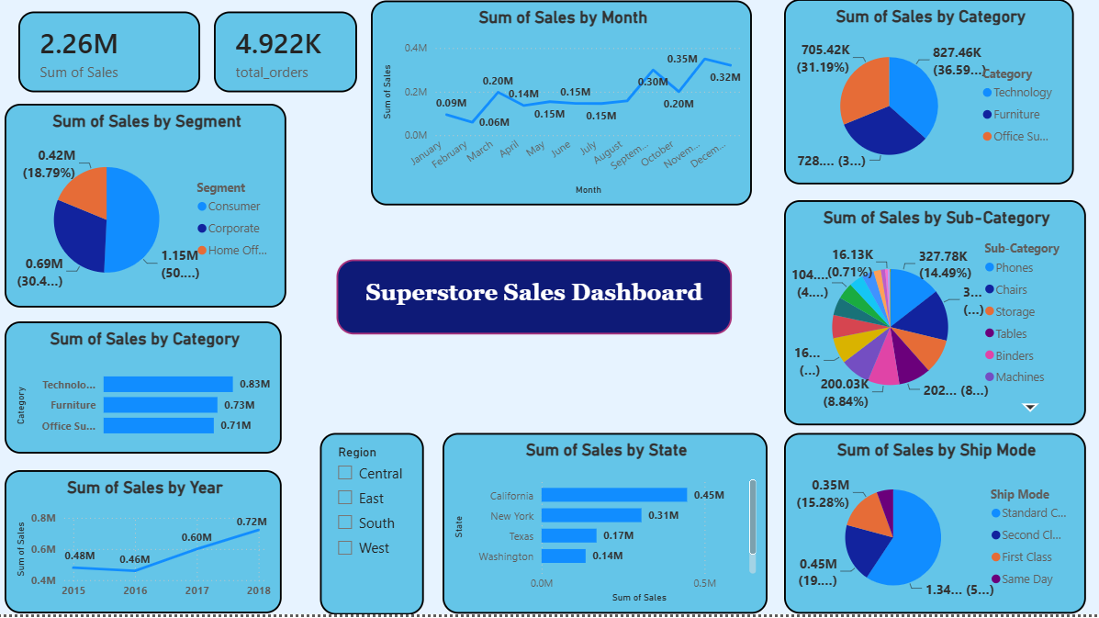
Figure 3: Superstore Sales Dashboard, built in Power BI.
The dashboard file (supersales_store_data_analysis.pbix) is included in the project repository so the report can be explored interactively, filtered by region, or extended with new visuals.

6. Recommendations
- Double down on Technology: it has the highest average order value; consider bundling accessories or extended warranties to lift Furniture and Office Supplies basket sizes toward similar levels.
- Plan inventory and staffing around the September and November–December sales surge identified in the seasonality analysis, rather than a flat year-round baseline.
- Investigate the West/East revenue concentration (California and New York alone drive ~33% of sales) — evaluate whether Central and South regions are under-penetrated or under-marketed.
- Review Standard Class delivery times (5 days average): if customer satisfaction data is available, check whether faster default shipping could improve retention without materially raising cost.
- Use the Corporate and Home Office segments, which together are smaller than Consumer, as a growth target via targeted B2B offers.

7. Conclusion
The Superstore dataset shows a healthy, accelerating sales trajectory from 2015 to 2018, concentrated in a few high-value categories, states, and a predictable seasonal pattern. The accompanying Power BI dashboard operationalizes these findings into a self-service tool, completing the project's EDA → Dashboard → Report workflow.

Appendix: Project Assets
- EDA notebooks/scripts – GitHub repository (data cleaning & initial exploration).
- Power BI report – supersales_store_data_analysis.pbix
- This report – Superstore_Sales_Analysis_Report.docx

