**Business Problem**

BlackRock, as a major asset management company, wants to analyze its equity holdings across various companies and sectors. The goal is to understand portfolio concentration, sectoral exposure, changes in ownership, and market value trends to support investment decisions and risk management.

**Business Objectives**

1. **Clean and Prepare the Dataset**: Convert data types, handle missing values, and ensure columns like “Market Value,” “% Ownership,” and “Change in Shares” are numeric for analysis.
2. **Analyze Investment Distribution**:
   * Explore distribution of market value and ownership across sectors.
   * Calculate and visualize holdings with significant changes in shareholding.
3. **Evaluate Sector Exposure**:
   * Sum total market value by sector to understand where the largest investments lie.
4. **Track Ownership Changes**:
   * Analyze changes in shares held and percent change over time.
5. **Price Movement Insight**:
   * Compare “Quarter End Price” and “Recent Price” to determine value movements.

**insights with Interpretations (Based on Charts & Calculations)**

1. **Histogram of % Ownership**

* **insights**: Most of BlackRock’s investments are small, but there are a few big investments where they own a large chunk.
* **interpretation**: They own small parts of many companies but have major stakes in a few big ones.

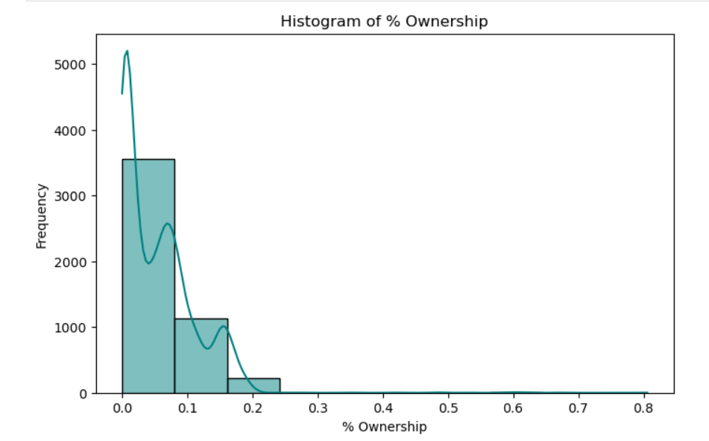

1. **High % Change Filter (> 5%)**

* **insights:** When filtering the data, the analysis highlights companies with more than a 5% change in ownership.
* **interpretation:** These changes indicate areas where BlackRock is either increasing or decreasing its investment significantly, which could be a sign of shifting focus or a reaction to market trends.

1. **Market Value by Sector**

* **insights:** By adding up the market values for each sector, the analysis shows which industries hold the most value.
* **interpretation:** This helps BlackRock understand where most of their money is invested. If one sector dominates, it might indicate a risk of not being diversified enough.

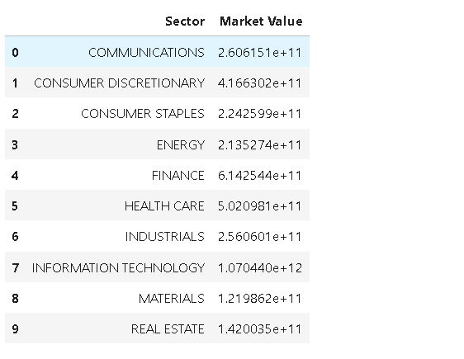

1. **Market Value by Sector (Pie Chart)**

**insights**:This pie chart would break down **how BlackRock’s total investment is spread across different sectors**, like Technology, Health Care, Finance, etc.

**interpretation**:It helps understand if BlackRock is **putting too much money in one sector**, which could be risky if that sector doesn’t perform well.

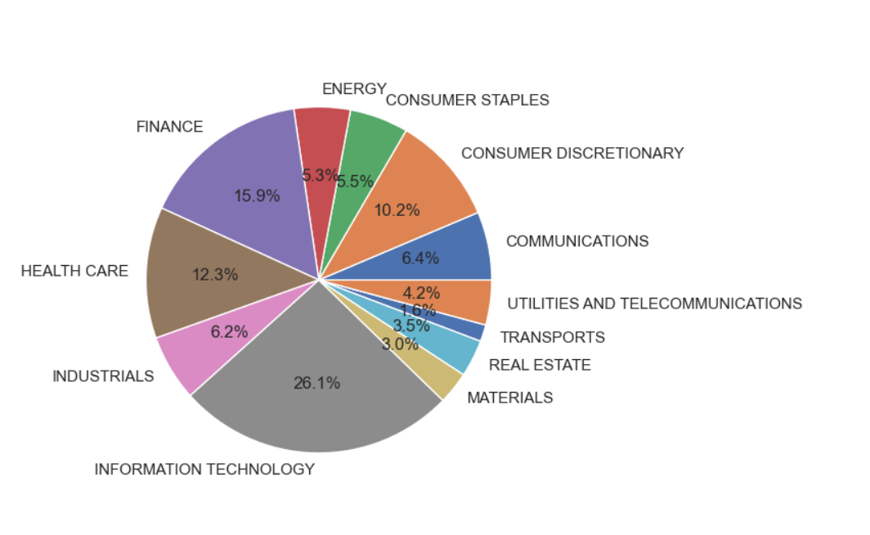

**Business Recommendation**

BlackRock should **review and balance its investments across sectors** to reduce risk. Right now, some sectors have a **very large share** of the total investment. If those sectors underperform, it could hurt the whole portfolio.