Report
Of
Internal Audit Job Simulation (Goldman Sachs, Forage)
Submitted
To
School of Computer Science and Engineering
IILM University, Greater Noida, U.P.
In partial fulfilment of the requirement of degree of
B.Tech CSE

By
Roll Number of Student: 2410030449
Name of Student: HIMANSHU KUMAR
Batch: 2026-27

CANDIDATE’S DECLARATION
I, HIMANSHU KUMAR do hereby declare that the internship report titled “Internal Audit Job Simulation (Goldman Sachs, Forage)” has been completed by me to fulfil the requirement for the award of the degree of Bachelor of Technology in CSE. All the references have been quoted and I have not taken as such any material from any other source. I affirm to you that this report is my own and has not been submitted to any other institute for any degree/diploma requirement and further I shall be solely responsible for any kind of copyright violation in this regard.

Signature
Student Name: HIMANSHU KUMAR
Roll No.: 2410030449

ACKNOWLEDGEMENT
I am using this opportunity to express my gratitude to everyone who supported me throughout the Internship Program. I am thankful for their aspiring guidance, invaluably constructive criticism and friendly advice during this work. I am sincerely grateful to them for sharing their truthful and illuminating views on a number of issues related to this work.
I express my gratitude to my parents for their blessings.

Signature
Student Name: HIMANSHU KUMAR
Roll No.: 2410030449

INTERNSHIP COMPLETION CERTIFICATE
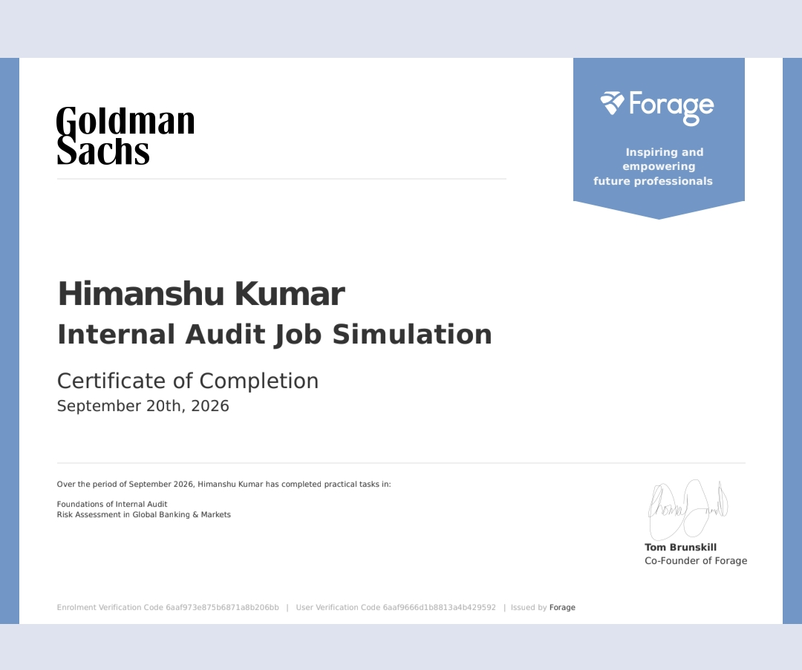

CONTENTS
Chapter No. | Chapter Name | Page Nos.
 | Cover Page | ----
1. | Candidate’s Declaration | i
2. | Acknowledgement | ii
3. | Internship Completion Certificate | ----
 | List of Tables and List of Figures | iv
4. | Project Description | 1
 | 4.1 Introduction | 1
 | 4.2 Organization Profile | 1
 | 4.3 Problem Statement | 1
 | 4.4 Project Objectives | 1
 | 4.5 Scope of the Project | 2
 | 4.6 Technologies and Tools Used | 2
 | 4.7 System Architecture | 2
 | 4.8 Methodology | 2
 | 4.9 Expected Outcomes | 2
 | 4.10 Certificates of completion and other communication mail proof must be attached | 2
5. | Bibliography/References | 4

LIST OF TABLES
Table No. | Title | Page No.
4.1 | Summary of the Internship Programme | 1
4.2 | Details of the Certificate of Completion | 3

LIST OF FIGURES
Figure No. | Title | Page No.
4.1 | Structure of the Internship Programme | 2

CHAPTER 4: PROJECT DESCRIPTION
4.1 Introduction
This report documents the Internal Audit Job Simulation completed by HIMANSHU KUMAR, offered by Goldman Sachs through the Forage platform. The practical tasks were completed during September 2026 and a Certificate of Completion was issued on 20 September 2026.
Internal audit is an independent and objective assurance function that evaluates whether an organization’s governance, risk management and internal controls are working effectively.
As stated on the certificate, practical tasks were completed in two areas: (1) Foundations of Internal Audit and (2) Risk Assessment in Global Banking & Markets.
Table 4.1: Summary of the Internship Programme
Particular | Details
Name of Student | HIMANSHU KUMAR
Roll Number | 2410030449
Programme | Internal Audit Job Simulation
Organization | Goldman Sachs
Issued by | Forage
Period | September 2026
Date of Certificate | 20 September 2026
Practical Tasks Completed | Foundations of Internal Audit; Risk Assessment in Global Banking & Markets

4.2 Organization Profile
Goldman Sachs. Goldman Sachs is a global investment banking, securities and investment management firm, founded in 1869 and headquartered in New York.
Forage. Forage is an online platform that offers virtual job simulations developed with leading companies. Forage issued the Certificate of Completion for this programme.
4.3 Problem Statement
The aim of this internship was to gain practical exposure to the work of internal audit and to the assessment of risk in global banking and markets.
4.4 Project Objectives
- To understand the foundations of internal audit.
- To understand risk assessment in the context of global banking and markets.
- To complete the practical tasks of the Goldman Sachs Internal Audit Job Simulation on Forage.
4.5 Scope of the Project
The scope of the internship is limited to the two practical task areas stated on the certificate: Foundations of Internal Audit and Risk Assessment in Global Banking & Markets. The programme was completed online during September 2026.
4.6 Technologies and Tools Used
The internship was completed online on the Forage platform.
4.7 System Architecture
This internship was a job simulation and not a software development project, so there is no software system architecture. The structure of the programme, as shown on the certificate, is given in Figure 4.1.
Goldman Sachs Internal Audit Job Simulation | Foundations of Internal Audit | Risk Assessment in Global Banking & Markets | Certificate of Completion
Figure 4.1: Structure of the Internship Programme
4.8 Methodology
The internship was completed online through the Forage platform. Practical tasks were completed in the following two areas, in line with the certificate:
- Foundations of Internal Audit
- Risk Assessment in Global Banking & Markets
On completing the practical tasks, a Certificate of Completion was issued by Forage on 20 September 2026.
4.9 Expected Outcomes
The expected outcomes of the internship are:
- Understanding of the foundations of internal audit.
- Understanding of risk assessment in global banking and markets.
- Successful completion of the Internal Audit Job Simulation and receipt of the Certificate of Completion, which has been achieved.
4.10 Certificates of completion and other communication mail proof must be attached
The Certificate of Completion is attached in this report as Chapter 3. Its details are summarised in Table 4.2.
Table 4.2: Details of the Certificate of Completion
Item | Details
Certificate issued to | HIMANSHU KUMAR
Programme | Internal Audit Job Simulation (Goldman Sachs)
Issued by | Forage
Date | 20 September 2026
Practical tasks completed | Foundations of Internal Audit; Risk Assessment in Global Banking & Markets
Enrolment Verification Code | 6aaf973e875b6871a8b206bb
User Verification Code | 6aaf9666d1b8813a4b429592

CHAPTER 5: BIBLIOGRAPHY/REFERENCES
[1] Goldman Sachs, “Goldman Sachs,” goldmansachs.com. [Online]. Available: https://www.goldmansachs.com
[2] Forage, “Goldman Sachs Internal Audit Job Simulation,” theforage.com. [Online]. Available: https://www.theforage.com

