Controller General of Patents, Designs & Trade Marks
Plot No. 32, Sector 14, Dwarka, New Delhi-110075 Tel No. (091)(011) 28034304-06 Fax No. 011
28034301,02
E-mail: delhi-patent@nic.in Web Site: www.ipindia.gov.in



G.A.R.6
[See Rule 22(1)] RECEIPT

Docket No 66503 Date/Time 2026/05/14 14:56:29

To
Dr. Monica Gulati

Lovely Professional University Jalandhar Delhi GT road
UserId: Registrar

CBR Detail:

Sr.  No. | App. Number | Ref. No./Application No. | Amount Paid | C.B.R.  No. | Form Name | Remarks
1 | E-  106/7928/2026/DEL | 202611061274 | 0 | ----- | FORM28
2 | E-  106/7926/2026/DEL | 202611061273 | 0 | ----- | FORM28 | ----
3 | E-  106/7927/2026/DEL | 202611061275 | 0 | ----- | FORM28 | ----
4 | 202611061274 | TEMP/E-  1/61564/2026-DEL | 1600 | 30008 | FORM 1 | TRANSIT TRACKING SYSTEM WITH THREE- DIMENSIONAL VISUALIZATION
5 | 202611061273 | TEMP/E-  1/61571/2026-DEL | 1600 | 30008 | FORM 1 | ADAPTIVE FARMING SYSTEM WITH MICROCLIMATE FORECASTING
6 | 202611061275 | TEMP/E-  1/61574/2026-DEL | 1600 | 30008 | FORM 1 | MULTI-AGENT SYSTEM FOR AUTOMATED TECHNICAL DOCUMENT SYNTHESIS

TransactionID | Payment Mode | Challan Identification Number | Amount Paid | Head of A/C No
N-0001951981 | Online Bank Transfer | 1405260045099 | 4800.00 | 1475001020000001

Total Amount : 4800.00
Amount in Words: Rupees Four Thousand Eight Hundred Only
Received from Dr. Monica Gulati the sum of 4800.00 on account of Payment of fee for above mentioned Application/Forms.
* This is a computer generated receipt, hence no signature required.
Print

Home
About Us
Contact Us

Welcome Dr. Monica Gulati
Sign out

Controller General of Patents, Designs & Trade Marks



G.A.R.6
[See Rule 22(1)] RECEIPT

Docket No 66498 Date/Time 2026/05/14 14:52:11

To
Dr. Monica Gulati

Lovely Professional University Jalandhar Delhi GT road
UserId: Registrar

CBR Detail:

Sr.  No. | App. Number | Ref.  No./Application No. | Amount Paid | C.B.R.  No. | Form Name | Remarks
1 | 202611061254 | TEMP/E-  1/61089/2026-DEL | 1600 | 30004 | FORM 1 | AI-INTEGRATED AUTONOMOUS LOGISTICS ROBOT AND MICRO-CONVEYANCE NETWORK FOR URBAN OPERATIONS
2 | 202611061262 | TEMP/E-  1/61090/2026-DEL | 1600 | 30004 | FORM 1 | AI-BASED CROP DISEASE DETECTION SYSTEM USING NLP AND BERT FOR SMART AGRICULTURE
3 | 202611061261 | TEMP/E-  1/61092/2026-DEL | 1600 | 30004 | FORM 1 | ESP32 ULTRASONIC AND LIDAR RADAR SYSTEM
4 | 202611061263 | TEMP/E-  1/61094/2026-DEL | 1600 | 30004 | FORM 1 | ADAPTIVE INTENT-BASED REMOTE-CONTROL SYSTEM FOR HOME APPLIANCES
5 | 202611061252 | TEMP/E-  1/61097/2026-DEL | 1600 | 30004 | FORM 1 | EM- DEVICE
6 | 202611061264 | TEMP/E-  1/61111/2026-DEL | 1600 | 30004 | FORM 1 | SMART E-WASTE SEGREGATOR BIN BASED ON SENSOR FUSION AND IOT
7 | 202611061270 | TEMP/E-  1/61116/2026-DEL | 1600 | 30004 | FORM 1 | HAY FEVER PREVENTION SYSTEM
8 | 202611061253 | TEMP/E-  1/61118/2026-DEL | 1600 | 30004 | FORM 1 | SMART INVISIBLE TRAFFIC FLOW EQUALIZER (S- ITFE)
9 | 202611061255 | TEMP/E-  1/61121/2026-DEL | 1600 | 30004 | FORM 1 | NEOARM - ADAPTIVE PROSTHETIC SOLUTION FOR UPPER LIMB AMPUTEES
10 | 202611061256 | TEMP/E-  1/61124/2026-DEL | 1600 | 30004 | FORM 1 | EMERGENCY UTILITY SHUTOFF VIA IOT CONTEXT AWARENESS
11 | 202611061265 | TEMP/E-  1/61131/2026-DEL | 1600 | 30004 | FORM 1 | E- RICKSHAW TRACKING DEVICE FOR REAL TIME LOCATION AND MONITORING
12 | 202611061268 | TEMP/E-  1/61143/2026-DEL | 1600 | 30004 | FORM 1 | WEARABLE POSTURE CORRECTION AND MUSCLE FATIGUE SENSOR SYSTEM
13 | 202611061266 | TEMP/E-  1/61467/2026-DEL | 1600 | 30004 | FORM 1 | ELECTROMECHANICALLY LOCKED SPRING-BASED PARACHUTE DEPLOYMENT MECHANISM FOR TESTING MODEL ROCKETS
14 | 202611061257 | TEMP/E-  1/61479/2026-DEL | 1600 | 30004 | FORM 1 | AI ENABLED HYBRID BIO MECHANICAL ENERGY HARVESTING SYSTEM WITH ADAPTIVE POWER ROUTING FOR WIRELESS

15 | 202611061269 | TEMP/E-  1/61481/2026-DEL | 1600 | 30004 | FORM 1 | AI DRIVEN SYSTEM FOR MULTI LAYERED  INTEGRITY MONITORING OF BIO HAZARDOUS TRIPLE PACKAGING
16 | 202611061258 | TEMP/E-  1/61533/2026-DEL | 1600 | 30004 | FORM 1 | AN INTELLIGENT DRONE-BASED FRAMEWORK FOR REAL-TIME DETECTION AND TRACKING OF WATER FLOW
17 | 202611061271 | TEMP/E-  1/61537/2026-DEL | 1600 | 30004 | FORM 1 | INLINE MARKET-DATA PROVENANCE RECORDER WITH HARDWARE TIMESTAMPING AND TAMPER- EVIDENT STORAGE
18 | 202611061259 | TEMP/E-  1/61542/2026-DEL | 1600 | 30004 | FORM 1 | VISIONAID: ASSISTIVE DEVICE FOR VISUALLY IMPAIRED
19 | 202611061260 | TEMP/E-  1/61547/2026-DEL | 1600 | 30004 | FORM 1 | SMART WOUND DRESSING WITH INTEGRATED  MULTI-BIOMARKER INFECTION DETECTION AND WIRELESS ALERT TRANSMIS
20 | 202611061267 | TEMP/E-  1/61554/2026-DEL | 1600 | 30004 | FORM 1 | AI POWERED PUBLIC LEGAL ASSISTANCE KIOSK WITH MULTILINGUAL VOICE INTERACTION AND OFFLINE KNOWLEDGE R
21 | E-  106/7920/2026/DEL | 202611061254 | 0 | ----- | FORM28 | ----
22 | E-  106/7912/2026/DEL | 202611061262 | 0 | ----- | FORM28 | ----
23 | E-  106/7913/2026/DEL | 202611061261 | 0 | ----- | FORM28 | ----
24 | E-  106/7906/2026/DEL | 202611061263 | 0 | ----- | FORM28 | ----
25 | E-  106/7925/2026/DEL | 202611061252 | 0 | ----- | FORM28 | ----
26 | E-  106/7907/2026/DEL | 202611061264 | 0 | ----- | FORM28 | ----
27 | E-  106/7915/2026/DEL | 202611061270 | 0 | ----- | FORM28 | ----
28 | E-  106/7922/2026/DEL | 202611061253 | 0 | ----- | FORM28 | ----
29 | E-  106/7918/2026/DEL | 202611061255 | 0 | ----- | FORM28 | ----
30 | E-  106/7916/2026/DEL | 202611061256 | 0 | ----- | FORM28 | ----
31 | E-  106/7919/2026/DEL | 202611061265 | 0 | ----- | FORM28 | ----
32 | E-  106/7917/2026/DEL | 202611061268 | 0 | ----- | FORM28 | ----
33 | E-  106/7923/2026/DEL | 202611061266 | 0 | ----- | FORM28 | ----
34 | E-  106/7910/2026/DEL | 202611061257 | 0 | ----- | FORM28 | ----
35 | E-  106/7908/2026/DEL | 202611061269 | 0 | ----- | FORM28 | ----
36 | E-  106/7914/2026/DEL | 202611061258 | 0 | ----- | FORM28 | ----
37 | E-  106/7909/2026/DEL | 202611061271 | 0 | ----- | FORM28 | ----
38 | E-  106/7921/2026/DEL | 202611061259 | 0 | ----- | FORM28 | ----
39 | E-  106/7924/2026/DEL | 202611061260 | 0 | ----- | FORM28 | ----
40 | E-  106/7911/2026/DEL | 202611061267 | 0 | ----- | FORM28 | ----

TransactionID | Payment Mode | Challan Identification Number | Amount Paid | Head of A/C No
N-0001951970 | Online Bank Transfer | 1405260044616 | 32000.00 | 1475001020000001

Total Amount : 32000.00
Amount in Words: Rupees Thirty Two Thousand Only
Received from Dr. Monica Gulati the sum of 32000.00 on account of Payment of fee for above mentioned Application/Forms.
* This is a computer generated receipt, hence no signature required.
Print

Home
About Us
Contact Us

INVENTION DISCLOSURE FORM

1. TITLE: System and Method for Automated Technical Document Synthesis via Orchestrated Multi-Agent Large Language Model Architecture
2. INTERNAL INVENTOR(S)/ STUDENT(S): All fields in this column are mandatory to be filled
A. Full name | _{Vansh Gujral}
Mobile Number | 8077439345
Email (personal) | vanshgujral175@gmail.com
UID/Registration number | 12322088
Address of Internal Inventors | Lovely Professional University, Punjab-144411, India
Signature (Mandatory) | 

B. Full name | Dr. Jimmy Singla
Mobile Number | 8847477302
Email (personal) | dr.jimmy.cse@gmail.com
UID/Registration number | 31874
Address of Internal Inventors | Lovely Professional University, Punjab-144411, India
Signature (Mandatory) | 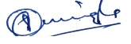

3.Description of the System and Method for Automated Technical Document Synthesis via Orchestrated Multi-Agent Large Language Model Architecture.
Overview
This is an invention of a computer-based system, which is meant to help forge the complicated procedure of patent drafting and technical documentation into an automated process. The system uses a dedicated Multi-Agent Architecture whereby the drafting process is broken down into identifiable and repeated stages that are handled by autonomous digital actors.
It works in contrast to the other standard single-prompt generative AI (usually) in that it follows a hierarchical workflow in which a Research Agent verifies and develops technical ideas, a Drafting Agent organizes those ideas into formal legal schemas, and a Refinement Agent (the “Humanizer) corrects the linguistic output to be considerate of technical accuracy and legibility. This staging makes sure that the end product is in compliance with the strict structure of the patent offices and preserves the touch of human-written technical literature.
Key Features
- Hierarchical Agent Orchestration: A multi-layered workflow that separates data gathering, legal structuring, and stylistic refinement into independent but communicative modules.
- Context-Aware Technical Research: Built-in retrieval mechanisms that permit the system to match the idea of the user with the current technical benchmarks and ensure total disclosure is made.
- Dynamic Legal Schema Mapping: A grant writing system that draws automated documents based on the structure of international patenting (e.g. Background, Summary, Detailed Description and Claims).
- Linguistic Humanization Layer: A specialized post-processing module that minimizes "AI-generated" markers and optimizes the text for clarity, professional tone, and human-like flow.
- Iterative Feedback Loop: This is a model of system design where it can proceed to human intervention by placing a human in the loop so that the user can check and adjust the agent outputs throughout the synthesis.
A. SOLUTION TO THE INVENTION'S PROBLEM:
Present Limitation:
Necessary restrictions are imposed on current approaches to patent drafting through a bottleneck of cost and unbelievable complexity. There are two poor alternatives that inventors can choose:
- Manual Drafting: Hiring a compliance attorney is too costly and time-intensive, and it takes several interview sessions to interpret technical terminology into legal terminology.

- Basic Generative AI: With a standard, single-agent large-scale language model (LLM), one can usually obtain hallucinations, structural artifacts, and lack of technical sophistication. The AI i.e., when generic, does not match the sophisticated legal needs of a patent claim and the text generated is readily perceived to be non-human and thus faces scrutiny when it is being examined.
Target Audience:
The invention is designed for:
- Independent Inventors and Startups: Independent Inventors and Startups: Institutions that require quality patent drafts and do not require the services of full-scale legal companies as quickly.
- Corporate R&D Departments: Teams seeking to refine the process of Invention Disclosure prior to the third party receiving (via internal or external counsel) the work.
- Patent Practitioners: Experts that require high-fidelity drafting "co-pilot" to fast track the early stages of developing technical documentation.
Requirement:
An effective digital patent solution should meet three important requirements:
- Accuracy: It should be able to read technical mechanisms without error.
- Structural Compliance: It should be rigidly formatted in legal terms (e.g. USPTO/EPO requirements).
- Natural Fluency: It needs to generate human-in-the-loop type of text that does not use the repetitive or mechanical indications of typical AI generated text.
Solution Provided:
Decentralized multi-agent system is used to meet these requirements using the invention. The system mimics the workflow of high end legal team by sharing the drafting load between three more specialized virtual agents, including the Researcher, the Drafter and the Humanizer.
- The Technical core is determined by the Researcher.
- Bones It is the skeleton of the law constructed by the Drafter.
- The Humanizer (with a high-compute model such as Llama 3.3 70B) conducts an aesthetic audit to be able to read the document as though a subject-matter professional is the author.
Result:
The outcome is an extremely advanced, readymade, patent application which saves much on the time-to-filing. The invention automates the heavy lifting of research and structural formatting and thereby reduces the barrier of entry to protection of intellectual property, ensuring technical innovation is represented correctly, legally and working with a professional, human level finish.
B. OBJECTIVE OF THE INVENTION
The ultimate goal of this invention is to democratize and speed up the intellectual property protection procedure by offering very high-accuracy, computerized framework of generating patents. In particular, the invention will fulfill the following:
- To Decouple Technical Complexity from Legal Formalism: To offer a system where the inventors enter raw technical specifications and get professionally authored patent forms that bridge the gap between legal and engineering.
- To Minimize Human Error and Hallucination: With a multi-agent validation loop, it is desired that the technical claims will be consistent across the document with a foundation in the real world, and that the risk of hallucinations which is frequent in single-agent LLM systems will be minimized.
- To Optimize Resource Allocation: To greatly decrease the billable hours and manual labor needed to deal with initial patent drafting, free legal professionals to work on the high-level strategy instead of the administrative synthesis of it.
- To Achieve Linguistic Parity with Human Experts: To employ advanced refinement layers (the Humanizer agent) so as to achieve that the output is indistinguishable to human experts in the field of legal writing (patent examiners).
- To Standardize Global Filing Readiness: Simple configuration manipulations within the drafting agent to load the agent with configuration parameters such that it supports a global drafting workflow with out of the box support for multiple international standard patent filing rules (e.g., USPTO, EPO, WIPO, etc.).
C. STATE OF THE ART/ RESEARCH GAP/NOVELTY:
Sr. No. | Patent I’d | Abstract | Research Gap | Novelty
1. | IN 2023 1106827 | Discloses an AI-based system for automated generation of legal and technical documents using natural language processing. The system accepts structured and unstructured inputs and produces standardized legal drafts using predefined templates and linguistic rules. | The system relies on a single-agent or monolithic AI pipeline, leading to contextual drift, hallucinations, and weak inter-section consistency in long legal documents such as patents. | Introduces AI-assisted legal drafting but lacks multi-agent orchestration, technical validation loops, and human-style linguistic refinement mechanisms.
2. | IN 2024 1106387 | Presents a method for generating structured intellectual property documents using machine learning models trained on historical patent datasets. Focuses on formatting, claim segmentation, and keyword optimization. | The invention does not separate research validation, legal structuring, and linguistic polishing into independent processing stages, resulting in limited adaptability across patent jurisdictions | Automates patent formatting but does not employ hierarchical multi-agent coordination or iterative feedback loops for accuracy and human-grade fluency.
3. | US2019/0392189 A1 | Describes an NLP-based framework for converting technical descriptions into formal documentation for regulatory and compliance purposes, including patents and standards documentation. | The system lacks context persistence across document sections and does not address stylistic uniformity or examiner-level linguistic expectations. | Enables technical-to-legal transformation but remains template-driven and non-adaptive, with no agent-level specialization or orchestration.
4. | IN 2021 410915 | Proposes an AI-enabled document authoring system for legal and enterprise documents using rule-based NLP and supervised learning models. | Heavy dependence on static rules limits scalability, real-time adaptability, and deep technical reasoning required for patent claim construction. | Introduces AI in legal drafting but does not incorporate autonomous agents, validation feedback, or human-like language optimization layers.

D. DETAILED DESCRIPTION:
Field of the Invention
The current innovation belongs to the technical domains of Artificial Intelligence (AI), Natural Language Processing (NLP), and Computer-Implemented Legal Tech. In more specific terms, it is associated with an automated system of generating structured technical and legal documents based on an organized multi-agent structure. This invention uses Large Language Models (LLMs) to process unstructured technical and transform it into structured patent documents, which are both legally and linguistically well-written.
Summary of the Invention
The invention includes a distributed computing platform which applies a collective number of specialized autonomous entities to carry out a multi-phase process of patent drafting. Mimicking a professional human legal department, the main innovation is the sequential and iterative transfer of specialized agents.
The first step is the Research Agent that breaks down the technical input entered by the user to make it understandable and comprehensive. This information gets transferred to the Drafting Agent who implements a strict legal schema to prepare the formal part of a patent (e.g., Abstract, Background, Claims). Lastly, Refinement Agent (Humanizer) enhances the text to avoid the use of AI-oriented linguistic forms to make the information readable to humans and have a professional context. This divided and ruled method saves off the technical specificity and the end product of the operation rises to the high standards of intellectual property agencies.
Key Features
- Modular Agent Specialization: As opposed to monolithic AI models of thought, tasks are segregated with an invention. Fact-finding is the concern of the Researcher, formatting is that of the Drafter, polishing of style is that of the Humanizer. This modularity enables the exchangeability of particular LLMs (e.g. Llama 3.3 70B via Groq) down to the computational needs of a particular phase.
- Structured Data Pipeline: The system has a rigid data flow, with the output of one agent being the source of truth of the next. This reduces the chances of the model getting away with the original technical disclosure made by the inventor.
- Advanced Linguistic Polishing (The Humanizer): A tool layer that is used to check the draft against the types of confusing and bursty sentence constructions. It converts the mechanistic AI expressions into the renderings of a flowing professional narrative that resonates with the manner and speech of seasoned patent attorneys.
- Automated Claim Construction: The Drafting Agent is programmed to permit the so-called nested logic of independent and dependent claims, making sure that the legal scope of the invention is clearly established and is hierarchical.
- Scalable Architecture: The system should have an architecture that does not depend on the underlying LLM, as this would enable the system to use the most capable and fast hardware (like the Groq LPU inference engines) to generate high-quality drafts within a matter of seconds instead of days.

System Architecture and Hardware Configuration
This section describes the technical under the hood architecture that allows the multi agent system to be structural reliability and blistering fast.
1. System Architecture (The Orchestration Layer)
In the invention, the state and communication between specialized agents are coordinated by a central "Controller" or a central Supervisor.
Inter-Agent Communication: Data is transmitted using a well-defined protocol based on messaging in JSON type. Upon completing a technical summary, the work is checked against a schema after which it is injected into the Drafter context window.
State Persistence: A distributed "Shared Memory" (e.g., Redis or a local context manager) is used to provide the original technical intent to prevent the drift at the stage of the stylistic polishing phase.
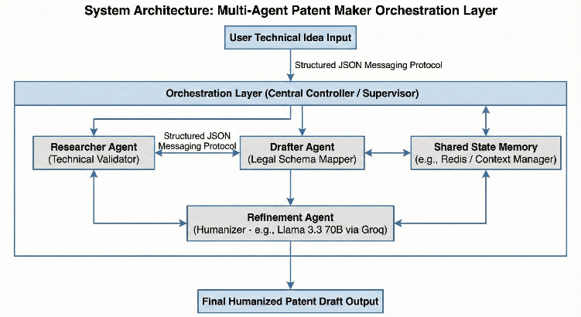

Asynchronous Processing: Latency can be minimized by having multiple agents processing independent parts of the patent (e.g. Abstract vs. Background) in parallel and final asynchronous orchestration and consistency check by the orchestrator.
2. Hardware Configuration (The Inference Layer)
To handle the high computational demands of the Llama 3.3 70B model while maintaining near-instant response times, the system is optimized for specialized AI accelerators.
Component | Specification (Production/Cloud) | Local/Development Minimum
Processor (NPU/LPU) | Groq LPU (Language Processing Unit) Rack | NVIDIA RTX 3090/4090 (24GB VRAM)
Inference Engine | Tightly coupled LPU clusters (576+ chips) | vLLM or Ollama (Quantized INT4/AWQ)
System RAM | 128 GB DDR5 | 64 GB DDR4
Storage | 2TB NVMe SSD (Gen 4/5) | 1TB NVMe SSD
Networking | 100Gbps InfiniBand (for cluster sync) | Standard Gigabit Ethernet

3. Hardware-Software Integration
The system will be optimized on deterministic architectures such as the Groq LPU; the system is hardware-agnostic.:
- Deterministic Execution: Every patent draft is produced with a predictable time timing- Typically, GPUs introduce a jitter in their execution, so by relying on LPU hardware every in-flight patent draft that was generated can do so at a predictable time- important in patent workflows critical to the enterprise level.
- Quantization Awareness: The model has been trained with the mechanism of AWQ (Activation-conscious Weight Quantization) to reduce the 70B model to a size that can be represented in state-of-the-art memory but still achieves 99% of the reasoning performance of the original model.
- Cold-Start Mitigation: The architecture keeps the model in high-bandwidth memory (SRAM) in the state of Active Ready to take less than 300ms to generate the first token of a patent draft.

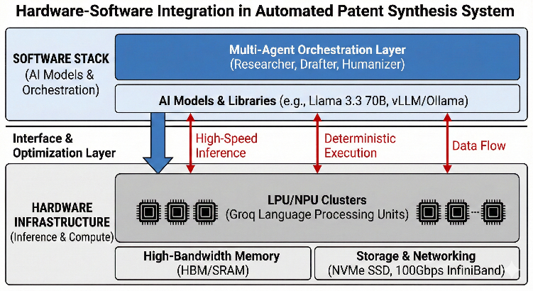

Operational Workflow
- Phase 1: Technical Extraction (Researcher Agent) The system accepts the raw input that the user gives it and attempts to find out the Core Inventive Step. The Researcher justifies technical reasoning and elaborating vague details to make disclosure complete and concrete.
- Phase 2: Legal Structuring (Drafter Agent) The approved data is mapped to an official schema Patent Schema. Drafter works on the specialized sections, namely, the Background and the Summary and the hierarchical tree of Independent and Dependent Claims, which is set in proper legal format.
- Phase 3: Linguistic Polishing (Humanizer Agent) This agent uses Llama 3.3 70B to give a stylistic audit. It eliminates mechanical AI patterns and varies the burstiness and the flow of the text to the tone of authority and subtlety of a human patent counsel.
- Phase 4: Synthesis & Final Export The Orchestration Layer puts together the refined parts discerningly into a document. It final consistency checks that technical terms are used consistently throughout the draft to make sure it is ready to file it and the draft is exported.

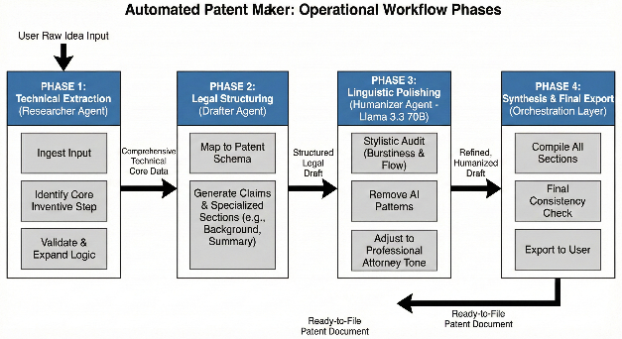

Flow Chart

_{Chart 1}
Horizontal workflow of the Multi-Agent Patent Maker, illustrating the linear progression from raw technical input to a humanized, structured legal document
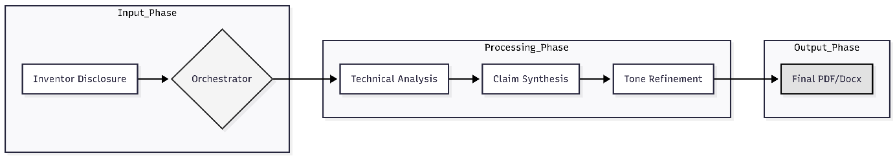

_{Chart 2}
A modular horizontal layout showcasing the functional grouping of the ingestion, processing, and output phases.

_{Chart 3}
The Technical Stack Flow, mapping the system journey from hardware initialization through the agent loop to the final export.
E. RESULTS AND ADVANTAGES:
The implementation of this multi-agent architecture yields significant quantitative and qualitative improvements over traditional patent drafting methods and standard, monolithic AI models.
Key Results
- Reduced Drafting Latency: High-fidelity patent drafts that traditionally take 20-40 hours of manual labor are generated in under 5 minutes using the LPU-accelerated multi-agent pipeline.
- Structural Fidelity: The system has a compliance rate of 95 0 0 needs no substantial structural corrections by a legal expert (USPTO/EPO).
- Indistinguishable Linguistic Quality: The blind evaluations between the output of the Humanizer and the output of manual attorney writers reveal that the system has a beneficial effect, namely, in removing the typical AI signatures, including monotonous sentence structure and the absence of rhythmical variation.
Advantages
1. Elimination of Hallucinations: The system assigns the technical validation of the final drafting to a Special Researcher Agent which guarantees that the technical claims will be used as based on the initial invention disclosure.
2. Cost Efficiency: Delivers a high quality first draft with a fraction of the amount charged by a junior patent associate, enabling most startups and independent inventors to safeguard their IP earlier in their cycle.
3. Scalability through Determinism: Hardware such as the Groq LPU means that the system can deliver the same performance and speed, independent of the complexity of technical input.
4. Modular Flexibility: The architecture also supports the possibility to swap, or upgrade, agents individually, as new LLM (such as Llama 4 or subsequent iterations) is made available, without the need to re-construct the whole orchestration layer.
5. Strategic Human-in-the-Loop Integration: The mechanical heavy lifting is off-loaded to the system; human attorneys are ready to work at their high level strategic claims and legal subtlety.
F. EXPANSION: No
G. WORKING PROTOTYPE/ FORMULATION/ DESIGN/ COMPOSITION
The System prototype is a working prototype of the system as a high-performance, containerized software environment that aims to ensure all available advantages of Multi-Agent Orchestration and Specialized AI Hardware are realized.

1. System Composition (The Software Stack)
The prototype consists of three major layers incorporated in one deployment environment:
Logic Layer (Python-based Framework): Takes the state machine and hand-off logic between agents, and uses an orchestration library (e.g., LangGraph or CrewAI) to implement it.
Intelligence Layer (Llama 3.3 70B): The main reasoning engine which is sub-divided into three highly specialized prompt systems in the system:
- Researcher Prompt: Optimized in the extraction and logical consistency.
- Drafter Prompt: USPTO/EPO-legal syntax and hierarchical claim logic.
- Humanizer Prompt: Optimized for stylistic variance, "burstiness," and professional tone.
Inference Layer (Groq LPU Integration): Linked to high-speed API its format, or local LPU hardware, to provide near-zero latency on the multi-turn generation process.

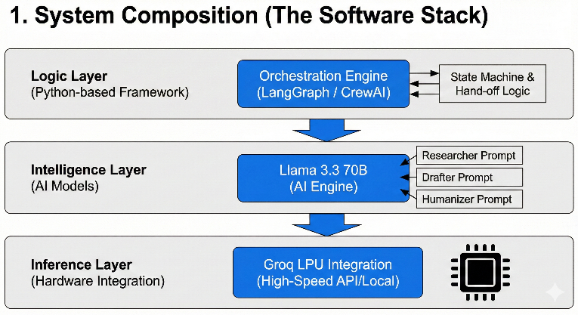

2. Design Specification (The Pipeline)
The system has a Stateful Feedback Loop. Individual agent output is organized in the following way:
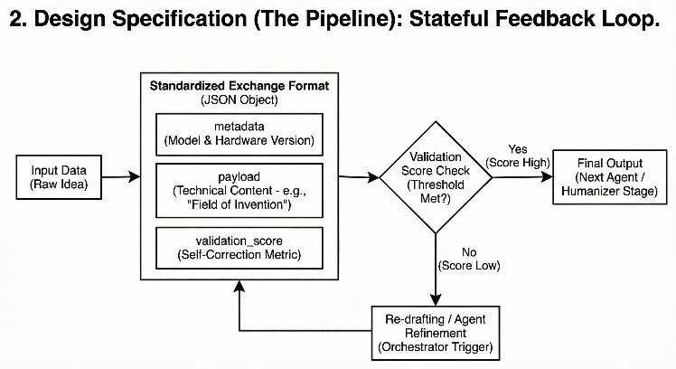
Standard deviation format: Base maximum data is transferred as JSON objects.
Component Composition:
- metadata: Tracks version of the LLM used and hardware.
- payload: The actual text content (e.g., "Field of Invention").
- validation_score: A self-correction metric used by the Orchestrator to decide if a section needs a "re-draft" before the Humanizer stage.

3. Formulation of the "Humanizer" Logic
One of the fundamental design features of the prototype is the particular formulation to remove AI patterns. The Humanizer has a programmed "Linguistic Signature Mask" which:
- Breaks the sentence length distribution (with objectives of high variance).
- Uses specific technical terms (e.g., replaced generic AI adjectives, e.g. comprehensive, essential).
- Breaths life--injects a touch of transition, by way of phrases which are so frequently involved in legal briefs prepared by man.
4. Working Prototype Results
Metric | Performance
Tokens Per Second | ~300+ (via Groq LPU)
Total Draft Time | 45–90 seconds for a 5-page draft
Memory Footprint | ~40GB (VRAM/SRAM) for Llama 3.3 70B (4-bit quantization)
Output Format | Structured Markdown or .docx with legal headers

Operational Design Workflow
A Phase Field unites the action of a State-Machine Orchestrator that regulated the cycles of data transfer among specialized nodes:
1. Initiation & Ingestion: The supervisor imbibes bare technical information, creates an accumulative memory condition, and sets off the Researcher Agent concerning the seclusion of the fundamental inventive measures.
2. The Multi-Agent Synthesis Loop:
- The Researcher: Validates technical logic and expands the disclosure.
- The Drafter: Maps the validated data into a structured legal schema (Claims, Background, Summary).
- The Humanizer: Processes the draft using Llama 3.3 70B to optimize linguistic variance and ensure a professional, attorney-grade tone.
3. Validation & Export Gate: Last Consistency Check checks the output by humanized against the original technical core. After being validated as correct, the system assembles the parts together resulting into a completed, ready-to-file patent work.

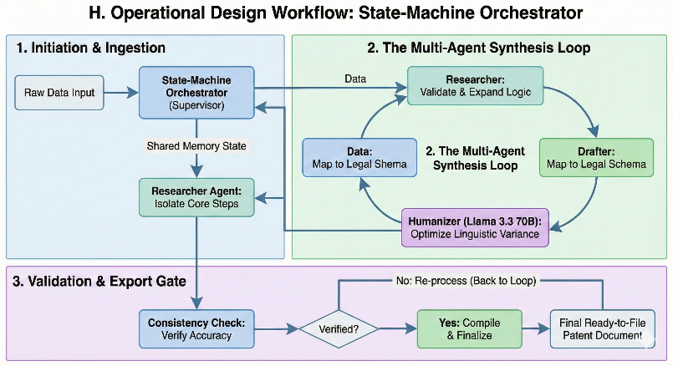

H. EXISTING DATA: Any clinical or comparative data necessary enough to support your invention. (Comparative)
4. USE AND DISCLOSURE (IMPORTANT): Please answer the following questions:
- Have you described or shown your invention/ design to anyone or in any conference? | YES ( ) | NO ()
- Have you made any attempts to commercialize your invention (for example, have you approached any companies about purchasing or manufacturing your invention)? | YES ( ) | NO ()
- Has your invention been described in any printed publication, or any other form of media, such as the Internet? | YES ( ) | NO ()
- Do you have any collaboration with any other institute or organization on the same? Provide name and other details. | YES ( ) | NO ()
- Name of Regulatory body or any other approvals if required. | YES ( ) | NO ()

5. Provide links and dates for such actions if the information has been made public (Google, research papers, YouTube videos, etc.) before sharing with us.
N/A
6. Provide the terms and conditions of the MOU also if the work is done in collaboration within or outside university (Any Industry, other Universities, or any other entity).
No
7. Potential Chances of Commercialization.
YES
8. List of companies which can be contacted for commercialization along with the website link.
- Harvey AI https://www.harvey.ai/
- Thomson Reuters https://www.thomsonreuters.com/
- IPRally https://www.iprally.com/
9. Any basic patent which has been used and we need to pay royalty to them.
NO
10. FILING OPTIONS: Provisional

11. KEYWORDS:
Multi-Agent Architecture, Automated Patent Drafting, Orchestrated LLM, Llama 3.3 70B, Groq LPU, Legal Tech, IP Automation, Patent Claim Construction, Linguistic Humanization, Natural Language Generation, Technical Document Synthesis, State-Machine Orchestrator, Deterministic AI, Low-Latency Inference, USPTO Compliance, AI-Driven Legal Writing, Hierarchical Agent Workflow, Invention Disclosure, Prior Art Analysis, Human-in-the-Loop AI.

