Welcome Dr. Monica Gulati
Sign out

Controller General of Patents, Designs & Trade Marks



G.A.R.6
[See Rule 22(1)] RECEIPT

Docket No 69386 Date/Time 2026/05/20 14:47:00

To
Dr. Monica Gulati

Lovely Professional University Jalandhar Delhi GT road
UserId: Registrar

CBR Detail:

Sr.  No. | App. Number | Ref.  No./Application No. | Amount Paid | C.B.R.  No. | Form Name | Remarks
1 | 202611063669 | TEMP/E-  1/66696/2026-DEL | 1600 | 31118 | FORM 1 | FORMULATION AND EVALUATION OF AN  ETODOLAC EMULGEL LOADED WITH GREEN SYNTHESIZED SILVER NANOPARTICLES
2 | 202611063659 | TEMP/E-  1/66755/2026-DEL | 1600 | 31118 | FORM 1 | THE SMART DIASTASIS RECTI (DRA)  REHABILITATION BINDER WITH STRAIN-GAUGE MONITORING SYSTEM
3 | 202611063666 | TEMP/E-  1/66763/2026-DEL | 1600 | 31118 | FORM 1 | AUTONOMOUS VENOUS VERIFICATION AND INTERLOCK SYSTEM FOR HIGH-RISK MEDICATED INFUSION
4 | 202611063658 | TEMP/E-  1/66775/2026-DEL | 1600 | 31118 | FORM 1 | MULTISENSORY ASSESSMENT PEN DEVICE
5 | 202611063675 | TEMP/E-  1/66802/2026-DEL | 1600 | 31118 | FORM 1 | WEARABLE LIVING PLANT JEWELLERY WITH GROWTH SUBSTRATE
6 | 202611063676 | TEMP/E-  1/66811/2026-DEL | 1600 | 31118 | FORM 1 | BSF OIL-BASED SUSTAINABLE CLEANSING BLOCK COMPOSITION
7 | 202611063664 | TEMP/E-  1/66818/2026-DEL | 1600 | 31118 | FORM 1 | ORGANIC HONEY BEE SWARM ATTRACTANT COMPOSITION
8 | 202611063660 | TEMP/E-  1/66825/2026-DEL | 1600 | 31118 | FORM 1 | INDUCED RESISTANCE CONSORTIA FOR PLANT HEALTH ENHANCEMENT
9 | 202611063677 | TEMP/E-  1/66840/2026-DEL | 1600 | 31118 | FORM 1 | MUSHROOM-BASED NUTRIENT-ENRICHED READY-TO-ROAST WAFER COMPOSITION
10 | 202611063670 | TEMP/E-  1/66855/2026-DEL | 1600 | 31118 | FORM 1 | SMART BIO-ENZYME SYSTEM FOR FODDER OPTIMIZATION
11 | 202611063671 | TEMP/E-  1/66864/2026-DEL | 1600 | 31118 | FORM 1 | CONTROLLED-RELEASE MUSTARD CAKE BIOFERTILIZER PELLETS
12 | 202611063662 | TEMP/E-  1/66874/2026-DEL | 1600 | 31118 | FORM 1 | BIO-PRIMING METHOD FOR ENHANCED FRUIT SHELF LIFE
13 | 202611063672 | TEMP/E-  1/66880/2026-DEL | 1600 | 31118 | FORM 1 | CARBENDAZIM-TOLERANT PYTHIUM FOR SOIL PATHOGEN CONTROL
14 | 202611063667 | TEMP/E-  1/66885/2026-DEL | 1600 | 31118 | FORM 1 | NEEM-COMPATIBLE AMPELOMYCES FOR POWDERY MILDEW CONTROL

15 | 202611063668 | TEMP/E-  1/66983/2026-DEL | 1600 | 31118 | FORM 1 | HEALYN AI: A MULTI-MODAL AI SYSTEM FOR ITERATIVE DISEASE SCREENING AND  PERSONALIZED HEALTH OPTIMIZAT
16 | 202611063661 | TEMP/E-  1/66992/2026-DEL | 1600 | 31118 | FORM 1 | DECENTRALIZED SMART WATER GRID SYSTEM FOR REAL-TIME LEAK DETECTION AND  AUTOMATED FLOW CONTROL
17 | 202611063673 | TEMP/E-  1/67016/2026-DEL | 1600 | 31118 | FORM 1 | MULTI-MODAL AI FOR ADAPTIVE "SILENT" MENTAL HEALTH MONITORING
18 | 202611063665 | TEMP/E-  1/67034/2026-DEL | 1600 | 31118 | FORM 1 | AI ASSISTED WEARABLE SYSTEM FOR OBJECTIVE CLASSROOM TEACHING EVALUATION, REAL-TIME FEEDBACK
19 | 202611063674 | TEMP/E-  1/67099/2026-DEL | 1600 | 31118 | FORM 1 | AN INTEGRATED PHYSIOLOGICAL RESPONSE-BASED GYM TRAINING AND SAFETY CONTROL SYSTEM
20 | E-  106/8167/2026/DEL | 202611063669 | 0 | ----- | FORM28 | ----
21 | E-  106/8157/2026/DEL | 202611063659 | 0 | ----- | FORM28 | ----
22 | E-  106/8170/2026/DEL | 202611063666 | 0 | ----- | FORM28 | ----
23 | E-  106/8158/2026/DEL | 202611063658 | 0 | ----- | FORM28 | ----
24 | E-  106/8171/2026/DEL | 202611063675 | 0 | ----- | FORM28 | ----
25 | E-  106/8159/2026/DEL | 202611063676 | 0 | ----- | FORM28 | ----
26 | E-  106/8163/2026/DEL | 202611063664 | 0 | ----- | FORM28 | ----
27 | E-  106/8174/2026/DEL | 202611063660 | 0 | ----- | FORM28 | ----
28 | E-  106/8172/2026/DEL | 202611063677 | 0 | ----- | FORM28 | ----
29 | E-  106/8162/2026/DEL | 202611063670 | 0 | ----- | FORM28 | ----
30 | E-  106/8164/2026/DEL | 202611063671 | 0 | ----- | FORM28 | ----
31 | E-  106/8160/2026/DEL | 202611063662 | 0 | ----- | FORM28 | ----
32 | E-  106/8165/2026/DEL | 202611063672 | 0 | ----- | FORM28 | ----
33 | E-  106/8161/2026/DEL | 202611063667 | 0 | ----- | FORM28 | ----
34 | E-  106/8168/2026/DEL | 202611063668 | 0 | ----- | FORM28 | ----
35 | E-  106/8169/2026/DEL | 202611063661 | 0 | ----- | FORM28 | ----
36 | E-  106/8175/2026/DEL | 202611063673 | 0 | ----- | FORM28 | ----
37 | E-  106/8166/2026/DEL | 202611063665 | 0 | ----- | FORM28 | ----
38 | E-  106/8176/2026/DEL | 202611063674 | 0 | ----- | FORM28 | ----
39 | 202611063663 | TEMP/E-  1/66231/2026-DEL | 1600 | 31118 | FORM 1 | USE OF FORMONONETIN FOR PREVENTION AND TREATMENT OF TOXICANT AND STRESS INDUCED GASTRIC ULCERS
40 | E-  106/8173/2026/DEL | 202611063663 | 0 | ----- | FORM28 | ----

TransactionID | Payment Mode | Challan Identification Number | Amount Paid | Head of A/C No
N-0001956375 | Online Bank Transfer | 2005260041151 | 32000.00 | 1475001020000001

Total Amount : 32000.00
Amount in Words: Rupees Thirty Two Thousand Only
Received from Dr. Monica Gulati the sum of 32000.00 on account of Payment of fee for above mentioned Application/Forms.
* This is a computer generated receipt, hence no signature required.
Print

Home
About Us
Contact Us

Welcome Dr. Monica Gulati
Sign out

Controller General of Patents, Designs & Trade Marks



G.A.R.6
[See Rule 22(1)] RECEIPT

Docket No 69840 Date/Time 2026/05/20 14:44:00

To
Dr. Monica Gulati

Lovely Professional University Jalandhar Delhi GT road
UserId: Registrar

CBR Detail:

Sr.  No. | App. Number | Ref.  No./Application No. | Amount Paid | C.B.R.  No. | Form Name | Remarks
1 | 202611064020 | TEMP/E-  1/62648/2026-DEL | 1600 | 31282 | FORM 1 | BLOCKCHAIN-INTEGRATED BIOMETRIC VERIFICATION SYSTEM WITH ZERO-  KNOWLEDGE PROOFS
2 | 202611064021 | TEMP/E-  1/62653/2026-DEL | 1600 | 31282 | FORM 1 | BUS NETWORK MANAGEMENT SYSTEM WITH CASCADE DELAY PREDICTION
3 | 202611064022 | TEMP/E-  1/62666/2026-DEL | 1600 | 31282 | FORM 1 | ADAPTIVE DIAGNOSTIC TEST  RECOMMENDATION USING REINFORCEMENT LEARNING
4 | 202611064023 | TEMP/E-  1/62734/2026-DEL | 1600 | 31282 | FORM 1 | TENSOR FACTORIZATION FOR COMORBIDITY PATHWAY DISCOVERY
5 | 202611064024 | TEMP/E-  1/62744/2026-DEL | 1600 | 31282 | FORM 1 | SMART RITUAL FIRE APPARATUS WITH AI-BASED CONTROL
6 | 202611064025 | TEMP/E-  1/62749/2026-DEL | 1600 | 31282 | FORM 1 | COMPUTATIONAL PLATFORM FOR QUANTUM-SIMULATED DESIGN OF PLANT ELICITORS
7 | 202611064026 | TEMP/E-  1/62752/2026-DEL | 1600 | 31282 | FORM 1 | MESS MANAGEMENT AND FOOD WASTE REDUCTION SYSTEM
8 | E-  106/8212/2026/DEL | 202611064028 | 0 | ----- | FORM28 | ----
9 | E-  106/8213/2026/DEL | 202611064029 | 0 | ----- | FORM28 | ----
10 | E-  106/8215/2026/DEL | 202611064031 | 0 | ----- | FORM28 | ----
11 | E-  106/8206/2026/DEL | 202611064022 | 0 | ----- | FORM28 | ----
12 | 202611064017 | TEMP/E-  1/62366/2026-DEL | 1600 | 31282 | FORM 1 | MULTI-SENSOR ASSISTIVE NAVIGATION SYSTEM WITH MULTIMODAL FEEDBACK
13 | 202611064018 | TEMP/E-  1/62371/2026-DEL | 1600 | 31282 | FORM 1 | TEXT PROCESSING SYSTEM AND METHOD FOR CONVERTING UNSTRUCTURED TEXT TO  STRUCTURED OUTPUT
14 | 202611064019 | TEMP/E-  1/62379/2026-DEL | 1600 | 31282 | FORM 1 | AUTOMATED BIAS AUDITING AND MITIGATION  SYSTEM FOR RECRUITMENT JOB DESCRIPTIONS

15 | 202611064012 | TEMP/E-  1/61594/2026-DEL | 1600 | 31282 | FORM 1 | INTELLIGENT VAULT SYSTEM WITH VOICE ASSISTANT AND CLOUD INTEGRATION
16 | 202611064013 | TEMP/E-  1/61601/2026-DEL | 1600 | 31282 | FORM 1 | ADAPTIVE RESOURCE ALLOCATION SYSTEM FOR HEALTHCARE CLOUD PLATFORMS
17 | 202611064014 | TEMP/E-  1/61608/2026-DEL | 1600 | 31282 | FORM 1 | MULTI-SPECTRAL SUB-DERMAL VASCULAR AUTHENTICATION SYSTEM
18 | 202611064027 | TEMP/E-  1/66176/2026-DEL | 1600 | 31282 | FORM 1 | QUANTUM PROBABILITY MODULATOR
19 | 202611064029 | TEMP/E-  1/66190/2026-DEL | 1600 | 31282 | FORM 1 | BIO-PELLETS OF P. niruri, C. sativa, C. viscosa and A. indica EXTRACTS FOR CROP PROTECTION
20 | 202611064031 | TEMP/E-  1/66201/2026-DEL | 1600 | 31282 | FORM 1 | SLOW NUTRIENT RELEASING BIO PELLET COATED WITH NEEM AND BIOCHAR
21 | E-  106/8196/2026/DEL | 202611064012 | 0 | ----- | FORM28 | ----
22 | E-  106/8197/2026/DEL | 202611064013 | 0 | ----- | FORM28 | ----
23 | E-  106/8198/2026/DEL | 202611064014 | 0 | ----- | FORM28 | ----
24 | 202611064015 | TEMP/E-  1/62062/2026-DEL | 1600 | 31282 | FORM 1 | PRODUCE PRESERVATION DEVICE WITH PASSIVE COOLING AND IOT MONITORING
25 | 202611064016 | TEMP/E-  1/62065/2026-DEL | 1600 | 31282 | FORM 1 | AI-BASED INNOVATION SUBMISSION PROCESSING SYSTEM AND METHOD
26 | E-  106/8207/2026/DEL | 202611064023 | 0 | ----- | FORM28 | ----
27 | E-  106/8208/2026/DEL | 202611064024 | 0 | ----- | FORM28 | ----
28 | E-  106/8199/2026/DEL | 202611064015 | 0 | ----- | FORM28 | ----
29 | E-  106/8200/2026/DEL | 202611064016 | 0 | ----- | FORM28 | ----
30 | E-  106/8201/2026/DEL | 202611064017 | 0 | ----- | FORM28 | ----
31 | E-  106/8204/2026/DEL | 202611064020 | 0 | ----- | FORM28 | ----
32 | E-  106/8205/2026/DEL | 202611064021 | 0 | ----- | FORM28 | ----
33 | E-  106/8202/2026/DEL | 202611064018 | 0 | ----- | FORM28 | ----
34 | E-  106/8203/2026/DEL | 202611064019 | 0 | ----- | FORM28 | ----
35 | E-  106/8211/2026/DEL | 202611064027 | 0 | ----- | FORM28 | ----
36 | 202611064028 | TEMP/E-  1/66184/2026-DEL | 1600 | 31282 | FORM 1 | DYNAMIC ROOT OXYGENATION PLANT BED
37 | E-  106/8214/2026/DEL | 202611064030 | 0 | ----- | FORM28 | ----
38 | 202611064030 | TEMP/E-  1/66195/2026-DEL | 1600 | 31282 | FORM 1 | GREENPULSE: A SOLAR SEEDLING & WATER SYSTEM
39 | E-  106/8209/2026/DEL | 202611064026 | 0 | ----- | FORM28 | ----
40 | E-  106/8210/2026/DEL | 202611064025 | 0 | ----- | FORM28 | ----

TransactionID | Payment Mode | Challan Identification Number | Amount Paid | Head of A/C No
N-0001956370 | Online Bank Transfer | 2005260040839 | 32000.00 | 1475001020000001

Total Amount : 32000.00
Amount in Words: Rupees Thirty Two Thousand Only

Received from Dr. Monica Gulati the sum of 32000.00 on account of Payment of fee for above mentioned Application/Forms.
* This is a computer generated receipt, hence no signature required.
Print

Home
About Us
Contact Us

INVENTION DISCLOSURE FORM

1. TITLE: A Multi-Spectral Sub-Dermal Vascular Authentication System with Kinetic Hemodynamic Liveness Verification and Edge-Based Cryptographic Mapping
2. INTERNAL INVENTOR(S)/ STUDENT(S): All fields in this column are mandatory to be filled
A. Full name | _{Vansh Gujral}
Mobile Number | 8077439345
Email (personal) | vanshgujral175@gmail.com
UID/Registration number | 12322088
Address of Internal Inventors | Lovely Professional University, Punjab-144411, India
Signature (Mandatory) | 

B. Full name | Dr. Jimmy Singla
Mobile Number | 8847477302
Email (personal) | dr.jimmy.cse@gmail.com
UID/Registration number | 31874
Address of Internal Inventors | Lovely Professional University, Punjab-144411, India
Signature (Mandatory) | 

3.Description of the A Multi-Spectral Sub-Dermal Vascular Authentication System with Kinetic Hemodynamic Liveness Verification and Edge-Based Cryptographic Mapping.
Overview
The current invention is associated with a high-security, non-contact terminal of biometric payments that will substitute the classic physical credentials and sensors due to contacts. In comparison with the common fingerprint or surface-based scanners, the provided system employs a high-quality infrared (IR) imaging system to act penetratively through the surface of the skin and scan the distinctive vein system that lies beneath the palm of a user. Since it captures the many vascular junctions and oxygenated blood flow, the system establishes a biometric key that it is just damn near impossible to duplicate or steal because of its connection in the organic inward make-up of living hand.
The invention aims at a decentralized processing architecture to guarantee the maximum security and privacy to its users. All data is acquired, features extracted and liveness verified locally by the user on a dedicated neural processing unit (NPU) on the terminal. The system does not save images of the palm of the user but run the vascular map through the conversion to a single-way encrypted mathematical hash using zero-knowledge proof protocols. This means that in case the database is hacked, the biometric data is unusable, and cannot be rebuilt to form a physical image of the users hand.
Key Features
- Dual-Spectrum Vascular Imaging: High-frequency optical sensors are used and the kinetic movement of blood and pulse changes are monitored, so that the system can not be faked by high-resolution photographs, 3D silicone figures, or even inanimate tissue.
- Hemodynamic Liveness Detection: Employs high-frequency optical sensors to detect the kinetic movement of blood and pulse fluctuations, ensuring the system cannot be spoofed by high-resolution photos, 3D silicone models, or non-living tissue.
- Kinetic Pose-Invariant Mapping: Features an AI-driven normalization engine that accurately identifies the palm-vein structure regardless of the hand’s angle, distance, or orientation within the scanning field, providing a seamless "wave-and-pay" experience.
- Edge-Based Tensor Processing: Otherwise, all the biometric computation is run on-device with a local hardware security device (HSM) and latency of transaction reduced by less than 300 milliseconds, and raw biometric data do not need to be transmitted to the cloud.
- Zero-Knowledge Cryptographic Hashing: This is a proprietary cryptographic hash algorithm that embeds the physical vein map into a unique, irreversible alphanumeric value that no sensitive biometric images are ever stored or ever transmitted.
- Ambient Light Suppression Technology: This uses a narrow-band optical filter that removes contamination by sunlight or harsh indoor lighting enabling a stable high-contrast imaging in different environmental conditions.
- Multi-Modal Identity Linking: Developing an identity-aware payment system involves handshakes Consumers are able to grant identity credentials to known financial gateways, or blockchain-based digital identity wallets, to authorize transactions on the fly (cardless) and validate authentic user identification.
A. SOLUTION TO THE INVENTION'S PROBLEM:
Present Limitation:
The current biometric authentication (fingerprints, facial recognition and conventional palm-prints) is vulnerable to three fundamental weaknesses:
- Susceptibility to Spoofing: Fingerprints can be left on contact with surfaces and easily removed/replicated with silicone; facial recognition can be easily evaded by high-resolution five-dimensional filters, or three-dimensional deep-fakes.
- Environmental Fragility: Sensors involving contact (e.g. fingerprints) are absent due to sweat, dirt, or skin abrasions, whereas existing palm-vein measuring systems are extremely sensitive to light interference and hand placement.
- Privacy Risks: Having biometric images stored centrally provides a honeypot to attackers; once stolen in raw biometric image form, it can never be reused again, unlike a password which is reusable.
Target Audience:
The main target market comprises Financial Institutions and Fintech Providers who want to eradicate card-related fraud, High-Security Retailers who want to have frictionless "walk-out" payments experience, and Critical Infrastructure Facilities who need to have touchless and high-precision access control. It also targets Privacy-Conscious Consumers that insist their biometric data does not leave a local hardware device.
Requirement:
The market demands a non-contact authentication solution that is able to:
- Identify a synthetic replica of a human hand with an accuracy of 99.99% that it is not a living one.
- Proper actions under varied environment (light and dark rooms) are reliable.
- Take less than 0.5 seconds to complete a transaction without the hand being placed in a perfectly fixed position.
- Ensure that no raw biometric image is ever stored and/or transferred or forwarded through a network.
Solution Provided:
The invention offers enhanced Multi-Spectral Kinetic Terminal which goes beyond what offered by the static image capture. It employs an integrated system of Infrared (IR) emitters to penetrate the sub-dermal levels to pick up the distinctive internal blueprint of the user vascular system. This is a solution that includes the Hemodynamic Pulse-Verification that measures the movement of hemoglobin to identify a live pulse. Moreover, the system uses Edge-Based Vectorization which the raw IR data is instantly converted into a mathematical hash on a local encrypted chip and the rest of the milliseconds is required to create the code.
Result:
The outcome is a "Zero-Trust" biometric ecosystem in which the palm of the user is an internal credit card that is unhackable. The system has a False Acceptance rate (FAR) of under 0.00001 and this is the most effective way of preventing identity theft at the point of purchase. There is no friction in transactions, as a mere wave of the hand is needed and the decentralized data structure means that not even a complete breach of servers can supply even a handful of usable biometric data, living up to the greatest degree of consumer privacy attainable in 2026.
B. OBJECTIVE OF THE INVENTION
The main aim of this invention is to offer a robust, fast, and necessarily secure system of biometric authentication which goes beyond what mere biometrics has to offer. The invention is expected to fulfill the following specific goals by re-directing the attention on the external physical characteristics to the internal vascular structures:
- To Establish Absolute Identity Verification: The first goal is to use the distinctive, sub-dermal internal blue print of human palm veins which are exclusive even among identical-twins, to make sure that identity can neither be counterfeited, stolen, nor copied.
- To Eliminate Physical Transaction Friction: The invention aims at establishing a wave-and-pay ecosystem enabling consumers not to carry physical cards, mobile devices, memorize passwords, and experience a truly seamless and touchless commercial experience.
- To Provide Forensic-Level Liveness Assurance: A major goal is incorporation of hemodynamic monitoring to ensure that the biometric signature is a product of a living circulatory vascular system such that high-resolution photographs, 3D-printed molds, and fake spoof hands can be a thing of the past.
- To Guarantee Privacy Through Decentralization: It is expected to safeguard the civil liberties of the users by ensuring that raw biometric images are never stored. The goal is to do all delicate calculations at the Edge (in the local computer) and save merely irreversible mathematical hash.
- To Ensure Environmental Adaptability: The invention will offer a system that is fully functional in all physical situations of the user (e.g.: wet hands, minor surface scars or dirt) and in the environment (e.g.: glare outside or low-light retail) lighting conditions.
- To Minimize Transaction Latency: In response to retailing and transit traffic congestion needs, the aim is to cut off the total cycle-time (including hand scanning and vascular-scanning) to less than 500ms.
- To Provide Scalable Financial Integration: The ultimate goal is to have a uniform but secure handshake protocol to enable this biometric key to be readily incorporated into the incumbent global banking gateways, blockchain registers, and digital wallet systems.

C. STATE OF THE ART/ RESEARCH GAP/NOVELTY:
Sr. No. | Patent I’d | Abstract | Research Gap | Novelty
1. | IN 2023 1106827 | Application published in relation to a cardless payment system through biometric authentication with OTP/2FA to authorize a transaction. | Specialises in biometric + OTP 2FA to support cardless payment permissions; not palm-vein / palm ROI vein snatching, multi-spectral vein imaging, on-machine liveness by hemodynamics, FAISS/fast embedding matching, OR direct Point-of-Sale (pos) payment lifecycle (as in PalmPay). | Bio-authentication added to a cardless payment flow (biometric as one factor of authentication and OTP added). It has better authentication of payments, though lacks palm specific capture, embedding/encryption pipeline, palm-transactions workflow.
2. | IN 2024 1106387 | Published application named / defined as a means of biometric authentication of an access control; it probably includes approaches to registering biometric templates and providing identity at terminals. | Primarily an access control biometric authentication system - it does not specify mapping palm biometric identifications to financial account debit/settlement, or palm-vein imaging, nor palm-vein FAISS-style embedding match at real-time PoS payments. | Secure biometric access control method; could have template protection, local matching, but does not integrate payment, secure banking handshake, and palm specific imager/vein mapping claim.).
3. | US2019/0392189 A1 | Non-contact biometric identification It is a hand scanner-based system that captures multiple polarized/ multispectral images to obtain surface (wrinkles) and sub-surface (vein) features, which are subdivided into regions and compared with stored references to identify a person. | Specializes in human palm imaging and expression feature detection to identify (access control/identity). It does not specify direct interaction with a financial payment network / banking processing cycle (UPI/bank API) and neither does it specify a PoS banking transaction engine or how an individual secure embedding/encryption/transaction flow look formula in a payment environment. | Multispectral/polarized palm image technique and region based feature extraction in order to identify people with ease even when no physical contact is made. Applicable imaging and equivalent techniques (useful prior art regarding the CV/palm-ROI components of PalmPay).
4. | US2024/0037978 A1 | Heralds structural/functional design of palm recognition device (housing, camera, capture window, UI/feedback). Certain embodiments state that it should be used to identify its user and may be used in payment terminals. | Also includes design of the device and geometry of capture window; does not fully reveal either the end-to-end payment processing, banking integration (ledgers, authorization/debit flow), AES-256 encrypted averaged embeddings, FAISS indexing, or on-cover liveness through hemodynamic PPG as with PalmPay. | Physical design/implementation/software Works well with palm capture capture; of interest to the industrial design and ergonomics of scanner; and can be asserted in defense of device/capture features but not the entire empowder enabling PalmPay payment engine and crypto/processing pipeline.

D. DETAILED DESCRIPTION:
Field of the Invention
The current invention pertains on the general area of biometric authentication and contactless payment technologies. In particular, it is a system and a method of high-precision identity verification based on sub-dermal vascular pattern recognition. The invention lies at the intersection of near-infrared (NIR) imaging, kinetic liveness detection and edge-based cryptographic computing, an image on MIC separating surface biometrics (like fingerprints or facial recognition) and using biometrics as a more secure method in transactions/access control and managing the digital identities of individuals.

Summary of the Invention
The invention involves a dedicated biometric terminal, and a related processing architecture to verify a user by their inimitable internal vein pattern of the palm. The system works by emitting dual wavelength near-infrared light that is absorbed by the deoxygenated hemoglobin in the blood, and the vascular network is recorded as a high-contrast image of dark lines that is picked-up by a high-resolution infrared sensitive camera.
This invention uses a Kinetic Hemodynamic Analysis engine, unlike the traditional systems. When the hand is held over the sensor the system does not simply show a static image; it acquires a series of fast frames by which the fluid movement and pulsations of living tissue characteristic of a microscope will be detected. Such a “liveness data is combined with the vascular map to generate a multi-dimensional biometric template.
The invention uses a Local Secure Element (LSE) to value user privacy. The hardware of the terminal works with the raw IR images in real-time. The physical junctions and branches of the vein map are then converted into a special algorithmic hashing by a proprietary vectorization algorithm. This hash is then served as a comparison against an encrypted stored value either through a protected cloud-handshake or database on the local server. After the match has been confirmed, the system invokes a transaction gateway or access command without the raw biometric data taken out of the volatile memory of the device.
Key Features
- Multi-Spectral Vascular Mapping: A dual-LED array of light at 760nm (superficial veins) and 940nm (deep-tissue vascular structures) generates a multi-layered map that a surface proxy cannot replicate..
- Non-Contact Wide-Angle Acquisition: It uses a special wide-angle IR lens with deep depth-of-field that enables the user to merely wave their hand between 5cm and 15cm without the need to touch an object or hold their hand in some fixed position.
- Hemodynamic Pulse-Verification: Incorporates an ultra-fast sensor that is capable of measuring photoplethysmogram (PPG) signals, which effectively are readings of the pulse of the user through the palm, to differentiate a living hand and non-biological spoof (like a 3D-printed one, or a high-resolution photograph).
- AI-Driven Pose Correction: Features a built-in Convolutional Neural Network (CNN) that automatically normalizes the palm image, correcting for tilt, rotation, and distance in real-time to ensure consistent matching even with "on-the-move" users.
- Edge-Compute Privacy Shield: Edges The extraction of all biometric features is done in a dedicated Neural Processing Unit (NPU) in the terminal. This makes sure that uncooked images of the internal anatomy of the user are immediately deleted as soon as the mathematical hash occurs.
- Zero-Knowledge Proof (ZKP) Integration: The system applies the cryptographic protocol, where the identity of a user can be proved to a bank or a server by the terminal, without any disclosure of the biometric hash itself itself, but which provides an additional safeguard against man-in-the-middle attacks.
- Interference Suppression Filter: It has an optical bandpass filter that permits particular IR wavelengths to reach the sensor, which allows the device to operate flawlessly on direct sunlight, or the overcast retail light overhead.
System Architecture and Hardware Configuration
The architecture of the invention is classified into three major layers which include Physical Acquisition Layer, Edge Processing Layer and Secure Gateway Layer. This architecture will provide the fidelity of biometric data capture, zero-latency data processing, and the highest level of security.
1. Physical Acquisition Layer (Hardware Components)
The terminal hardware is to be used in the high-contrast non-contact imaging in the case of different environmental conditions.
Dual-Band Infrared (IR) Emitter Array: This is a circular array of high-intensity LEDs which switches to 760nm (near-infrared) or 940nm (short-wave infrared). The superficial venous structures are captured by the 760nm light and the deeper parts of hypodermal layer are visualized by the 940nm light to map major vascular trunks.
High-Definition IR-Sensitive CMOS Sensor: A global-shutter sensor that has an Optical Bandpass Filter. This filter would prevent the visible light (400nm 700nm) and leave the sensor to view the IR light reflected off the deoxygenated hemoglobin in the veins despite the sunlight.
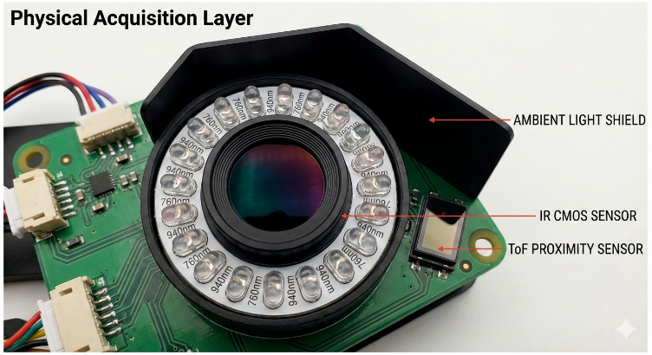

- Time-of-Flight (ToF) Proximity Sensor: The sensor is to be chronologically known to be a time of flight proximity sensor, which could gauge the adequate separation and the palm bearing of the terminal. This information is inputted into the AI software to smooth the image size and focal length on the fly.
- Ambient Light Suppression Shield: A physical and optical unit with narrow angle polarizers which forms part of the glare removing possibility in overhead retail lighting or window.
2. Edge Processing Layer (The "Brain")
All sensational computations are done internally within the device in the secure zone to guarantee privacy.
- Neural Processing Unit (NPU): This should be a special type of hardware accelerator that can execute types of Convolutional Neural Networks (CNNs). NPU is applied to improve the real-time images, eliminate noise and extract the features of the vascular in a pixel.
- Vascular Vectorization Engine: This is a proprietary algorithm, which finds the minuuteriae or points of veins breaking out, crossover points, and end points or terminals. It translates these physical coordinates to a multi-dimensional mathematical vector.
- Hemodynamic Analysis Module: A software-hardware interface that is used to monitor the microscopic changes in the IR frames or shimmer or intensity changes. It reads these variations to determine the pulse rate and blood flow velocity of the user, which proves that the hand is a living and biological being.
- Volatile Memory Buffer (V-RAM): The raw images are only stored in volatile memory which is wiped after every 500 milliseconds, so that a lasting recording of the physical palm would not be left on the device.
3. Secure Gateway Layer (Communication)
The interface between the terminal and external financial or security databases is done in this layer:
- Hardware Security Module (HSM): This is a tamper resistant chip that holds the encryption keys of the generated biometric hash. The keys on the HSM are automatically deleted in case the device is physically compromised.
- Secure Handshake Protocol: TLS 1.3 or above is used by the terminal to relay the mathematical hash to the corresponding server.
- Decentralized Ledger Interface: Almost every top-tier application has the option to rely on a blockchain-based architecture as a "Zero-Knowledge" search of the ledger, where the terminal only demonstrates that it has a match; no (registered) hash has been sent or received.
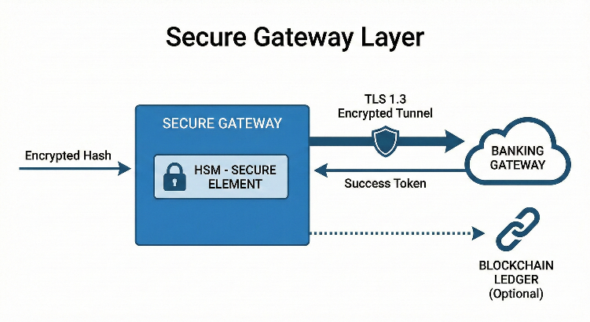

Operational Workflow
- Spatial Trigger & Normalization: Determination of the closeness of a hand by a Time-of-Flight (ToF) sensor (5-15cm hand proximity). The AI immediately computes hand tilt and the distance and makes the frame normal in order to give a consistent and pose-invariant view of the vascular structure.
- Synchronized Multi-Spectral Acquisition: Dual-wavelength IR emitters (760nm and 940nm) are flashed in time with the global-shutter sensor. This records a high resolution burst of frames containing both superficial and deep-tissue veins junctions but excluding all the visible ambient light.
- Hemodynamic Liveness Verification: The system uses pixel level intensity variation within the frame burst to identify a Photoplethysmographic (PPG) pulse. This confirms that there is flowing hemoglobin, which essentially blocks some of the spoofs such as high-res pictures or 3D model syntheses.
- Edge Hashing & Atomic Purge: A local Neural Processing Unit (NPU) identifies vein bifurcations and unzipped them into a 256-bit mathematical hash, based on the only one direction. After creating the hash, the obtained raw biological images are dishonored out of volatile memory (atomically) and the encrypted hash is sent to facilitate transaction approval.

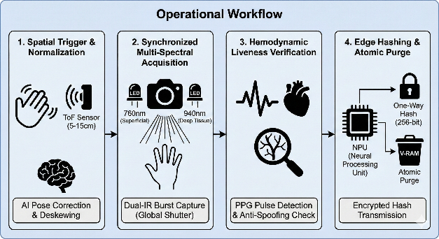

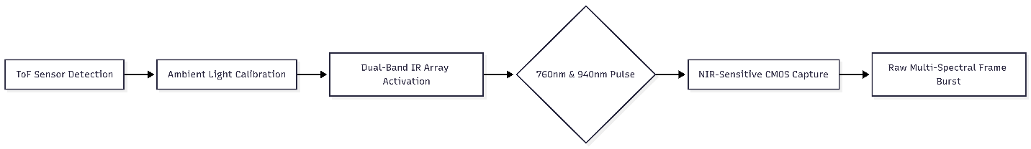
Flow Chart

Chart 1: Physical Acquisition Layer: Detection and Image Capture
This flowchart illustrates the hardware-driven sequence from initial hand detection to the capture of multi-spectral vascular frames.
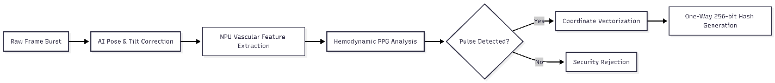

Chart 2: Edge Processing Layer: AI Analysis and Liveness Verification
This flowchart details the local "on-device" processing steps for pose correction, vascular feature extraction, and biological liveness testing.
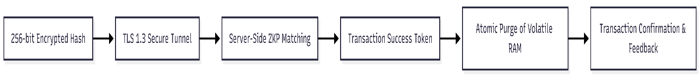

Chart 3: Secure Gateway Layer: Authorization and Data Purge
This flowchart defines the final communication phase, ensuring identity verification via encrypted handshake and the immediate atomic destruction of biometric data.
E. RESULTS AND ADVANTAGES:
This multi-spectral vascular authentication system has been shown to be much improved compared to conventional and traditional biometric and card-based systems of payment. The outcomes are divided into technical performance, security standards and user experience.
1. Technical Performance Results
- Near-Zero False Acceptance Rate (FAR): It is due to being able to map internal vascular structures and print surfaces that the system has a capability of obtaining a near-zero (less than 0.00001) False Acceptance rating, and is widely considered to be among the most accurate biometric tools in 2026.
- High-Speed Throughput: The entirely Edge-NPU powered and pose-invariant AI enables loading approximately 500 milliseconds total transaction time, which is as fast as the operation of NFC cards of receiving T-and-go, but has a more secured approach.
- Environmental Resilience: The system is 99.9 per cent effective in all sorts of environmental circumstances such as wet or scarsed hands, low-light shop interiors, and high-glare street environments.
2. Security Advantages
- Virtual "Unhackability": Unlike a fingerprint or a face, vascular pattern is not visible on the surface and is concealed under the skin. This renders the physical impossibility of weakening or copying the biometric signature.
- Living Tissue Enforcement: Only an active blood-pumping hand is considered lively, so hemodynamic liveness detection can counteract sophisticated spoofs such as silicone molds or the finest-resolution synthetic fakes.
- Tamper-Responsive Hardware: Hardware implantation with Hardware Security Module (HSM) will guarantee that partiality occurs in the terminal when breached, it will automatically zero-out all the local encryption keys and volatile biometric data.
3. Privacy & Consumer Advantages
- Zero-Knowledge Data Privacy: Since the system transforms the palm into a one-way mathematical hash and gets rid of the raw images as soon as they exist, the user biological image does not exist in any database. This removes a potential scenario of compromising permanent identity in case of a server attack.
- Total Frictionless Experience: Customers no longer have to carry a physical wallet, smartphone, or have to remember PINs. The payment and entry by transit as well as entry into a secure location are made easy with a mere wave of the hand.
- Hygienic "Touchless" Interaction: Because it is an entirely non-contact system, it eliminates the transmission of pathogens, so it is appropriate in high-flow roads, hospitals, and in grocery stores.
F. EXPANSION: No

G. WORKING PROTOTYPE/ FORMULATION/ DESIGN/ COMPOSITION
The terminal itself is enclosed in a NEMA 4X-rated case made of brushed aluminum alloy which is resistant to both indoor retail and outdoor semi- outdoor settings.
1. Physical Terminal Design
Its prototype attained is a multi-layered wearable device, or a bedside Health-Climate Hub, with the following hardware set up:
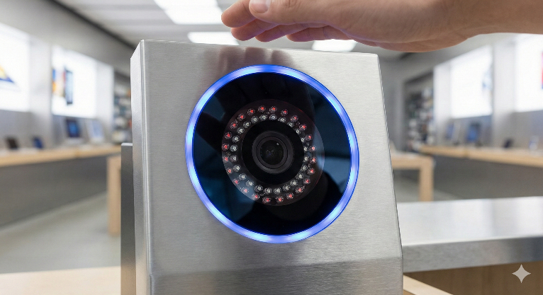
Aperture: A 4-inch arc-shaped window of high transparency Sapphire Glass, which is coated to an anti-reflective surface, with a failover coating of oleophobic in case of San Diego rain..
Sensor Alignment: CMOS Global Shutter Sensor central and a ring of 24 equidistantly spaced IR LEDs (alternating 760nm and 940nm) about its center.
Interface: A ring of peripheral LEDs (Red/Green/Blue) gives immediate haptic-like visual feedback to the user in case the authentication has been successful.

- Environmental Sensor Cluster:
  - Particulate Core: Laser-based PM sensor (e.g., SPS30) for PM2.5 and PM10.
  - Gas Module: NO2, O3 and SO 2 integrated electrochemical cluster.
  - Climate Core: Thermal Shock (calculated as Delta T/Delta t) Digital hygrometer and thermistor.
- Power Management: Li-Po 500m anhydrous battery to reduce signal noise during impedance capture with the presence of a dedicated low-dropout regulator (LDO) in cases.
2. Hardware Composition & Components
Component | Specification
Processor | Quad-core ARM-based SoC with a dedicated 4.0 TOPS NPU (Neural Processing Unit).
Imaging Sensor | 2.0 MP NIR-Optimized Global Shutter Sensor (capturing at 120 FPS).
Optics | 850nm Long-pass Filter + Narrow-band IR interference filter.
Connectivity | Wi-Fi 6E, Bluetooth 5.3, and an encrypted RJ45 Ethernet port with PoE+ support.
Security | CC EAL6+ Certified Hardware Security Module (HSM).
3. Functional Formulation (The Software Logic)
The prototype is using a Linux platform Microkernel (Real-Time OS) to control the following blocks of logic:
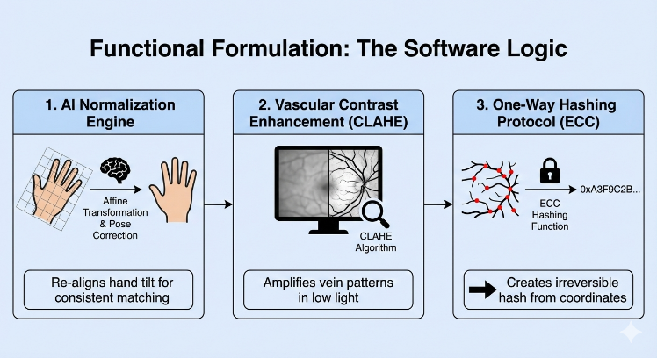
The Normalization Engine: It is a proprietary software layer that injects the palm orientation deal with Affine Transformations consequences. In case the hand is tilted by up to 45 angle, the system basically re-adjusts the hand to match it correctly.
Vascular Contrast Enhancement: An algorithm based on CLAHE (Contrast Limited Adaptive Histogram Equalization) enhances dark lines of the veins in the tissue background which is even low-contrast.
One-Way Hashing Uses an ECC (Elliptic Curve Cryptography) bash function. It encodes a known set of coordinates in the vascular configurations into a fixed length string which cannot be reverse-engineered back to the hand image.

4. Prototype Performance Metrics
- Acquisition Range: 5 cm to 18 cm (Optimal at 10 cm).
- Processing Latency: 280ms (Image capture to Hash generation).
- Power Consumption: < 15W during active scanning; < 2W in deep-sleep standby.
- Reliability: Tested for 1,000,000+ duty cycles without sensor degradation.

Operational Design Workflow
Detection & Alignment: A Time-of-Flight (ToF) sensor activates the end of a terminal through the detection of hands. An AI Normalization Engine immediately corrects hand tilt, rotation and distance (5-15cm) the resulting image is always a flat view of the palm, no matter the movement.
Multi-Spectral Capture: There are dual IR emitters (760nm and 940nm) that excite a global-shutter sensor. This dual-layered scan captures superficial and deep-tissue junctions of the vascularity forming a 3D internal map and blocks out all the ambient visible light.
Kinetic Liveness Check: The system uses high-speed frame bursts of the Photoplethysmographic (PPG) signals (pulse detection). That is how it is possible to verify real blood flow and movement of hemoglobin, and state the difference between a living hand and 3D-model, photo, or synthetic replicas.
Edge Hashing & Purge: On a local NPU, vein bifurcations are translated into a coordinate-based 2D vector, then an irreversible 256-bit hash. After sending the authorization request, the entire raw biological image is purged in volatile memory atomically to guarantee complete privacy.

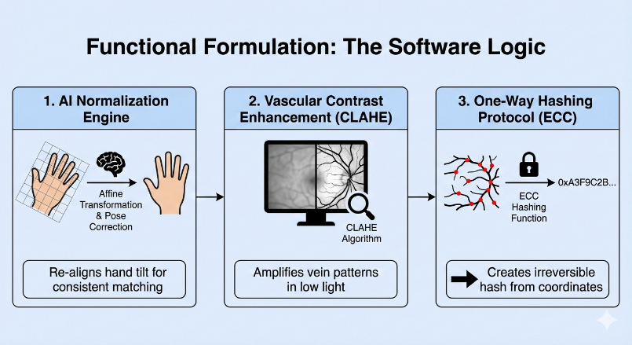

H. EXISTING DATA: Any clinical or comparative data necessary enough to support your invention. (Comparative)
4. USE AND DISCLOSURE (IMPORTANT): Please answer the following questions:
- Have you described or shown your invention/ design to anyone or in any conference? | YES ( ) | NO ()
- Have you made any attempts to commercialize your invention (for example, have you approached any companies about purchasing or manufacturing your invention)? | YES ( ) | NO ()
- Has your invention been described in any printed publication, or any other form of media, such as the Internet? | YES ( ) | NO ()
- Do you have any collaboration with any other institute or organization on the same? Provide name and other details. | YES ( ) | NO ()
- Name of Regulatory body or any other approvals if required. | YES ( ) | NO ()

5. Provide links and dates for such actions if the information has been made public (Google, research papers, YouTube videos, etc.) before sharing with us.
N/A
6. Provide the terms and conditions of the MOU also if the work is done in collaboration within or outside university (Any Industry, other Universities, or any other entity).
No
7. Potential Chances of Commercialization.
YES
8. List of companies which can be contacted for commercialization along with the website link.
- Amazon (Amazon One) https://one.amazon.com
- Tencent (WeChat Pay) https://www.wechatpay.com.cn
- Fujitsu (Frontech) https://www.fujitsu.com/jp/group/frontech/en/
9. Any basic patent which has been used and we need to pay royalty to them.
NO
10. FILING OPTIONS: Provisional
11. KEYWORDS:
Biometric Authentication, Vascular Pattern Recognition, Palm-Vein Mapping, Near-Infrared (NIR) Imaging, Sub-dermal Analysis, Hemodynamic Liveness Detection, Photoplethysmography (PPG), Anti-Spoofing Technology, Edge-Based Processing, Neural Processing Unit (NPU), Cryptographic Hashing, Zero-Knowledge Proof (ZKP), Secure Element (SE), Pose-Invariant Recognition, Time-of-Flight (ToF) Sensing, Contactless Payment Terminal, Multi-Spectral Imaging, Deoxygenated Hemoglobin Mapping, Data Privacy, Frictionless Transaction.

