Round 1 Submission — "The Plan"
Team: [TEAM NAME — fill before submitting]
Product working title: BrandProof
Tagline: Proof your brand before the world does.
Event: Inkloom AI — Intelligent Brand-Governance Platform
Track: Round 1 — The Plan
Date: 25 October 2026
Contact: [TEAM LEAD EMAIL — fill before submitting]
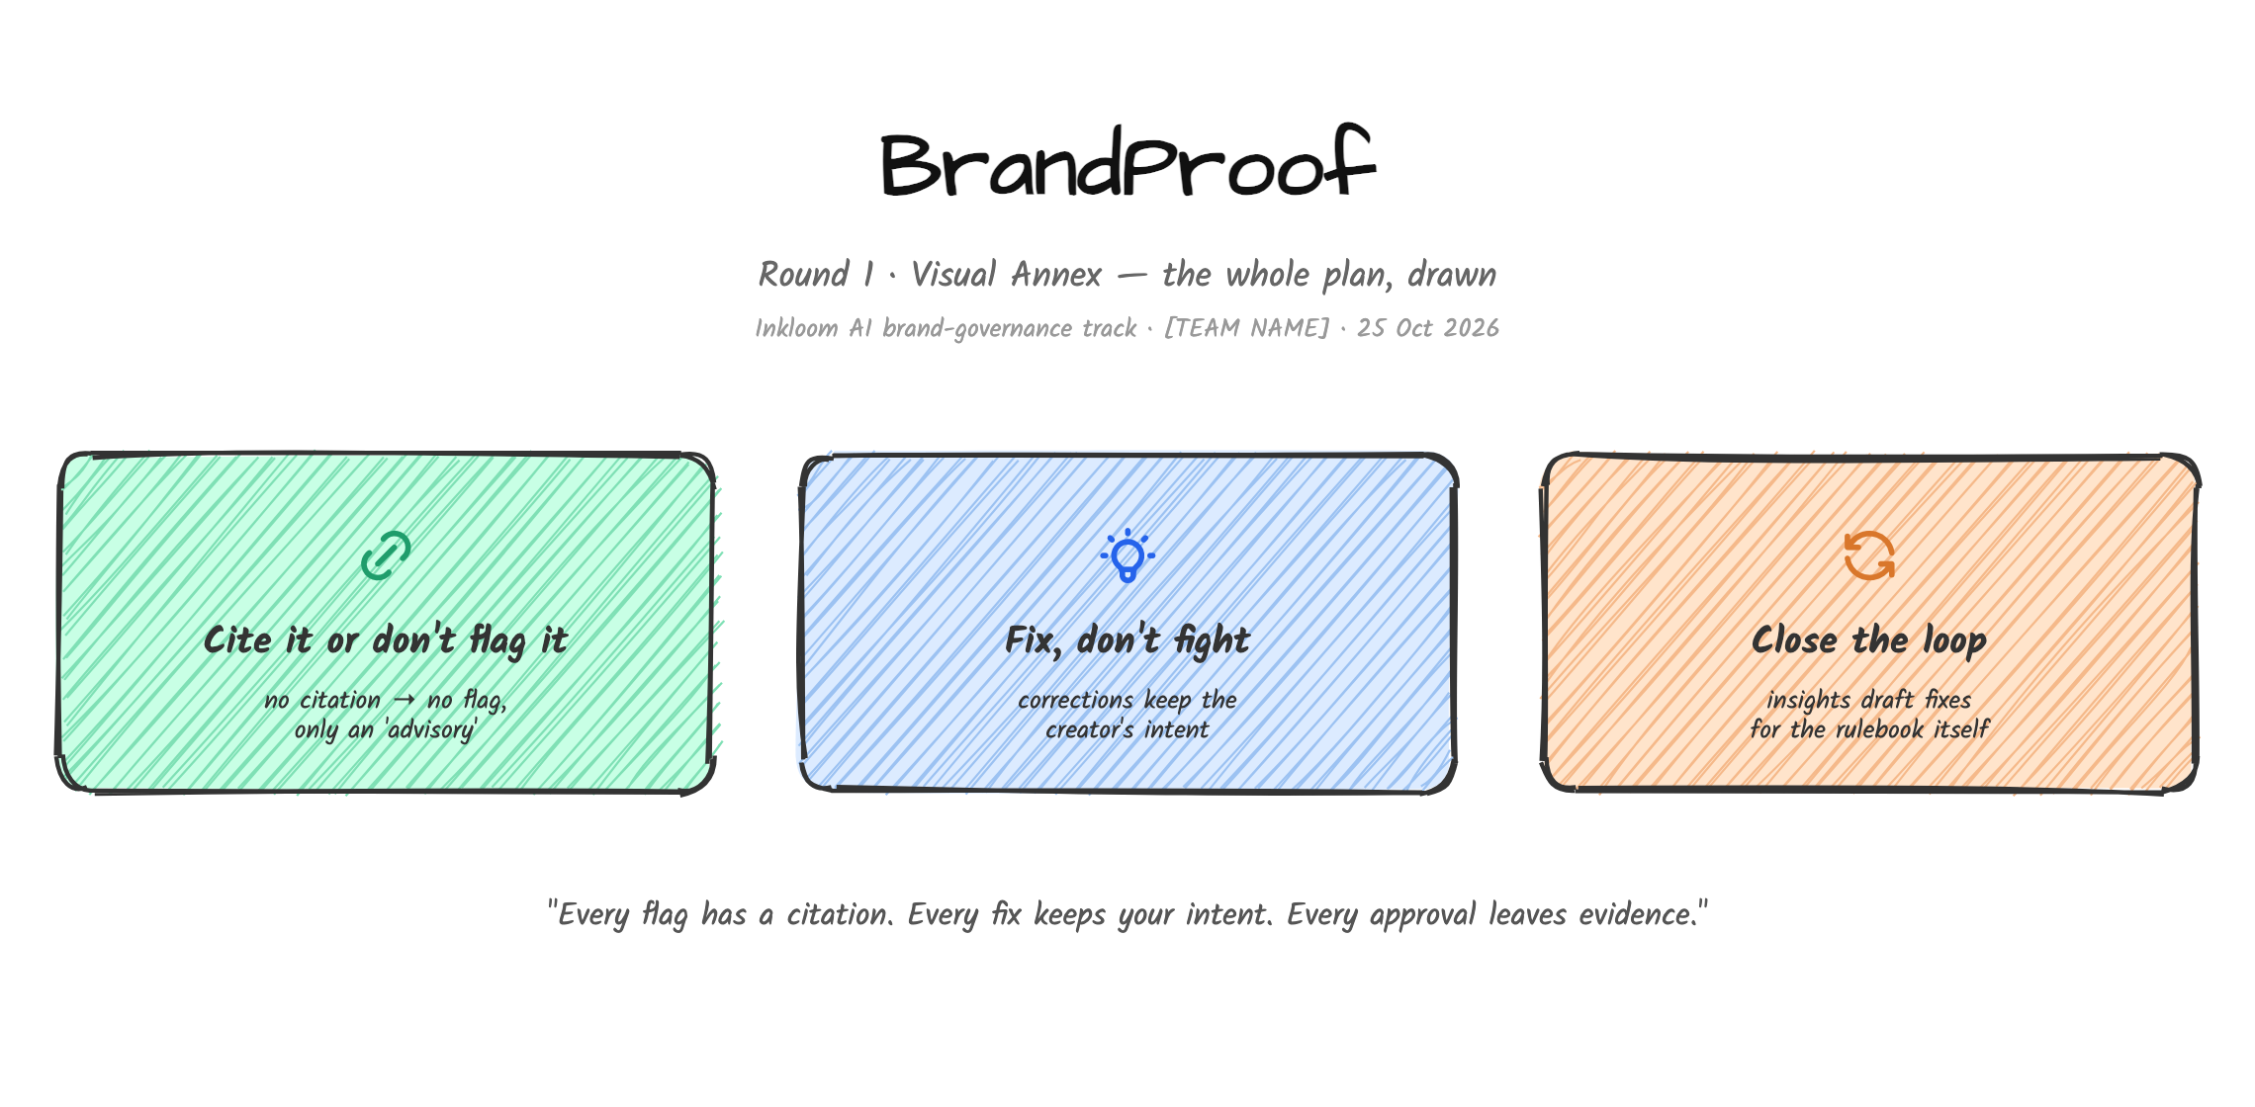

Executive Summary
Growing organisations now produce content through employees, agencies, and AI tools at a scale no manual review process can police. The evidence is blunt: 77% of organisations see off-brand content created at their company (Lucidpress/Marq, 2021), 95% have brand guidelines but only about one in four enforce them formally (Lucidpress + Demand Metric, 2016), and 87% of content teams now use AI to create content (Ahrefs, 2025) — with over 70% of marketers reporting at least one AI-related incident such as hallucinated or off-brand content (IAB, 2025).
BrandProof is an intelligent brand-governance platform that reviews content before publication and checks it against the organisation's approved guidelines, facts, and assets. It finds problems of tone, terminology, messaging, factual claims, visual consistency, and accessibility; explains every flag it raises with a verifiable citation to the guideline, fact, or asset that triggered it; proposes corrections that preserve the creator's original intent; and routes work through a role-based review and approval workflow with full revision history. Every AI flag remains advisory — an authorised human reviewer always makes the final publication decision — and the platform closes the loop by telling brand teams which guidelines are themselves unclear.
Our three named improvements (committed for Rounds 2 and 3) are: (1) Cite-it-or-don't-flag-it citation-anchored issue cards, (2) Fix-don't-fight intent-preserving corrections under human control, and (3) Close-the-loop governance insights with a Guideline Clarity Radar that drafts amendments to unclear guidelines.

1. Problem Definition and Evidence

1.1 Problem definition
Large and growing organisations publish marketing, product, and corporate content through multiple channels and many hands: in-house teams, freelancers, agencies, and increasingly generative AI tools. In this setting the brand identity — the organisation's claims, voice, terminology, visual identity, and accessibility promises — drifts and degrades. Incorrect claims, outdated information, inconsistent language, and off-brand visuals go live before anyone responsible notices, and are frequently expensive or impossible to retract afterwards.
The underlying failure is structural, not personal. Brand knowledge (guidelines, approved facts, terminology, assets) is stored in documents and slide decks that are written once and rarely enforced; brand review is a manual, late-stage, single- or two-person step with a queue; and new AI tooling multiplies content volume and variability while multiplying the categories of risk. The result is a systematic gap: brands *know* what good content is, and still *cannot prove* each item of content is compliant before it ships.
The problem to solve, precisely stated: organisations need a pre-publication, machine-assisted review layer that checks any piece of content against the organisation's own approved sources (guidelines, facts, assets), explains each finding in terms a human can verify, preserves the creator's intent when suggesting fixes, keeps humans in control of publication decisions, and reports back on recurring failures — all while protecting confidential brand material.

1.2 Evidence the problem is real (desk research)
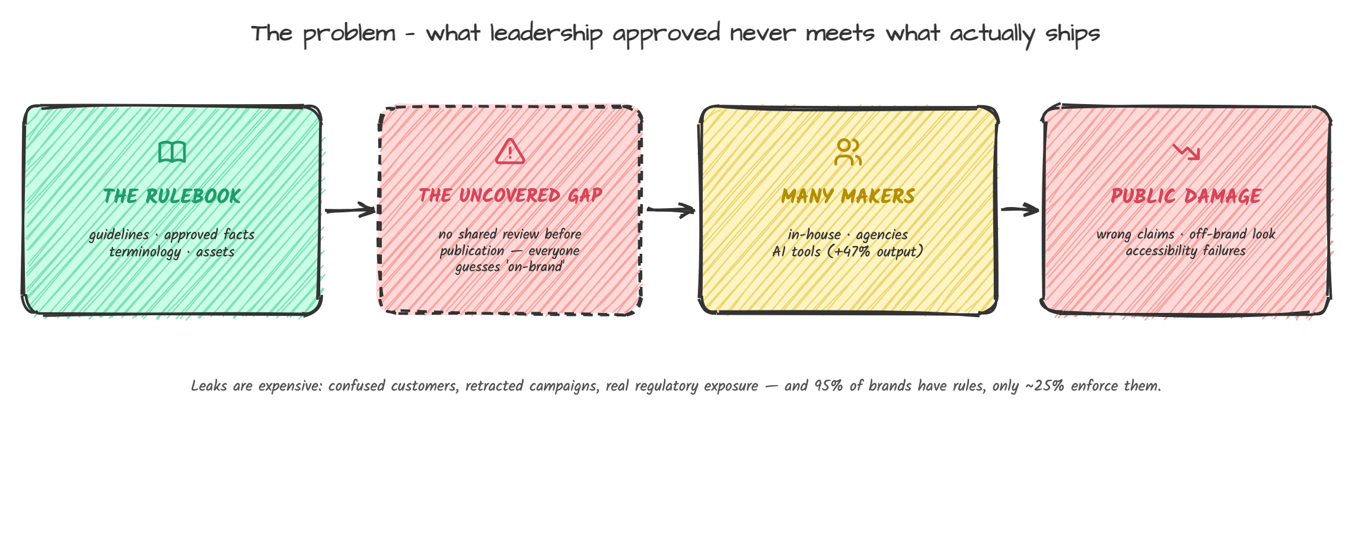
Figure 1 — Rules exist, but nothing checks content against them before publication.
All sources are listed in Appendix D with links and access dates (accessed 25 October 2026).
Evidence cluster 1 — Inconsistency is widespread and costly.
- 95% of organisations have brand guidelines, but only about 25% have formal guidelines that are consistently enforced; over 60% report materials that do not conform to their own guidelines. (Lucidpress + Demand Metric, Impact of Brand Consistency, 2016)
- 77% of organisations see off-brand content created at their company; 85% are creating more content than the year prior. (Lucidpress/Marq State of Brand Consistency; Content Effectiveness Report 2021, n=452)
- Consistent brand presentation is estimated to contribute 10–20% (or more) of revenue growth by 68% of respondents, and earlier studies estimated up to 23–33% revenue upside from uniform presentation. (Lucidpress 2016/2019/2021 reports)
- 71% of organisations name market confusion as the greatest negative impact of inconsistent brand usage, and firms with enforced formal guidelines are more than twice as likely to achieve consistent brand presentation. (Lucidpress + Demand Metric 2016)
- 39% of teams take a week or more to fulfil content requests; only 11% can complete requests in under a day — the review bottleneck is measurable. (Lucidpress Content Effectiveness Report 2021)
Evidence cluster 2 — AI has multiplied the volume and the risk.
- 87% of content-marketing respondents use AI to create content, and teams using AI publish 47% more content per month; the single biggest barrier to further AI adoption cited is accuracy (60%), and misinformation is the biggest perceived risk (62%). (Ahrefs State of AI in Content Marketing, 2025, n=879)
- 95% of marketing and advertising professionals use generative/agentic AI at least monthly (85% weekly); 71.4% believe consumers will find a brand less authentic if it uses AI-generated content, and 88.6% rate AI-driven brand-safety and misinformation risk as moderate to significant. (Basis, AI and the Future of Marketing 2025, n=140)
- More than 70% of marketers have encountered an AI-related incident — hallucinations, bias, off-brand or offensive content — and the consequences were material: 40% had to pause or pull advertising, over a third dealt with brand damage or PR issues, and nearly 30% ran internal audits. Yet only about one-third of brands, agencies, and publishers have adopted or plan to adopt formal AI-governance tools. (IAB State of AI 2025, n=125)
- 92% of organisations use more AI for content creation than a year ago, but only 33% judge their organisation's AI guardrails to be strong and consistently applied; 80% still fall back to manual reviews and spot checks. Nine in ten C-suite leaders agree that dedicated content guardrails would be valuable. (Markup AI, The AI Trust Gap, 2025, n=266 at 500+ employee firms)
- Only 38% of organisations have generative AI policies guiding content use, and fewer than 1 in 10 marketing organisations have a well-established AI governance framework. (Marketing AI Institute 2025; SAS Marketers and AI 2025)
- Brand-voice protection is the top concern of heavy AI users: 29% of surveyed B2B teams now produce over half their content with AI. (Walnut + Wynter, State of Generative AI in B2B Marketing, 2025)
Evidence cluster 3 — Accessibility failures ship by default.
- 94.8% of the world's top 1,000,000 home pages had detectable WCAG 2 conformance failures in February 2025, averaging 51 errors per page; low-contrast text (79.1% of pages) and missing image alt text (55.5%) remain the two most common failures. These figures cover only automatically detectable errors. (WebAIM Million, 2025)
Reading the evidence together: brands have rules (95% have guidelines), the rules are weakly enforced (~25%), content volume is exploding with AI (87% adoption, +47% output), incidents are already routine (70%+ experienced), governance tooling is rare (~35% adopting), and accessibility failures are near-universal — while enforcement today depends on a human reading line by line at the end of the pipeline. The gap is real, quantified, and worsening. This is exactly where a pre-publication brand-governance layer operates.
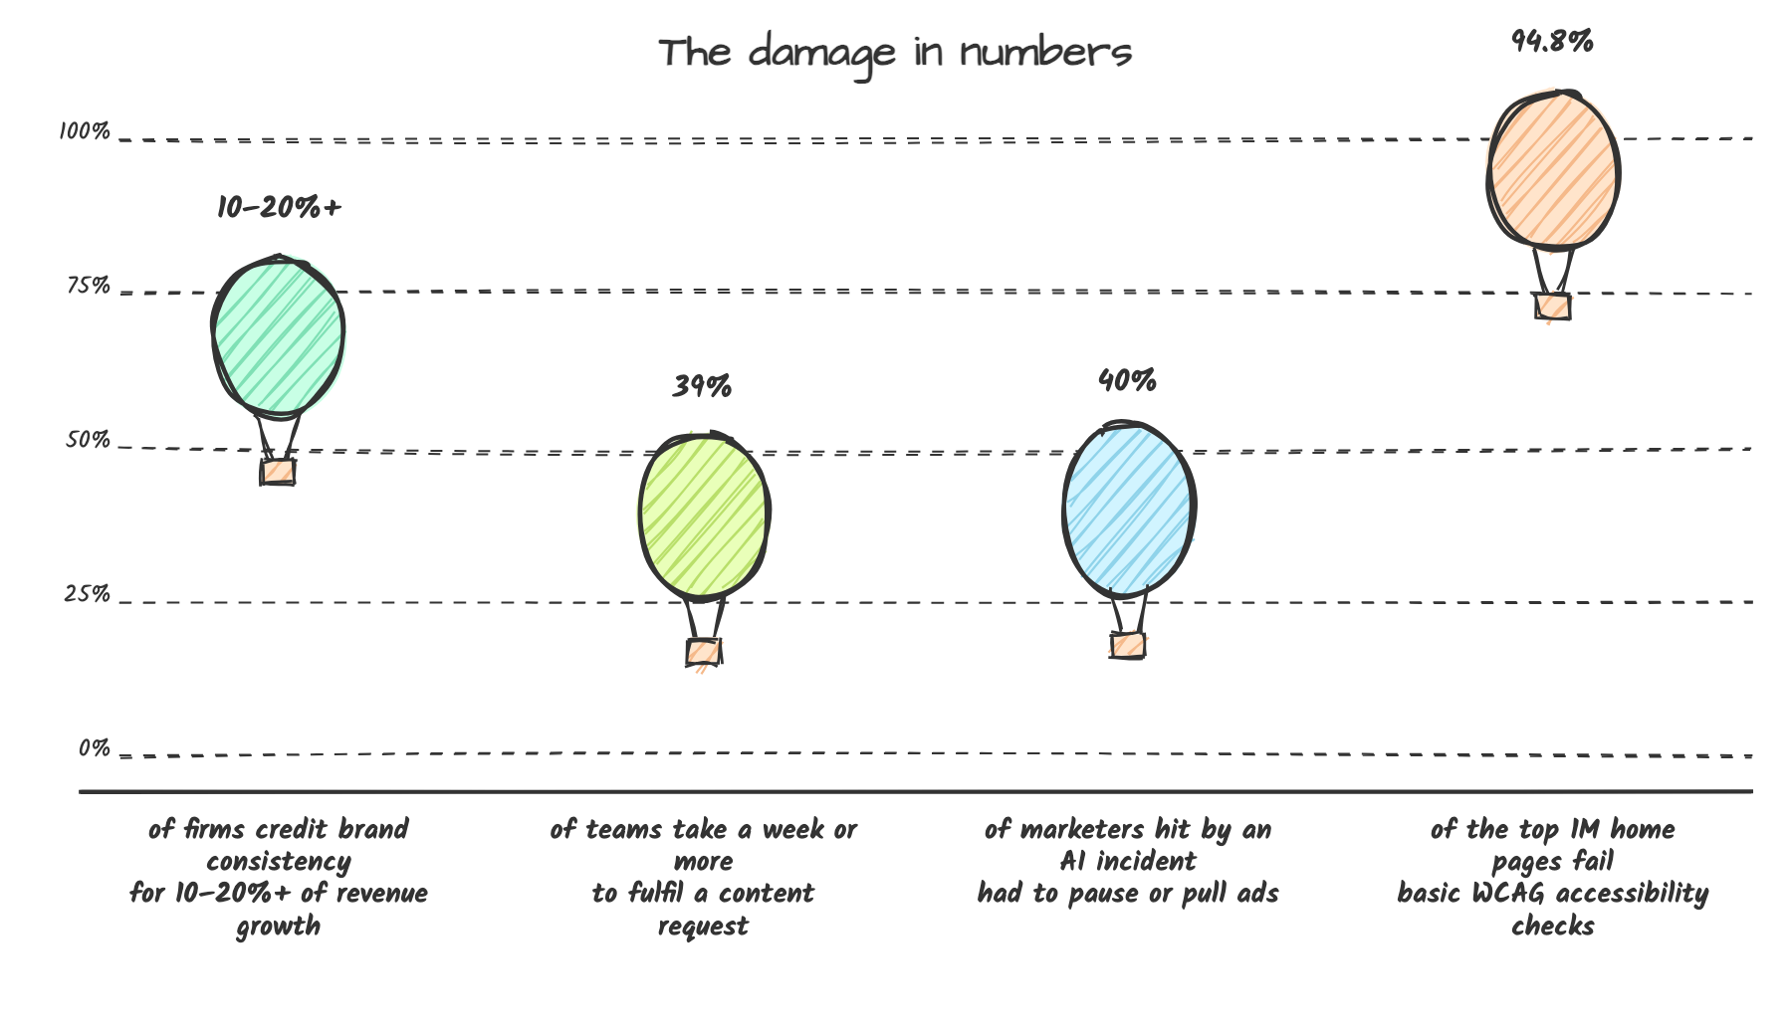
Figure 2 — The damage in numbers (desk-research sources in Appendix D).

1.3 Supporting evidence we will gather ourselves (plan and templates ready)
Primary research, designed to be executable within today given the deadline (survey can collect 20+ responses from marketing/content professionals; the tiny experiment and observation can run without third parties). Templates are in Appendix A (survey), B (interview guide), C (observation protocol), and E (tiny brand-governance experiment). Aggregated raw results will be included in the submitted plan before the deadline.
- Survey (target n>=20): role profile, whether off-brand/incorrect content ships, how the review happens today, who owns guidelines, whether guidelines are clear, AI use and trust, willingness to adopt. Distributed via LinkedIn, WhatsApp communities, and classmates in marketing roles.
- Semi-structured interviews (target 5–8, 25–35 min): brand managers, content creators, an agency account manager, and a compliance-aware reviewer; includes a 10-sample content audit exercise to rank real failures.
- Observation: walk through one real content-approval cycle with a participating organisation, recording where checks are skipped or duplicated and what gets escalated.
- Tiny experiment (no external contacts needed): take one public brand guideline; give 5 volunteers a 10-item sample flyer/landing page seeded with 6 deliberate violations (wrong term, unsupported superlative, outdated stat, off-palette colour, missing alt text, wrong logo variant); measure violations caught unaided vs. with a checklist — demonstrating the human-review gap we automate.
- Expected outputs: quantified confirmation of the desk-research pattern (off-brand content ships; review is the bottleneck; guidelines are unclear); 3–5 recurring failure categories to weight in our detection pipeline; persona validation for Section 2.

2. Target Users, Their Needs, and the Organisational Setting

2.1 Organisational setting
BrandProof targets mid-size to enterprise organisations (roughly 50–10,000 employees) withBrand presence across websites, social, marketing collateral, and partner material, where content is produced by more than one team or external partner. Priority settings, ordered:
1. Marketing teams at multi-brand or multi-market companies: several teams and agencies produce content against shared brand and product claims.
2. Regulated or claims-sensitive industries (fintech, health, insurance, education, food, supplements, sustainability claims): an unsupported feature or efficacy claim creates legal, regulatory, or consumer-protection exposure. This is where "approved facts" matter most.
3. Agencies and studios serving multiple clients: each client guidelines set must be held strictly separate and confidential.
4. Non-profits and universities with distributed content owners and few reviewers.
The setting is characterised by: a small brand or compliance function reviewing a high volume, growing AI-tool usage across the org without governance, and existing guidelines that exist but are rarely consulted at creation time.

2.2 Personas and needs
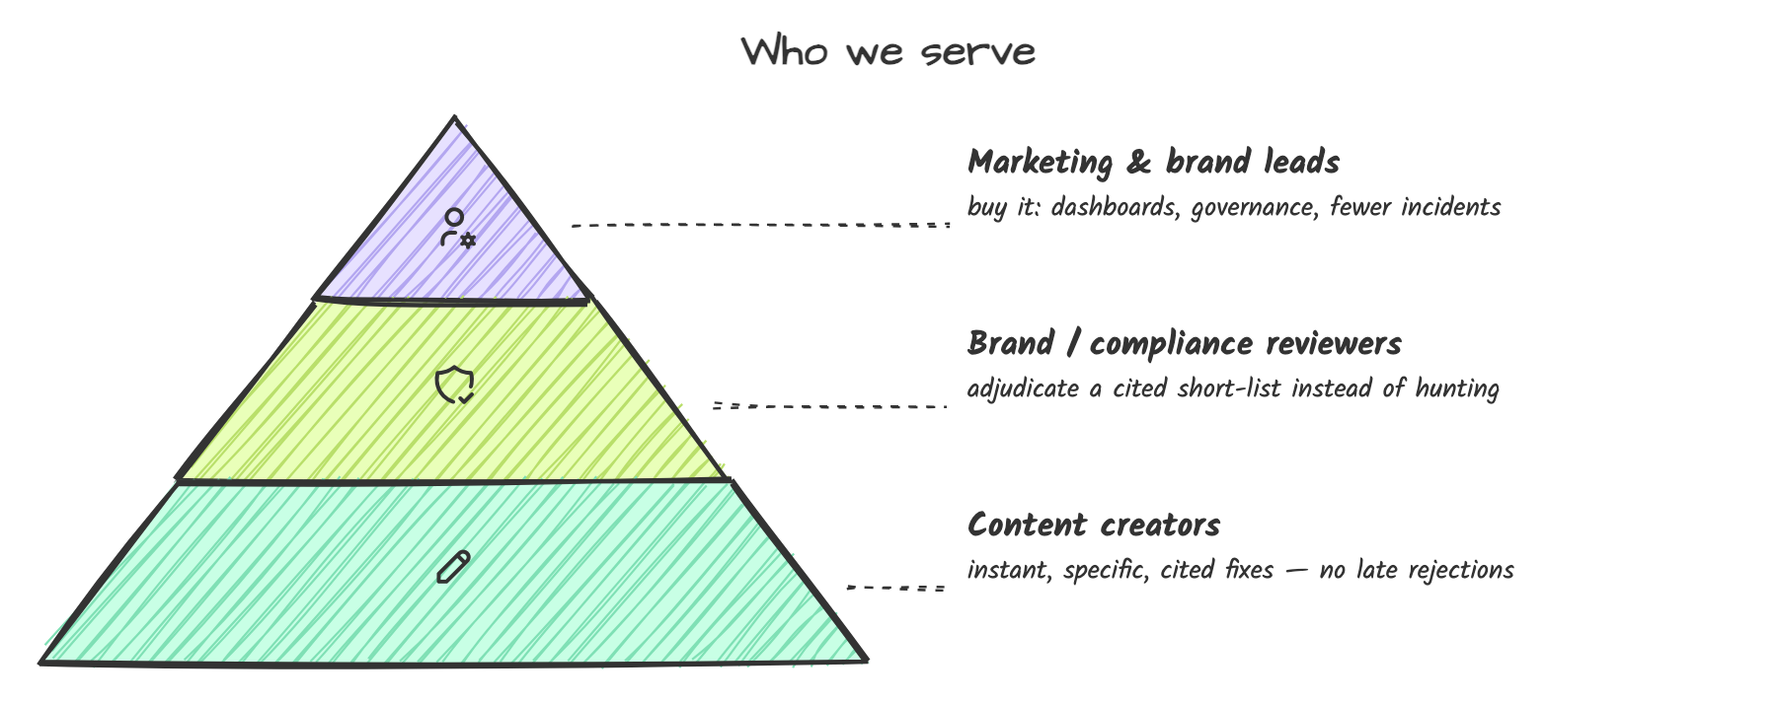
Figure 6 — The three user layers BrandProof serves.
Persona 1 — The Content Creator (e.g., marketing associate, product-marketer, sales-support). Persona 1 (Content Creator: e.g., marketing associate)
- Goals: produce content fast; not be sent back repeatedly; not look careless.
- Pain: brand rules live in a 60-page PDF the person has never fully read; feedback comes late ("please change this tone") without explanation; AI draft assistance creates doubt about accuracy.
- Needs: instant, in-place, specific feedback with a cited reason and a ready fix; confidence that the fix preserves their message; a record of what was approved and why.
- Success for us: first-pass submission with fewer review cycles.
Persona 2 — The Brand/Compliance Reviewer (brand manager, product-claims owner, compliance officer)
- Goals: zero reputational or regulatory incidents; catch unsupported claims and off-brand usage early; stop reviewing trivia.
- Pain: unable to review every asset personally; no memory of every rule; manual spot-checks miss things; reviewers who argue back require evidence.
- Needs: automated pre-screen with citations, severity, and confidence; adjudication tools (accept/edit/dismiss with reason); audit trail to show what was approved and on what basis; visibility into systemic issues.
- Success for us: reviews shift from hunting issues to adjudicating machine-flagged issues.
Persona 3 — The Marketing/Brand Lead (decision maker and buyer)
- Goals: brand consistency that supports revenue; faster content throughput; demonstrable governance as AI usage grows inside the org.
- Pain: cannot see the aggregate — which guidelines fail most, which teams bypass review, where risk concentrates; board/leadership keeps asking "who reviews the AI content?"
- Needs: dashboards on volume, violations, review turnaround, coverage gaps; evidence pack (approval manifest) for leadership or regulators; a path to improve the guidelines themselves.
- Success for us: one screen that answers "are we getting safer over time?"
(Validation for these personas and needs comes from the survey and interview plan in Section 1.3; the desk research in 1.2 already corroborates the key needs statements.)

2.3 What users do NOT want
From the problem statement and the evidence: users resist heavyweight approval bureaucracies, black-box scores, tools that rewrite or block content automatically, and tooling that treats confidential guidelines as training data. Product decisions follow directly: never auto-reject; never auto-apply changes; always cite; always disclose.

3. Proposed Solution, Value Proposition, and End-to-End Workflow

3.1 The solution in one paragraph
BrandProof is a web platform where an organisation first registers its brand knowledge — guideline documents (broken into citable clauses), approved facts (claims with sources and expiry), terminology (preferred, banned, alias terms), and visual assets (logo variants, brand colours, fonts) — and then every piece of content (text, PDF/DOCX documents, images, webpages) is checked against that knowledge base before publication. Deterministic checks run first (exact terminology, banned/unsupported-claim patterns, accessibility calculations, palette/contrast math, logo-variant matching), and a retrieval-augmented LLM review runs over the content and the retrieved guideline/fact clauses to catch semantic issues (tone, messaging, claims). Every detected issue is displayed as a citation-anchored issue card: what rule, which exact clause/asset, how confident, why — with an intent-preserving fix the creator can accept, edit, or dismiss with a reason. A role-based workflow (creator → reviewer → authorised approver) governs the decision, with comments, revision history, and an exportable approval manifest. Governance dashboards show volume, recurrence, and guideline-clarity gaps, and can draft amendments for guideline owners.

3.2 Value proposition
For creators: get a specific, cited answer in minutes instead of a vague rejection in days. For reviewers: stop man-hunting issues; adjudicate a pre-screened, evidence-backed list. For the organisation: measurable risk reduction pre-publication on tone, terminology, claims, visuals, and accessibility — the categories named in the problem statement — plus hard evidence (the audit trail) that review actually happened. Quantified upside for the adopting organisation: recovered revenue from consistency (68% of respondents attribute 10–20%+ of revenue growth to consistency; Lucidpress 2021), reduced spend on rework caused by late feedback (39% of teams take a week+ per content request; Lucidpress 2021), and avoided incidents (40% of marketers who had AI incidents had to pause or pull ads; IAB 2025).
What makes our approach original (for the 15-if-criterion originality): first, no flag is presented as truth without a citation — if the engine cannot point to a guideline clause, approved fact, or asset rule, it is labelled "advisory, uncited", keeping the product honest and auditable. Second, detection is deliberately separated from decision-making: an AI advisory layer plus a human decision layer, matching the problem statement's requirement to balance automation with human control. Third, we close the loop on governance: the platform diagnoses the rules themselves (Guideline Clarity Radar), because unenforced or unclear guidelines are a documented root cause (95% have guidelines, ~25% enforce them).

3.3 End-to-end product workflow (happy path)
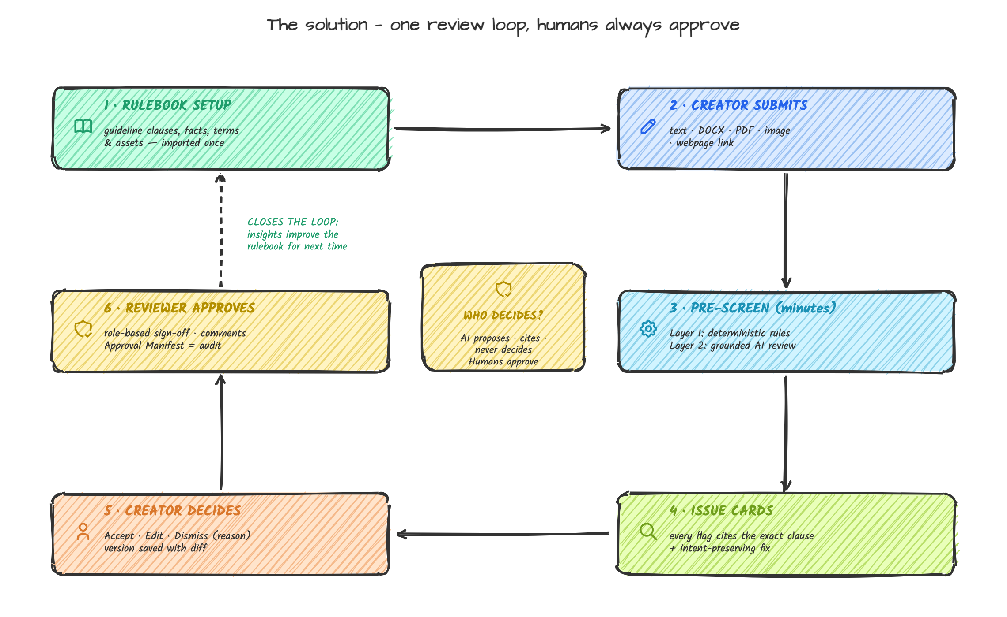
Figure 3 — The BrandProof review loop: AI proposes and cites; humans always approve.
Step 1 — Brand setup (once, per workspace). A brand lead imports guideline files (PDF/DOCX/MD), which BrandProof splits and stores as clausal, citable units; uploads approved facts (as structured rows: claim, source, date, expiry), terminology lists, and brand assets (logo variants, hex palette, fonts). Guidelines are versioned and encrypted at rest; access is role-restricted.
Step 2 — Content intake. A creator uploads or types content: plain text, Markdown, DOCX, PDF, or one of a set of supported image formats (PNG/JPG poster/flyer/social asset, or a webpage URL for text+image extraction).
Step 3 — Automated pre-screen (minutes). Deterministic checks run first: banned/aliased terminology, known unsupported-claim patterns, factual-claim lookup against approved facts (with retrieval for near-matches), colour contrast and brand-palette deviation math, logo variant match, alt-text presence and quality checks. Then the LLM review (grounded via retrieval over guideline clauses and facts) produces semantic findings: tone drift from voice rules, messaging mismatch, claims that sound factual but have no approved-fact mapping, promotional superlatives without substantiation. Each finding is emitted with a citation ID.
Step 4 — Creator self-review. The creator sees the flagged item in place, opens the issue card (the citation, the rationale, confidence), reads the intent-preserving fix (he has to click to view the AI's proposed edit), and chooses: Accept / Edit / Dismiss with reason. All three actions are logged. Revisions are saved as versions with a diff view; re-review on upload is automatic, and previously cleared sections are re-evaluated only when changed.
Step 5 — Submit for approval. The creator submits; BrandProof routes the item to a designated reviewer/approver (role-based thresholds, e.g., major claims require a compliance reviewer; visual-only issues may not). The submission view shows remaining open flags, dismissed flags with reasons, and revision history.
Step 6 — Reviewer adjudication. The reviewer works issue by issue: confirm violation, overrule with reason, comment, or request change. The reviewer cannot go around citations: each adjudication attaches the cited clause. Approval requires explicit sign-off; rejections must include a stated reason.
Step 7 — Decision and record. On approval, the item's status becomes approved (or Published via CMS webhook, later) and BrandProof generates an approval manifest — a structured record (what content version, which rules applied, which flags dismissed with reasons, who approved and when) exportable as PDF/JSON for audits, leadership, or regulator surface. Nothing is ever auto-published.
Step 8 — Governance dashboard (continuous). Aggregate views: content volume reviewed, issues by category over time, top recurring violations by team/clause, review turnaround, dismissal rate by rule (a dismissal magnet often signals an unclear rule), and the Guideline Clarity Radar — terms and situations flagged repeatedly with no supporting clause, plus AI-drafted amendment suggestions routed to guideline owners.

3.4 Competitive landscape (why existing tools don't solve this)
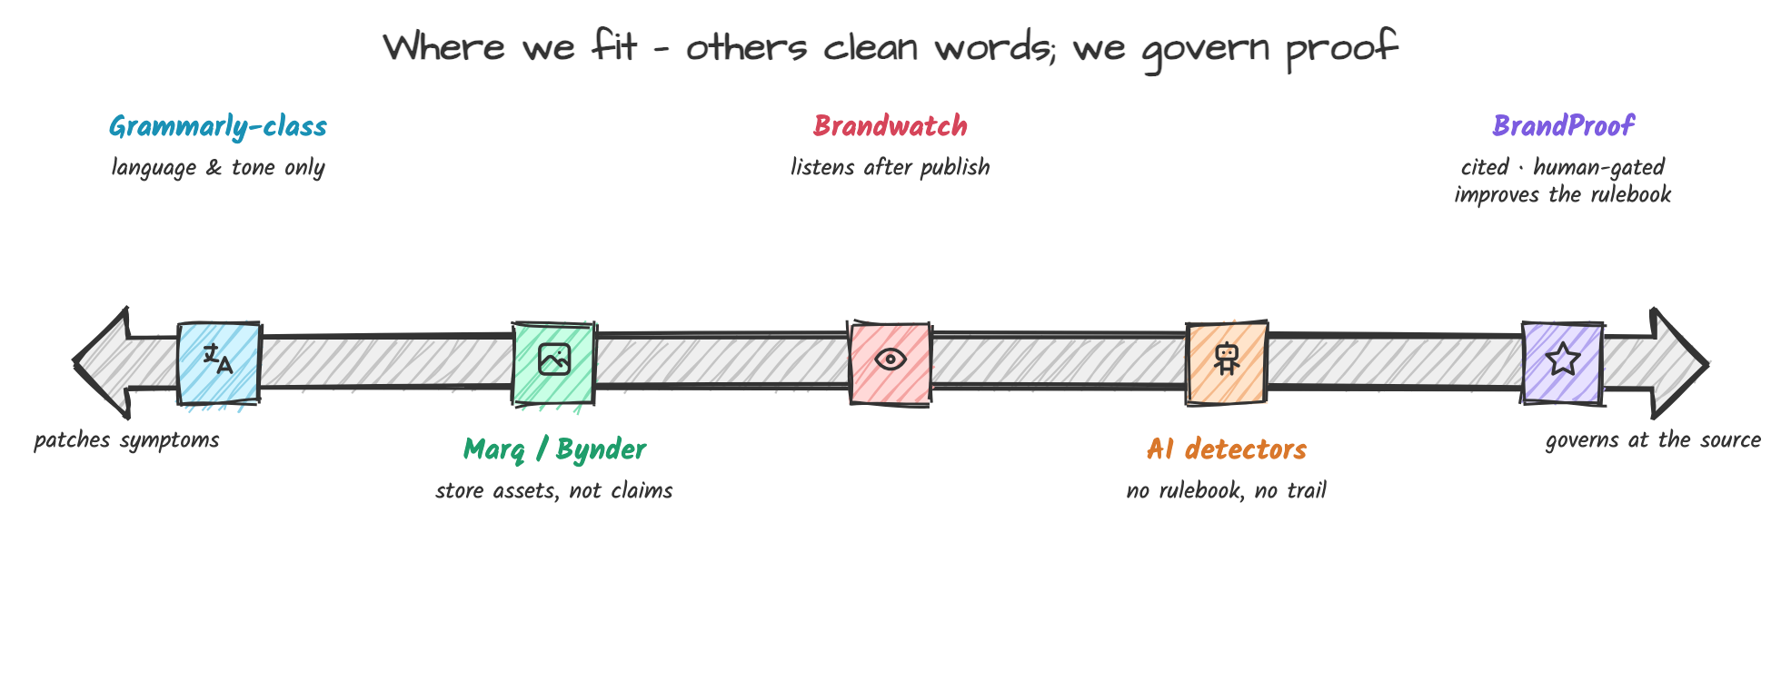
Figure 7 — Where BrandProof sits versus existing tool categories.
Grammarly Business and similar checkers: language-level correctness and generic tone rules, but they don't know an organisation's facts, assets, or specific claims, and they give no citation back to internal guidelines. DAM/brand-asset platforms (Marq/Bynder): excellent for storing assets and templates, but they do not review finished content claims; enforcement is manual. Social-listening/brand-monitoring tools (Brandwatch, Sprinklr): audit after publication. Generic AI-detection tools: detect machine-generated text, not brand violation; no governance workflow, no explainability. Regulated-industry document review: specialist, expensive, and document-type-bound. BrandProof's position is the missing pre-publication review layer with verifiable citations, human-gated workflow, insight loop, and support across text + document + image (a category none of the listed incumbents own end to end).

4. Planned Features, Technology Stack, Integrations, and Data Sources

4.1 Feature plan and scope discipline
MVP (must ship in Round 2 — the end-to-end workflow runs end to end):
1. Workspace setup with multi-tenant isolation; email-OTP auth; role-based access (Creator, Reviewer, Approver, Admin).
2. Brand knowledge base ingestion: guideline files → citable clauses; approved facts (structured list with source and expiry); terminology lists (preferred/banned/aliases); asset library (logo variants, palette hex set, fonts).
3. Content intake: text, Markdown, DOCX, PDF text extraction, and image upload; webpage URL fetch (policy-allowed pages only).
4. Automated review: deterministic checks + retrieval-grounded LLM review; issue cards with citations, category, severity, confidence, explanation, suggested fix.
5. Creator actions: accept / edit / dismiss-with-reason per flag; versioned revisions with diff; resubmittal flow.
6. Review workflow: assign thin roles, comment threads per flag, approve/reject with reasons, outstanding-flag gating (configurable).
7. Audit trail and approval manifest export (JSON + PDF).
8. Governance dashboard v1: volume, top violations, dismissal rate, coverage gaps; simple Clarity Radar visual.
Round 3 in addition (the same three improvements, hardened):
- Clarity Radar upgrade: recurring-issue detection with prompt-drafted guideline amendment text; "guideline owner" routing and acceptance.
- Evaluation report: precision/recall of our engine measured on our gold-set corpus; inter-rater agreement with external raters on intent preservation.
- Usability improvements from user testing: guided flows, keyboard/screen-reader pass, in-app AI disclosure page.
- Reliability: batch re-run engine, cache/queue, error states, deployment hardening, fixtures on judge bar.
Explicitly out of scope for the hackathon (recorded to protect scope): CMS connectors (WordPress/Shopify/Figma/Drive) beyond webhook stub, video review, automatic retraining/fine-tuning, multi-language beyond English (detection framework is language-agnostic but we will demonstrate in English only), SSO/enterprise directory integrations, deployment of an on-prem version.

4.2 The three named improvements (committed; measured across Rounds 2 and 3)
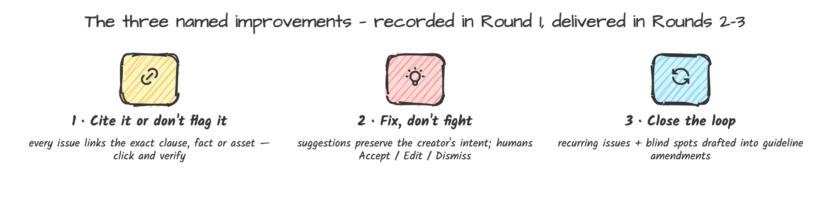
Figure 9 — The three named improvements, committed in Round 1 and delivered in Rounds 2–3.
Improvement 1 — Cite it or don't flag it (citation-anchored issue cards). Every issue card displays the exact guideline clause, approved fact row, or asset rule that triggered the flag, with the underlying text reachable in one click, plus machine-calculated confidence and clearly labelled "advisory, uncited" status for heuristic findings. Verification (Round 2): 100% of grounded flags carry resolvable citations; untraceable findings are visibly labelled; a judge can click any flag and see the source. Baseline: black-box tools show issues with generic reasons or no source at all.
Improvement 2 — Fix, don't fight (intent-preserving corrections). Given the creator's stated intent and content purpose (captured at submission in one line, optional), suggestions are constrained by the retrieved clause set to align to guidelines rather than impose generic style, and the creator retains three auditable actions (accept / edit / dismiss-with-reason); no change is applied automatically; every decision is part of the approval manifest. Verification (Round 2): demo shows a before/after where the suggested fix preserves the creator's meaning while resolving the flag, and the per-flag decision trail is exportable.
Improvement 3 — Close the loop (guideline clarity radar). The platform will aggregate flags and show which guidelines/terms are systemically unclear: rules with above-threshold dismissal rates, recurring mentions with no matching clause ("never covered"), and it will proactively draft amendments against evidence. Guideline owners receive a one-click, evidence-backed proposal with an accept/reject action. Verification (Round 3): a judge can inspect a seeded corpus and the drafted amendment trace from insight to accepted change.

4.3 Technical plan and responsibilities
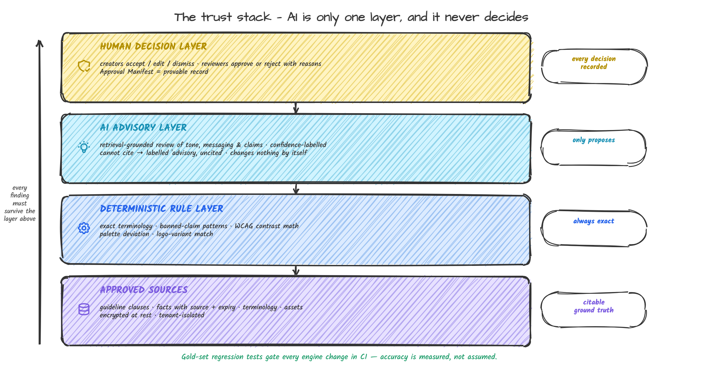
Figure 4 — The trust stack: every finding must survive the layer above; accuracy is measured, not assumed.
Architecture summary. A single Next.js 15 front-end (TypeScript, Tailwind, shadcn/ui) and a FastAPI (Python 3.12) backend, both stateless, fronting a PostgreSQL (with pgvector) database and an S3-compatible object store. Ingestion, deterministic checks, and the AI pipeline are Python services in the same backend; long tasks (file parsing, batch re-review) go through a lightweight queue (arq) to keep the workflow responsive. This keeps hosting simple (Vercel + one container service + managed Postgres), the audit trail complete, and each component independently testable.
Data model essentials (verification of completeness vs. problem statement): Workspaces; Users/Role assignments; Guidelines (versioned) with Clauses (text, order, embedding); ApprovedFacts (claim text, source, date, expiry); Terminology (term, status: preferred/banned/alias-of, notes); Assets (type: logo/palette/font, references); ContentItems; ContentVersions (diffs); Issues (type/category, span/severity/confidence, citation references[citation IDs, advisories], explanation, suggested fix, status, decision log); Comments; Decisions/AuditLog (immutable); ApprovalManifest; InsightAggregates (dashboard materialised views).
AI design (the plan the judges will look at):
- Retrieval: Claude/approved clauses are chunked (~200–400 tokens, overlap), embedded (text-embedding-3-small), stored in pgvector; retrieval by hybrid similarity (cosine + keyword) at review time with k=5–8 per flagged region.
- Detection, layered by design:
- Layer 1 deterministic (no LLM): terminology (exact + normalised), banned/unsupported-claim phrase patterns, accessibility math (WCAG contrast via palette hexes; alt-text presence heuristics), palette deviation and logo-variant image hashing/perceptual hash lookup. Cheap, reliable, always cited to a stored rule.
- Layer 2 retrieval-grounded LLM review (structured outputs): given content + retrieved clauses/facts, the LLM classifies issues (tone, messaging, claim, promotional language, brand-edit consistency, accessibility wording guidance) with JSON-schema-compliant output, one object each, including: issue category, span, cited clause ID, paraphrase of the rule as understood, rationale, suggested fix, confidence (0.0–1.0), and citation status (cited vs advisory). Brand model: temperature low (0–0.3), max retries on schema violation, automatic downgrade to advisory if no citation resolves.
- Layer 3 adjudication support: issue-level summarisation for reviewers, amendment drafting for guideline owners (Improvement 3).
- Fact checking semantics: a claim is "supported" if it maps (exact or high-similarity) to an approved fact row and its expiry has not passed; if the claim does not map, it is flagged as "unsupported/unverified claim" with a citation to the facts list policy; near-claims trigger retrieval for candidate facts; LLM is never allowed to conceive facts, and model weights never replace the fact store.
- Accuracy measurement (guards AI trustworthiness): a 60-item seeded gold-set corpus for text (10 per issue category) and 15 images; measures precision (flagged items judged valid by independent raters), recall (of the violations we planted), and citation validity (flag resolves to the correct clause) — these numbers will be reported in Round 2 for verification of the improvements. Each pipeline change is regression-tested against the gold set (CI).
- Model disclosure: primary candidate Gemini 2.5 Flash (structured outputs, vision, favourable cost) with OpenAI GPT-4.1/4o-mini as an interchangeable alternative via a shared adapter; embedding model text-embedding-3-small. Zero-retention/no-training API settings selected. Deterministic layer works without any AI provider.
Execution stack detail: FastAPI (+ Pydantic v2 schemas = the JSON contract), SQLAlchemy 2, Alembic migrations, PostgreSQL 16 (Neon) + pgvector 0.7; file processing: PyMuPDF (PDF text), python-docx, Pillow (image inspection), BeautifulSoup + Readability-style text extraction for webpages; report generator: WeasyPrint or fpdf2 for the approval manifest PDF; frontend: Next.js 15, tanstack-query, react-diff-view for revisions, Recharts for dashboards; auth: Supabase Auth (OTP) + custom RBAC claims, verified server-side; file storage: Supabase Storage (encrypted at rest); queue: arq + Redis (Railway box); deployments: Vercel for web + Fly.io/Railway container for API; observability: structured logs (audit log append-only), Sentry optional; CI: GitHub Actions (lint, unit tests, gold-set regression run).
Integrations (planned, de-scoped to stubs in MVP): Google Drive/.doc import, Slack notifications for approvers, CMS publish webhook (generic), Figma asset import stub. External services disclosure (per competition rules): hosted LLM APIs (Google/OpenAI) and managed services (Vercel, Neon/Railway, Supabase) — an in-app and document disclosure lists each provider, purpose, data sent, and the zero-retention configuration setting.
Data sources our product consumes: exclusively the customer's own brand material (guideline files, fact sheets, terminology lists, asset files) and their content under review; plus internal seeds for evaluation (our golden corpus is built from public sample guidelines, sanitised by us, and no real-brand confidential data enters public repos). No scraping, no third-party data brokers; benchmark statistics used in this plan are cited in Appendix D.

4.4 Responsible design (privacy, security, human oversight, disclosure)
Privacy and confidentiality. Brand guidelines and fact bases are trade secrets; the design treats them accordingly: workspace-level tenancy with row-level isolation; files encrypted at rest (AES-256 at the storage provider) and in transit (TLS 1.2+/1.3); access to the KB is role-gated (Approvers/Admin can view full clauses; Creators see only the clauses adjudicated against their content's issues; no cross-tenant retrieval); customer content and guidelines are never used to train models, and API calls run under zero-retention/no-training options where the provider offers them (documented). Retention: content uploads and knowledge bases can be deleted by the Admin within 30 days (demo setting: immediate); deletion propagates to storage and derived index data (clause shards, embeddings) — a documented deletion pipeline, not an aspiration. Data-minimisation: we ingest only required material; no idle analytics or crawling; PII stays out of event logs (no email/body text in logs). Regional self-hosting/on-prem employs an honest roadmap: Round 3 documents a deployment path (single-tenant Docker compose) that customers can audit.
Security (the brand-governance attack surface is metadata theft, not nor the model). RBAC enforced server-side on every endpoint; OWASP-minded practices throughout: parameterised ORM queries, output encoding, CSRF protection on cookie flows, rate limits, CSP headers, upload validation (type/size/magic-byte checks), object storage served via signed expiring URLs. Input quarantine for uploads (scan/hash) before parsing. Secrets in environment vaults/providers, not in code; least-privilege DB roles (app has no table-level access beyond its schema). Secrets scanning, dependency audit (pip-audit, npm audit, Dependabot) and CI-enforced. All privileged actions (guideline edits, role assignment, publish decisions, KB deletion) require an audit-log record (actor, timestamp, action, before/after) with append-only table.
Human oversight (this is what builds trust in a governance product). The product architecture separates detection from decisions: the AI advisory layer can only propose and cite; only an authorised human role may approve/publish/reject; there is no auto-approval at any confidence level; advisory-only predicted items are labelled and routeable manually. Disagreement is a feature: each flag can be adjudicated or dismissed-with-reason, and dismissal with reason is recorded in the manifest; repeated dismissal patterns feed Improvement 3. Users can contest any flag, and overrules are visible. The product itself, not just its output, is reviewed with accessibility (we target WCAG 2.2 AA for our own interface so we review others' content with the same standard we meet).
Transparency and AI disclosure. Every issue card shows model confidence and citation: status, suggestion is diff-formatted (never pre-applied), and there is a public in-app "How this review works" page per workspace (model name/version, retrieval sources, provider zero-retention settings, what is logged). The submission and Round 2/3 docs disclose every external service and AI component per competition rules 5–7 and the Submission Integrity section.
Licences and IP: all OSS dependencies used per licence; no training on third-party corpora; device/graphics of our demo corpus are either generated or licensed (to be documented in Round 3).

5. Development Plan, Role Allocation, and Expected Impact

5.1 Phase plan mapped to the official build window
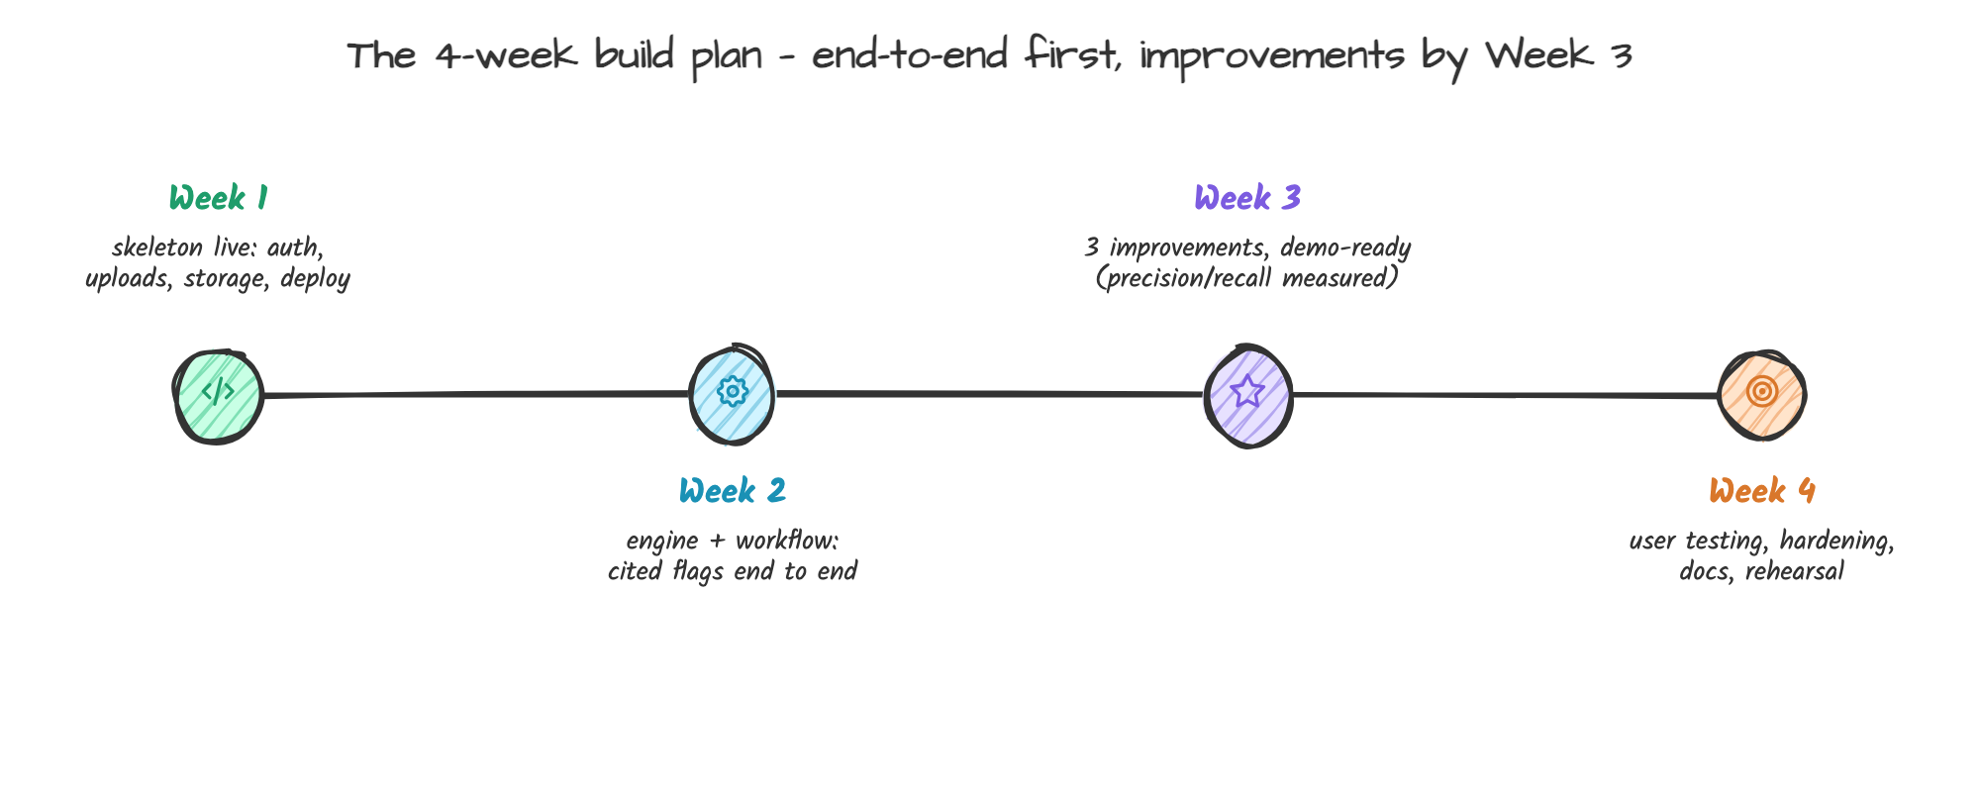
Figure 10 — The four-week build plan.
The plan is stated per 4-week window; the team will re-baseline the milestones to the organiser's official build window date without changing the sequence (this is the baseline for "progress against the plan" in Round 2).
Week 1 — Foundations (ship skeleton). Monorepo + CI; auth/roles/RBAC; workspace/tenant model; DB schema + migrations; guideline ingestion (clause splitter) v1; content intake for text/MD/DOCX/PDF; upload validation; deploy pipeline (Vercel + API container) with health checks. Milestone M1: sign-in, upload document, see text stored versioned.
Week 2 — Detection engine and workflow. Deterministic check layer (terminology, banned claims, accessibility math, palette checks); pgvector retrieval over clauses/facts; LLM structured-output review with citation anchoring; issue data model + acceptance/edit/dismiss actions; version diff; reviewer pipeline (assign, approve/reject with reasons); audit log. Milestone M2: seeded workspace review produces cited issue cards end to end; approval/reject recorded in manifest.
Week 3 — The three named improvements (primary engineering effort). Citation anchor trust (advisory downgrade, click-through clauses), intent field + fix constrained suggestions, Clarity Radar aggregation views + amendment drafting; approval manifest PDF/JSON export; governance dashboard; image checks (contrast/palette/logo variant, alt-text); gold-set adjudication runs; polish + accessibility pass on app. Milestone M3: three improvements demo-ready against gold set first precision/recall numbers measured and CI-gated.
Week 4 — Reliability, testing, documentation, demo. User testing (5–8 participants; recorded findings and fixes); bug triage/hardening; deploy to final URLs; demo corpus + judge walkthrough script; architecture/README/set-up docs; contribution statements; pitch recording. Milestone M4: functional demo environment + repository + doc set complete (Round 2/3 submissions only require polish from here).

5.2 Role allocation (5 members; structure holds with 4 by merging P5 duties)
P1 — Team Lead / Product & Workflow engineer. Product definition, scoping, workflow (states/roles), approval semantics, intake/manifest, integration glue, progress tracking, judge-facing demo script. Owns: review workflow, audit/manifest, role model.
P2 — AI/LLM engineer. Retrieval pipeline, LLM structured review, advisory citation gating, prompt engineering and versioning, gold-set corpus builder, eval harness and regression in CI, model disclosures. Owns: detection engine, quality metrics, AI documentation.
P3 — Frontend engineer. Next.js app shell, brand setup UI, annotation/issue-card UX with citation click-through, diff views, decision actions, dashboards (Recharts), accessibility of our own UI, visual polish. Owns: review UI, clarity radar visual, information design.
P4 — Backend engineer. FastAPI services, DB and vector store, ingestion/parsing (PDF/DOCX/image), deterministic checks layer, storage/tenancy, queue workers, export generators, security hardening (RBAC, validation, rate limits, upload scans), deployment. Owns: APIs and infrastructure, security checklist.
P5 — Design/QA/Data & content engineer. Design system + brand kit UI (workspace is the product's face), demo corpus curation (sanitised sample guidelines + content, seeded scenarios), QA plan and test matrices, user-testing sessions (recruitment, scripts, synthesis), documentation (architecture, user guide, disclosure page), pitch assets. Owns: demo data, test coverage, docs. (Works with 4: P5 duties split across P1 [docs] and P3 [design/QA tasks].)

5.3 Expected impact
For adopting organisations (the platform's users): measurable pre-publication catches: (a) reduced off-brand and unsupported-claim content reaching the public; (b) faster review cycles — from day-long manual queueing to in-place same-hour adjudication (39% of teams currently take a week+ per content request; Lucidpress 2021, which is the time target we attack); (c) an auditable record (approval manifest) that AI-era content got human-governed review, addressing the <35%-of-orgs-with-governance-tooling gap (IAB 2025; SAS 2025); (d) guideline quality improvements over time via the clarity radar (treats the 95%-have-guidelines / 25%-enforce gap). Expected internal metrics we will track on the dashboards: % of shipped items with zero unresolved high-severity issues; review turnaround; flag-adjudication rates; disappearance of recurring violations over successive quarters.
For this competition: value is demonstrated across realistic workflows (Sections 1–4), with the three improvements named, measurable, and scheduled (4.2, 5.1); and with an honest technology plan that includes the failure modes (prediction errors, confidentiality, provider dependence) and how the design mitigates them (4.3, 4.4). Success targets we commit to for Round 2: end-to-end run on a seeded workspace; gold-set precision >= 0.80 and planted-recall >= 0.70 (measured, reported verbatim in the submission); 100% of grounded flags carrying clickable citations; approval manifest export; a recorded user testing session with findings.

5.4 Risks, assumptions, and scope control
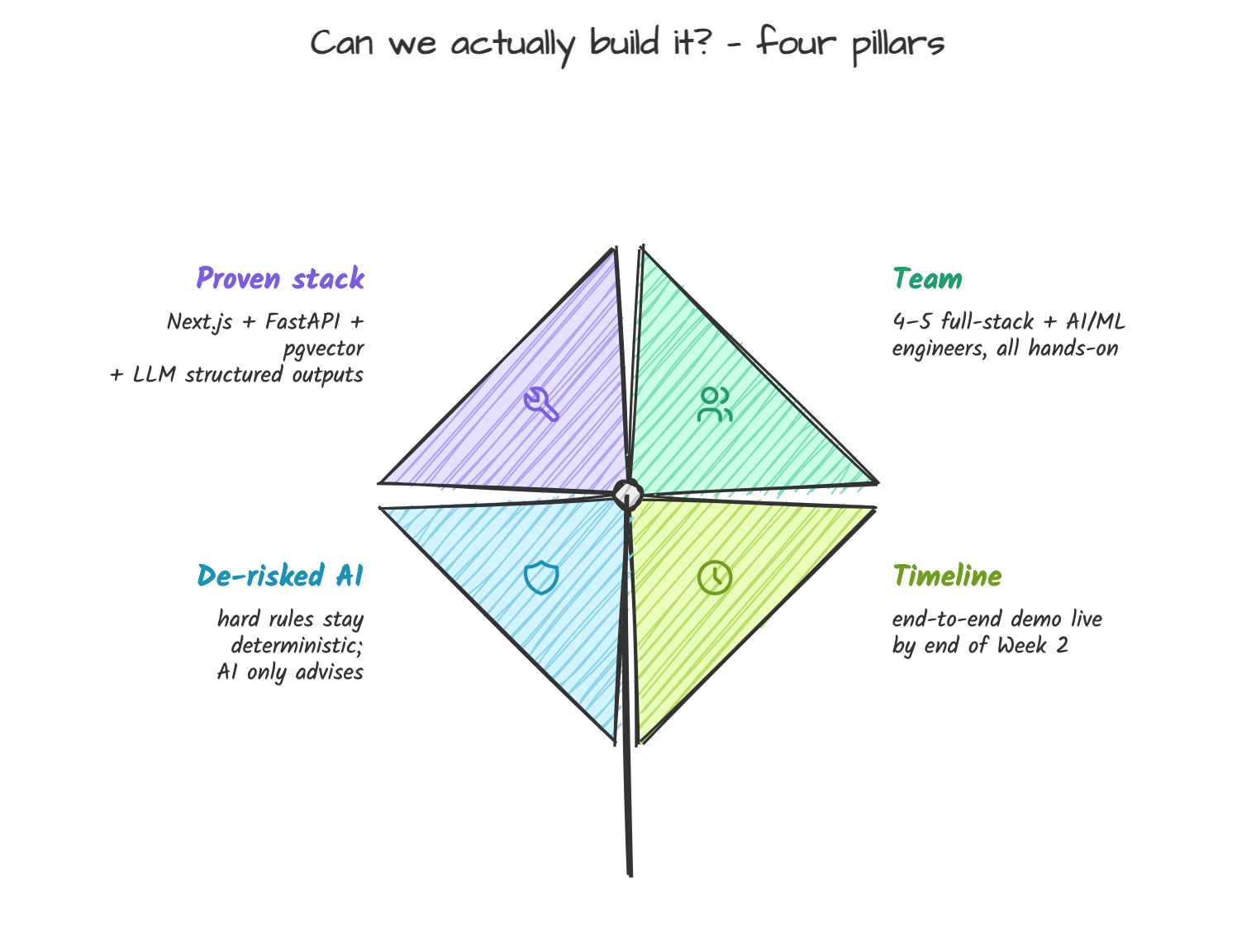
Figure 8 — The four feasibility pillars.
Risk 1 — AI precision/recall may be weak on semantics, hurting trust. Mitigation: layered design (deterministic layer carries hard rules reliably), confidence thresholds + advisory labelling, gold-set regression to keep engine changes measurable, and a human adjudication layer so errors are survivable, not shipped.
Risk 2 — Confidentiality concerns block adoption. Mitigation: tenancy isolation, zero-retention providers, minimal/minimal-at-rest logging, deletion pipeline, documented disclosure; roadmap path to single-tenant deploy for assurance-sensitive buyers.
Risk 3 — Provider dependence/cost (LLM APIs). Mitigation: provider adapter pattern (Gemini/OpenAI swap), caching of clause embeddings, batched review, and deterministic fallback to still deliver core value offline/aborted-provider; token budgeting per review run; free-tier configuration for judging environments.
Risk 4 — Time. Mitigation: MVP scope locked (4.1), image review limited to deterministic checks + vision-model classification (3 check types), "out of scope" list enforced by the team lead; three improvements targeted early (Week 3) with a two-day buffer inside the window.
Risk 5 — Judges may not see value without their own data. Mitigation: seeded demo corpus showing a realistic multi-team setup (two guidelines, two teams, pre-seeded violations mapped to all six problem-statement categories) plus clear 3-minute walkthrough; also reusable "upload-from-scratch" setup script allowed for judges (workspace bootstrap with synthetic brand).
Assumption to confirm before Round 2: official build-window dates; we will re-baseline the phase plan to them and show the change log in the Round 2 submission ("progress against the plan" evidence).

6. Appendix

Appendix A — Survey (ready to run today; target n>=20; results appended before submission)
Q1. Role: content creator / brand or marketing manager / compliance-reviewer / agency / other.
Q2. Organisation size: <50 / 50–500 / 500–5,000 / 5,000+.
Q3. How does content for public channels get reviewed today? (multi: manual by 1 reviewer / two-stage review / no formal review / agency only / AI only)
Q4. In the last 6 months, has off-brand, factually wrong, or inconsistent content reached a public channel? (yes / no / unsure)
Q5. How long does the average piece take from creator-ready to approved? (<1 day / 2–3 days / about a week / more)
Q6. How often do brand guidelines get consulted when content is being written (not at start/never / during Q&A revisions / at review / regularly)?
Q7. How clear are your guidelines in practice? (very clear / mostly / patchy / unclear)
Q8. Do you/your teams use AI tools to create content? (daily / weekly / monthly / never)
Q9. How much do you trust AI-generated content to go out as-is? (fully / with human review / not without human review / not at all)
Q10. If a tool flagged issues in your content with a citation to the exact guideline clause and suggested a fix preserving your intent, would you adopt it in your workflow? (incl. why/why-not free text)

Appendix B — Interview guide (target 5–8; 25–35 min; record with permission)
Warm-up: role, channels, volume per week. Walkthrough: take the last piece of content they got approved; step through who saw it, where review slowed, what was caught/missed. Probes: what does an "off-brand" incident cost internally; where are guidelines stored/consulted; who has authority to approve; what happens when a reviewer and creator disagree; how are AI-generated drafts currently handled; what would make a reviewer trust a machine flag; what would make the creator refuse to use it. Closing: sketch 3 most important features on paper (mini card-sort) — we tally the most-wanted features.

Appendix C — Observation protocol
One content-approval cycle, observed end to end with permission: record timings (submitted, first response, revisions, final approval); count tokens/hops (who saw it, what tools used); record every check skipped and why ("no time", "not my job", "trusted the AI draft"); record escalations. Output: one-page process map + 3 bottleneck findings used to corroborate Section 1.2 and shape Step 3/4 of the workflow.

Appendix D — References (desk-research sources; links verified 25 Oct 2026)
1. Lucidpress + Demand Metric (2016). Impact of Brand Consistency. (95% guideline ownership, ~25% enforced; >60% non-conforming materials; 23% revenue estimate; 71% confusion impact)
2. Lucidpress (2019). State of Brand Consistency Report. PRNewswire. (consistency => up to 33% revenue increase; 81% deal with off-brand content)
3. Lucidpress/Marq (2021). Content Effectiveness Report. (n=452; 77% see off-brand content; 68% report 10–20%+ revenue growth from consistency; 39% >=1-week turnaround; only 11% <1 day)
4. WebAIM (2025). The WebAIM Million — accessibility of the top 1,000,000 home pages. (94.8% with WCAG failures; 51 errors/page; 79.1% low contrast; 55.5% missing alt text)
5. Ahrefs (2025). State of AI in Content Marketing. (n=879; 87% use AI; 60% accuracy concern; 62% misinformation risk)
6. Basis (2025). AI and the Future of Marketing. (n=140; 95% monthly AI use; 71.4% authenticity concern; 88.6% moderate-to-significant brand-safety risk)
7. IAB (2025). AI Adoption is Surging in Advertising, but is the Industry Prepared for Responsible AI? (n=125; >70% AI incident; 40% pulled ads; ~1/3 brand damage; ~1/3 adopting governance tools)
8. SAS (2025). Marketers and AI: Navigating New Depths. (85% adoption; <10% well-established governance; <10% strong confidence)
9. Marketing AI Institute (2025). State of Marketing AI. (38% with generative AI policies)
10. Markup AI (2025). The AI Trust Gap. (n=266 at 500+ firms; 92% more AI content; 99% want guardrails; 80% manual checks; 33% strong guardrails; top risks 51% regulatory, 47% IP, 46% accuracy, 41% brand misalignment)
11. Walnut + Wynter (2025). State of Generative AI in B2B Marketing. (29% of teams >50% AI content; brand voice top concern)

Appendix E — Tiny brand-governance experiment (runnable today without external participants)
Design: take one published public brand guideline (we will pick a large consumer-brand guideline PDF). Build a 10-item sample asset (one-page flyer + 3-line social caption) seeded with 6 deliberate violations: (1) a banned/preferred-word choice, (2) an unsupported superlative ("world's best" with no source), (3) a plausible but outdated statistic, (4) an off-palette colour (one hex step off), (5) an image lacking alt text in a landing-page mock, (6) an outdated logo variant. Brief 5 volunteers (90 seconds, no guidelines access) to "approve or not" the piece. Measure: violations caught before vs. after allowing a one-page checklist. Hypothesis to test: unaided human review misses >= half the violations (replicating the 95%/25% enforcement gap at micro scale). Output added to Section 1.3: violations caught (n/6 unaided vs n/6 with checklist), time to decide, and what participants said they needed. This is a miniature of the detection layer our platform automates — and of the citation checklist it enforces.

