Report
Of
NETWORKING BASICS
Submitted
To
School of Computer Science and Engineering
IILM University, Greater Noida, U.P.
In partial fulfilment of the requirement of degree of
B.Tech CSE

By
Roll Number of Student: 25SCS1003003970
Name of Student: HIMANSHU RAJ SOLANKI
Batch: 2025–2029

CANDIDATE'S DECLARATION
I, Himanshu Raj Solanki, do hereby declare that the internship report titled "Networking Basics" has been completed by me to fulfil the requirement for the award of the degree of Bachelor of Technology in Computer Science and Engineering. All the references have been quoted and I have not taken as such any material from any other source. I affirm that this report is my own work and has not been submitted to any other institute for any degree/diploma requirement, and I shall be solely responsible for any kind of copyright violation in this regard.

Signature: ______________________
Student Name: HIMANSHU RAJ SOLANKI
Roll No.: 25SCS1003003970

ACKNOWLEDGEMENT
I am using this opportunity to express my gratitude to everyone who supported me throughout the internship program. I am thankful for their aspiring guidance, invaluably constructive criticism, and friendly advice during this work. I am sincerely grateful to the mentors and instructors of Cisco Networking Academy for their well-structured curriculum and support during the completion of the "Networking Basics" course, and to the faculty of the School of Computer Science and Engineering, IILM University, for their continuous encouragement and guidance throughout the program.
I would also like to express my sincere gratitude to my parents for their blessings and constant support.

Signature: ______________________
Student Name: HIMANSHU RAJ SOLANKI
Roll No.: 25SCS1003003970

TABLE OF CONTENTS

Chapter No. | Chapter Name | Page Nos.
 | Cover Page | —
1. | Candidate's Declaration | i
2. | Acknowledgement | ii
3. | Internship Completion Certificate | iv
4. | Project Description | 1
 | 4.1 Introduction | 1
 | 4.2 Organization Profile | 1
 | 4.3 Problem Statement | 1
 | 4.4 Project Objectives | 2
 | 4.5 Scope of the Project | 2
 | 4.6 Technologies and Tools Used | 2
 | 4.7 System Architecture | 2
 | 4.8 Methodology | 3
 | 4.9 Expected Outcomes | 3
 | 4.10 Certificate of Completion & Communication Proof | 4
5. | Bibliography / References | 5

INTERNSHIP COMPLETION CERTIFICATE
The certificate issued by Cisco Networking Academy on successful completion of the “Networking Basics” course is provided below as proof of completion.
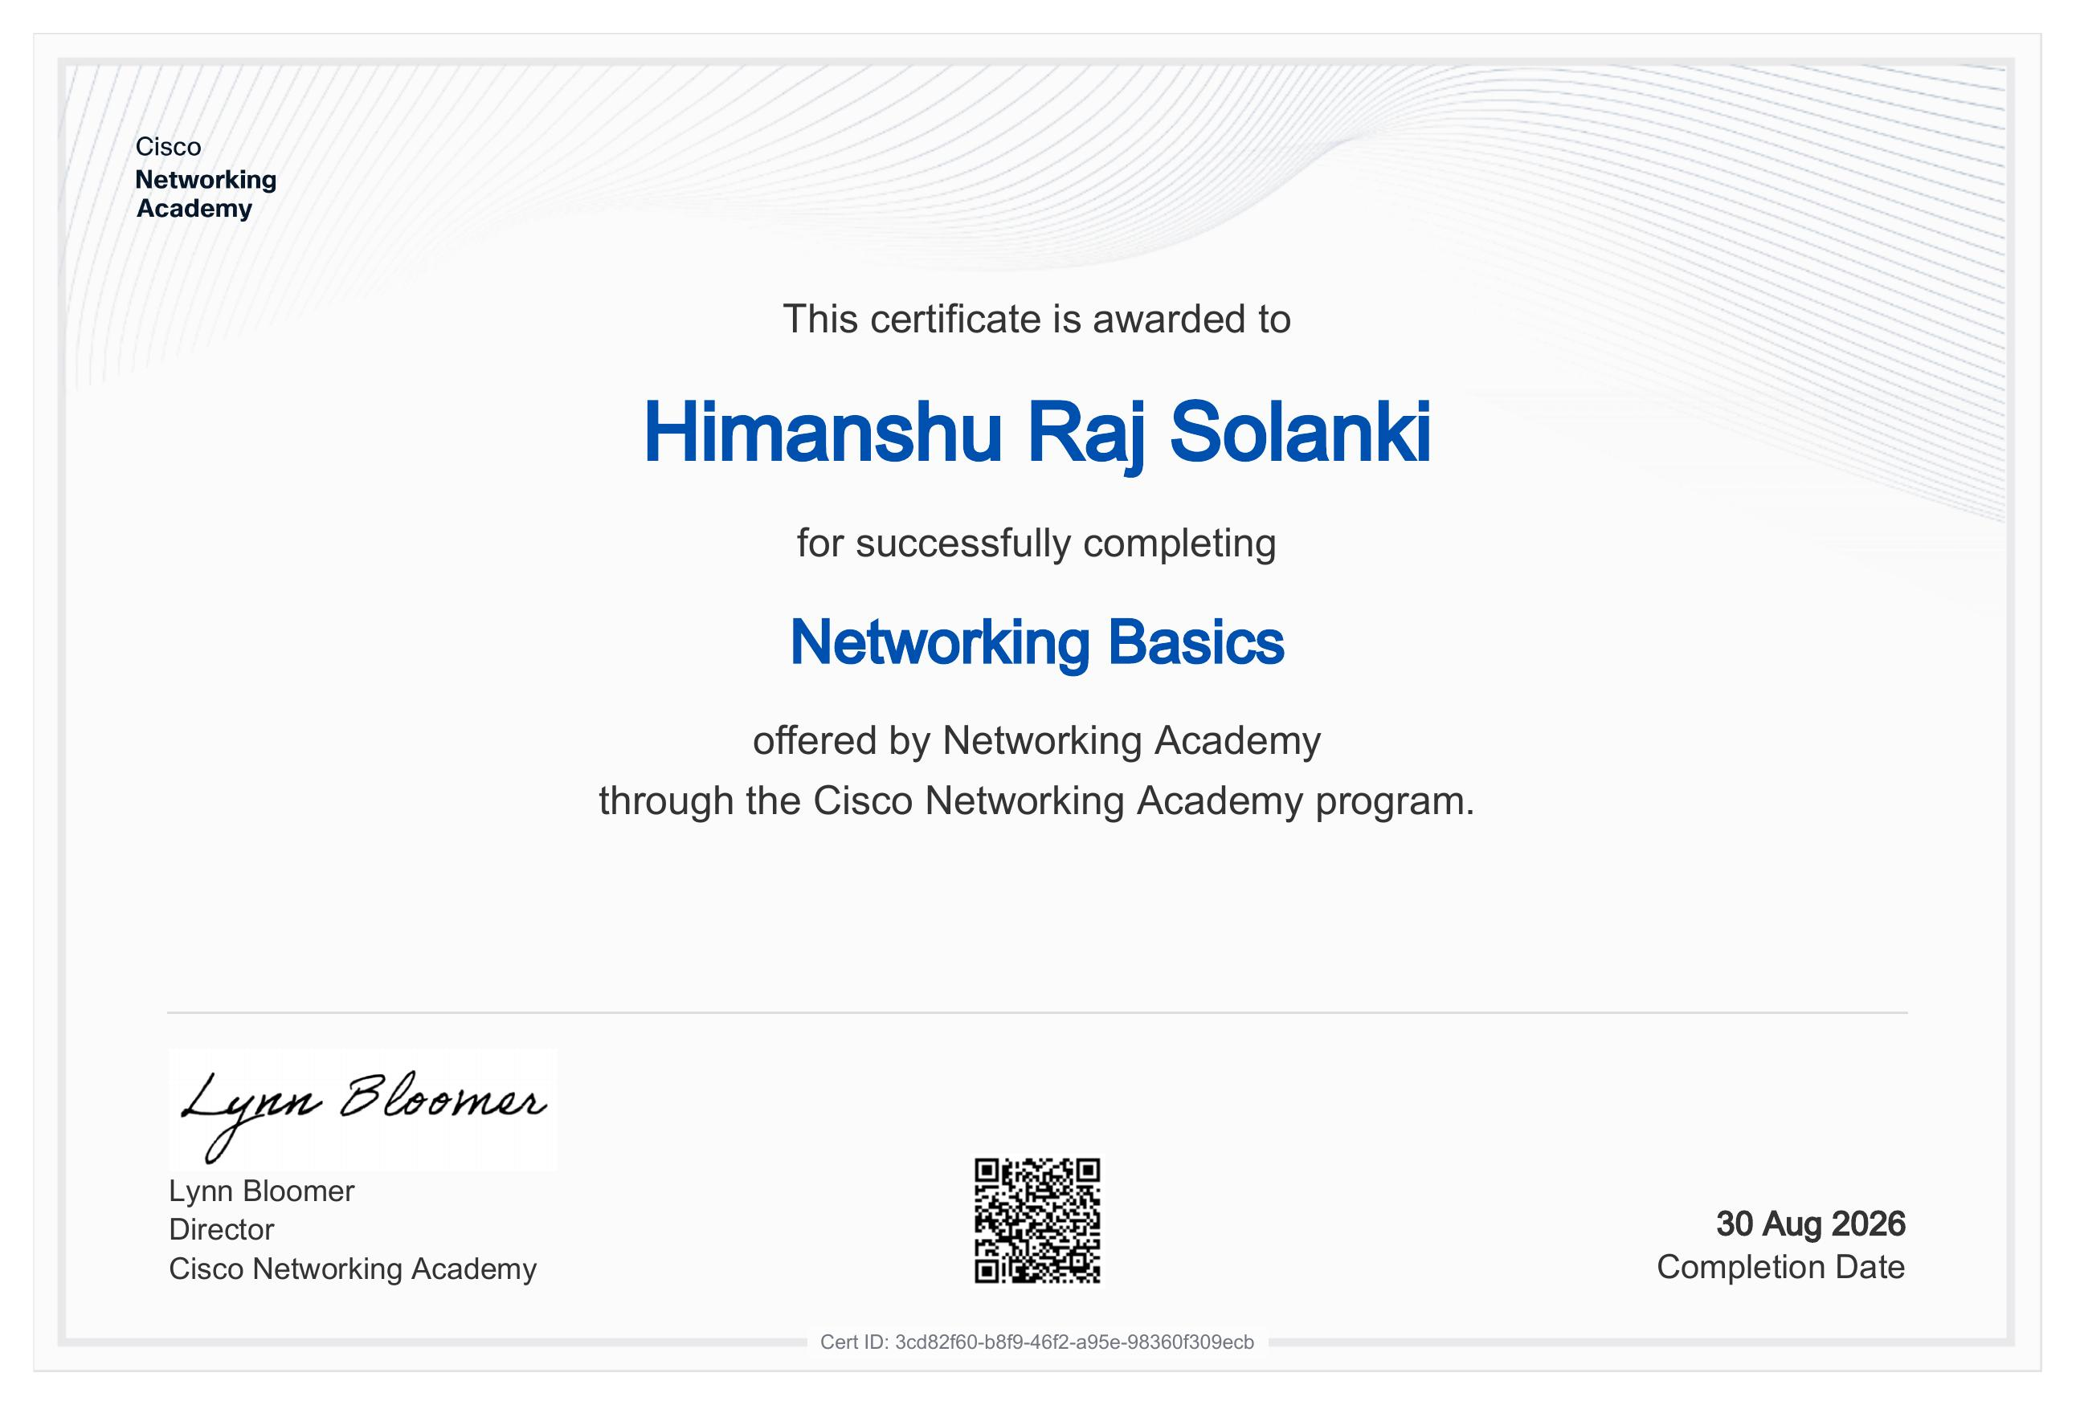

CHAPTER 4: PROJECT DESCRIPTION
4.1 Introduction
Computer networking forms the backbone of virtually every modern digital system, from small home setups to large enterprise infrastructures and the global internet itself. As part of my internship requirement for the Bachelor of Technology programme in Computer Science and Engineering at IILM University, I undertook and completed the “Networking Basics” course offered through the Cisco Networking Academy program. This report documents the course structure, the organization that delivered it, the concepts covered, and the practical skills gained during the course of study.
The course was chosen to build a strong conceptual foundation in networking, an area that is fundamental to nearly every specialization within computer science, including software development, cybersecurity, cloud computing, and systems administration. It provided an entry point into understanding how devices communicate, how data is addressed and routed, and how networks are designed, secured, and maintained.
4.2 Organization Profile
Cisco Networking Academy is a global IT skills and career-building program run by Cisco Systems, Inc. Operating in more than 190 countries, the Academy partners with schools, colleges, and universities to deliver structured, industry-aligned curricula in networking, cybersecurity, and related IT domains. Since its inception, the program has trained millions of students worldwide, combining self-paced online modules with hands-on simulations using tools such as Cisco Packet Tracer.
The Academy's courses are designed to be accessible to beginners while remaining aligned with real-world, entry-level IT job roles, making them a widely recognized stepping stone for students pursuing careers in networking and information technology.
4.3 Problem Statement
Students entering the IT and computer science fields often possess strong programming or theoretical foundations but lack practical exposure to how data communication actually functions at the network level. Without this grounding, concepts such as IP addressing, routing, and network security remain abstract and disconnected from real-world systems. This course was undertaken to address that gap — to build a working understanding of networking fundamentals that complements academic coursework in the CSE program and prepares the student for more advanced study or practical work involving networked systems.
4.4 Project Objectives
- To understand the fundamental principles of computer networking and data communication.
- To study the OSI and TCP/IP reference models and how they structure network communication.
- To learn IP addressing, including IPv4/IPv6 concepts and basic subnetting.
- To identify common networking devices, topologies, and their roles within a network.
- To understand core networking protocols and standards.
- To develop awareness of fundamental network security threats and safeguards.
4.5 Scope of the Project
The scope of this course was limited to foundational, introductory-level networking concepts suitable for beginners with no prior background in the subject. It covered conceptual and simulation-based learning rather than configuration on live enterprise hardware. Advanced topics such as dynamic routing protocol design, enterprise network architecture, and advanced cybersecurity techniques were outside the scope of this particular course, though the foundation built here supports progression into such topics in the future.
4.6 Technologies and Tools Used
- Cisco Networking Academy online learning platform (self-paced modules and assessments).
- Cisco Packet Tracer — a network simulation tool used to visualize device behaviour and topologies.
- Core protocol suite: TCP/IP, HTTP, and related standard networking protocols.
- OSI and TCP/IP layered reference models used as conceptual frameworks throughout the course.
4.7 System Architecture
Although this course did not involve building a physical or software system, it was structured around the layered architecture used to describe all computer networks — principally the OSI seven-layer model and the four-layer TCP/IP model. Each layer, from the physical transmission of bits to the application-level exchange of data, was studied to understand how information is encapsulated, transmitted, and interpreted as it passes from a source device to a destination device across a network.
The course also covered common network topologies (bus, star, ring, and mesh) and the placement and role of devices such as routers, switches, and hubs within a typical network architecture, giving a conceptual map of how real-world networks, including the one used for the Cisco Packet Tracer simulations, are organized.
4.8 Methodology
The course was completed through the Cisco Networking Academy's self-paced online learning platform. The methodology followed a structured, module-based approach: each module introduced a core concept through instructional content, followed by interactive checks for understanding and, where applicable, hands-on simulation exercises in Cisco Packet Tracer. Concepts were reinforced through periodic quizzes, and the course concluded with a final assessment validating overall understanding before the certificate of completion was issued.
4.9 Expected Outcomes
On completion of the “Networking Basics” course, the following outcomes were achieved:
- A clear conceptual understanding of how computer networks and data communication function.
- Familiarity with IP addressing and basic subnetting logic.
- The ability to identify and describe common networking devices and topologies.
- A working knowledge of key networking protocols and standards.
- Foundational awareness of network security risks and basic safeguards.
These outcomes provide a practical foundation that directly supports further coursework in the CSE program and lays the groundwork for more advanced study in networking, systems administration, or cybersecurity.
4.10 Certificate of Completion and Other Communication Proof
The certificate of completion issued by Cisco Networking Academy for the “Networking Basics” course is attached in Chapter 3 (Internship Completion Certificate) of this report as proof of successful completion.

CHAPTER 5: BIBLIOGRAPHY / REFERENCES
1. Cisco Networking Academy, “Networking Basics” course materials and learning modules, Cisco Systems, Inc.
2. Cisco Networking Academy official website — https://www.netacad.com
3. Cisco Packet Tracer software documentation, Cisco Systems, Inc.
4. Internship Report Format Guidelines, School of Computer Science and Engineering, IILM University.

