Road to Codeception on how to set-up and run the tests

Setup for Codeception:
- Download PHP from http://windows.php.net/download/
- Extract in PHP folder and save in your machine like I saved “C:\Program Files\PHP”
- Setup PHP path in your system environment variable.
- Open command prompt and check php version.

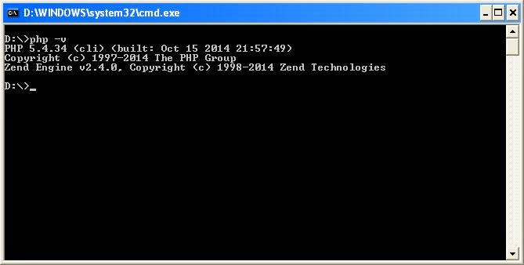

- Download Codecept.phar file from location http://codeception.com/builds as per your PHP version.
- Save this file into your created project root directory.
- Open command prompt and run below command.
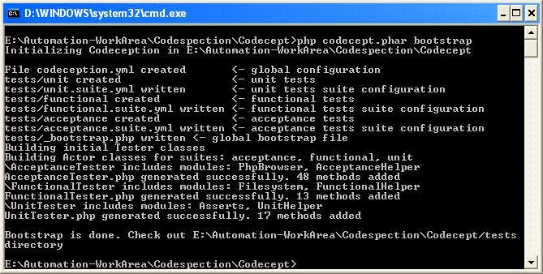

- You should see that “tests” folder and “codeception.yml” file generated under project directory.
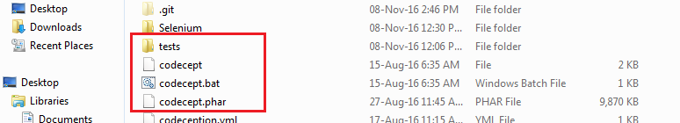

Setup for Java:
- Download JAVA from http://www.oracle.com/technetwork/java/javase/downloads/jdk8-downloads-2133151.html
- Install it in your machine.
- Setup JAVA path in your system environment variable.

Setup for SELENIUM SERVER and CHROME DRIVER:
- Download SELENIUM from http://www.seleniumhq.org/download/
- Download CHROME DRIVER from https://sites.google.com/a/chromium.org/chromedriver/downloads
- Save both files in 1 folder like I saved “C:\Selenium”
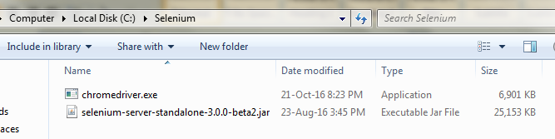

Script Creation:

- To create your first test just runs below command:

php codecept.phar generate:cest acceptance MyFirstTest

You should see that test is generated under “tests\acceptance” directory.

- Open file “acceptance.suite.yml” and set your application url like below:

class_name: AcceptanceTester
modules:
enabled:
#- PhpBrowser
- WebDriver
- \Helper\Acceptance
config:
PhpBrowser:
url: 'http://localhost/myapp'
WebDriver:
url: 'http://localhost/myapp'
wait: 3
browser: chrome
window_size: 800*600
capabilities:
unexpectedAlertBehaviour: 'accept'

- Write your acceptance code into file “tests\acceptance\MyfirstTestCest.php” in created file like I have created: Google search

<?php
$I = new AcceptanceTester($scenario);
$I->wantTo('Google search testing keyword');
$I->fillField('q','testing');
$I->click('btnG');
?>
Run Test: For running test firstly runs command to start Selenium Server
- Run below command to Start SELENIUM SERVER:
java -Dwebdriver.chrome.driver=C:\Selenium\chromedriver.exe -jar C:\Selenium\selenium-server-standalone-3.0.0-beta2.jar
- Now run below command to execute test.
php codecept.phar run acceptance MyFirstTestCest.php --env chrome --steps --html

