2-

create table Client_master(

clientno int,

name char(200),

address varchar(200),

city char(200),

state char(200),

bal_due int);

mysql> insert into Client_master(clientno,name,address,city,state,bal_due) value

s("C121","vaibhav","123 maidagin","varanasi","UP",4000);

Query OK, 1 row affected (0.06 sec)

mysql> insert into Client_master(clientno,name,address,city,state,bal_due) value

s("C122","arjunpallu","420 yadavbhavan","varanasi","UP",5000);

Query OK, 1 row affected (0.06 sec)

mysql> insert into Client_master(clientno,name,address,city,state,bal_due) value

s("C123","Hima","assi","ghaziabad","Delhi",6000);

Query OK, 1 row affected (0.30 sec)

mysql> insert into Client_master(clientno,name,address,city,state,bal_due) value

s("C124","SRC","maachi","Kolkata","West Bengal",5500);

Query OK, 1 row affected (0.28 sec)

mysql> insert into Client_master(clientno,name,address,city,state,bal_due) value

s("C125","Vini","Sarnath","Varanasi","UP",3500);

Query OK, 1 row affected (0.28 sec)

mysql> select * from Client_master

-> ;

+----------+------------+-----------------+-----------+-------------+---------+

| clientno | name | address | city | state | bal_due |

+----------+------------+-----------------+-----------+-------------+---------+

| C121 | vaibhav | 123 maidagin | varanasi | UP | 4000 |

| C122 | arjunpallu | 420 yadavbhavan | varanasi | UP | 5000 |

| C123 | Hima | assi | ghaziabad | Delhi | 6000 |

| C124 | SRC | maachi | Kolkata | West Bengal | 5500 |

| C125 | Vini | Sarnath | Varanasi | UP | 3500 |

+----------+------------+-----------------+-----------+-------------+---------+

Select name from Client_master where bal_due>5000;

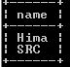

update Client_master set bal_due=5100 where clientno="C123";

select * from Client_master;

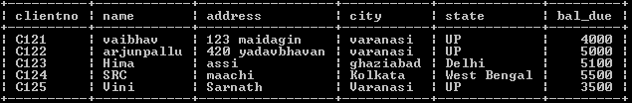

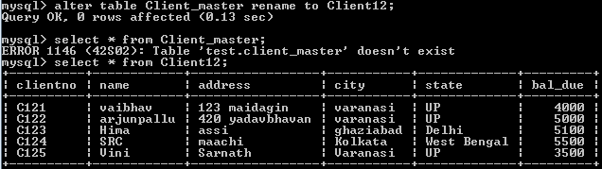

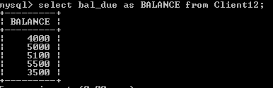

9-

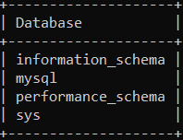Show databases;

use mysql;

show tables;

CREATE TABLE Departments(dept_noint,dept_name varchar(200),dept_location varchar(200));

INSERT into Departments(dept_no,dept_name,dept_location) values(1,'CIMS','ISC');

INSERT into Departments(dept_no,dept_name,dept_location) values(2,'HINDI','FOA');

INSERT into Departments(dept_no,dept_name,dept_location) values(3,'COMMERCE','FOC');

INSERT into Departments(dept_no,dept_name,dept_location) values(4,'HISTORY','FOS');

CREATE TABLE Employees(emp_idint,emp_name varchar(200),emp_salaryint,dept_no int);

INSERT into Employees(emp_id,emp_name,emp_salary,dept_no) values(101,'Vaibhav',3500,1);

INSERT into Employees(emp_id,emp_name,emp_salary,dept_no) values(102,'Himanshu',3000,2);

INSERT into Employees(emp_id,emp_name,emp_salary,dept_no) values(103,'Vinayak',4000,3);

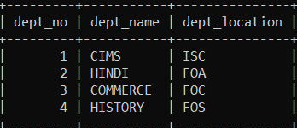INSERT into Employees(emp_id,emp_name,emp_salary,dept_no) values(104,'Arjun',2500,4);

Select * from Departments;

Select * from Employees;

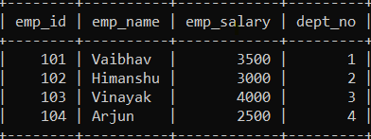

1. select * from Departments INNER JOIN Employees ON Employees.dept_no=Departments.dept_no;

OR

1. select Departments.dept_no,Departments.dept_name,Departments.dept_location,Employees.emp_id,Employees.emp_name,Employees.emp_salary,Employees.dept_no from Departments INNER JOIN Employees ON Employees.dept_no=Departments.dept_no;

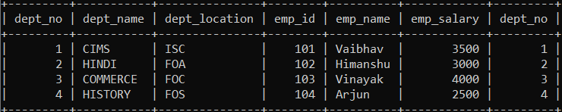

1. select Departments.dept_name,Employees.emp_name from Departments LEFT JOIN Employees ON Employees.dept_no=Departments.dept_no;

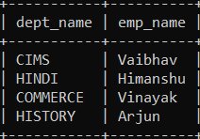

1. select Departments.dept_name,Employees.emp_name from Departments RIGHT JOIN Employees ON Employees.dept_no=Departments.dept_no;



1. select * from Employees where emp_salary> (select AVG(emp_salary) from Employees);

