**Template String** : `${variable} – show msg`  
  
**Destructuring Object** :

let uniStudent = (student) => {  
 let { name, university } = student;

console.log(`${name} from ${university}`);

};

uniStudent({ name: “Himanshu”, university: “UPTU” });

**OR**

let uniStudent = ({ name, university }) => {

console.log(`${name} from ${university}`);

};

uniStudent({ name: “Himanshu”, university: “UPTU” });

**Destructuring Array** :

let [ , , firstMountain] = [‘Everest’, ‘Fish Tail’, ‘Annapurna’];

console.log(firstMountain);

**Restructuring** :

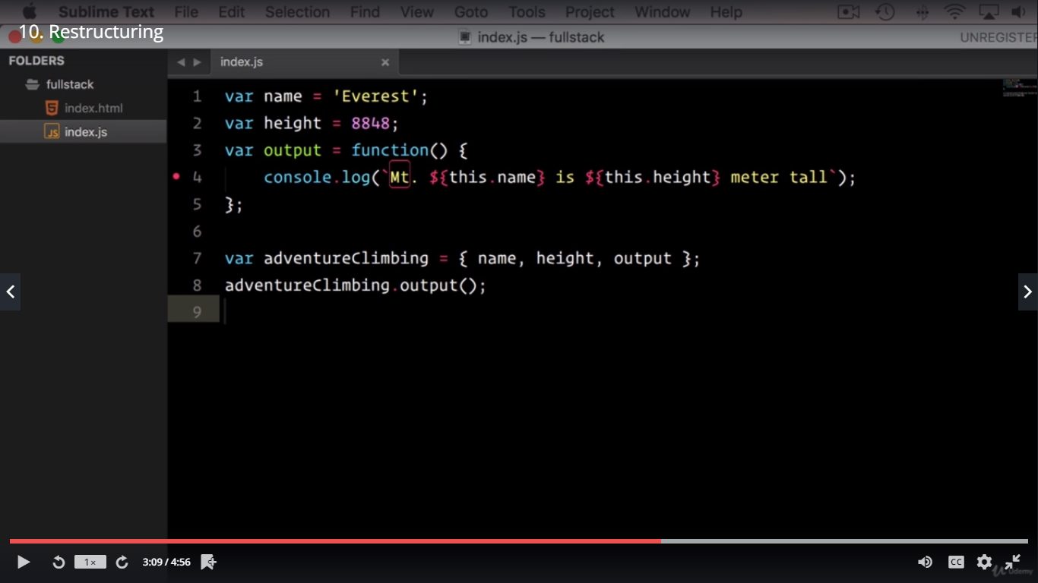

ES6 Object : focus on how to write methods in ES6

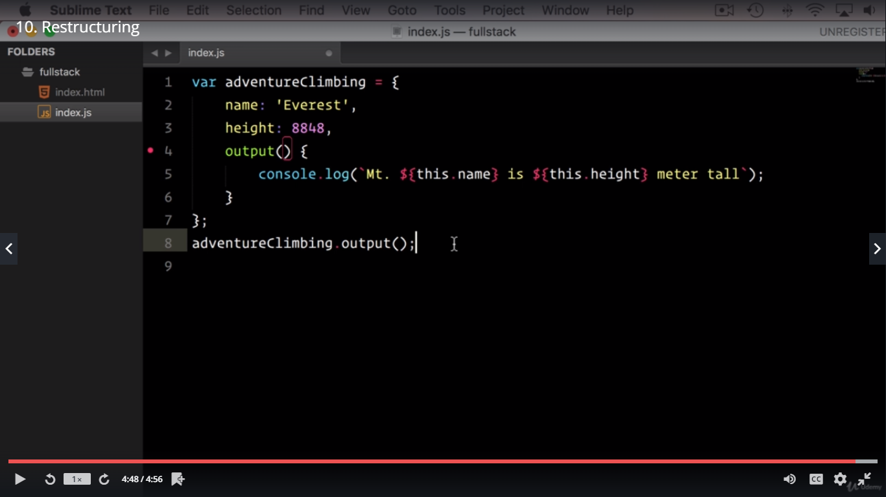

**Spread and rest operators**:

Spread:

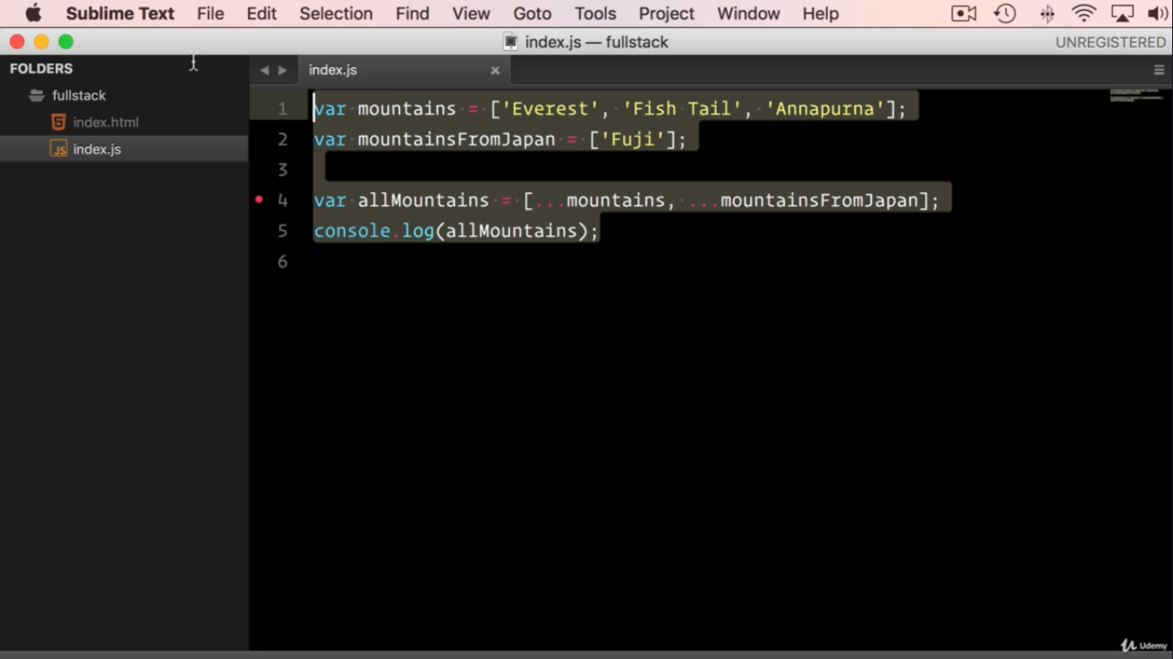

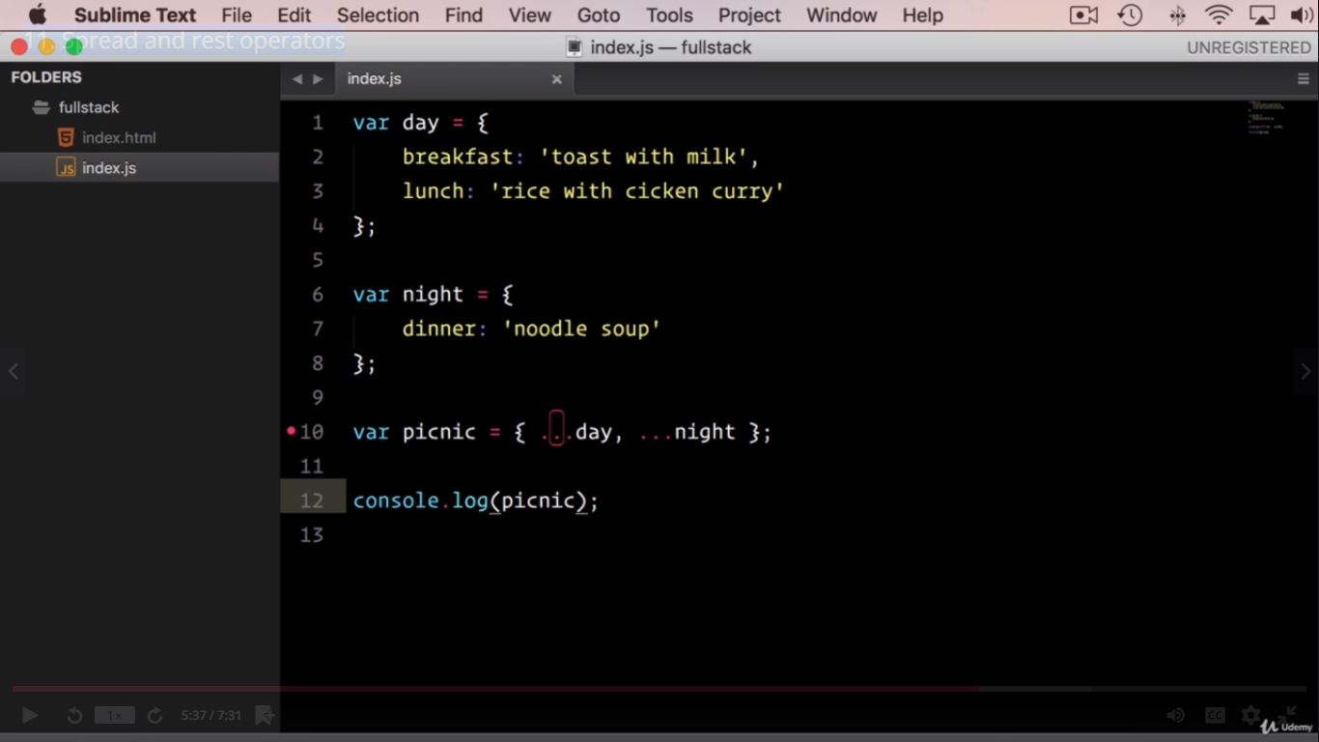

Rest

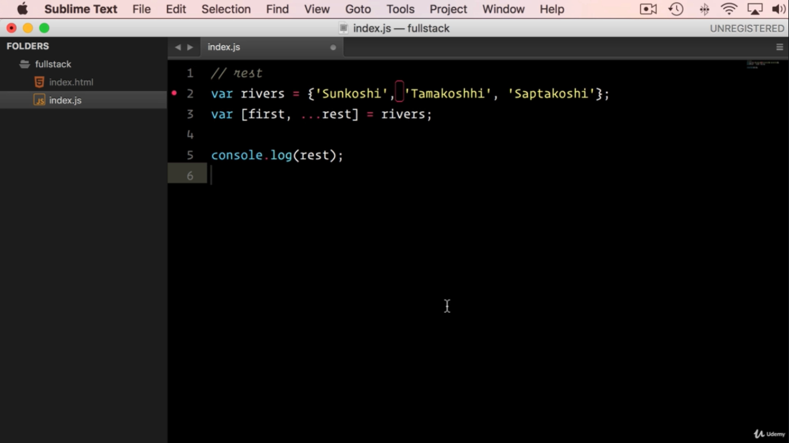

Class Constructor super

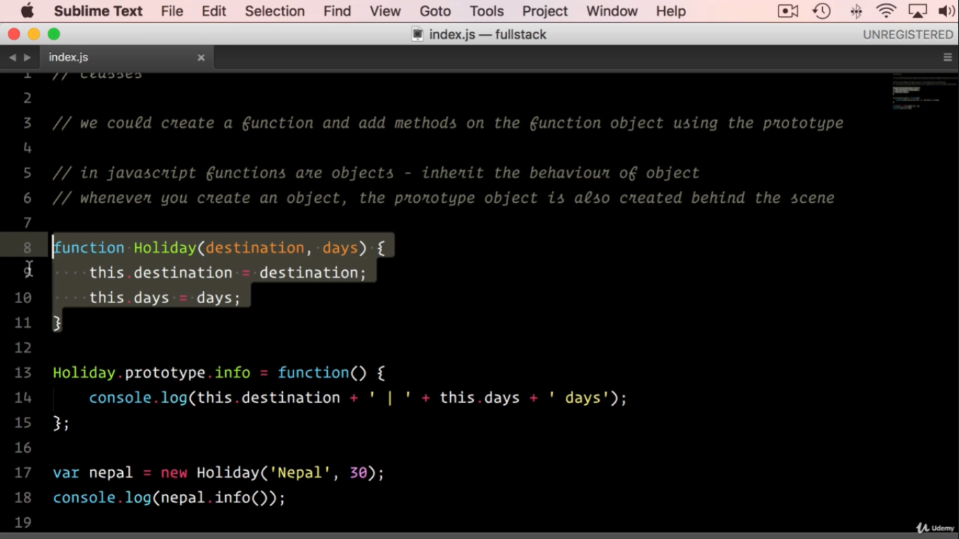

class Holiday { }

console.log(Holiday);

console.log(Holiday.prototype)

