Himansi rudra

422156

Assignment 07:

1. Write shell script for commands :

more,nl,nice,passwd,pr,rlogin,rcp,rsh,talk,telnet,tput,tty,uname,wc,who,write

#!/bin/bash

# Display the contents of file1.txt

cat file1.txt

# Display the contents of file1.txt with line numbers

nl file1.txt

# Run a command with a specified priority (modify 'your_command' accordingly)

nice -n 10 ls -l

# Change the password for the current user (might not work in a script)

passwd

# Prepare file1.txt for printing (commented out as it may not be necessary)

pr file1.txt

# Remote login to 127.0.0.1 (may not work, consider using ssh instead)

rlogin 127.0.0.1

# Copy file1.txt to file2.txt using rcp (may not be enabled or recommended)

rcp file1.txt file2.txt

# Execute a command remotely on 127.0.0.1 with specified priority (modify 'your_command' accordingly)

rsh 127.0.0.1 -n 10 your_command

# Initiate a talk session with the user 'student' (may not work, consider using other communication tools)

talk student

# Initiate a telnet session to 127.0.0.1 (may not be enabled or recommended)

telnet 127.0.0.1

# Get the number of columns in the terminal

tput cols

# Print the file name of the terminal connected to standard input

tty

# Print system information

uname -a

# Count lines, words, and characters in file1.txt

wc file1.txt

# Display who is logged in

who

write student

OUTPUT

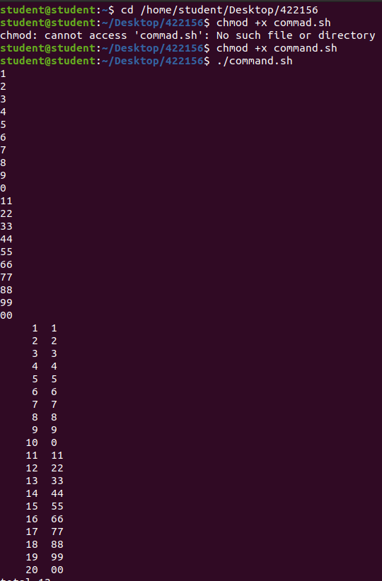

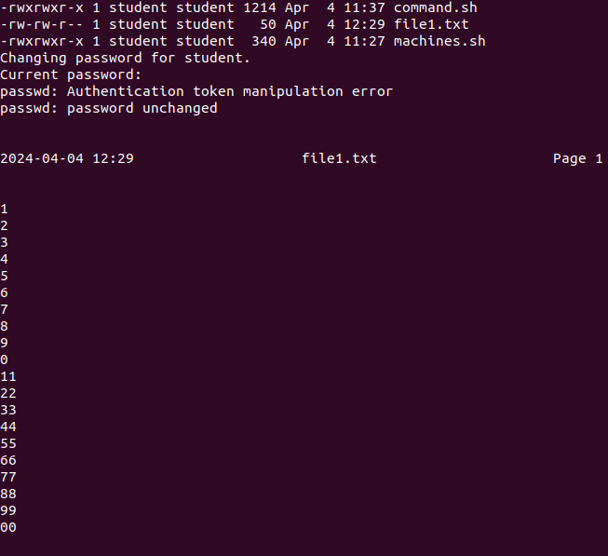

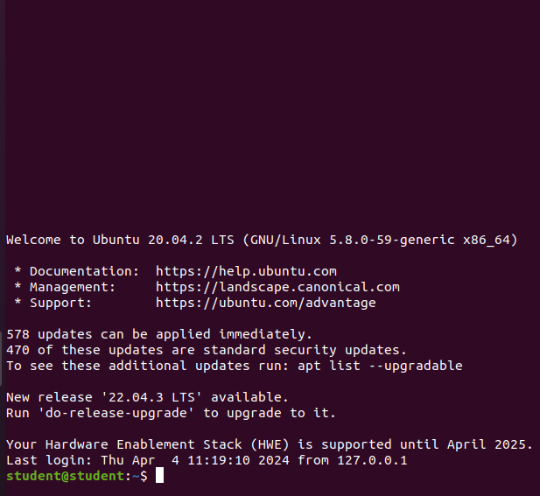

2. Write a shell script that list the memory usage and cpu usage of multiple machines.

#!/bin/bash

# List of remote machines

machines=("127.0.0.1" "172.50.9.213" "172.50.11.106")

# SSH into each machine and retrieve memory and CPU usage

for machine in "${machines[@]}"; do

echo "Machine: $machine"

ssh "$machine" "echo 'Memory Usage:'; free -m; echo ''; echo 'CPU Usage:'; top -bn1 | grep 'Cpu(s)'"

echo ""

done