Name : HIMANSI RUDRA

ROLL NO. : 422156

SEC : A

LAB WEEK 4&5

Write shell script for pattern matching using awk, sed utilities , tar , cpio.

AWK COMMAND:

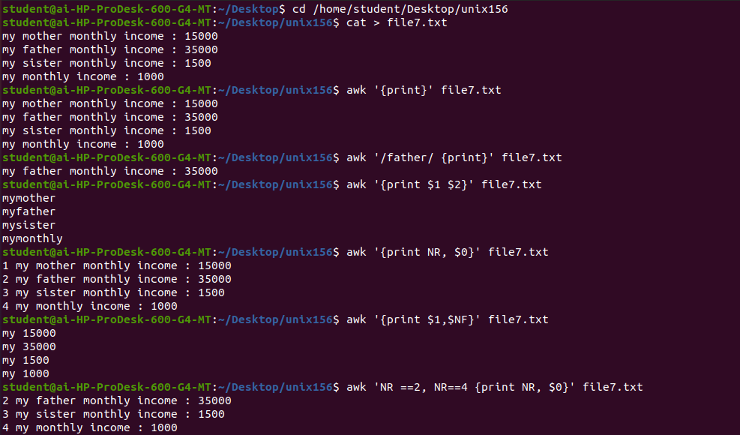

sed utilities COMMAND:

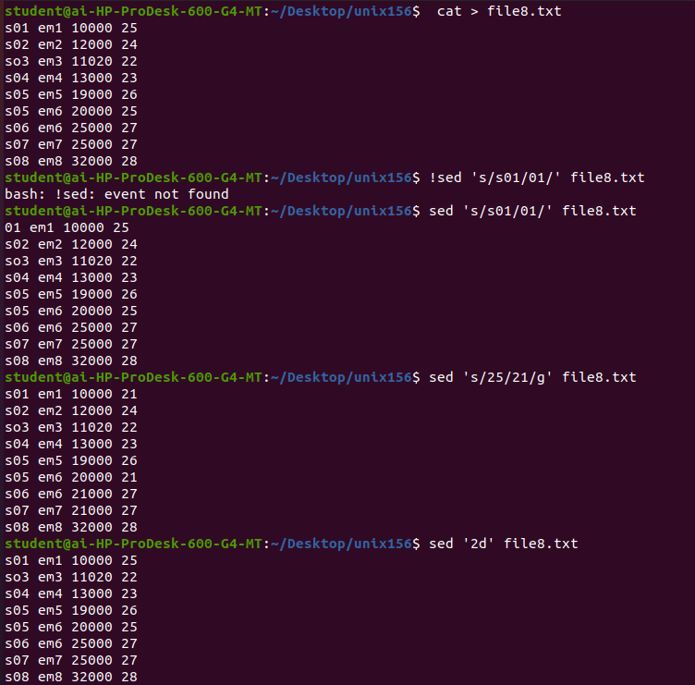

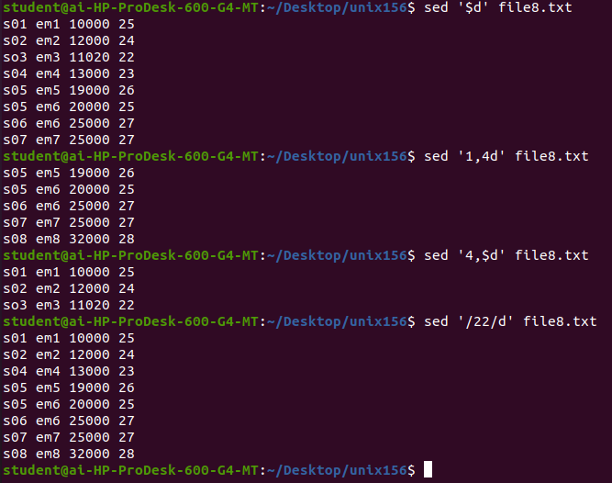

TAR COMMAND:

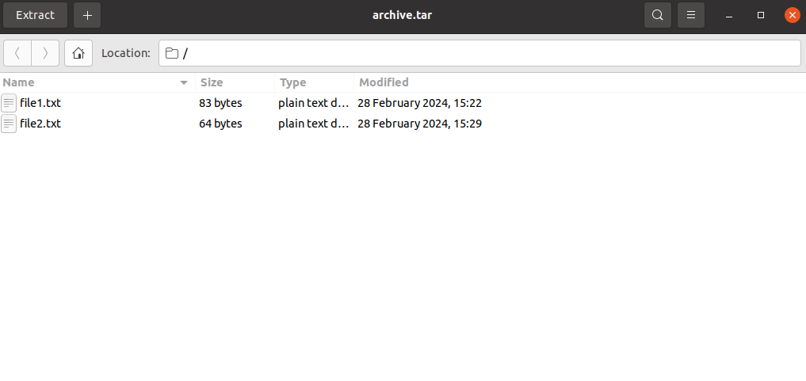

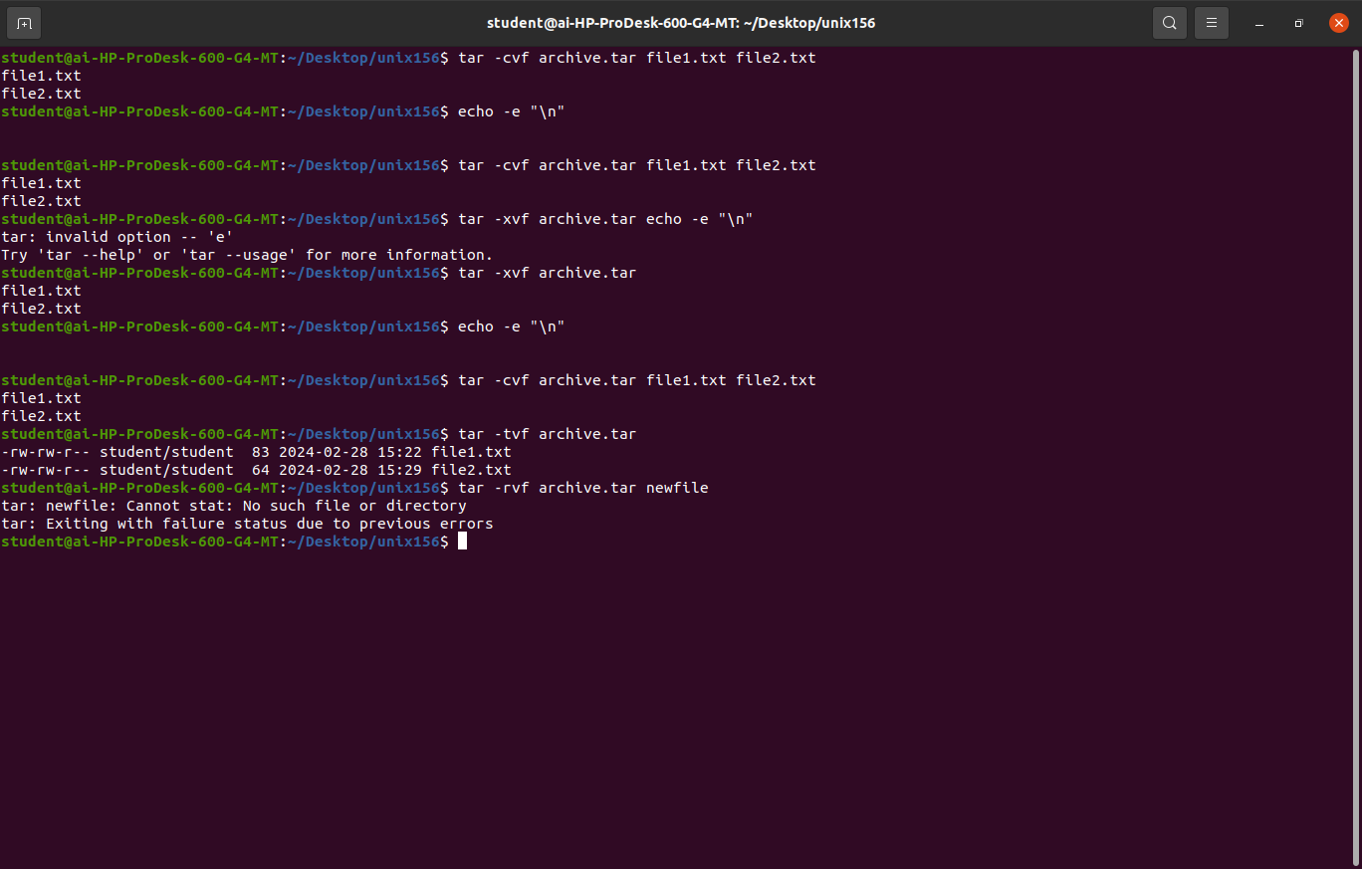

CAPIO COMMAND:

