Sabaragamuwa University of Sri Lanka


Sri Lanka Cost of Living & Inflation Analysis
(BUSINESS INTELLIGENCE PROJECT REPORT)

Prepared by | K. Himash Madushanka
Registration number | 22CDS0420
Institution | Sabaragamuwa University of Sri Lanka
Module | Business Intelligence (DS4108)
Tools | Microsoft Power BI Desktop and Power Query

Sabaragamuwa University of Sri Lanka
Faculty of Computing
Department of Data Science

Contents
Executive Summary 3
Project at a glance 3
1. Introduction 4
1.1 Background 4
1.2 Project aim 4
1.3 Objectives 4
2. Business Problem and Objectives 4
2.1 Questions the dashboard can answer 4
2.2 Business value 4
3. Scope and Dataset 5
4. Data Preparation and Quality Checks 5
4.1 Recommended validation checklist 5
5. Analysis Approach and Measures 6
5.1 Comparing different units 6
6. Dashboard Design 7
6.1 User journey 7
7. Dashboard Results and Interpretation 8
7.1 National overview 8
7.2 Matara district view 9
7.3 Hambantota high-price view 10
8. Key Findings 11
9. Recommendations and Action Plan 11
9.1 How this supports business decisions 11
10. Conclusion 12
11. References and Project Resources 12

Executive Summary
This report describes a Power BI project that explores recorded prices for essential food items in Sri Lanka. The dashboard brings summary cards, category charts, a map, a time trend, a province-by-item matrix and slicers into one interactive page. It allows users to move from a national overview to a selected province, district, product or price level.
The project documentation describes a practice dataset covering 2018–2025, 20 items, 9 provinces and 25 districts, with about 50,000 item-price records. Data preparation is carried out in Power Query. The three views discussed are the national overview, Matara district and a filtered high-price view for Hambantota.
MAIN MESSAGE A useful dashboard does more than show charts. It helps users ask a clear question, compare the right groups, spot patterns and decide what needs further checking.

Project at a glance
Topic | Summary
Business question | How do recorded food prices vary by item, category, time and location?
Users | Business analysts, data analysts, managers, researchers and other non-technical users.
Preparation | Power Query cleaning, standardisation and validation.
Outputs | Interactive Power BI dashboard and this written report.
Important boundary | The dataset is modelled for practice; findings are not official national inflation statistics.

1. Introduction

1.1 Background
Food prices are an important part of household spending. When prices change, households and businesses may need to review budgets, purchasing plans and supply choices. A single national figure cannot answer every question about individual products or local areas. A dashboard can help people explore these differences in a visual and interactive way.

1.2 Project aim
The aim is to use Power BI to explore the recorded prices of selected essential food items across Sri Lanka from 2018 to 2025 and present the results in a clear, interactive format.

1.3 Objectives
- Show summary measures for the selected dataset.
- Compare price observations across food categories and items.
- Explore how recorded prices change over time.
- Allow users to filter by year, month, item, price level, province and district.
- Present the results in simple language for business discussion.
- Identify data-quality issues and improvements needed before formal use.

2. Business Problem and Objectives
The business problem is that a large table of item-price observations is difficult to explore quickly. A user may need to know which categories contribute most observations, how prices changed over time, or what the data shows for one district. The dashboard brings these questions together and lets the user apply filters without manually searching rows in a spreadsheet.

2.1 Questions the dashboard can answer
- What is the average recorded price under the current filters?
- Which categories contain the most observations?
- How does the recorded-price trend move across the selected years?
- What values are shown for selected items in different provinces?
- What changes when the user selects one district or price level?

2.2 Business value
The dashboard can support exploration, reporting and follow-up questions. It can help an analyst identify where to investigate further. It does not, by itself, prove why a price changed or what caused an economic trend; those questions require additional evidence.

3. Scope and Dataset
Dataset detail | Description in project documentation
Period | 2018–2025
Records | About 50,000 item-price records
Items | 20 essential food items
Geography | 9 provinces and 25 districts
Categories | Vegetables, Rice, Spices, Coconut, Flour, Cooking Oil, Pulses and Sugar
Fields | Date, Year, Quarter, Month, Province, District, Category, Item, Unit, Price_LKR and classification/quality fields
Preparation tool | Power Query in Power BI Desktop
Source basis | Modelled on the DCS Sri Lanka retail-price reporting framework

4. Data Preparation and Quality Checks
Data preparation helps make sure that the charts use consistent and meaningful values. The documented workflow uses Power Query before building the report.
Task | What to do | Why it matters
Date fields | Convert date text to Date type and check Year, Quarter and Month fields. | Supports correct time filtering and trends.
Location fields | Standardise province and district names. | Prevents spelling differences from splitting one location into multiple values.
Price fields | Check numeric types, blanks, invalid values and outliers; record issues where appropriate. | Reduces the risk of misleading totals and averages.
Item/category names | Standardise labels and category assignment. | Keeps the same item grouped consistently.
Price level | Review the Low, Medium, High and Very High classification. | Makes the price-level slicer meaningful.
Validation | Compare counts, totals, averages and filtered results against the source data. | Helps identify unexpected changes after cleaning.

4.1 Recommended validation checklist
- Confirm the number of rows before and after cleaning.
- Check for blank dates, missing item names and missing locations.
- Confirm that price fields are numeric and units are documented.
- Check for duplicate records using the appropriate business keys.
- Compare KPI results before and after applying slicers.
- Record each transformation so another analyst can repeat the work.

5. Analysis Approach and Measures
The report combines summary measures with comparisons by category, time and geography. The meaning of every measure should be clear before it is used to make a decision.
Measure / concept | Simple meaning | Use
Record count | Number of rows that meet the current filters. | Shows the amount of data included.
Average price | Mean of the selected price values, according to the measure definition. | Summarises price values in the filtered data.
Category share | Category observations divided by all observations in the same selection. | Shows the mix of observations.
Month-on-month change | Change compared with the previous month, if the data and calculation support it. | Helps examine short-term movement.
Year-on-year change | Change compared with the same period 12 months earlier, if available and validated. | Helps examine annual movement.
Price index | A standardised value designed to support comparisons over time or between products when correctly constructed. | Can be more suitable than comparing unlike units directly.

5.1 Comparing different units
Items may be measured in kilograms, litres or individual units. Their raw prices are not directly comparable as if they were the same product or unit. Before comparing items, show the unit clearly and use a suitable index or like-for-like comparison where possible.

6. Dashboard Design
The dashboard is arranged to show key information first, then category and geographic views, followed by the trend and item comparison matrix. The slicers on the left allow users to select a date range, month, item, price level, province and district.
Visual | What it shows | Why it is useful
KPI cards | Summary values and coverage. | Quick view of the current selection.
Donut chart | Share of observations by category. | Shows category composition.
Column chart | Observation count by category. | Compares category volumes.
Map | Geographic distribution for the selected data. | Adds location context.
Line chart | Recorded price values over time. | Shows direction and variation.
Matrix | Item price values by province, with drill-down if configured. | Supports detailed comparisons.
Slicers | Filters for year, month, item, price level and location | Lets users explore their own questions.

6.1 User journey
- Start with the national overview and check the selected date range.
- Use the category chart to identify a category for closer analysis.
- Select a province or district in the location slicer.
- Use the trend chart to review changes across time.
- Use the matrix to compare selected item values.
- Clear filters before returning to the national view.

7. Dashboard Results and Interpretation

7.1 National overview
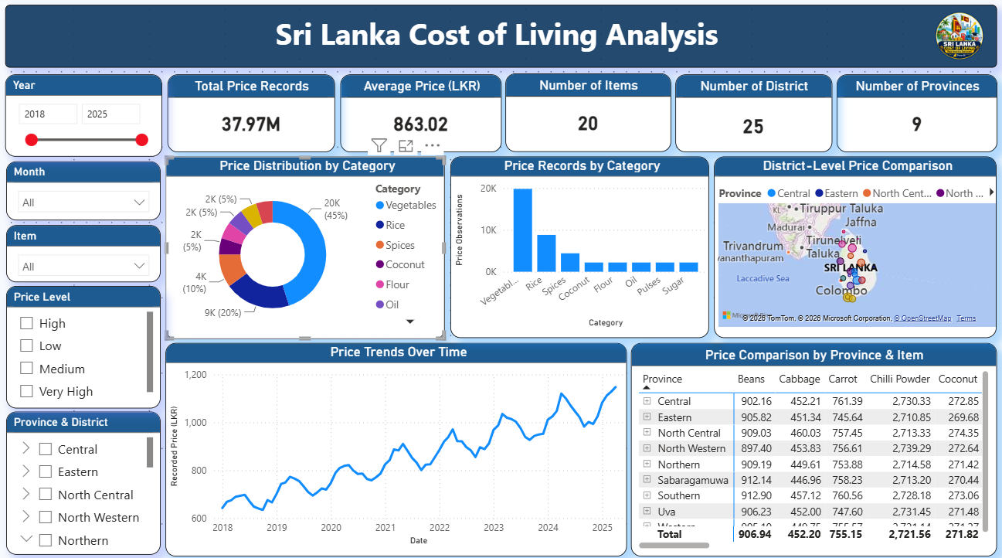
Figure 1. National overview: all provinces and districts, 2018–2025.
The national screenshot shows an average-price card of LKR 863.02, 20 items, 25 districts and 9 provinces. The recorded-price line rises overall from approximately LKR 650 in 2018 to around LKR 1,150 in 2025, with several short-term rises and falls. The category chart shows vegetables as the largest observation group, followed by rice and spices.
- The national view provides the baseline for exploring more specific areas.
- The matrix displays selected item values and can help identify which items merit closer review.
- The trend describes the selected price series in the practice dataset; it should not automatically be called an official inflation rate.

7.2 Matara district view
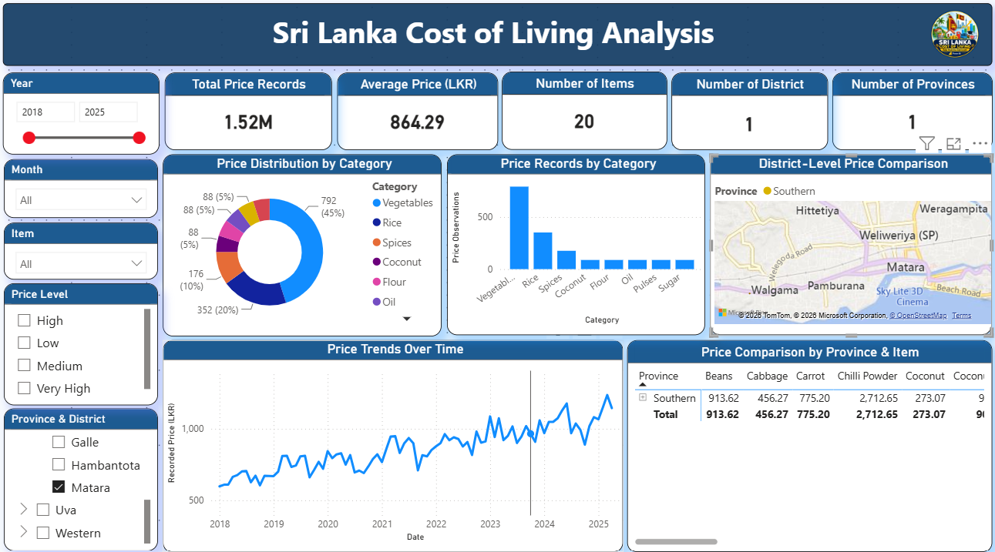
Figure 2. Matara district view: Southern Province.
The Matara screenshot shows an average price of LKR 864.29. The project report compares selected item values against the national values: beans, cabbage, carrot and coconut are slightly higher in the displayed Matara view, while chilli powder is slightly lower. These comparisons only apply to the selected dataset, items and measure definitions.
Item | National (LKR) | Matara (LKR) | Difference (LKR)
Beans | 906.94 | 913.62 | +6.68
Cabbage | 452.20 | 456.27 | +4.07
Carrot | 755.15 | 775.20 | +20.05
Chilli Powder | 2,721.56 | 2,712.65 | −8.91
Coconut | 271.82 | 273.07 | +1.25
Interpretation: Matara’s overall average is close to the national average in this dashboard. Carrot has the largest positive difference among these five selected items. A difference in a displayed average does not, by itself, explain why that difference exists.

7.3 Hambantota high-price view
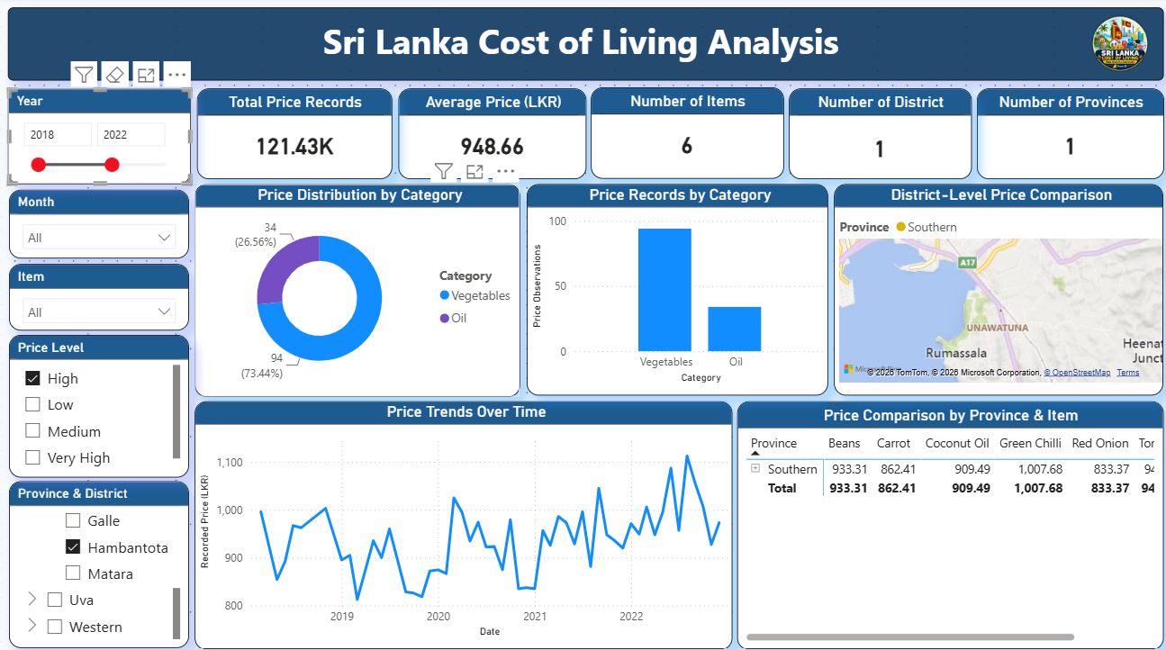
Figure 3. Hambantota view: High price level, 2018–2022.
This screenshot filters the dashboard to Hambantota, the High price level and the period 2018–2022. It shows an average price of LKR 948.66 and six items. Vegetables represent 73.44% of the displayed category observations and oil represents 26.56%.
Item | Average price shown (LKR)
Green Chilli | 1,007.68
Beans | 933.31
Coconut Oil | 909.49
Carrot | 862.41
Red Onion | 833.37
Interpretation: this view helps isolate selected higher-price records for investigation. It should not be compared directly with the national average because the filters and record population differ.

8. Key Findings
- The recorded-price trend in the national view increases overall from 2018 to 2025, but it does not rise at the same rate every month.
- Vegetables account for the largest share of category observations in the displayed national view.
- The Matara filter enables item-by-item comparison with the national values shown in the project report.
- The Hambantota view shows how a price-level filter can focus attention on a smaller subset of records.
- The dashboard is useful for exploring patterns, but a trend line alone does not establish the cause of a price change.
- Clear KPI definitions, consistent units and validated calculations are essential before using results in business decisions.

9. Recommendations and Action Plan
Action | Reason | Suggested owner | Priority
Correct the first KPI label or measure | A summed price value is not a record count. | Dashboard developer / data analyst | High
Validate price and inflation measures | Prevent incorrect interpretation of averages and percentage changes. | Data analyst | High
Document data cleaning | Make the process repeatable and easier to review. | Data analyst | High
Use consistent comparisons | Match dates, items, units and filters across locations. | Business / data analyst | High
Improve matrix readability | Make selected item comparisons easier to read. | Dashboard developer | Medium
Add income or wage data if reliable data is available | Price alone does not measure affordability. | Business analyst / researcher | Future
Refresh with verified data sources | Keep the analysis current and traceable. | Data owner / analyst | Future

9.1 How this supports business decisions
The dashboard can help an analyst identify an area or product that needs further investigation. A business user could then ask for a source check, compare supply or transport information, or request a deeper analysis. The dashboard should be treated as a starting point for questions, not as proof of the reason behind a change.

10. Conclusion
This project demonstrates how Power BI can turn item-level price data into an interactive report. Users can view a national summary, focus on a district, compare categories and items, and explore how recorded prices move over time. The project also demonstrates important data-analysis habits: prepare data carefully, check measures, compare like with like and explain limitations clearly.
For a business or data analyst, the value is not only the charts. It is the ability to translate a question into analysis, explain what the data supports, identify what it does not support, and recommend the next step.

11. References and Project Resources
The following references are listed in the project documentation. Use the official sources directly when checking national statistics.
- Department of Census and Statistics, Sri Lanka — Retail Prices: https://www.statistics.gov.lk/InflationAndPrices/StaticalInformation/RetailPrices
- Department of Census and Statistics, Sri Lanka — National Consumer Price Index: https://www.statistics.gov.lk/InflationAndPrices/StaticalInformation/MonthlyNCPI
- Central Bank of Sri Lanka — Measures of Consumer Price Inflation: https://www.cbsl.gov.lk/en/measures-of-consumer-price-inflation
- Microsoft Learn — Power BI documentation: https://learn.microsoft.com/en-us/power-bi/
- Project repository (as recorded in the project README): https://github.com/HimashMadushanka/Sri-Lanka-Cost-of-Living-Analysis-Dashboard

.

