

**Higher Education Institute in Sri Lanka**

**Probability and Statistics Report**

**Name: M A H Lakshani**

**SA Number: SA22886040**

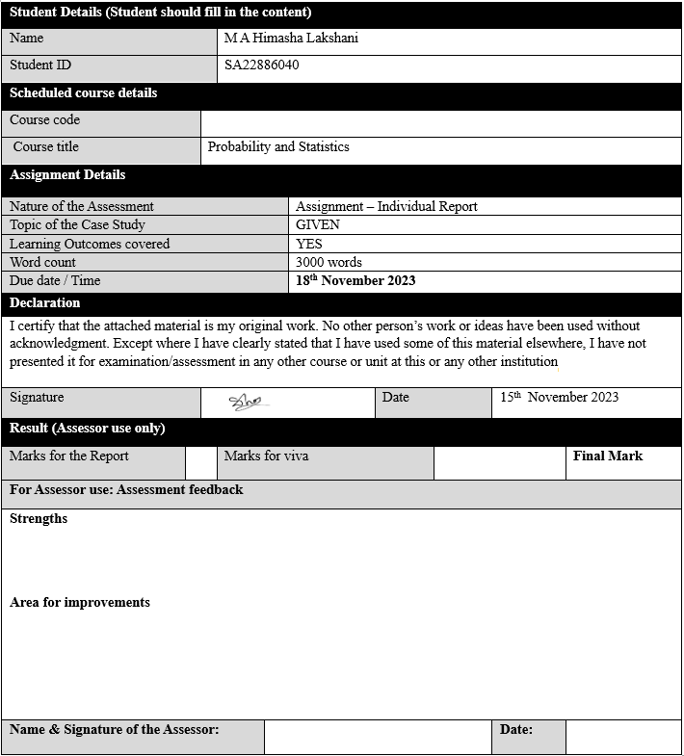

# **ABSTRACT**

This paper investigates the attitudes and opinions of Sri Lankans on higher education institutions. A survey was used to acquire the dataset. I chose undergraduate and graduate students from public and private universities for my sample. This study focuses on students' perceptions of higher education institutions in Sri Lanka. Discuss whether private universities should be closed or whether private university standards and certain parts of government universities should be improved.

According to UGC, only 25% of A/L applicants who passed would be accepted to government universities in 2022. It raises the already strong demand for private universities. Because private universities are in high demand, their standards should also be examined. The main objective of the research is to look into suggestions for developing and enhancing both private and public universities in Sri Lanka

It strives to raise awareness of the opportunities for enhancing the educational landscape, addressing the nation's academic challenges and aspirations.

This conclusion demonstrates the participants' valuable ideas for improving higher education in both private and public universities in Sri Lanka. They provide numerous alternatives. This study would help policymakers improve the quality of undergraduate education.

# **DECLARATION**

I, M.A.Himasha Lakshani, declare that I am the sole author of the study and that all of the information in this paper is my original work unless otherwise noted. As a result, I can ensure that this work wasn't previously released or approved for publication by another publisher.

# **ACKNOWLEDGEMENTS**

I want to thank everyone who helped me finish my Higher Education in Sri Lanka Probability and Statistics Report and express my gratitude. First and foremost, I'd like to express my gratitude to Mrs. Thilini Kulaweera, our PS instructor, for her invaluable guidance, support, and criticism during the semester.

Finally, I want to thank my family and close friends for their ongoing encouragement and drive throughout this effort.

I'd like to close by expressing my heartfelt appreciation to everyone who has helped with this effort in any way.

**TABLE OF CONTENTS**

**ABSTRACT** i

**DECLARATION** ii

**ACKNOWLEDGEMENTS** ii

**LIST OF FIGURES** iv

**CHAPTER 01 – Introduction** 1

**1.1** **Background** 1

**1.2** **Problem Identification** 2

**1.3** **Significance of Research** 2

**1.4** **Objective of Study** 3

**1.5** **Chapter Framework** 3

**CHAPTER 02- Literature Review** 4

**CHAPTER 03 - Theory and Methodology** 5

**3.1. Data Collection Method** 5

**3.2. Structure of the Questionnaire** 6

**3.3 Preliminary Data Analysis** 7

**3.3.1. Descriptive Analysis** 7

**3.3.2. Analyzing Demographic Data** 8

**CHAPTER 04 - Results** 9

**4.1 Descriptive Data Analysis** 9

**CHAPTER 05 – Conclusion** 14

**REFERENCES** 15

**R DIAGRAMS** 16

# **LIST OF FIGURES**

Figure 1 Chapter Framework 3

Figure 2 Central Tendency Measures 7

Figure 3 Composition of Age 9

Figure 4 Data of Age 9

Figure 5 Composition of gender 10

Figure 6 Education Background 10

Figure 7 Comparison of age and Education background 11

Figure 8 Bar Graph of education background 11

Figure 9 Type of Universities 12

Figure 10 University choice 12

Figure 11 Opinion about private universities 13

Figure 12 Factors affecting to closure private universities 13

Figure 13 Comparison of Age and Education background 16

Figure 14 Factors affecting to choose higher education 16

Figure 15 Factors affecting to close private universities 16

Figure 16 Scatterplot Age vs Education Background 17

# **CHAPTER 01 – Introduction**

## **Background**

Education has a long history in Sri Lanka. In Sri Lanka, higher education is an optional final stage of formal instruction beyond secondary school. The most common places for higher education, often tertiary education, are universities or degree-granting institutions. These degrees could be from public universities, public and private degree-granting institutions, or international universities. High-profile challenges include governmental institutions' inadequate capacity to accommodate demand and antipathy towards private universities from certain segments (Wikipedia, 2017).

IN 2022, the A/L Examination was taken by 263,933 candidates, according to secondary data. At the GCE (A/L) Examination, 166,938 applicants met the minimum criteria for university entrance (Doenets, 2023). However, only 25.39% of those who passed were admitted to government universities in the 2021/2022 academic year (UGC, 2022). 74.61% of applicants were denied admission. As a result, most candidates denied admission to government colleges seek admission to private universities to pursue their future aspirations.

According to the study, Sri Lanka requires more universities and an increase in the annual student intake. With other objectives in health, transportation, infrastructure development, etc., this is not a simple assignment for the government (Gunarathna, n.d.) t. As a result, the government is having difficulty investing in new public universities. The government consider different solutions to this challenge in 2023. Cabinet Memorandum No. 28 recommends introducing the notion of a privately run "non-profit" organization to Sri Lanka, both through official sponsorship and contributions from "private philanthropists” (Perera, 2023).

The issue of whether private universities should be closed has recently been a hot topic. Many government university students are on strike to force the closure of private universities. They believe that many private universities provide inadequate education. As a result, the purpose of this study was to uncover the factors that influence students' decision to attend private or public universities for their higher education. We will also discuss the alternatives we have for improving private and public universities in Sri Lanka.

The diversity of these educational institutions is examined in the study, which ranges from the historic and prominent University of Peradeniya to specialized colleges such as the Sri Lanka Institute of Information Technology (SLIIT). It delves into their academic offerings, faculty expertise, research projects, and overall impact on their respective regions and the nation. The sample participants were 150 undergraduates and graduates from private and public sector universities in Sri Lanka, and the data were acquired by questionnaires.

## **Problem Identification**

University admission in Sri Lanka is exceedingly tough, with only 2% of candidates admitted. This fosters fierce competition among students, leading to the establishment of private universities. Although there is a high demand for private universities, admission should not be provided arbitrarily. Authorities should evaluate three elements before granting authorization to build a university: educational excellence, financial feasibility, and long-term sustainability (W.A. Wijewardena, n.d.).

In Sri Lanka, there are numerous private universities. Most candidates who are denied entrance to government colleges seek admission to private universities to further their education. This issue is caused by the limited capacity of government universities. Government universities have limited resources, therefore only individuals with the top grades can attend. As a result, most students must attend private universities (Dilushi S. Kodithuwakku, 2015). After finishing their O/L, the majority of students now attend private universities. Some private universities provide the most valuable degrees available, such as medicine. There must be a criterion if they provide such a prestigious degree.

The closing of private universities in Sri Lanka remains a radical choice with far-reaching consequences. The educational, economic, social, and regulatory ramifications of such a decision are all possible. Sri Lankan money will leave the nation if private universities are closed. That is a significant influence. This study's findings aid in overcoming these issues and identifying alternatives.

## **Significance of Research**

* This research is essential for understanding the complex dynamics of Sri Lanka's educational scene. It delves into the complicated difficulties and probable ramifications of closing private institutions, which are important concerns for policymakers, educators, and stakeholders.
* It is vital to comprehend the influence on pupils, educational access, and educational quality. This study looks into the potential effects on student choices, learning environments, and the overall educational quality of the country.
* Both private and public universities have some flaws. We can see what challenges the student sees in a university circle by conducting this inquiry.
* We can observe the various choices for the development of private and public universities.

## **Objective of Study**

Higher education possibilities in Sri Lanka have grown dramatically over the last decade. Today's youth are more eager to learn, and the vast majority of them attend. The majority of those chose private universities as opposed to government universities (Muhandiramge, n.d.). Our research looked into the factors that had a major impact on student satisfaction, if there was a relationship between those factors, and whether those factors had a significant impact on student satisfaction at private and public universities. This study's major purpose was to determine whether or not students were satisfied. It is expected to be done with a focus on.

The primary goal of this study is to discuss what steps can be taken to increase the number of private and public universities in Sri Lanka. The goal is to promote a deeper understanding of the potential possibilities for improving and expanding the educational landscape.

## **Chapter Framework**

## 

Figure Chapter Framework

# **CHAPTER 02- Literature Review**

Universities, in particular, must pursue knowledge in two ways: by encouraging the highest level of creative thinking and by contributing to the settlement of current societal and global concerns. Its fundamental purpose is to be a higher learning institution that promotes freedom and democracy, knowledge and innovation, and humanity and the environment (Escotet, 2020). The primary goal of this study is to discuss strategies for increasing the number of private and public universities in Sri Lanka. There is competition for that between public and private universities.

In the educational process, both formal and informal settings are significant. Formal education is the process of formally enrolling in and studying in a school or college to improve one's knowledge and abilities. Some countries were praised for their innovative technologies, while others were lauded for their progressive higher education options. We recognize that Finland, Denmark, Norway, Japan, and Russia have all had an impact on modern education when we look at factors like GDP per person, teacher-to-student ratios, and access to public research resources (Bscholary, 2023).

The number of private higher education universities in Sri Lanka is growing due to the relatively high demand for such universities. The main reason for this decision is the shortage of accessible space at public universities. The Ministry of Higher Education has given the authority to issue degrees and bestow program-based acknowledgment to private universities (Gunarathna, n.d.).

In his budget address to parliament today, President Ranil Wickramasinghe said that Sri Lanka will establish a new technology university in Kandy and expand the capacity of existing higher education institutions. "A new Technology University will be established in Kandy under the guidance of IIT University in Chennai, India," Wickremesinghe said today during the 2024 budget reading in parliament (economynext, 2023).

The Sri Lankan government has made significant investments in students' higher education. When a student finishes the advanced levels and is accepted to university, the government spends significantly on the four-year degree program. at the moment bachelor's degree in law, business, humanities, or social science costs between $3000 and USD 5,000 on average. It would cost between 6000 and 12500 USD to study biological science, computer, or engineering if you were studying physics. In an impoverished nation, this amounts to a lot more money. The average monthly household income in Sri Lanka was 76,414 rupees. When deciding whether to spend money on a private college, one should examine how satisfied students are with the pricing. The Sri Lankan economy is predicted to have a severe recession in 2022, 2023, and beyond, while income levels have recently decreased. As a result, while analyzing student satisfaction at private colleges, we must additionally include the cost of the degree will help both foreign students who are interested in coming to Sri Lanka for higher education and locals who are willing to pay a significant amount of money for the campus or take out a study loan from a bank to attend private universities determine whether they are making a good long-term investment.

# **CHAPTER 03 - Theory and Methodology**

## [**3.1. Data Collection Method**](https://docs.google.com/document/d/1w_DhrU5w25wPlyupZjRavQhzhQZCshAd/edit#heading=h.2xcytpi)

I found the data set for this study by doing a survey. I chose 150 undergraduate and graduate students from public and private universities for my sample. The survey questionnaire was carefully designed and covered a wide range of topics, such as respondents' educational backgrounds, experiences at their respective institutions, important variables influencing their university preferences, evaluations of strengths and weaknesses, perspectives on interest closures, and recommendations to improve both private and public universities. To provide a balanced representation across multiple universities and academic programs, participants were chosen impartially using random selection techniques.

The usage of online survey tools such as Google Forms prioritizes accessibility and ease of answer collection. Strict attention to moral values assured participant confidentiality, voluntary participation, and the use of informed consent. The carefully collected data was meticulously evaluated utilizing statistical approaches and software tools such as SPSS, ensuring dependability and stimulating interesting discoveries. Overall, the goal of this survey approach was to gather diverse viewpoints from students, providing the framework for a thorough and educated assessment of Sri Lanka's educational landscape.

## **3.2. Structure of the Questionnaire**

The dataset used for this study contains information on higher education institutions in Sri Lanka. There are 20 variables in the dataset.

These are the variables in the data set:

* **Age** - to identify the age range of the respondents.
* **Gender** - to identify the gender of the respondents.
* **Education Background** - to understand educational background.
* **Have you been or are you now enrolled in a Sri Lankan university**? - Have you been or are you now enrolled in a Sri Lankan university? Aids in determining the participants' current or previous affiliation with a university in Sri Lanka.
* **If yes, what type of university attend** - to understand the type of university.
* **Rating university experience** - A measure of participant satisfaction that provides information on how they perceive their university experience.
* **Factors that affect choosing a private or government university** - Investigates the factors that influence a participant's decision to attend a private or public university.
* **Strengths and weaknesses of private universities**. - It allows participants to convey both the positive and negative aspects of private universities.
* **Strengths and weaknesses of government universities**. - It allows participants to convey both the positive and negative aspects of government universities.
* **Opinions about private universities should be closed** - A binary question asking participants for their thoughts on the closure of private universities.
* **If yes, what are the factors that affect closing the private universities** - Only applicable if the participant is in favor of the closure and wishes to know why.
* **Quality of government universities** - Participants' assessment or judgment of educational quality in government universities.
* **Quality of private universities** - Participants' assessment or judgment of educational quality in private universities.
* **Suggestions to improve Government Education** - Participants are encouraged to make proposals for improving the quality and offerings of government-run educational institutions.
* **Suggestions to improve Private education** - Participants are encouraged to make proposals for improving the quality and offerings of private educational institutions.

## **3.3 Preliminary Data Analysis**

So, in this data collection, there are four columns of different data: age, gender, educational background, and university type. Here all the have a connection with higher education in Sri Lanka. If we can modify the data, we can see which factors influence students' decisions to attend private versus public universities.

### **3.3.1. Descriptive Analysis**

The descriptive analysis that follows will assist you in comprehending and learning how to effectively present and interpret descriptive statistics. A descriptive study aims to correctly portray the characteristics of a certain group or condition. In the context of higher education in Sri Lanka. As a result, we carried out descriptive research on the participants' age, gender, educational level, and university type.

Data and geographical patterns and trends can be demonstrated using diagrams and graphs. For example, to identify the distribution of university type among individuals in the data set, we may generate a histogram of university type. Scatterplots can also be used to examine possible correlations between variables (Age vs. Education Background). Data visualization can reveal links or patterns that are not obvious from total numbers alone.

We would use statistical analysis to evaluate hypotheses about the data to assess whether the trends and correlations we observe are statistically significant. Overall, preliminary data analysis may assist us in determining how to manage the data and what more analysis is required, as well as laying the groundwork for future diabetes research.

Figure Central Tendency Measures

### **3.3.2. Analyzing Demographic Data**

Age: Because young students are more interested in higher education, the sample's age range should be studied. You should also look for discrepancies in the age distribution of the dataset's distinct groups.

Gender: Men and women both want to go to university, but each gender is affected differently. For example, male master's students are more inclined to than female undergraduates.

Education Background: Undergraduates make up the vast majority of my sample. The majority of the young participants are undergraduates. Some of the participants in their forties are bachelors, while others are masters.

Type of University: Government students make up the vast majority of my sample.

In general, studying a Higher Education Institute in Sri Lanka demographic information may aid in identifying options that can we take for expanding and improving both private and public universities in Sri Lanka.

# **CHAPTER 04 - Results**

## **4.1 Descriptive data analysis**

* **Composition of Age**

Of the 150 participants, 76.7% were between the ages of 18-24 and 23.3% were between the ages of 25-34. The below pie chart shows that.

Mean = 22

Median = 22

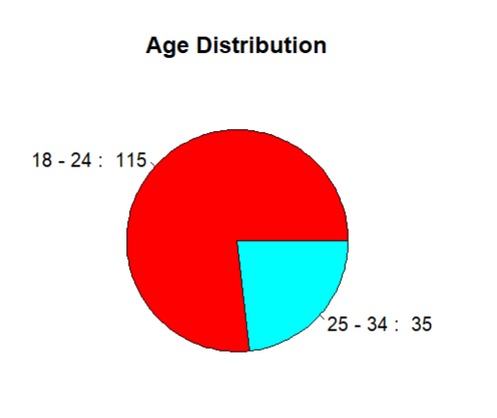Standard Deviation = 3.72

Figure Composition of Age

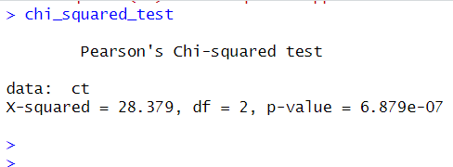

Figure Data of Age

* **Composition of Gender**

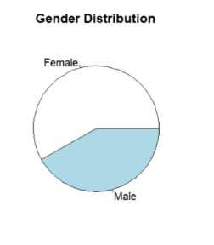60% of female participants in the survey reported 40% of male participants. It reveals that female participants exceed male participants.

Figure Composition of gender

* **Composition of Education Background**

62.3% of participants are undergraduate students. 34.7% are graduates and the rest are master's degree holders. When we take as count 93 participants are undergraduates, 52 participants are bachelors and 5 participants are masters. In my survey, most participants are still undergraduates in private and public universities.

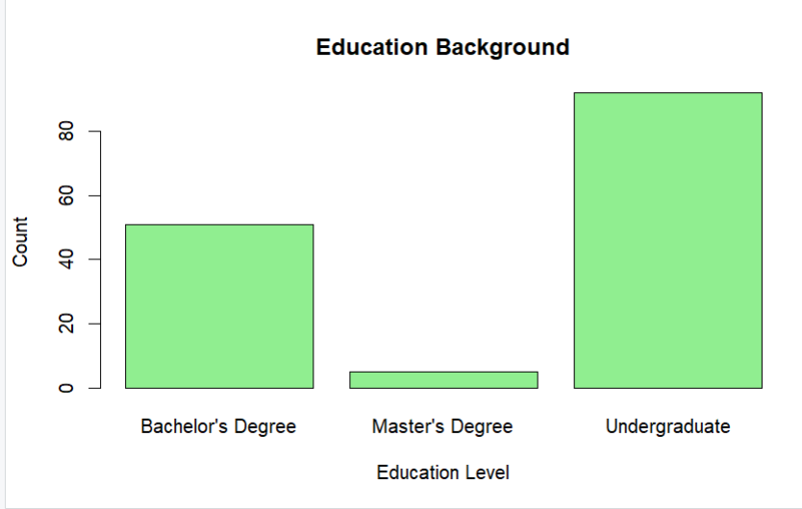

Figure Education Background

When we compare the educational background with age, 82 participants are undergraduates in the age range 18-24, and 33 participants have bachelors. Also, there are no master's degree holders in the age range 18-24.

But there are 5 master's degree holders in the age range 25-34. There are 11 undergraduates and 19 bachelor’s degrees.

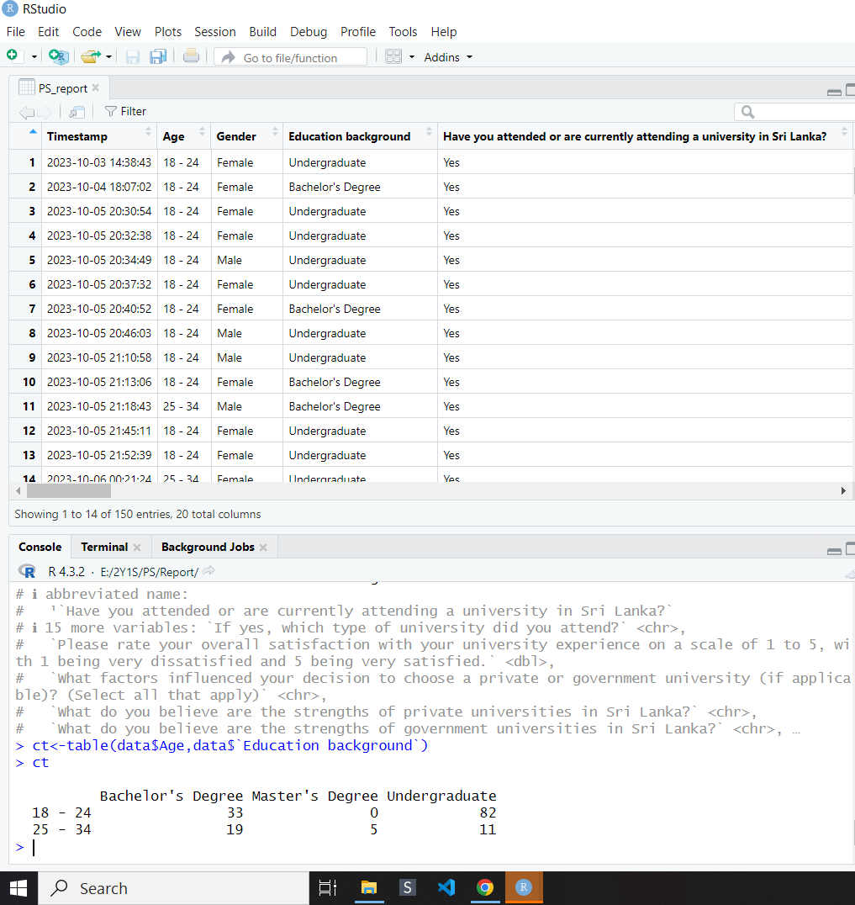

Figure Comparison of age and Education background

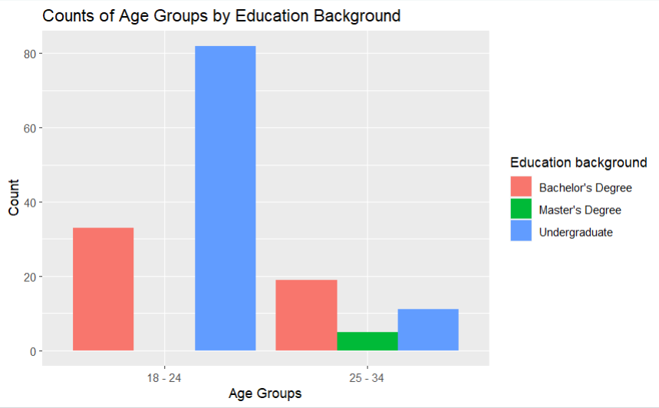

Figure Bar Graph of education background

This bar graph clearly shows the age distribution with educational background.

* **Composition of Type of university**

According to my survey, most participants had a government degree. 77 participants belong to government universities, 58 participants belong to private universities and 15 participants doing both degrees.

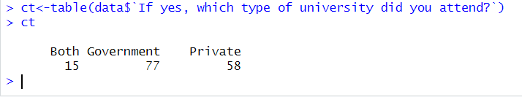

Figure Type of Universities

* **Factors that influenced to choice of private or government universities**

Figure University choice

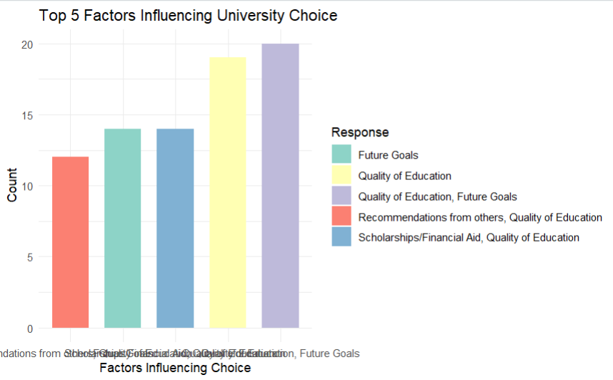

This graph shows clearly the factors that affect to choice of private and government universities. Most students choose because of future goals, scholarships, and quality of education.

* **Opinion about private universities closure**

Forms response chart. Question title: Do you believe private universities in Sri Lanka should be closed?
. Number of responses: 150 responses.

Figure Opinion about private universities

12% of participants said that private universities should be closed, and most of them provided reasons for that are political influence and the low quality of degrees provided by private universities.

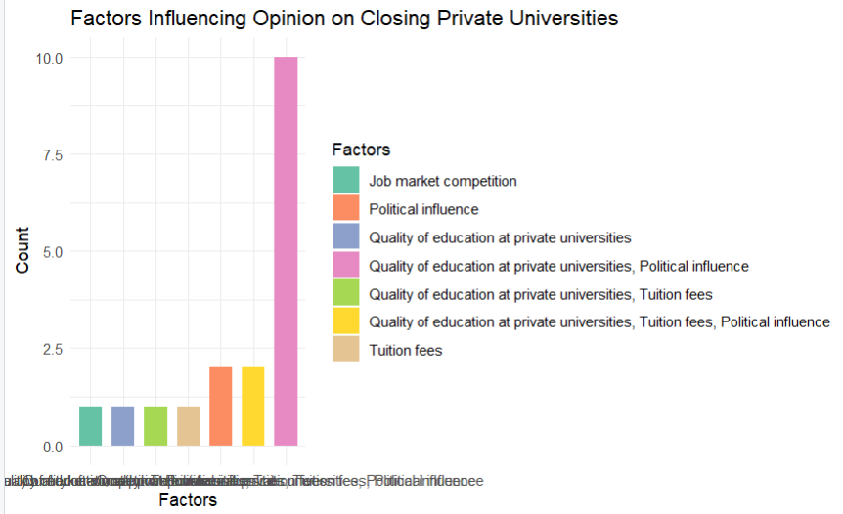

Figure Factors affecting to closure private universities

# **CHAPTER 05 – Conclusion**

In conclusion, this study offers an important new understanding of Higher Education in Sri Lanka. I chose undergraduate and graduate students from public and private universities for my sample. Male respondents accounted for 40% of all respondents, while female respondents accounted for 60%. I chose different educational backgrounds for students. The majority of the student population ranged in age from 18 to 24.

According to the data, the vast majority of students are admitted to public universities. The key motive is scholarship. Several individuals chose private universities because they require less time than state universities

Respondents make many suggestions for improving public and private universities. Enrolling more students and decreasing the time it takes to graduate are two possibilities for public universities. Some private university initiatives involve reducing admission costs and improving degree quality.

In addition, 12% feel that private universities should be closed down. It is the result of political influence and a low degree of quality.

**Google Form Link**

<https://docs.google.com/forms/d/e/1FAIpQLSfN5CGIEA6nMl6rBQtEOVf_MvhS5uSeMneHoSWKOYS50UP0OA/viewform?usp=sf_link>

# **REFERENCES**

Bscholary, 2023. *Bscholary.* [Online]   
Available at: https://bscholarly.com/countries-with-the-best-education-system/  
[Accessed 13 11 2023].

Dilushi S. Kodithuwakku, 2015. *Academia.edu,* s.l.: Dilushi S. Kodithuwakku.

Doenets, 2023. *Doenets.* [Online]   
Available at: https://www.doenets.lk/images/resources/STAT/final%20POC-AL-2022-web_1694447239752.pdf  
[Accessed 11 11 2023].

economynext, 2023. *economynext.* [Online]   
Available at: https://economynext.com/sri-lanka-to-establish-new-expand-existing-science-and-technology-universities-139753/  
[Accessed 15 11 2023].

Escotet, 2020. *Escotet.* [Online]   
Available at: https://miguelescotet.com/2020/what-is-the-purpose-of-higher-education-knowledge-or-utility/  
[Accessed 13 11 2023].

Gunarathna, A., n.d. *The Factors that Affect the Demand for Private University Education in Sri Lanka.,* s.l.: s.n.

Muhandiramge, K., n.d. *The Reasons of Students Choose Private Universities,* s.l.: s.n.

Perera, S., 2023. Colombo Telegraph. *Colombo Telegraph.*

UGC, 2022. *UGC.* [Online]   
Available at: https://www.ugc.ac.lk/downloads/statistics/stat_2022/Chapter%202.pdf  
[Accessed 11 11 2023].

W.A. Wijewardena, n.d. *Sunday Times.* [Online]   
Available at: https://www.sundaytimes.lk/100606/BusinessTimes/bt39.html  
[Accessed 11 11 2023].

Wikipedia, 2017. *Wikipedia.* [Online]   
Available at: https://en.wikipedia.org/wiki/Higher_education_in_Sri_Lanka  
[Accessed 11 11 2023].

# **R DIAGRAMS**

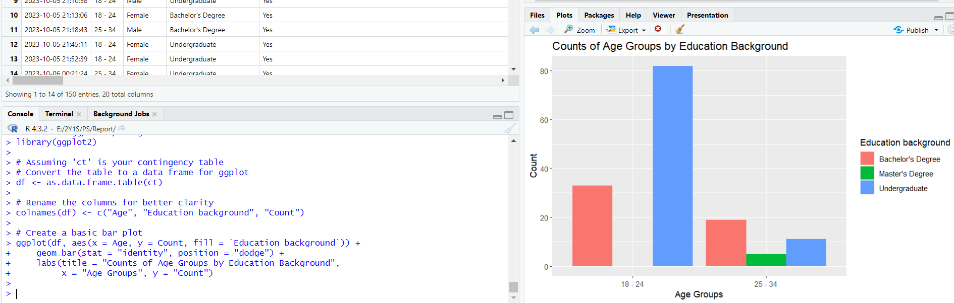

Figure Comparison of Age and Education background

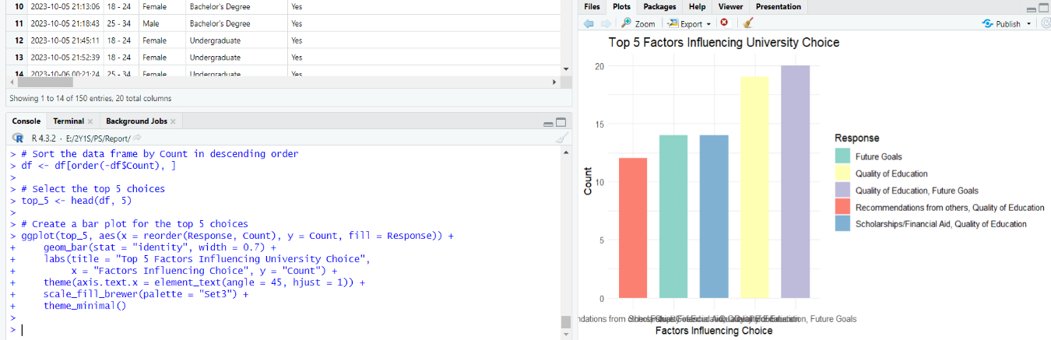

Figure Factors affecting to choose higher education

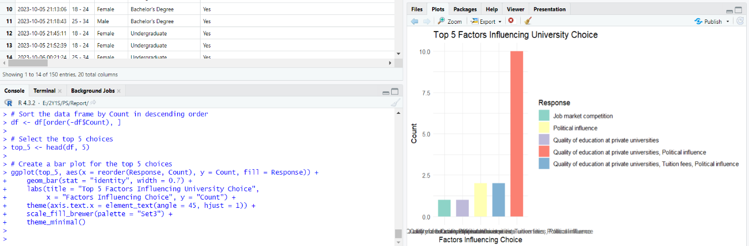

Figure Factors affecting to close private universities

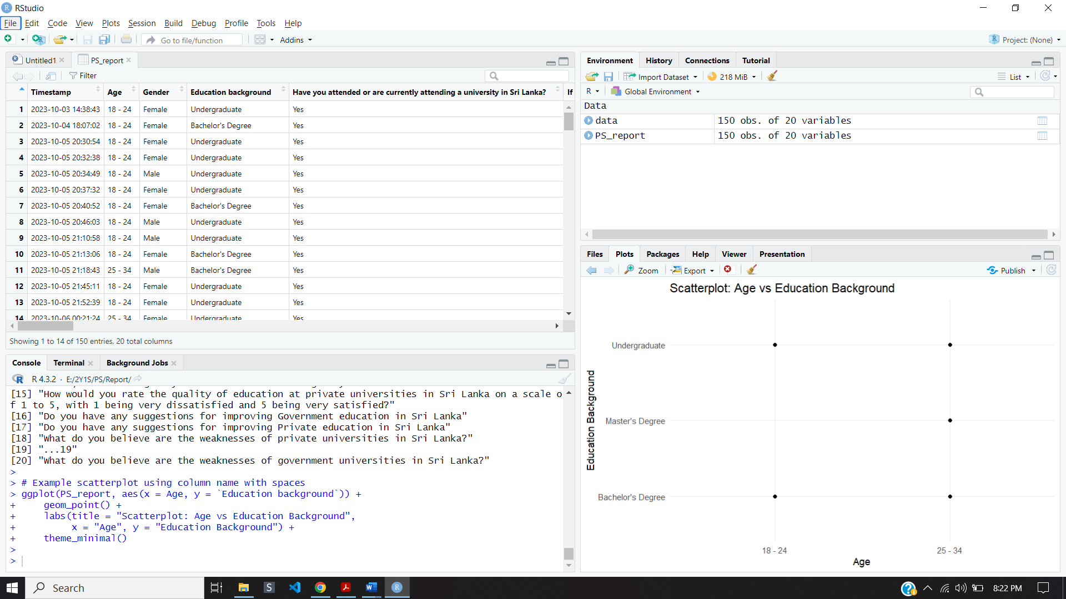

Figure Scatterplot Age vs Education Background