SKILL 21.22.23.24
21.To Connect Modules, Validate Interfaces, Test End-to-End Execution, Handle Errors, Improve Reliability, Refactor Components.
- To Detect Runtime Errors, Generate Messages, Log Failures, Handle Invalid Syntax, Recover Gracefully, Test Error Scenarios.
INPUT: 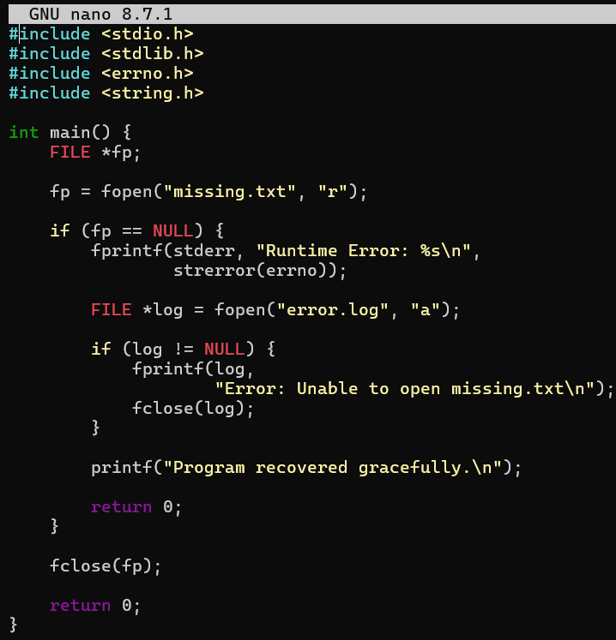
output:
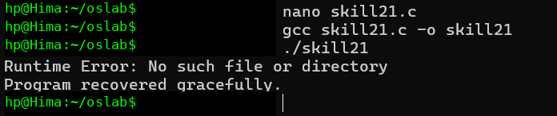
22. To Run Valgrind, Identify Leaks, Fix Memory Errors, Release Resources, Verify Cleanup, Document Findings.
To Design Test Cases, Create Test Scripts, Automate Execution, Verify Outputs, Compare Results, Generate Reports.
- INPUT:
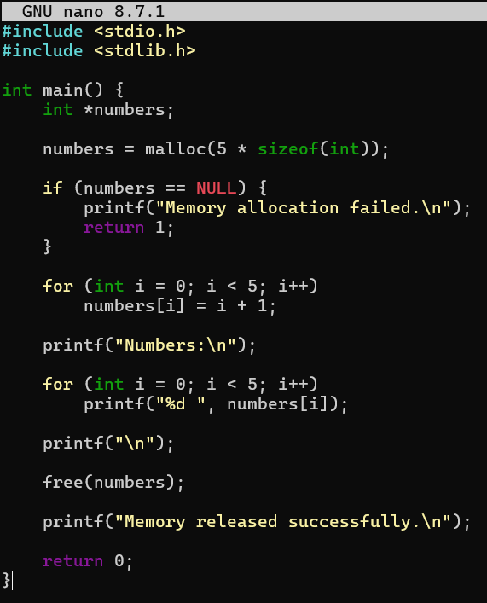
output:
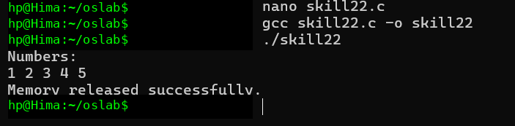
23. To Execute Large Pipelines, Launch Multiple Jobs, Measure Stability, Monitor Resources, Detect Failures, Analyze Performance.
- To Document Architecture, Create Flow Diagrams, Explain Execution Paths, Describe Syscalls, Record Design Decisions, Review Documenta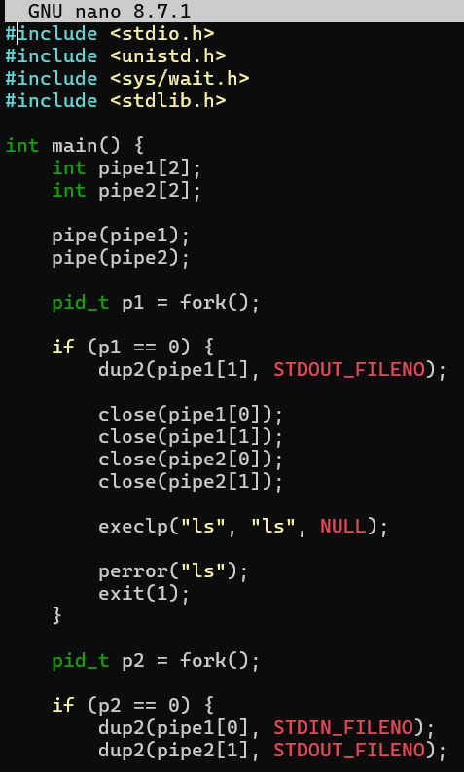
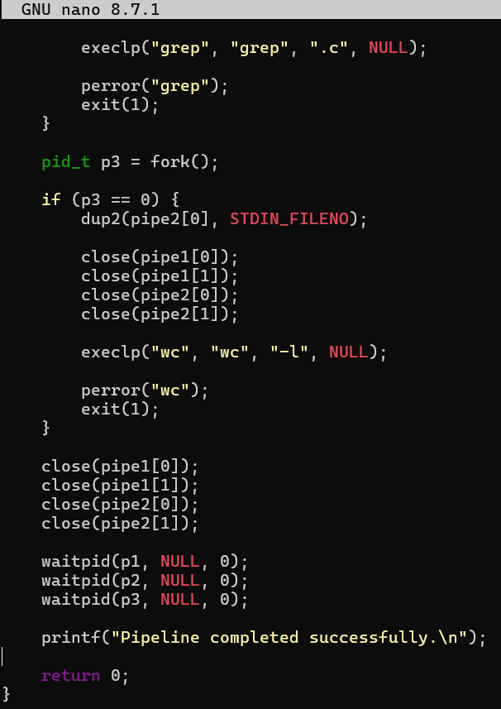
OUTPUT:
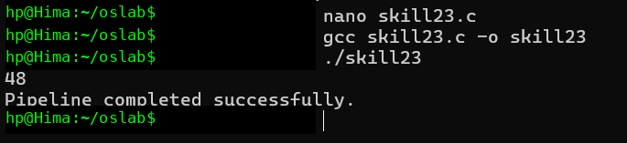
24. To Organize Source Code, Improve Build Scripts, Add README, Verify Repository Structure, Tag Releases, Validate Deliverables.
To Create Demo Scenarios, Validate Features, Rehearse Presentation, Demonstrate Pipelines, Demonstrate Signals, Final Project Review.
INPUT:
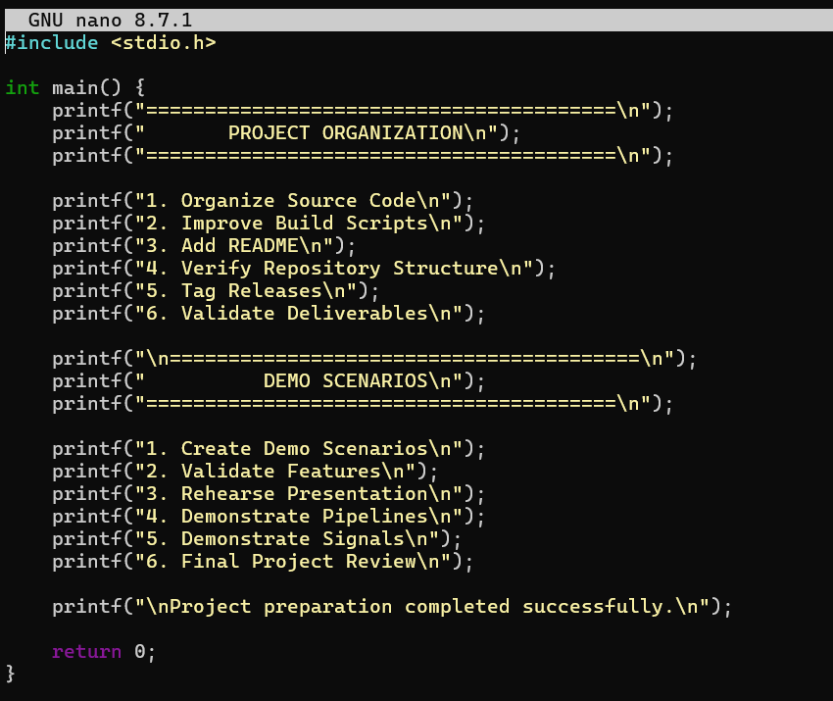
OUTPUT:
