Skill17.18.19.20
17. To Implement how to List Active Jobs, Display Status Information, Retrieve Job IDs, Format Output, Update State Information, Test Job Listings.

To design how to Identify Target Job, Transfer Terminal Control, Resume Processes, Wait for Completion, Update Job State, Test Foreground Switching.
INPUT:
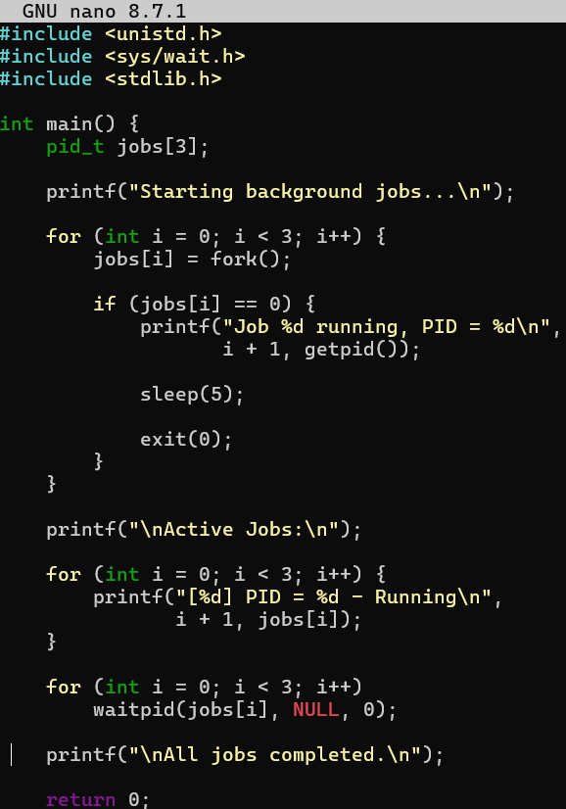
OUTPUT:
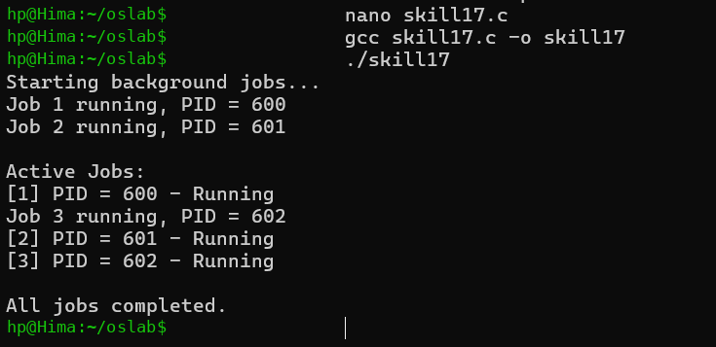
18.To Analyze Signal Delivery, Understand Signal Masks, Review Process Groups, Explore Terminal Signals, Test Signal Behavior.
To implement how to resume Stopped Jobs, Send Continue Signals, Update Job Status, Maintain Job Table, Verify Execution, Test Background Recovery.
INPUT:
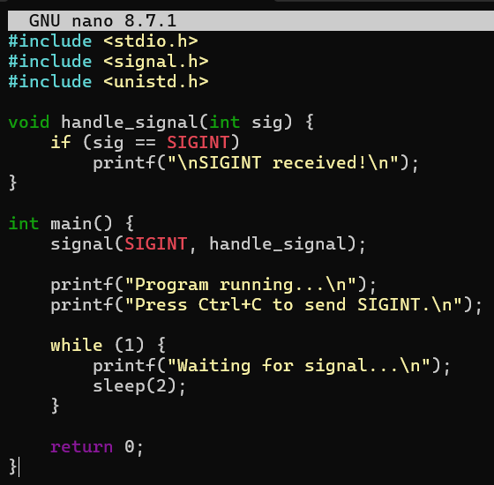
OUTPUT:
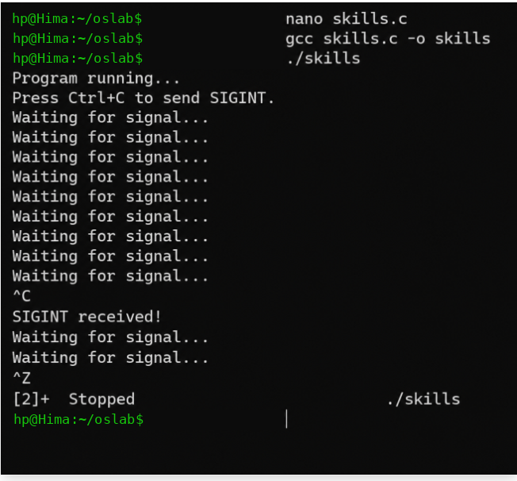
19.To Register Handlers, Configure Signal Actions, Handle Interrupts, Manage Signal Context, Verify Stability, Test Signal Events.
To Capture SIGINT, Forward Signals, Protect Shell Process, Terminate Foreground Jobs, Update Job States, Test Interrupt Handling.
INPUT:
OUTPUT:
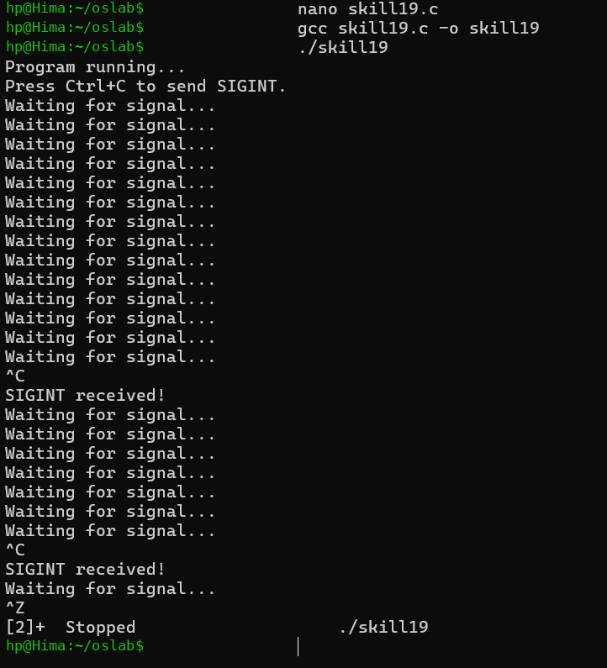
20.To Capture SIGTSTP, Suspend Processes, Update Job Table, Preserve State, Resume Later, Test Suspension Workflow.
To Create Process Groups, Assign Group IDs, Transfer Terminal Control, Restore Ownership, Coordinate Signals, Validate Behavior.
INPUT:
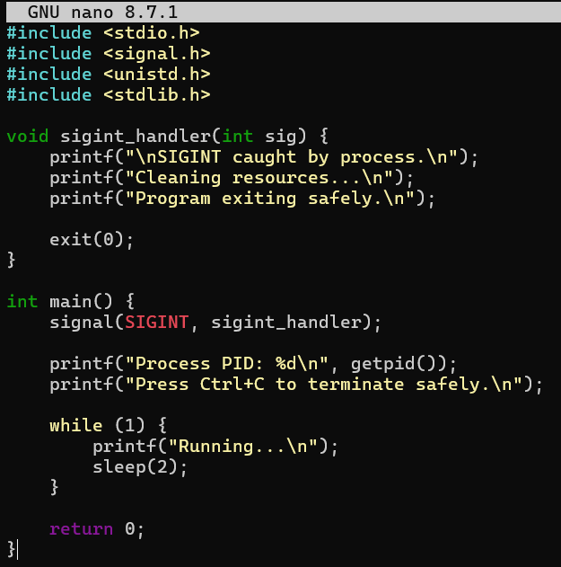
OUTPUT:
