DOCUMENT NAME
Document title | Architecture Design Document
Reporting Period | December 2025
Date | Dec 10th, 2025 | File Name: | C1SE40_Architecture_Design_v2.0.docx

REVISION HISTORY
Version | Date | Comments | Author | Approval
1.0 | 22/08/2025 | Initial release | All members
1.2 | 27/08/2025 | Updated | All members
1.3 | 17/10/2025 | Updated | All members
2.0 | 22/10/2025 | Official | All members

TABLE OF CONTENTS
1. Introduction 1
1.1 Purpose 1
2. Project Overview 1
2.1 Business needs 1
2.2 Proposed solution 1
2.3 Business drivers 4
2.4 Project goal 5
3. Architectural drivers 6
3.1 Functional requirements 6
3.2 Business constraints 6
3.3 Technical constraints 7
3.4 Quality Attribute 7
3.5 Contex Diagram 13
4. C&C view 14
5. Module view 15
6. Allocation view 17

1. Introduction

1.1. Purpose
This document aims to provide a complete overview of the architectural design for the Elderly Health Monitoring and Alert System. It outlines the project's main goals, including its core objectives, key business and technical constraints, and the main architectural drivers shaping the system. Additionally, it describes the system’s architectural design using multiple view types, such as the Component-and-Connector (C&C) View, the Module View, and the Allocation View.
This architecture is built to ensure that the system reliably monitors the health and safety of elderly individuals through real-time sensor data, intelligent video analysis, and automated alert mechanisms. The application helps family members track vital information like BMI, water intake reminders, AI-assisted health guidance, and fall detection, all using an ESP32-MPU6050 setup combined with camera-based posture evaluation. Moreover, the system includes an administrative dashboard for device management, account approvals, activity history, and reporting.

2. Project Overview

2.1. Business needs
The Elderly Health Monitoring and Alert System addresses essential needs of families, caregivers, and healthcare providers by providing continuous and dependable monitoring of elderly individuals. As aging populations increase and families become busier or more geographically separated, there is a growing demand for solutions that guarantee safety, offer health visibility, and enable timely responses during emergencies. The primary business needs include:
- Ensure the safety of elderly individuals: Families need a dependable system capable of detecting abnormal events such as sudden falls or loss of consciousness. Immediate alerts must be delivered to caregivers to reduce response time and prevent severe injuries or complications.
- Provide continuous, accessible health monitoring: Users require an easy-to-use mobile application to track key health metrics such as weight, BMI, hydration reminders, and (in future versions) blood pressure, blood glucose, and heart rate. These insights support proactive health management and early detection of risks.
- Enable real-time emergency detection and automated responses: Businesses need an intelligent monitoring mechanism that uses sensors (ESP32 + MPU6050) combined with video-based posture analysis to improve accuracy. In cases where the elderly person remains unresponsive, the system must escalate actions—sending repeated alerts or initiating emergency contact calls.
- Support future scalability and advanced medical integration: The system must be extensible to incorporate additional sensors (heart rate, oxygen saturation, medical devices) and integrate with healthcare services in later phases. This ensures long-term business viability and product competitiveness.

2.2. Proposed solution
To address the identified business needs, the Elderly Health Monitoring and Alert System proposes an integrated solution combining mobile application technologies, IoT sensors, computer vision, and an administrative management dashboard. The system is designed to ensure real-time health monitoring, immediate emergency detection, and efficient device and user management.
- Mobile Application for Family Members (User App)
The mobile app provides a centralized interface for family members to monitor the elderly person’s health and receive alerts. Key features include:
+ Fall detection alerts: This is the core safety feature. Alerts are triggered based on sensor data and are verified for reliability through video posture analysis.
+ BMI & weight tracking: Users can record and monitor health trends over time.
+ Water intake reminders: Automated notifications help maintain hydration.
+ AI Doctor assistant: A lightweight conversational agent providing basic health guidance.
+ Future support: Blood pressure and glucose monitoring via additional sensors.
- Camera-Based Posture Verification
To reduce false alarms and improve detection accuracy, the solution integrates:
+ A camera module linked to the backend. A computer vision model (YOLO or pose estimation) to detect changes in body posture.
+ A verification flow:
If sensor event → check video posture → confirm fall → trigger alert.
- Real-time Alerting and Escalation
+ Upon detecting a confirmed fall or extended immobility:
The system immediately sends push notifications to the caregiver’s mobile app.
If no response or if posture remains unchanged, the system escalates by:
+ Sending repeated urgent alerts
+ Optionally triggering an automated emergency phone call
+ This ensures timely intervention in critical situations.
- Admin Dashboard (Web Application)
The web-based Admin Dashboard provides management functions for system administrators:
+ Device Management: Register, approve, and monitor cameras and sensors.
+ Account Management: Approve user sign-ups, manage roles, and track device assignments.
+ Alert History & Activity Logs: Review fall events, timestamps, and user responses.
+ Reports & Analytics: Overview of system performance and health trends.
+ System Settings: Manage configurations, thresholds, and escalation rules.

2.3. Business drivers
Based on the identified business needs and the proposed solution, our team has decided to develop the Elderly Health Monitoring and Alert System as the primary application to address these challenges effectively.
The business drivers represent the essential factors influencing the architectural decisions of the Elderly Health Monitoring and Alert System. As the elderly population increases and families become busier or live farther away, the demand for reliable remote monitoring systems continues to grow. Ensuring the safety and well-being of elderly individuals is a primary motivation, especially in detecting emergencies such as sudden falls or loss of consciousness. These situations require immediate attention, and reducing response time directly impacts survival rates and long-term health outcomes. This need for rapid intervention strongly drives the system to support real-time sensor processing, instant alert delivery, and escalation mechanisms.
Another key driver is the increasing desire for continuous visibility into daily health conditions. Family members and caregivers need simple tools to track health metrics such as weight, BMI, hydration reminders, and, in the future, additional vital signs like blood pressure and glucose levels. Providing this level of transparency helps families identify health risks early and make informed decisions. At the same time, the system aims to reduce caregiver workload by automating repetitive tasks such as health reminders, fall detection, and basic AI health guidance, ensuring that caregivers can focus on more important responsibilities.
Accuracy is also a critical business requirement. False alarms reduce user trust and may cause unnecessary worry, while missed detections could lead to severe injury or death. To address this, the system combines IoT sensor data with camera-based posture verification to maximize detection reliability. This dual-layer approach directly influences the architecture by requiring support for real-time video analysis, sensor integration, and intelligent event validation.

2.4. Project goal
The goal of the project is to build the Elderly Health Monitoring and Alert System, a comprehensive solution designed to ensure the safety, wellbeing, and continuous health monitoring of elderly individuals. The system aims to support family members and caregivers by providing real-time visibility, intelligent fall detection, automated alerts, and centralized management tools. Through the combination of IoT sensors, AI-based posture analysis, mobile applications, and an administrative dashboard, the project seeks to deliver a reliable and scalable platform that enhances elderly care and reduces emergency response times.
This project focuses on five main features that form the core functionality of the system:
- Fall Detection and Alerting: Automatically detects abnormal movement patterns using sensors and validates potential falls through video posture analysis, ensuring accurate and timely alerts to caregivers.
- Health Monitoring (BMI & Weight Tracking): Allows users to record and monitor essential health metrics such as weight and BMI, enabling early detection of health risks and long-term trend analysis.
- Water Intake Reminders: Provides scheduled reminders to encourage proper hydration, promoting healthier daily routines for elderly users.
- AI Doctor Assistant: Offers basic medical guidance through a conversational agent capable of answering simple health-related questions, supporting caregivers with quick, accessible advice.
- Admin Website: Enables administrators to manage user accounts, approve devices, monitor sensor status, view alert history, and configure system settings through a centralized web-based dashboard.

3. Architectural drivers

3.1. Functional requirements
Table 1: Functional requirements
Functional ID | Functional Name | Description
1 | Login | Users log in using username/password to access system features.
2 | Logout | Users log out after completing tasks to ensure data security.
3 | Register | Users can create a new account to use the system.
4 | Delete User Account | Admin can disable or remove a user who violates system policies.
5 | Fall Detection | The system detects falls using Camera + AI Model.
6 | Real-times notification | When a fall is detected, the system sends push notifications to the Mobile App and Admin Dashboard.
7 | Store Fall Events | All fall event data (timestamp, status, evidence) is stored in the MySQL database.
8 | Admin Dashboard | Admin monitors users, fall logs, devices, and alerts via Web Admin Dashboard.

3.2. Business constraints
- Project Timeline: From Aug 17,2025 to Dec 12, 2025. After delivery, only defect fixes are allowed (no new features).
- Team Members: 5 developers available from Aug 17, 2025 to Dec 12, 2025
- Stakeholder Requirements: The product strictly follows mentor and client requirements.
- Budget Constraints: Use open-source tools and cloud services with minimal cost.

3.3. Technical constraints
Technical to develop
- Language: JavaScript, Python
- Framework: Reactjs , NodeJs, YOLO, numpy, ….
- Develop tool: Vscode, FFmpeg
- Database Management System: MySQL
- Web browsers: Mozilla Firefox, Google Chrome
- Operation systems: Microsoft Windows

3.4. Quality Attribute
- Usability: Usability refers to how easy and comfortable it is for users (especially elderly users) to interact with the system. The system's interface should be user-friendly, intuitive, and simple to understand for all users.
Table 2: Quality Attributes: Usability
Quality Attributes: Usability | ID: QA01
Stimulus | Users want the system to be easy to navigate and intuitive, providing a comfortable experience without confusion
Source(s) of the stimulus | Elderly Users and Administrators.
Relevant environmental conditions | The system should function under normal operating conditions without downtime or lag.
Architectural elements | User Interface (UI) for both Mobile App and Web Admin Dashboard.
System response | The system provides clear, simple, and helpful UI elements, ensuring that users can easily find what they need.
Response measure(s) | Ease of Use: Users should be able to use the system without difficulties the first time they interact with it.  Satisfaction: Users should express satisfaction with the UI, including the clarity of features and the ease of navigation.  Error Rate: The system should minimize user errors, particularly for elderly users.
- Performance: Performance refers to the system's ability to respond quickly to user actions, especially when using critical functions like searching or submitting data. Users are highly interested in fast response times, as it enhances the overall user experience and encourages them to engage more with the system.
Table 3: Quality Attributes: Performance
Quality Attributes: Performance | ID: QA02
Stimulus | Users expect the system to respond to their requests quickly and efficiently.
Source(s) of the stimulus | Users
Relevant environmental conditions | The system is running under normal operational conditions without interruptions.
Architectural elements | The entire System, including backend, database, and front-end interfaces.
System response | Users should be able to access the system and interact with it with minimal delays.
Response measure(s) | Login Time: The system should allow users to log in within 3 seconds.  Search Time: The system should return search results within 5 seconds.  Other Functionality: All other system functions (e.g., viewing fall events, notifications) should respond within 5 seconds.
- Security: Security ensures that user data, particularly sensitive information like personal details, bank account information, and transaction history, is kept secure to prevent unauthorized access and potential theft. The system must protect users' private data and maintain confidentiality and integrity at all times.

Table 4: Quality Attributes: Security
Quality Attributes: Security | ID: QA03
Stimulus | Users need to feel confident that their personal and financial information is secure and protected from unauthorized access.
Source(s) of the stimulus | Users
Relevant environmental conditions | The system is operating normally with secure connections and proper security measures in place.
Architectural elements | Network Security, Backend System, Authentication Mechanism (JWT).
System response | The system must authenticate users properly, encrypt sensitive data, and ensure secure transactions.
Response measure(s) | Data Encryption: All sensitive user data (e.g., personal information, bank account details) must be encrypted at rest and in transit.  Authentication: The system uses JWT (JSON Web Token) to ensure that only authorized users can access their account and perform secure actions.  Access Control: User roles (admin, caregiver, family member) must be clearly defined, ensuring that only authorized users can access certain types of information.  Regular Security Audits: The system should undergo periodic security audits to detect vulnerabilities and ensure that security standards are maintained.
- Reliability: Reliability refers to the system's ability to operate consistently without failures, particularly in handling sensitive user data. Users must trust that the system will not lose or mismanage their information, and that it will function as expected under normal conditions. Reliability also means that the system will ensure the protection and proper management of user data, including not selling it to third parties.

Table 5: Quality Attributes: Reliability
Quality Attributes: Reliability | ID: QA04
Stimulus | Users expect the system to be reliable, ensuring their data is handled securely and consistently. They trust the system not to share or sell their information to third parties.
Source(s) of the stimulus | Users.
Relevant environmental conditions | The system is operating normally without any downtime or critical errors.
Architectural elements | Backend System, Database, Data Encryption.
System response | The system must store and retrieve data reliably, without data loss or corruption, and maintain privacy by ensuring that no user data is shared or sold to unauthorized parties.
Response measure(s) | Data Integrity: The system should ensure the integrity of user data by preventing data corruption or loss.  Uptime: The system should have a high uptime rate (e.g., 99.9%) to ensure reliability during normal operations.  Data Privacy: The system should ensure that user information is never shared or sold to third parties, and user consent must be obtained before sharing any data with external services.  Error Handling: Any failure or error should be handled gracefully without affecting the user experience, and users should be notified in case of issues
- Supportability: Supportability refers to the system’s ability to assist users who may need help or advice, especially in situations where they experience emotional or psychological challenges. The system should provide support channels for users to reach out to staff members, ensuring timely assistance.

Table 6: Quality Attributes: Supportability
Quality Attributes: Supportability | ID: QA05
Stimulus | Users may face emotional issues or need guidance and want to feel supported by the system and staff.
Source(s) of the stimulus | Elderly Users.
Relevant environmental conditions | The system is running and accessible, and support staff is available to assist users.
Architectural elements | Support Services (Admin support, Emergency contact), User Interface (Mobile App for Family Members).
System response | The system should provide mechanisms for users to contact support staff directly through the Mobile App or Web Admin Dashboard for help with emotional issues or consultations.
Response measure(s) | Immediate Assistance: The system should allow users to contact support staff immediately through the Mobile App or Admin Dashboard.  Support Availability: Support should be available during critical times to address users' emotional or consultation needs.  Response Time: Users should receive assistance or a response from support staff within 5 minutes after initiating contact.  User Satisfaction: Users should feel comfortable and supported when using the system, knowing that help is available when needed.
- Supportability refers to the system’s ability to assist users who may need help or advice, especially during emotional or psychological challenges. The system must provide direct support channels, enabling elderly users to contact staff members for timely assistance through the Mobile App or Web Admin Dashboard. This ensures users receive assistance or a response from support staff within five minutes after initiating contact.

Table 7: Quality Attributes: Operability
Quality Attributes: Operability | ID: QA06
Stimulus | The system faces issues with the database server, and there is a need to switch to a backup system to maintain service availability.
Source(s) of the stimulus | System and Server
Relevant environmental conditions | The system is running and online, with the backup server ready to take over if needed.
Architectural elements | Server, Backup Server, Database.
System response | If the database server fails, the system should automatically switch to the backup server without interrupting service for the users.
Response measure(s) | - Failover Time: The system should switch to the backup server within 5 seconds of detecting a failure.  - System Availability: The system should maintain 99.9% uptime, with no noticeable impact on user experience during the failover process.  - Seamlessness: The system should handle the transition to the backup server smoothly without requiring user intervention or causing disruptions in service.
- Operability focuses on the system’s ability to maintain service availability and functionality during critical failures. Should the database server encounter issues, the system must automatically switch to a backup server without interrupting service for users. This seamless transition must ensure that failover occurs within five seconds and maintains the system's target of uptime.
3.5. Context Diagram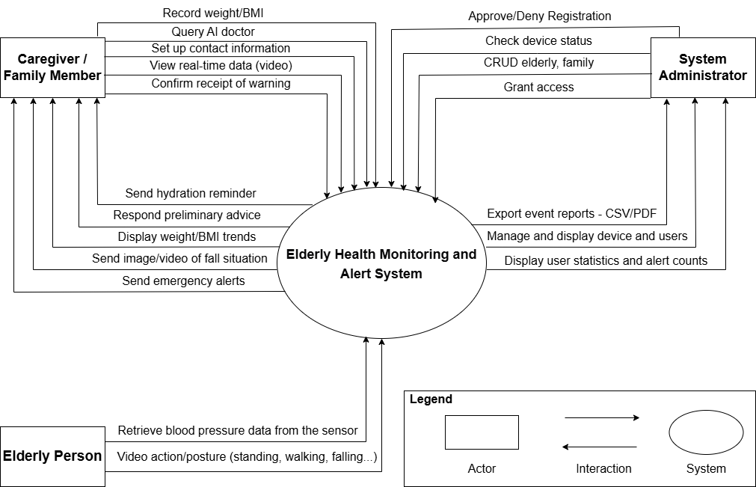
Figure 1. System Context Diagram

4. C&C view
We mainly used C&C view to argue and reason about architectural properties, quality attribute requirements, and functional requirements that the system must adhere to.
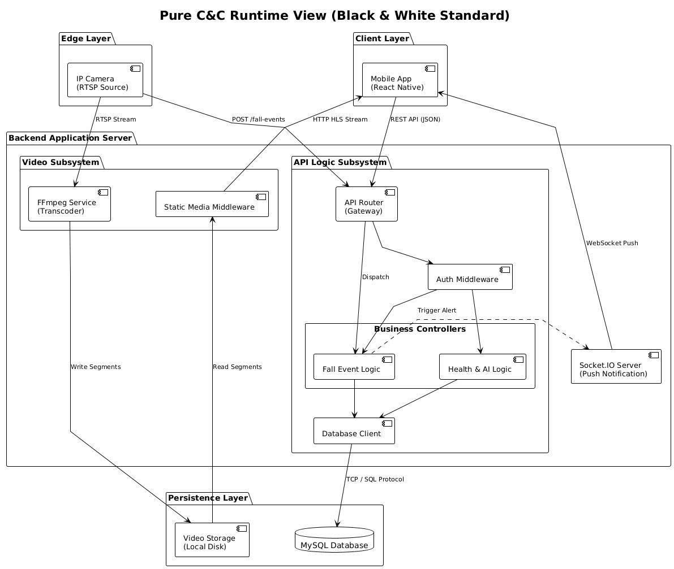
Figure 2. C&C View
Prose: The user accesses the system by logging into the website. Once logged in, the front-end interface (either the Mobile App for Elderly Users or the Web Admin Dashboard for Admin Users) is displayed. From there, users can interact with the system according to their roles.

5. Module view

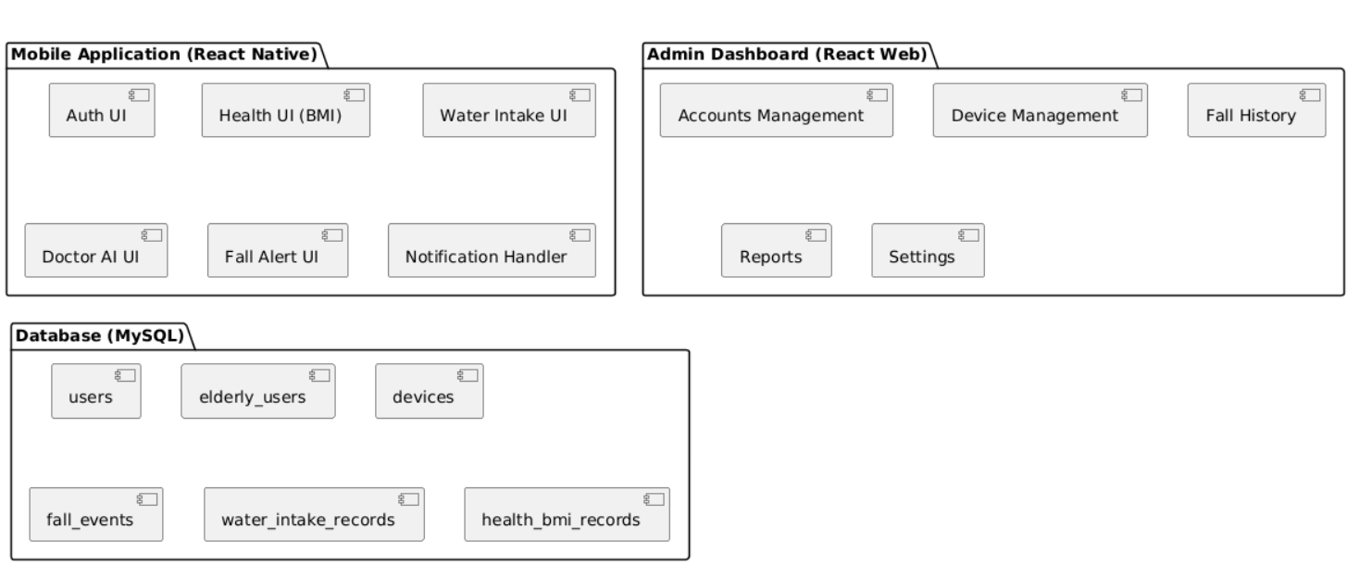

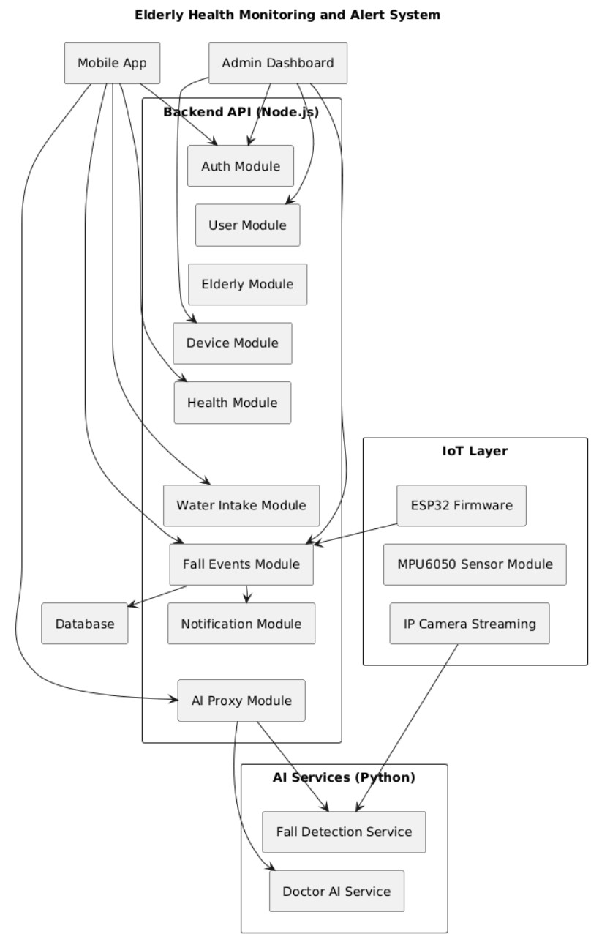
Figure 3. Module View

6. Allocation view
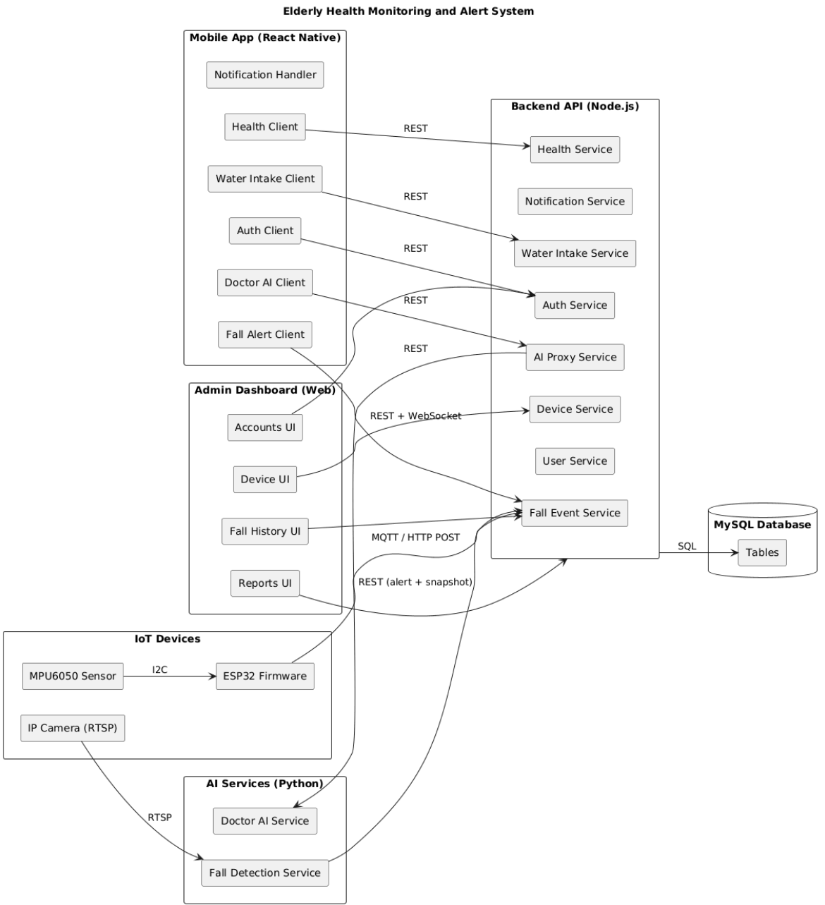

Figure 4. Allocation View

Prose: Client will use web browser (Internet Explorer, Mozilla Firefox, Apple Safari, Google Chrome, and so on) to access to the system. It required internet network if you use external link. Once you did access to the website, the PHP environment will be processed handle to interact database between user and system. Any transaction between user and system will be implemented on MySQL.

