DOCUMENT NAME
Document Title | Database Design Document
Author(s) | Dung, Mai Van
Role | Team Member
Date | Dec 10th, 2025 | File name: | C1SE.40_Database_Design_ver2.0.docx

REVISION HISTORY
Version | Date | Comments | Author | Approval
1.0 | 29/08/2025 | Initial Release | All Members
1.1 | 16/10/2025 | Updated | All Members
1.2 | 15/11/2025 | Updated | All Members
1.3 | 05/12/2025 | Updated | All Members
2.0 | 10/12/2025 | Official | All Members

TABLE OF CONTENTS
1. Introduction 3
1.1 Purpose 3
1.2 Scope 3
1.3 Introduction about MySQL 4
2. Database Diagram 4
2.1 Table Overview 4
2.2 Table Relationship Diagram 5
3. Database Design for Sprint 6
3.1 Table Users 6
3.2 Table Admins 6
3.3 Table Elderly_Users 7
3.4 Table Devices 7
3.5 Table Device_Registrations 8
3.6 Table Device_Assignments 8
3.7 Table Weight and BMI 9
3.8 Table Fall Events 10
3.9 Table doctor_ai_chat_history 11
3.10 Table water_intake_records 12
4. Hardware and Software Requirements 12

Introduction
The Database Design maps the logical data model for the Elderly Health Monitoring and Alert System to the target database management system, with specific consideration to the system’s real-time performance, data integrity, and alert efficiency. The Database Design converts logical or conceptual data constructs (e.g., patient records, vital signs, alert rules) to physical data constructs (e.g., tables, indexes, stored procedures) of the target Database Management System.

Purpose
The purpose of the Database Design is to ensure that every database transaction, especially those involving the collection of real-time vital signs (heart rate, SpO2, temperature) and the generation of urgent alerts, meets or exceeds the system's performance and reliability requirements. This document takes into account the volume of continuous sensor data, the need for quick data retrieval for monitoring dashboards, and the strict latency requirements for the alert mechanism to produce a robust schema and environment that will meet necessary performance and ensure timely care.

Scope
The Database Design Document for the Elderly Health Monitoring and Alert System has the following key objectives:
- To describe the design of the database, that is, a collection of related health and profile data (e.g., Elderly Profile, Health Metrics, Alert History, Device Status) stored in one or more computerized files that can be accessed by caregivers, medical staff, or the system's alert services via a DBMS.
- To serve as a basis for implementing the database and related software units (e.g., the Data Ingestion Module, the Alert Engine, and the Caregiver Dashboard). It provides the software development team visibility into the data architecture and provides essential information necessary for the development of real-time monitoring and alert functionalities.

Introduction about MySQL
MySQL is an open-source Relational Database Management System (RDBMS) that uses Structured Query Language (SQL) to manage and manipulate data. It is one of the most popular databases in the world, developed and maintained by Oracle Corporation. MySQL allows users to store, retrieve, and manage structured data in the form of tables, using relationships between them to ensure data integrity.
MySQL is known for its high performance, reliability, and scalability, making it suitable for both small-scale and enterprise-level applications. It supports multiple operating systems, including Windows, Linux, and macOS, and can be integrated easily with web technologies such as PHP, Python, and Node.js.
In a relational database like MySQL, data is stored in tables (relations) that consist of rows (records) and columns (fields). Each table represents an entity, and relationships are defined through primary keys and foreign keys.

Database Diagram

2.1. Table Overview
Table Name | Short Description
Users | This table stores information of caregivers/relatives who manage elderly people and register devices.
Admin | This table stores system administrator accounts who review and approve device registrations.
Elderly_Users | This table stores detailed information of elderly people being monitored by the system.
Devices | This table stores device information such as type, owner, and status of each monitoring device.
Device_Registrations | This table stores device registration requests made by users and reviewed by admins.
Device_assignments | This table stores the assignment history of devices to users, including time and location.
Weight and BMI | This table stores the weight, height, and calculated BMI records for the elderly users.
Device_Assignments | Tracks the devices currently assigned to users, including device status and assignment metadata.
Fall Events | Stores all fall detection events captured by AI analysis and Sensor, including timestamps, severity, and related user information.
Doctor_ai_chat_history | Stores interactions between users and the AI doctor assistant, including questions, responses, detected conditions, and timestamps.
Water_intake_records | Stores records of users’ daily water consumption, including intake time and volume for hydration tracking.

Table Relationship Diagram
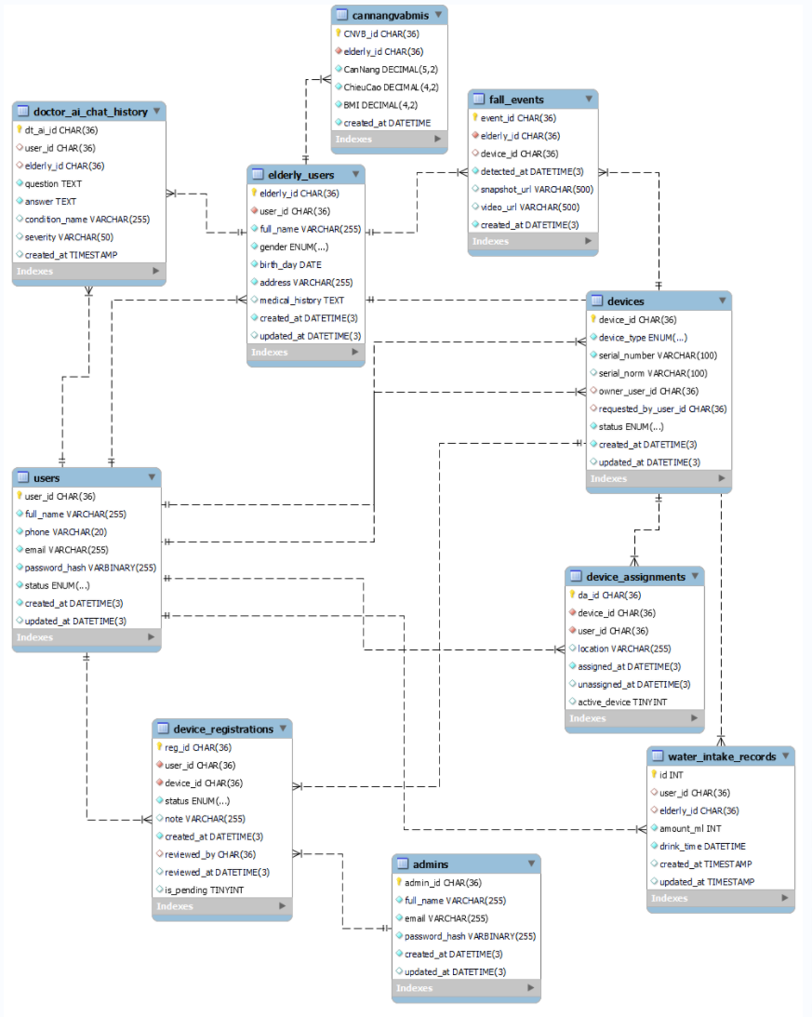

Figure 2: Table Relationship Diagra

Database Design for Sprint

3.1. Table Users
 |  |  | Users
Id | Field | Type | Constrain | Description
1 | user_id | CHAR(36) | Primary Key, NOT  NULL | UUID for each user
2 | full_name | VARCHAR(255) | NOT NULL | The full name of the user.
3 | phone | VARCHAR(20) | UNIQUE, NOT NULL | The phone number, must be unique
4 | email | VARCHAR(255) | UNIQUE, NOT NULL | The email, must be unique
5 | password_hash | VARBINARY(255) | NOT NULL | The encrypted password
6 | status | ENUM(...) | NOT NULL, Default ‘inactive’ | The accout status
7 | created_at | DATETIME(3) | NOT NULL, DEFAULT CURRENT_TIMESTAMP(3) | Creation time, auto-assign
8 | updated_at | DATETIME(3) | DEFAULT NULL, ON UPDATE CURRENT_TIMESTAMP(3) | Last update time, auto update

3.2. Table Admins
Admins
Id | Field | Type | Constrain | Description
1 | admin_id | CHAR(36) | Primary key, NOT NULL | UUID for each admin account.
2 | full_name | VARCHAR(255) | NOT NULL | The full name of the admin.
3 | email | VARCHAR(255) | UNIQUE, NOT NULL | Email used to login must be unique
4 | password_hash | VARBINARY(255) | NOT NULL | Hashed password of the admin.
5 | created_at | DATETIME(3) | NOT NULL, DEFAULT CURRENT_TIMESTAMP(3) | Account creation time, auto-assign.
6 | updated_at | DATETIME(3) | DEFAULT NULL, ON UPDATE CURRENT_TIMESTMAP (3) | Last update time, auto update.

3.3. Table Elderly_Users
Elderly_Users
Id | Field | Type | Constrain | Description
1 | Elderly_id | CHAR(36) | Primary key, NOT NULL | UUID for each senior profile
2 | user_id | CHAR(36) | Foreign Key, NOT NULL | Link profiles to Users accouts
3 | full_name | VARCHAR(255) | NOT NULL | The full name of the elderly person
4 | gender | ENUM(...) | NOT NULL | Gender limited to the values “male”, “female”, “other”.
5 | birth_day | DATE | NOT NULL | The date of birth
6 | address | VARCHAR(255) | NULL | Address (Included in Figure 1, not in Figure 2).
7 | Created_at | DATETIME(3) | NOT NULL, DEFAULT CURRENT_TIMESTAMP(3) | Profile creation time
8 | updated_at | DATETIME(3) | DEFAULT NULL, ON UPDATE CURRENT_TIME | Last update time.

3.4. Table Devices
Devices
Id | Field | Type | Constrain | Description
1 | device_id | CHAR(36) | Primary key, NOT NULL | A unique identifier (UUID) for each device.
2 | device_type | ENUM('CAMERA','JEWELRY') | NOT NULL | Device type (Camera or Smart Jewelry).
3 | serial_number | VARCHAR(100) | UNIQUE, NOT NULL | The official serial number of the device
4 | serial_norm | VARCHAR(100) | Generated Always | Normalized lowercase version of the serial number, used for comparison purposes
5 | owner_user_id | CHAR(36) | Foreign Key → USERs(user_id).  NULL allowed | The user currently owns the device. May be NULL if not owned.
6 | requested_by_user_id | CHAR(36) | Foreign Key → USERs(user_id).  NULL allowed | The user has requested to own or register the device. May be NULL
7 | status | ENUM('active','inactive','pending','rejected') | NOT NULL, Default 'pending' | Current status of the device in the system
8 | created_at | DATETIME(3) | Default CURRENT_TMESTAMP | Date and time the device record was created
9 | updated_at | DATETIME(3) | Auto Update | Date and time the device record was last updated.

3.5. Table Device_Registrations
Device_Registrations
Id | Field | Type | Constraint | Description
1 | reg_id | CHAR(36) | Primary Key | A unique identifier (UUID) for each device registration request.
2 | user_id | CHAR(36) | Foreign Key →  Users(user_id), NOT NULL | The user who submits the device registration request.
3 | device_id | CHAR(36) | Foreign Key →  DEVICES(device_id), NOT NULL | The device being requested for registration.
4 | device_type | ENUM('CAMERA', 'JEWELRY') | NOT NULL | The type of the device being registered.
5 | status | ENUM('pending', 'approved', 'rejected') | NOT NULL, Default 'pending' | The current status of the registration request.
6 | note | VARCHAR(255) | NULL allowed | Additional comments or reasons related to the request.
7 | created_at | DATETIME(3) | Default CURRENT_TIMESTAMP | The date and time when the registration request was created.
8 | reviewed_by | CHAR(36) | Foreign Key →  ADMINS(admin_id), NULL allowed | The admin who reviews and approves/rejects the request.
9 | reviewed_at | DATETIME(3) | NULL allowed | The date and time when the request was reviewed.

3.6. Table Device_Assignments
Device_Assignments
Id | Field | Type | Constrain | Description
1 | da_id | CHAR(36) | Primary key | A unique identifier (UUID) for each device assignment record.
2 | device_id | CHAR(36) | Foreign Key → DEVICEs(device_id), NOT NULL | The device that is assigned to the user.
3 | user_id | CHAR(36) | Foreign Key → USERs(user_id), NOT NULL | The user who is assigned to use the device.
4 | location | VARCHAR(255) | NULL allowed | The location where the device is used or installed.
5 | assigned_at | DATETIME(3) | Default CURRENT_TIMESTAMP | The date and time when the device was assigned to the user.
6 | unassigned_at | DATETIME(3) | NULL allowed | The date and time when the device was returned or unassigned.
7 | active_device | TINYINT | Generated Always | Indicates whether the device is currently active (1) or not (NULL).

3.7. Table Weight and BMI
Weight and BMI
Id | Field | Type | Constrain | Description
1 | cnvb_id | VARCHAR(255) | Primary Key, NOT NULL | A unique identifier for the weight and BMI record.
2 | elderly_id | CHAR(36) | Foreign Key → Elderly_Users(elderly_id), NOT NULL | The ID of the elderly user this record belongs to.
3 | Weight | DECIMAL(5, 2) | NOT NULL | The recorded weight (in kg).
4 | Height | DECIMAL(5, 2) | NOT NULL | The recorded height (in meters).
5 | bmi | DECIMAL(5, 2) | Generated Always | The calculated Body Mass Index (BMI).
6 | created_at | DATETIME | Default CURRENT_TIMESTAMP | The date and time the record was created.

3.8. Table Fall Events
FALL_EVENTs
Id | Field | Type | Constrain | Description
1 | event_id | CHAR(36) | Primary key | A unique identifier (UUID) for each fall event.
2 | elderly_id | CHAR(36) | Foreign Key → ELDERLY_USERs(elderly_id), NOT NULL | The elderly person who experienced the fall.
3 | device_id | CHAR(36) | Foreign Key → DEVICEs(device_id), NULL allowed | The device (camera) that detected the fall
4 | detected_at | DATETIME(3) | Default CURRENT_TIMESTAMP(3), NOT NULL | The exact time when the fall was detected.
5 | snapshot_url | VARCHAR(500) | NULL allowed | The snapshot image URL captured at the fall moment.
6 | video_url | VARCHAR(500) | NULL allowed | The video URL stored in cloud (MP4/HLS).
7 | created_at | DATETIME(3) | Default CURRENT_TIMESTAMP(3), NOT NULL | The timestamp when this record was created.

3.9. Table doctor_ai_chat_history
Doctor_ai_chat_history
Id | Field | Type | Constrain | Description
1 | dt_ai_id | CHAR(36) | Primary key | A unique identifier (UUID) for each AI doctor chat record.
2 | user_id | CHAR(36) | Foreign Key → users(user_id), NULL allowed | The caregiver or user who asked the question.
3 | elderly_id | CHAR(36) | Foreign Key → elderly_users(elderly_id), NULL allowed | The elderly person related to the medical context.
4 | question | TEXT | NOT NULL | The question asked by the user to the AI doctor.
5 | answer | TEXT | NOT NULL | The AI-generated medical answer.
6 | condition_name | VARCHAR(255) | NULL allowed | The medical condition identified (if any).
7 | severity | VARCHAR(50) | NULL allowed | Severity level of the condition (mild, moderate, severe...).
8 | created_at | TIMESTAMP | Default CURRENT_TIMESTAMP | The timestamp when the chat entry was created.
9 | Idx_user_id | INDEX | INDEX (user_id) | Improves lookup for chats by user.
10 | idx_elderly_id | INDEX | INDEX (elderly_id) | Improves lookup for chats by elderly person.
11 | idx_created_at | INDEX | INDEX (created_at) | Improves sorting/searching by date.

3.10. Table water_intake_records
water_intake_records
Id | Field | Type | Constrain | Description
1 | id | INT | AUTO_INCREMENT, Primary Key | A unique identifier (UUID) for each device.
2 | user_id | CHAR(36) | Foreign Key → users(user_id), NULL allowed | Device type (Camera or Smart Jewelry).
3 | elderly_id | CHAR(36) | Foreign Key → elderly_users(elderly_id), NULL allowed | The official serial number of the device
4 | amount_ml | INT | NOT NULL | Normalized lowercase version of the serial number, used for comparison purposes
5 | drink_time | DATETIME | NOT NULL | The user currently owns the device. May be NULL if not owned.
6 | created_at | TIMESTAMP | Default CURRENT_TIMESTAMP | The user has requested to own or register the device. May be NULL
7 | updated_at | TIMESTAMP | Default CURRENT_  TIMESTAMP ON  UPDATE CURRENT_  TIMESTAMP | Timestamp when the record was last updated.

Hardware and Software Requirements
This section provides an overview of hardware and software requirements. Below are descriptions of the technological components of the Elderly Health Monitoring and Alert System:
Attributes of Elderly Health Monitoring and Alert System
Attributes | Descriptions
Database | MySQL
Software | Nodejs, React
Hardware | Computer
Library | Re

