

International School

Capstone Project 1

CMU-SE 450
Project Proposal
Version 2.0
Date: December 10, 2025

Elderly Health Monitoring and Alert System

Submitted by
Thang, Huynh Minh
Duy, Vo Le
Cuong, Truong Manh
Khoa, Nguyen Khac Nguyen
Dung, Mai Van

Approved by
B.Eng. Jan Samuelsson
Proposal Review Panel Representative:
Name Signature Date

Capstone Project 1 - Mentor:
Name B.Eng. Jan Samuelsson Signature Date

PROJECT INFORMATION
Project acronym | EHMAS
Project Title | Elderly Health Monitoring and Alert System
Start Date | Aug 17,2025 | End Date | Dec 12, 2025
Lead Institution | International School, Duy Tan University
Project Mentor | Jan Samuelsson
Scrum master / Project Leader & contact details | Thang, Huynh Minh  Email: thang05112004@gmail.com  Tel: 0865189511  ID: 28219201080
Partner Organization
Project Web URL
Team members | Name | Email |  | Tel
 | Thang, Huynh Minh | thang05112004@gmail.com |  | 0865189511
 | Cuong, Truong Manh | tmanhcuong2k4@gmai.com |  | 0853028999
 | Khoa, Nguyen Khac Khoa | nguyenkhoa04@gmail.com |  | 0912985858
 | Dung, Van Mai | maivandung277@gmail.com |  | 0916056090
 | Duy, Vo Le | duyvole9@gmail.com |  | 0972364654

REVISION HISTORY
Version | Date | Comments | Author | Approval
1.0 | 22/08/2025 | Initial release | All members
1.2 | 27/09/2025 | Updated | All members
1.3 | 10/10/2025 | Updated | All members
1.4 | 20/11/2025 | Updated | All members
2.0 | 10/12/2025 | Official | All members

TABLE OF CONTENTS
1. Project Title 1
2. Team members 1
3. Supervisor 1
4. Problem Statement 1
4.1. Project Overview 1
4.2. Project Background and Motivation 2
5. Existing Solutions 3
6. Objectives and Scope 4
6.1 Objectives 4
6.2. Scope 4
7. Key Features & Requirements 5
7.1. Core Features 5
7.2 Functional Requirements 6
7.3 Non-Functional Requirements 6
8. Constraints and Assumptions 7
9.1. Primary Users 8
10. Tools and Technologies: 9
11. Methodology & Development Plan 11
11.1. Methodology - Scrum Process 11
11.2. Project Plan 13
12. System Architecture Overview 13
12.1. System Context Diagram 13
12.2. System Context Description 14
13. Potential Risks and Mitigation Strategies 16
14. Deliverables 17
15. Conclusion 17
16. References 18
17. Attached “DESCRIPTION OF PRODUCT REQUIREMENTS” 18
17.1. Brief description of product ideas (less than 7 statements) 18
17.2. Requirement 19

LIST OF TABLES
Table 1. Team members …………………………………………………………… 1
Table 2. Constraints and Assumptions ……………………………………………. 7
Table 3. Project Plan.…………………………………………………………….... 13
Table 4. Potential Risks and Mitigation Strategies………………………………... 16
Table 5. References………………………………………………………………... 18

LIST OF FIGURES
Figure 1. Scrum Process ...........................................................................................11
Figure 2. System Context Diagram ………………………………………………. 13

1. Project Title
“Elderly Health Monitoring and Alert System”

2. Team members
Table 1. Team members
ID | Name | Role | Contact Email
28219201080 | Thang, Huynh Minh | Scrum Master | thang05112004@gmail.com
27211202824 | Duy, Vo Le | Backend Developer | duyvole9@gmail.com
28211149985 | Khoa, Nguyen Khac Nguyen | Frontend Developer | nguyenkhoa04@gmail.com
28211247724 | Cuong, Truong Manh | AI Developer, Backend Developer | tmanhcuong2k4@gmai.com
28219025364 | Dung, Mai Van | Backend Developer | maivandung277@gmail.com

3. Supervisor
Supervisor Name: Jan Samuelsson
Department: International School- CMU
Contact Email: jan452@gmail.com

4. Problem Statement

4.1. Project Overview
The project "Elderly Health Monitoring and Alert System" is being researched and developed to establish a proactive safety solution, utilizing advanced AI algorithms for timely monitoring and intervention. The system integrates intelligent tools including real-time vision processing for movement analysis and fall pattern recognition, alongside an automatic alert mechanism to notify relatives and emergency services. An in-depth knowledge base on elderly health provides preventative recommendations and post-incident handling guidelines. With AI and IOT at its core, this solution reshapes the at-home healthcare model, providing immediate intervention support and valuable health data, while significantly reducing the burden of manual monitoring. The ultimate goal of the system is to enhance quality of life, grant independence, and ensure security for elderly users.

4.2. Project Background and Motivation
The rapid growth of the global elderly population has raised significant concerns regarding health monitoring, safety, and independent living. According to the World Health Organization (WHO), falls are the second leading cause of unintentional injury deaths worldwide, with adults over the age of 65 being the most vulnerable group. Falls not only result in serious injuries such as fractures and head trauma but also lead to long-term psychological consequences, including the fear of falling again, which may reduce mobility and independence.
Traditional fall detection methods, such as wearable sensors and emergency alert buttons, have been implemented in healthcare and home care systems. However, these solutions often face several limitations:
- User compliance – elderly individuals may forget or refuse to wear devices.
- False alarms – sensor-based solutions sometimes misinterpret normal movements as falls.
- Limited real-time monitoring – delays in detection can critically affect emergency response time.
Recent advancements in Artificial Intelligence (AI) and computer vision provide an opportunity to overcome these limitations. By leveraging AI-based models with video surveillance or smart sensors, fall detection systems can achieve higher accuracy, real-time monitoring, and non-intrusive operation without heavily relying on the user’s interaction. Such systems can automatically detect abnormal postures, sudden movements, or collapse events, and immediately alert caregivers or medical staff.
The motivation behind this project is to enhance the safety and quality of life for elderly individuals by providing a reliable, automated, and real-time fall detection system. The system aims to reduce the risks associated with delayed medical intervention, support independent living for older adults, and ease the burden on caregivers and healthcare providers. Ultimately, the proposed AI-based fall detection solution has the potential to contribute to smart healthcare, aligning with the broader vision of intelligent and technology-driven elderly care systems.

5. Existing Solutions
The proposed project aims to develop a fall detection system for elderly individuals, integrating human skeletal recognition from images with accelerometer sensor data to detect and diagnose fall incidents. The system is designed to provide reliable, accurate, and real-time monitoring, thereby enhancing safety levels and supporting more effective elderly care. The proposed solution focuses on addressing the limitations of traditional monitoring methods.
The system will consist of three main components:
- Data Acquisition Layer
+ Collects data from Ezviz cameras and accelerometer sensors (with the potential to integrate additional sensors in the future).
+ Continuously monitors the living environment of elderly individuals.
- AI-Based Fall Detection Module
+ Implements YOLO-based libraries and custom logic to detect abnormal posture changes, sudden body movements, and various fall patterns.
+ Pre-trained models are fine-tuned using fall-specific datasets to improve detection accuracy.
+ Reduces noise and minimizes false alarms by fusing data from sensor inputs. Detection accuracy can be further enhanced when physiological parameters (e.g., blood pressure, etc.) exhibit abnormal changes.
- Alert and Notification System
+ Automatically generates alerts when a fall is detected.
+ Sends real-time notifications to caregivers or family members via mobile applications, SMS, or IoT devices.
+ Can be integrated with emergency healthcare services to enable immediate intervention.
Ultimately, this proposed solution aims to provide a cost-effective, scalable, and intelligent fall detection system that combines modern sensors and AI to monitor elderly individuals continuously and reliably. The system can detect fall incidents in real time with high accuracy while reducing false alarms, and it can be easily deployed in households, nursing homes, and healthcare facilities. In addition to emergency detection, it supports basic long-term health monitoring, helping caregivers respond faster and enabling elderly individuals to live more safely, independently, and with a better quality of life.

6. Objectives and Scope

6.1 Objectives
This project focuses on developing a fall detection system based on an existing library, using cameras and posture recognition to automatically identify when a person falls and send emergency alerts to family members. The goal is to present a working prototype, along with technical documentation and evaluation.
- Objective 1: Implement Real-Time Pose Detection for Fall Recognition
+ Measurable Goal: Measurable objective: Use Python with OpenCV and YOLO to detect key body points and identify abnormal postures indicating a fall.
+ Success Criteria: Rule-based logic correctly recognizes falls (body tilt + immobility for X seconds) in test scenarios and small-scale experiments.
- Objective 2: Integrate Emergency Alert Notifications
+ Measurable Goal: Send real-time alerts via the application.
+ Success Criteria: Notifications are delivered reliably within seconds after detection.
- Objective 3: Develop a Simple Monitoring Interface
+ Measurable Goal: Build a lightweight interface/dashboard that displays camera input.
+ Success Criteria: The interface is functional, easy to use, and demonstrates the system’s core capability.
- Objective 4: Document System Design and Implementation
+ Measurable Goal: Provide clear documentation of the system architecture, algorithms, and constraints.
+ Success Criteria: The documentation helps students understand, reproduce, and improve the system in the future.

6.2. Scope
System Scope Description
Where the System Will Be Used
- Home Environment: For elderly individuals living alone or with family, using standard webcams or smart cameras installed in living spaces.
- Nursing Homes / Care Centers: Assisting caregivers by providing real-time monitoring for multiple residents.
- Small-Scale Healthcare Facilities: As a supportive monitoring tool to complement existing safety measures.
What the System Will Cover
- Real-time monitoring via camera input.
- Image-based diagnosis of abnormal postures and fall events using Python libraries.
- Automated alerts sent immediately to registered caregivers or family members.
What the System Will Not Cover
- No full healthcare diagnosis or medical treatment recommendation.
- No long-term video storage; only snapshots or short clips of events are kept temporarily.
- No large-scale enterprise deployment (prototype supports small household or care home environments).

7. Key Features & Requirements

7.1. Core Features
- Real-Time Fall Detection
+ AI-based system utilizing computer vision (OpenCV + YOLO) to recognize abnormal postures and detect falls in real-time.
+ Processes video streams at 15–20 FPS without GPU.
- Instant Alert & Notification System
+ Sends emergency notifications via APP within 1-2 seconds after detection. Allow caregiver acknowledgment to confirm alerts and reduce false alarms.
- Monitoring Application
+ View live camera feed.
+ Access fall detection logs and verification snapshots.
+ Monitor system status and active users.
- Event Logging & Data Storage
+ Records detected events with timestamp, status, and visual confirmation.
+ Stores event metadata in mySQL for further review and reporting.
- Privacy & Security Compliance
+ Data encryption for sensitive information.
+ Video storage is limited to short clips or snapshots to ensure user privacy.
+ Requires user/caregiver consent before monitoring.

7.2 Functional Requirements
- FR1: Detect falls with accuracy ≥ 70% under test conditions.
- FR2: Send real-time notifications Application within 2 seconds. If necessary, we will contact the user’s guardian or a family member to verify their condition.
- FR3: App must display live video feed and maintain a real-time event log.
- FR4: Event logs must include timestamp, status, and verification data (image/clip).
- FR5: Users must authenticate via secure login to access system functions.
- FR6: System must support up to 3–5 concurrent users during prototype phase.

7.3 Non-Functional Requirements
- NFR1 – Performance: System processes video streams smoothly at 15–20 FPS on standard hardware.
- NFR2 – Reliability: Achieves ≥ 90% uptime and maintains alert delivery rate with < 10% failure.
- NFR3 – Security: Implements encryption, secure login, and role-based access control.
- NFR4 – Usability: Dashboard interface must be intuitive for non-technical users.
- NFR5 – Scalability: Architecture supports future enhancements (e.g., multi-camera, wearable integration).
- NFR6 – Privacy Compliance: System stores only event metadata and short verification clips; no long-term raw video is saved.
- NFR7 – Compatibility: Dashboard works on Chrome, Edge, and supports PWA installation on mobile devices.

8. Constraints and Assumptions
Table 2. Constraints and Assumptions
Constraint | Constraints Description | Guidelines for Acceptance
Economic | Economic constraints require the project to balance system performance with cost efficiency by leveraging open-source technologies and low-cost infrastructure to reduce development, operational, and maintenance expenses. | Elements for consideration are design costs, production costs, maintenance costs, operating costs, and sales price
Environmental | The system is constrained to operate efficiently in indoor environments with varying lighting conditions while minimizing energy consumption and avoiding negative environmental impacts during deployment and operation. | Impact of the design on the environment as well as impact of the environment (e.g, temperature range, humidity, vibration, electromagnetic interference immunity, and shock) on the design should be considered. Design for recycling and design to use recycled materials should also be considered
Ethical | The project must comply with ethical principles by ensuring user privacy, securing personal and video data, and obtaining informed consent from elderly users and their caregivers. Data must be collected and processed responsibly without misuse or unauthorized access. | Ethical considerations can be broad. Areas that are typically addressed include intellectual property, reverse- engineering, privacy, security, and the conflict between cost and safety.
Public health, safety, and welfare | The system is constrained to provide accurate and timely fall detection to enhance user safety, minimize false alarms, and support rapid response in emergency situations, thereby improving the overall health and well-being of elderly individuals. | Includes safety standards as well as impact of the design on users (for example, electrical or physical hazards)
Social and Global | The project must consider social and global constraints by ensuring usability, accessibility, and affordability across diverse user groups, while supporting the growing global need for elderly care solutions in aging societies. | Addresses aspects such as benefits, risks, the man-machine interface, the acceptance of products by the intended user or by society at large, global and socially responsible engineering.
Cultural | The project is constrained to respect cultural norms and living habits of elderly users, particularly in family-oriented societies, by ensuring the system is non-intrusive, easy to use, and culturally acceptable in daily life. | Which cultural characteristics could influence the approach?  How do the design from different cultures differ?
Sustainability | The system must be designed with sustainability constraints in mind by supporting long-term operation, easy maintenance, scalability, and efficient resource usage, ensuring the solution remains viable and adaptable over time. | Refers to sustainability of resources, including material, energy, supplies, manufacturing techniques, personnel, operation, and the need for additional infrastructure, as well as sustainability of the design including reliability, lifetime, durability, reusability, maintainability.
9. Target Users & Stakeholders

9.1. Primary Users
- Elderly Individuals
- Role: Subjects being monitored by the system to ensure their safety.
- Specific Needs:
+ Non-intrusive monitoring (no wearable devices required).
+ Reliable detection of falls with minimal false alarms.
+ Assurance of privacy – no long-term storage of raw video, only short clips for verification.
+ Immediate assistance from family or caregivers in case of emergencies.
+ Unobtrusive system that does not interfere with daily life activities.
- Family Members
- Role: Recipients of alerts and viewers of event history for their elderly relatives.
- Specific Needs:
+ Instant notifications via Application or SMS if necessary.
+ Access to event history, including timestamps, images, and status of incidents.
+ Simple and intuitive main page accessible from mobile.
+ Confirmation system to verify whether an alert is a real emergency or a false alarm.
+ Assurance that personal data is encrypted and securely stored.
- Admin
Role: Responsible for managing the overall monitoring system, configuring user accounts, and overseeing alert notifications across multiple patients.
  - Specific Needs:
+ Monitor all system activities (e.g., new customer registrations, alerts, and updates).
+ Simplified configuration process to easily add or remove users and devices.

10. Tools and Technologies:
- Frontend (Web & App Interface)
+ React: Used to build both the Web Dashboard (for Admin) and the App Interface (for Family Member), ensuring responsive and interactive UIs.
- Web Dashboard (Admin Interface):
+ Styling: TailwindCSS for rapid, utility-first styling of the administrative dashboard
- Mobile App (Family Member Interface):
+ Styling: Style CSS (standard CSS stylesheets) for structured and platform- specific styling.
- Backend (Web Server & Real-Time Communication)
+ Node.js with Express.js: RESTful API server for communication between frontend, AI service, and database.
+ JWT (JSON Web Token): For secure user authentication and role-based access (admin, caregiver, family member).
- AI Fall Detection Service
+ Python (FastAPI): Hosts the AI fall detection model as a microservice.
OpenCV + YOLO: For real-time body pose estimation and abnormal posture detection.
+ PyTorch: For training/testing enhanced fall detection models on datasets.
+ ESP32 Controller: Acts as an edge IoT device that reads motion and orientation data from the MPU6050 sensor. Sends preprocessed acceleration and rotation data to the backend or AI service over Wi-Fi.
+ MPU6050 Sensor: Provides 3-axis accelerometer and 3-axis gyroscope data. Used to detect sudden falls or impacts based on motion patterns.
+ Wi-Fi Hotspot/MQTT/HTTP Communication: Serves as the communication channel between ESP32 and the backend server.
+ Local Preprocessing (on ESP32): The ESP32 filters noise from raw sensor data.
+ Alert Trigger (via Backend): When a fall is detected locally or by the AI service, the backend sends a push notification to the Android app. The alert contains the timestamp and visual evidence (video or image) of the elderly individual, allowing family members to monitor their status.
- Database & Storage
+ Mysql : For structured storage (users, logs, fall events).
+ Cloud/Local File Storage: For saving snapshots or short video clips of detected falls.
- Deployment & DevOps
+ Docker: Containerization of backend and AI microservices.
+ NGINX: Reverse proxy and load balancing.
+ AWS / Google Cloud: Cloud hosting for web, backend, and AI modules.
GitHub + GitHub Actions: Version control and CI/CD automation.
- Project Management & Collaboration
+ Git + GitHub/GitLab: Source code version control.
+ Jira / Trello: Scrum backlog management and sprint tracking.
+ Slack / Discord: Team communication.
- Testing & Quality Assurance
+ PyTest: For AI module testing.
+ Postman: For API testing.
+ Cypress: For end-to-end testing of the web application.

11. Methodology & Development Plan

11.1. Methodology - Scrum Process
The project will adopt the Agile Scrum framework, which enables iterative and incremental development. This approach is particularly suitable for AI-based systems that require continuous testing, refinement, and integration with IoT and computer vision technologies.
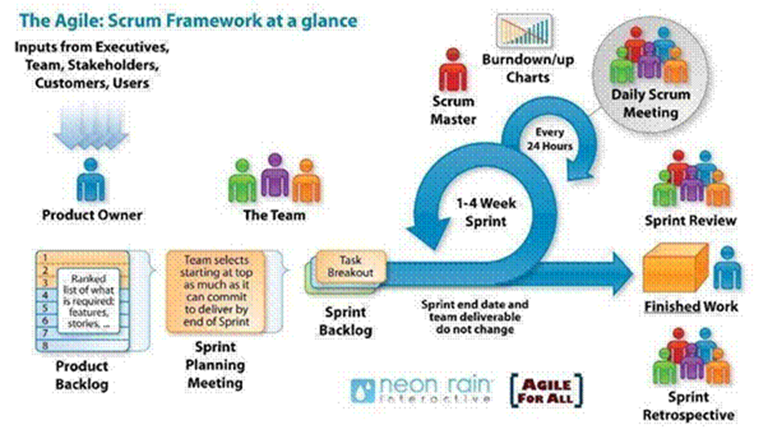
Figure 1. Scrum Process
- Scrum is an iterative and incremental agile software development framework for managing software projects and product or application development.
- Scrum focuses on project management institutions that are difficult to plan.
- Mechanisms of empirical process control, where feedback loops that constitute the core management technique are used as opposed to traditional command-and-control management.
- Its approach to planning and managing projects is to bring decision-making authority to the level of operation properties and certainties.
Why did we choose the Scrum process to develop the system?
We chose the Scrum process for developing the AI-based platform due to its flexibility and iterative approach, which is ideal for accommodating evolving user needs and integrating additional features in the future. Scrum allows our team to adapt and refine the platform based on feedback from each sprint, which is crucial given that this is our first project together and we anticipate encountering various challenges.
The iterative nature of Scrum enables us to identify and address issues early, ensuring continuous improvement and alignment with project goals while mitigating risks associated with inexperience and changing requirements.
Scrum Process Overview:
Product Backlog: Maintained by the Product Owner, containing all required features such as real-time fall detection, alert notifications, monitoring dashboard, and system integration. Items are prioritized based on importance and feasibility.
Sprint Planning: At the beginning of each sprint (2–3 weeks), the development team selects items from the product backlog to form the Sprint Backlog. The scope is carefully chosen to ensure the delivery of working features at the end of each sprint.
Daily Scrum Meeting: A 15-minute daily stand-up where team members share progress, identify blockers, and synchronize tasks. The Scrum Master ensures the process flows smoothly and removes obstacles.
Sprint Execution (1–4 weeks): Development is carried out in iterations. Each sprint aims to deliver a functional increment of the system, such as a prototype of pose detection, fall detection logic, or alert integration.
Sprint Review: At the end of each sprint, the team demonstrates the completed work (e.g., working fall detection module, notification system) to the Product Owner and stakeholders for feedback.
Sprint Retrospective: The team reflects on the sprint to identify improvements in workflow, collaboration, or technical execution for subsequent sprints.

11.2. Project Plan
Table 3. Project Plan
Week 1-2 | Complete the document | 2 weeks
Week 3-4 | Design UI & Design database | 2 weeks
Week 5-7 | Sprint 1 | 3 weeks
Week 7-10 | Sprint 2 | 3 weeks
Week 11-13 | Sprint 3 | 4 weeks
Week 14 | Sprint 4 | 3 weeks
Week 15 | Final deployment and presentation preparation. | 1 week

12. System Architecture Overview

12.1. System Context Diagram
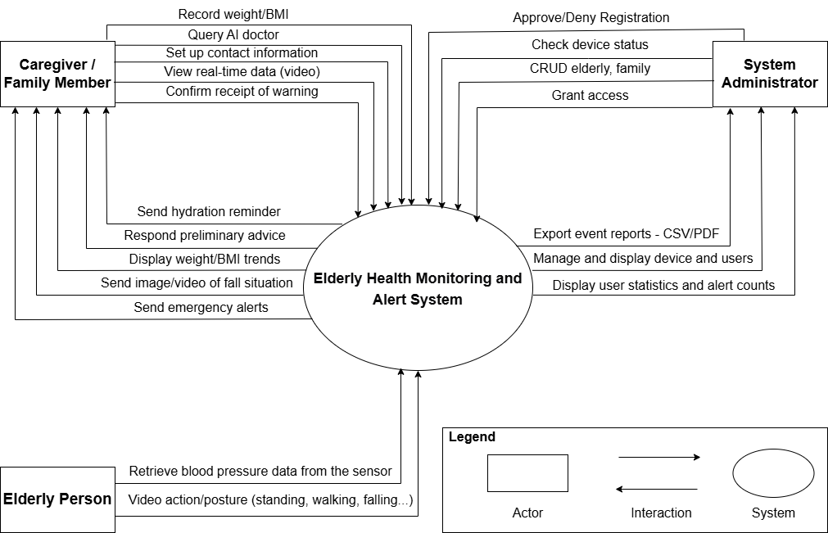
Figure 2. System Context Diagram

12.2. System Context Description
- Application Server (Elderly Health Core System):
The system serves as the core processor for data, alerts, and user/device management.
- Core Feature: Anomaly Fall Detection
+ Integrates Video Stream processing to verify the elderly person's posture and confirm the fall event.
+ Triggers a higher-level alert if the posture remains unchanged (unconsciousness/severe shock), leading to a direct phone call to the emergency contact number.
- Health Monitoring Features:
+ Tracks Weight and BMI indices.
+ Hydration Reminder functionality.
+ Basic AI Doctor: Provides basic questions/diagnoses based on symptoms entered by the user (e.g., headache, common illnesses).
+ Future Development: Monitoring of Blood Pressure, Blood Sugar, and Heart Rate (via specialized sensor integration).
- System Management:
+ API Communication with Frontend (React WebApp) and mobile applications.
+ User Authentication and Role Management (Admin, User/Family Member).
+ Emergency Alert Trigger via Mobile App and Direct Phone Call.
+ Database Interaction (health records, alert history, event logs, and contact information).
- User Roles
User (Family Member/Caregiver
The primary user role responsible for monitoring the elderly person's health and responding to alerts.
+ Login with a personal account.
+ Monitor Health Data (Weight, BMI, Alert History).
+ Interact with the Hydration Reminder feature.
+ Utilize the Basic AI Doctor for symptom checks.
+ Receive Fall Alerts from the system (via the app).
+ Set up and update emergency contact information (Emergency contact numbers)
- System Administrator (Admin - Dashboard Website)
Manages the overall operation of the system, users, and devices.
+ Dashboard: View system status and ongoing events overview.
+ Accounts Management: CRUD operations for User and Admin accounts.
- Device Management:
+ Monitor and control the status of devices (Camera, ESP32-MPU6050 Sensors).
+ Approve new account and device registrations (if self-registration is enabled).
- Monitoring & Reporting:
+ View detailed Activity/Alert History.
+ Generate comprehensive Reports on user activity and health status.
- Setting: General system configuration.
- Elderly Person:
The monitored subject.
+ Provides Input through real-life actions (standing, walking, sitting, falling).
+ No direct interaction with the system or applications is required.
- Specific Operational Mechanism (Hybrid Fall Detection)
+ Phase 1 (Video-based Fall Detection): The system continuously analyzes the elderly person's posture through the Video Stream using AI-based pose estimation. If the system detects a sudden posture change that indicates a possible fall, it immediately proceeds to Phase 2.
+ Phase 2 (Alert Notification): Upon confirming a potential fall event, the system sends an alert to the family member’s or caregiver’s application. The alert includes details such as timestamp, location (room/camera), and a short video snapshot for verification.
+ Phase 3 (High Emergency Response): If the elderly person’s posture remains unchanged for a period of time after the alert—indicating possible unconsciousness or severe injury—the system automatically initiates a phone call to the designated emergency contact.

13. Potential Risks and Mitigation Strategies
Table 4. Potential Risks and Mitigation Strategies
Risk | Description | P | I | Risk Exposure | Mitigation Strategy
Lack of technical expertise. | The project team may lack the required technical skills or experience, leading to delays or suboptimal outcomes. | 4 | 4 | 16 | Provide training for team members and seek external consultation if necessary.
Development delays | Limited experience or unexpected challenges may cause the development timeline to extend beyond the plan. | 5 | 4 | 20 | Create a phased development plan and release content incrementally to maintain progress.
Data security risks | Data breaches, unauthorized access, or system hacks may result in data loss or legal issues. | 4 | 5 | 20 | Implement robust security protocols, regular audits, and compliance with data protection regulations.
Poor user adoption | A complicated or confusing user interface may discourage users from adopting the system. | 4 | 4 | 16 | Simplify the user interface, conduct usability testing, and provide tutorials and customer support
Team conflicts | Lack of communication skills or unclear communication channels may cause misunderstandings or disagreements within the team. | 4 | 4 | 16 | Establish clear communication guidelines, regular meetings, and a collaborative problem-solving environment.

14. Deliverables
Deliverable 1: Functional Prototype
+ Camera input with real-time pose detection.
+ Fall detection logic (rule-based, with option to extend using ML).
+ Multi-channel alert system (Telegram, Email, Firebase).
+ Simple monitoring dashboard.
Deliverable 2: Technical Documentation
+ Covers software architecture, libraries used (Python, OpenCV, MediaPipe, TensorFlow/PyTorch for extension), and implementation steps.
Deliverable 3: Project Report and Presentation
+ Summarizes the problem statements, related works, methodology, implementation results, testing, and potential future improvements

15. Conclusion
This project presents a compelling opportunity to revolutionize elderly care through an innovative AI-based fall detection system. By developing intelligent monitoring and alert mechanisms, we aim to provide timely assistance and ensure the safety of elderly individuals living independently. This system will empower families and caregivers with real-time insights, enabling rapid response to emergencies and reducing risks associated with unattended falls. The project will significantly enhance the quality of life for elders and stand as a testament to the transformative potential of AI in promoting safety, independence, and well-being.

16. References
Table 5. References
No. | References | Document Information
1 | Scrum Model | https://en.wikipedia.org/wiki/Scrum_(software_development)
 |  | https://www.atlassian.com/agile/scrum
 |  | https://www.digite.com/agile/scrum-methodology/
 |  | https://www.scrum.org/resources/scrum-guide
2 | Technical | https://docs.opencv.org/
 |  | https://ai.google.dev/edge/mediapipe/solutions/vision/pose_landmarker
 |  | https://docs.pytorch.org/docs/stable/index.html
 |  | https://fastapi.tiangolo.com/
 |  | https://nodejs.org/docs/latest/api/
 |  | https://www.postgresql.org/docs/
 |  | https://core.telegram.org/bots/api
 |  | https://firebase.google.com/docs/cloud-messaging
 |  | https://cloud.google.com/docs
 |  | https://socket.io/docs/v4
 |  | https://www.researchgate.net/publication/257351867_A_Survey_on_Fall_Detection_Principles_and_Approaches
3 | Standard | https://www.nws.noaa.gov/oh/hrl/developers_docs/General_So ftware_Standards.pdf
 |  | https://standards.ieee.org/standard/12208-2017.html
 |  | https://en.wikipedia.org/wiki/Scrum_(software_development)
4 | Academic/  Research | https://www.researchgate.net/publication/257351867_A_Survey_on_Fall_Detection_Principles_and_Approaches
 |  | https://www.researchgate.net/publication/230741672_Posture_Recognition_Based_Fall_Detection_System_For_Monitoring_An_Elderly_Person_In_A_Smart_Home_Environment

17. Attached “DESCRIPTION OF PRODUCT REQUIREMENTS”

17.1. Brief description of product ideas (less than 7 statements)
The proposed system would be a comprehensive platform based on skeletal detection for fall detection and health monitoring, designed to enhance safety and independence for older adults. The system will continuously monitor daily activities through camera-based data and sensor inputs, utilizing deep learning models such as YOLO to accurately detect abnormal movements and fall events. An intelligent monitoring and alert mechanism will promptly notify caregivers or family members in emergency situations, ensuring timely assistance. The platform will also provide basic health-related records and activity tracking to support long-term well-being. By leveraging cost-effective hardware, open-source technologies, and scalable system architecture, the solution aims to be suitable for deployment in households, nursing homes, and healthcare facilities, ultimately improving the quality of life and overall safety of elderly users.

17.2. Requirement
High-level functional  requirements | 1. Continuous Monitoring
 | 2. Fall Detection
 | 3. Real-time Alert and Notification
 | 4. Event Recording and History Management
 | 5. User and Device Management

Quality property requirements (e.g., related to issues: Easy ,Easy to Use, Easy to Like, Easy to Learn, Easy to Understand, Easy to Buy / Yes,) | 1. Easy to Use
 | 2. Easy to Interact
 | 3. Easy to Learn
 | 4. Easy to Statistics
 | 5. Easy to Understand

Operational requirements  (related to the following issues: Speed,  Accuracy, Performance,  Stability, Load  Protection, Scalability, Safety, ...) | 1. Ensure the stability of the system
 | 2. Ensure the safety of the system
 | 3. Ensure system security
 | 4. Ensure load balancing for the system
 | 5. Ensure system scalability

Maintenance and support requirements | 1. Easily maintain source code
 | 2. Easily expand source code
 | 3. Specific description of the

Standard requirements | X | 1. Code standard. (GNU, Oracle standard, …)
2. Design standards. (object-oriented design,
analysis, and design templates...).
 | X | 3. IEEE (1058, 1540, 830, 1016, 829, 1012, 1008)
 | X | 4. ISO/IEC/IEEE 12207:2017 (TCVN 10539:2014);  ISO/IEC 25051:2006 (TCVN 10540:2014);
 |  | 5. Other standards. (related to specific topics)

