DOCUMENT NAME
Document Title | User Interface Design Document
Author(s) | Dung, Mai Van
Role | Team Member
Date | Dec 10th, 2025 | File name: | C1SE.40_User_Interface_Design_ver2.0.docx

REVISION HISTORY
Version | Date | Comments | Author
1.0 | 29/09/2025 | Initial Release | All Members
1.1 | 16/10/2025 | Updated | All Members
1.2 | 15/11/2025 | Updated | All Members
1.3 | 20/11/2025 | Updated | All Members
1.4 | 05/12/2025 | Updated | All Members
2.0 | 10/12/2025 | Official | All Members

TABLE OF CONTENTS
1. Introduction 1
1.1. Purpose 1
1.2. Scope 1
2.Interface Design 1
2.1.Registration & Login 1
2.2. Home Page 4
2.3. Weight & BMI Tracking 6
2.4. Camera Management 9
2.5. LifeStyle 11
2.7. Settings 14
2.8. Alerts 15
2.9. AI Doctor 17
2.10. Chat Screen 19
2.11. Health Tracking 20
2.12. Blood Sugar 22
2.13. Blood Pressure 24
2.14. Login / Dashboard 26
2.15. ElderCare Admin – Dashboard 27
2.16. Analysis Report 30
2.17. UI Specification 32
2.18. Approve device registration 34
2.19. Device details 36
2.20. Device management 37
2.21. User details 39
2.22. User management 40
2.23. Dashboard 42

Introduction

Purpose
This specification covers following:
- Documentation assists in achieving a comprehensive understanding of the HealthApp mobile application's user interface and its detailed description and functionality.
- With this documentation, the development team can understand the structural and compositional details to create a consistent and complete health management system.

Scope
- Overview of the stages and modules of the HealthApp software, including authentication, data tracking, device management, and lifestyle features.
- Create a complete mobile application interface and describe its elements and interactions clearly.

Interface Design

Registration & Login
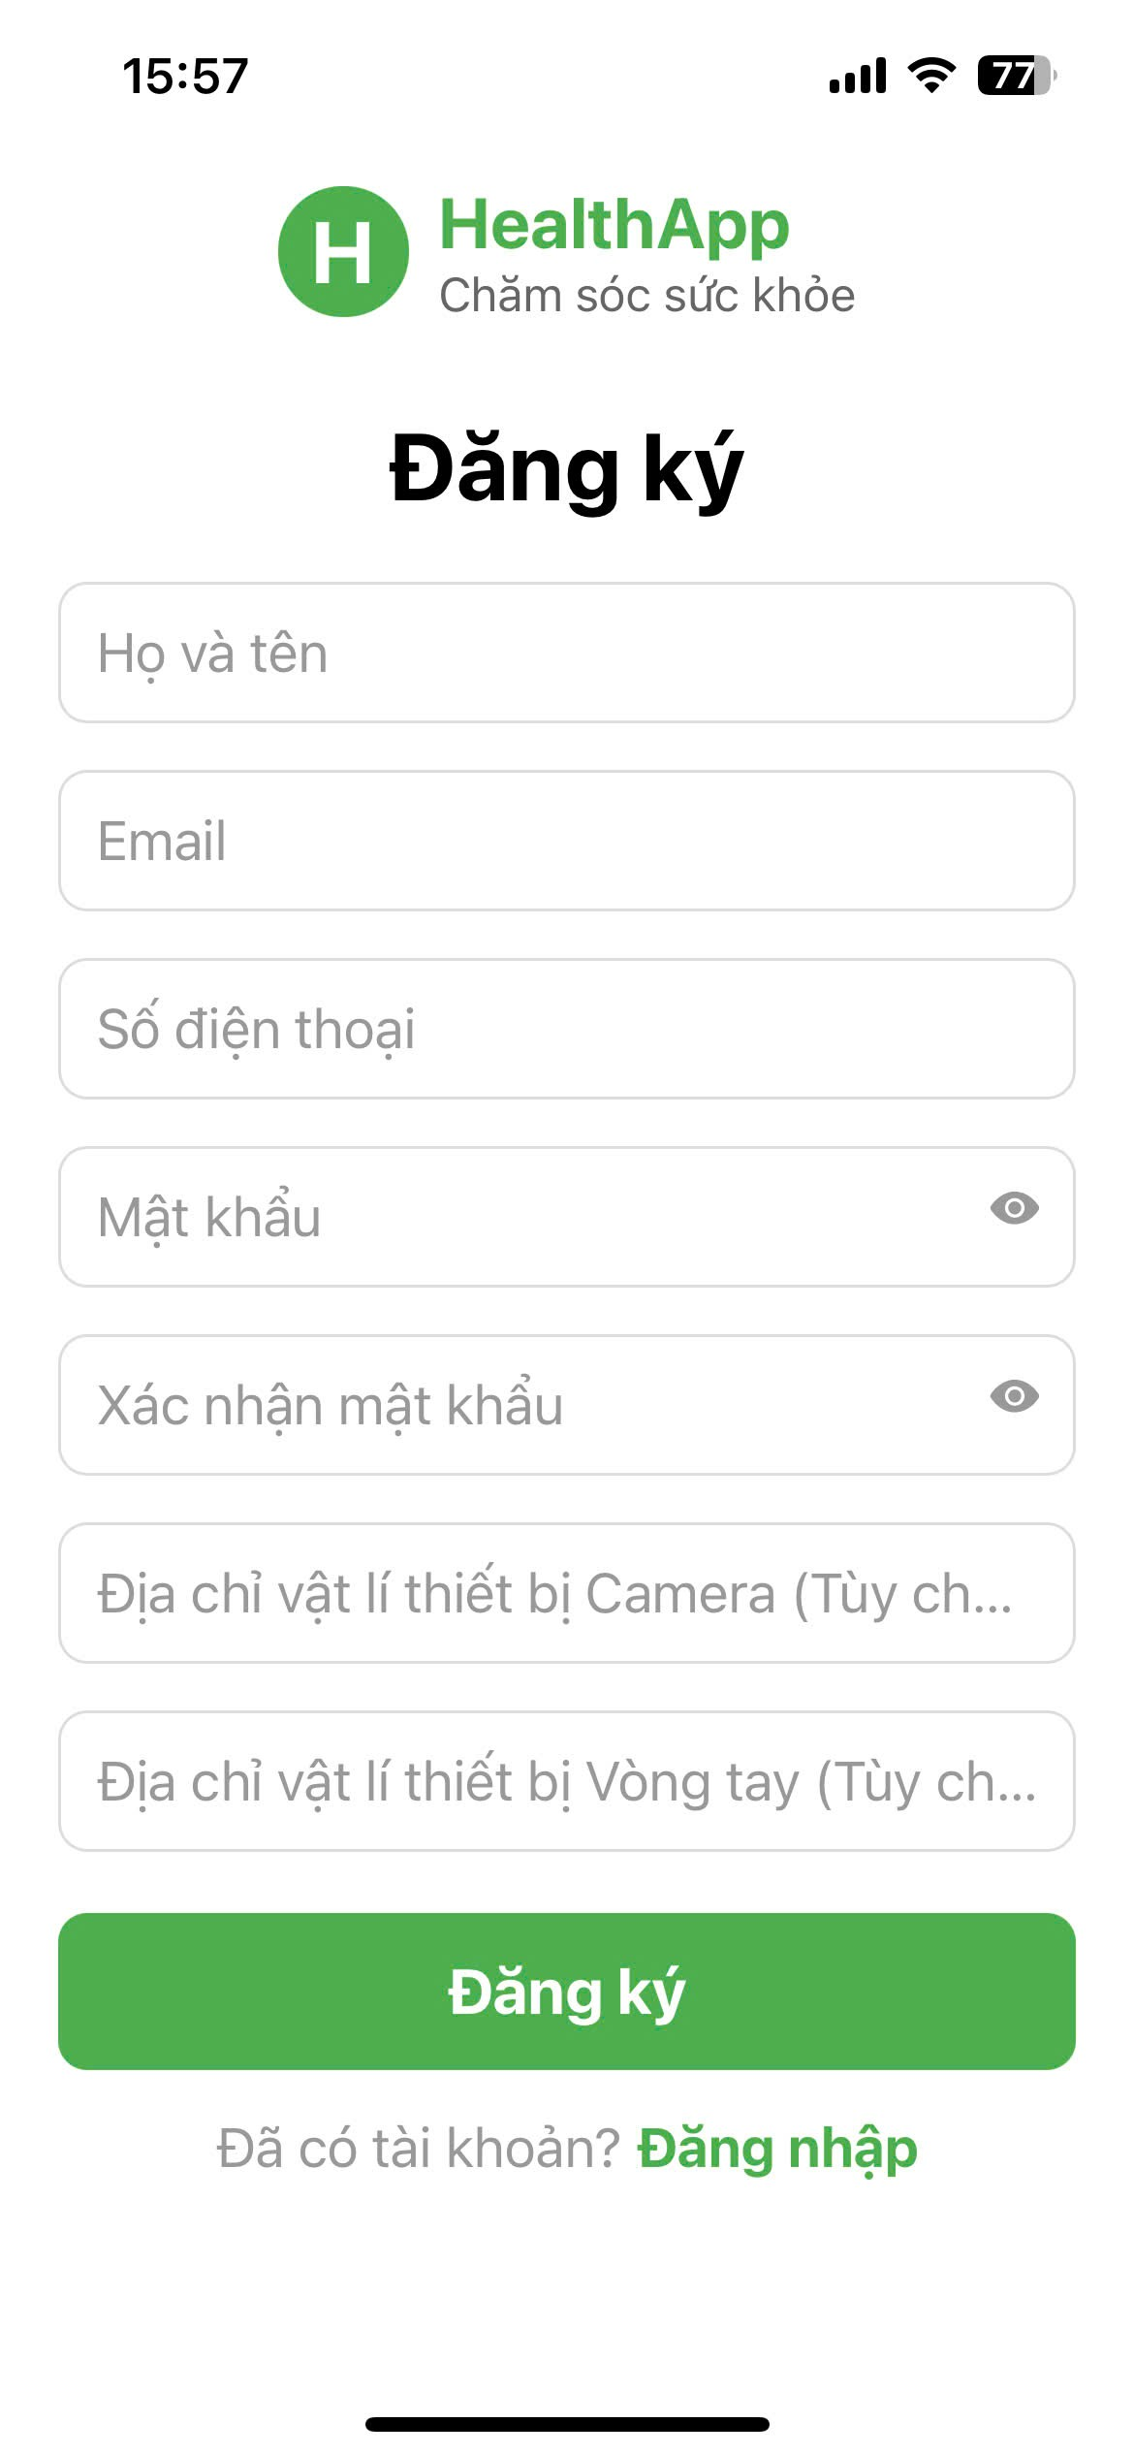
 |  |  | Registration
No. | Field name | Type | Require | Target
1 | Background | Background | Background color: #101522 | Defines the overall visual background of the registration screen.
2 | Registration Form | Screen | Heading: “Registration” | Screen that allows users to create a new account.
3 | Full Name | Input Text | Placeholder: “Full Name” | Allows the user to enter their full name.
4 | Email | Input Text | Placeholder:“Email” | Allows the user to enter an email address for account registration.
5 | Phone Number | Input Text | Placeholder: “Phone Number” | Allows the user to enter a phone number.
6 | Password | Input Password | Placeholder: “Password”; Eye icon to show/hide password | Allows the user to set an account password securely.
7 | Confirm Password | Input Password | Placeholder: “Confirm Password”; Eye icon to show/hide password | Allows the user to re-enter and confirm the password.
8 | Camera Device MAC Address | Input Text (Optional) | Placeholder: “Camera device MAC Address (Optional)” | Allows the user to enter the camera device MAC address (optional).
9 | Bracelet Device MAC Address | Input Text (Optional) | Placeholder: “Bracelet device MAC Address (Optional)” | Allows the user to enter the bracelet device MAC address (optional).
10 | Registration Button | Button | Background color: Green | Submits the registration information to create a new account.
11 | Already have an account? | Text Link | Text color: Green | Redirects the user to the Login screen.

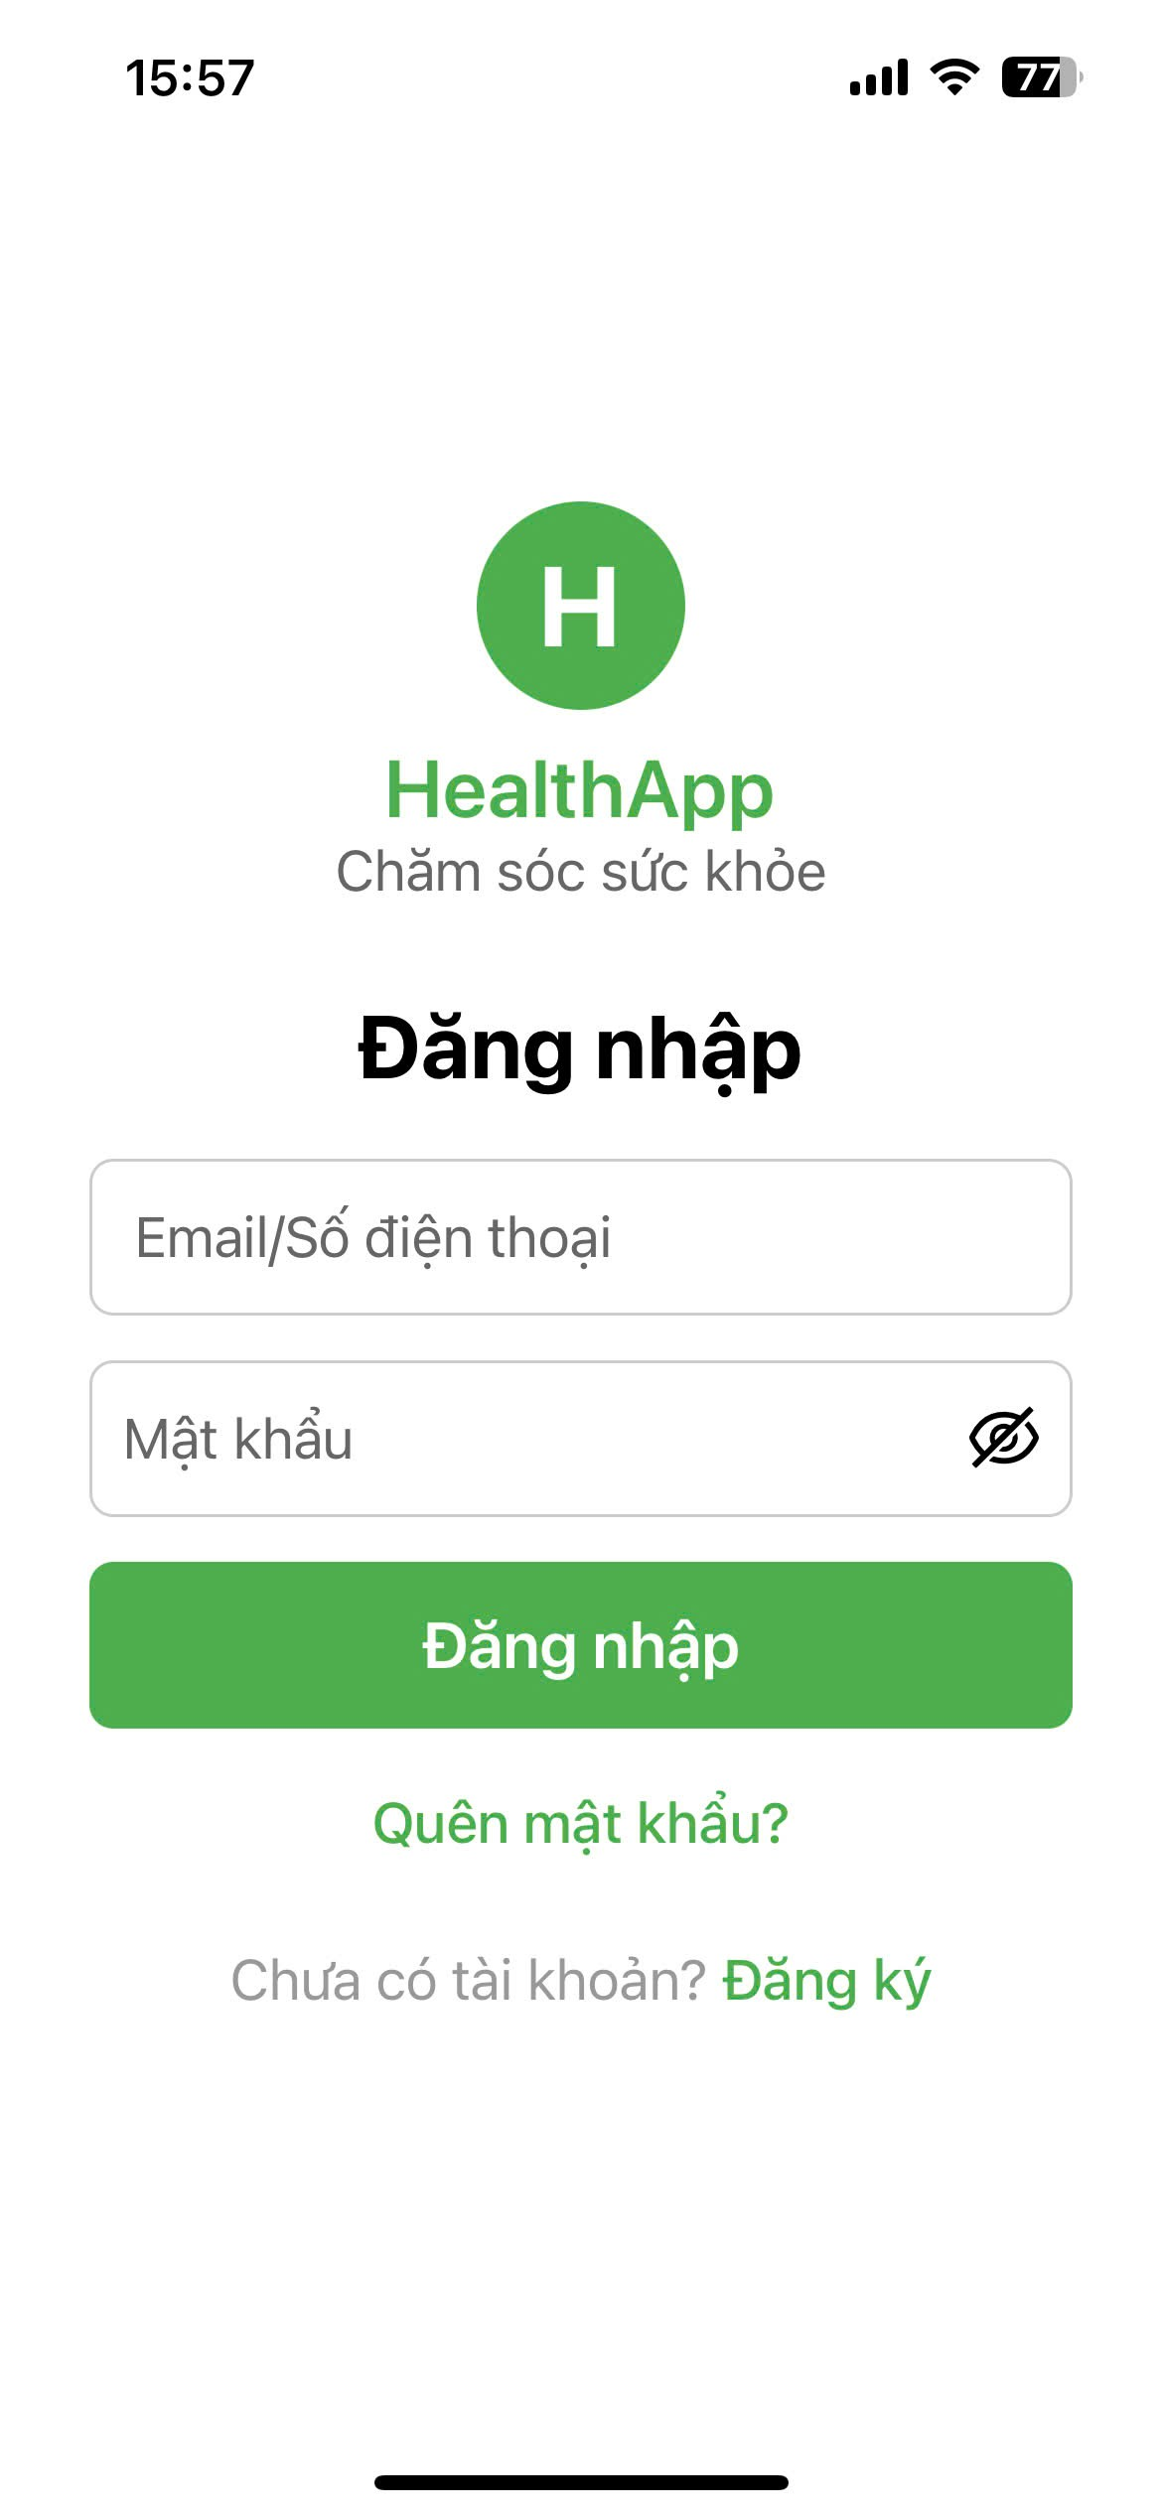
 |  |  | Login
No. | Field Name | Type | Require | Target
1 | Login Form | Screen | Heading: “Login” | Screen that allows users to access an existing account.
2 | Email / Phone Number | Input Text | Placeholder: “Email / Phone Number” | Allows the user to enter an email address or phone number.
3 | Password | Input Password | Placeholder: “Password”; Slashed eye icon to hide/show password | Allows the user to enter their account password securely.
4 | Login Button | Button | Background color: Green | Authenticates the user and grants access to the application.
5 | Forgot Password? | Text Link | Text color: Green | Redirects the user to the password recovery process.
6 | Don’t have an account? | Text Link | Text color: Green | Redirects the user to the Registration screen.

2.2. Home Page
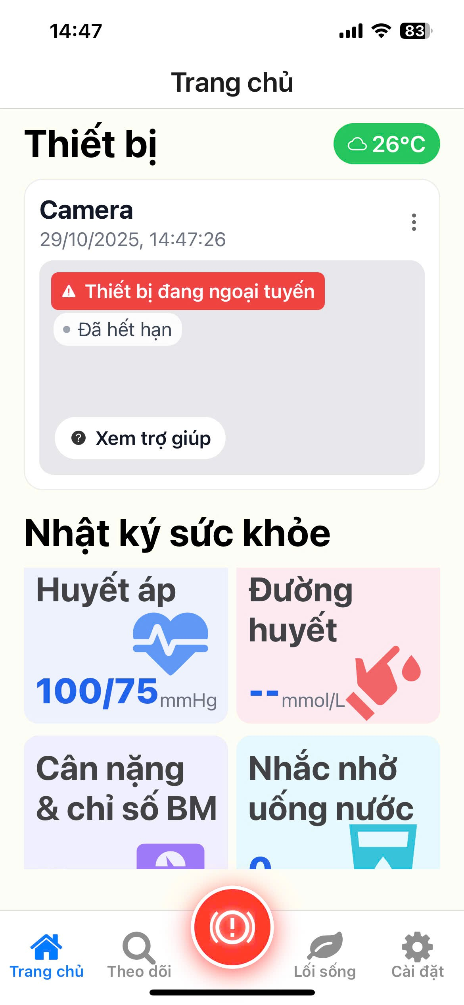
Home Page
No. | Field Name | Type | Require | Target
1 | Page Header | Heading | Title: “Home Page” | Identifies the current screen displayed to the user.
2 | Current Weather | Text / Icon | Temperature: 26°C; Weather icon: Cloud / Sun / relevant weather icon | Displays current weather information to provide environmental context.
3 | Devices Section | Section Heading | Title: “Devices” | Contains status information for all connected smart devices.
4 | Camera Device Status | Card | Device name: “Camera”; Date/Time: 29/10/2025, 14:47:26 | Displays the latest update time and current operational status of the camera device.
5 | Offline / Expired Alert | Alert Badge | Background color: Red; Text: “Device is offline”, “Expired” | Alerts the user to critical device connection or subscription issues.
6 | View Help Link | Text Link | Text: “View help” | Redirects the user to troubleshooting instructions or device support information.
7 | Health Diary Section | Section Heading | Title: “Health Diary” | Provides an overview of key health metrics with access to detailed tracking features.
8 | Blood Pressure | Metric Card | Value: 100/75 mmHg; Icon: Heart / Pulse wave | Displays blood pressure data and links to detailed blood pressure tracking.
9 | Blood Sugar | Metric Card | Value: -- mmol/L; Icon: Finger pricking | Displays blood sugar status and links to detailed blood sugar tracking.
10 | Weight & BMI Index | Metric Card | Title: “Weight & BMI Index”; Icon: Weight scale | Provides access to detailed weight and BMI tracking information.
11 | Water Reminder | Metric Card | Title: “Water Reminder”; Icon: Water glass | Links to the water intake reminder and tracking feature.
12 | AI Doctor Access | Floating Action Button (FAB) | Position: Center of bottom navigation bar; Icon: Exclamation mark in a circle (!) | Provides quick access to the AI Doctor / consultation feature (intended feature).
13 | Bottom Navigation Bar | Navigation | Tabs: Home, Tracking, FAB (AI Doctor), Lifestyle, Settings | Serves as the main navigation mechanism of the application.

2.3. Weight & BMI Tracking
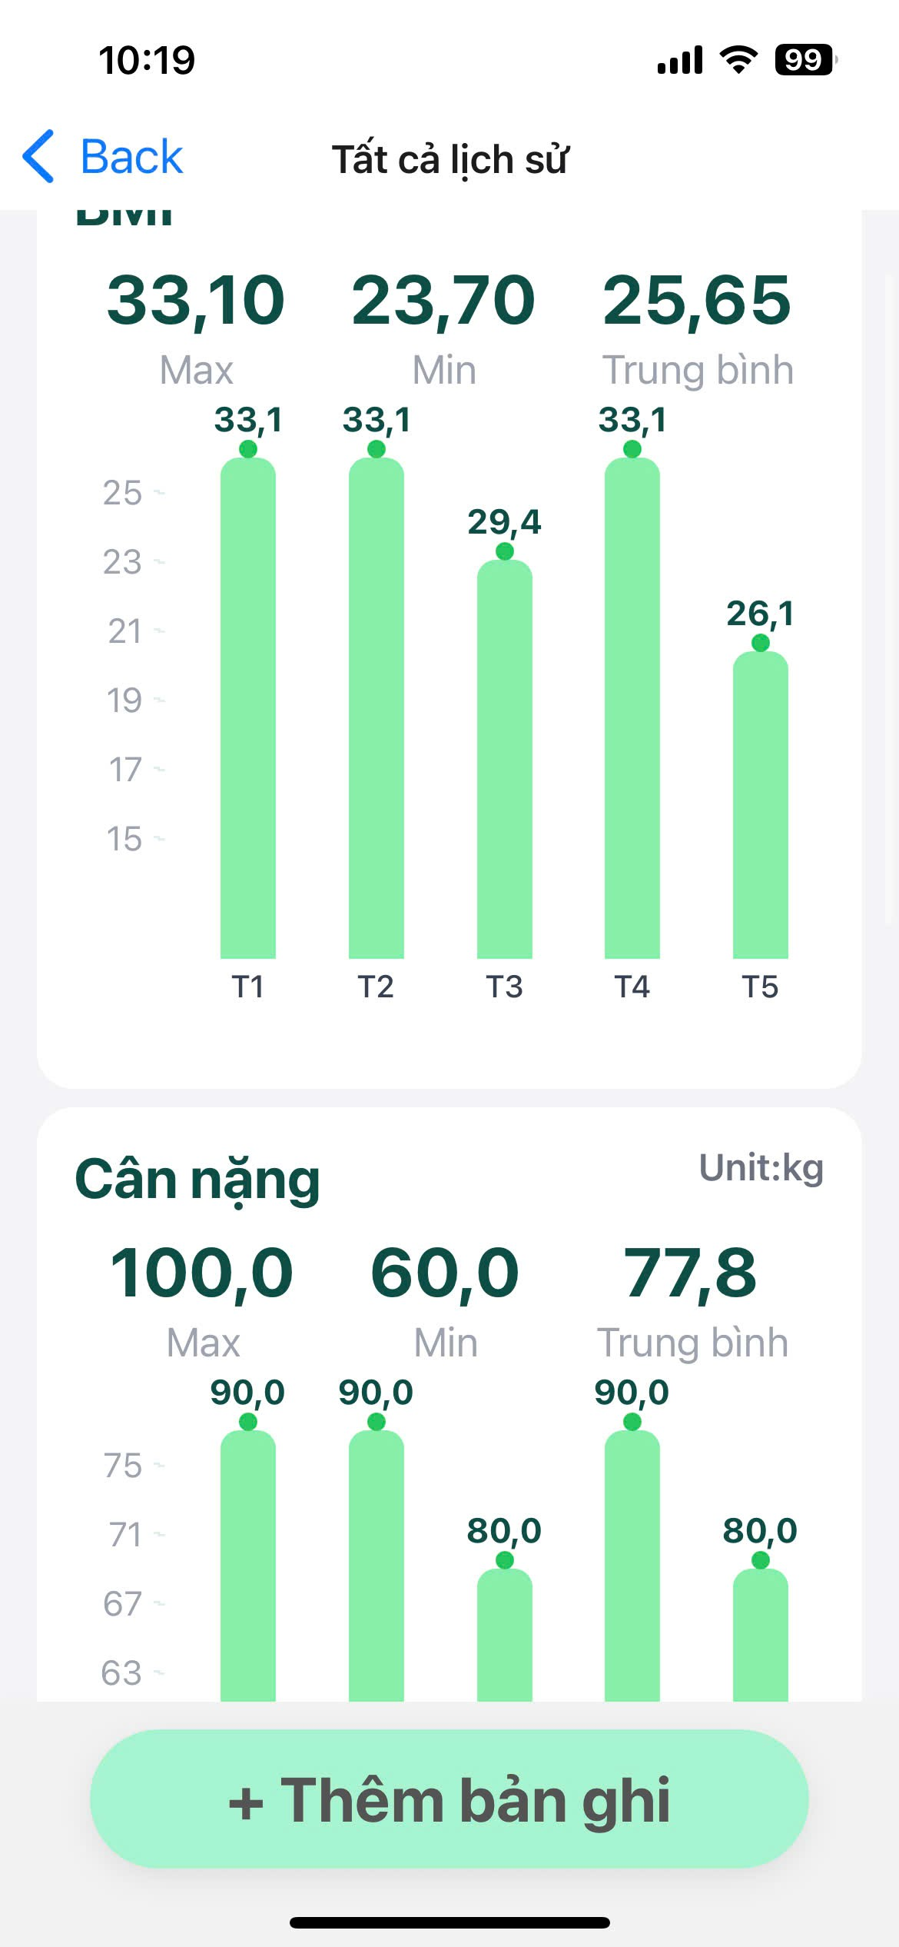
Weight and BMI
No. | Field Name | Type | Require | Target
1 | Screen | Screen | Design and requirement details for Weight & BMI Tracking | Displays the interface for monitoring weight and BMI records over time.
2 | BMI Chart | Bar Chart | Max: 33.10; Min: 23.70; Average: 25.65 | Visualizes historical BMI trends across time periods (T1 to T5).
3 | Weight Chart | Bar Chart | Title: “Weight”; Unit: kg | Visualizes historical weight trends over time.
4 | Add Record Button | Button | Text: “+ Add Record”; Background color: Light Green | Redirects the user to the weight and height input screen to add a new record.

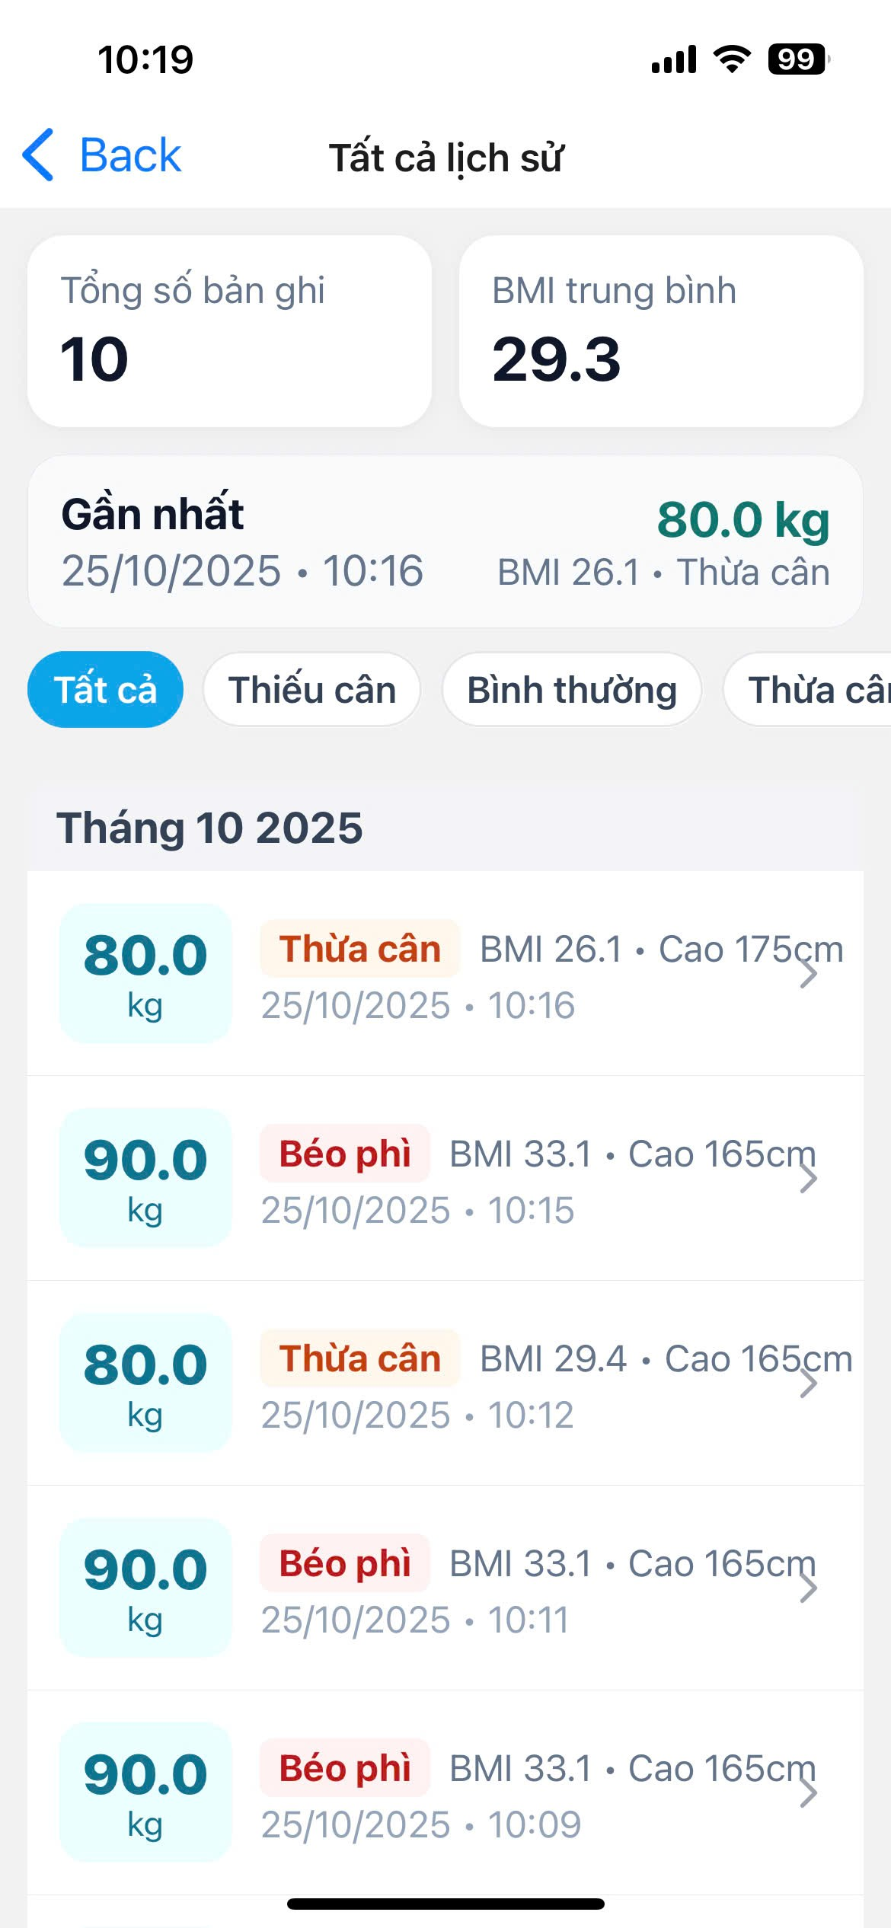
History Record
No. | Field Name | Type | Require | Target
1 | Total Records | Card | Text: “Total Records”; Value: 10 | Displays the total number of recorded weight and BMI entries.
2 | Average BMI | Card | Text: “Average BMI” | Displays the average BMI calculated from all recorded entries.
3 | Latest Record Overview | Summary Card | Date & Time: 25/10/2025 • 10:16; Weight: 80.0 kg; BMI: 26.1; Status: Overweight | Provides a quick overview of the most recent weight and BMI record.
4 | Filter Tabs | Tabs | Options: All, Underweight, Normal, Overweight, Obese | Allows users to filter history records based on BMI classification.
5 | Group Header | Text | October 2025 | Groups history records by month and year for better readability.
6 | History List | List View (per item) | Weight: 80.0 kg / 90.0 kg (blue column); Status: Overweight / Obese (red/orange text); Details: BMI, Height (e.g., 175 cm / 165 cm); Timestamp: 25/10/2025 • Time | Displays detailed historical weight and BMI records in a chronological list format.

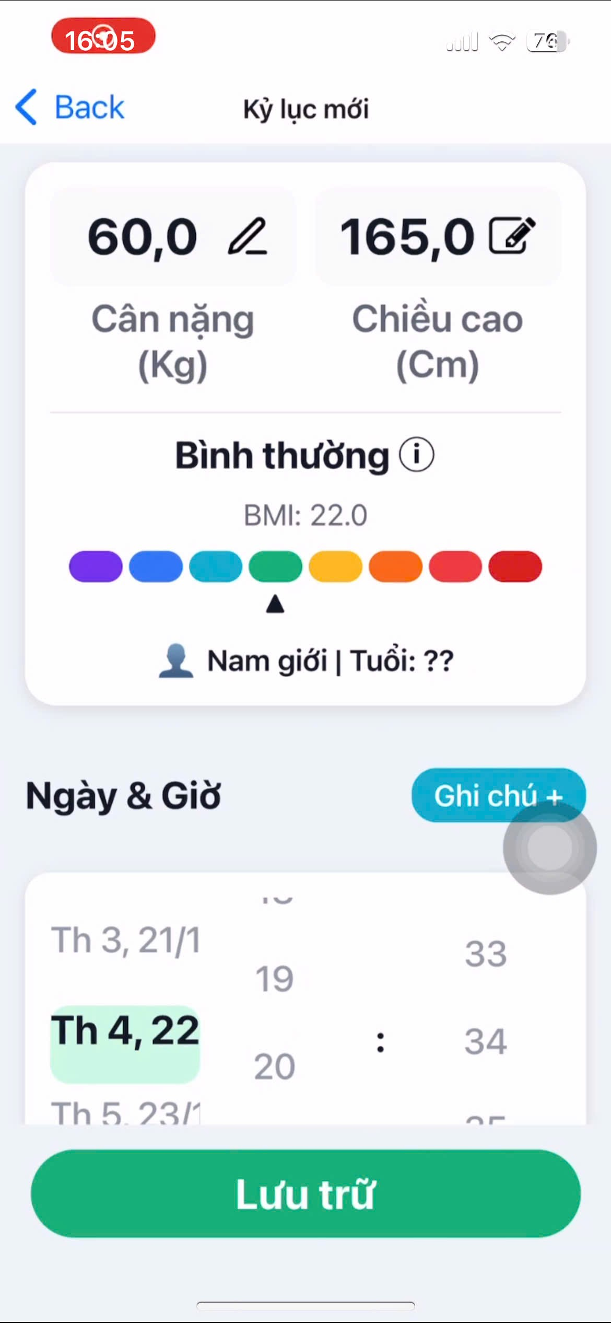
Add record
No. | Field Name | Type | Require | Target
1 | New Record Screen | Screen | Title: “New Record” | Provides an interface that allows users to manually enter new weight and height data.
2 | Weight Input | Input Field | Current value: 60.0 kg; Pencil icon for editing | Allows the user to enter or edit the current body weight.
3 | Height Input | Input Field | Current value: 165.0 cm | Allows the user to enter or edit the current body height.
4 | BMI Status | Text / Indicator | Status: Normal; BMI value: 22.0 | Displays the calculated BMI and its corresponding health classification.
5 | BMI Color Scale | Visual Scale | Color-coded BMI scale with indicator arrow pointing to 22.0 (Normal) | Provides a visual reference to help users understand their BMI status.
6 | Personal Info | Text | Gender: Male; Age: N/A | Displays basic personal information relevant to BMI calculation.
7 | Date & Time Header | Header | Header text for date and time selection | Identifies the section used to select the timestamp of the record.
8 | Date & Time Picker | Date / Time Picker | Selectable dates (e.g., Tue 21/1, Wed 22, Thu 23) and time values (e.g., 19:33, 20:34) | Allows the user to select the date and time associated with the record.
9 | Add Note Button | Button | Text: “Add Note +” | Opens an input field allowing the user to add notes to the record.
10 | Save Button | Button | Text: “Save”; Background color: Green | Saves and finalizes the newly entered weight and height record.

2.4. Camera Management
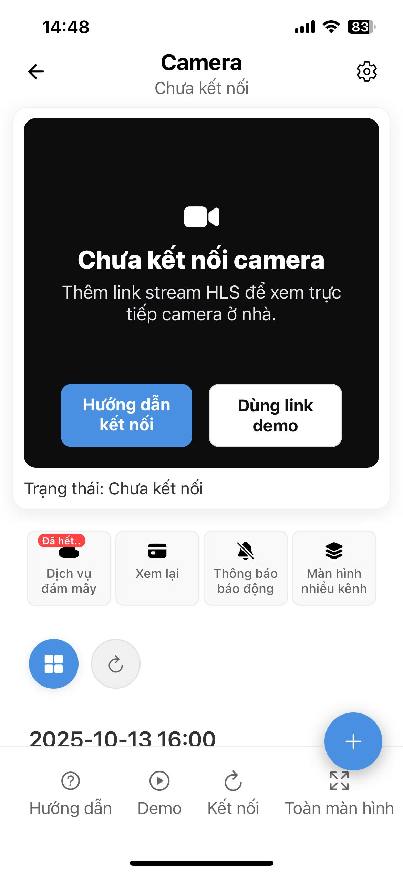
Camera
No. | Field Name | Type | Require | Target
1 | Page Header | Heading | Title: “Camera”; Subtitle: “Not connected” | Identifies the current camera screen and displays the connection status.
2 | Settings Icon | Icon Button | Icon: Gear / Settings | Provides access to camera-specific configuration settings.
3 | Video Stream Area | Content Area | Background: Black; Placeholder text: “Camera not connected” | Displays the live video stream when the camera is connected.
4 | Connection Guide Text | Text | Instruction: “Add HLS stream link to watch live home camera” | Guides the user on how to connect the camera via streaming link.
5 | Guide Button | Button | Text: “Connection Guide”; Background color: Blue | Navigates to a detailed step-by-step camera connection guide.
6 | Demo Link Button | Button | Text: “Use demo link”; Background color: White | Loads a demo video stream to allow users to test the camera feature.
7 | Connection Status | Text | Text: “Status: Not connected” | Confirms and displays the current camera connection status.
8 | Feature Buttons (Top Row) | Icon Buttons | Icons: Expired, Review, Alarm Notification, Multi-channel Screen | Provides quick access to primary camera-related features.
9 | Action Icons (Mid-Screen) | Icon Buttons | Icons: Grid view, Refresh | Allows switching layouts or refreshing the camera stream/status.
10 | Timeline / Timestamp | Text | Date & Time: 2025-10-13 16:00 | Indicates the timestamp of the video segment being viewed (review mode).
11 | Control Buttons (Bottom Row) | Icon Buttons | Icons: Guide, Connect, Fullscreen | Provides core camera control actions for the user.

2.5. Lifestyle
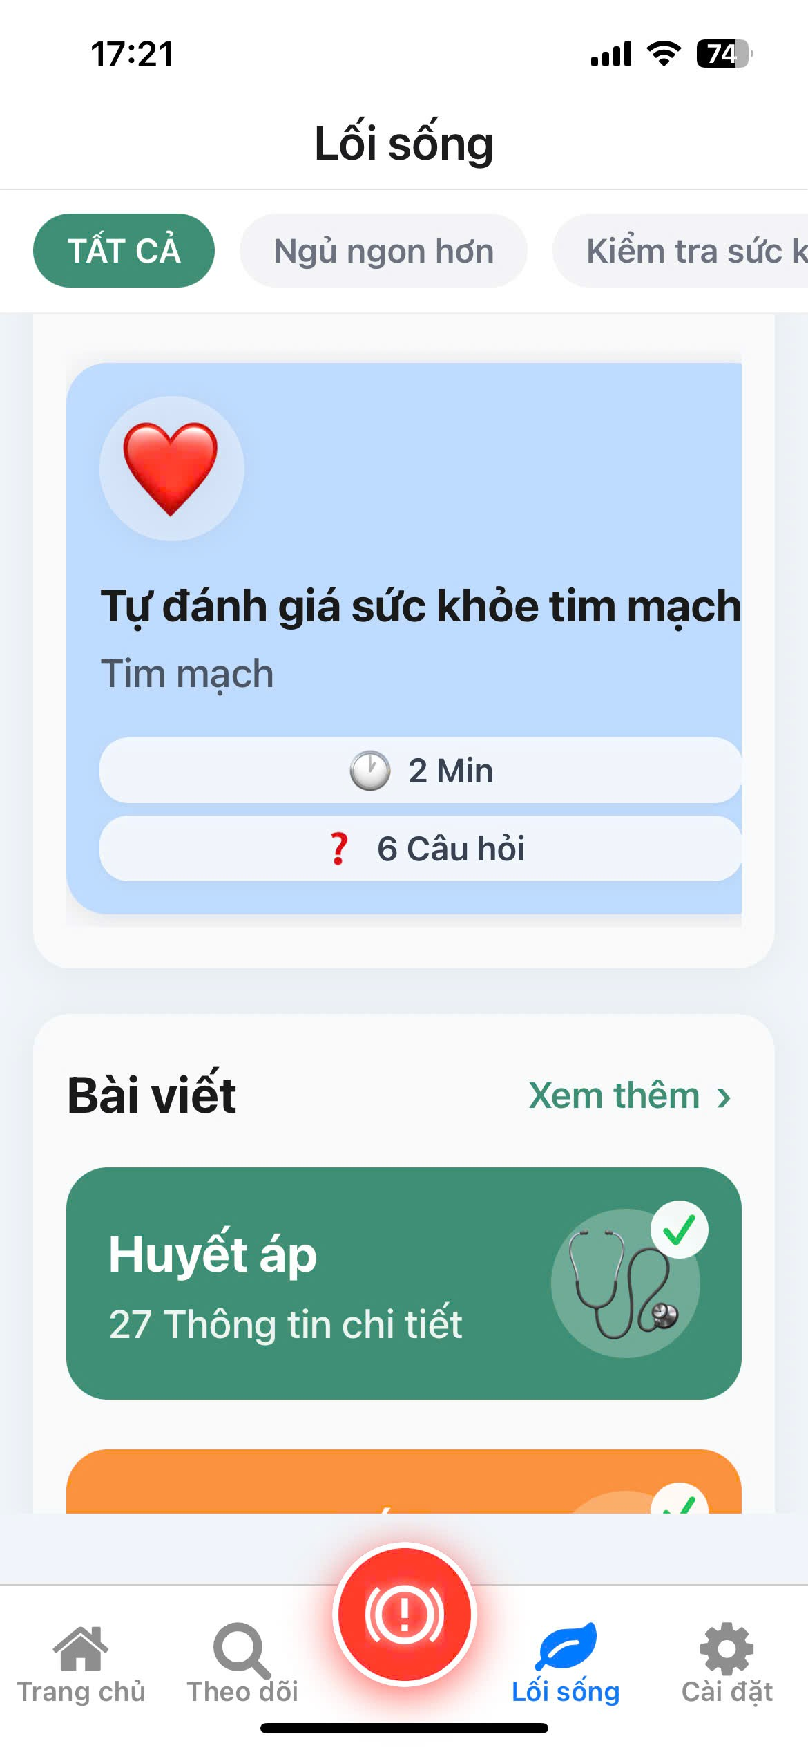

 |  | Lifestyle
No. | Field Name | Type | Require | Target
1 | Page Header | Heading | Title: “Lifestyle” | Identifies the content section related to overall well-being and daily lifestyle activities.
2 | Content Filter Tabs | Tabs | Options: All, Sleep Better, Health Check | Filters the displayed lifestyle content based on selected category.
3 | Sleep Better Section | Video / Article List Section | Title: “Sleep Better” | Provides videos and articles focused on improving sleep quality.
4 | Health Check Section | Tool Card Section | Title: “Health Check” | Contains interactive tools that allow users to self-assess their health conditions.
5 | Health Tips Section | Card Section | Title: “Health Tips” | Displays short and practical tips to help users maintain a healthy lifestyle.
6 | Articles Section | Article List Section | Title: “Articles” | Provides in-depth educational articles on various health-related topics.
7 | Cooking Recipes Section | Card Section | Title: “Cooking Recipes” | Offers healthy cooking ideas and nutrition-friendly recipes.
2.6. Water Reminder
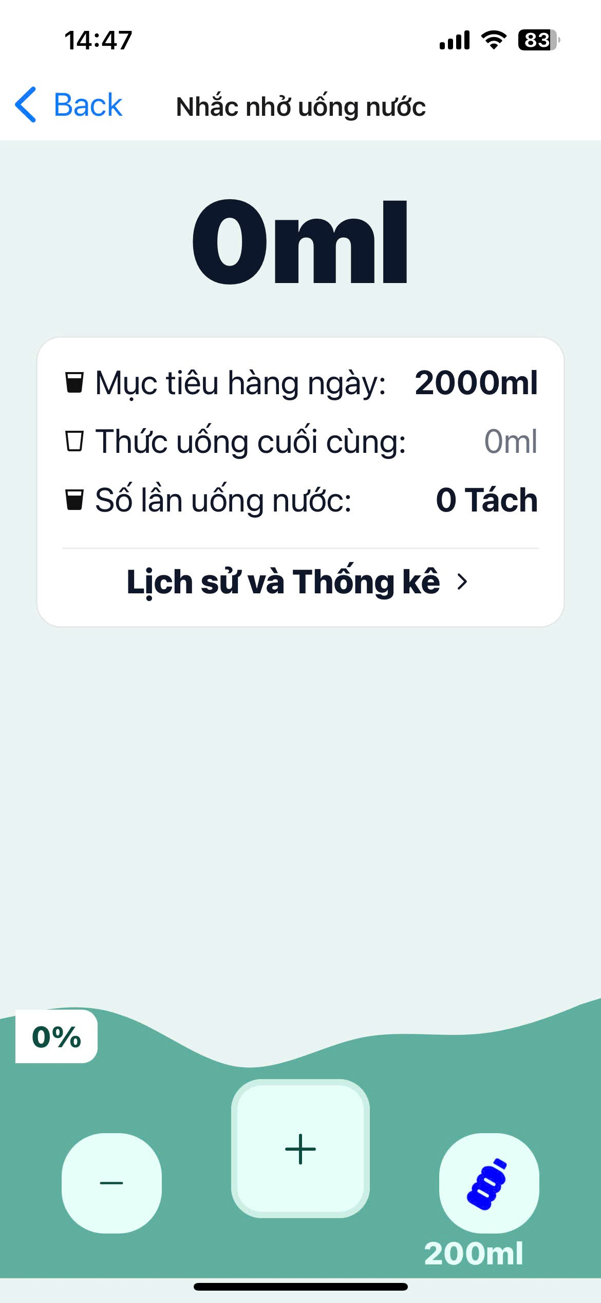
Water Reminder
No. | Field Name | Type | Require | Target
1 | Page Header | Heading | Title: “Water Reminder” | Identifies the screen dedicated to water intake tracking.
2 | Current Intake | Large Text | Value: ml (updates dynamically as the user logs water intake) | Displays the total amount of water consumed during the current day.
3 | Daily Goal | Text | Title: “Daily Goal:”; Value: 2000 ml; Icon: Water cup | Displays the target daily water intake the user aims to achieve.
4 | Last Drink | Text | Title: “Last drink:”; Value: 0 ml (updated with the most recent entry) | Displays the most recent recorded water intake amount.
5 | Number of Drinks | Text | Title: “Number of drinks:”; Value: 0 cups; Icon: Water cup | Displays the total number of water intake entries recorded for the day.
6 | History & Stats Link | Text Link | Text: “History and Statistics >” | Navigates the user to a detailed history and statistical view of water intake.
7 | Progress Indicator | Progress Bar / Text | Value: Dynamic (based on current intake vs. daily goal) | Visually represents the progress toward achieving the daily water intake goal.
8 | Decrease Button | Button | Icon: Minus (-) | Decreases the current water intake amount (if applicable).
9 | Increase Button | Button | Icon: Plus (+) | Adds a default amount of water or opens an interface to select an intake amount (e.g., 200 ml).
10 | Quick Add Button | Button | Value: 200 ml; Icon: Water bottle | Allows the user to quickly log a fixed amount of water (200 ml).

2.7. Settings
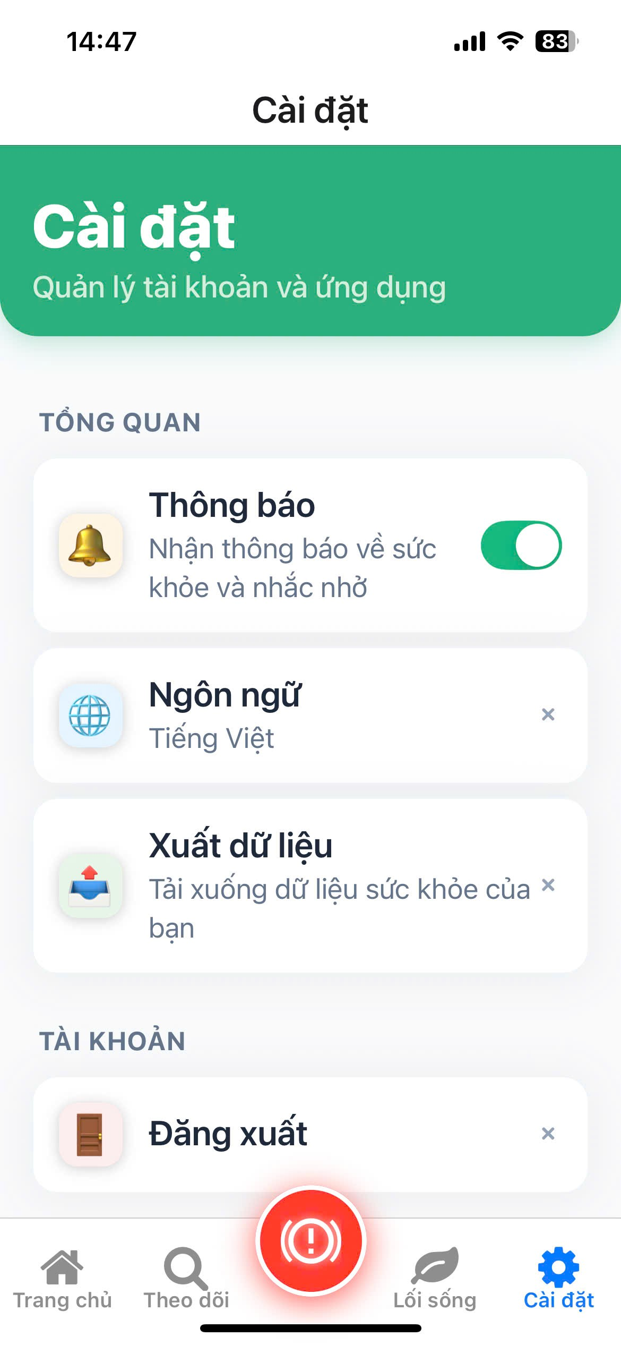
Settings
No. | Field Name | Type | Require | Target
1 | Page Header | Heading | Title: “Settings”; Subtitle: “Manage account and application” | Identifies the screen used for managing user preferences and application settings.
2 | Overview Section | Section Heading | Title: “OVERVIEW” | Groups general application-level settings.
3 | Notifications | Toggle Switch | Title: “Notifications”; Description: “Receive health notifications and reminders”; Icon: Bell; Toggle: On / Off | Allows the user to enable or disable all application notifications.
4 | Language | List Item | Title: “Language”; Current value: “Vietnamese”; Icon: Globe | Allows the user to change the application language.
5 | Data Export | List Item | Title: “Data Export”; Description: “Download your health data”; Icon: Book / Export | Initiates the process of exporting and downloading personal health data.
6 | Account Section | Section Heading | Title: “ACCOUNT” | Groups account-related actions and settings.
7 | Log Out | List Item / Button | Title: “Log out”; Icon: Door | Logs the user out of the current account session securely.

2.8. Alerts
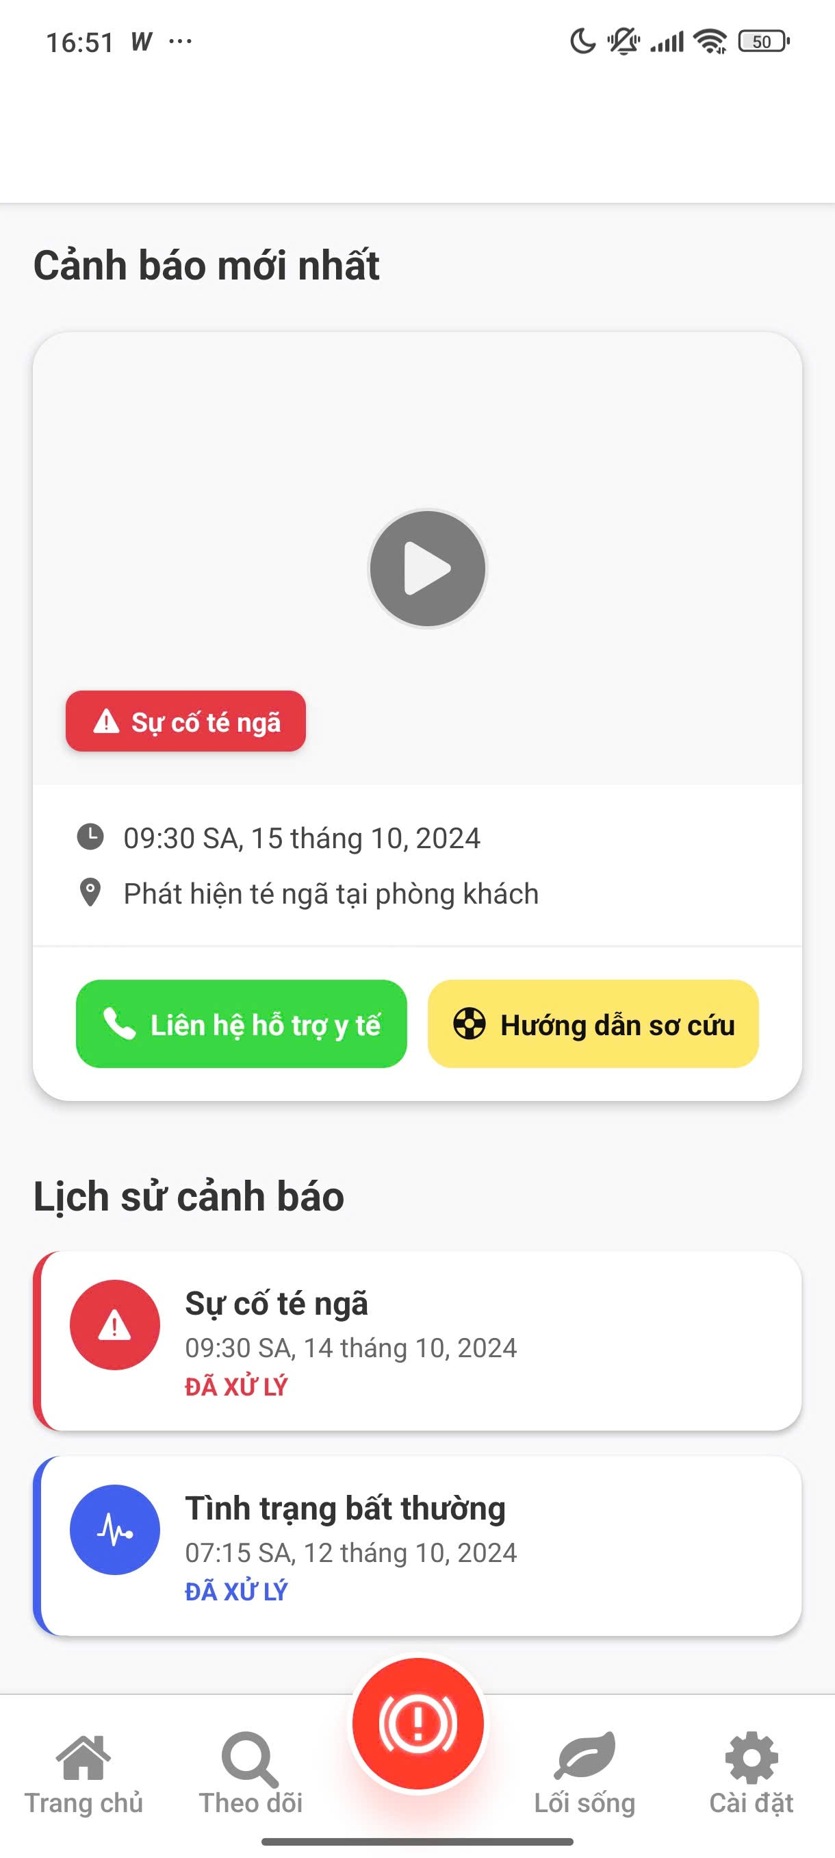
Alerts
No. | Field name | Type | Require | Target
1 | Page Header | Heading | Title: " Latest Alert " | Identifies the section showing the latest and historical alerts.
2 | Latest Alert Card | Card |  | Displays the detailed information for the most recent alert.
3 | Video Placeholder/Icon | Icon/Area | Icon: Play button | The intended area to play a video or show an image capturing the alert event.
4 | Alert Type Badge | Badge | Text: " Falling Incident " Background: Red | Highlights the type of incident that occurred.
5 | Timestamp | Text | Value: 09:30 AM, October 15, 2024 | The time the alert was recorded.
6 | Location/Details | Text | Text: " Detected fall in the living room " | Provides details about the event and the location of detection.
7 | Contact Medical Button | Button | Text: " Contact medical support"  Background: Green | An urgent call-to-action button to contact medical services.
8 | First Aid Guide Button | Button | Text: " First aid guide " Background: Yellow | A button providing first aid instructions for this type of incident.
9 | History Section | Section Heading | Title: " Alert History " | A segment displaying previously occurred alerts.
10 | Historical Alert - Fall | List Item/Card | Text: "Sự cố té ngã" Timestamp: 09:30 AM, October 14, 2024 Status: " PROCESSED " | A record of a processed falling incident alert.
11 | Historical Alert - Abnormal | List Item/Card | Text: " Abnormal condition " Timestamp: 07:15 AM, October 12, 2024 Status: " PROCESSED " | A record of a processed abnormal health condition alert.
12 | Bottom Navigation | Navigation | Tabs: Home, Tracking, Alerts -FAB, Lifestyle, Settings | The main navigation bar for the application.

2.9. AI Doctor
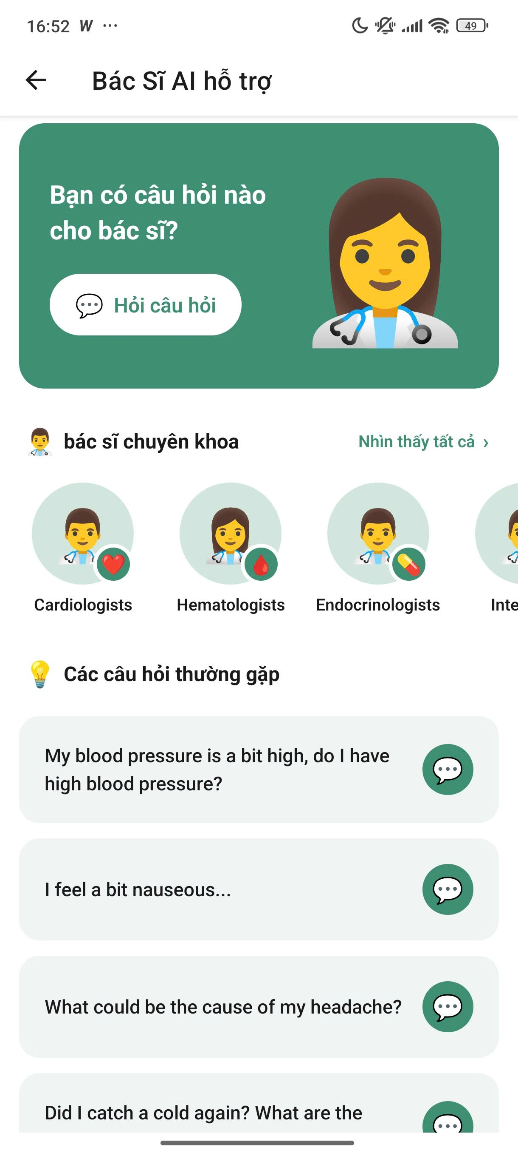
AI Doctor
No. | Field Name | Type | Require | Target
1 | Page Header | Heading | Title: “AI Doctor Support” | Identifies the screen dedicated to AI-powered health consultation and support.
2 | Chat Input Card | Card / Banner | Text: “Do you have any questions for the doctor?”; Icon: Doctor / Female avatar | Invites the user to enter a health-related question or concern.
3 | Ask Question Button | Button | Text: “Ask question”; Icon: Chat bubble | Initiates a consultation or conversation with the AI Doctor.
4 | Specialist Section | Section Heading | Title: “Specialist Doctors” | Groups options for selecting a medical specialist.
5 | View All Link | Text Link | Text: “See all >” | Redirects the user to a complete list of available medical specialists.
6 | Cardiologists Option | Icon / Text Label | Text: “Cardiologists”; Icon: Male avatar with heart | Starts a consultation focused on cardiovascular-related issues.
7 | Hematologists Option | Icon / Text Label | Text: “Hematologists”; Icon: Female avatar with blood drop | Starts a consultation focused on blood-related conditions.
8 | Endocrinologists Option | Icon / Text Label | Text: “Endocrinologists”; Icon: Male avatar with syringe | Starts a consultation focused on endocrine-related conditions.
9 | FAQs Section | Section Heading | Title: “Frequently Asked Questions”; Icon: Lightbulb | Displays a list of suggested or common health-related questions.
10 | FAQ Item 1 | Question Card | Text: “My blood pressure is a bit high, do I have high blood pressure?”; Icon: Chat bubble | Provides a predefined question related to blood pressure concerns.
11 | FAQ Item 2 | Question Card | Text: “I feel a bit nauseous…” | Provides a predefined question related to nausea symptoms.
12 | FAQ Item 3 | Question Card | Text: “What could be the cause of my headache?” | Provides a predefined question related to headache causes.
13 | FAQ Item 4 | Question Card | Text: “Did I catch a cold again? What are the…” | Provides a predefined question related to common cold symptoms.

2.10. Chat Screen
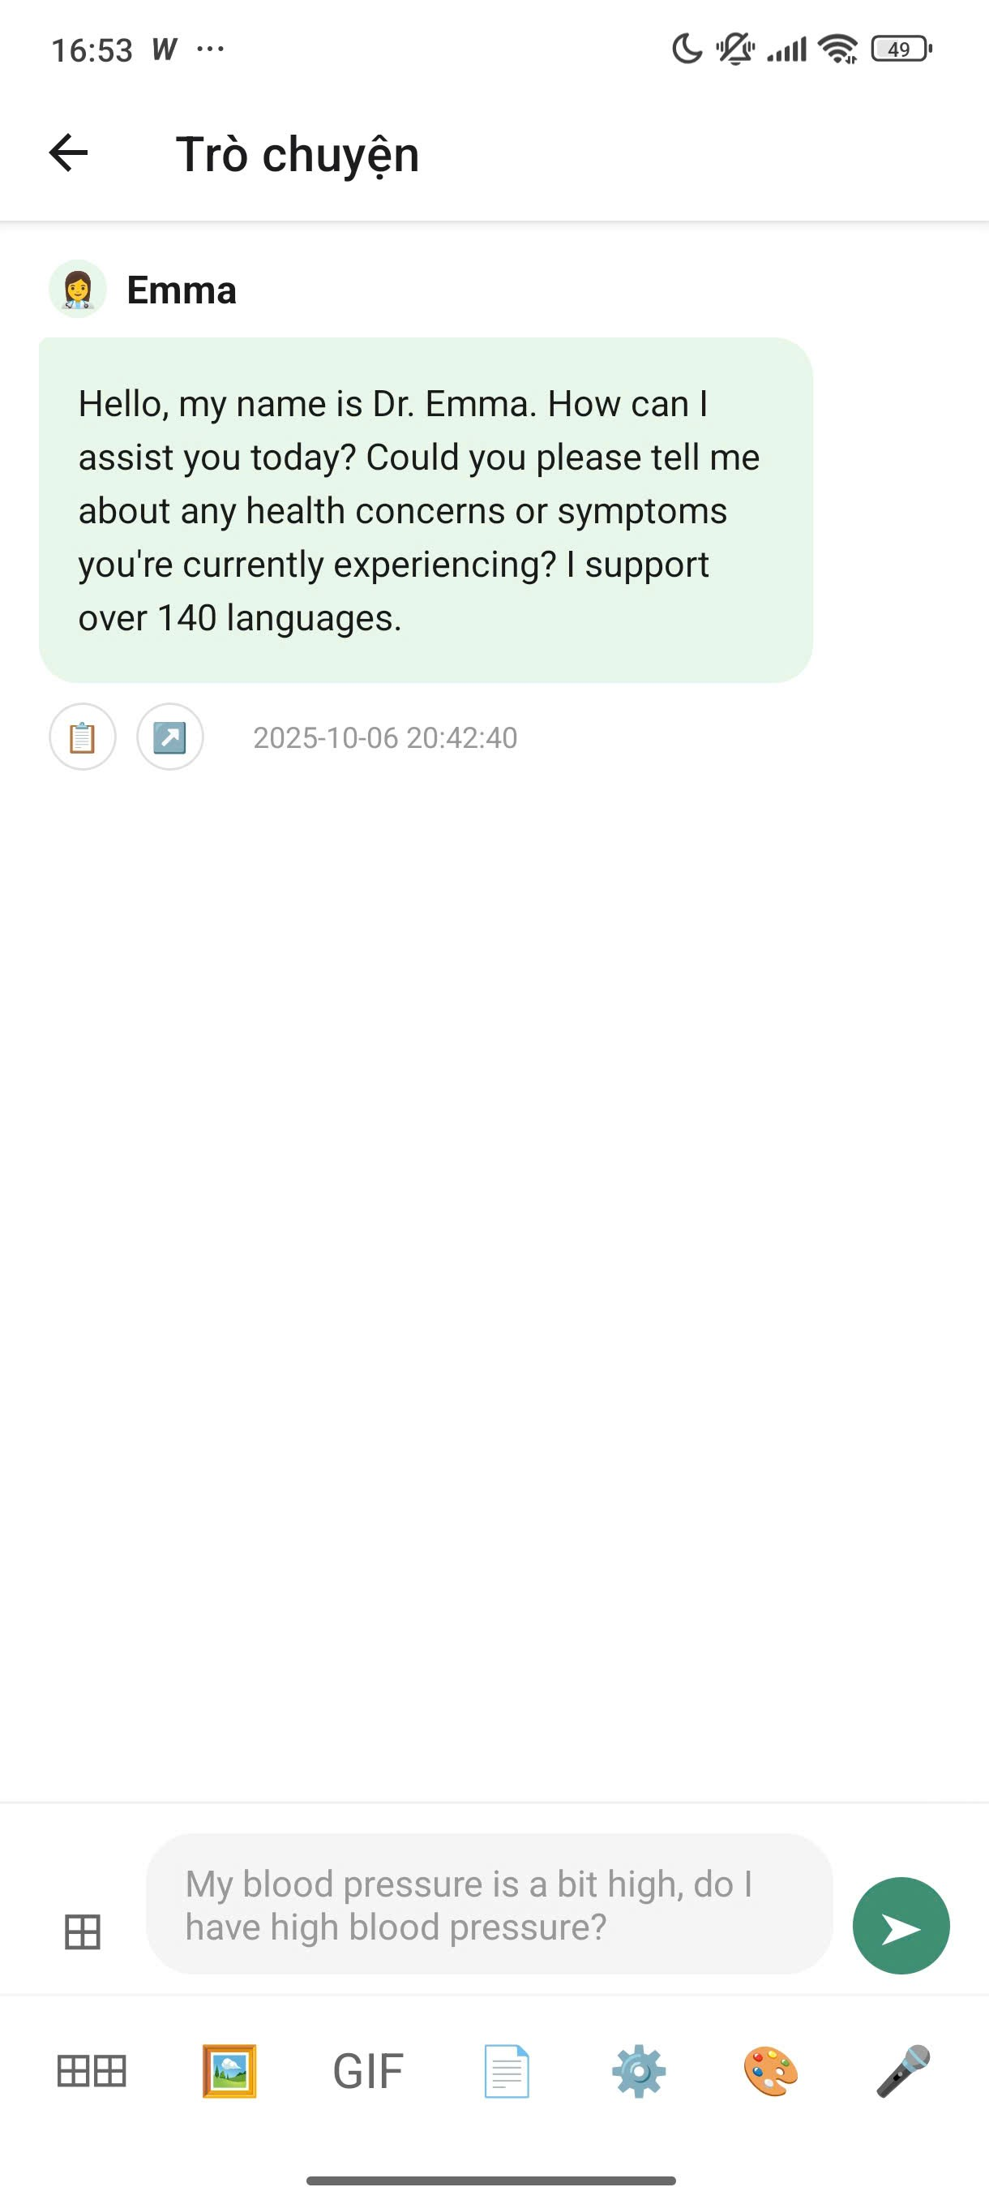
Chat Screen
No. | Field Name | Type | Require | Target
1 | Page Header | Heading | Title: “Chat” | Identifies the screen as the direct chat and consultation interface.
2 | Back Button | Icon Button | Icon: Back arrow | Navigates the user back to the previous screen (AI Doctor Support screen).
3 | AI Doctor Message | Chat Bubble (Received) | Sender: “Emma”; Content: “Hello, my name is Dr. Emma.....”; Timestamp: 2025-10-06 20:42:40 | Displays the initial greeting and consultation prompt from the AI Doctor.
4 | Message Options | Icons / Buttons | Icons: Copy, Gallery (Image) | Allows the user to copy message content or open the image gallery related to the conversation.
5 | Input Field | Text Input | Placeholder: “My blood pressure is a bit high do I have high blood pressure?” | Allows the user to type a message or health-related question.
6 | Send Button | Button | Icon: Paper plane | Sends the typed message to the AI Doctor for processing.
7 | Keyboard Options | Icons / Buttons | Icons: Keyboard switch, Gallery, GIF, Document, Settings, Emoji / Sticker | Provides extended input options such as media, documents, emojis, and keyboard settings.

2.11. Health Tracking
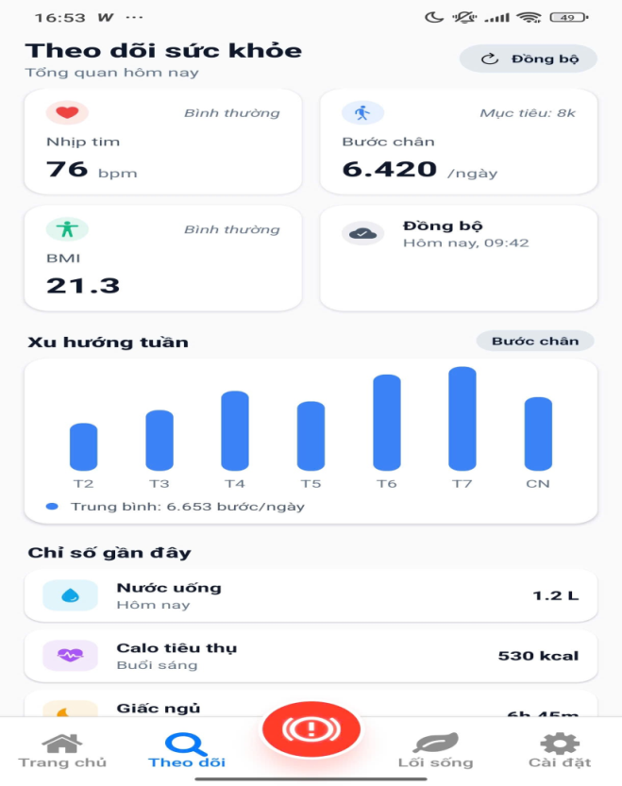

 |  |  | Heath Tracking
No. | Field Name | Type | Require | Target
1 | Page Header | Heading | Title: “Health Tracking” | Identifies the screen as the health metrics overview dashboard.
2 | Sync Button | Icon Button | Text: “Sync”; Icon: Refresh / Sync | Allows the user to manually synchronize the latest health data from connected devices.
3 | Summary Header | Text | Text: “Today’s Overview” | Serves as the title for the section displaying key health metrics for the current day.
4 | Heart Rate Card | Metric Card | Title: “Heart Rate”; Status: Normal; Value: 76 bpm | Displays the current heart rate along with its health status classification.
5 | Steps Card | Metric Card | Title: “Steps”; Goal: 8,000 steps; Value: 6,420 / day | Displays the number of steps achieved compared to the daily goal.
6 | BMI Card | Metric Card | Title: “BMI”; Status: Normal; Value: 21.3 | Displays the current BMI value and its classification status.
7 | Last Sync Status | Card | Title: “Sync”; Details: “Today, 09:42” | Displays the timestamp of the most recent health data synchronization.
8 | Weekly Trend Header | Section Heading | Text: “Weekly Trend” | Identifies the section that visualizes health data trends for the week.
9 | Weekly Trend Chart | Bar Chart | Data: Steps (Mon–Sun); Average: 6,653 steps/day | Visualizes the weekly trend of the selected health metric (default: steps).
10 | Chart Filter Button | Button | Text: “Steps” | Allows the user to switch the metric displayed in the weekly trend chart (e.g., Steps, Heart Rate).
11 | Recent Metrics Header | Section Heading | Text: “Recent Metrics” | Serves as the title for the section displaying additional health data.
12 | Water Intake Card | List Item / Card | Title: “Water Intake”; Details: “Today”; Value: 1.2 L | Displays the total water intake recorded for the current day.
13 | Calorie Consumption Card | List Item / Card | Title: “Calories Consumed”; Details: “Morning”; Value: 530 kcal | Displays calorie consumption for a specific time period.
14 | Sleep Card | List Item / Card | Title: “Sleep”; Value: 6h 45m | Displays sleep duration or sleep quality information.
15 | Bottom Navigation Bar | Navigation | Tabs: Home, Tracking, FAB (AI Doctor), Lifestyle, Settings | Provides the main navigation structure of the application.

2.12. Blood Sugar
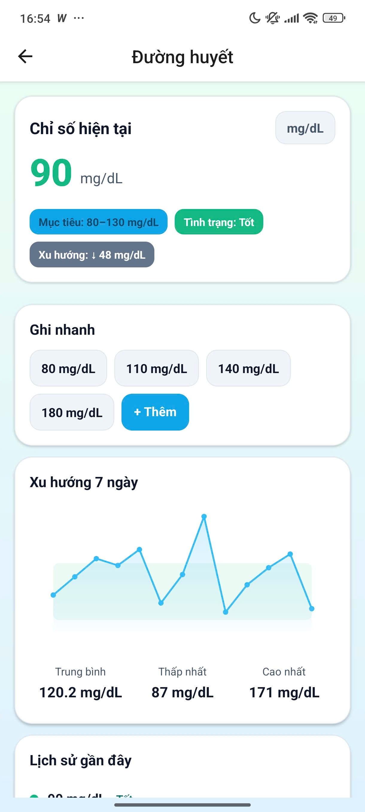
Blood Sugar
No. | Field Name | Type | Require | Target
1 | Page Header | Heading | Title: “Blood Sugar” | Identifies the screen dedicated to tracking blood sugar metrics.
2 | Current Metric Section | Card | Title: “Current Metric” | Displays the most recent blood sugar measurement result.
3 | Current Value | Large Text | Value: 90 mg/dL | Shows the latest recorded blood sugar reading.
4 | Measurement Unit | Text / Badge | Unit: mg/dL | Indicates the unit of measurement for blood sugar values.
5 | Target Range | Badge | Text: “Target: 80–130 mg/dL” | Displays the user’s target blood sugar range.
6 | Status | Badge | Text: “Status: Good” | Evaluates the current blood sugar level relative to the target range.
7 | Trend | Badge | Text: “Trend: +48 mg/dL” | Indicates the change compared to the previous measurement cycle.
8 | Quick Record Section | Card | Title: “Quick Record” | Allows quick entry of commonly used blood sugar values.
9 | Quick Value Button 1 | Button | Value: 80 mg/dL | Quickly logs a blood sugar value of 80 mg/dL.
10 | Quick Value Button 2 | Button | Value: 110 mg/dL | Quickly logs a blood sugar value of 110 mg/dL.
11 | Quick Value Button 3 | Button | Value: 140 mg/dL | Quickly logs a blood sugar value of 140 mg/dL.
12 | Quick Value Button 4 | Button | Value: 180 mg/dL | Quickly logs a blood sugar value of 180 mg/dL.
13 | Add Button | Button | Text: “+ Add” | Opens the detailed or custom blood sugar data entry interface.
14 | 7-Day Trend Section | Card | Title: “7-Day Trend” | Displays charts and statistics summarizing the last 7 days.
15 | Trend Line Chart | Line Chart | — | Visualizes blood sugar fluctuations over the past 7 days.
16 | Average Value | Metric | Text: “Average”; Value: 120.2 mg/dL | Displays the average blood sugar level over 7 days.
17 | Lowest Value | Metric | Text: “Lowest”; Value: 87 mg/dL | Displays the lowest blood sugar value recorded over 7 days.
18 | Highest Value | Metric | Text: “Highest”; Value: 171 mg/dL | Displays the highest blood sugar value recorded over 7 days.
19 | Recent History Header | Section Heading | Title: “Recent History” | Identifies the section displaying the most recent detailed blood sugar records.

2.13. Blood Pressure

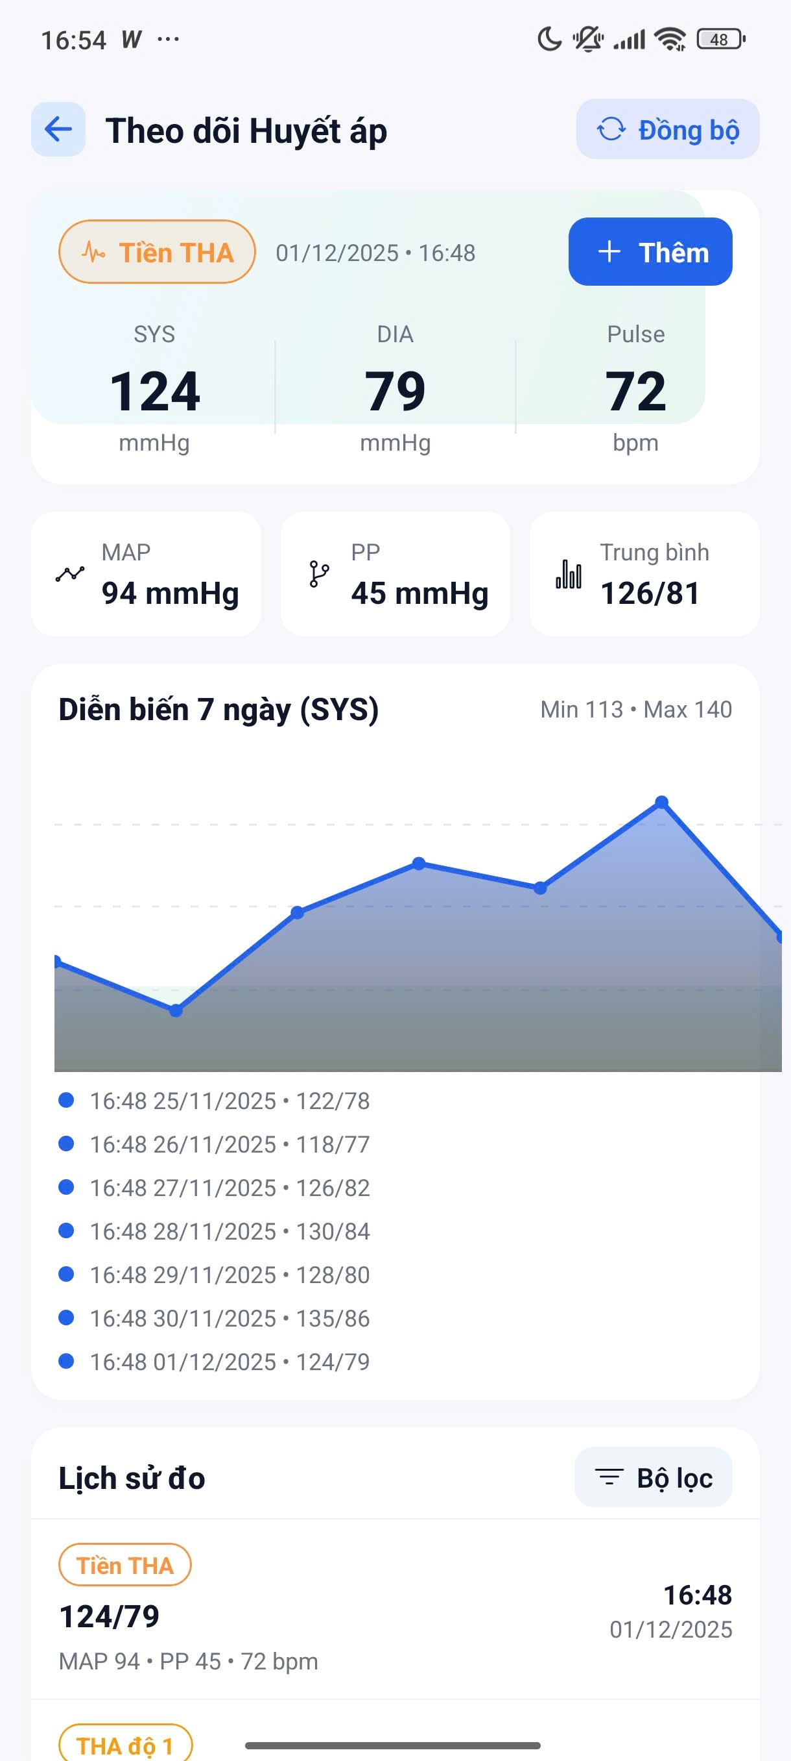
Blood Pressure
No. | Field Name | Type | Require | Target
1 | Page Header | Heading | Title: “Blood Pressure Tracking” | Identifies the screen dedicated to monitoring blood pressure metrics.
2 | Back Button | Icon Button | Icon: Back arrow | Navigates the user back to the previous screen.
3 | Sync Button | Icon Button | Text: “Sync”; Icon: Refresh / Sync | Synchronizes the latest blood pressure data from connected devices.
4 | Latest Record Time | Text / Icon | Icon: Pulse; Text: 01/12/2025 • 16:48 | Displays the timestamp of the most recent blood pressure record.
5 | Add Button | Button | Text: “+ Add”; Background color: Blue | Opens the interface for manual entry of a new blood pressure record.
6 | Latest SYS Value | Metric Card | Title: “SYS (Systolic)”; Value: 124 mmHg | Displays the most recent systolic blood pressure value.
7 | Latest DIA Value | Metric Card | Title: “DIA (Diastolic)”; Value: 79 mmHg | Displays the most recent diastolic blood pressure value.
8 | Latest Pulse Value | Metric Card | Title: “Pulse”; Value: 72 bpm | Displays the latest heart rate (pulse) value.
9 | MAP Value | Metric Card | Title: “MAP (Mean Arterial Pressure)”; Value: 94 mmHg | Displays the calculated mean arterial pressure value.
10 | PP Value | Metric Card | Title: “PP (Pulse Pressure)”; Value: 45 mmHg | Displays the pulse pressure derived from SYS and DIA values.
11 | Average Value | Metric Card | Title: “Average”; Value: 126 / 81 | Displays the average blood pressure values over a defined period.
12 | 7-Day Trend Header | Section Heading | Text: “7-Day Trend (SYS)” | Identifies the chart section showing 7-day systolic blood pressure trends.
13 | Trend Range | Text | Min: 113; Max: 140 | Displays the minimum and maximum systolic values in the 7-day range.
14 | Trend Line Chart | Line Chart | — | Visualizes systolic blood pressure (SYS) changes over the last 7 days.
15 | Chart Data Points | List / Labels | Date/Time and values (e.g., 16:48 01/12/2025 • 124/79) | Displays detailed data points used to generate the trend chart.
16 | History Header | Section Heading | Title: “Measurement History” | Identifies the section listing detailed blood pressure records.
17 | Filter Button | Button | Text: “Filter”; Icon: Filter | Opens filtering and sorting options for the measurement history.
18 | Latest History Item | List Item | Value: 124/79; Details: MAP 94 • PP 45 • 72 bpm; Status: Hypertension Grade 1; Time: 16:48 01/12/2025 | Displays the most recent detailed blood pressure measurement record.

2.14. Login / Dashboard
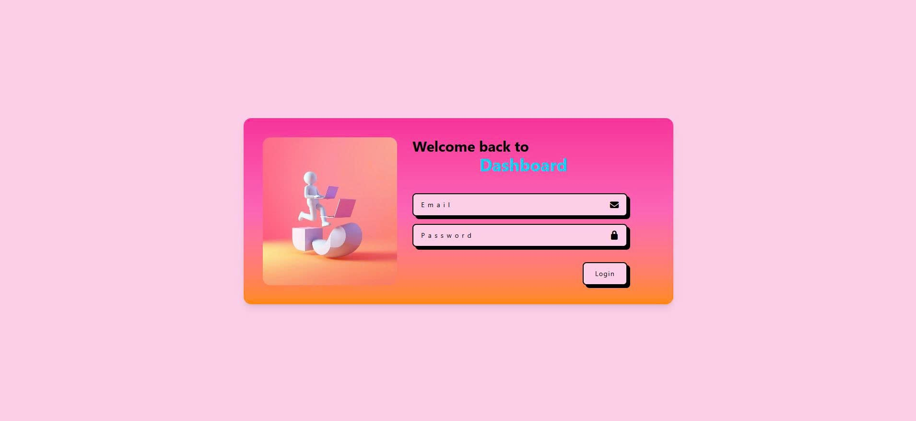
 | Login/Dashboard
No. | Field name | Type | Require | Target
1 | Page Container | Layout / Card | Gradient background (Pink → Orange) | Main container holding the login interface.
2 | Illustration Section | Image / Card | 3D illustration image | Visual representation to enhance user experience and engagement.
3 | Welcome Text | Heading | Text: "Welcome back to" | Greets the user returning to the system.
4 | Page Title | Heading | Text: "Dashboard" | Identifies the destination after successful login.
5 | Login Form Section | Form | Email + Password fields | Area where users enter their authentication information.
6 | Email Input | Input (Text) | Placeholder: "Email" | Allows the user to enter their registered email address.
7 | Email Icon | Icon | Envelope icon | Visual cue indicating email input field.
8 | Password Input | Input (Password) | Placeholder: "Password" | Allows the user to enter their password securely.
9 | Password Icon | Icon | Lock icon | Visual cue indicating password input field.
10 | Login Button | Button | Text: "Login" | Submits login credentials for authentication.
11 | Button Style | UI Style | Rounded, bordered | Enhances button visibility and usability.
12 | Card Shadow | UI Effect | Box-shadow enabled | Creates depth and separates the card from background.
13 | Color Theme | UI Style | Pink–Orange gradient | Provides a modern and friendly visual appearance.
14 | Typography | UI Style | Bold title, normal inputs | Improves readability and visual hierarchy.
15 | Responsive Layout | Layout | Center aligned | Ensures proper display across different screen sizes.

2.15. Eldercare Admin – Dashboard
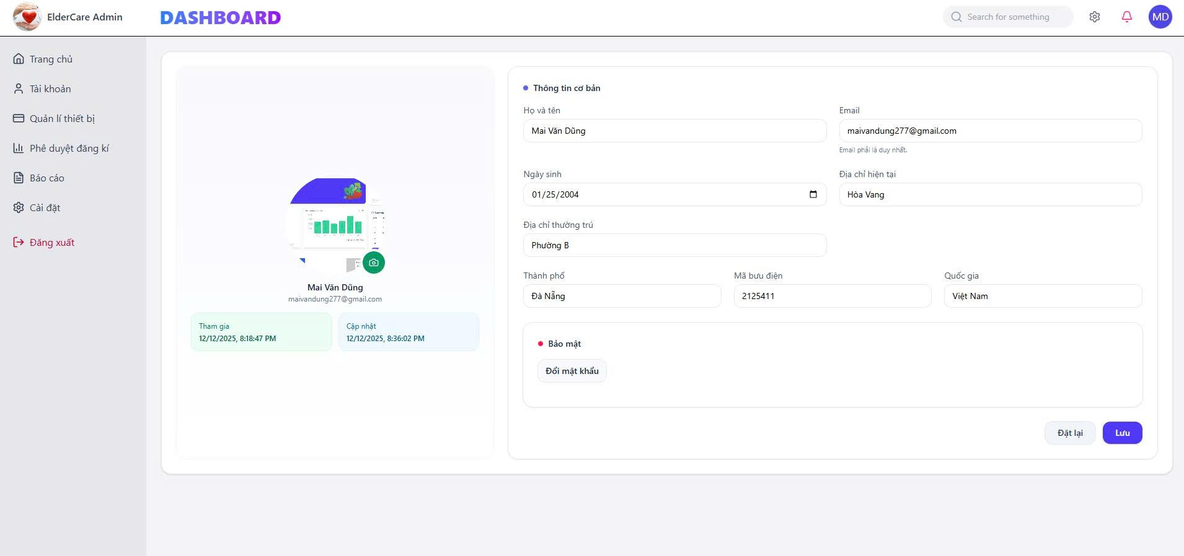
Eldercare Admin
No. | Field Name | Type | Require | Target
1 | Top Navigation Bar | Header | Logo + Title + Search + Icons | Provides global navigation and quick access actions across the system.
2 | System Logo | Image | Text: ElderCare Admin | Identifies the system branding.
3 | Page Title | Heading | Text: “DASHBOARD” | Indicates the currently active system page.
4 | Search Bar | Input (Search) | Placeholder: “Search for something” | Allows quick searching within the admin system.
5 | Notification Icon | Icon | Bell icon | Displays system notifications and alerts.
6 | Settings Icon | Icon | Gear icon | Navigates to system configuration settings.
7 | User Avatar | Avatar | Initials / Profile image | Represents the currently logged-in admin user.
8 | Sidebar Navigation | Sidebar | Vertical menu | Enables navigation between main administrative modules.
9 | Home Menu Item | Menu Item | Text: “Trang chủ” | Navigates to the main admin dashboard.
10 | Account Menu Item | Menu Item | Text: “Tài khoản” | Opens user account and profile management screen.
11 | Device Management Menu | Menu Item | Text: “Quản lí thiết bị” | Manages connected elderly care devices.
12 | Registration Approval Menu | Menu Item | Text: “Phê duyệt đăng kí” | Handles approval of new user registration requests.
13 | Reports Menu | Menu Item | Text: “Báo cáo” | Displays system usage and health-related reports.
14 | Settings Menu | Menu Item | Text: “Cài đặt” | Configures system-level preferences.
15 | Logout Button | Action Button | Text: “Đăng xuất” | Logs the admin out of the system securely.
16 | Profile Card | Card | Avatar + Name + Email | Displays a summary of the admin user’s profile.
17 | Profile Avatar | Image / Avatar | Editable | Displays profile image with option to update.
18 | User Full Name | Text | Example: “Mai Văn Dũng” | Displays the administrator’s full name.
19 | User Email | Text | Unique email address | Displays the registered email address.
20 | Join Date | Info Badge | Date & Time | Indicates when the user joined the system.
21 | Last Updated Time | Info Badge | Date & Time | Displays the last profile update timestamp.
22 | Basic Information Section | Form Section | Title: “Thông tin cơ bản” | Groups editable personal information fields.
23 | Full Name Input | Input (Text) | Required | Allows updating the user’s full name.
24 | Email Input | Input (Email) | Required – Unique | Allows updating the email address (must be unique).
25 | Date of Birth | Input (Date) | Required | Stores the user’s date of birth.
26 | Current Address | Input (Text) | Optional | Stores the user’s current address.
27 | Permanent Address | Input (Text) | Optional | Stores the user’s permanent residence address.
28 | City | Input (Text) | Required | Stores city information.
29 | Postal Code | Input (Text / Number) | Optional | Stores postal or ZIP code.
30 | Country | Input (Text) | Required | Stores country of residence.
31 | Security Section | Section | Title: “Bảo mật” | Groups account security–related actions.
32 | Change Password Button | Button | Text: “Đổi mật khẩu” | Allows the user to change the account password.
33 | Reset Button | Button | Text: “Đặt lại” | Resets all form fields to their previous values.
34 | Save Button | Button | Text: “Lưu” | Saves updated profile and account information.
35 | Card Layout Style | UI Style | Rounded corners + Shadow | Enhances readability and provides a modern UI appearance.
36 | Responsive Layout | Layout | Desktop-first | Ensures usability across different screen sizes.

2.16. Analysis Report
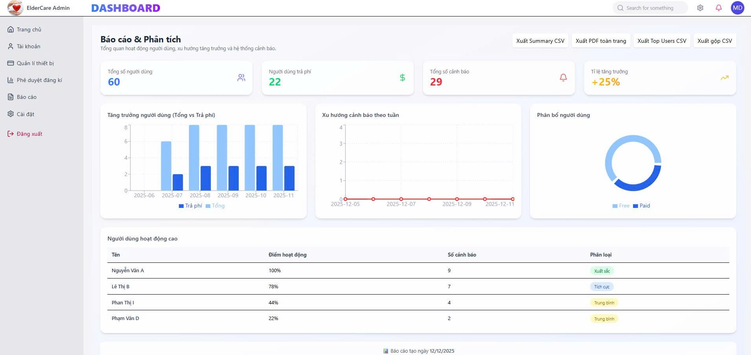
Analysis Report
No. | Field name | Type | Require | Target
1 | Page Title | Heading | Text: “Báo cáo & Phân tích” | Identifies the analytics and reporting dashboard.
2 | Page Description | Text | Overview description | Summarizes user activity, growth trends, and alert system status.
3 | Export Summary CSV Button | Button | Text: “Xuất Summary CSV” | Allows exporting summary analytics data in CSV format.
4 | Export Full PDF Button | Button | Text: “Xuất PDF toàn trang” | Exports the entire dashboard as a PDF report.
5 | Export Top Users CSV Button | Button | Text: “Xuất Top Users CSV” | Exports top active users data in CSV format.
6 | Export Combined CSV Button | Button | Text: “Xuất gộp CSV” | Exports combined analytics data into one CSV file.
7 | Total Users Card | Statistic Card | Value: 60 | Displays the total number of users in the system.
8 | Paid Users Card | Statistic Card | Value: 22 | Shows the number of paid users.
9 | Total Alerts Card | Statistic Card | Value: 29 | Displays the total number of alerts generated.
10 | Growth Rate Card | Statistic Card | Value: +25% | Indicates the system growth rate over time.
11 | User Growth Chart | Bar Chart | Total vs Paid users | Visualizes user growth comparison over time.
12 | Chart Legend | Legend | “Tổng”, “Trả phí” | Explains data categories in the growth chart.
13 | Alert Trend Chart | Line Chart | Weekly alert data | Shows the trend of alerts by week.
14 | Chart Timeline | Axis | Date-based | Displays time progression for charts.
15 | User Distribution Chart | Doughnut Chart | Free vs Paid | Visualizes the distribution of free and paid users.
16 | Distribution Legend | Legend | Free / Paid | Explains user segmentation.
17 | High Activity Users Section | Table Section | Title: “Người dùng hoạt động cao” | Lists users with the highest activity levels.
18 | User Name Column | Table Column | Text | Displays the user’s full name.
19 | Activity Score Column | Table Column | Percentage (%) | Indicates user activity level.
20 | Alert Count Column | Table Column | Number | Shows how many alerts the user generated.
21 | Classification Column | Table Column | Badge | Classifies user activity level.
22 | Classification Badge – Excellent | Badge | Text: “Xuất sắc” | Indicates excellent user activity.
23 | Classification Badge – Positive | Badge | Text: “Tích cực” | Indicates positive user activity.
24 | Classification Badge – Average | Badge | Text: “Trung bình” | Indicates average user activity.
25 | Table Row | Table Row | Multiple users | Displays detailed analytics per user.
26 | Report Date Footer | Text | Date format | Shows the date the report was generated.
27 | Card Layout Style | UI Style | Rounded + Shadow | Improves visual clarity and separation.
28 | Color Coding | UI Style | Green / Blue / Red / Yellow | Enhances data interpretation through color meaning.
29 | Responsive Layout | Layout | Dashboard grid | Ensures proper display on different screen sizes.
30 | Data Visualization Library | Chart Component | Bar / Line / Doughnut | Supports visual analytics representation.

2.17. UI Specification
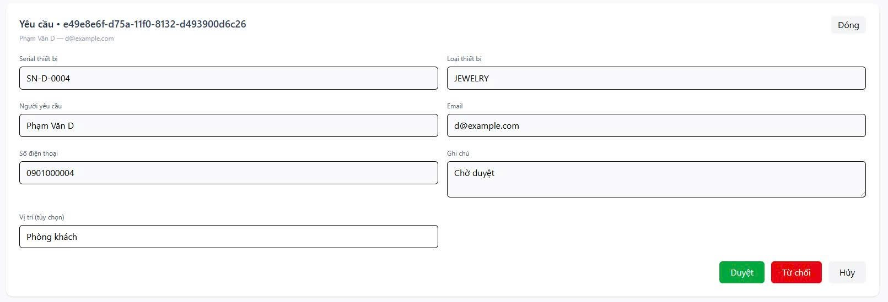
UI Specification
No. | Field name | Type | Require | Target
1 | Request Header | Header | Text: “Yêu cầu – {Request ID}” | Identifies the device registration request with a unique ID.
2 | Request ID | Text | UUID format | Unique identifier for tracking the request.
3 | Requester Info | Text | Name + Email | Displays requester’s basic identification.
4 | Close Button | Button | Text: “Đóng” | Closes the request detail view.
5 | Device Serial Number | Input (Read-only) | Example: SN-D-0004 | Displays the serial number of the requested device.
6 | Device Type | Input (Read-only) | Example: JEWELRY | Indicates the type/category of the device.
7 | Requester Name | Input (Read-only) | Example: Phạm Văn D | Shows the name of the user who submitted the request.
8 | Email | Input (Read-only) | Example: d@example.com | Displays the requester’s email address.
9 | Phone Number | Input (Read-only) | Example: 0901000004 | Shows the requester’s contact phone number.
10 | Note | Textarea (Read-only) | Text: “Chờ duyệt” | Displays the current status or note of the request.
11 | Location (Optional) | Input (Read-only) | Example: Phòng khách | Indicates the intended device location (if provided).
12 | Approval Button | Action Button | Text: “Duyệt” | Approves the device registration request.
13 | Reject Button | Action Button | Text: “Từ chối” | Rejects the request with administrative decision.
14 | Cancel Button | Action Button | Text: “Hủy” | Cancels the current approval action.
15 | Button Color – Approve | UI Style | Green | Indicates positive confirmation action.
16 | Button Color – Reject | UI Style | Red | Indicates denial or negative action.
17 | Form Layout | Layout | Two-column form | Organizes information clearly and efficiently.
18 | Read-only Fields | Field State | Disabled | Prevents editing of request data by admin.
19 | Status Handling | Logic | Pending / Approved / Rejected | Manages the lifecycle of the request.
20 | Validation | System Rule | Required fields present | Ensures request data completeness before action.
21 | Confirmation Action | System Action | Popup / Toast | Confirms approval or rejection result.
22 | Audit Log | Backend Logic | Admin action recorded | Logs admin decisions for traceability.
23 | Security Constraint | Access Control | Admin only | Restricts access to authorized administrators.
24 | Responsive Layout | Layout | Desktop-first | Ensures consistent UI on different screen sizes.

2.18. Approve device registration
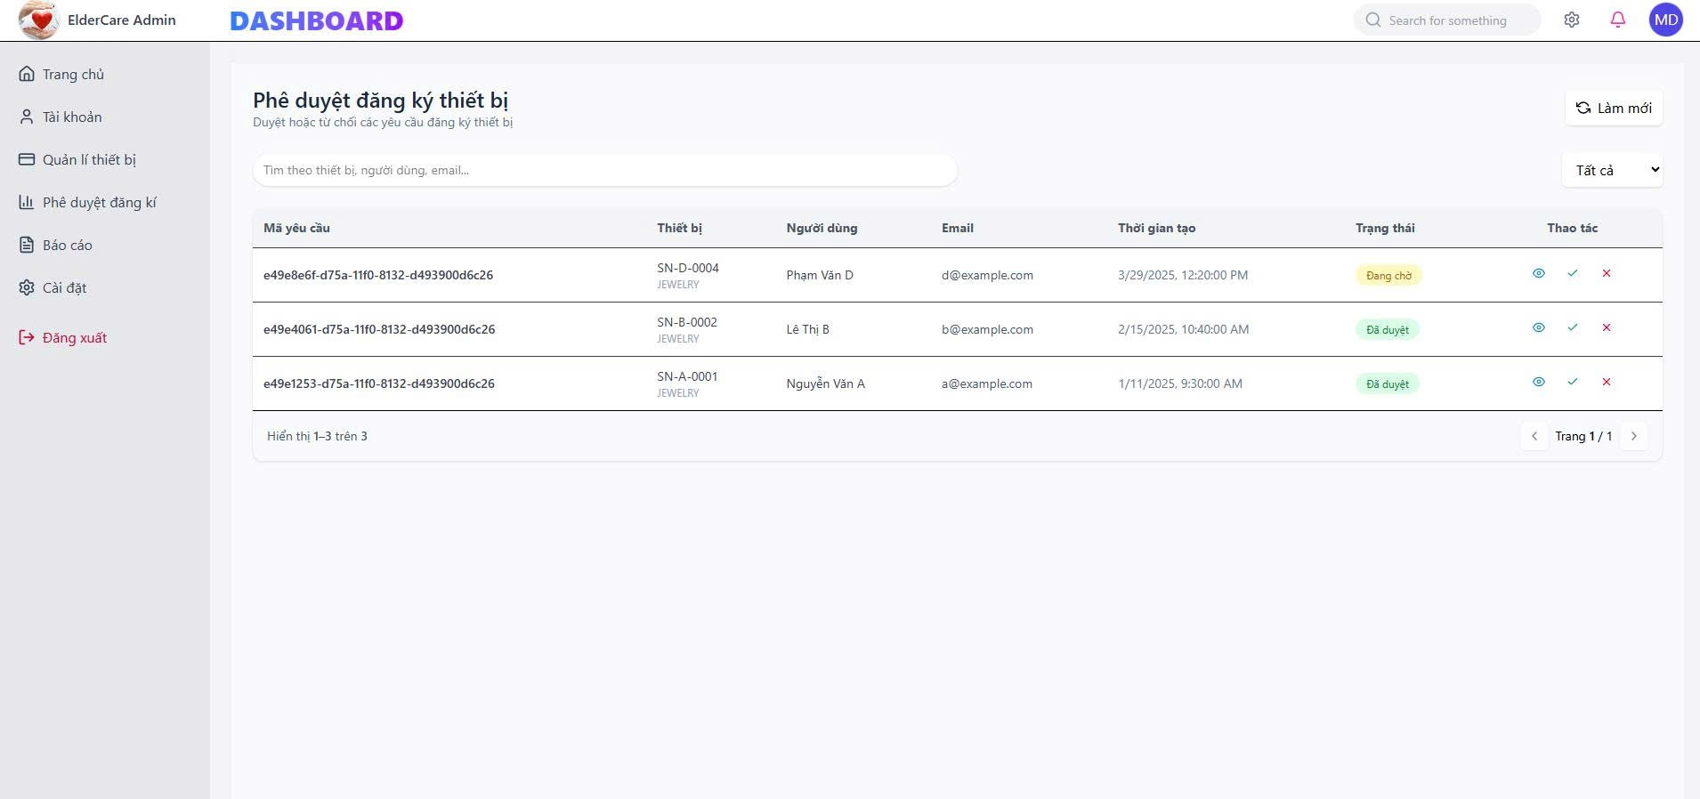
Approve device registration
No. | Field name | Type | Require | Target
1 | Page Title | Heading | Text: “Phê duyệt đăng ký thiết bị” | Identifies the device registration approval management screen.
2 | Page Description | Text | Instruction text | Explains the purpose of approving or rejecting device registration requests.
3 | Refresh Button | Button | Text: “Làm mới” | Reloads and refreshes the request list data.
4 | Search Bar | Input (Search) | Placeholder: “Tìm theo thiết bị, người dùng, email…” | Allows searching requests by device, user name, or email.
5 | Status Filter | Dropdown | Default: “Tất cả” | Filters requests by status (All / Pending / Approved / Rejected).
6 | Request Table | Data Table | Multiple rows | Displays all device registration requests.
7 | Request ID Column | Table Column | UUID | Displays the unique request identifier.
8 | Device Column | Table Column | Serial + Type | Shows device serial number and device type.
9 | User Column | Table Column | Full name | Displays the requesting user’s name.
10 | Email Column | Table Column | Email | Displays the requester’s email address.
11 | Created Time Column | Table Column | Date & Time | Shows when the request was created.
12 | Status Column | Table Column | Badge | Indicates the current request status.
13 | Status Badge – Pending | Badge | Text: “Đang chờ” | Indicates request is waiting for approval.
14 | Status Badge – Approved | Badge | Text: “Đã duyệt” | Indicates request has been approved.
15 | Action Column | Table Column | Action Icons | Contains available actions for each request.
16 | View Detail Action | Icon Button | Eye icon | Opens detailed view of the request.
17 | Approve Action | Icon Button | Check icon | Approves the device registration request.
18 | Reject Action | Icon Button | Cross icon | Rejects the device registration request.
19 | Pagination Info | Text | “Hiển thị 1–3 trên 3” | Displays current result range and total items.
20 | Pagination Control | Pagination | Page navigation | Allows navigation between pages of requests.
21 | Table Row Highlight | UI Style | Hover effect | Improves readability and user interaction.
22 | Badge Color – Pending | UI Style | Yellow | Visual indication for pending status.
23 | Badge Color – Approved | UI Style | Green | Visual indication for approved status.
24 | Confirmation Handling | System Logic | Modal / Toast | Confirms approve or reject actions.
25 | Access Control | Security Rule | Admin only | Restricts access to authorized administrators.
26 | Audit Logging | Backend Logic | Action recorded | Records approval/rejection actions for traceability.
27 | Responsive Layout | Layout | Table responsive | Ensures usability on different screen sizes.

2.19. Device details
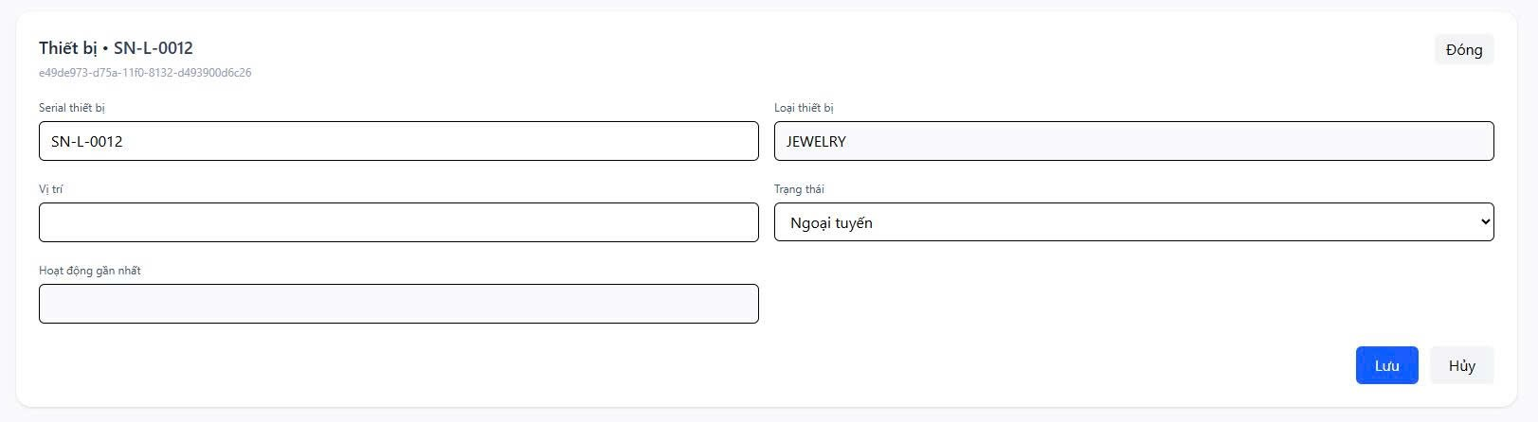
Device details
No. | Field name | Type | Require | Target
1 | Page Header | Header | Text: “Thiết bị – {Serial Number}” | Identifies the device detail screen with its serial number.
2 | Device ID | Text | UUID | Unique internal identifier of the device.
3 | Close Button | Button | Text: “Đóng” | Closes the device detail view.
4 | Device Serial Number | Input (Read-only) | Example: SN-L-0012 | Displays the unique serial number of the device.
5 | Device Type | Input (Read-only) | Example: JEWELRY | Indicates the category/type of the device.
6 | Location | Input (Text) | Optional | Allows entering or updating the device location.
7 | Device Status | Dropdown | Values: Online / Offline | Displays and updates the current device status.
8 | Status Value – Offline | Dropdown Option | Text: “Ngoại tuyến” | Indicates the device is currently offline.
9 | Last Activity | Input (Read-only) | Date & Time | Displays the most recent activity time of the device.
10 | Save Button | Primary Button | Text: “Lưu” | Saves any changes made to the device information.
11 | Cancel Button | Secondary Button | Text: “Hủy” | Cancels changes and restores previous values.
12 | Form Layout | Layout | Two-column layout | Organizes device information clearly.
13 | Editable Fields | Field State | Location, Status | Specifies which fields can be edited.
14 | Read-only Fields | Field State | Serial, Type, Activity | Prevents modification of critical device data.
15 | Validation Rule | System Rule | Required format | Ensures valid data before saving changes.
16 | Update Confirmation | System Action | Toast / Notification | Confirms successful update of device information.
17 | Error Handling | System Action | Validation message | Displays errors if update fails.
18 | Audit Logging | Backend Logic | Update recorded | Logs device updates for traceability.
19 | Access Control | Security Rule | Admin only | Restricts access to authorized administrators.
20 | Responsive Design | Layout | Desktop-first | Ensures usability across different screen sizes.

2.20. Device management
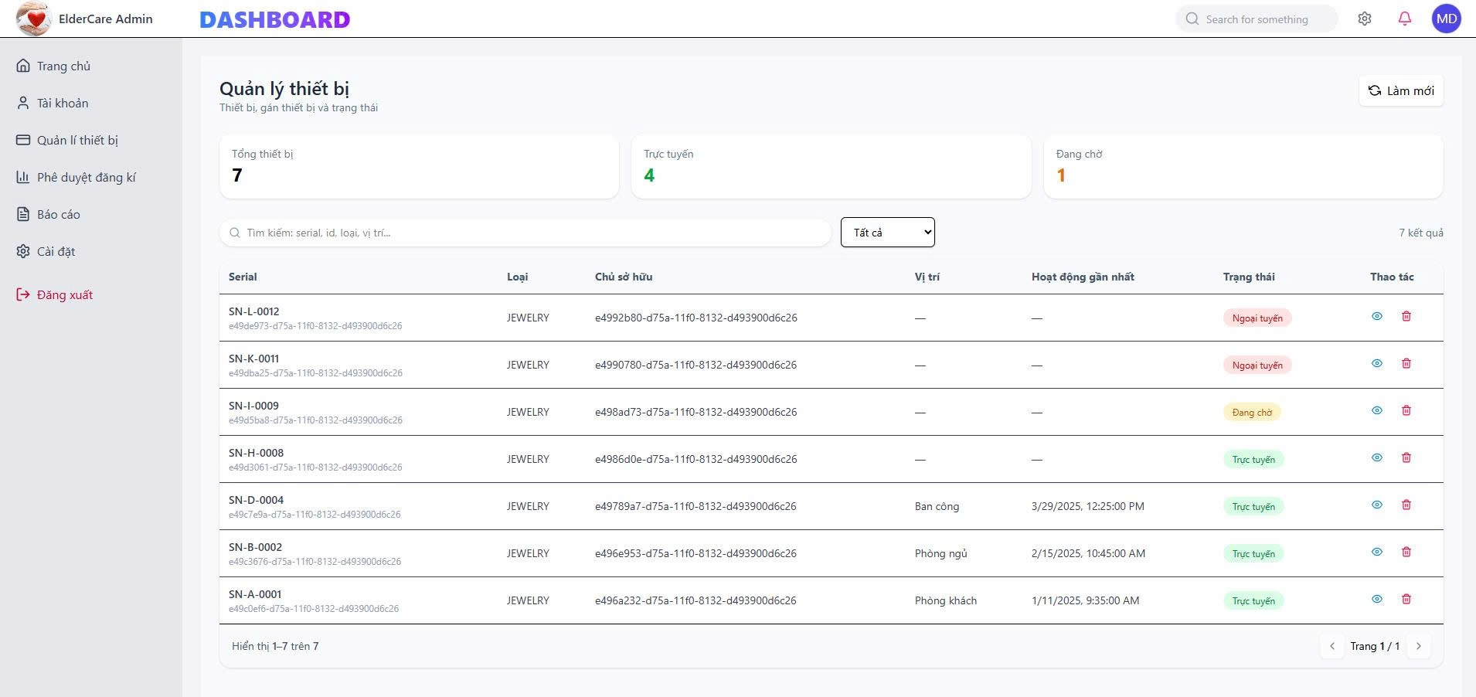
Device management
No. | Field name | Type | Require | Target
1 | Page Title | Heading | Text: “Quản lý thiết bị” | Identifies the device management screen.
2 | Page Description | Text | Instruction text | Describes device list, assignment, and status management.
3 | Refresh Button | Button | Text: “Làm mới” | Reloads the device list and statistics.
4 | Total Devices Card | Statistic Card | Value: 7 | Displays total number of devices in the system.
5 | Online Devices Card | Statistic Card | Value: 4 | Shows number of devices currently online.
6 | Pending Devices Card | Statistic Card | Value: 1 | Shows number of devices pending approval or activation.
7 | Search Bar | Input (Search) | Placeholder: “Tìm kiếm: serial, id, loại, vị trí…” | Allows searching devices by serial, ID, type, or location.
8 | Status Filter | Dropdown | Default: “Tất cả” | Filters devices by status (All / Online / Offline / Pending).
9 | Result Count | Text | Example: “7 kết quả” | Displays the number of matching devices.
10 | Device Table | Data Table | Multiple rows | Displays the list of devices.
11 | Serial Column | Table Column | Serial + Device ID | Displays the device serial number and internal ID.
12 | Device Type Column | Table Column | Example: JEWELRY | Indicates the type/category of the device.
13 | Owner Column | Table Column | User ID | Displays the owner (user) of the device.
14 | Location Column | Table Column | Text | Shows the assigned physical location of the device.
15 | Last Activity Column | Table Column | Date & Time | Displays the most recent activity timestamp.
16 | Status Column | Table Column | Badge | Shows current device status.
17 | Status Badge – Online | Badge | Text: “Trực tuyến” | Indicates the device is currently online.
18 | Status Badge – Offline | Badge | Text: “Ngoại tuyến” | Indicates the device is offline.
19 | Status Badge – Pending | Badge | Text: “Đang chờ” | Indicates the device is pending approval or setup.
20 | Action Column | Table Column | Icon buttons | Contains available actions for each device.
21 | View Detail Action | Icon Button | Eye icon | Opens device detail view.
22 | Delete Device Action | Icon Button | Trash icon | Removes the device from the system.
23 | Pagination Info | Text | “Hiển thị 1–7 trên 7” | Displays current result range and total items.
24 | Pagination Control | Pagination | Page navigation | Allows navigation between pages if applicable.
25 | Table Row Hover | UI Style | Hover effect | Improves readability and interaction.
26 | Color Coding | UI Style | Green / Red / Yellow | Enhances visual distinction of device statuses.
27 | Confirmation Dialog | System Logic | Modal | Confirms destructive actions such as deletion.
28 | Audit Logging | Backend Logic | Action recorded | Logs device changes for traceability.
29 | Access Control | Security Rule | Admin only | Restricts access to device management to admins.
30 | Responsive Layout | Layout | Dashboard grid | Ensures usability across different screen sizes.

2.21. User details
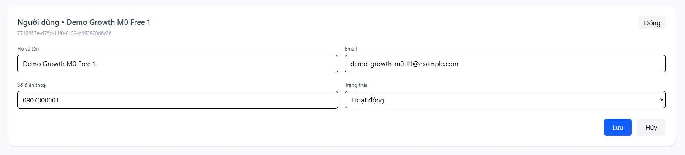
User details
No. | Field name | Type | Require | Target
1 | Page Header | Header | Text: “Người dùng – {User Name}” | Identifies the user detail screen with user name.
2 | User ID | Text | UUID | Unique internal identifier of the user.
3 | Close Button | Button | Text: “Đóng” | Closes the user detail view.
4 | Full Name | Input (Text) | Required | Displays and allows editing of the user’s full name.
5 | Email | Input (Email, Read-only) | Required – Unique | Displays the user’s registered email address.
6 | Phone Number | Input (Text) | Required | Displays and allows editing of the user’s phone number.
7 | User Status | Dropdown | Values: Active / Inactive | Displays and updates the user’s current status.
8 | Status Value – Active | Dropdown Option | Text: “Hoạt động” | Indicates the user account is active.
9 | Save Button | Primary Button | Text: “Lưu” | Saves changes made to user information.
10 | Cancel Button | Secondary Button | Text: “Hủy” | Cancels changes and restores previous values.
11 | Form Layout | Layout | Two-column layout | Organizes user information clearly and consistently.
12 | Editable Fields | Field State | Name, Phone, Status | Specifies which user attributes can be updated.
13 | Read-only Fields | Field State | Email, User ID | Prevents modification of critical user identifiers.
14 | Validation Rule | System Rule | Required fields, format check | Ensures valid input before saving changes.
15 | Update Confirmation | System Action | Toast / Notification | Confirms successful update of user information.
16 | Error Handling | System Action | Validation message | Displays errors if update fails.
17 | Audit Logging | Backend Logic | Update recorded | Logs user updates for traceability.
18 | Access Control | Security Rule | Admin only | Restricts access to user management functions.
19 | Data Privacy | Security Rule | Mask sensitive data | Ensures compliance with data protection policies.
20 | Responsive Layout | Layout | Desktop-first | Ensures usability across different screen sizes.

2.22. User management
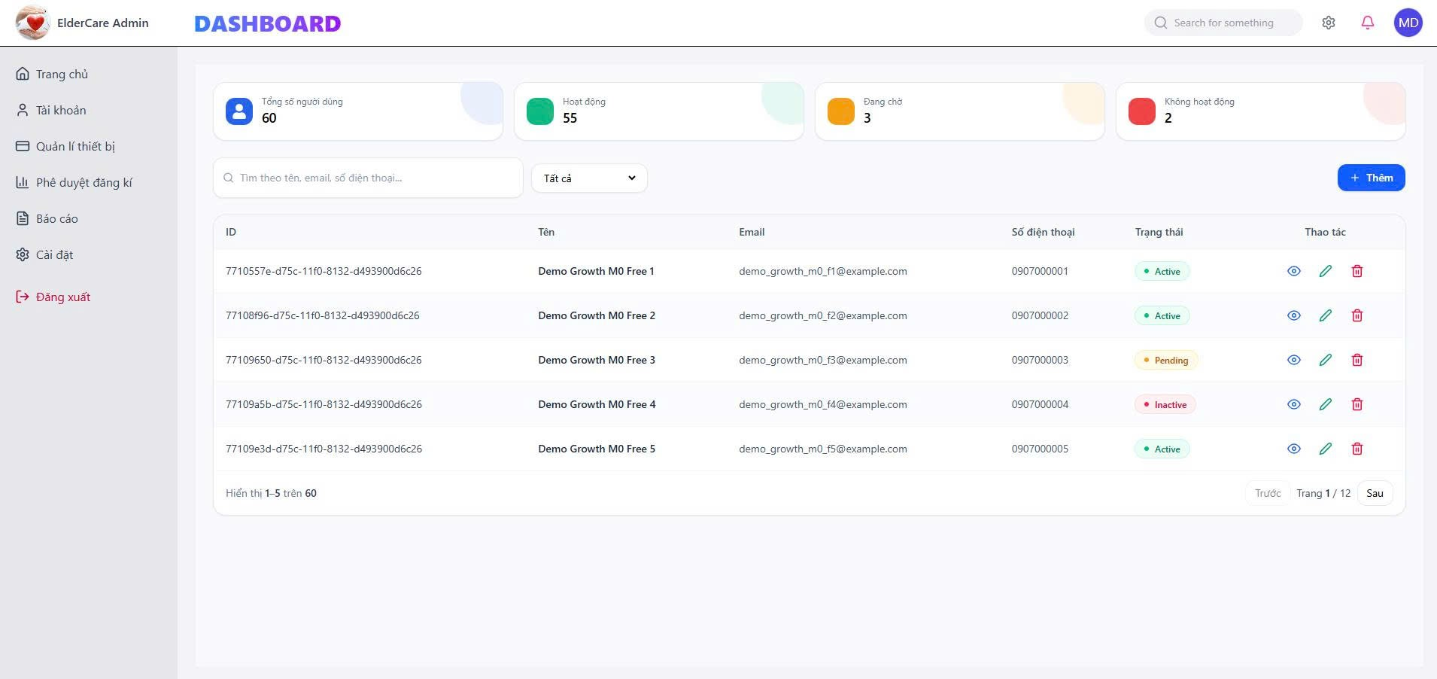
User management
No. | Field name | Type | Require | Target
1 | Page Title | Heading | Text: “Quản lý thiết bị” | Identifies the device management screen.
2 | Page Description | Text | Instruction text | Describes device list, assignment, and status management.
3 | Refresh Button | Button | Text: “Làm mới” | Reloads the device list and statistics.
4 | Total Devices Card | Statistic Card | Value: 7 | Displays total number of devices in the system.
5 | Online Devices Card | Statistic Card | Value: 4 | Shows number of devices currently online.
6 | Pending Devices Card | Statistic Card | Value: 1 | Shows number of devices pending approval or activation.
7 | Search Bar | Input (Search) | Placeholder: “Tìm kiếm: serial, id, loại, vị trí…” | Allows searching devices by serial, ID, type, or location.
8 | Status Filter | Dropdown | Default: “Tất cả” | Filters devices by status (All / Online / Offline / Pending).
9 | Result Count | Text | Example: “7 kết quả” | Displays the number of matching devices.
10 | Device Table | Data Table | Multiple rows | Displays the list of devices.
11 | Serial Column | Table Column | Serial + Device ID | Displays the device serial number and internal ID.
12 | Device Type Column | Table Column | Example: JEWELRY | Indicates the type/category of the device.
13 | Owner Column | Table Column | User ID | Displays the owner (user) of the device.
14 | Location Column | Table Column | Text | Shows the assigned physical location of the device.
15 | Last Activity Column | Table Column | Date & Time | Displays the most recent activity timestamp.
16 | Status Column | Table Column | Badge | Shows current device status.
17 | Status Badge – Online | Badge | Text: “Trực tuyến” | Indicates the device is currently online.
18 | Status Badge – Offline | Badge | Text: “Ngoại tuyến” | Indicates the device is offline.
19 | Status Badge – Pending | Badge | Text: “Đang chờ” | Indicates the device is pending approval or setup.
20 | Action Column | Table Column | Icon buttons | Contains available actions for each device.
21 | View Detail Action | Icon Button | Eye icon | Opens device detail view.
22 | Delete Device Action | Icon Button | Trash icon | Removes the device from the system.
23 | Pagination Info | Text | “Hiển thị 1–7 trên 7” | Displays current result range and total items.
24 | Pagination Control | Pagination | Page navigation | Allows navigation between pages if applicable.
25 | Table Row Hover | UI Style | Hover effect | Improves readability and interaction.
26 | Color Coding | UI Style | Green / Red / Yellow | Enhances visual distinction of device statuses.
27 | Confirmation Dialog | System Logic | Modal | Confirms destructive actions such as deletion.
28 | Audit Logging | Backend Logic | Action recorded | Logs device changes for traceability.
29 | Access Control | Security Rule | Admin only | Restricts access to device management to admins.
30 | Responsive Layout | Layout | Dashboard grid | Ensures usability across different screen sizes.

2.23. Dashboard
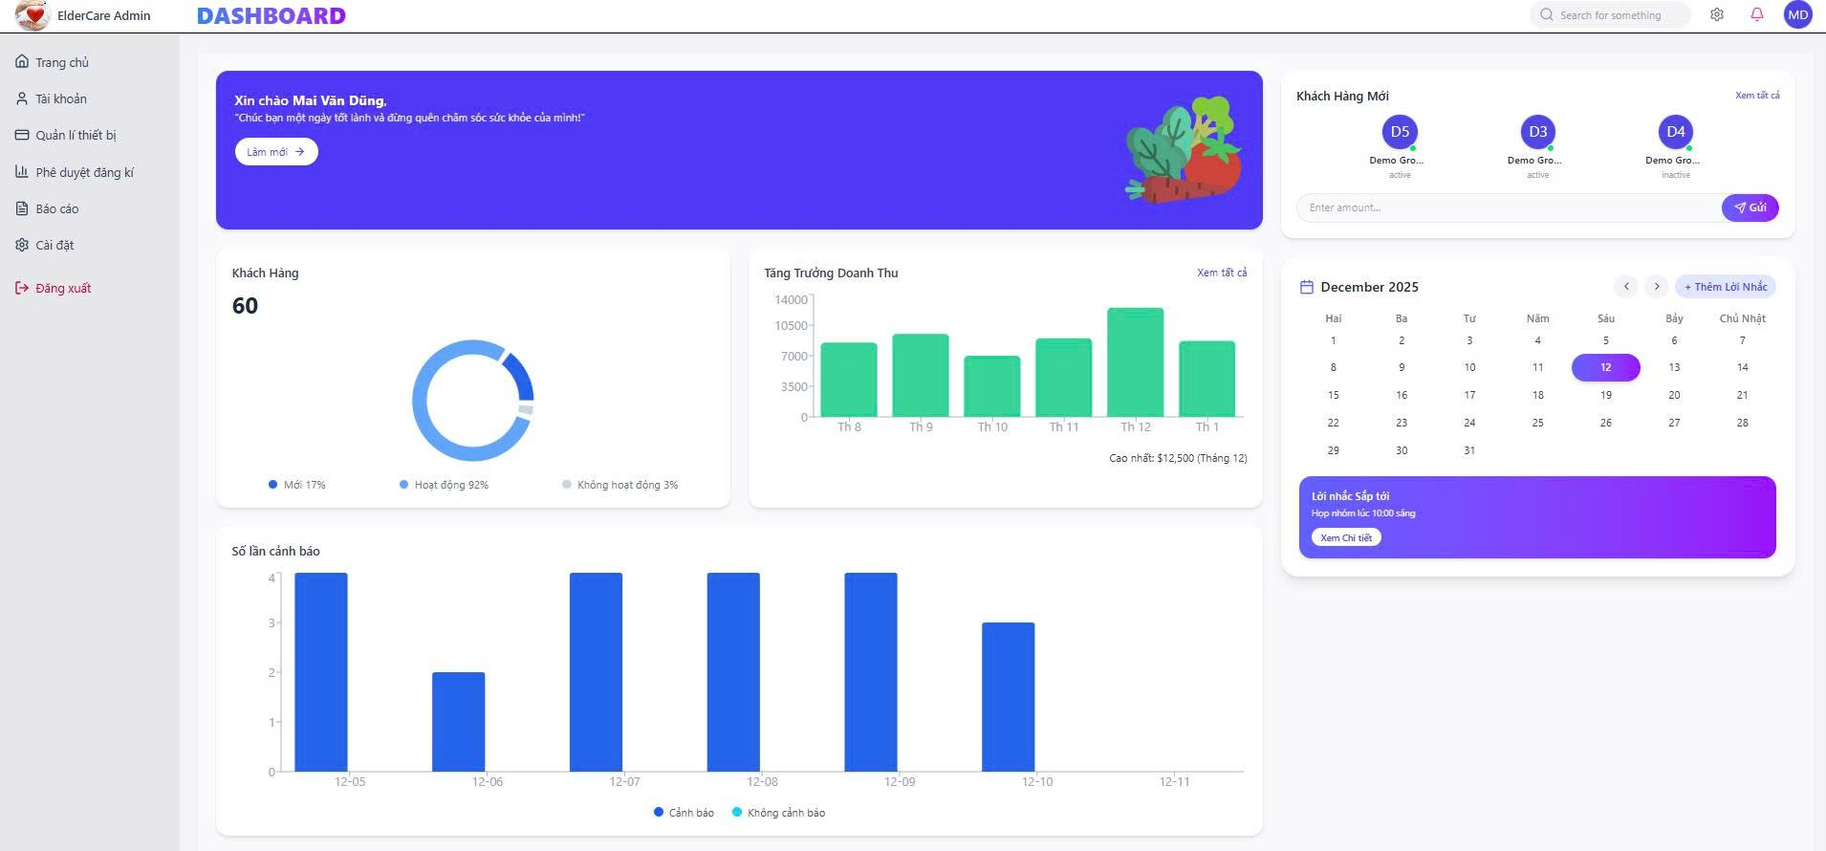
Dashboard
No. | Field name | Type | Require | Target
1 | Page Title | Heading | Text: “DASHBOARD” | Identifies the main overview dashboard screen.
2 | Welcome Banner | Banner / Card | Greeting message | Displays a personalized welcome message to the admin.
3 | Welcome Text | Text | “Xin chào {Admin Name}” | Greets the logged-in administrator.
4 | Welcome Description | Text | Inspirational message | Encourages positive engagement with the system.
5 | Refresh Button | Button | Text: “Làm mới” | Refreshes dashboard data.
6 | New Customers Section | Card | Title: “Khách hàng mới” | Displays recently registered users.
7 | New Customer Avatar | Avatar | Initials | Represents new users visually.
8 | New Customer Status | Badge | Active / Inactive | Shows current status of new users.
9 | View All Customers Link | Link | Text: “Xem tất cả” | Navigates to full user list.
10 | Quick Action Input | Input | Placeholder: “Enter amount…” | Allows quick data entry or action.
11 | Send Button | Button | Text: “Gửi” | Submits quick action input.
12 | Total Customers Card | Statistic Card | Value: 60 | Displays total number of customers/users.
13 | Customer Distribution Chart | Doughnut Chart | New / Active / Inactive | Visualizes customer status distribution.
14 | Chart Legend | Legend | Percentage labels | Explains chart segments.
15 | Revenue Growth Section | Chart Card | Title: “Tăng Trưởng Doanh Thu” | Displays revenue growth trends.
16 | Revenue Bar Chart | Bar Chart | Monthly revenue data | Visualizes revenue changes by month.
17 | Revenue Peak Label | Text | Highest revenue note | Highlights peak revenue month and value.
18 | Calendar Widget | Calendar | Month view | Displays current month calendar.
19 | Calendar Navigation | Button | Previous / Next | Navigates between months.
20 | Add Reminder Button | Button | Text: “+ Thêm Lời Nhắc” | Adds a new reminder.
21 | Upcoming Reminder Card | Card | Reminder details | Displays upcoming reminder information.
22 | Reminder Title | Text | Example: “Lời nhắc sắp tới” | Identifies reminder section.
23 | Reminder Action Link | Link | Text: “Xem chi tiết” | Opens reminder detail view.
24 | Alert Statistics Section | Chart Card | Title: “Số lần cảnh báo” | Displays alert frequency statistics.
25 | Alert Bar Chart | Bar Chart | Daily alert data | Visualizes number of alerts per day.
26 | Alert Legend | Legend | Alert / No Alert | Explains alert chart data.
27 | Sidebar Navigation | Sidebar | Menu items | Enables navigation to other modules.
28 | Top Navigation Bar | Header | Search + Icons | Provides global search and quick actions.
29 | User Profile Icon | Avatar | Initials | Represents logged-in admin.
30 | Notification Icon | Icon | Bell | Displays system notifications.
31 | Settings Icon | Icon | Gear | Opens system settings.
32 | Responsive Layout | Layout | Dashboard grid | Ensures usability across devices.
33 | Color Theme | UI Style | Purple / Blue gradient | Enhances visual appeal and hierarchy.
34 | Data Refresh Logic | System Logic | Real-time / periodic | Keeps dashboard data up to date.

