ENTERPRISE MULTI-AGENT RAG SYSTEM
Master Technical Report: System Architecture, MoSCoW Framework & First Principle
1. System Architecture Flowchart Diagram
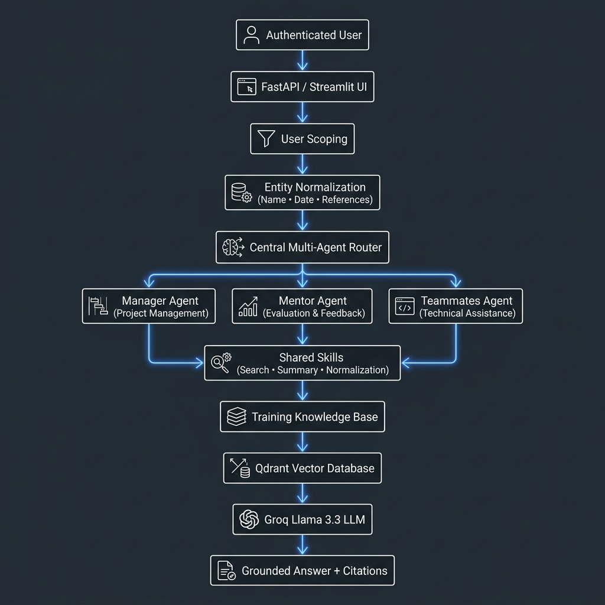
2. Project Prioritization Framework (MoSCoW)
Must Have
- Training Transcript Ingestion from Word Documents (.docx): Primary input source parsing and indexing of Microsoft Teams meeting transcripts.
- User Scoping (Scope Before Search): Scope all queries, vectors, and responses strictly to caller identity (user_id / speaker) before retrieval begins.
- Semantic Transcript Retrieval using Qdrant: 2,843 384-dimensional vector chunks indexed with Cosine similarity search.
- Persistent SHA-256 Embedding Cache (emb_cache): Sub-4ms instant vector lookups at $0.00 cost (Implemented).
- Grounded AI Responses with Proof: Grounded answers generated strictly from retrieved transcript context.
- Exact Source Citations: Citing Date, Page, and Speaker [Date | Page | Speaker] with zero guessing.
- FastAPI REST APIs & Agent Access: Programmatic endpoints for multi-agent dispatching.
Should Have
- GitHub Repository Integration & Automatic Code Review: Connecting directly to GitHub repositories for automatic code reviews so trainees focus on building rather than debugging.
- Interactive Code Debugging & Guided Learning Assistant: AI guidance explaining how trainees can debug code to foster learning through problem-solving.
- Automatic Folder Watcher (auto_folder_watcher.py): Background daemon automatically indexing new transcript files live.
- Quick Preset Action Buttons: Interactive buttons for Quiz Generation, Reading Topics, Action Items, and Spoken Quotes.
Could Have (Future Productivity Enhancements)
- Microsoft Teams Live Transcript Ingestion via Graph API.
- Whisper-Based Speech-to-Text running locally on laptops.
- Live In-Meeting Real-Time Prompt Assistant (Teams / Slack).
- Export Evaluation Reports directly to Word/PDF.
- Visual Analytics Dashboard for team participation metrics.
- Qdrant Cloud Synchronization for remote team access.
3. The First Principle of Our RAG System
- Understand Meaning, Not Just Keywords: The system uses 384-dimensional semantic vector search to understand the intent behind a query, even when users phrase it differently.
- Scope Before Search: Every query is first scoped to the appropriate user, speaker, or meeting context before any retrieval begins to ensure privacy and relevance.
- First-Principles Entity Matching (Simple Substring Resolution): Rather than building complex data normalization classes, the system uses simple, elegant substring matching ('himaya' -> 'Himaya Perumal', '23rd' -> '23 July') to map human queries directly to database entities.
- No Guessing, Only Evidence: Every response is grounded in retrieved transcript content with citations [Date | Page | Speaker]. If no evidence exists, the system returns 'Information Not Available'.

