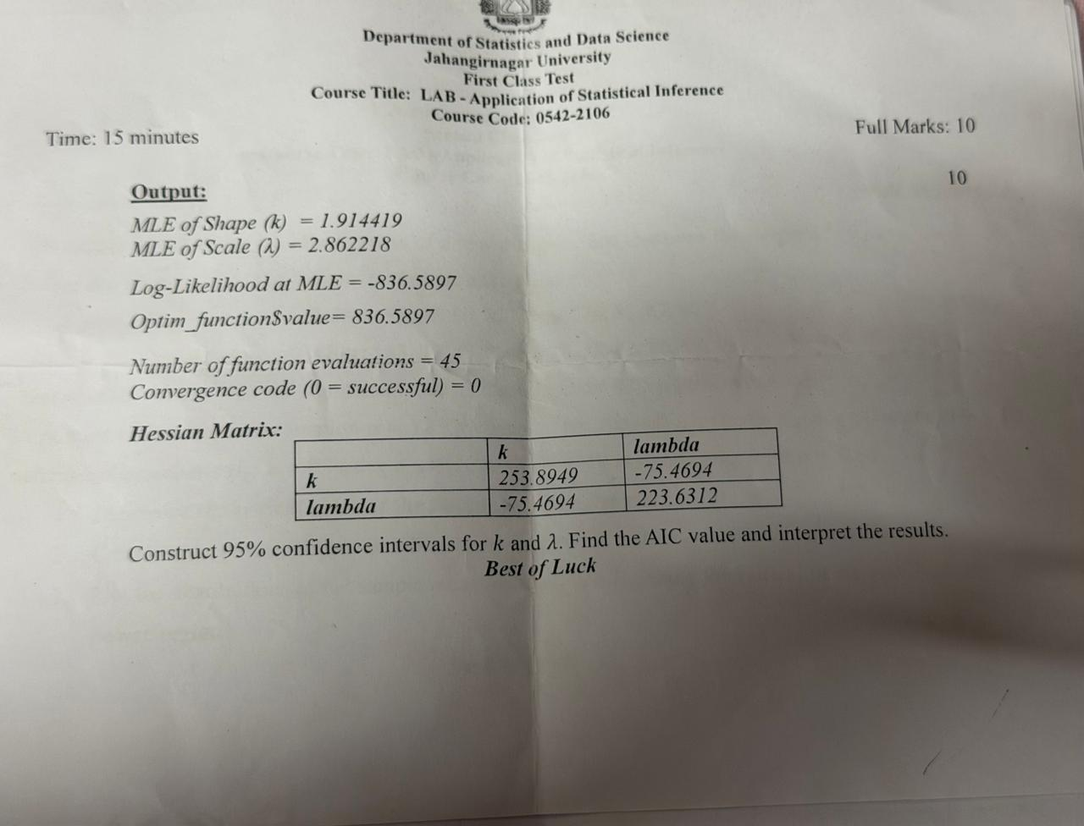
Given:
- MLE of shape parameter: $\hat{k}=1.914419$
- MLE of scale parameter: $\hat{λ}=2.862218$
- Log-likelihood at MLE: $l(\hat{θ})=-836.5897$
- Hessian matrix
$$H=\left[\begin{matrix}253.8949 & -75.4694 \\ -75.4694 & 223.6312\end{matrix}\right]$$
For MLE, the asymptotic covariance matrix is approximately
$$Σ=H^{-1}=\left[\begin{matrix}0.00437778 & 0.00147738 \\ 0.00147738 & 0.00497022\end{matrix}\right].$$

Therefore,
$$SE(\hat{k})=\sqrt{0.00437778}=0.06616,$$95% Confidence Interval for $k$
Using
$$\hat{k}±1.96 SE(\hat{k}) \\ 1.914419±1.96(0.06616) \\ 1.914419±0.12968 \\ \boxed{\left(1.7847 , 2.0441\right)}$$

95% Confidence Interval for $λ$
Using
$$\hat{λ}±1.96 SE(\hat{λ}) \\ 2.862218±1.96(0.07050) \\ 2.862218±0.13818 \\ \boxed{\left(2.7240 , 3.0004\right)}$$

AIC Calculation
The Akaike Information Criterion (AIC) is
$$AIC=2p-2l(\hat{θ}),$$
where $p=2$parameters ($k,λ$).
$$AIC=2(2)-2(-836.5897) \\ =4+1673.1794 \\ \boxed{AIC=1677.1794}$$

Interpretation
- Shape parameter $k$:
  - Estimated value: $1.9144$
  - 95% CI: $\left(1.7847 , 2.0441\right)$
  - We are 95% confident that the true shape parameter lies within this interval.
- Scale parameter $λ$:
  - Estimated value: $2.8622$
  - 95% CI: $\left(2.7240 , 3.0004\right)$
  - The true scale parameter is likely to lie in this range.
- AIC = 1677.1794
  - AIC is mainly used to compare competing models.
  - A smaller AIC indicates a better balance between goodness-of-fit and model complexity.
  - By itself, the AIC value has no absolute interpretation; it is meaningful only relative to other candidate models.

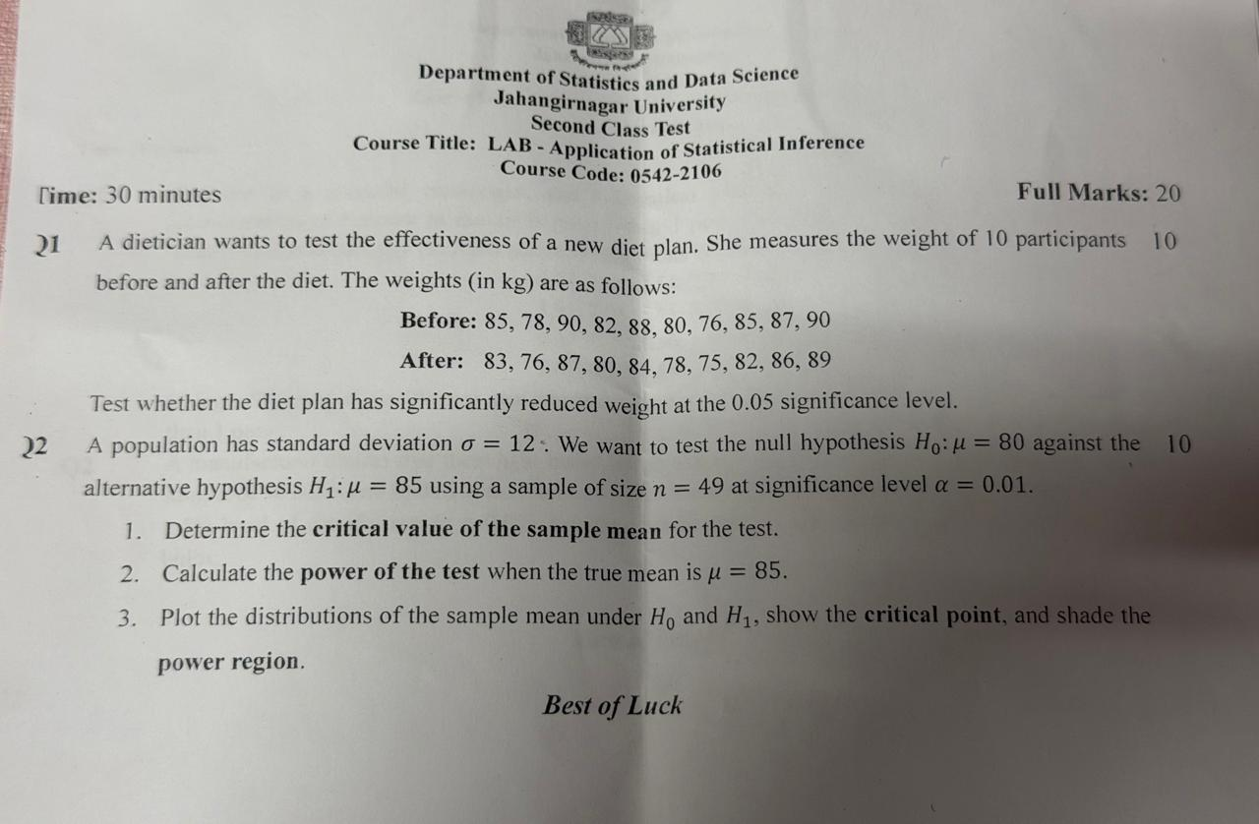

#CT2
#Q1
# Data
before <- c(85, 78, 90, 82, 88, 80, 76, 85, 87, 90)
after <- c(83, 76, 87, 80, 84, 78, 75, 82, 86, 89)

# Paired t-test
t.test(before, after,
paired = TRUE,
alternative = "greater")

#Q2
mu0 <- 80
mu1 <- 85
sigma <- 12
n <- 49
alpha <- 0.01

SE <- sigma/sqrt(n)

z_alpha <- qnorm(1-alpha)

xbar_critical <- mu0 + z_alpha*SE

SE
z_alpha
xbar_critical

power <- 1 - pnorm(xbar_critical,
mean = mu1,
sd = SE)

power

x <- seq(70, 95, length = 1000)

y0 <- dnorm(x, mean = mu0, sd = SE)
y1 <- dnorm(x, mean = mu1, sd = SE)

plot(x, y0,
type = "l",
col = "blue",
xlab = expression(bar(X)),
ylab = "Density",
main = "Sampling Distributions Under H0 and H1")

lines(x, y1,
col = "red")

abline(v = xbar_critical,
lwd = 2,
lty = 2)

# Shade power region
xp <- seq(xbar_critical, max(x), length = 500)
yp <- dnorm(xp, mean = mu1, sd = SE)

polygon(c(xbar_critical, xp, max(x)),
c(0, yp, 0),
col = "lightgreen")
legend("topright",
legend = c("H0: mu=80",
"H1: mu=85",
"Critical Value",
"Power Region"),
col = c("blue","red","black","lightgreen"),
lwd = c(2,2,2,10),
lty = c(1,1,2,1))
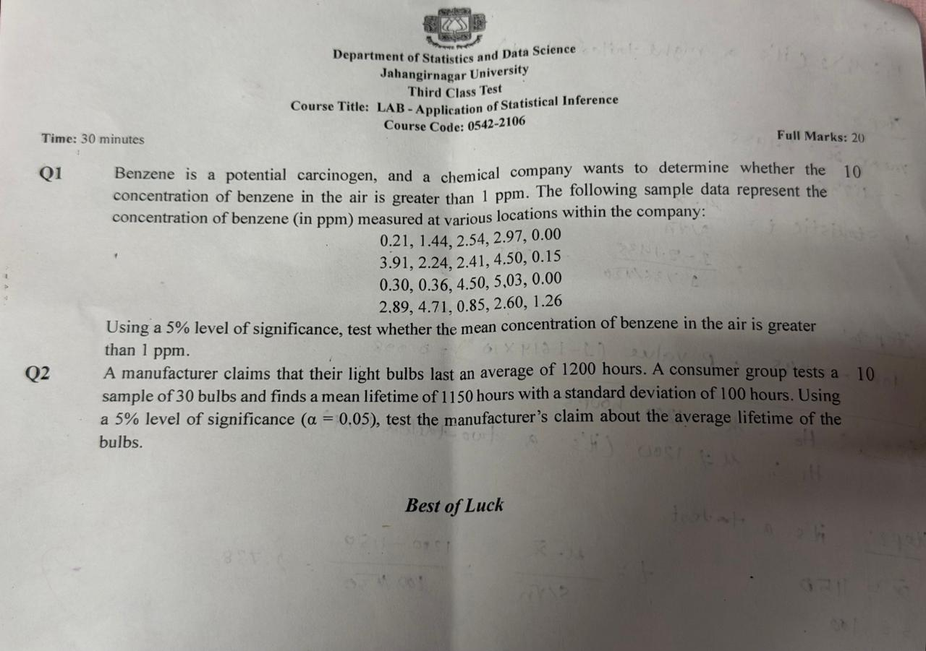
Step 1: State the hypotheses
The company wants to know whether the mean benzene concentration exceeds 1 ppm.
$$H_{0}:μ=1 \\ H_{1}:μ>1$$
(One-tailed t-test)
Step 2: Sample Data
$$0.21,1.44,2.54,2.97,0.00,3.91,2.24,2.41,4.50,0.15,0.30,0.36,4.50,5.03,0.00,2.89,4.71,0.85,2.60,1.26$$
Sample size:
$$n=20$$
Step 3: Compute Sample Mean
Sum of observations:
$$∑x_{i}=42.87 \\ \overset{ˉ}{x}=\frac{42.87}{20}=2.1435$$
Step 4: Compute Sample Standard Deviation
$$s≈1.795$$
Step 5: Test Statistic
$$t=\frac{\overset{ˉ}{x}-μ_{0}}{s/\sqrt{n}} \\ t=\frac{2.1435-1}{1.795/\sqrt{20}} \\ t=\frac{1.1435}{0.4014} \\ t≈2.85$$

Step 6: Critical Value
Degrees of freedom:
$$df=n-1=19$$
At $α=0.05$(right-tailed),
$$t_{0.95,19}=1.729$$
Step 7: Decision
$$t_{calc}=2.85>1.729=t_{crit}$$
Reject $H_{0}$.
Conclusion
At the 5% significance level, there is sufficient evidence that
$$\boxed{μ>1\text{ ppm}}$$
Therefore, the mean benzene concentration in the air is significantly greater than 1 ppm.

Q2: Light Bulb Lifetime Test
Step 1: State Hypotheses
Manufacturer claims:
$$μ=1200$$
Consumer group wants to test the claim.
$$H_{0}:μ=1200 \\ H_{1}:μ≠1200$$
(Two-tailed t-test)

Step 2: Given
$$n=30 \\ \overset{ˉ}{x}=1150 \\ s=100 \\ α=0.05$$
Step 3: Test Statistic
$$t=\frac{\overset{ˉ}{x}-μ_{0}}{s/\sqrt{n}} \\ t=\frac{1150-1200}{100/\sqrt{30}} \\ t=\frac{-50}{18.257} \\ t≈-2.74$$
Step 4: Critical Value
$$df=29$$
For a two-tailed test at $α=0.05$:
$$t_{0.975,29}=2.045$$
Critical region:
$$∣t∣>2.045$$
Step 5: Decision
$$∣t∣=2.74>2.045$$
Reject $H_{0}$.
Conclusion
There is sufficient evidence at the 5% significance level that the average lifetime differs from 1200 hours.
Since $\boxed{μ<1200}$
Thus, the manufacturer's claim of an average lifetime of 1200 hours is not supported.

