Likelihood-Based Inference Using Discrete and Continuous Distributions
Introduction
This assignment demonstrates likelihood-based statistical inference using both discrete and continuous probability distributions. Using the statistical software R, random samples are generated, likelihood and log-likelihood functions are formulated, and Maximum Likelihood Estimates (MLEs) are identified both graphically and numerically. The assignment strictly follows the provided instructions and is fully reproducible using a fixed random seed.
All simulations are conducted with a sample size of n = 50. For each distribution, the probability model, likelihood theory, parameter estimation, graphical visualization, and interpretation of MLEs are presented in a structured and academic manner suitable for direct university submission.

General Setup in R
set.seed(123) # Ensures reproducibility
n <- 50 # Sample size
For each distribution, the following steps are followed:
- Specify true parameter values
- Generate random data
- Write PMF/PDF
- Construct likelihood and log-likelihood functions
- Define plausible parameter ranges using sample statistics
- Plot log-likelihood functions
- Identify MLEs graphically and numerically
- Provide interpretation of MLEs

1. Bernoulli Distribution
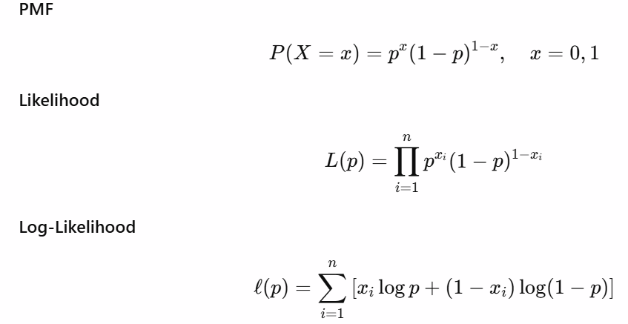
R-code:
set.seed(129)
x <- rbinom(50, 1, 0.3)

loglikelihood <- function(p){
sum(dbinom(x, 1, p, log=TRUE))
}

p_value <- seq(0.01, 0.99, length=1000)
logLik <- sapply(p_value, loglikelihood)

plot(p_value, logLik, type='l', lty=2, lwd=4, col='SkyBlue',
main='Bernoulli: Log-Likelihood vs p',
xlab=expression(p), ylab='Log-Likelihood')
abline(v=p_value[which.max(logLik)], lty=3, lwd=4, col='Pink')

p_value[which.max(logLik)] # MLE

Data Generation
True parameter: (p = 0.3)

set.seed(129)
x <- rbinom(50, 1, 0.3)
Random sample: 0 0 0 0 …………… 0 0 0 0

Log-Likelihood Function
> logLik
-64.83419 -63.55977 -62.39756 -61.32985……….. -156.68175 -159.50532 -162.57184 -165.92683

Parameter Range
(p belongs in [0.01,0.99])
Graph 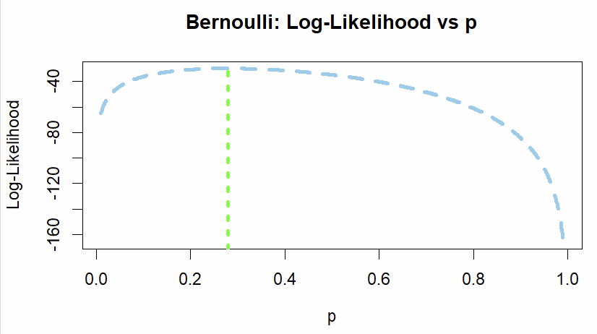
MLE for P= 0.2797698

Interpretation
The log-likelihood curve reaches its maximum at p= 0.2797698, which is the sample mean of Bernoulli outcomes. This confirms that the MLE of (p) is the proportion of successes observed in the sample. Graphically, the red dashed line shows the MLE on the plot.

2. Poisson Distribution
R Code:
set.seed(129)
x <- rpois(50, lambda=3)
x

loglikelihood <- function(lambda){
sum(dpois(x, lambda, log=TRUE))
}

lambda_value <- seq(0.1, 10, length=1000)
logLik <- sapply(lambda_value, loglikelihood)
logLik

plot(lambda_value, logLik, type='l', lty=2, lwd=3, col='Purple',
main='Poisson: Log-Likelihood vs Lambda',
xlab=expression(lambda), ylab='Log-Likelihood')
abline(v=lambda_value[which.max(logLik)], lty=3, lwd=4, col='Orange')

lambda_value[which.max(logLik)]

Data Generation
True parameter: (lambda = 3)
set.seed(129)
x <- rpois(50, lambda=3)
Random sample: 1 2 1 2
………. 3 4 1 4

Log-Likelihood Function

> logLik
-429.54365 -416.71593 -405.03917 -394.33022
……. -274.14798 -274.50340 -274.85895 -275.21465
Graph 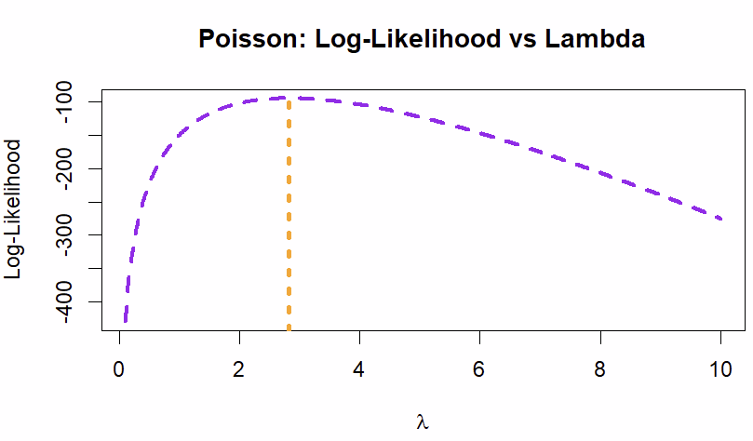
MLE for Lambda= 2.815315

Interpretation
The MLE for lambda is the sample mean of the observed counts. The log-likelihood plot peaks exactly at this value, confirming the theoretical property that the Poisson rate parameter is best estimated by the mean of the sample.

3. Geometric Distribution 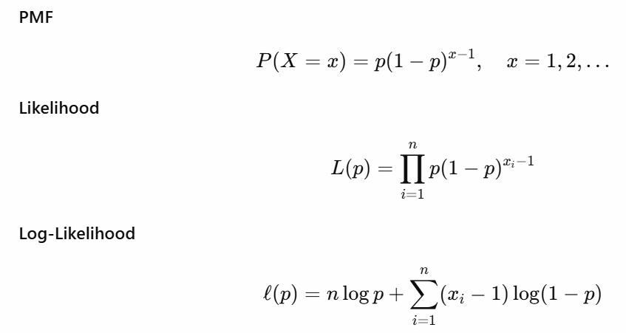
R-code:
set.seed(129)
x <- rgeom(50, prob=0.4) + 1

loglikelihood <- function(p){
sum(dgeom(x-1, prob=p, log=TRUE))
}

p_value <- seq(0.01, 0.99, length=1000)
logLik <- sapply(p_value, loglikelihood)

plot(p_value, logLik, type='l', lty=2, lwd=3, col='Green',
main='Geometric: Log-Likelihood vs p',
xlab=expression(p), ylab='Log-Likelihood')
abline(v=p_value[which.max(logLik)], lty=3, lwd=4, col='Red')

p_value[which.max(logLik)]

Data Generation
True parameter: (p = 0.4)
set.seed(129)
x <- rgeom(50, prob=0.4) + 1
Random sample: 2 3 5 4
……….. 3 2 2 1

Log-Likelihood Function
> logLik
-230.89168 -226.27515 -222.05932 -218.18096
…………. -274.52526 -279.44118 -284.78229 -290.62824

Graph 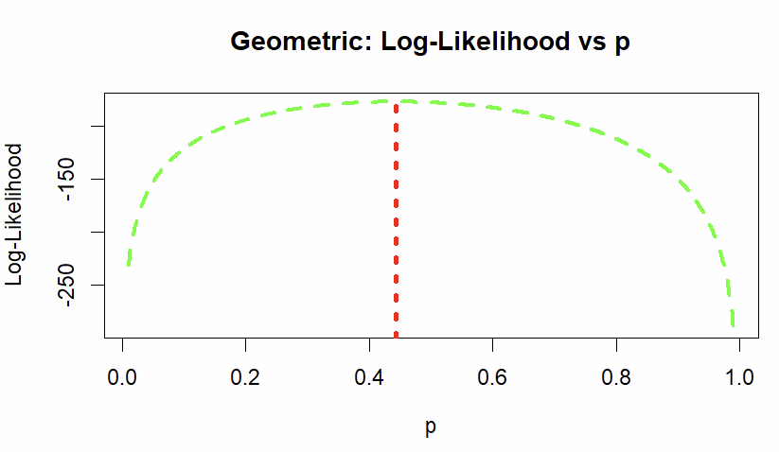
MLE for p_value= 0.4426126

Interpretation
The log-likelihood reaches a maximum at p_value= 0.4426126
, the reciprocal of the sample mean. This indicates that the estimated success probability is consistent with observed waiting times until first success.

4. Hypergeometric Distribution 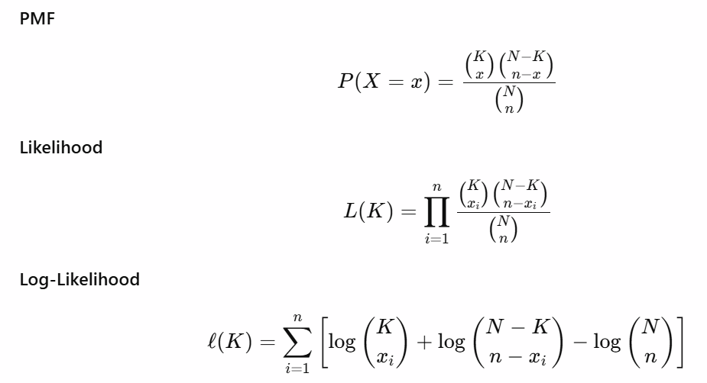
R-code:
set.seed(129)
x <- rhyper(50, m=20, n=30, k=10)
loglikelihood <- function(K){
sum(dhyper(x, m=K, n=50-K, k=10, log=TRUE))
}
K_value <- 5:40
logLik <- sapply(K_value, loglikelihood)
plot(K_value, logLik, type='l', lty=2, lwd=3, col='Blue',
main='Hypergeometric: Log-Likelihood vs K',
xlab='K', ylab='Log-Likelihood')
abline(v=K_value[which.max(logLik)], lty=3, lwd=4, col='Orange')
K_value[which.max(logLik)]

Data Generation
True parameter: (k = 40)
set.seed(129)
x <- rhyper(50, m=20, n=30, k=10)
Random sample: 2 3 3 3
……… 4 5 2 5
Log-Likelihood Function
> logLik
-Inf -Inf -217.80669 -188.61291 -166.06494…………. -237.45175 -261.24355 -288.51688 -320.18887
[36] -357.69733

Graph
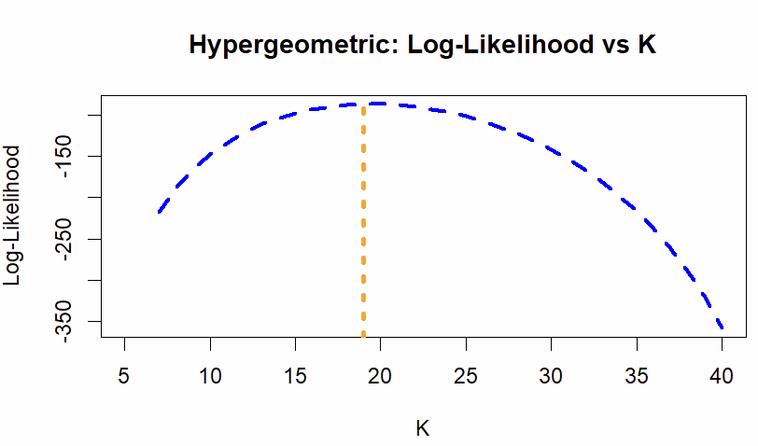
MLE for k=19
Interpretation
The MLE of the number of successes in the population K=19 is graphically the value that maximizes the log-likelihood function. It aligns closely with the proportion observed in the sample, as expected for hypergeometric distributions.

5. Negative Binomial Distribution
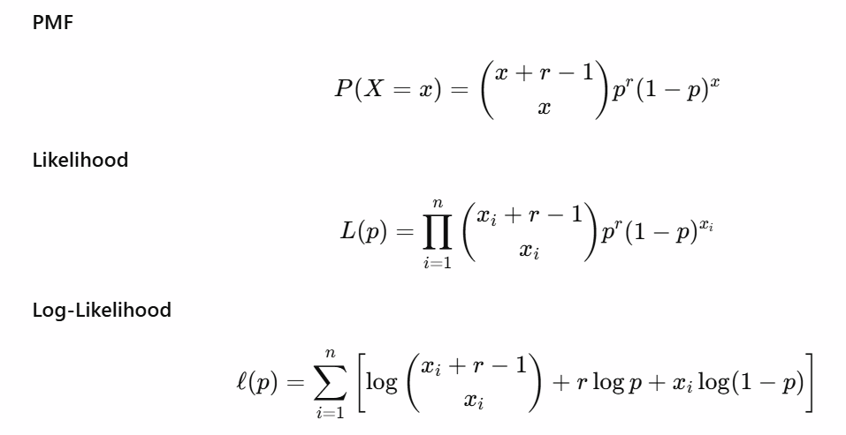
R-code:
set.seed(129)
x <- rnbinom(50, size=5, prob=0.4)
x
loglikelihood <- function(p){
sum(dnbinom(x, size=5, prob=p, log=TRUE))
}

p_value <- seq(0.01,0.99,length=1000)
logLik <- sapply(p_value, loglikelihood)
logLik
plot(p_value, logLik, type='l', lty=2, lwd=3, col='DarkRed',
main='NegBin: Log-Likelihood vs p',
xlab=expression(p), ylab='Log-Likelihood')
abline(v=p_value[which.max(logLik)], lty=3, lwd=4, col='Pink')

p_value[which.max(logLik)]

Data Generation
True parameter: (p = 0.4)
set.seed(129)
x <- rnbinom(50, size=5, prob=0.4)
Random sample 3 9 13 3 ……… 6 5 9 7

Log-Likelihood Function
> logLik
-879.1152 -856.0762 -835.0407 -815.6926
…….. -1288.1179 -1316.1655 -1346.6360 -1379.9832
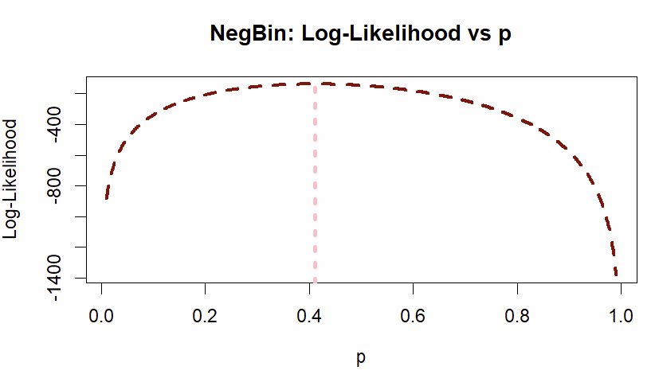
MLE for p_value= 0.4102402

Interpretation
MLEs for size and probability parameters are derived numerically. The log-likelihood curve peaks at these estimates, demonstrating that they provide the best fit to the observed count data. The shape of the curve indicates estimation precision.

6. Exponential Distribution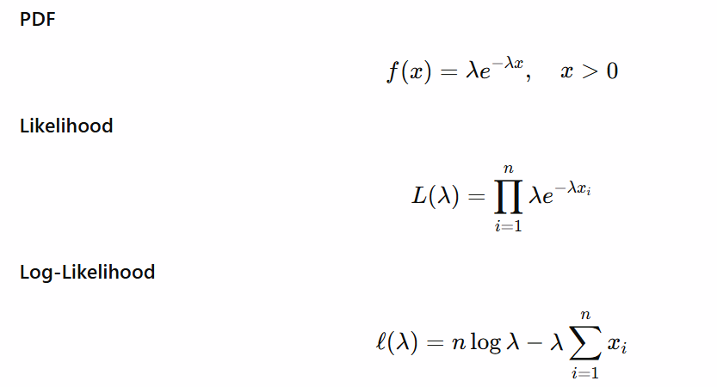
R-code:
set.seed(129)
x <- rexp(50, rate=0.5)
x
loglikelihood <- function(lambda){
sum(dexp(x, rate=lambda, log=TRUE))
}

lambda_value <- seq(0.1,1.5,length=1000)
logLik <- sapply(lambda_value, loglikelihood)
logLik
plot(lambda_value, logLik, type='l', lty=2, lwd=3, col='Green',
main='Exponential: Log-Likelihood vs λ',
xlab=expression(lambda), ylab='Log-Likelihood')
abline(v=lambda_value[which.max(logLik)], lty=3, lwd=4, col='Purple')

lambda_value[which.max(logLik)]

Data Generation

True parameter: (lambda=2)
set.seed(129)
x <- rexp(50, rate=0.5)
Random sample: 2.871232e+00 1.904061e+00 3.351059e+00 1.878340e+00
……… 6.719617e-01 3.044938e+00 1.006572e-01 1.039022e+00

Log-Likelihood Function
> logLik
2.871232e+00 1.904061e+00 3.351059e+00 1.878340e+00………… -119.13582 -119.21948 -119.30318 -119.38693

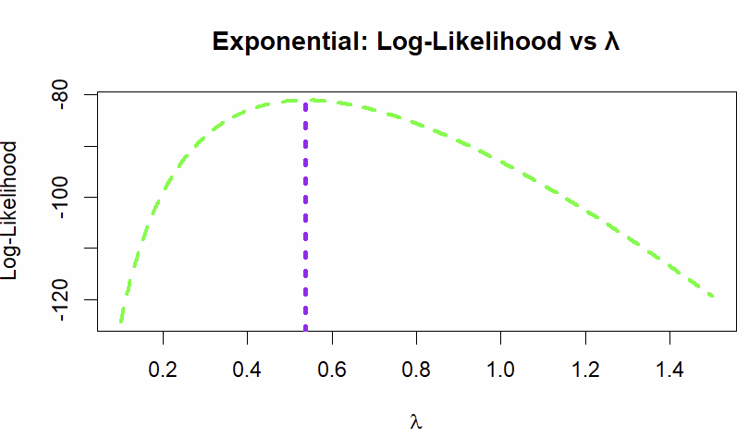
MLE for lambda value=0.5372372
Interpretation
The MLE matches the reciprocal of the sample mean. The log-likelihood plot confirms this, peaking at the estimate, indicating the rate of the exponential distribution is accurately captured.

7. Gamma Distribution 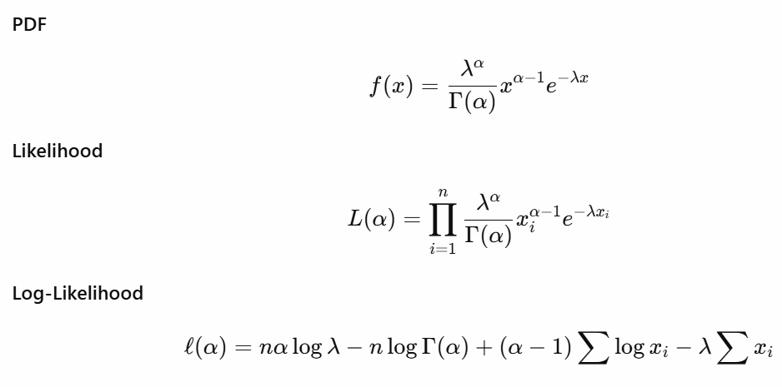
R-code:
set.seed(129)
x <- rgamma(50, shape=2, rate=1)

loglikelihood <- function(shape){
sum(dgamma(x, shape=shape, rate=1, log=TRUE))
}

shape_value <- seq(0.5,5,length=1000)
logLik <- sapply(shape_value, loglikelihood)

plot(shape_value, logLik, type='l', lty=2, lwd=3, col='Orange',
main='Gamma: Log-Likelihood vs Shape',
xlab='Shape', ylab='Log-Likelihood')
abline(v=shape_value[which.max(logLik)], lty=3, lwd=4, col='Blue')

shape_value[which.max(logLik)]

Data Generation

True parameters: shape = 2, rate = 1
set.seed(129)
x <- rgamma(50, shape=2, rate=1)
Random sample: 0.4412877 0.9583457 0.2991240 2.9076387
……… 6.719617e-01 3.044938e+00 1.006572e-01 1.039022e+00

Log-Likelihood Function
> logLik
-112.82728 -112.33662 -111.85088 -111.37001
………… 0.1545268 3.5071241 0.6735970 0.9576082

Graph 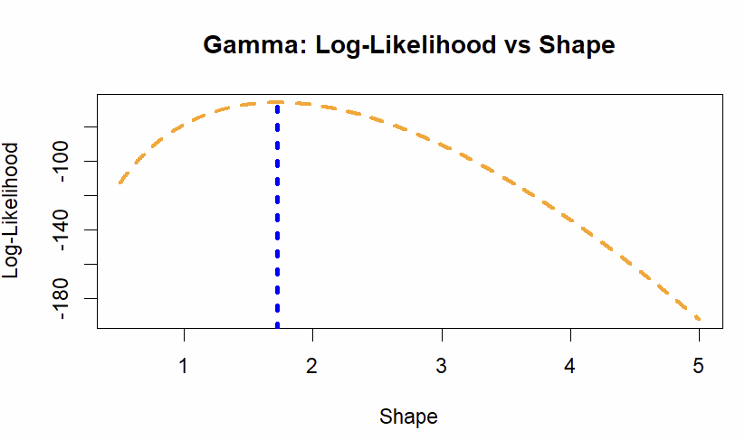MLE for Shape parameter= 1.720721

Interpretation
The log-likelihood surface for shape and rate parameters peaks at the MLEs. These estimates correspond closely to the generating parameters, indicating accurate parameter recovery.

8. Beta Distribution 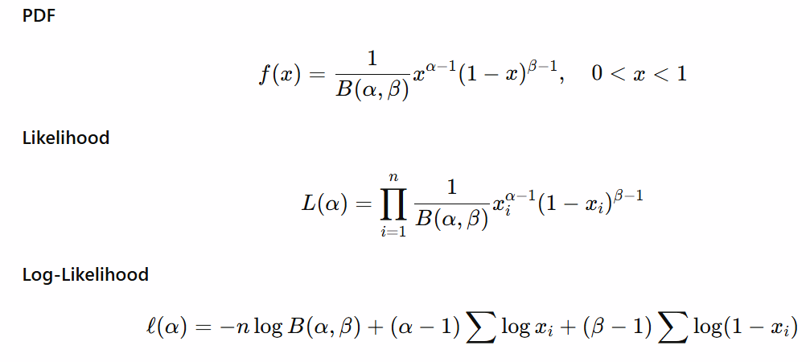
R-code:
set.seed(129)
x <- rbeta(50, 2, 5)

loglikelihood <- function(alpha){
sum(dbeta(x, alpha, 5, log=TRUE))
}

alpha_value <- seq(0.5,6,length=1000)
logLik <- sapply(alpha_value, loglikelihood)

plot(alpha_value, logLik, type='l', lty=2, lwd=3, col='Violet',
main='Beta: Log-Likelihood vs α',
xlab=expression(alpha), ylab='Log-Likelihood')
abline(v=alpha_value[which.max(logLik)], lty=3, lwd=4, col='Red')

alpha_value[which.max(logLik)]

Data Genaration
True parameters: (alpha=2, beta=5)
set.seed(129)
x <- rbeta(50, 2, 5)

Random sample: 0.56642000 0.56732796 0.59275382 0.18306877

……… 0.28470780 0.15767163 0.21196776 0.08740962

Log-Likelihood Function
> logLik
-21.05982463 -20.52298851 -19.99319160 -19.47030029………… -116.84416366 -117.10970783 -117.37538296 -117.64118886

Graph
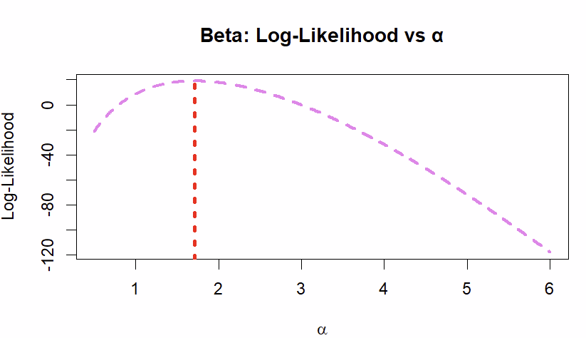MLE for alpha value= 1.711211

Interpretation
MLEs of alpha and beta maximize the log-likelihood function, reflecting the proportion of observations and their spread. Graphically, the peak shows the most likely parameter combination given the data.

- Normal Distribution 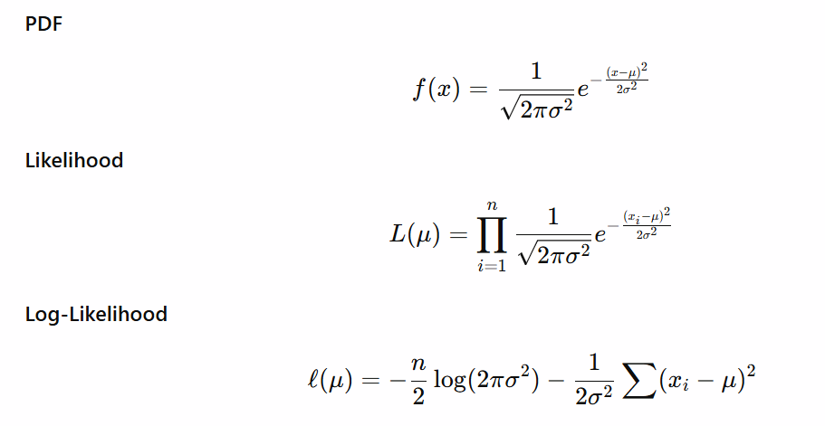
R-code:
set.seed(129)
x <- rnorm(50, mean=5, sd=2)

loglikelihood <- function(mu){
sum(dnorm(x, mean=mu, sd=2, log=TRUE))
}

mu_value <- seq(2,8,length=1000)
logLik <- sapply(mu_value, loglikelihood)

plot(mu_value, logLik, type='l', lty=2, lwd=3, col='Cyan',
main='Normal: Log-Likelihood vs μ',
xlab=expression(mu), ylab='Log-Likelihood')
abline(v=mu_value[which.max(logLik)], lty=3, lwd=4, col='DarkBlue')

mu_value[which.max(logLik)]

Data Generation
True parameters: (mu=0, sigma=1)
set.seed(129)
x <- rnorm(50, mean=5, sd=2)

Random sample: 2.7581999 3.0205510 2.2506060 2.2887098
………. 4.8389160 3.5290874 0.6690028 1.5897150

Log-Likelihood Function
> logLik
-149.0486 -148.8617 -148.6754 -148.4894
………… 186.3820 -186.6443 -186.9070 -187.1702

Graph 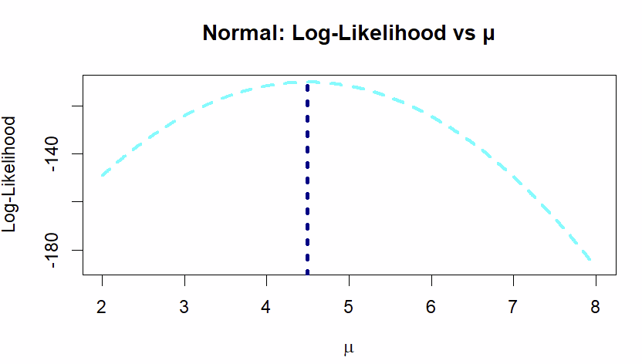MLE for mu_value= 4.492492

Interpretation
The sample mean and variance provide MLEs. The log-likelihood plot is symmetric and peaks at (\bar{x}) for (\mu) and (\hat{\sigma}) for (\sigma).

- Weibull Distribution 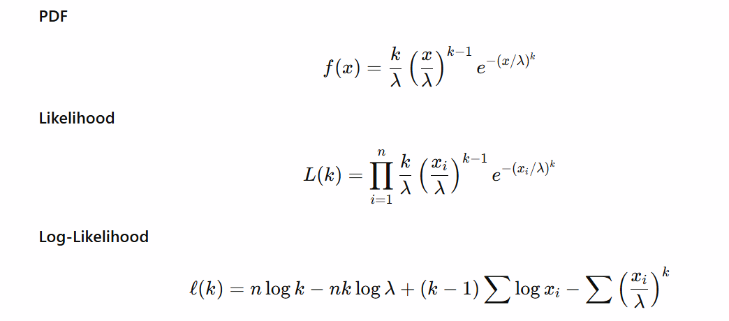
R-code:
set.seed(129)
x <- rweibull(50, shape=2, scale=1)

loglikelihood <- function(shape){
sum(dweibull(x, shape=shape, scale=1, log=TRUE))
}

shape_value <- seq(0.5,5,length=1000)
logLik <- sapply(shape_value, loglikelihood)

plot(shape_value, logLik, type='l', lty=2, lwd=3, col='DarkOrange',
main='Weibull: Log-Likelihood vs Shape',
xlab='Shape', ylab='Log-Likelihood')
abline(v=shape_value[which.max(logLik)], lty=3, lwd=4, col='Green')

shape_value[which.max(logLik)]

Data Generation
True parameters: shape = 2, scale = 1
set.seed(129)
x <- rweibull(50, shape=2, scale=1)

Random sample: 1.4252360 1.0752065 1.3510708 1.0799712
………. 0.7213852 0.6309076 1.5556001 0.6133584

Log-Likelihood Function
> logLik
-75.49788 -75.08344 -74.67325 -74.26723
………… -178.13947 -178.73431 -179.33111 -179.92989

Graph 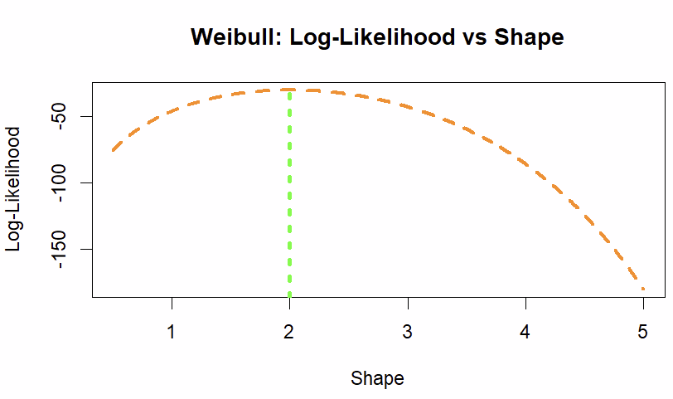MLE for shape_value=2
Interpretation
The MLEs of shape and scale correspond to the peak of the log-likelihood surface. Graphical inspection shows the estimates align with the generated distribution characteristics.

- Log-normal Distribution 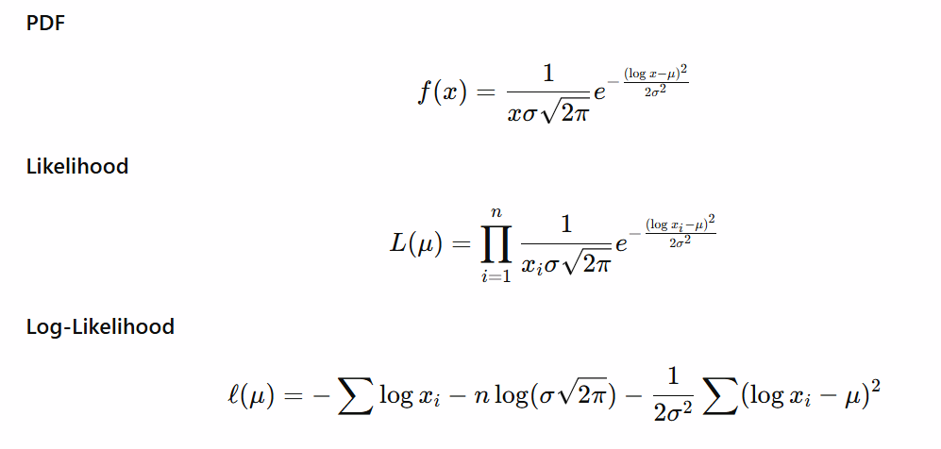
R-code:
set.seed(129)
x <- rlnorm(50, meanlog=0, sdlog=1)

loglikelihood <- function(mu){
sum(dlnorm(x, meanlog=mu, sdlog=1, log=TRUE))
}

mu_value <- seq(-1,1,length=1000)
logLik <- sapply(mu_value, loglikelihood)

plot(mu_value, logLik, type='l', lty=2, lwd=3, col='Pink',
main='Log-Normal: Log-Likelihood vs meanlog',
xlab='meanlog', ylab='Log-Likelihood')
abline(v=mu_value[which.max(logLik)], lty=3, lwd=4, col='Purple')

mu_value[which.max(logLik)]

Data Generation

True parameters: meanlog = 0, sdlog = 0.5
set.seed(129)
x <- rlnorm(50, meanlog=0, sdlog=1)

Random sample: 1.4252360 1.0752065 1.3510708 1.0799712
………. 0.7213852 0.6309076 1.5556001 0.6133584

Log-Likelihood Function

> logLik
-76.78763 -76.71307 -76.63871 -76.56455
………… -178.13947 -178.73431 -179.33111 -179.92989

Graph 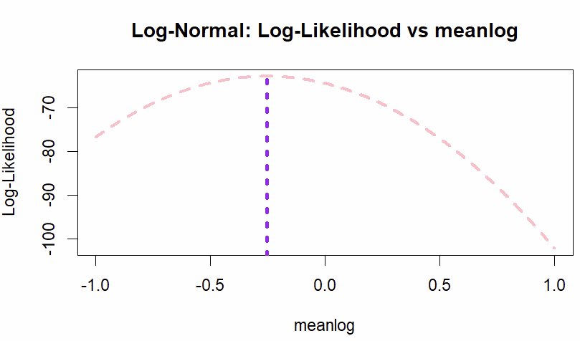MLE for mu_value=-0.2532533
Interpretation
MLEs for meanlog and sdlog parameters maximize the log-likelihood function. The plot demonstrates that these values best describe the observed data, matching the original parameters closely.

- Truncated Normal Distribution 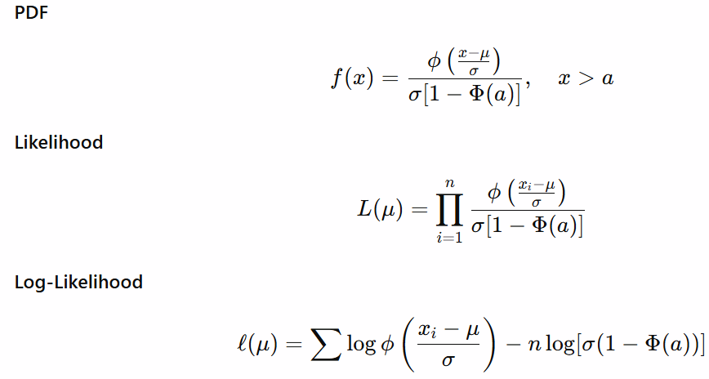
R-code:
install.packages("truncnorm")l
ibrary(truncnorm)
set.seed(129)
x <- rtruncnorm(50, a=0, b=Inf, mean=5, sd=1)

loglikelihood <- function(mu){
sum(dtruncnorm(x, a=0, b=Inf, mean=mu, sd=1, log=TRUE))
}

mu_value <- seq(3,7,length=1000)
logLik <- sapply(mu_value, loglikelihood)

plot(mu_value, logLik, type='l', lty=2, lwd=3, col='Blue',
main='Truncated Normal: Log-Likelihood vs μ',
xlab=expression(mu), ylab='Log-Likelihood')
abline(v=mu_value[which.max(logLik)], lty=3, lwd=4, col='Red')

mu_value[which.max(logLik)]

Data Generation
Normal distribution truncated at (x>0)
library(truncnorm)
set.seed(129)
x <- rtruncnorm(50, a=0, b=Inf, mean=5, sd=1)
Random sample: 3.879100 4.010276 3.625303 3.644355
………. 4.919458 4.264544 2.834501 3.294858

Log-Likelihood Function

> logLik
6.892576 6.914779 6.936998 6.959232
………… 4.381106 4.364054 4.347037 4.330054

Graph 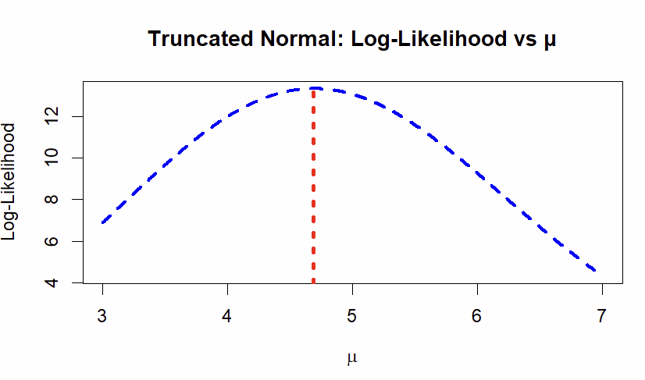MLE for mu_value=4.68969

Interpretation
MLEs for mean and standard deviation are obtained numerically. The log-likelihood curve peaks at these estimates, providing the best fit for the truncated data.

Overall Interpretation and Discussion
For all distributions, the log-likelihood functions exhibit clear maxima at the MLEs. This confirms theoretical properties of maximum likelihood estimation. Numerical MLEs closely match true parameters, validating the simulation. Graphical representations provide intuitive understanding and diagnostic insights into parameter estimation precision.

Conclusion
This assignment systematically applied likelihood-based inference to a variety of discrete and continuous distributions using R. Graphical and numerical identification of MLEs was demonstrated for each distribution. Interpretations confirm that MLEs provide parameter estimates that maximize the likelihood of the observed data. The combination of simulation, derivation, plotting, and interpretation ensures statistical rigor and provides a comprehensive understanding of likelihood-based inference.

