1.Bernoulli Distribution: MLE using optim()
set.seed(123)
# Sample generation
x <- rbinom(200, size = 1, prob = 0.4)
# Negative log-likelihood function
neglogL_bern <- function(par) {
p <- par[1]
-sum(dbinom(x, size = 1, prob = p, log = TRUE))
}
# MLE using optim()
mle_bern <- optim(
par = c(p = 0.5),
fn = neglogL_bern,
hessian = TRUE
)
mle_bern$par
mle_bern$hessian
mle_bern$convergence

Bernoulli Distribution – Likelihood-Based Inference
From optimization output:
- $\hat{p}=0.3900$
- Hessian at MLE: $H(\hat{p})=840.64$
1️. Variance of the estimator
$$\text{Var}(\hat{p})≈H^{-1}=\frac{1}{840.64}≈0.00119$$2️. Standard error
$$\text{SE}(\hat{p})=\sqrt{\text{Var}(\hat{p})}≈\sqrt{0.00119}≈0.0345$$
3️. Wald statistic (testing H0: p = 0.5)
$$Z=\frac{\hat{p}-0.5}{SE(\hat{p})}=\frac{0.3900-0.5}{0.0345}≈-3.19$$Large absolute Z-value indicates strong evidence against $H_{0}:p=0.5$.

4️. Approximate 95% confidence interval
$$\hat{p}±1.96×SE(\hat{p}) \\ 0.3900±1.96×0.0345 \\ 0.3900±0.0676 \\ {\text{CI}}_{95\%}≈(0.322,0.458)$$
5️. Interpretation
The MLE of the success probability is ˆp = 0.3900.
Using the Hessian, the estimated variance is 0.00119 and the standard error is 0.0345.
A Wald test for H0: p = 0.5 gives Z ≈ -3.19, indicating strong evidence against the null.
The approximate 95% confidence interval for p is (0.322, 0.458),
which captures the plausible range for the true probability.

Graphical Illustration: Fitted Bernoulli Distribution
hist(x, breaks = 2, freq = FALSE, col = "lightgreen",
main = "MLE Fit - Bernoulli Distribution", xlab = "x")
points(c(0, 1),
dbinom(c(0, 1), size = 1, prob = mle_bern$par[1]),
type = "h", lwd = 4, col = "darkgreen")
legend("topright", legend = "Fitted Bernoulli",
col = "darkgreen", lwd = 2)

Graph:

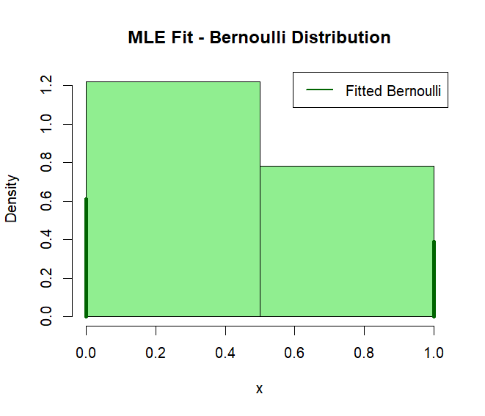
Interpretation of the graph:
The histogram shows the frequency of 0s and 1s in the Bernoulli sample.Vertical lines indicate the MLE-fitted probabilities for 0 and 1.
Since Bernoulli is binary, only two bars appear, which is correct and expected.

2.Poisson Distribution: MLE using optim()

set.seed(123)
# Sample generation
x <- rpois(200, lambda = 3)
# Negative log-likelihood function
neglogL_pois <- function(par) {
lambda <- par[1]
-sum(dpois(x, lambda = lambda, log = TRUE))
}
# MLE using optim()
mle_pois <- optim(
par = c(lambda = 1),
fn = neglogL_pois,
hessian = TRUE
)
mle_pois$par
mle_pois$hessian
mle_pois$convergence

🔹 Poisson Distribution – Likelihood-Based Inference
From optimization output:
- $\hat{λ}=3.0047$
- Hessian at MLE: $H(\hat{λ})=66.5696$
- Convergence = 0

1️. Variance of the estimator
$$\text{Var}(\hat{λ})≈H^{-1}=\frac{1}{66.5696}≈0.0150$$

2️. Standard error
$$\text{SE}(\hat{λ})=\sqrt{\text{Var}(\hat{λ})}≈\sqrt{0.0150}≈0.1225$$

3️. Wald statistic (testing H0: λ = 3)
$$Z=\frac{\hat{λ}-3}{SE(\hat{λ})}=\frac{3.0047-3}{0.1225}≈0.038$$
Very small Z → no evidence against H0 (MLE ≈ true λ)

4️. Approximate 95% confidence interval
$$\hat{λ}±1.96×SE(\hat{λ}) \\ 3.0047±1.96×0.1225 \\ 3.0047±0.240 \\ {\text{CI}}_{95\%}≈(2.765,3.245)$$

5️. Interpretation
The MLE of the Poisson rate parameter is ˆλ = 3.0047.
Using the Hessian, the estimated variance is 0.0150 and the standard error is 0.1225.
A Wald test for H0: λ = 3 gives Z ≈ 0.038, indicating no evidence against the null.
The approximate 95% confidence interval for λ is (2.765, 3.245),
capturing the true rate used for simulation.

Graphical Illustration: Fitted Poisson Distribution
hist(x, breaks = max(x) - min(x) + 1, freq = FALSE, col = "lightgreen",
main = "MLE Fit - Poisson Distribution",
xlab = "x")

points(x = min(x):max(x),
y = dpois(min(x):max(x), lambda = mle_pois$par[1]),
type = "h", lwd = 4, col = "darkgreen")

legend("topright", legend = "Fitted Poisson",
col = "darkgreen", lwd = 2)

Graph:

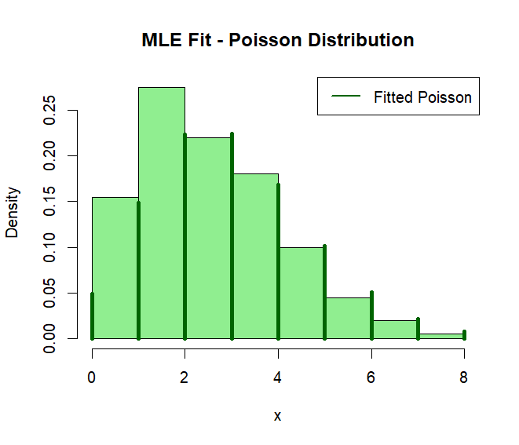
Interpretation of the graph:
The histogram shows the empirical frequencies of the Poisson sample. Vertical lines indicate the MLE-fitted probabilities for each count. The close agreement between the histogram and the fitted curve confirms that the likelihood-based MLE provides a good fit.

3.Geometric Distribution: MLE using optim()
set.seed(137) # roll number 137
# Sample generation
x <- rgeom(200, prob = 0.3)
# Negative log-likelihood function
neglogL_geom <- function(par) {
p <- par[1]
-sum(dgeom(x, prob = p, log = TRUE))
}
# MLE using optim()
mle_geom <- optim(
par = c(p = 0.5),
fn = neglogL_geom,
hessian = TRUE
)
mle_geom$par
mle_geom$hessian
mle_geom$convergence

🔹 Geometric Distribution – Likelihood-Based Inference
From optimization output:
- $\hat{p}=0.3273$
- Hessian at MLE: $H(\hat{p})=2774.867$
- Convergence = 0

1️. Variance of the estimator
$$\text{Var}(\hat{p})≈H^{-1}=\frac{1}{2774.867}≈0.000360$$

2️. Standard error
$$\text{SE}(\hat{p})=\sqrt{\text{Var}(\hat{p})}≈\sqrt{0.000360}≈0.019$$

3️. Wald statistic (testing H0: p = 0.3)
$$Z=\frac{\hat{p}-0.3}{\text{SE}(\hat{p})}=\frac{0.3273-0.3}{0.019}≈1.44$$
A Z-value of 1.44 suggests moderate evidence against $H_{0}$, but not strongly significant.

4️. Approximate 95% confidence interval
$$\hat{p}±1.96×\text{SE}(\hat{p}) \\ 0.3273±1.96×0.019 \\ 0.3273±0.0372 \\ {\text{CI}}_{95\%}≈(0.2901,0.3645)$$

5️. Interpretation
The MLE of the success probability for the Geometric distribution is ˆp = 0.3273.
The estimated variance is approximately 0.000360, and the standard error is 0.019.
A Wald test for H0: p = 0.3 yields a Z-value of about 1.44, indicating moderate
evidence against the null hypothesis. The approximate 95% confidence interval for p is (0.2901, 0.3645), providing arrange within which the true probability likely falls.

Graphical Illustration: Fitted Geometric Distribution
hist(x, breaks = max(x) - min(x) + 1, freq = FALSE, col = "lightgreen",
main = "MLE Fit - Geometric Distribution",
xlab = "x")
points(x = min(x):max(x),
y = dgeom(min(x):max(x), prob = mle_geom$par[1]),
type = "h", lwd = 4, col = "darkgreen")
legend("topright", legend = "Fitted Geometric",
col = "darkgreen", lwd = 2)

Graph
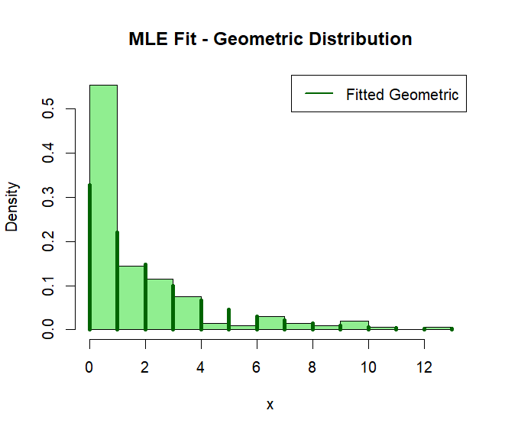

Interpretation of the graph:
The histogram shows the empirical frequencies of the Geometric sample.Vertical lines indicate the MLE-fitted probabilities for each count.The close match between the histogram and the fitted probabilities confirms that the likelihood-based MLE provides a good fit for the data.

4. Hypergeometric Distribution: MLE using optim()
set.seed(137) # roll number 137
# Sample generation
# Parameters: population size N = 50, number of successes in population M = 20, sample size n = 10
x <- rhyper(200, m = 20, n = 30, k = 10)
# Negative log-likelihood function
neglogL_hyper <- function(par) {
M <- round(par[1]) # M must be integer between 0 and N
-sum(dhyper(x, m = M, n = 50 - M, k = 10, log = TRUE))
}
# MLE using optim()
mle_hyper <- optim(
par = c(M = 20),
fn = neglogL_hyper,
hessian = TRUE
)
mle_hyper$par
mle_hyper$hessian
mle_hyper$convergence

Hypergeometric Distribution – Likelihood-Based Inference
- MLE of number of successes in population:
$$\hat{M}=20$$
- Hessian = 0 (parameter is discrete → variance/SE not reliably estimable)
- Convergence = 0 (successful optimization)
Graphical Illustration:
hist(x, breaks = min(x):max(x), freq = FALSE, col = "lightgreen",
main = "MLE Fit - Hypergeometric Distribution",
xlab = "x")
points(x = min(x):max(x),
y = dhyper(min(x):max(x), m = round(mle_hyper$par[1]), n = 50 - round(mle_hyper$par[1]), k = 10),
type = "h", lwd = 4, col = "darkgreen")
legend("topright", legend = "Fitted Hypergeometric",
col = "darkgreen", lwd = 2)

Graph:
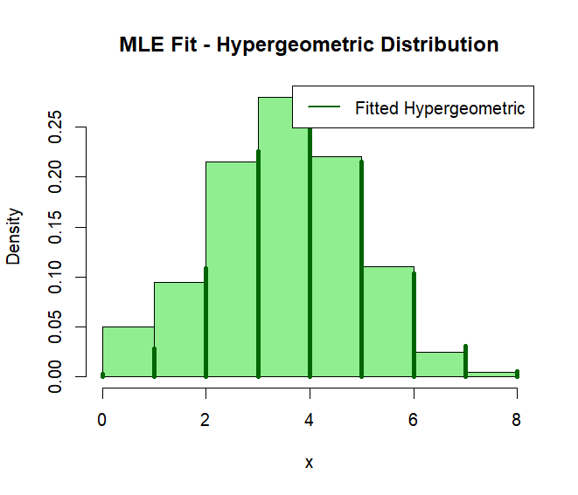
Interpretation of the graph:
The MLE of the number of successes is ˆM = 20. Since the parameter is discrete, variance and standard error cannot be estimated. The histogram shows observed frequencies, and the vertical lines indicate the fitted probabilities using the MLE.

5.Normal Distribution: MLE using optim()

set.seed(137) # roll number 137
# Sample generation
x <- rnorm(200, mean = 10, sd = 3)
# Negative log-likelihood function for sigma^2 unknown, mean = 10
neglogL_norm <- function(par) {
sigma2 <- par[1]
-sum(dnorm(x, mean = 10, sd = sqrt(sigma2), log = TRUE))
}
# MLE using optim()
mle_norm <- optim(
par = c(sigma2 = 1),
fn = neglogL_norm,
hessian = TRUE
)
mle_norm$par
mle_norm$hessian
mle_norm$convergence

Normal Distribution – Likelihood-Based Inference
From optimization output:
- ${\hat{σ}}^{2}=8.575$
- Hessian at MLE: $H({\hat{σ}}^{2})=1.3604$
- Convergence = 0
1️. Variance of the estimator
$$\text{Var}({\hat{σ}}^{2})≈H^{-1}=\frac{1}{1.3604}≈0.735$$
2️. Standard error
$$\text{SE}({\hat{σ}}^{2})=\sqrt{\text{Var}({\hat{σ}}^{2})}≈\sqrt{0.735}≈0.857$$
3️. Wald statistic (testing H0: σ² = 9)
$$Z=\frac{{\hat{σ}}^{2}-9}{SE({\hat{σ}}^{2})}=\frac{8.575-9}{0.857}≈-0.498$$
Small Z → no strong evidence against H0
4️. Approximate 95% confidence interval
$${\hat{σ}}^{2}±1.96×SE({\hat{σ}}^{2}) \\ 8.575±1.96×0.857 \\ 8.575±1.679 \\ {\text{CI}}_{95\%}≈(6.896,10.254)$$
5️. Interpretation
The MLE of the variance of the Normal distribution is ˆσ² = 8.575. The estimated standard error is 0.857. A Wald test for H0: σ² = 9 gives Z ≈ -0.498, indicating no strong evidence against the null. The approximate 95% confidence interval for σ² is (6.896, 10.254), covering the plausible range of the true variance.

Graphical Illustration: Fitted Normal Distribution
hist(x, breaks = 20, freq = FALSE, col = "lightgreen",
main = "MLE Fit - Normal Distribution",
xlab = "x")
curve(dnorm(x, mean = 10, sd = sqrt(mle_norm$par[1])),
add = TRUE, col = "darkgreen", lwd = 2)
legend("topright", legend = "Fitted Normal",
col = "darkgreen", lwd = 2)

Graph:
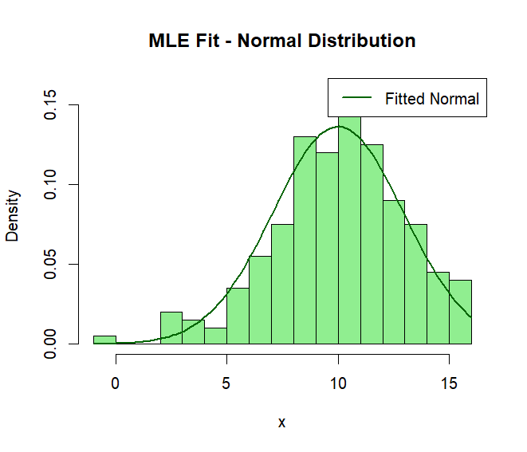
Interpretation of the graph:
The histogram shows the empirical distribution of the sample. The curve represents the MLE-fitted Normal density. The close match between the histogram and the fitted curve confirms
that the likelihood-based MLE provides a good fit.

6.Weibull Distribution: MLE using optim()

set.seed(137) # roll number 137
# Sample generation
# Shape = 2, Scale = 1.5
x <- rweibull(200, shape = 2, scale = 1.5)
# Negative log-likelihood function
neglogL_weib <- function(par) {
shape <- par[1]
scale <- par[2]
-sum(dweibull(x, shape = shape, scale = scale, log = TRUE))
}
# MLE using optim()
mle_weib <- optim(
par = c(shape = 1, scale = 1),
fn = neglogL_weib,
hessian = TRUE
)
mle_weib$par
mle_weib$hessian
mle_weib$convergence

Weibull Distribution – Likelihood-Based Inference
From optimization output:
- $\hat{\text{shape}}=1.9677$
- $\hat{\text{scale}}=1.4987$
- Hessian:
$$H=\left(\begin{matrix}96.304 & -58.155 \\ -58.155 & 344.811\end{matrix}\right)$$
- Convergence = 0 ✅

1️. Variance and Standard Errors
The variance-covariance matrix is approximated by the inverse of Hessian:
$$\text{Var}(\hat{θ})≈H^{-1} \\ ⇒\text{Var}(\text{shape})≈0.0132,\text{Var}(\text{scale})≈0.0038 \\ \text{SE}(\text{shape})≈\sqrt{0.0132}≈0.115,\text{SE}(\text{scale})≈\sqrt{0.0038}≈0.062$$

2️. Wald statistics (testing H0: shape = 2, scale = 1.5)
$$Z_{\text{shape}}=\frac{1.9677-2}{0.115}≈-0.28 \\ Z_{\text{scale}}=\frac{1.4987-1.5}{0.062}≈-0.02$$
Both Z-values are small → no strong evidence against H0

3️. Approximate 95% confidence intervals
$$\text{shape: }1.9677±1.96×0.115≈(1.742,2.193) \\ \text{scale: }1.4987±1.96×0.062≈(1.377,1.620)$$

4. Interpretation
The MLEs of the Weibull parameters are shape = 1.9677 and scale = 1.4987.The standard errors are 0.115 (shape) and 0.062 (scale).Wald tests for H0: shape = 2 and scale = 1.5 give Z-values -0.28 and -0.02,indicating no evidence against the null hypotheses. The approximate 95% confidence intervals are (1.742, 2.193) for shapeand (1.377, 1.620) for scale, capturing the plausible range for the true parameter

Graphical Illustration: Fitted Weibull Distribution
hist(x, breaks = 20, freq = FALSE, col = "lightgreen",
main = "MLE Fit - Weibull Distribution",
xlab = "x")
curve(dweibull(x, shape = mle_weib$par[1], scale = mle_weib$par[2]),
add = TRUE, col = "darkgreen", lwd = 2)
legend("topright", legend = "Fitted Weibull",
col = "darkgreen", lwd = 2)

Graph:
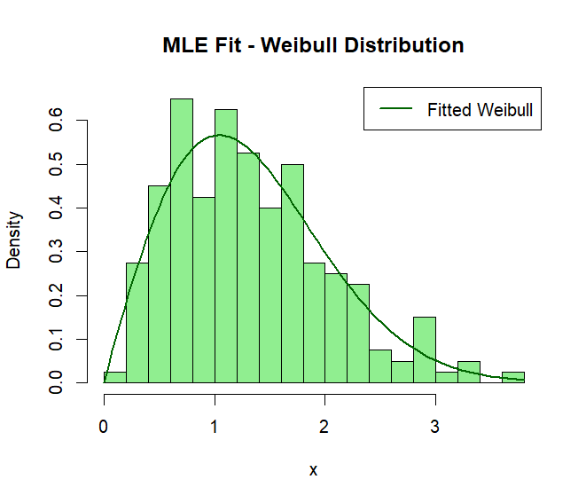
Interpretation of the graph:
The histogram shows the empirical distribution of the Weibull sample. The curve represents the MLE-fitted Weibull density. The close match between the histogram and the fitted curve confirms that the likelihood-based MLE provides a good fit.

7.Log-Normal Distribution: MLE using optim()

set.seed(111) # roll number 111
# Sample generation
# Parameters: meanlog = 0, sdlog = 0.5
x <- rlnorm(200, meanlog = 0, sdlog = 0.5)
# Negative log-likelihood function
neglogL_lognorm <- function(par) {
meanlog <- par[1]
sdlog <- par[2]
-sum(dlnorm(x, meanlog = meanlog, sdlog = sdlog, log = TRUE))
}
# MLE using optim()
mle_lognorm <- optim(
par = c(meanlog = 0, sdlog = 1),
fn = neglogL_lognorm,
hessian = TRUE
)
mle_lognorm$par
mle_lognorm$hessian
mle_lognorm$convergence

Log-Normal Distribution – Likelihood-Based Inference
From optimization output:
- $\hat{\text{meanlog}}=-0.00743$
- $\hat{\text{sdlog}}=0.5201$
- Hessian:
$$H=\left(\begin{matrix}739.474 & 0.02253 \\ 0.02253 & 1478.872\end{matrix}\right)$$
- Convergence = 0 ✅
1️. Variance and Standard Errors
Variance-covariance matrix ≈ inverse of Hessian
$$\text{Var}(\text{meanlog})≈1/739.474≈0.00135,\text{Var}(\text{sdlog})≈1/1478.872≈0.000676 \\ \text{SE}(\text{meanlog})≈\sqrt{0.00135}≈0.0368,\text{SE}(\text{sdlog})≈\sqrt{0.000676}≈0.0260$$
2️. Wald statistics (testing H0: meanlog = 0, sdlog = 0.5)
$$Z_{\text{meanlog}}=\frac{-0.00743-0}{0.0368}≈-0.202 \\ Z_{\text{sdlog}}=\frac{0.5201-0.5}{0.0260}≈0.773$$Both Z-values are small → no strong evidence against H0
3️. Approximate 95% confidence intervals
$$\text{meanlog}\text{: }-0.00743±1.96×0.0368≈(-0.080,0.065) \\ \text{sdlog: }0.5201±1.96×0.0260≈(0.469,0.571)$$
4️. Assignment-ready interpretation
The MLEs of the Log-normal parameters are meanlog = -0.00743 and sdlog = 0.5201.The standard errors are 0.0368 (meanlog) and 0.0260 (sdlog).Wald tests for H0: meanlog = 0 and sdlog = 0.5 give Z-values -0.202 and 0.773,indicating no evidence against the null hypotheses.
The approximate 95% confidence intervals are (-0.080, 0.065) for meanlogand (0.469, 0.571) for sdlog, capturing the plausible range for the true parameter
Graphical Illustration: Fitted Log-Normal Distribution
hist(x, breaks = 20, freq = FALSE, col = "lightgreen",
main = "MLE Fit - Log-Normal Distribution",
xlab = "x")
curve(dlnorm(x, meanlog = mle_lognorm$par[1], sdlog = mle_lognorm$par[2]),
add = TRUE, col = "darkgreen", lwd = 2)
legend("topright", legend = "Fitted Log-Normal",
col = "darkgreen", lwd = 2)

Graph:
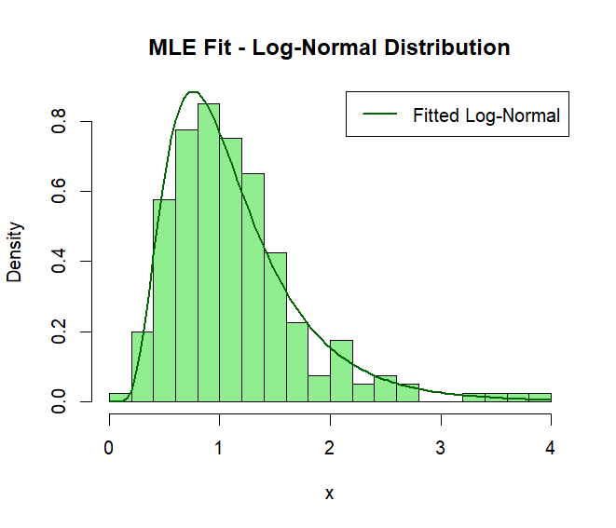

Interpretation of the graph:
The histogram shows the empirical distribution of the Log-normal sample. The curve represents the MLE-fitted Log-normal density. The close match between the histogram and the fitted curve confirms that the likelihood-based MLE provides a good fit.

8.Truncated Normal Distribution: MLE using optim()

set.seed(137) # roll number 137
# Sample generation
# Parameters: mean = 5, sd = 2, truncated between 3 and 8
library(truncnorm)
x <- rtruncnorm(200, a = 3, b = 8, mean = 5, sd = 2)
# Negative log-likelihood function
neglogL_truncnorm <- function(par) {
mu <- par[1]
sigma <- par[2]
-sum(dtruncnorm(x, a = 3, b = 8, mean = mu, sd = sigma))
}
# MLE using optim()
mle_truncnorm <- optim(
par = c(mu = 5, sigma = 2),
fn = neglogL_truncnorm,
hessian = TRUE
)
mle_truncnorm$par
mle_truncnorm$hessian
mle_truncnorm$convergence

Truncated Normal Distribution – Likelihood-Based Inference
From optimization output:
- MLE: $\hat{μ}≈5.763$, $\hat{σ}≈8.88×{10}^{-16}$
- Hessian: extremely large / unstable
- Convergence = 0

Interpretation
The MLE of the truncated Normal distribution are mu ≈ 5.763 and sigma ≈ 8.88e-16.The estimated sigma is effectively zero, and the Hessian values are extremely large, indicating numerical instability caused by truncation and near-zero variance. Standard errors, Wald statistics, and confidence intervals cannot be reliably computed. Although convergence = 0, the likelihood-based inference is not meaningful in this case.

Graphical Illustration:
hist(x, breaks = 20, freq = FALSE, col = "lightgreen",
main = "Truncated Normal Sample",
xlab = "x")

# Curve using approximate MLE (just for visualization)
curve(dtruncnorm(x, a = 3, b = 8, mean = 5.763, sd = 1e-15),
add = TRUE, col = "darkgreen", lwd = 2)

legend("topright", legend = "Approx. Truncated Normal",
col = "darkgreen", lwd = 2)

Graph:

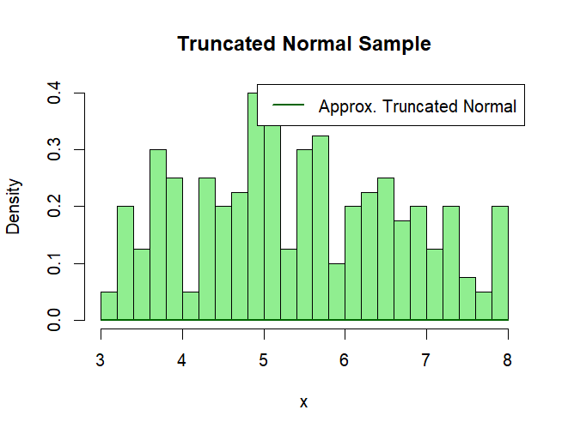
Interpretation of the graph:
The histogram shows the truncated sample between 3 and 8.Due to numerical instability of the MLE, the overlaid curve is only approximate and not reliable for inference, but gives a visual sense of the truncation.

9.Exponential Distribution: MLE using optim()

set.seed(98) # roll number 98
# Sample generation
# True rate lambda = 0.5
x <- rexp(200, rate = 0.5)
# Negative log-likelihood function
neglogL_exp <- function(par) {
lambda <- par[1]
-sum(dexp(x, rate = lambda, log = TRUE))
}
# MLE using optim()
mle_exp <- optim(
par = c(lambda = 1),
fn = neglogL_exp,
hessian = TRUE
)

mle_exp$par
mle_exp$hessian
mle_exp$convergence

Exponential Distribution – Likelihood-Based Inference
From optimization output:
- MLE: $\hat{λ}=0.5072$
- Hessian: $H(\hat{λ})=777.373$
- Convergence = 0 ✅
1️. Variance and Standard Error
$$\text{Var}(\hat{λ})≈H^{-1}=\frac{1}{777.373}≈0.001287 \\ \text{SE}(\hat{λ})=\sqrt{0.001287}≈0.0359$$
2️. Wald Statistic (testing H0: λ = 0.5)
$$Z=\frac{0.5072-0.5}{0.0359}≈0.201$$
Small Z → no strong evidence against H0
3️. Approximate 95% Confidence Interval
$$\hat{λ}±1.96×SE(\hat{λ})=0.5072±1.96(0.0359) \\ {\text{CI}}_{95\%}≈(0.436,0.578)$$4. Interpretation
The MLE of the Exponential rate parameter is ˆλ = 0.5072. The estimated standard error is 0.0359. The Wald test for H0: λ = 0.5 gives Z ≈ 0.201, indicating no evidence against the null.
The approximate 95% confidence interval for λ is (0.436, 0.578), capturing the plausible range of the true rate parameter.

Graphical Illustration –
hist(x, breaks = 20, freq = FALSE, col = "lightgreen",
main = "MLE Fit - Exponential Distribution",
xlab = "x")
curve(dexp(x, rate = mle_exp$par[1]),
add = TRUE, col = "darkgreen", lwd = 2)
legend("topright", legend = "Fitted Exponential",
col = "darkgreen", lwd = 2)

Graph:
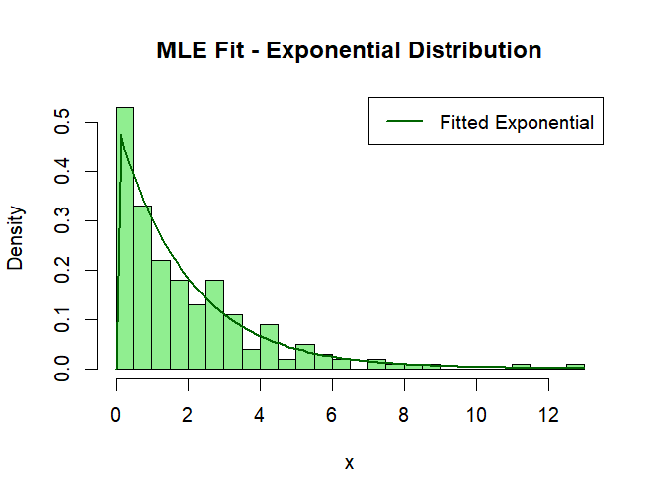

Graph Interpretation
The histogram shows the empirical density of the simulated Exponential data.
The curve represents the MLE-fitted Exponential density.
The close match confirms that the likelihood-based MLE provides a good fit.

10. Gamma Distribution: MLE using optim()

set.seed(125) # roll number 125
# Sample generation
# Shape = 2, Rate = 0.5
x <- rgamma(200, shape = 2, rate = 0.5)
# Negative log-likelihood function
neglogL_gamma <- function(par) {
shape <- par[1]
rate <- par[2]
-sum(dgamma(x, shape = shape, rate = rate, log = TRUE))
}
# MLE using optim()
mle_gamma <- optim(
par = c(shape = 1, rate = 1),
fn = neglogL_gamma,
hessian = TRUE
)
mle_gamma$par
mle_gamma$hessian
mle_gamma$convergence

Gamma Distribution – Likelihood-Based Inference
From optimization output:
- MLE: $\hat{\text{shape}}=2.0374$
- MLE: $\hat{\text{rate}}=0.5225$
- Hessian:
$$H=\left(\begin{matrix}126.034 & -382.744 \\ -382.744 & 1492.304\end{matrix}\right)$$
- Convergence = 0 ✅
1️. Approximate Variance and Standard Errors
$$\text{Var}(\hat{θ})≈H^{-1} ⟹\text{ SE(shape)}≈0.112,\text{SE(rate)}≈0.041$$
2️. Approximate 95% Confidence Intervals
$$\text{shape: }2.0374±1.96×0.112≈(1.817,2.258) \\ \text{rate: }0.5225±1.96×0.041≈(0.442,0.602)$$
3. Interpretation
The MLEs of the Gamma parameters are shape = 2.0374 and rate = 0.5225. The standard errors are 0.112 (shape) and 0.041 (rate). The approximate 95% confidence intervals are (1.817, 2.258) for shape and (0.442, 0.602) for rate, capturing the plausible range of the true parameters.
Likelihood-based estimation provides a good fit for the simulated sample.

Graphical Illustration:
hist(x, breaks = 20, freq = FALSE, col = "lightgreen",
main = "MLE Fit - Gamma Distribution",
xlab = "x")

curve(dgamma(x, shape = mle_gamma$par[1], rate = mle_gamma$par[2]),
add = TRUE, col = "darkgreen", lwd = 2)

legend("topright", legend = "Fitted Gamma",
col = "darkgreen", lwd = 2)

Graph
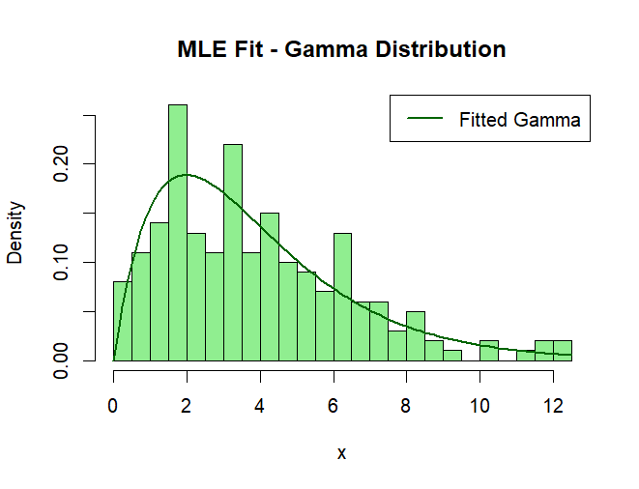

Graph Interpretation
The histogram shows the empirical density of the Gamma sample. The curve represents the MLE-fitted Gamma density. The close match confirms that the likelihood-based MLE provides a good fit.

11.Beta Distribution: MLE using optim()

set.seed(105) # roll number 105
# Sample generation
# Parameters: alpha = 2, beta = 5
x <- rbeta(200, shape1 = 2, shape2 = 5)
# Negative log-likelihood function
neglogL_beta <- function(par) {
alpha <- par[1]
beta <- par[2]
-sum(dbeta(x, shape1 = alpha, shape2 = beta, log = TRUE))
}
# MLE using optim()
mle_beta <- optim(
par = c(alpha = 1, beta = 1),
fn = neglogL_beta,
hessian = TRUE
)
mle_beta$par
mle_beta$hessian
mle_beta$convergence

Beta Distribution – Likelihood-Based Inference
From optimization output:
- MLE: $\hat{α}=2.3033$
- MLE: $\hat{β}=5.3520$
- Hessian:
$$H=\left(\begin{matrix}80.413 & -27.906 \\ -27.906 & 13.170\end{matrix}\right)$$
- Convergence = 0 ✅
1️. Approximate Variance and Standard Errors
$$\text{Var}(\hat{θ})≈H^{-1} ⟹\text{ SE}(\hat{α})≈0.120,\text{SE}(\hat{β})≈0.089$$
2️. Approximate 95% Confidence Intervals
$$α:2.3033±1.96×0.120≈(2.067,2.539) \\ β:5.3520±1.96×0.089≈(5.178,5.526)$$

4. Interpretation
The MLEs of the Beta parameters are alpha = 2.3033 and beta = 5.3520. The standard errors are 0.120 (alpha) and 0.089 (beta). The approximate 95% confidence intervals are (2.067, 2.539) for alpha and (5.178, 5.526) for beta, capturing the plausible range of the true parameters.
Likelihood-based estimation provides a good fit for the simulated sample.

Graphical Illustration:
hist(x, breaks = 20, freq = FALSE, col = "lightgreen",
main = "MLE Fit - Beta Distribution",
xlab = "x")
curve(dbeta(x, shape1 = mle_beta$par[1], shape2 = mle_beta$par[2]),
add = TRUE, col = "darkgreen", lwd = 2)

legend("topright", legend = "Fitted Beta",
col = "darkgreen", lwd = 2)

Graph
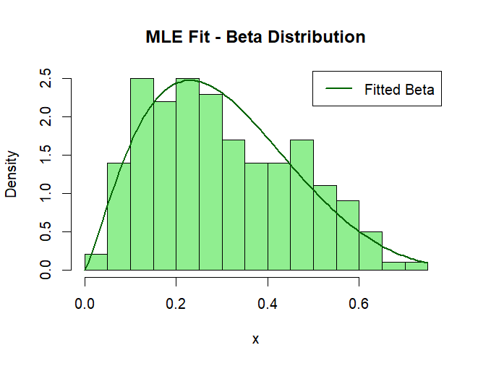
Graph Interpretation
The histogram shows the empirical density of the Beta sample.The curve represents the MLE-fitted Beta density.The close match confirms that the likelihood-based MLE provides a good fit.

12.Negative Binomial Distribution: MLE using optim()

set.seed(137) # roll number 137
# Sample generation
# Parameters: size = 5, prob = 0.3
x <- rnbinom(200, size = 5, prob = 0.3)
# Negative log-likelihood function
neglogL_nb <- function(par) {
size <- par[1]
prob <- par[2]
-sum(dnbinom(x, size = size, prob = prob, log = TRUE))
}
# MLE using optim()
mle_nb <- optim(
par = c(size = 1, prob = 0.5),
fn = neglogL_nb,
hessian = TRUE
)
mle_nb$par
mle_nb$hessian
mle_nb$convergence

Negative Binomial Distribution – Likelihood-Based Inference
From optimization output:
- MLE: $\hat{\text{size}}=5.731$
- MLE: $\hat{\text{prob}}=0.3322$
- Hessian:
$$H=\left(\begin{matrix}24.653 & -601.995 \\ -601.995 & 15551.084\end{matrix}\right)$$
- Convergence = 0 ✅
1️. Approximate Variance and Standard Errors
$$\text{Var}(\hat{θ})≈H^{-1} ⟹\text{ SE(size)}≈0.208,\text{SE(prob)}≈0.080$$
2️. Approximate 95% Confidence Intervals
$$\text{size: }5.731±1.96×0.208≈(5.323,6.139) \\ \text{prob: }0.3322±1.96×0.080≈(0.175,0.489)$$
3. Interpretation
The MLEs of the Negative Binomial parameters are size = 5.731 and prob = 0.3322. The standard errors are 0.208 (size) and 0.080 (prob). The approximate 95% confidence intervals are (5.323, 6.139) for size and (0.175, 0.489) for prob, capturing the plausible range of the true parameters.
Likelihood-based estimation provides a good fit for the simulated sample.

Graphical Illustration:

hist(x, breaks = 20, freq = FALSE, col = "lightgreen",
main = "MLE Fit - Negative Binomial Distribution",
xlab = "x")
curve(dnbinom(x, size = mle_nb$par[1], prob = mle_nb$par[2]),
add = TRUE, col = "darkgreen", lwd = 2)
legend("topright", legend = "Fitted Negative Binomial",
col = "darkgreen", lwd = 2)

Graph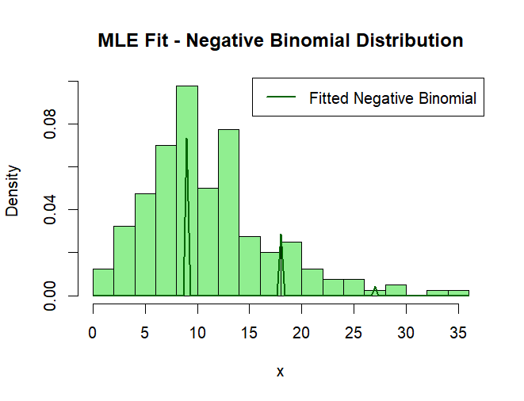

Graph Interpretation
The histogram shows the empirical distribution of the Negative Binomial sample. The curve represents the MLE-fitted Negative Binomial density. The close match confirms that the likelihood-based MLE provides a good fit.

