BMIN503 Final Project: Disparities in managing migraine pain in the pediatric ER

Sansanee Craig

December 11, 2018

## Overview

Racial disparities in pain management have been documented in the adult and pediatric population. Most studies have focused on pathologies with definitive diagnostic testing, such as appendicitis, long-bone fractures, and sickle cell disease. Few studies have assessed variability of pain management in pediatric migraine. The purpose of this project is to utilize secondary analysis of EHR data to determine if race/ethnicity-based differences exist in the management of pediatric migraine pain in the emergency room at the Childrenâs Hospital of Philadelphia (CHOP).

## Introduction

Pain management cross-sects most fields of medical practice. In the case of migraine pain, a patientâs care team may comprise a primary care physician and a neurologist, with ER and hospitalist providers added during refractory migraine episodes. Alleviating pain efficiently, safely, and equally for all patients is the ultimate goal during an emergency room visit. In the few pediatric studies to date, however, some sociodemographic disparities have been shown to exist in pediatric headache care across the United States.  
In beginning to study this issue, thoughtful data queries in conjunction with data analysts is vital as the choices behind codifying race and ethnicity alone could significantly alter study results. Workflow analysis during direct observations in the ER provides insight into missing field factors, such as non-mandatory data entry in assigning a pain scale/score or completing demographic fields. Nursesâ feedback sheds light on why pain reassessment alerts were being ignored or pain scales not being assigned during registration. Discussions with ER physicians and the ER director provides background information on previous disparities study results and QI projects, identifying most relevant outcome to study, and factors in choosing which statistical result to report. Meeting with a pediatric neurologist, the director of the headache clinic, results in an additional view of focusing QI efforts on giving primary care providers better tools to care for migraine pain in order to decrease unnecessary neurology referrals or ER visits. In short, data scientists and quality improvement (QI) teams can contribute to understanding the best methods to study where these disparities lie and how to rapidly conduct improvement projects to decrease known disparities. Clinical informaticists help to facilitate change management by navigating the socio-technical factors in hospital and clinic organizations. Thus, this is a multidisciplinary project with stakeholders spanning the field biomedical and health informatics.

## Methods

The data used in this project were imported as a CSV file from Qlikview, a software that displays results from SQL queries written by CHOP data analysts. This SQL query specifically pulls data from the CHOP EMR (Epic) on patients ages 5 -18 who were treated with the migraine pain order set in the CHOP ER. Results exported as .xlsx file were de-identified before saving as a .csv file for import to R. All data available in Qlikview were imported without filtering. One observation was noted to be missing MRN and 20 other variables, so was assumed error and deleted before import.

### Data loading and cleaning

#### Load data set, assign NA’s, transform variable classes

data_all<- read.csv("https://raw.githubusercontent.com/scraig10/BMIN503_Final_Project/master/data_all_11_28_2018.csv", header=TRUE)  
str(data_all) # 3709 observations of 33 variables

## 'data.frame': 3709 obs. of 33 variables:  
## $ X : int 1 2 3 4 5 6 7 8 9 10 ...  
## $ ED.Arrive : Factor w/ 3709 levels "1/1/2016 12:23",..: 998 997 993 992 985 984 983 968 967 966 ...  
## $ ED.LOS..min. : Factor w/ 638 levels "-","1,018","1,022",..: 163 1 195 193 477 49 178 121 88 141 ...  
## $ Pathway : Factor w/ 2 levels "No","Yes": 2 2 2 2 2 2 2 2 2 2 ...  
## $ Sex : Factor w/ 2 levels "F","M": 2 1 1 2 1 1 1 1 1 2 ...  
## $ Race.Ethnicity : Factor w/ 4 levels "HISPANIC OR LATINO",..: 4 1 3 2 2 4 1 3 2 3 ...  
## $ Payer.Type : Factor w/ 3 levels "-","COMMERCIAL",..: 2 3 3 3 3 2 2 2 3 2 ...  
## $ Primary.Language : Factor w/ 2 levels "ENGLISH","NON-ENGLISH": 1 1 1 1 1 1 1 1 1 1 ...  
## $ Acuity : Factor w/ 5 levels "1 Critical","2 Acute",..: 3 3 3 3 3 4 3 3 3 3 ...  
## $ CCC : Factor w/ 2 levels "No","Yes": 1 1 2 2 2 2 1 2 1 2 ...  
## $ HCG : Factor w/ 2 levels "No","Yes": 1 1 2 1 2 1 2 2 2 1 ...  
## $ HCG.Result : Factor w/ 1830 levels "-","1/1/2015 0:31",..: 1 1 493 1 1 1 492 484 483 1 ...  
## $ Arrive.to.Room : int 11 32 12 3 2 4 3 5 10 4 ...  
## $ Room.to.MD.Eval : int 30 31 12 23 1 10 7 3 2 4 ...  
## $ MD.Eval.to.First.Med.Order : Factor w/ 299 levels "-","-1","-10",..: 176 1 1 244 227 185 222 181 162 211 ...  
## $ X1st.Med.Ordered.to.Started : Factor w/ 164 levels "-","-1","-1,170",..: 99 1 1 64 38 79 95 115 107 64 ...  
## $ X1st.Med.Started.to.Given : Factor w/ 259 levels "-","0","1","1,000",..: 127 1 1 68 250 2 259 96 115 2 ...  
## $ Bolus.Start : Factor w/ 2861 levels "-","1/1/2015 2:31",..: 762 1 1 760 759 1 753 741 740 1 ...  
## $ Toradol.Given : Factor w/ 2555 levels "-","1/1/2015 2:41",..: 1 1 1 686 687 1 681 1 670 1 ...  
## $ Reglan.Start : Factor w/ 2930 levels "-","1/1/2015 2:42",..: 781 1 1 777 778 770 1 755 754 753 ...  
## $ Reglan.Given : Factor w/ 2933 levels "-","1/1/2015 2:42",..: 779 1 1 775 776 768 1 753 752 751 ...  
## $ Reglan.Infusion.Time : Factor w/ 130 levels "-","-17","-7",..: 27 1 1 124 62 4 1 27 27 4 ...  
## $ Reglan.Route : Factor w/ 4 levels "-","Intravenous",..: 2 1 1 2 2 4 1 2 2 4 ...  
## $ Arrive.to.1st.Med.Given : Factor w/ 398 levels "-","100","101",..: 26 1 1 352 318 345 77 2 395 335 ...  
## $ X1st.Med.Reassessment : Factor w/ 219 levels "-","100","101",..: 182 1 1 206 182 1 1 14 1 1 ...  
## $ X1st.Med.Given.to.2nd.Med.Ordered: Factor w/ 319 levels "-","-1","-10",..: 1 1 1 1 1 1 1 1 1 1 ...  
## $ Initial.2nd.Med.Given : Factor w/ 4 levels "-","MAGNESIUM SULFATE",..: 1 1 4 1 1 1 1 1 1 1 ...  
## $ X2nd.Med.Reassessment : Factor w/ 180 levels "-","100","101",..: 1 1 97 1 1 1 1 1 1 1 ...  
## $ X2nd.Meds.Given : Factor w/ 9 levels "-","ALL","MAGNESIUM SULFATE",..: 6 1 7 6 6 6 6 6 6 6 ...  
## $ X72hr.Revisit : Factor w/ 2 levels "No","Yes": 1 1 1 1 1 1 1 1 1 1 ...  
## $ X7d.Revisit : Factor w/ 2 levels "No","Yes": 1 1 1 1 1 1 1 1 1 1 ...  
## $ Dispo : Factor w/ 2 levels "Admitted","Discharged": 2 2 1 2 2 2 2 2 2 2 ...  
## $ Team.Assessment. : Factor w/ 3 levels "-","0","1": 2 2 2 2 2 2 2 2 2 2 ...

summary(data_all) #First glance, it seems there are no missing variables.

## X ED.Arrive ED.LOS..min. Pathway Sex   
## Min. : 1 1/1/2016 12:23 : 1 213 : 22 No : 645 F:2615   
## 1st Qu.: 928 1/1/2017 11:18 : 1 255 : 22 Yes:3064 M:1094   
## Median :1855 1/10/2014 12:17: 1 199 : 20   
## Mean :1855 1/10/2016 18:34: 1 261 : 20   
## 3rd Qu.:2782 1/10/2016 19:26: 1 216 : 19   
## Max. :3709 1/10/2017 14:10: 1 204 : 18   
## (Other) :3703 (Other):3588   
## Race.Ethnicity Payer.Type Primary.Language  
## HISPANIC OR LATINO: 264 - : 112 ENGLISH :3641   
## NON-HISPANIC BLACK:1514 COMMERCIAL :2089 NON-ENGLISH: 68   
## NON-HISPANIC WHITE:1750 MEDICAL ASSISTANCE:1508   
## OTHER : 181   
##   
##   
##   
## Acuity CCC HCG HCG.Result   
## 1 Critical : 7 No :2095 No :1664 - :1873   
## 2 Acute : 623 Yes:1614 Yes:2045 1/31/2015 19:01 : 2   
## 3 Urgent :2753 11/7/2014 11:55 : 2   
## 4 Urgent : 312 12/11/2017 21:18: 2   
## 5 Non-Urgent: 14 2/25/2014 20:26 : 2   
## 3/24/2015 10:20 : 2   
## (Other) :1826   
## Arrive.to.Room Room.to.MD.Eval MD.Eval.to.First.Med.Order  
## Min. :-56.00 Min. :-15.00 - : 451   
## 1st Qu.: 4.00 1st Qu.: 3.00 19 : 67   
## Median : 9.00 Median : 9.00 20 : 63   
## Mean : 24.84 Mean : 19.41 23 : 61   
## 3rd Qu.: 29.00 3rd Qu.: 26.00 29 : 59   
## Max. :405.00 Max. :293.00 26 : 58   
## (Other):2950   
## X1st.Med.Ordered.to.Started X1st.Med.Started.to.Given  
## - : 451 0 : 563   
## 21 : 90 - : 451   
## 27 : 89 1 : 75   
## 26 : 88 20 : 71   
## 24 : 87 21 : 63   
## 23 : 83 18 : 61   
## (Other):2821 (Other):2425   
## Bolus.Start Toradol.Given Reglan.Start   
## - : 846 - :1153 - : 771   
## 1/30/2015 9:00 : 2 12/17/2014 21:14: 2 1/28/2014 15:30 : 2   
## 3/17/2014 21:30: 2 3/7/2016 15:45 : 2 10/9/2017 12:16 : 2   
## 9/7/2017 13:30 : 2 1/1/2015 2:41 : 1 11/11/2014 17:39: 2   
## 1/1/2015 2:31 : 1 1/1/2016 13:38 : 1 12/10/2015 18:19: 2   
## 1/1/2016 13:43 : 1 1/1/2017 17:44 : 1 12/16/2015 14:45: 2   
## (Other) :2855 (Other) :2549 (Other) :2928   
## Reglan.Given Reglan.Infusion.Time Reglan.Route   
## - : 771 0 :1297 - : 771   
## 1/28/2014 15:30 : 2 - : 771 Intravenous :2505   
## 1/28/2016 16:44 : 2 15 : 325 NOT APPLICABLE: 1   
## 10/9/2017 12:16 : 2 20 : 89 Oral : 432   
## 11/11/2014 17:39: 2 16 : 60   
## 12/16/2015 15:00: 2 30 : 57   
## (Other) :2928 (Other):1110   
## Arrive.to.1st.Med.Given X1st.Med.Reassessment  
## - : 451 - :1278   
## 153 : 31 44 : 54   
## 102 : 29 46 : 46   
## 131 : 29 42 : 44   
## 109 : 28 36 : 41   
## 113 : 28 37 : 40   
## (Other):3113 (Other):2206   
## X1st.Med.Given.to.2nd.Med.Ordered Initial.2nd.Med.Given  
## - :2607 - :2600   
## 49 : 20 MAGNESIUM SULFATE : 70   
## 37 : 16 METHYLPREDNISOLONE: 292   
## 72 : 16 VALPROATE : 747   
## 53 : 14   
## 50 : 13   
## (Other):1023   
## X2nd.Med.Reassessment X2nd.Meds.Given X72hr.Revisit  
## - :2973 NONE :2406 No :3600   
## 20 : 18 VALPROATE : 463 Yes: 109   
## 60 : 16 VALPROATE, METHYLPREDNISOLONE: 273   
## 31 : 15 - : 194   
## 32 : 14 METHYLPREDNISOLONE : 172   
## 55 : 14 ALL : 75   
## (Other): 659 (Other) : 126   
## X7d.Revisit Dispo Team.Assessment.  
## No :3524 Admitted : 597 -: 4   
## Yes: 185 Discharged:3112 0:3414   
## 1: 291   
##   
##   
##   
##

pct_miss_var(data_all) #No missing data values , using NaNiar package

## [1] 0

table_miss_var <- miss_var_table(data_all) # create table of all missing data in all variables  
print(table_miss_var) #Zero data missing in all 33 variables that comprise 100% of the data set

## # A tibble: 1 x 3  
## n_miss_in_var n_vars pct_vars  
## <int> <int> <dbl>  
## 1 0 33 100

sum(is.na(data_all)) #Similarly, there are zero NAs

## [1] 0

Hmisc::describe(data_all) # But then I realized counts show values with dashes, so that is how missing data is being coded in this data set. Hmisc package outlines descriptive statistics in visually appealing format

## data_all   
##   
## 33 Variables 3709 Observations  
## ---------------------------------------------------------------------------  
## X   
## n missing distinct Info Mean Gmd .05 .10   
## 3709 0 3709 1 1855 1237 186.4 371.8   
## .25 .50 .75 .90 .95   
## 928.0 1855.0 2782.0 3338.2 3523.6   
##   
## lowest : 1 2 3 4 5, highest: 3705 3706 3707 3708 3709  
## ---------------------------------------------------------------------------  
## ED.Arrive   
## n missing distinct   
## 3709 0 3709   
##   
## lowest : 1/1/2016 12:23 1/1/2017 11:18 1/10/2014 12:17 1/10/2016 18:34 1/10/2016 19:26  
## highest: 9/9/2017 15:20 9/9/2017 17:31 9/9/2017 21:06 9/9/2018 13:16 9/9/2018 17:50   
## ---------------------------------------------------------------------------  
## ED.LOS..min.   
## n missing distinct   
## 3709 0 638   
##   
## lowest : - 1,018 1,022 1,049 1,054, highest: 972 975 98 981 99   
## ---------------------------------------------------------------------------  
## Pathway   
## n missing distinct   
## 3709 0 2   
##   
## Value No Yes  
## Frequency 645 3064  
## Proportion 0.174 0.826  
## ---------------------------------------------------------------------------  
## Sex   
## n missing distinct   
## 3709 0 2   
##   
## Value F M  
## Frequency 2615 1094  
## Proportion 0.705 0.295  
## ---------------------------------------------------------------------------  
## Race.Ethnicity   
## n missing distinct   
## 3709 0 4   
##   
## Value HISPANIC OR LATINO NON-HISPANIC BLACK NON-HISPANIC WHITE  
## Frequency 264 1514 1750  
## Proportion 0.071 0.408 0.472  
##   
## Value OTHER  
## Frequency 181  
## Proportion 0.049  
## ---------------------------------------------------------------------------  
## Payer.Type   
## n missing distinct   
## 3709 0 3   
##   
## Value - COMMERCIAL MEDICAL ASSISTANCE  
## Frequency 112 2089 1508  
## Proportion 0.030 0.563 0.407  
## ---------------------------------------------------------------------------  
## Primary.Language   
## n missing distinct   
## 3709 0 2   
##   
## Value ENGLISH NON-ENGLISH  
## Frequency 3641 68  
## Proportion 0.982 0.018  
## ---------------------------------------------------------------------------  
## Acuity   
## n missing distinct   
## 3709 0 5   
##   
## Value 1 Critical 2 Acute 3 Urgent 4 Urgent  
## Frequency 7 623 2753 312  
## Proportion 0.002 0.168 0.742 0.084  
##   
## Value 5 Non-Urgent  
## Frequency 14  
## Proportion 0.004  
## ---------------------------------------------------------------------------  
## CCC   
## n missing distinct   
## 3709 0 2   
##   
## Value No Yes  
## Frequency 2095 1614  
## Proportion 0.565 0.435  
## ---------------------------------------------------------------------------  
## HCG   
## n missing distinct   
## 3709 0 2   
##   
## Value No Yes  
## Frequency 1664 2045  
## Proportion 0.449 0.551  
## ---------------------------------------------------------------------------  
## HCG.Result   
## n missing distinct   
## 3709 0 1830   
##   
## lowest : - 1/1/2015 0:31 1/10/2017 16:46 1/10/2017 19:53 1/10/2017 22:50  
## highest: 9/9/2014 22:16 9/9/2016 0:05 9/9/2016 22:45 9/9/2018 15:35 9/9/2018 20:09   
## ---------------------------------------------------------------------------  
## Arrive.to.Room   
## n missing distinct Info Mean Gmd .05 .10   
## 3709 0 193 0.998 24.84 31.67 2 2   
## .25 .50 .75 .90 .95   
## 4 9 29 71 102   
##   
## lowest : -56 -51 0 1 2, highest: 255 285 310 362 405  
## ---------------------------------------------------------------------------  
## Room.to.MD.Eval   
## n missing distinct Info Mean Gmd .05 .10   
## 3709 0 159 0.997 19.41 24.2 1 1   
## .25 .50 .75 .90 .95   
## 3 9 26 52 72   
##   
## lowest : -15 -13 -6 -5 -4, highest: 216 232 239 258 293  
## ---------------------------------------------------------------------------  
## MD.Eval.to.First.Med.Order   
## n missing distinct   
## 3709 0 299   
##   
## lowest : - -1 -10 -102 -12 , highest: 95 96 97 98 99   
## ---------------------------------------------------------------------------  
## X1st.Med.Ordered.to.Started   
## n missing distinct   
## 3709 0 164   
##   
## lowest : - -1 -1,170 -1,179 -1,265, highest: 95 96 97 98 99   
## ---------------------------------------------------------------------------  
## X1st.Med.Started.to.Given   
## n missing distinct   
## 3709 0 259   
##   
## lowest : - 0 1 1,000 1,243, highest: 95 96 97 98 99   
## ---------------------------------------------------------------------------  
## Bolus.Start   
## n missing distinct   
## 3709 0 2861   
##   
## lowest : - 1/1/2015 2:31 1/1/2016 13:43 1/1/2017 13:29 1/10/2014 16:25  
## highest: 9/9/2015 17:35 9/9/2017 15:54 9/9/2017 2:59 9/9/2018 13:52 9/9/2018 19:53   
## ---------------------------------------------------------------------------  
## Toradol.Given   
## n missing distinct   
## 3709 0 2555   
##   
## lowest : - 1/1/2015 2:41 1/1/2016 13:38 1/1/2017 17:44 1/10/2014 16:30  
## highest: 9/9/2015 17:38 9/9/2017 15:57 9/9/2017 5:56 9/9/2018 14:46 9/9/2018 19:55   
## ---------------------------------------------------------------------------  
## Reglan.Start   
## n missing distinct   
## 3709 0 2930   
##   
## lowest : - 1/1/2015 2:42 1/1/2016 13:43 1/1/2017 17:29 1/10/2014 16:35  
## highest: 9/9/2015 12:47 9/9/2017 15:56 9/9/2017 2:59 9/9/2017 23:48 9/9/2018 14:51   
## ---------------------------------------------------------------------------  
## Reglan.Given   
## n missing distinct   
## 3709 0 2933   
##   
## lowest : - 1/1/2015 2:42 1/1/2016 14:57 1/1/2017 17:45 1/10/2014 16:35  
## highest: 9/9/2016 0:50 9/9/2017 16:32 9/9/2017 23:48 9/9/2017 3:59 9/9/2018 15:06   
## ---------------------------------------------------------------------------  
## Reglan.Infusion.Time   
## n missing distinct   
## 3709 0 130   
##   
## lowest : - -17 -7 0 1 , highest: 92 94 95 96 98   
## ---------------------------------------------------------------------------  
## Reglan.Route   
## n missing distinct   
## 3709 0 4   
##   
## Value - Intravenous NOT APPLICABLE Oral  
## Frequency 771 2505 1 432  
## Proportion 0.208 0.675 0.000 0.116  
## ---------------------------------------------------------------------------  
## Arrive.to.1st.Med.Given   
## n missing distinct   
## 3709 0 398   
##   
## lowest : - 100 101 102 103, highest: 95 96 97 98 99   
## ---------------------------------------------------------------------------  
## X1st.Med.Reassessment   
## n missing distinct   
## 3709 0 219   
##   
## lowest : - 100 101 102 103, highest: 95 96 97 98 99   
## ---------------------------------------------------------------------------  
## X1st.Med.Given.to.2nd.Med.Ordered   
## n missing distinct   
## 3709 0 319   
##   
## lowest : - -1 -10 -100 -101, highest: 95 96 97 98 99   
## ---------------------------------------------------------------------------  
## Initial.2nd.Med.Given   
## n missing distinct   
## 3709 0 4   
##   
## Value - MAGNESIUM SULFATE METHYLPREDNISOLONE  
## Frequency 2600 70 292  
## Proportion 0.701 0.019 0.079  
##   
## Value VALPROATE  
## Frequency 747  
## Proportion 0.201  
## ---------------------------------------------------------------------------  
## X2nd.Med.Reassessment   
## n missing distinct   
## 3709 0 180   
##   
## lowest : - 100 101 102 103, highest: 95 96 97 98 99   
## ---------------------------------------------------------------------------  
## X2nd.Meds.Given   
## n missing distinct   
## 3709 0 9   
##   
## - (194, 0.052), ALL (75, 0.020), MAGNESIUM SULFATE (42, 0.011),  
## METHYLPREDNISOLONE (172, 0.046), METHYLPREDNISOLONE, MAGNESIUM SULFATE  
## (20, 0.005), NONE (2406, 0.649), VALPROATE (463, 0.125), VALPROATE,  
## MAGNESIUM SULFATE (64, 0.017), VALPROATE, METHYLPREDNISOLONE (273, 0.074)  
## ---------------------------------------------------------------------------  
## X72hr.Revisit   
## n missing distinct   
## 3709 0 2   
##   
## Value No Yes  
## Frequency 3600 109  
## Proportion 0.971 0.029  
## ---------------------------------------------------------------------------  
## X7d.Revisit   
## n missing distinct   
## 3709 0 2   
##   
## Value No Yes  
## Frequency 3524 185  
## Proportion 0.95 0.05  
## ---------------------------------------------------------------------------  
## Dispo   
## n missing distinct   
## 3709 0 2   
##   
## Value Admitted Discharged  
## Frequency 597 3112  
## Proportion 0.161 0.839  
## ---------------------------------------------------------------------------  
## Team.Assessment.   
## n missing distinct   
## 3709 0 3   
##   
## Value - 0 1  
## Frequency 4 3414 291  
## Proportion 0.001 0.920 0.078  
## ---------------------------------------------------------------------------

data_all_na <- read.csv("https://raw.githubusercontent.com/scraig10/BMIN503_Final_Project/master/data_all_11_28_2018.csv", header=T, na.strings=c(""," ","NA", "-")) #assign NAs to blanks, spaces, and dashes  
summary(data_all_na) #Now, NA's appear in the summary tables

## X ED.Arrive ED.LOS..min. Pathway Sex   
## Min. : 1 1/1/2016 12:23 : 1 213 : 22 No : 645 F:2615   
## 1st Qu.: 928 1/1/2017 11:18 : 1 255 : 22 Yes:3064 M:1094   
## Median :1855 1/10/2014 12:17: 1 199 : 20   
## Mean :1855 1/10/2016 18:34: 1 261 : 20   
## 3rd Qu.:2782 1/10/2016 19:26: 1 216 : 19   
## Max. :3709 1/10/2017 14:10: 1 (Other):3605   
## (Other) :3703 NA's : 1   
## Race.Ethnicity Payer.Type Primary.Language  
## HISPANIC OR LATINO: 264 COMMERCIAL :2089 ENGLISH :3641   
## NON-HISPANIC BLACK:1514 MEDICAL ASSISTANCE:1508 NON-ENGLISH: 68   
## NON-HISPANIC WHITE:1750 NA's : 112   
## OTHER : 181   
##   
##   
##   
## Acuity CCC HCG HCG.Result   
## 1 Critical : 7 No :2095 No :1664 1/31/2015 19:01 : 2   
## 2 Acute : 623 Yes:1614 Yes:2045 11/7/2014 11:55 : 2   
## 3 Urgent :2753 12/11/2017 21:18: 2   
## 4 Urgent : 312 2/25/2014 20:26 : 2   
## 5 Non-Urgent: 14 3/24/2015 10:20 : 2   
## (Other) :1826   
## NA's :1873   
## Arrive.to.Room Room.to.MD.Eval MD.Eval.to.First.Med.Order  
## Min. :-56.00 Min. :-15.00 Min. :-128.00   
## 1st Qu.: 4.00 1st Qu.: 3.00 1st Qu.: 21.00   
## Median : 9.00 Median : 9.00 Median : 37.00   
## Mean : 24.84 Mean : 19.41 Mean : 48.52   
## 3rd Qu.: 29.00 3rd Qu.: 26.00 3rd Qu.: 61.00   
## Max. :405.00 Max. :293.00 Max. : 536.00   
## NA's :451   
## X1st.Med.Ordered.to.Started X1st.Med.Started.to.Given  
## 21 : 90 0 : 563   
## 27 : 89 1 : 75   
## 26 : 88 20 : 71   
## 24 : 87 21 : 63   
## 23 : 83 18 : 61   
## (Other):2821 (Other):2425   
## NA's : 451 NA's : 451   
## Bolus.Start Toradol.Given Reglan.Start   
## 1/30/2015 9:00 : 2 12/17/2014 21:14: 2 1/28/2014 15:30 : 2   
## 3/17/2014 21:30: 2 3/7/2016 15:45 : 2 10/9/2017 12:16 : 2   
## 9/7/2017 13:30 : 2 1/1/2015 2:41 : 1 11/11/2014 17:39: 2   
## 1/1/2015 2:31 : 1 1/1/2016 13:38 : 1 12/10/2015 18:19: 2   
## 1/1/2016 13:43 : 1 1/1/2017 17:44 : 1 12/16/2015 14:45: 2   
## (Other) :2855 (Other) :2549 (Other) :2928   
## NA's : 846 NA's :1153 NA's : 771   
## Reglan.Given Reglan.Infusion.Time Reglan.Route   
## 1/28/2014 15:30 : 2 0 :1297 Intravenous :2505   
## 1/28/2016 16:44 : 2 15 : 325 NOT APPLICABLE: 1   
## 10/9/2017 12:16 : 2 20 : 89 Oral : 432   
## 11/11/2014 17:39: 2 16 : 60 NA's : 771   
## 12/16/2015 15:00: 2 30 : 57   
## (Other) :2928 (Other):1110   
## NA's : 771 NA's : 771   
## Arrive.to.1st.Med.Given X1st.Med.Reassessment  
## Min. : 18.0 Min. : 20.00   
## 1st Qu.:105.0 1st Qu.: 39.00   
## Median :144.0 Median : 56.00   
## Mean :163.2 Mean : 68.78   
## 3rd Qu.:199.0 3rd Qu.: 83.00   
## Max. :835.0 Max. :521.00   
## NA's :451 NA's :1278   
## X1st.Med.Given.to.2nd.Med.Ordered Initial.2nd.Med.Given  
## Min. :-375.00 MAGNESIUM SULFATE : 70   
## 1st Qu.: 20.25 METHYLPREDNISOLONE: 292   
## Median : 53.00 VALPROATE : 747   
## Mean : 48.36 NA's :2600   
## 3rd Qu.: 87.00   
## Max. : 397.00   
## NA's :2607   
## X2nd.Med.Reassessment X2nd.Meds.Given X72hr.Revisit  
## Min. : 20.00 NONE :2406 No :3600   
## 1st Qu.: 42.00 VALPROATE : 463 Yes: 109   
## Median : 63.00 VALPROATE, METHYLPREDNISOLONE: 273   
## Mean : 77.21 METHYLPREDNISOLONE : 172   
## 3rd Qu.: 92.25 ALL : 75   
## Max. :441.00 (Other) : 126   
## NA's :2973 NA's : 194   
## X7d.Revisit Dispo Team.Assessment.   
## No :3524 Admitted : 597 Min. :0.00000   
## Yes: 185 Discharged:3112 1st Qu.:0.00000   
## Median :0.00000   
## Mean :0.07854   
## 3rd Qu.:0.00000   
## Max. :1.00000   
## NA's :4

# Change team assessment from integer to factor with assigned labels based on chart and Qlikview review  
data_all_na <- mutate(data_all_na, Team.Assessment. = factor(Team.Assessment. , levels=c(0,1), labels = c("No", "Yes")))

### Evaluate missingess

The data set contains 15% missing fields. The top three variables with missing data are all related to a second line medication being given. This is because not everyone receives a second line medication, so those cells will be empty. At one end of the spectrum, 23.3% (865) of cases had 4 values missing whereas at the other end, 9.4% (349) of cases had 0 values missing. A total of 7 cases had the max count of 17 values missing. Data visualizations suggest a gradiant of missing data amongst demographic groups. The groups with the highest pct of theses missing variables is NH Black (87.52%), Hispanic (84.47%), Other (79.56%), then NH White (73.20).

Of the select variables I am interested in, the total percentage of missing data is 1.70%. The variable with the greatest precentage of missing data is “Arrival to first medication given” (12.16%), followed by “Payer Type” (3%), then Team Assessment (0.1%). When grouped by demographic status, the greatest percent of missing arrival to first med given is in the “Other” group(16.02%), followed by NH Black (14.40%), Hispanic (12.12%), then NH white (9.83%). Data visualization supports this, with a gradiant of missing values.

For internal validity, I looked at the relationship between in missing data between arrival to first line med given and acuity level. Critical acuity level does not have as much missing Arrival to First med data, suggesting that those patients are the ones who all get a first line medication.

pct_miss(data_all_na) # %15 total missing data

## [1] 15.13844

table_all_missing_var <-miss_var_summary(data_all_na) # table of all missing variables with n and pct, in descending order  
print(table_all_missing_var)

## # A tibble: 33 x 3  
## variable n_miss pct_miss  
## <chr> <int> <dbl>  
## 1 X2nd.Med.Reassessment 2973 80.2  
## 2 X1st.Med.Given.to.2nd.Med.Ordered 2607 70.3  
## 3 Initial.2nd.Med.Given 2600 70.1  
## 4 HCG.Result 1873 50.5  
## 5 X1st.Med.Reassessment 1278 34.5  
## 6 Toradol.Given 1153 31.1  
## 7 Bolus.Start 846 22.8  
## 8 Reglan.Start 771 20.8  
## 9 Reglan.Given 771 20.8  
## 10 Reglan.Infusion.Time 771 20.8  
## # ... with 23 more rows

table_all_missing_case <-miss_case_table(data_all_na) #table of all missing values by case.  
print(table_all_missing_case)

## # A tibble: 17 x 3  
## n_miss_in_case n_cases pct_cases  
## <int> <int> <dbl>  
## 1 0 349 9.41   
## 2 1 348 9.38   
## 3 2 169 4.56   
## 4 3 529 14.3   
## 5 4 865 23.3   
## 6 5 512 13.8   
## 7 6 224 6.04   
## 8 7 154 4.15   
## 9 8 65 1.75   
## 10 9 31 0.836   
## 11 10 12 0.324   
## 12 12 5 0.135   
## 13 13 2 0.0539  
## 14 14 36 0.971   
## 15 15 230 6.20   
## 16 16 171 4.61   
## 17 17 7 0.189

miss_case_sum <- miss_case_summary(data_all_na) #individual cases listed by total missing values  
print(miss_case_sum)

## # A tibble: 3,709 x 3  
## case n_miss pct_miss  
## <int> <int> <dbl>  
## 1 2 17 51.5  
## 2 682 17 51.5  
## 3 2018 17 51.5  
## 4 2049 17 51.5  
## 5 3067 17 51.5  
## 6 3214 17 51.5  
## 7 3308 17 51.5  
## 8 14 16 48.5  
## 9 18 16 48.5  
## 10 67 16 48.5  
## # ... with 3,699 more rows

top_6_miss_case <-head(miss_case_sum) # Shows the case number for the 7 cases with the maximum missing values  
  
table_miss_var_na <- miss_var_table(data_all_na) # create table of all missing data in all variables  
print(table_miss_var_na) # 14/33 (42%) variables have no missing data.

## # A tibble: 14 x 3  
## n_miss_in_var n_vars pct_vars  
## <int> <int> <dbl>  
## 1 0 14 42.4   
## 2 1 1 3.03  
## 3 4 1 3.03  
## 4 112 1 3.03  
## 5 194 1 3.03  
## 6 451 4 12.1   
## 7 771 4 12.1   
## 8 846 1 3.03  
## 9 1153 1 3.03  
## 10 1278 1 3.03  
## 11 1873 1 3.03  
## 12 2600 1 3.03  
## 13 2607 1 3.03  
## 14 2973 1 3.03

sum(is.na(data_all_na)) #total of 18,529 cells are missing data

## [1] 18529

vis_miss(data_all_na) #Highest concentration of missing NA's are in second med metrics and HCG, because not everyone gets a second med or HCG test.

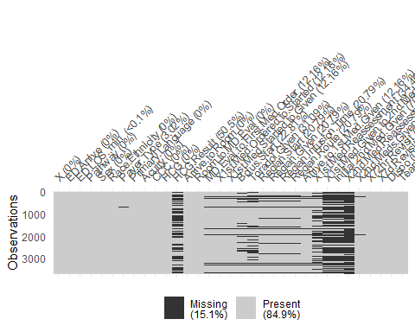

gg_miss_upset(data_all_na) #Different visualization models of same data here,

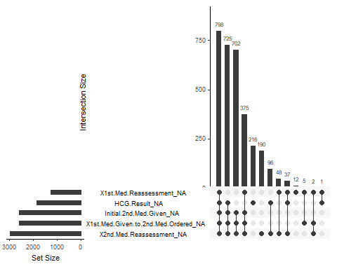

gg_miss_fct(x = data_all_na, fct = Race.Ethnicity) #here, (differential gradiant possible amongst demographic groups)

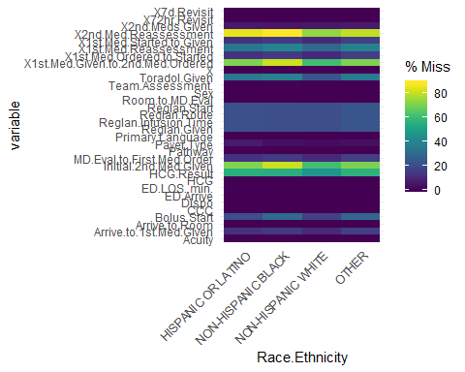

gg_miss_var(data_all_na,facet = Race.Ethnicity) # and here.

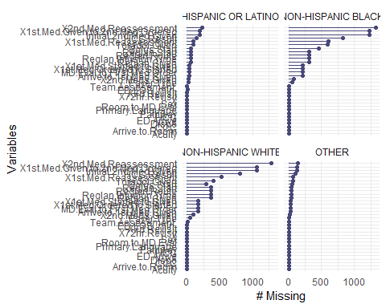

data_all_na %>%  
 group_by(Race.Ethnicity) %>%  
 miss_var_summary() #summarizing missing data in all variables across demographic groups

## # A tibble: 128 x 4  
## Race.Ethnicity variable n_miss pct_miss  
## <fct> <chr> <int> <dbl>  
## 1 OTHER X2nd.Med.Reassessment 144 79.6  
## 2 OTHER X1st.Med.Given.to.2nd.Med.Ordered 128 70.7  
## 3 OTHER Initial.2nd.Med.Given 127 70.2  
## 4 OTHER HCG.Result 102 56.4  
## 5 OTHER X1st.Med.Reassessment 69 38.1  
## 6 OTHER Toradol.Given 66 36.5  
## 7 OTHER Bolus.Start 52 28.7  
## 8 OTHER Reglan.Start 42 23.2  
## 9 OTHER Reglan.Given 42 23.2  
## 10 OTHER Reglan.Infusion.Time 42 23.2  
## # ... with 118 more rows

data_select <- data_all_na %>%  
 select(Pathway,Sex, Race.Ethnicity, Payer.Type, Primary.Language, Acuity,Arrive.to.1st.Med.Given, Dispo, Team.Assessment. ) #dataframe of select variables  
pct_miss(data_select)

## [1] 1.698571

miss_var_summary(data_select) #Pcts of missing data in select variables

## # A tibble: 9 x 3  
## variable n_miss pct_miss  
## <chr> <int> <dbl>  
## 1 Arrive.to.1st.Med.Given 451 12.2   
## 2 Payer.Type 112 3.02   
## 3 Team.Assessment. 4 0.108  
## 4 Pathway 0 0   
## 5 Sex 0 0   
## 6 Race.Ethnicity 0 0   
## 7 Primary.Language 0 0   
## 8 Acuity 0 0   
## 9 Dispo 0 0

data_select %>%  
 group_by(Race.Ethnicity) %>%  
 miss_var_summary() #summarizing missing data in select variables across demographic groups

## # A tibble: 32 x 4  
## Race.Ethnicity variable n_miss pct_miss  
## <fct> <chr> <int> <dbl>  
## 1 OTHER Arrive.to.1st.Med.Given 29 16.0   
## 2 OTHER Payer.Type 6 3.31  
## 3 OTHER Pathway 0 0   
## 4 OTHER Sex 0 0   
## 5 OTHER Primary.Language 0 0   
## 6 OTHER Acuity 0 0   
## 7 OTHER Dispo 0 0   
## 8 OTHER Team.Assessment. 0 0   
## 9 HISPANIC OR LATINO Arrive.to.1st.Med.Given 32 12.1   
## 10 HISPANIC OR LATINO Payer.Type 16 6.06  
## # ... with 22 more rows

gg_miss_fct(x = data_select, fct = Race.Ethnicity) #visualizing pct of missing data in select variables across demographic groups

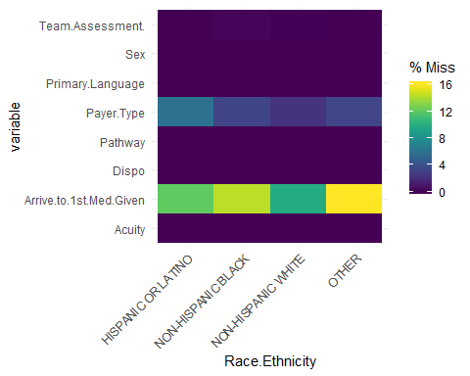

ggplot(data_select,  
 aes(x = data_select$Arrive.to.1st.Med.Given,  
 y = data_select$Acuity)) +  
 geom_miss_point() # visualizing missing data relationship between arrival to first line med given and acuity level

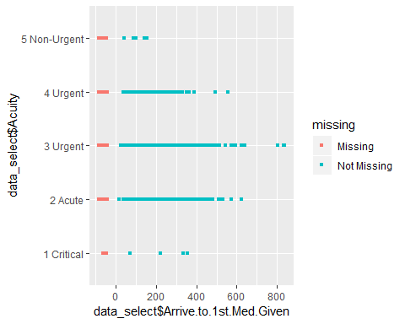

### Descriptive Statistics

Table 1. Categorical variables

library(tableone) #Use tableone package to output table one counts and pcts of select data  
tab_one <- CreateTableOne(data = data_select, includeNA = TRUE)  
print(tab_one, showAllLevels = TRUE)

##   
## level Overall   
## n 3709   
## Pathway (%) No 645 (17.4)   
## Yes 3064 (82.6)   
## Sex (%) F 2615 (70.5)   
## M 1094 (29.5)   
## Race.Ethnicity (%) HISPANIC OR LATINO 264 ( 7.1)   
## NON-HISPANIC BLACK 1514 (40.8)   
## NON-HISPANIC WHITE 1750 (47.2)   
## OTHER 181 ( 4.9)   
## Payer.Type (%) COMMERCIAL 2089 (56.3)   
## MEDICAL ASSISTANCE 1508 (40.7)   
## <NA> 112 ( 3.0)   
## Primary.Language (%) ENGLISH 3641 (98.2)   
## NON-ENGLISH 68 ( 1.8)   
## Acuity (%) 1 Critical 7 ( 0.2)   
## 2 Acute 623 (16.8)   
## 3 Urgent 2753 (74.2)   
## 4 Urgent 312 ( 8.4)   
## 5 Non-Urgent 14 ( 0.4)   
## Arrive.to.1st.Med.Given (mean (sd)) 163.22 (85.47)  
## Dispo (%) Admitted 597 (16.1)   
## Discharged 3112 (83.9)   
## Team.Assessment. (%) No 3414 (92.0)   
## Yes 291 ( 7.8)   
## <NA> 4 ( 0.1)

Table 2. Arrival to first medication given variables across demographic groups

time_vars <- data_all_na %>%  
 select(Race.Ethnicity, Arrive.to.1st.Med.Given, ED.LOS..min.,Arrive.to.Room, Room.to.MD.Eval, MD.Eval.to.First.Med.Order, X1st.Med.Ordered.to.Started, X1st.Med.Started.to.Given, X1st.Med.Reassessment) #select time variables related to first medication  
  
describeBy(time_vars, time_vars$Race.Ethnicity) #summary of functions by demographic groups -> Group 1: Hisp, 2: NH Black, 3: NH White, 4: Other

##   
## Descriptive statistics by group   
## group: HISPANIC OR LATINO  
## vars n mean sd median trimmed mad  
## Race.Ethnicity* 1 264 1.00 0.00 1 1.00 0.00  
## Arrive.to.1st.Med.Given 2 232 177.42 93.04 155 164.38 65.23  
## ED.LOS..min.* 3 263 253.08 143.07 225 238.79 134.92  
## Arrive.to.Room 4 264 25.06 34.85 10 17.32 11.12  
## Room.to.MD.Eval 5 264 22.30 30.71 9 16.01 11.86  
## MD.Eval.to.First.Med.Order 6 232 55.79 52.53 43 47.18 29.65  
## X1st.Med.Ordered.to.Started* 7 232 96.87 27.78 95 96.65 21.50  
## X1st.Med.Started.to.Given* 8 232 121.64 81.05 140 122.08 92.66  
## X1st.Med.Reassessment 9 173 71.27 50.83 56 62.98 35.58  
## min max range skew kurtosis se  
## Race.Ethnicity* 1 1 0 NaN NaN 0.00  
## Arrive.to.1st.Med.Given 39 831 792 2.38 10.73 6.11  
## ED.LOS..min.* 15 631 616 0.78 -0.08 8.82  
## Arrive.to.Room 0 193 193 2.45 6.55 2.14  
## Room.to.MD.Eval -3 196 199 2.61 8.99 1.89  
## MD.Eval.to.First.Med.Order -80 332 412 2.19 6.99 3.45  
## X1st.Med.Ordered.to.Started* 4 157 153 -0.08 0.54 1.82  
## X1st.Med.Started.to.Given* 1 258 257 -0.23 -1.28 5.32  
## X1st.Med.Reassessment 20 317 297 2.19 6.36 3.86  
## --------------------------------------------------------   
## group: NON-HISPANIC BLACK  
## vars n mean sd median trimmed mad  
## Race.Ethnicity* 1 1514 2.00 0.00 2 2.00 0.00  
## Arrive.to.1st.Med.Given 2 1296 159.88 81.76 143 149.96 66.72  
## ED.LOS..min.* 3 1514 218.89 138.87 185 202.97 117.87  
## Arrive.to.Room 4 1514 25.64 38.61 10 16.79 11.86  
## Room.to.MD.Eval 5 1514 20.36 28.01 10 14.66 11.86  
## MD.Eval.to.First.Med.Order 6 1296 48.80 46.77 37 41.24 26.69  
## X1st.Med.Ordered.to.Started* 7 1296 92.32 25.63 91 91.63 19.27  
## X1st.Med.Started.to.Given* 8 1296 113.95 84.44 123 112.42 115.64  
## X1st.Med.Reassessment 9 915 65.77 44.10 55 59.05 28.17  
## min max range skew kurtosis se  
## Race.Ethnicity* 2 2 0 NaN NaN 0.00  
## Arrive.to.1st.Med.Given 26 640 614 1.62 4.37 2.27  
## ED.LOS..min.* 2 637 635 1.01 0.57 3.57  
## Arrive.to.Room -51 405 456 3.18 14.49 0.99  
## Room.to.MD.Eval -13 293 306 3.12 15.59 0.72  
## MD.Eval.to.First.Med.Order -128 361 489 2.28 8.80 1.30  
## X1st.Med.Ordered.to.Started* 3 163 160 0.16 0.53 0.71  
## X1st.Med.Started.to.Given* 1 258 257 -0.09 -1.39 2.35  
## X1st.Med.Reassessment 20 486 466 3.25 18.44 1.46  
## --------------------------------------------------------   
## group: NON-HISPANIC WHITE  
## vars n mean sd median trimmed mad  
## Race.Ethnicity* 1 1750 3.00 0.00 3 3.00 0.00  
## Arrive.to.1st.Med.Given 2 1578 164.16 87.37 143 152.28 66.72  
## ED.LOS..min.* 3 1750 253.61 133.29 228 243.14 131.21  
## Arrive.to.Room 4 1750 23.87 36.23 9 15.42 8.90  
## Room.to.MD.Eval 5 1750 18.04 26.07 8 12.41 10.38  
## MD.Eval.to.First.Med.Order 6 1578 47.34 49.45 37 40.37 26.69  
## X1st.Med.Ordered.to.Started* 7 1578 93.43 24.37 92 93.25 17.79  
## X1st.Med.Started.to.Given* 8 1578 127.58 79.10 145 129.50 86.73  
## X1st.Med.Reassessment 9 1231 70.48 48.79 57 62.11 31.13  
## min max range skew kurtosis se  
## Race.Ethnicity* 3 3 0 NaN NaN 0.00  
## Arrive.to.1st.Med.Given 18 835 817 1.83 6.16 2.20  
## ED.LOS..min.* 1 630 629 0.62 -0.30 3.19  
## Arrive.to.Room -56 362 418 2.88 11.16 0.87  
## Room.to.MD.Eval -15 258 273 3.04 13.43 0.62  
## MD.Eval.to.First.Med.Order -96 536 632 2.55 13.33 1.24  
## X1st.Med.Ordered.to.Started* 2 163 161 0.00 0.93 0.61  
## X1st.Med.Started.to.Given* 1 258 257 -0.33 -1.15 1.99  
## X1st.Med.Reassessment 20 521 501 2.59 11.04 1.39  
## --------------------------------------------------------   
## group: OTHER  
## vars n mean sd median trimmed mad  
## Race.Ethnicity* 1 181 4.00 0.00 4.0 4.00 0.00  
## Arrive.to.1st.Med.Given 2 152 160.39 82.81 143.0 149.48 58.56  
## ED.LOS..min.* 3 181 237.08 139.92 207.0 223.82 133.43  
## Arrive.to.Room 4 181 27.17 35.26 10.0 20.03 10.38  
## Room.to.MD.Eval 5 181 20.60 24.91 12.0 15.54 16.31  
## MD.Eval.to.First.Med.Order 6 152 47.18 59.26 32.5 37.07 20.02  
## X1st.Med.Ordered.to.Started* 7 152 91.67 25.72 91.0 92.10 17.79  
## X1st.Med.Started.to.Given* 8 152 117.84 84.71 131.0 117.25 105.26  
## X1st.Med.Reassessment 9 112 70.76 47.11 62.0 62.22 28.91  
## min max range skew kurtosis se  
## Race.Ethnicity* 4 4 0 NaN NaN 0.00  
## Arrive.to.1st.Med.Given 46 593 547 1.77 4.96 6.72  
## ED.LOS..min.* 28 615 587 0.75 -0.27 10.40  
## Arrive.to.Room 0 207 207 1.99 4.43 2.62  
## Room.to.MD.Eval -2 123 125 1.91 3.80 1.85  
## MD.Eval.to.First.Med.Order -69 498 567 4.20 24.82 4.81  
## X1st.Med.Ordered.to.Started* 1 153 152 -0.34 1.17 2.09  
## X1st.Med.Started.to.Given* 1 253 252 -0.15 -1.43 6.87  
## X1st.Med.Reassessment 20 300 280 2.12 5.59 4.45

#Create dataframes for each group  
hisp <- subset(time_vars, time_vars$Race.Ethnicity == "HISPANIC OR LATINO")  
nhw <- subset(time_vars, time_vars$Race.Ethnicity == "NON-HISPANIC WHITE")  
nhb <- subset(time_vars, time_vars$Race.Ethnicity == "NON-HISPANIC BLACK")  
other <- subset(time_vars, time_vars$Race.Ethnicity == "OTHER")  
  
# Arrival to first medication descriptive statistics with histograms in separate demographic groups  
hist(data_all_na$Arrive.to.1st.Med.Given)

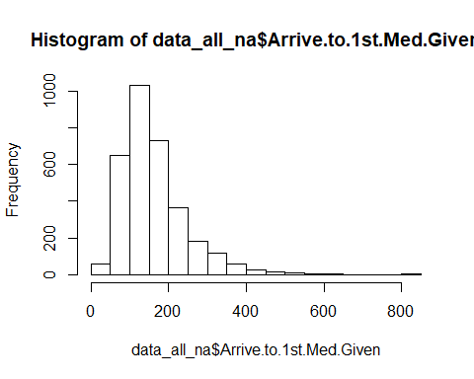

describe.by(hisp)

## vars n mean sd median trimmed mad  
## Race.Ethnicity* 1 264 1.00 0.00 1 1.00 0.00  
## Arrive.to.1st.Med.Given 2 232 177.42 93.04 155 164.38 65.23  
## ED.LOS..min.* 3 263 253.08 143.07 225 238.79 134.92  
## Arrive.to.Room 4 264 25.06 34.85 10 17.32 11.12  
## Room.to.MD.Eval 5 264 22.30 30.71 9 16.01 11.86  
## MD.Eval.to.First.Med.Order 6 232 55.79 52.53 43 47.18 29.65  
## X1st.Med.Ordered.to.Started* 7 232 96.87 27.78 95 96.65 21.50  
## X1st.Med.Started.to.Given* 8 232 121.64 81.05 140 122.08 92.66  
## X1st.Med.Reassessment 9 173 71.27 50.83 56 62.98 35.58  
## min max range skew kurtosis se  
## Race.Ethnicity* 1 1 0 NaN NaN 0.00  
## Arrive.to.1st.Med.Given 39 831 792 2.38 10.73 6.11  
## ED.LOS..min.* 15 631 616 0.78 -0.08 8.82  
## Arrive.to.Room 0 193 193 2.45 6.55 2.14  
## Room.to.MD.Eval -3 196 199 2.61 8.99 1.89  
## MD.Eval.to.First.Med.Order -80 332 412 2.19 6.99 3.45  
## X1st.Med.Ordered.to.Started* 4 157 153 -0.08 0.54 1.82  
## X1st.Med.Started.to.Given* 1 258 257 -0.23 -1.28 5.32  
## X1st.Med.Reassessment 20 317 297 2.19 6.36 3.86

hist(hisp$Arrive.to.1st.Med.Given)

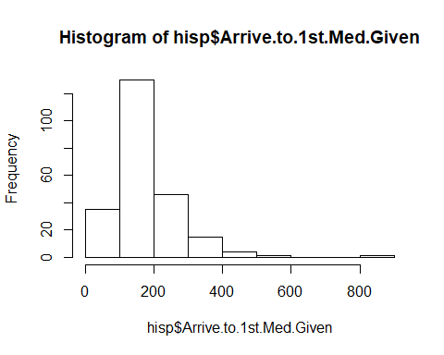

describe.by(nhw)

## vars n mean sd median trimmed mad  
## Race.Ethnicity* 1 1750 3.00 0.00 3 3.00 0.00  
## Arrive.to.1st.Med.Given 2 1578 164.16 87.37 143 152.28 66.72  
## ED.LOS..min.* 3 1750 253.61 133.29 228 243.14 131.21  
## Arrive.to.Room 4 1750 23.87 36.23 9 15.42 8.90  
## Room.to.MD.Eval 5 1750 18.04 26.07 8 12.41 10.38  
## MD.Eval.to.First.Med.Order 6 1578 47.34 49.45 37 40.37 26.69  
## X1st.Med.Ordered.to.Started* 7 1578 93.43 24.37 92 93.25 17.79  
## X1st.Med.Started.to.Given* 8 1578 127.58 79.10 145 129.50 86.73  
## X1st.Med.Reassessment 9 1231 70.48 48.79 57 62.11 31.13  
## min max range skew kurtosis se  
## Race.Ethnicity* 3 3 0 NaN NaN 0.00  
## Arrive.to.1st.Med.Given 18 835 817 1.83 6.16 2.20  
## ED.LOS..min.* 1 630 629 0.62 -0.30 3.19  
## Arrive.to.Room -56 362 418 2.88 11.16 0.87  
## Room.to.MD.Eval -15 258 273 3.04 13.43 0.62  
## MD.Eval.to.First.Med.Order -96 536 632 2.55 13.33 1.24  
## X1st.Med.Ordered.to.Started* 2 163 161 0.00 0.93 0.61  
## X1st.Med.Started.to.Given* 1 258 257 -0.33 -1.15 1.99  
## X1st.Med.Reassessment 20 521 501 2.59 11.04 1.39

hist(nhw$Arrive.to.1st.Med.Given)

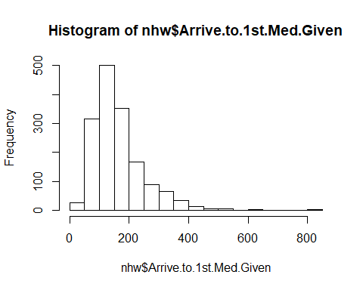

describe.by(nhb)

## vars n mean sd median trimmed mad  
## Race.Ethnicity* 1 1514 2.00 0.00 2 2.00 0.00  
## Arrive.to.1st.Med.Given 2 1296 159.88 81.76 143 149.96 66.72  
## ED.LOS..min.* 3 1514 218.89 138.87 185 202.97 117.87  
## Arrive.to.Room 4 1514 25.64 38.61 10 16.79 11.86  
## Room.to.MD.Eval 5 1514 20.36 28.01 10 14.66 11.86  
## MD.Eval.to.First.Med.Order 6 1296 48.80 46.77 37 41.24 26.69  
## X1st.Med.Ordered.to.Started* 7 1296 92.32 25.63 91 91.63 19.27  
## X1st.Med.Started.to.Given* 8 1296 113.95 84.44 123 112.42 115.64  
## X1st.Med.Reassessment 9 915 65.77 44.10 55 59.05 28.17  
## min max range skew kurtosis se  
## Race.Ethnicity* 2 2 0 NaN NaN 0.00  
## Arrive.to.1st.Med.Given 26 640 614 1.62 4.37 2.27  
## ED.LOS..min.* 2 637 635 1.01 0.57 3.57  
## Arrive.to.Room -51 405 456 3.18 14.49 0.99  
## Room.to.MD.Eval -13 293 306 3.12 15.59 0.72  
## MD.Eval.to.First.Med.Order -128 361 489 2.28 8.80 1.30  
## X1st.Med.Ordered.to.Started* 3 163 160 0.16 0.53 0.71  
## X1st.Med.Started.to.Given* 1 258 257 -0.09 -1.39 2.35  
## X1st.Med.Reassessment 20 486 466 3.25 18.44 1.46

hist(nhb$Arrive.to.1st.Med.Given)

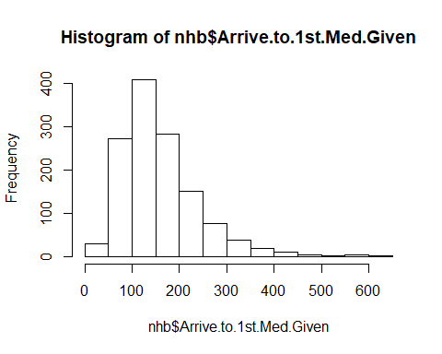

describe.by(other)

## vars n mean sd median trimmed mad  
## Race.Ethnicity* 1 181 4.00 0.00 4.0 4.00 0.00  
## Arrive.to.1st.Med.Given 2 152 160.39 82.81 143.0 149.48 58.56  
## ED.LOS..min.* 3 181 237.08 139.92 207.0 223.82 133.43  
## Arrive.to.Room 4 181 27.17 35.26 10.0 20.03 10.38  
## Room.to.MD.Eval 5 181 20.60 24.91 12.0 15.54 16.31  
## MD.Eval.to.First.Med.Order 6 152 47.18 59.26 32.5 37.07 20.02  
## X1st.Med.Ordered.to.Started* 7 152 91.67 25.72 91.0 92.10 17.79  
## X1st.Med.Started.to.Given* 8 152 117.84 84.71 131.0 117.25 105.26  
## X1st.Med.Reassessment 9 112 70.76 47.11 62.0 62.22 28.91  
## min max range skew kurtosis se  
## Race.Ethnicity* 4 4 0 NaN NaN 0.00  
## Arrive.to.1st.Med.Given 46 593 547 1.77 4.96 6.72  
## ED.LOS..min.* 28 615 587 0.75 -0.27 10.40  
## Arrive.to.Room 0 207 207 1.99 4.43 2.62  
## Room.to.MD.Eval -2 123 125 1.91 3.80 1.85  
## MD.Eval.to.First.Med.Order -69 498 567 4.20 24.82 4.81  
## X1st.Med.Ordered.to.Started* 1 153 152 -0.34 1.17 2.09  
## X1st.Med.Started.to.Given* 1 253 252 -0.15 -1.43 6.87  
## X1st.Med.Reassessment 20 300 280 2.12 5.59 4.45

hist(other$Arrive.to.1st.Med.Given)

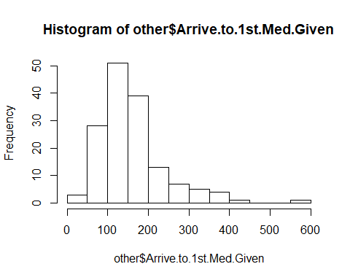

Contingency (two-way) tables: Group table one variables by race and eth

race_eth_all <- data_all_na$Race.Ethnicity  
payer_type <- data_all_na$Payer.Type  
sex_all <- data_all_na$Sex  
pth_all <- data_all_na$Pathway  
lng_all <- data_all_na$Primary.Language  
acu_all <- data_all_na$Acuity  
dis_all <- data_all_na$Dispo  
team_all <- data_all_na$Team.Assessment.  
arr_all <- data_all_na$Arrive.to.1st.Med.Given  
  
payer_by_tab <- addmargins(table(race_eth_all, payer_type)) #n's for each group  
print(payer_by_tab)

## payer_type  
## race_eth_all COMMERCIAL MEDICAL ASSISTANCE Sum  
## HISPANIC OR LATINO 114 134 248  
## NON-HISPANIC BLACK 445 1020 1465  
## NON-HISPANIC WHITE 1422 287 1709  
## OTHER 108 67 175  
## Sum 2089 1508 3597

prop.table(payer_by_tab,2)%>%  
 round (digits =2) # column pcts ie race/eth

## payer_type  
## race_eth_all COMMERCIAL MEDICAL ASSISTANCE Sum  
## HISPANIC OR LATINO 0.03 0.04 0.03  
## NON-HISPANIC BLACK 0.11 0.34 0.20  
## NON-HISPANIC WHITE 0.34 0.10 0.24  
## OTHER 0.03 0.02 0.02  
## Sum 0.50 0.50 0.50

prop.table(payer_by_tab,1)%>%  
 round (digits =2) # row pcts ie payer type. which one is the best way to display this data ***

## payer_type  
## race_eth_all COMMERCIAL MEDICAL ASSISTANCE Sum  
## HISPANIC OR LATINO 0.23 0.27 0.50  
## NON-HISPANIC BLACK 0.15 0.35 0.50  
## NON-HISPANIC WHITE 0.42 0.08 0.50  
## OTHER 0.31 0.19 0.50  
## Sum 0.29 0.21 0.50

sex_by_tab <- table(race_eth_all, sex_all)   
prop.table(sex_by_tab,2)%>%  
 round (digits =2) #more black males than white males have migraines?? ***

## sex_all  
## race_eth_all F M  
## HISPANIC OR LATINO 0.07 0.07  
## NON-HISPANIC BLACK 0.39 0.45  
## NON-HISPANIC WHITE 0.49 0.42  
## OTHER 0.04 0.06

prop.table(sex_by_tab,1)%>%  
 round (digits =2) #makes more sense

## sex_all  
## race_eth_all F M  
## HISPANIC OR LATINO 0.72 0.28  
## NON-HISPANIC BLACK 0.67 0.33  
## NON-HISPANIC WHITE 0.74 0.26  
## OTHER 0.64 0.36

pth_by_tab <- table(race_eth_all,pth_all)   
prop.table(pth_by_tab,2) %>%  
 round (digits =2)

## pth_all  
## race_eth_all No Yes  
## HISPANIC OR LATINO 0.07 0.07  
## NON-HISPANIC BLACK 0.48 0.39  
## NON-HISPANIC WHITE 0.40 0.49  
## OTHER 0.05 0.05

prop.table(pth_by_tab,1) %>%  
 round (digits =2)

## pth_all  
## race_eth_all No Yes  
## HISPANIC OR LATINO 0.17 0.83  
## NON-HISPANIC BLACK 0.21 0.79  
## NON-HISPANIC WHITE 0.15 0.85  
## OTHER 0.17 0.83

lng_by_tab <- table(race_eth_all, lng_all)  
prop.table(lng_by_tab,2)%>%  
 round (digits =2)

## lng_all  
## race_eth_all ENGLISH NON-ENGLISH  
## HISPANIC OR LATINO 0.06 0.54  
## NON-HISPANIC BLACK 0.41 0.04  
## NON-HISPANIC WHITE 0.48 0.09  
## OTHER 0.04 0.32

prop.table(lng_by_tab,1)%>%  
 round (digits =2)

## lng_all  
## race_eth_all ENGLISH NON-ENGLISH  
## HISPANIC OR LATINO 0.86 0.14  
## NON-HISPANIC BLACK 1.00 0.00  
## NON-HISPANIC WHITE 1.00 0.00  
## OTHER 0.88 0.12

acu_by_tab <- addmargins(table(race_eth_all, acu_all))  
print(acu_by_tab)

## acu_all  
## race_eth_all 1 Critical 2 Acute 3 Urgent 4 Urgent 5 Non-Urgent  
## HISPANIC OR LATINO 0 58 180 24 2  
## NON-HISPANIC BLACK 1 207 1060 237 9  
## NON-HISPANIC WHITE 5 334 1376 35 0  
## OTHER 1 24 137 16 3  
## Sum 7 623 2753 312 14  
## acu_all  
## race_eth_all Sum  
## HISPANIC OR LATINO 264  
## NON-HISPANIC BLACK 1514  
## NON-HISPANIC WHITE 1750  
## OTHER 181  
## Sum 3709

acu_by_tab_p <-table(race_eth_all, acu_all)  
prop.table(acu_by_tab_p,2) %>%  
 round (digits =2)

## acu_all  
## race_eth_all 1 Critical 2 Acute 3 Urgent 4 Urgent 5 Non-Urgent  
## HISPANIC OR LATINO 0.00 0.09 0.07 0.08 0.14  
## NON-HISPANIC BLACK 0.14 0.33 0.39 0.76 0.64  
## NON-HISPANIC WHITE 0.71 0.54 0.50 0.11 0.00  
## OTHER 0.14 0.04 0.05 0.05 0.21

prop.table(acu_by_tab_p,1)%>%  
 round (digits =2)

## acu_all  
## race_eth_all 1 Critical 2 Acute 3 Urgent 4 Urgent 5 Non-Urgent  
## HISPANIC OR LATINO 0.00 0.22 0.68 0.09 0.01  
## NON-HISPANIC BLACK 0.00 0.14 0.70 0.16 0.01  
## NON-HISPANIC WHITE 0.00 0.19 0.79 0.02 0.00  
## OTHER 0.01 0.13 0.76 0.09 0.02

dis_by_tab <- addmargins(table(race_eth_all, dis_all))  
print(dis_by_tab)

## dis_all  
## race_eth_all Admitted Discharged Sum  
## HISPANIC OR LATINO 40 224 264  
## NON-HISPANIC BLACK 157 1357 1514  
## NON-HISPANIC WHITE 372 1378 1750  
## OTHER 28 153 181  
## Sum 597 3112 3709

dis_by_tab_p <-table(race_eth_all, dis_all)  
prop.table(dis_by_tab_p,2) %>%  
 round (digits =2)

## dis_all  
## race_eth_all Admitted Discharged  
## HISPANIC OR LATINO 0.07 0.07  
## NON-HISPANIC BLACK 0.26 0.44  
## NON-HISPANIC WHITE 0.62 0.44  
## OTHER 0.05 0.05

prop.table(dis_by_tab_p,1)%>%  
 round (digits =2)

## dis_all  
## race_eth_all Admitted Discharged  
## HISPANIC OR LATINO 0.15 0.85  
## NON-HISPANIC BLACK 0.10 0.90  
## NON-HISPANIC WHITE 0.21 0.79  
## OTHER 0.15 0.85

#Arrival to first med given in minutes, grouped by race/eth  
arr_group_by_all <- data_all_na %>%  
 group_by(Race.Ethnicity) %>%  
 summarise(mean_arr = mean(Arrive.to.1st.Med.Given, na.rm = TRUE),  
 sd_arr = sd(Arrive.to.1st.Med.Given, na.rm = TRUE),  
 med_arr = median(Arrive.to.1st.Med.Given, na.rm = TRUE ),  
 min_arr = min(Arrive.to.1st.Med.Given, na.rm = TRUE ),  
 max_arr = max(Arrive.to.1st.Med.Given, na.rm = TRUE )) %>%  
 return  
  
print.data.frame(arr_group_by_all)

## Race.Ethnicity mean_arr sd_arr med_arr min_arr max_arr  
## 1 HISPANIC OR LATINO 177.4224 93.03745 155 39 831  
## 2 NON-HISPANIC BLACK 159.8750 81.76349 143 26 640  
## 3 NON-HISPANIC WHITE 164.1565 87.37185 143 18 835  
## 4 OTHER 160.3882 82.81489 143 46 593

### Statistical Analyses

#### Linear regression models: data set of select variables without NAs

#Make a data set of select variables without NAs  
data_select_clean <- data_select[complete.cases(data_select[ , ]),]%>%  
 mutate(Team.Assessment.=factor(Team.Assessment., levels=c(0, 1), labels=c("no", "yes"))) %>%  
 return  
  
ggplot(data_select_clean, aes(x=Race.Ethnicity, y= Arrive.to.1st.Med.Given))+  
 geom_boxplot(color="black", fill="lightblue")

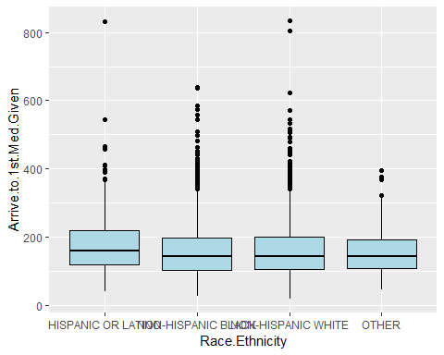

data_fit <- lm(Arrive.to.1st.Med.Given ~ Race.Ethnicity, data=data_select_clean)  
summary(data_fit) #So the odds when the demographic is "0" or not defined, is 258 minutes? the odds of arrival to first med given for any er pt of a non predetermined race is 258 minutes??? What happened to Hispanic group?

##   
## Call:  
## lm(formula = Arrive.to.1st.Med.Given ~ Race.Ethnicity, data = data_select_clean)  
##   
## Residuals:  
## Min 1Q Median 3Q Max   
## -146.23 -58.33 -19.23 35.72 670.77   
##   
## Coefficients:  
## Estimate Std. Error t value Pr(>|t|)   
## (Intercept) 180.009 5.782 31.133 < 2e-16 ***  
## Race.EthnicityNON-HISPANIC BLACK -19.681 6.264 -3.142 0.00169 **   
## Race.EthnicityNON-HISPANIC WHITE -15.777 6.178 -2.554 0.01070 *   
## Race.EthnicityOTHER -24.145 9.111 -2.650 0.00809 **   
## ---  
## Signif. codes: 0 '***' 0.001 '**' 0.01 '*' 0.05 '.' 0.1 ' ' 1  
##   
## Residual standard error: 85.37 on 3155 degrees of freedom  
## Multiple R-squared: 0.003527, Adjusted R-squared: 0.00258   
## F-statistic: 3.722 on 3 and 3155 DF, p-value: 0.01094

coef(data_fit) #Coefficients of X

## (Intercept) Race.EthnicityNON-HISPANIC BLACK   
## 180.00917 -19.68142   
## Race.EthnicityNON-HISPANIC WHITE Race.EthnicityOTHER   
## -15.77671 -24.14523

confint(data_fit) #Confidence intervals

## 2.5 % 97.5 %  
## (Intercept) 168.67228 191.346072  
## Race.EthnicityNON-HISPANIC BLACK -31.96428 -7.398567  
## Race.EthnicityNON-HISPANIC WHITE -27.88947 -3.663942  
## Race.EthnicityOTHER -42.00936 -6.281094

summary.lm(lm(Arrive.to.1st.Med.Given ~ Race.Ethnicity + Acuity, data=data_select_clean))

##   
## Call:  
## lm(formula = Arrive.to.1st.Med.Given ~ Race.Ethnicity + Acuity,   
## data = data_select_clean)  
##   
## Residuals:  
## Min 1Q Median 3Q Max   
## -174.67 -58.00 -19.73 36.93 674.27   
##   
## Coefficients:  
## Estimate Std. Error t value Pr(>|t|)   
## (Intercept) 260.860 42.941 6.075 1.39e-09 ***  
## Race.EthnicityNON-HISPANIC BLACK -17.856 6.259 -2.853 0.00436 **   
## Race.EthnicityNON-HISPANIC WHITE -15.194 6.166 -2.464 0.01378 *   
## Race.EthnicityOTHER -21.995 9.096 -2.418 0.01566 *   
## Acuity2 Acute -65.919 42.683 -1.544 0.12260   
## Acuity3 Urgent -84.933 42.559 -1.996 0.04606 *   
## Acuity4 Urgent -89.604 43.011 -2.083 0.03731 *   
## Acuity5 Non-Urgent -135.748 57.142 -2.376 0.01758 *   
## ---  
## Signif. codes: 0 '***' 0.001 '**' 0.01 '*' 0.05 '.' 0.1 ' ' 1  
##   
## Residual standard error: 85.03 on 3151 degrees of freedom  
## Multiple R-squared: 0.01264, Adjusted R-squared: 0.01044   
## F-statistic: 5.762 on 7 and 3151 DF, p-value: 1.201e-06