

A PROJECT REPORT

SUBMITTED IN PARTIAL FULFILLMENT OF THE REQUIREMENT FOR FIRST SEMESTER OF

## Masters in Computer Application

## TO

**RK UNIVERSITY, RAJKOT**

## SUBMITTED BY

### Name of Student Enrollment No.

**Student Name 1: Krish Beladiya 23SOECA21009**

**Student Name 2: Jem Jetani 23SOECA21025**

**Student Name 3: Himesh Kukadiya 23SOECA21036**

## UNDER THE GUIDANCE OF

## INTERNAL GUIDE

## PROF. HOMERA DURANI

## ASST. Professor,

## RK University.

## RAJKOT



## SCHOOL OF ENGINEERING, RK UNIVERSITY, RAJKOT



**DECLARATION**

We hereby certify that we are the sole authors of this project work and that neither any part of this project work nor the whole of the project work has been submitted for a degree to any other University or Institution. We certify that, to the best of our knowledge, our project work does not infringe upon anyone’s copyright nor violate any proprietary rights and that any ideas, techniques, quotations, or any other material from the work of other people included in our project document, published or otherwise, are fully acknowledged in accordance with the standard referencing practices. We declare that this is a true copy of our project work, including any final revisions, as approved by our project review committee.

## Signature of Students

Krish Beladiya Jem Jetani Himesh Kukadiya

Date:- 21/12/2023

Place:- School of Engineering RK University.

# **TABLE OF CONTENTS**

|  |  |
| --- | --- |
| **TITLE** | **PAGE NO.** |
| **ACKNOWLEDGEMENT** | **I** |
| **ABSTRACT** | **II** |
| **1. INTRODUCTION** | **07** |
| **1.1 PROJECT SUMMARY** |
| **1.2 PURPOSE** |
| **1.3 HTML, CSS, BOOSTRAP, JAVASCRIPT, NODE JS** |
| **2. PROJECT MANAGEMENT** | **13** |
| **2.1 PROJECT PLANNING AND SCHEDULING** |
| **2.1.1 PROJECT DEVELOPMENT APPROACH** |
| **2.1.2 PROJECT PLAN** |
| **2.1.3 SCHEDULE REPRESENTATION** |
| **3. SYSTEM REQUIREMENTS STUDY** | **16** |
| **3.1 USER CHARACTERISTICS** |
| **3.2 HARDWARE** |
| **4. SYSTEM ANALYSIS** | **19** |
| **4.1 STUDY OF CURRENT SYSTEM** |
| **4.2 PROBLEM & WEAKNESS OF CURRENT SYSTEM** |
| **4.3 FEASIBILITY STUDY** |
| **4.4 REQUIREMENT VALIDATION** |
| **4.5 FUNCTION SYSTEM** |
| **4.5.1 USE CASE DIAGRAM** |
| **4.6 DATA MODELING** |
| **4.7 MAIN MODULES OF NEW SYSTEM** |

|  |  |
| --- | --- |
| **5. TESTING** | **32** |
| **5.1 TEST PLAN** |
| **5.2 TESTING STRATEGY** |
| **5.3 TESTING METHODS** |
| **6. SCREEN SHOTS** | **36** |
| **7. LIMITATION & FUTURE ENHANCEMENT** | **53** |
| **8. CONCLUSION AND DISCUSSION** | **55** |
| **9. REFERENCES** | **56** |

**ACKNOWLEDGEMENT**

The success and final outcome of this project required a lot of guidance and assistance from many people and We are extremely fortunate to have got this all along the completion of my project work. Whatever we have done is only due to such guidance and assistance and we would not forget to thank them.

We respect and thank **RK University** for giving us an opportunity to do the project work in 1MCA and providing us all support and guidance which make us complete the project on time. We are extremely grateful to him for providing such a nice support and guidance though he had busy schedule managing the company affairs.

We also thank our internal project guide, **Pervez Belim, RK University Rajkot**, for his guidance and suggestions during this project work.

We are thankful to and fortunate enough to get constant encouragement, support and guidance from all Teaching staffs of Department of Master of Computer Application which helped using successfully completing our project work.Also,we would like to extend our sincere regards to all the non-teaching staff of department for their timely support.

**Abstract:**

The demand for sustainable and efficient urban mobility solutions has led to a renewed focus on designing and implementing robust public transport systems. This abstract provides an overview of the key components and considerations in establishing an effective public transport setup.

1. Infrastructure Planning and Development:

* Initial stages involve comprehensive planning to determine optimal routes, stops, and infrastructure requirements.
* Integration with existing urban infrastructure to minimize disruptions and enhance connectivity.
* Consideration of dedicated lanes, terminals, and transfer points for seamless transitions between different modes of transportation.

1. Multi-Modal Integration:

* Implementation of a multi-modal transport network that incorporates buses, trains, subways, trams, and other modes.
* Development of integrated ticketing systems to facilitate smooth transfers between different modes of transport.
* Efficient synchronization of schedules to minimize waiting times and enhance overall user experience.

1. Technological Integration:

* Implementation of advanced technologies, including real-time tracking, predictive analytics, and smart scheduling.
* Integration of mobile applications for trip planning, fare payment, and real-time updates to enhance user convenience.
* Incorporation of smart infrastructure, such as sensors and IoT devices, to monitor and optimize traffic flow and passenger movement.

1. Accessibility and Inclusivity:

* Designing infrastructure and vehicles to be accessible for people with disabilities and elderly individuals.
* Ensuring inclusive practices in route planning and station design to cater to diverse demographics.
* Collaboration with community stakeholders to address specific accessibility needs.

1. Environmental Sustainability:

* Adoption of eco-friendly technologies, such as electric or hybrid vehicles, to minimize environmental impact.
* Implementation of green infrastructure, such as bike-sharing programs and pedestrian-friendly zones, to encourage sustainable modes of transportation.

1. **Introduction of Project:**

* **Name: Public Transport setup’s :**

Urbanization has brought unprecedented challenges to transportation systems, necessitating innovative solutions for efficient and sustainable urban mobility. This project seeks to design and implement a comprehensive public transport setup that integrates diverse modes, prioritizes accessibility, embraces advanced technologies, and fosters environmental sustainability. With a focus on community engagement and stakeholder collaboration, this initiative aims to redefine urban mobility for a more connected and sustainable future.

* 1. **Key Features:**

**1.1.1 Multi-Modal Integration:**

* Seamless integration of buses, trains, subways, trams, and alternative modes like bike-sharing.
* Unified ticketing system for convenient transfers and streamlined user experience.

**1.1.2. Advanced Technologies:**

* Real-time tracking and predictive analytics for precise scheduling and efficient route planning.
* Mobile applications offering trip planning, fare payment, and real-time updates to enhance user convenience.
* Smart infrastructure deployment for traffic optimization and improved overall system efficiency.

**1.1.3. Infrastructure Development:**

* Optimal route planning and design of dedicated lanes to reduce congestion and enhance efficiency.
* Well-placed stops, terminals, and transfer points for easy and convenient transitions between modes.

**1.1.4. Accessibility and Inclusivity:**

* Infrastructure and vehicles designed to cater to the needs of people with disabilities and the elderly.
* Inclusive route planning and station design to ensure accessibility for all demographics.

**1.1.5. Environmental Sustainability:**

* Adoption of eco-friendly technologies, such as electric or hybrid vehicles, to minimize environmental impact.
* Integration of renewable energy sources, where feasible, to power the public transport system.
* Implementation of green infrastructure, promoting sustainable transportation modes like walking and cycling.

**1.1.6. Community Engagement:**

* Active involvement of the community in decision-making processes and project planning.
* Collaboration with local government, businesses, and environmental groups to address specific community needs.
* Proactive communication strategies to keep the public informed and engaged throughout the project.

**1.1.7. Optimization through Technology:**

* Continuous monitoring and optimization of operations using data-driven insights.
* Implementation of machine learning algorithms for predictive maintenance, reducing downtime and service disruptions.

**1.1.8. User-Centric Design:**

* Focus on enhancing the overall user experience, from easy navigation to comfortable waiting areas.
* Regular feedback mechanisms to incorporate user suggestions and address concerns promptly.

**1.1.9. Safety and Security Measures:**

* Implementation of robust safety protocols for passengers and infrastructure.
* Integration of surveillance systems and emergency response mechanisms to ensure public safety.
  1. **PURPOSE:**

**1.2.1. Addressing Urban Mobility Challenges:**

* Problem Statement: Rapid urbanization often leads to increased traffic congestion, longer commute times, and environmental pollution.
* Purpose: The public transport setup aims to provide a solution by offering a well-integrated, efficient, and sustainable alternative to private vehicle transportation.

**1.2.2. Enhancing Accessibility:**

* Problem Statement: Many individuals, especially those with disabilities and the elderly, face challenges in accessing public transportation.
* Purpose: By prioritizing accessibility in design and operations, the project seeks to ensure that public transport is inclusive and available to everyone.

**1.2.3. Promoting Sustainable Transportation:**

* Problem Statement: Conventional transportation systems contribute significantly to air pollution and environmental degradation.
* Purpose: The public transport setup aims to reduce the environmental impact by incorporating eco-friendly technologies, renewable energy sources, and promoting sustainable modes of transportation.

**1.2.4. Improving Efficiency through Integration:**

* Problem Statement: Fragmented transportation systems often result in inefficiencies, with disjointed schedules and limited connectivity between different modes.
* Purpose: The integration of various modes of transportation, unified ticketing systems, and advanced technologies aims to streamline operations, reduce waiting times, and enhance the overall efficiency of the public transport network.

**1.2.5. Fostering Technological Advancements:**

* Problem Statement: Outdated transportation systems may not fully leverage the benefits of modern technologies.
* Purpose: The project aims to embrace advanced technologies such as real-time tracking, mobile applications, and smart infrastructure to provide a more convenient and tech-savvy transportation experience.

**1.2.6. Community Well-Being:**

* Problem Statement: Urban communities often face disruptions and inconveniences due to inadequate or inefficient public transportation.
* Purpose: By actively involving the community in the planning process, the project seeks to address specific needs, minimize disruptions, and contribute to overall community well-being.

**1.2.7. Economic Growth and Livability:**

* Problem Statement: Unreliable or inconvenient public transportation can impact a city's economic growth and overall livability.
* Purpose: A well-designed and efficient public transport system can stimulate economic activities, attract investments, and enhance the overall quality of life for residents.

**1.2.8. Safety and Security:**

* Problem Statement: Concerns about safety and security can deter individuals from using public transportation.
* Purpose: Implementing robust safety measures, surveillance systems, and emergency response mechanisms is essential to build trust and ensure the security of passengers and infrastructure.
  1. **HTML, CSS, BOOSTRAP, JAVASCRIPT, NODE JS**

**HTML**

HTML or HyperText Markup Language is the standard markup language used to create web

pages.

HTML is written in the form of HTML elements consisting of tags enclosed in angle brackets

(like <html>). HTML tags most commonly come in pairs like <h1> and </h1>, although some

tags represent empty elements and so are unpaired, for example <img>. The first tag in a pair is

the start tag, and the second tag is the end tag (they are also called opening tags and closing

tags).

The purpose of a web browser is to read HTML documents and compose them into visible or

audible web pages. The browser does not display the HTML tags, but uses the tags to interpret

the content of the page. HTML describes the structure of a website semantically along with cues

for presentation, making it a markup language rather than a programming language.

HTML elements form the building blocks of all websites. HTML allows images and objects to be

embedded and can be used to create interactive forms. It provides a means to create structured

documents by denoting structural semantics for text such as headings, paragraphs, lists, links,

quotes and other items. It can embed scripts written in languages such as JavaScript which affect

the behavior of HTML web pages.

**CSS**

CSS was first developed in 1997, as a way for Web developers to define the look and feel of their Web pages. It was intended to allow developers to separate content from design so that HTML could perform more of the function that it was originally based on the markup of content, without worry about the

design and layout. CSS didn't gain in popularity until around 2000, when Web browsers began using

more than the basic font and color aspects of CSS. Web Designers that don't use CSS for their design

and development of Web sites are rapidly becoming a thing of the past. And it is arguably as important

to understand CSS as it is to know HTML - and some would say it was more important to know CSS. Style sheet refers to the document itself. Style sheets have been used for document design for years.

They are the technical specifications for a layout, whether print or online. Print designers use style

sheets to insure that their designs are printed exactly to specifications. A style

sheet for a Web page serves the same purpose, but with the added functionality of also telling the viewing engine (the Web browser) how to render the document being viewed.

**Bootstrap**

Bootstrap is a popular front-end framework that simplifies web development by providing pre-built design components, templates, and JavaScript plugins.

It offers a collection of reusable UI components (such as buttons, forms, navigation bars) and a responsive grid system that helps in creating mobile-first and responsive web layouts.

Bootstrap aids in building consistent and visually appealing web applications quickly, as it comes with ready-to-use CSS and JavaScript components.

**JAVASCRIPT**

JavaScript is integral to the success of the comprehensive public transport setup project, providing dynamic and interactive features across web and mobile interfaces. Through AJAX and the fetch API, JavaScript ensures real-time data updates, presenting users with accurate information on routes, schedules, and service disruptions. It enhances user interfaces by facilitating client-side form validation and submission, creating smooth transitions between mobile app screens, and dynamically rendering content for real-time notifications. JavaScript's role extends to optimizing performance, handling errors, and logging functionalities. Its responsive design capabilities contribute to a seamless user experience, making it a crucial element in elevating the overall functionality and interactivity of the public transport system's digital platforms.

**NODE JS**

Node.js plays a pivotal role in the comprehensive public transport setup project, serving as the backbone for the backend development. Its event-driven architecture facilitates real-time data processing, enabling instantaneous updates on vehicle locations and service disruptions. Node.js is instrumental in crafting RESTful APIs, ensuring seamless communication between frontend interfaces and the backend server, supporting features like interactive maps and real-time notifications. The platform's scalability, support for WebSocket implementation, and proficiency in asynchronous operations contribute to a responsive and efficient server-side architecture. Additionally, Node.js integrates well with databases, middleware, and follows a microservices architecture, enhancing modularity and maintainability. The extensive

community support and package ecosystem further streamline development, making Node.js a key technology in delivering a robust and scalable public transport system.

**2. project management:**

Project management for a online bus booking-related project involves overseeing and coordinating various tasks, resources, and stakeholders to ensure the successful execution of the project. Here's an outline of steps and considerations for managing a PTS's project:

**2.1. project planning and scheduling**

**2.1.1 PROJECT DEVELOPMENT APPROACH**

The development of the comprehensive public transport setup adopts an Agile approach, characterized by iterative cycles and continuous collaboration. Through iterative development, the project is segmented into sprints, allowing for the delivery of specific features in each cycle. This method ensures that stakeholders provide regular feedback, fostering adaptability and refinement. The user-centric design places a premium on meeting user needs, with continuous user testing and feedback sessions integrated into each sprint. Cross-functional teams, comprising developers, designers, testers, and domain experts, collaborate closely, promoting a shared understanding of project objectives. The adaptive planning strategy accommodates changing requirements and priorities, maintaining a prioritized backlog that enables adjustments based on evolving user needs and dynamic market conditions. Embracing continuous integration and regular reviews, the Agile approach aims to deliver a responsive and user-focused public transport system that can readily adapt to the evolving demands of urban mobility.

**2.1.2 PROJECT PLAN**

**2.1.2.1. Initiation:**

* Define project objectives, scope, and stakeholders.
* Conduct a thorough feasibility study to assess the project's viability.
* Establish a project team with clearly defined roles and responsibilities.

**2.1.2.2. Planning:**

* Develop a detailed project plan outlining tasks, timelines, and dependencies.
* Identify and allocate resources, including personnel, technology, and budgetary requirements.
* Conduct risk assessments and develop mitigation strategies.
* Define key performance indicators (KPIs) to measure project success.

**2.1.2.3. Requirements Gathering:**

* Engage with stakeholders to gather comprehensive requirements for the public transport system.
* Prioritize features and functionalities based on user needs and project objectives.
* Document and validate requirements to ensure a clear understanding among all team members.

**2.1.2.4. Design and Architecture:**

* Develop system architecture, considering scalability, security, and integration points.
* Create design specifications for both frontend and backend components.
* Conduct design reviews to ensure alignment with project goals.

**2.1.2.5. Development:**

* Implement an Agile development methodology for iterative and adaptive development.
* Break down the project into sprints, each focusing on specific features or functionalities.
* Regularly review and adjust development priorities based on feedback and changing requirements.

**2.1.2.6. Testing:**

* Conduct rigorous testing at each stage of development, including unit testing, integration testing, and user acceptance testing.
* Address and rectify issues identified during testing promptly.
* Ensure compliance with accessibility and usability standards.

**2.1.2.7. Deployment:**

* Plan and execute a phased deployment strategy to minimize disruptions to existing transportation services.
* Monitor system performance closely during the initial rollout and address any unexpected issues promptly.
* Provide training to users and stakeholders on the new public transport system.

**2.1.2.8. Monitoring and Optimization:**

* Implement monitoring tools to track system performance, user engagement, and any potential issues.
* Collect and analyze data to identify areas for optimization and improvement.
* Regularly update the system based on user feedback and emerging technologies.

**2.1.2.9. Documentation:**

* Maintain comprehensive documentation throughout the project lifecycle, including design documents, user manuals, and technical specifications.
* Ensure knowledge transfer within the team for sustainability.

**2.1.2.10. Project Review and Closure:**

* Conduct a thorough project review to assess achievements against initial objectives.
* Capture lessons learned and areas for improvement for future projects.
* Formalize project closure, including documentation.

**2.1.3 SCHEDULE REPRESENTATION**

|  |  |
| --- | --- |
| **Activities** | **Time Duration** |
| **Requirement gathering** | **30 Days** |
| **Design** | **30 Days** |
| **Development & coding** | **30 Days** |
| **Quality assurance** | **14 Days** |
| **Testing & implementation** | **21 Days** |

1. **System requirement study:**

The system requirement study for the comprehensive public transport setup involves a meticulous examination of the project's needs and specifications. This phase focuses on understanding the functionality, performance, and constraints of the proposed system. Engaging stakeholders and end-users, the study aims to capture detailed requirements, prioritize features, and ensure alignment with the project's overarching goals. By conducting a comprehensive system requirement study, the project team gains valuable insights into user expectations, enabling the formulation of a robust plan for subsequent development stages. This initial phase lays the foundation for a successful implementation, fostering clarity and consensus on the essential elements that the public transport system must encompass to meet the diverse needs of its users.

**3.1 User characteristics:**

Understanding user characteristics is crucial in designing a public transport system that caters to the diverse needs of its users. Users in this context encompass a wide range of individuals, each with unique preferences, capabilities, and requirements. These characteristics may include:

* + 1. **Demographics:**
* Age: Consideration of various age groups, from children to seniors, to ensure accessibility and user-friendly features.
* Socio-economic status: Tailoring fare structures and services to accommodate different income levels within the community.
  + 1. **Physical Abilities:**
* Mobility: Addressing the needs of individuals with varying levels of mobility, including those with disabilities.
* Vision and hearing: Implementing features that cater to individuals with visual or hearing impairments, such as audible announcements and accessible signage.
  + 1. **Technological Proficiency:**
* Digital literacy: Recognizing the range of technological proficiency among users and ensuring that digital interfaces are intuitive and user-friendly.
* Smartphone usage: Considering the prevalence of smartphone usage and incorporating mobile applications for convenient access to information and services.
  + 1. **Cultural and Linguistic Diversity:**
* Language preferences: Offering information and services in multiple languages to accommodate a culturally diverse user base.
* Cultural considerations: Addressing cultural norms and preferences to create an inclusive and respectful public transport environment.
  + 1. **Travel Patterns and Habits:**
* Commuting preferences: Understanding how users typically commute and tailoring services to align with common travel patterns.
* Peak hours: Designing schedules and services to accommodate peak travel times and minimize congestion.
  + 1. **Safety Concerns:**
* Perception of safety: Recognizing user perceptions of safety and implementing measures to enhance security, particularly during evening hours.
* Emergency preparedness: Providing clear information and resources for users to navigate emergency situations.
  + 1. **Environmental Awareness:**
* Eco-conscious preferences: Considering the preferences of environmentally conscious users and incorporating sustainable transportation options.
* Green initiatives: Implementing eco-friendly practices, such as electric vehicles or renewable energy sources, to align with community sustainability goals.
  + 1. **Affordability and Payment Preferences:**
* Fare affordability: Ensuring fare structures are reasonable and accessible to a broad range of users.

**3.2 hardware**

Certainly, for a public transport system utilizing Node.js and MongoDB, the hardware infrastructure would generally involve components that support the server-side operations and the database management. Here are the main hardware considerations:

**3.2.1. Server Infrastructure:**

* Physical Servers or Cloud Instances: Depending on the scale and requirements, consider whether to use physical servers in a data center or cloud-based instances from platforms like AWS, Azure, or Google Cloud. Node.js applications can run effectively in either environment.
* Processor and RAM: Select servers with sufficient processing power (CPU) and RAM to handle the expected concurrent connections and computational load. Node.js's event-driven, non-blocking nature can benefit from multi-core processors.
* Load Balancers: If scaling horizontally, implement load balancers to distribute incoming traffic across multiple Node.js server instances for improved performance and reliability.
  + 1. **Database Server:**
* MongoDB Server: Choose hardware that supports MongoDB's storage and processing requirements. MongoDB is flexible and can run on various server configurations, but consider factors like disk speed and capacity, as well as memory for efficient data handling.
* Backup and Redundancy: Implement a robust backup strategy and consider redundancy to ensure data integrity and availability. This may involve redundant servers, sharding, or replication mechanisms.
  + 1. **Networking Infrastructure:**
* Bandwidth: Ensure sufficient network bandwidth to handle data traffic between the application servers, database servers, and external connections. This is crucial for real-time updates and data retrieval.
* Security Measures: Implement firewalls, encryption, and secure communication protocols to protect data in transit and secure the network infrastructure against potential threats.
  + 1. **Monitoring and Logging:**
* Monitoring Tools: Set up hardware resources monitoring tools to track server performance, identify bottlenecks, and ensure optimal resource utilization.
* Logging Infrastructure: Implement logging mechanisms to capture system events, errors, and user interactions for debugging and performance analysis.
  + 1. **Scalability Considerations:**
* Horizontal Scaling: Plan for scalability by adding more servers horizontally to distribute the workload effectively. Ensure that the hardware infrastructure supports seamless scaling as the user base grows.
* Containerization and Orchestration: Consider containerization using technologies like Docker and orchestration tools like Kubernetes to enhance deployment flexibility and resource utilization.
  + 1. **Security Hardware:**
* Hardware Security Modules (HSM): If dealing with sensitive data, consider implementing HSMs to enhance the security of cryptographic operations and protect critical data.
* Physical Security Measures: Implement physical security measures at data centers or server locations to protect against unauthorized access and potential physical threats.

1. **system analysis:**

System analysis is a crucial phase in the software development lifecycle, laying the groundwork for a well-defined system design and development process for the ASP.NET project. Clear and accurate analysis ensures alignment between the developed system and the stakeholders' expectations.

**4.1 study of current system:**

**4.1.1. Current Technological Stack:**

* Node.js Implementation: Evaluate how Node.js is currently employed in the system, including its role in server-side development, handling concurrent connections, and facilitating real-time interactions. Assess the version of Node.js being used and the compatibility with existing modules and dependencies.
* MongoDB Integration: Examine the integration of MongoDB within the system for data storage and retrieval. Consider the data models, collections, and indexing strategies employed to optimize database performance.

**4.1.2. Server Architecture:**

* Server Deployment: Study the deployment model of Node.js servers, whether they are hosted on physical servers or cloud instances. Assess the server specifications, including processing power, memory, and any load balancing strategies.
* Scalability Measures: Investigate how the current system addresses scalability concerns with Node.js. Determine if horizontal scaling is implemented to accommodate increasing user loads effectively.

**4.1.3. Database Management:**

* Data Schema and Models: Analyze the current data schema and models utilized in MongoDB. Assess whether the schema aligns with the application's requirements and if any changes or optimizations are necessary.
* Indexing Strategies: Evaluate the indexing strategies applied in MongoDB to enhance query performance. Identify areas for improvement and optimization based on query patterns.

**4.1.4. Application Logic and Functionality:**

* Node.js Modules and Middleware: Examine the Node.js modules and middleware used for handling routing, authentication, and other application logic. Assess the modularity and maintainability of the current codebase.
* Real-Time Features: Investigate how real-time features are implemented using Node.js, especially in the context of public transport where real-time updates can be critical. Consider the use of WebSocket technology or other mechanisms for instant communication.

**4.1.5. Data Security and Access Controls:**

* Authentication and Authorization: Study how user authentication and authorization are managed within the Node.js application. Ensure that access controls are robust, and sensitive data is appropriately protected.
* Encryption Practices: Assess the implementation of encryption for data in transit and at rest, particularly when interacting with MongoDB. Ensure compliance with security best practices.

**4.1.6. Performance Metrics and Monitoring:**

* Performance Metrics: Evaluate the current monitoring and performance tracking mechanisms for Node.js servers and MongoDB. Identify key performance indicators (KPIs) and assess how they align with system objectives.
* Logging and Debugging: Examine the logging and debugging practices within the Node.js application to facilitate efficient troubleshooting and error resolution.

**4.1.7. Documentation and Codebase Overview:**

* Documentation Quality: Assess the quality and comprehensiveness of documentation for both Node.js and MongoDB aspects. Identify areas for improvement to enhance knowledge sharing and onboarding processes.
* Codebase Overview: Gain an understanding of the overall structure of the Node.js application codebase. Evaluate code readability, adherence to coding standards, and potential areas for refactoring.

**4.2 Problem and weakness of current system**

**4.2.1. Scalability Challenges:**

* Problem: The current system may face scalability challenges, particularly during peak usage times, resulting in slow response times or service disruptions.
* Weakness: Inadequate strategies for horizontal scaling and load balancing may hinder the system's ability to handle a growing number of concurrent users efficiently.
  + 1. **Inefficient Database Queries:**
* Problem: Inefficient or unoptimized MongoDB queries may lead to performance bottlenecks, impacting the system's responsiveness.
* Weakness: Poorly designed queries, lack of proper indexing, or large dataset handling can contribute to slower data retrieval and processing times.
  + 1. **Security Vulnerabilities:**
* Problem: Security vulnerabilities may exist in the Node.js application or MongoDB database, posing risks of unauthorized access, data breaches, or other security threats.
* Weakness: Inadequate authentication and authorization mechanisms, lack of encryption, or outdated security practices may compromise the integrity and confidentiality of user data.
  + 1. **Limited Real-Time Capabilities:**
* Problem: The current system may lack robust real-time features, impacting its ability to provide timely updates on vehicle locations, service disruptions, or other critical information.
* Weakness: Inefficient real-time communication mechanisms, such as WebSocket implementation, may hinder the delivery of instant updates to users.
  + 1. **Complex Codebase and Maintenance Challenges:**
* Problem: The Node.js application codebase may be complex, making it challenging for developers to understand, maintain, and enhance.
* Weakness: Lack of modularization, inconsistent coding practices, or insufficient documentation can impede the agility and efficiency of development and maintenance efforts.
  + 1. **Insufficient Monitoring and Logging:**
* Problem: Inadequate monitoring tools and logging mechanisms may result in a lack of visibility into the system's performance, making it challenging to identify and address issues promptly.
* Weakness: Insufficient logs for debugging or analyzing system behavior can prolong issue resolution and impact overall system reliability.
  + 1. **Limited User Accessibility and Inclusivity:**
* Problem: The system may not adequately address the needs of users with diverse abilities, languages, or technological proficiency.
* Weakness: Insufficient features for accessibility, language localization, or accommodating users with disabilities can lead to a less inclusive and user-friendly experience.
  + 1. **Lack of Comprehensive Documentation:**
* Problem: Incomplete or outdated documentation may hinder new developers' ability to understand the system, resulting in longer onboarding times.
* Weakness: Inadequate documentation practices may contribute to knowledge gaps, making it challenging to transfer knowledge and maintain system consistency.

**4.3 feasibility study:**

**4.3.1. Technical Feasibility:**

* Assessment of Technology: Evaluate the technical feasibility of implementing the public transport system using Node.js and MongoDB. Consider factors such as compatibility, scalability, and the ability to meet the project's requirements.
* System Architecture: Examine the feasibility of the chosen system architecture, including the deployment of Node.js servers, MongoDB database management, and real-time communication capabilities. Ensure that the technical stack aligns with the project's objectives.
* Integration Possibilities: Investigate the feasibility of integrating third-party services or APIs that may enhance the functionality of the public transport system. Assess the compatibility and ease of integration.

**4.3.2. Economic Feasibility:**

* Cost-Benefit Analysis: Conduct a cost-benefit analysis to determine the economic feasibility of the project. Consider development costs, hardware and software expenses, licensing fees, and potential return on investment.
* Total Cost of Ownership (TCO): Evaluate the total cost of ownership over the project's lifecycle, including maintenance, upgrades, and operational costs. Compare this with the expected benefits to assess economic viability.
* Return on Investment (ROI): Calculate the anticipated ROI based on projected gains in efficiency, user satisfaction, and potential revenue streams. Analyze whether the benefits outweigh the costs over the long term.

**4.3.3. Operational Feasibility:**

* Workflow Alignment: Assess how well the proposed system aligns with existing operational workflows and processes within the public transport infrastructure. Ensure that the system can seamlessly integrate into the daily operations of transportation services.
* User Adoption: Evaluate the feasibility of user adoption by considering the ease of use, training requirements, and potential resistance to change. Ensure that the system enhances operational efficiency without causing disruptions.
* Scalability and Maintenance: Examine the operational feasibility of the system's scalability and maintenance. Ensure that the system can accommodate growth in user numbers and evolving requirements and assess the feasibility of ongoing maintenance processes.

**4.3.4. Scheduling Feasibility:**

* Project Timeline: Assess the feasibility of the project timeline, considering development phases, testing, deployment, and potential unforeseen challenges. Ensure that the proposed schedule aligns with project goals and stakeholder expectations.
* Resource Availability: Evaluate the availability of resources, including human resources, technology, and infrastructure, to determine if the project can proceed as planned. Identify potential bottlenecks and risks related to resource constraints.
* Dependencies and Constraints: Analyze dependencies on external factors, such as regulatory approvals, data sources, or collaborations with other entities. Ensure that the project schedule accounts for these dependencies and potential constraints.

**4.3.5. Environmental and Social Feasibility:**

* Environmental Impact: Consider the environmental feasibility of the project, assessing its impact on factors such as energy consumption, emissions, and sustainability. Identify opportunities to minimize the environmental footprint.
* Social Impact: Evaluate the social feasibility by considering how the public transport system may impact communities, accessibility, and inclusivity. Ensure that the system contributes positively to social well-being and addresses potential concerns.

**4.4 REQUIREMENT VALIDATION**

**4.4.1. Prototyping and Mockups:**

* User Interface Prototypes: Develop prototypes or mockups focusing on key features and the user interface to visually represent the proposed system.
* Stakeholder Validation: Share prototypes with stakeholders to validate that the user interface aligns with their expectations and facilitates an intuitive and efficient user experience.

**4.4.2. Traceability Matrix:**

* Linking Requirements: Create a traceability matrix to link each requirement back to its source, whether it be regulatory guidelines, stakeholder requests, or project objectives.
* Cross-Verification: Cross-verify the traceability matrix to ensure all requirements have clear origins and align with stakeholder needs.

**4.4.3. Use Cases and User Stories:**

* Detailed Scenarios: Develop detailed use cases and user stories to illustrate how users will interact with the public transport system.
* Stakeholder Validation: Validate these scenarios with stakeholders to ensure they accurately represent real-world situations and that the requirements support the desired user interactions.

**4.4.4. Feasibility Analysis:**

* Technical Feasibility: Assess the technical feasibility of each requirement, considering Node.js capabilities, system architecture, scalability, and integration requirements.
* Operational Feasibility: Evaluate operational feasibility by analyzing how each requirement aligns with existing transportation workflows and processes.

**4.4.5. Testing and Verification:**

* Test Case Development: Develop test cases based on acceptance criteria to verify the correct implementation of each requirement.
* Test Execution: Execute test cases to validate that the system behaves as specified in the requirements. Address any discrepancies or issues identified during testing promptly.

**4.5 FUNCTION SYSTEM :**

**4.5.1 ER diagram:**

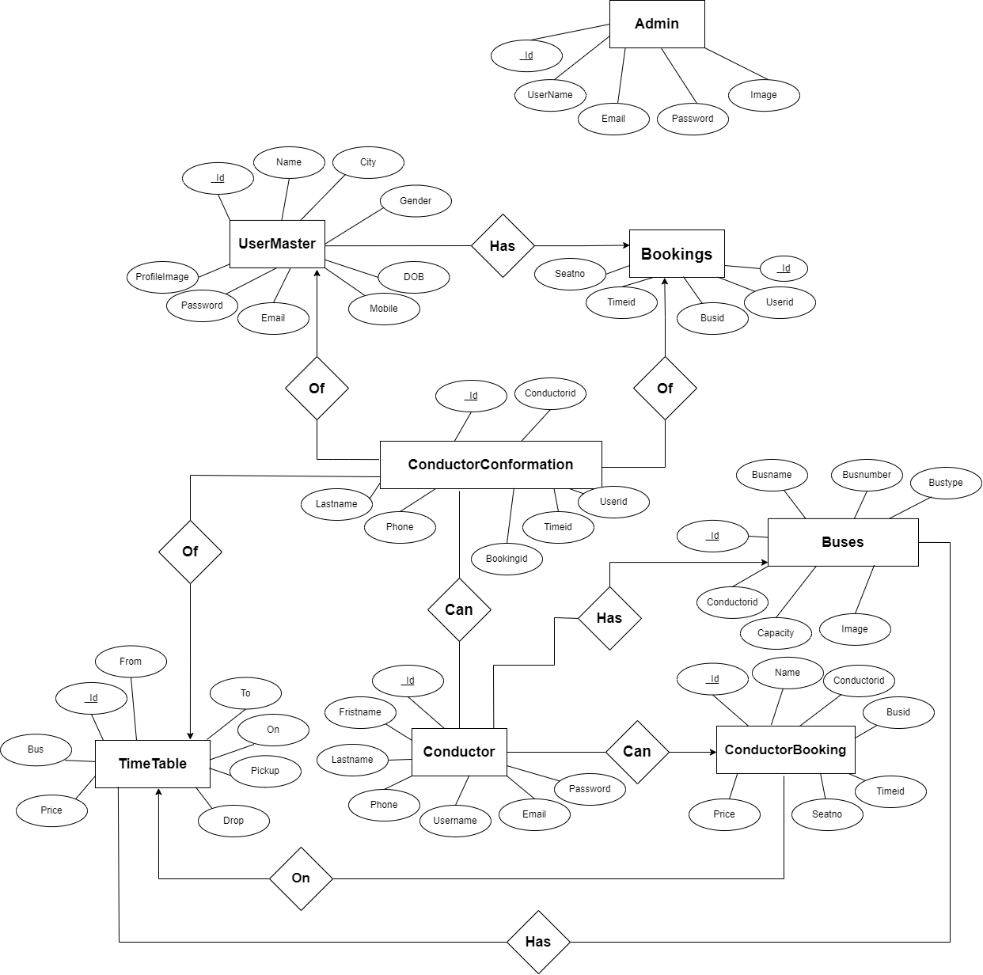

**4.5.2 data flow diagram:**

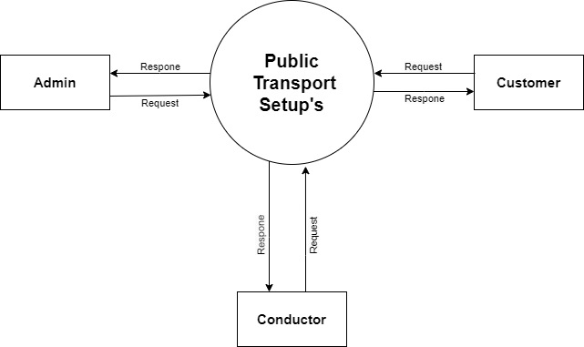

**[0 Level diagram]**

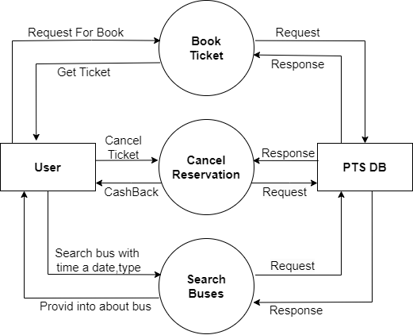

**[1st level User Diagram]**

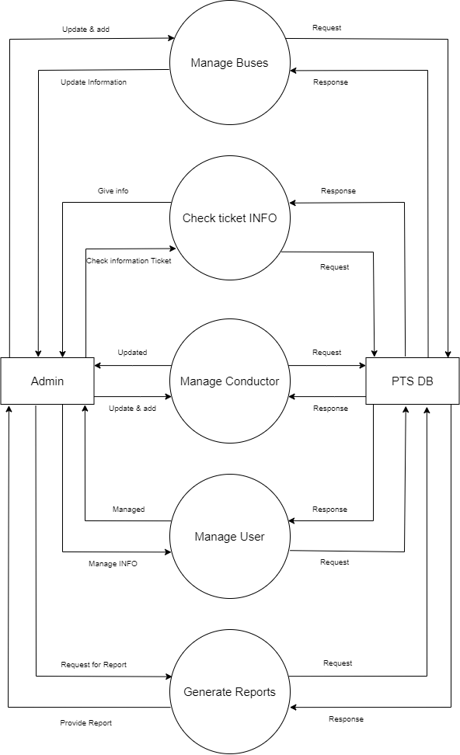

**[1st level Admin Diagram]**

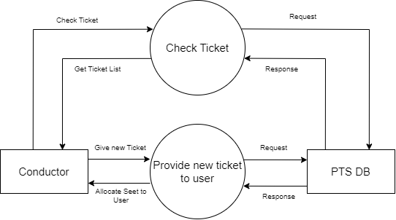

**[1st level Conductor Diagram]**

**4.6 data modeling:**

In a theoretical context, data modeling for a public transport system involves conceptualizing and structuring the data entities, attributes, and relationships that will be managed by the system. Below is a more abstract and theoretical overview of data modeling for a public transport system:

**4.6.1. Entities:**

* User Entity: Represents individuals interacting with the system, such as passengers, administrators, and drivers. Attributes may include username, email, password, and role.
* Vehicle Entity: Represents public transport vehicles (e.g., buses, trains). Attributes may include vehicle type, registration number, and seating capacity.
* Route Entity: Represents the predefined routes that vehicles follow. Attributes may include route name and a list of stops.
* Trip Entity: Represents specific instances of a vehicle traveling along a route. Attributes may include the vehicle involved, the route taken, departure time, and other trip-related information.
* Booking Entity: Represents reservations made by passengers for a particular trip. Attributes may include the passenger involved, the associated trip, seat number, and booking status.

**4.6.2. Relationships:**

* User-Booking Relationship: Users (passengers) are connected to bookings, representing the reservations they make for trips.
* Vehicle-Trip Relationship: Vehicles are associated with specific trips, defining when and where they operate.
* Route-Trip Relationship: Trips are linked to routes, indicating the path the vehicle takes during a journey.
* User-Role Relationship: Users have roles (e.g., passenger, driver, admin), influencing their permissions and interactions within the system.

**4.6.3. Attributes:**

* Temporal Attributes: Represent time-related information, such as departure times for trips or timestamps for user activities.
* Quantitative Attributes: Include numerical data, such as seating capacity for vehicles or the number of stops on a route.
* Qualitative Attributes: Involve descriptive data, such as names for routes or usernames for users.

**4.6.4. Normalization:**

* Consider the normalization of data structures to reduce redundancy and dependency issues. This involves organizing data into well-structured tables or documents to avoid duplication.

**4.7 main module for new system**

* **Data Dictionary :**

|  |  |  |  |
| --- | --- | --- | --- |
| 1. **Admin** | | | |
| **Sr. No** | **Name** | **Datatype** | **Description** |
| 1. | _id | ObjectId | It is storing the id of Admin. |
| 2. | UserName | String | It is storing the User Name of Admin. |
| 3. | Email | String | It is storing the Email of Admin. |
| 4. | Password | String | It is storing the password of Admin. |
| 5. | Image | String | It is storing Image URL of Admin. |

|  |  |  |  |
| --- | --- | --- | --- |
| 1. **User** | | | |
| **Sr. No** | **Name** | **Datatype** | **Description** |
| 1. | _id | ObjectId | It is storing the Id of User. |
| 2. | Name | String | It is storing the Name of User. |
| 3. | City | String | It is storing the City of User. |
| 4. | Gender | String | It is storing the Gender of User. |
| 5. | DOB | Date | It is storing the Date of Birth of User. |
| 6. | Mobile | String | It is storing the Mobile of User. |
| 7. | Email | String | It is storing the Email of User. |
| 8. | Password | String | It is storing the Password of User. |
| 9. | Image | String | It is storing the Image URL of User. |

|  |  |  |  |
| --- | --- | --- | --- |
| 1. **Conductor** | | | |
| **Sr. No** | **Name** | **Datatype** | **Description** |
| 1. | _id | ObjectId | It is storing the Id of Conductor. |
| 2. | FirstName | String | It is storing the First Name of Conductor. |
| 3. | LastName | String | It is storing the Last Name of Conductor. |
| 4. | Phone | String | It is storing the Phone of Conductor. |
| 5. | UserName | String | It is storing the User Name of Conductor. |
| 6. | Email | String | It is storing the Email of Conductor. |
| 7. | Password | String | It is storing the Password of Conductor. |

|  |  |  |  |
| --- | --- | --- | --- |
| 1. **Buses** | | | |
| **Sr. No** | **Name** | **Datatype** | **Description** |
| 1. | _id | ObjectId | It is storing the Id of Buses. |
| 2. | BusName | String | It is storing the Name of Buses. |
| 3. | BusNumber | String | It is storing the Number of Buses. |
| 4. | BusType | String | It is storing the Type of Buses. |
| 5. | Image | String | It is storing the Image URL of Buses. |
| 6. | Capacity | Number | It is storing the Capacity of Seating. |
| 7. | ConductorId | ObjectId | It is storing the ConductorId for Making Connection. |

|  |  |  |  |
| --- | --- | --- | --- |
| 1. **TimeTable** | | | |
| **Sr. No** | **Name** | **Datatype** | **Description** |
| 1. | _id | ObjectId | It is storing the id of TimeTable. |
| 2. | From | String | It is storing the starting stop of bus. |
| 3. | To | String | It is storing the ending stop of bus. |
| 4. | On | Date | It is storing the data of travaling. |
| 5. | Pickup | String | It is storing the pickup time. |
| 6. | Drop | String | It is storing the drop time. |
| 7. | Price | Number | It is storing the price of ticket. |
| 8. | BusId | ObjectId | It is storing the busId for Making Connection. |

|  |  |  |  |
| --- | --- | --- | --- |
| 1. **Bookings** | | | |
| **Sr. No** | **Name** | **Datatype** | **Description** |
| 1. | _id | ObjectId | It is storing the id of Bookings. |
| 2. | UserId | ObjectId | It is storing the UserId for Making Connection. |
| 3. | BusId | ObjectId | It is storing the busId for Making Connection. |
| 4. | TimeId | ObjectId | It is storing the timeId for Making Connection. |
| 5. | SeatNo | [Number] | It is storing the Seat Number of user. |

|  |  |  |  |
| --- | --- | --- | --- |
| 1. **ConductorConfirmation** | | | |
| **Sr. No** | **Name** | **Datatype** | **Description** |
| 1. | _id | ObjectId | It is storing the id of ConductorConfirmation. |
| 2. | ConductorId | ObjectId | It is storing the ConductorId for Making Connection. |
| 3. | UserId | ObjectId | It is storing the UserId for Making Connection. |
| 4. | TimeId | ObjectId | It is storing the TimeId for Making Connection. |
| 5. | BookingId | ObjectId | It is storing the BookingId for Making Connection. |
| 6. | Name | String | It is storing the Name of User. |
| 7. | Email | String | It is storing the Email of User. |
| 8. | SeatNo | [Number] | It is storing the Seat Number of User. |

|  |  |  |  |
| --- | --- | --- | --- |
| 1. **ConductorBooking** | | | |
| **Sr. No** | **Name** | **Datatype** | **Description** |
| 1. | _id | ObjectId | It is storing the id of ConductorBooking. |
| 2. | Name | String | It is storing the Name of User. |
| 3. | ConductorId | ObjectId | It is storing the conductorId for Making Connection. |
| 4. | BusId | ObjectId | It is storing the busIdfor Making Connection. |
| 5. | TimeId | ObjectId | It is storing the timeId for Making Connection. |
| 6. | SeatNo | [Number] | It is storing the Seat Numbers of user. |
| 7. | Price | Number | It is storing the Price of Ticket. |

1. **testing:**

* Testing is a set of activities which are decided in advance i.e., before the start of development and organized systematically.
* In the literature of software engineering various testing strategies to implement the testing are defined.
* Following are the characteristic that process the testing templates:
* The developer should conduct the successful technical reviews to perform the testing successful.
* Testing starts with the component level and work from outside toward the integration of the whole computer-based system.
* Different testing techniques are suitable at different points in time.
* Testing is organized by the developer of the software and by an independent test group.
* Debugging and testing are different activities, then also the debugging should be accommodated in any strategy of testing.

* 1. **test plan**

A test plan is a comprehensive document that outlines the strategy, objectives, resources, and schedule for testing a software application or system. It serves as a roadmap for the testing process and provides guidance on how to ensure the quality and reliability of the software. The key components of a test plan include:

* + 1. **Introduction:**
* Overview of the project, its purpose, and the scope of testing.
  + 1. **Test Objectives:**
* Clearly defined goals and objectives for the testing effort, aligning with project requirements.
  + 1. **Test Scope:**
* Inclusions and exclusions specifying what aspects of the software will be tested and what will not be covered.
  + 1. **Test Deliverables:**
* A list of documents, reports, and artifacts that will be produced as part of the testing process.
  + 1. **Test Environment:**
* Description of the hardware, software, and network configurations where testing will be conducted.
  + 1. **Test Schedule:**
* A timeline outlining the testing phases, milestones, and deadlines.
  + 1. **Test Cases:**
* Detailed test cases specifying the inputs, expected outputs, and conditions for executing tests.
  + 1. **Test Data:**
* Information about the data required for testing, including sample datasets and any data generation processes.
  + 1. **Risks and Contingencies:**
* Identification of potential risks associated with testing and strategies for mitigating or managing them.
  1. **testing strategy:**

A testing strategy is a high-level plan that outlines the overall approach, goals, and methods for testing a software application or system. It serves as a framework for making testing-related decisions and ensures that testing activities align with the project's objectives. The key components of a testing strategy include:

* + 1. **Test Levels:**
* Identification of the testing levels to be conducted, such as unit testing, integration testing, system testing, and user acceptance testing.
  + 1. **Test Types:**
* Definition of the types of testing to be performed, including functional testing, non-functional testing (performance, security, usability), and regression testing.
  + 1. **Testing Techniques:**
* Selection of testing techniques, such as black-box testing, white-box testing, and gray-box testing, based on the nature of the application and testing requirements.
  + 1. **Test Environment:**
* Specification of the test environment, including hardware, software, and network configurations required for testing.
  + 1. **Test Data Management:**
* Guidelines for managing test data, including data creation, data privacy, and strategies for maintaining test data integrity.
  + 1. **Risk Analysis:**
* Identification and assessment of potential risks associated with the testing process, along with mitigation strategies.
  1. **testing method:**

Testing methods refer to the specific techniques and approaches used to assess the functionality, performance, and quality of a software application. Various testing methods serve different purposes in the software development lifecycle. Here are some common testing methods:

* + 1. **Unit Testing:**
* Focuses on testing individual units or components of the software in isolation. It ensures that each unit functions as intended.
  + 1. **System Testing:**
* Evaluates the complete and integrated system to ensure that it meets specified requirements. It involves testing the system as a whole.
  + 1. **Non-Functional Testing:**
* Assesses non-functional aspects of the software, such as performance, security, usability, and reliability.
  + 1. **Security Testing:**
* Identifies vulnerabilities and weaknesses in the software's security measures. It helps ensure that the application is resistant to security threats.

1. **Screenshots:**
   1. **Admin:**
      1. **Login**

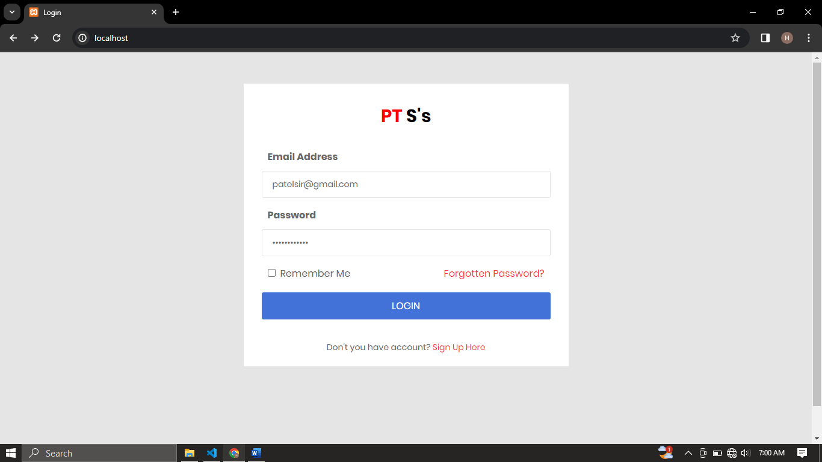

* It is the login page of admin. That allows to login in the system.
  + 1. **Dashboard:**

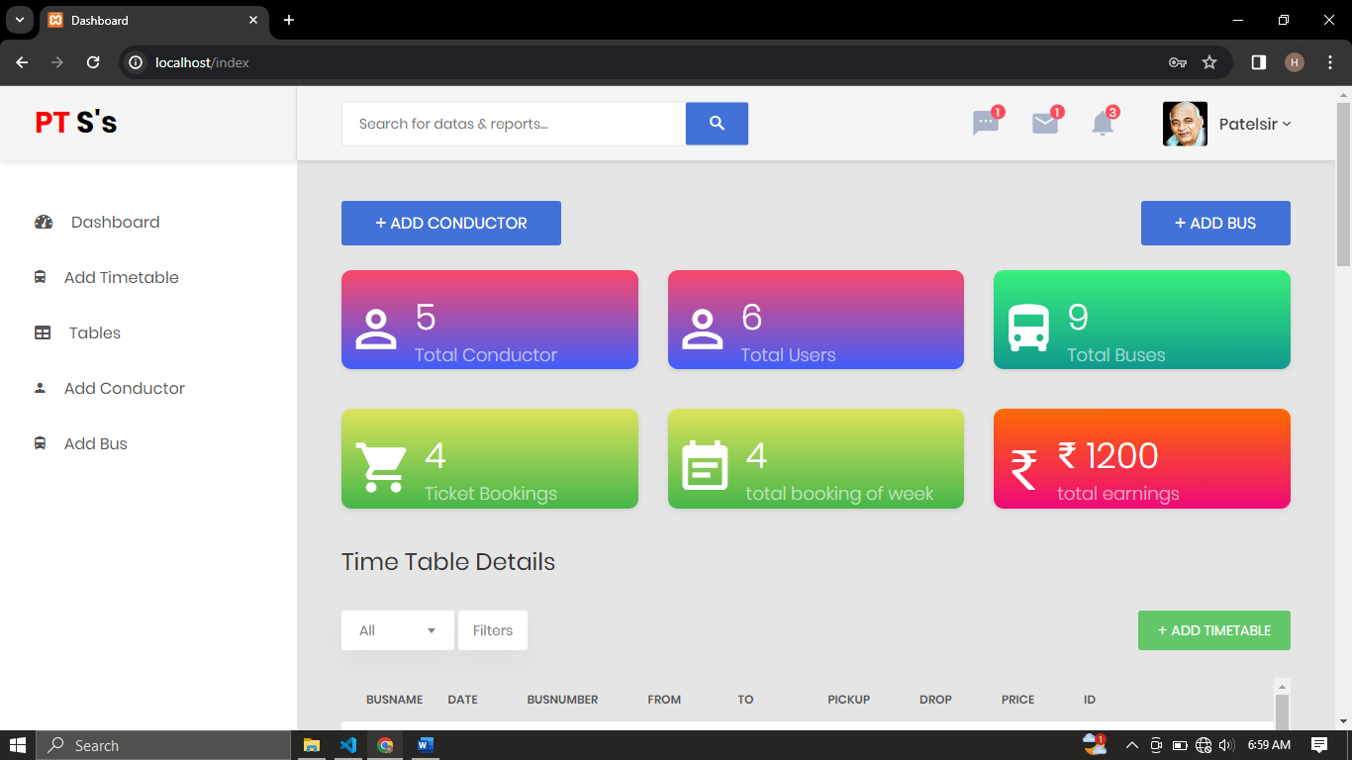

* It is a Dashboard of Admin. That can show details regarding business. And will be provide summary of the system user, and buses.
  + 1. **Dashboard:**

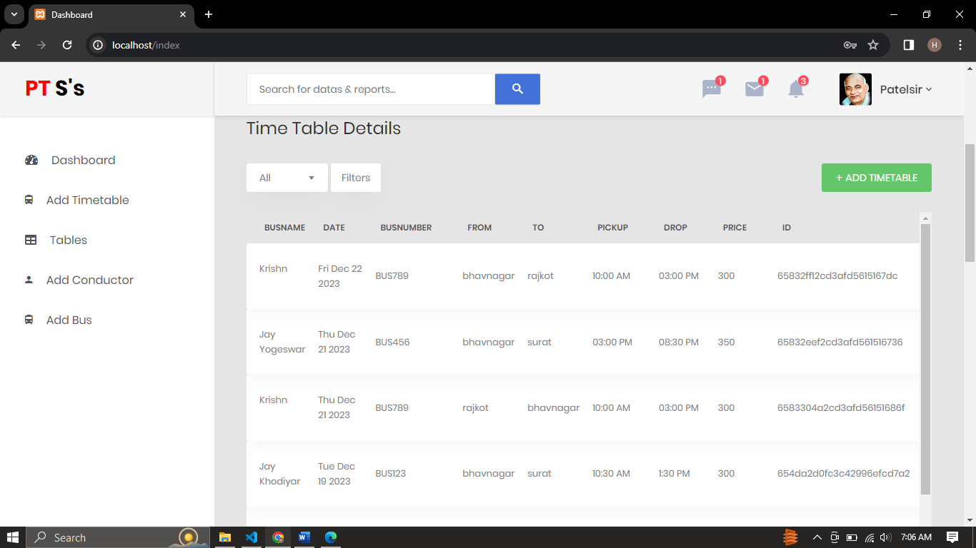

* It is also dashboard that show the details of timetable of bus.
  + 1. **Dashboard:**

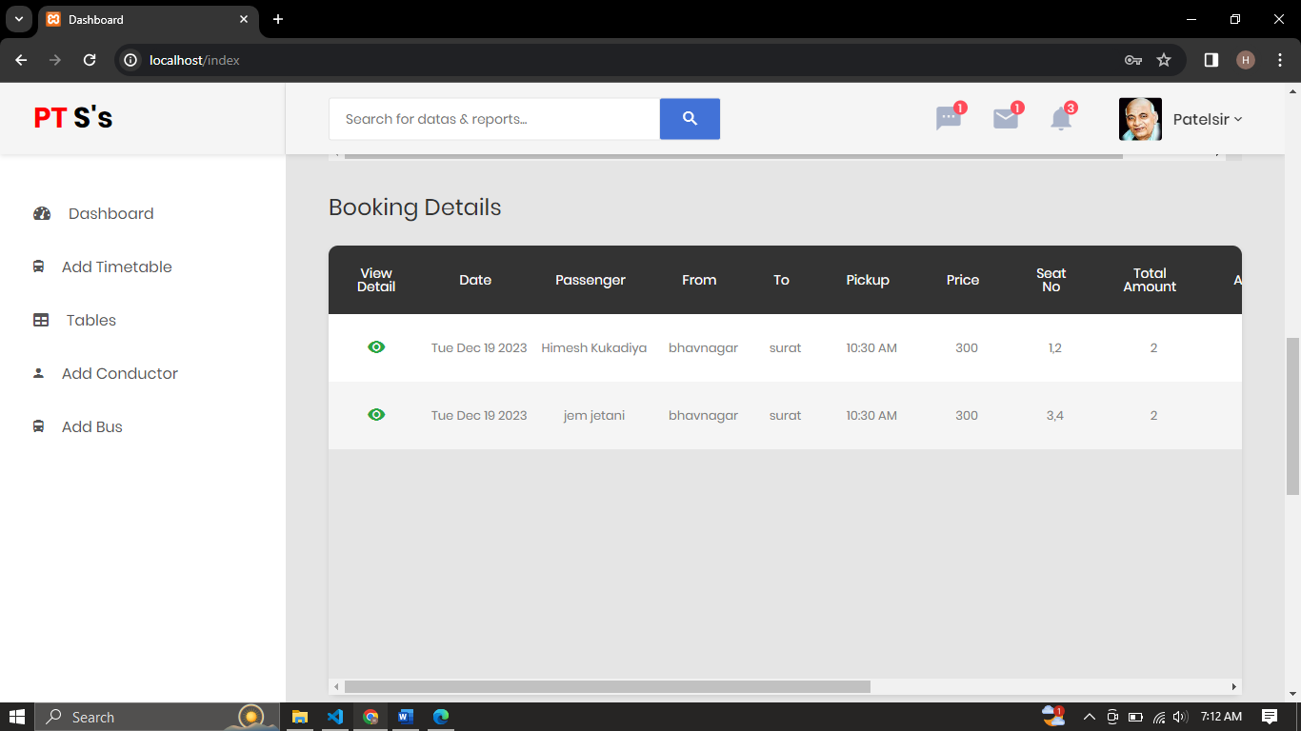

* It is also dashboard that show the detail of Bookings.
  + 1. **Dashboard:**

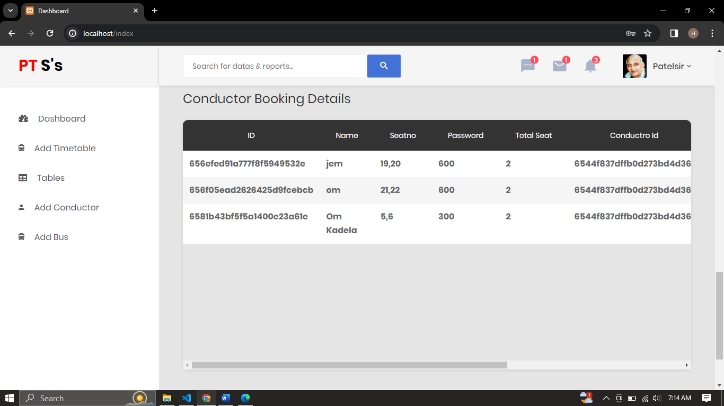

* It is also dashboard that show the detail of those booking who have done by conductor.
  + 1. **Table:**

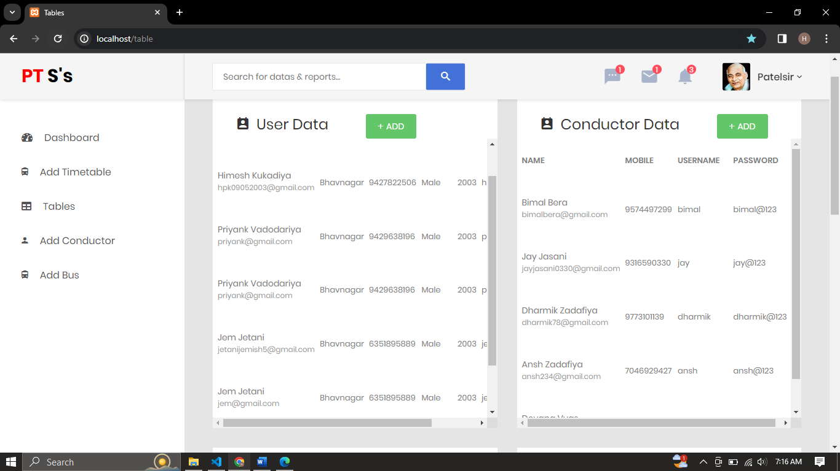

* It is table page that show the detail about Customer, Conductor, Buses, Admin, Booking.
  + 1. **Add Timetable**

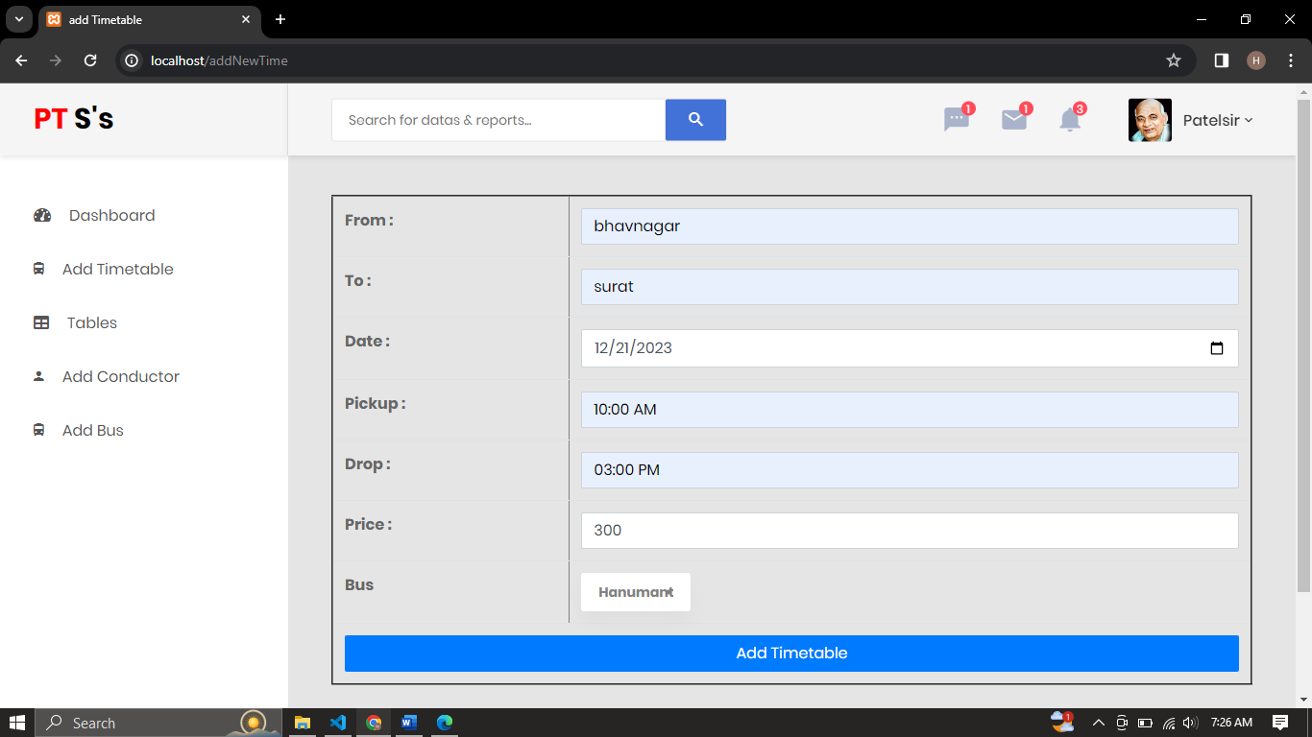

It is add Timetable page. That allows to Add new timetable. There is or 3 page of adding that is (add_Buses, add_conductor, add_user).

* 1. **Conductor**
     1. **Login**

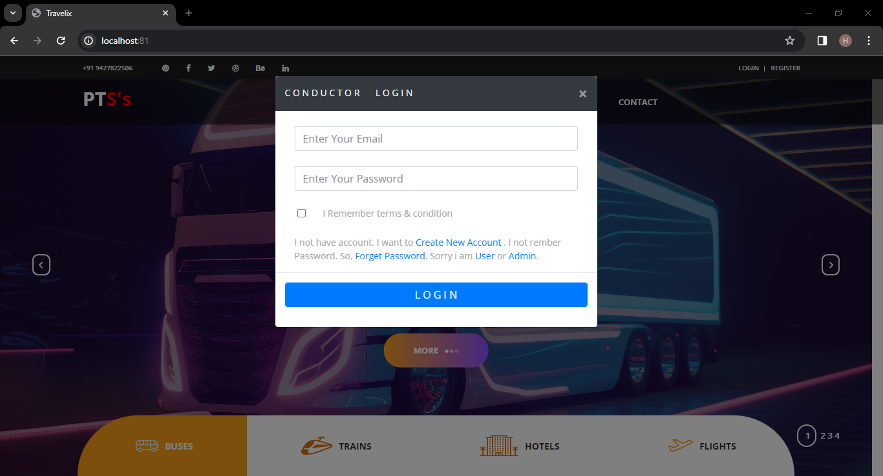

* It is the login page of Conductor. That allows to login in the system.
  + 1. **Login**

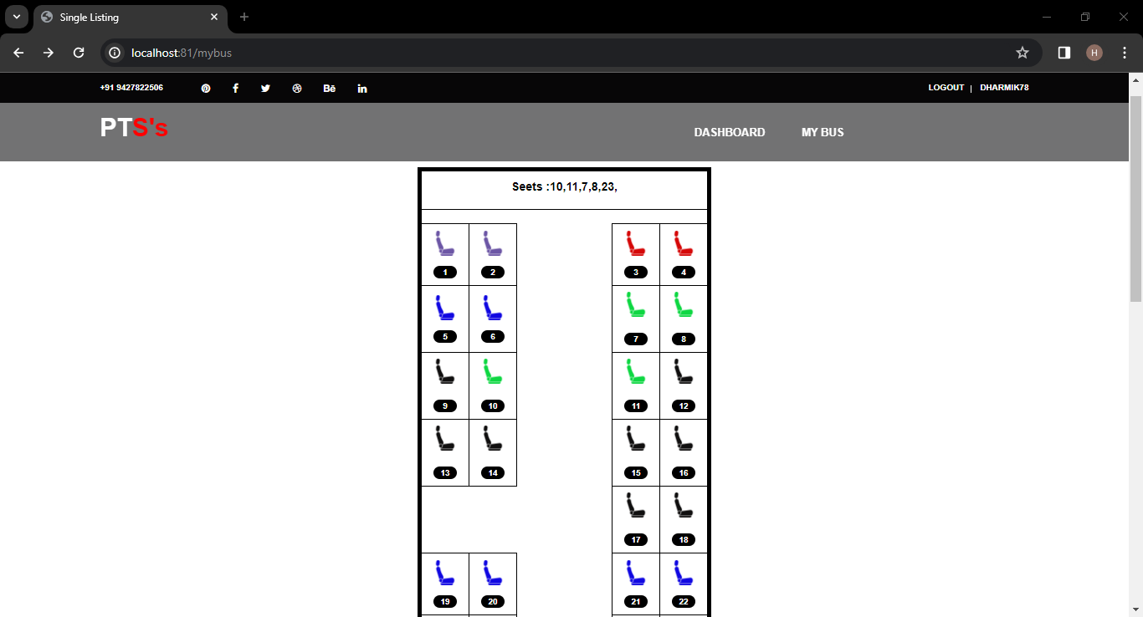

* It is the mybus page. That is display the list of seat those booked, not booked, selected, and new generated seat.
  + 1. **New Ticket**

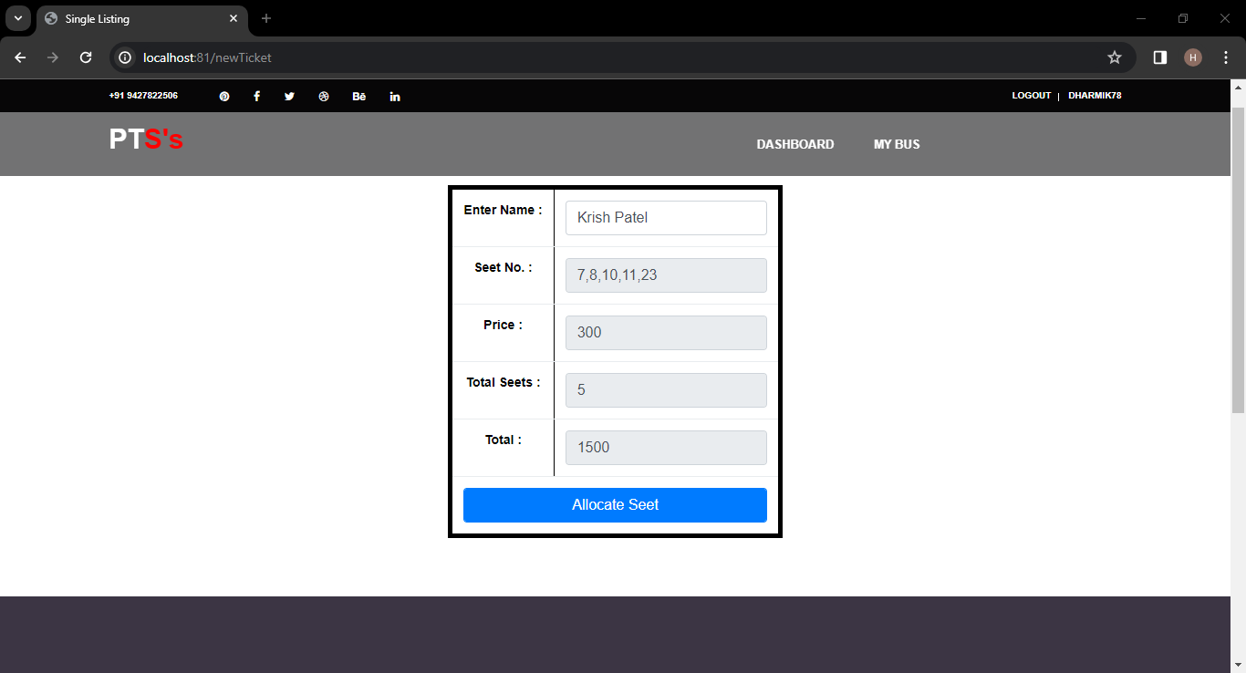

* It is the new Ticket page. There conductor can generate new ticket.
  + 1. **Confirm Ticket**

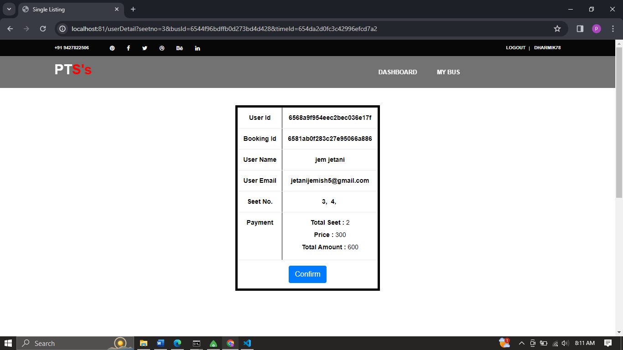

* It is the confirm Ticket page. There conductor can confirm already booked seat.
  1. **User**
     1. **Login**

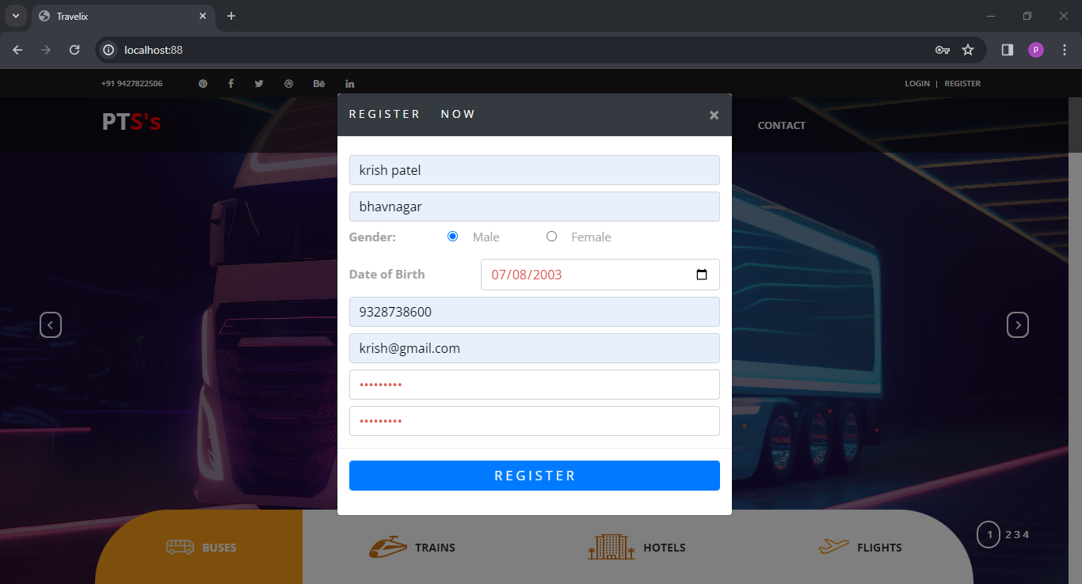

* It is the registration page. There user can register.
  + 1. **Home**

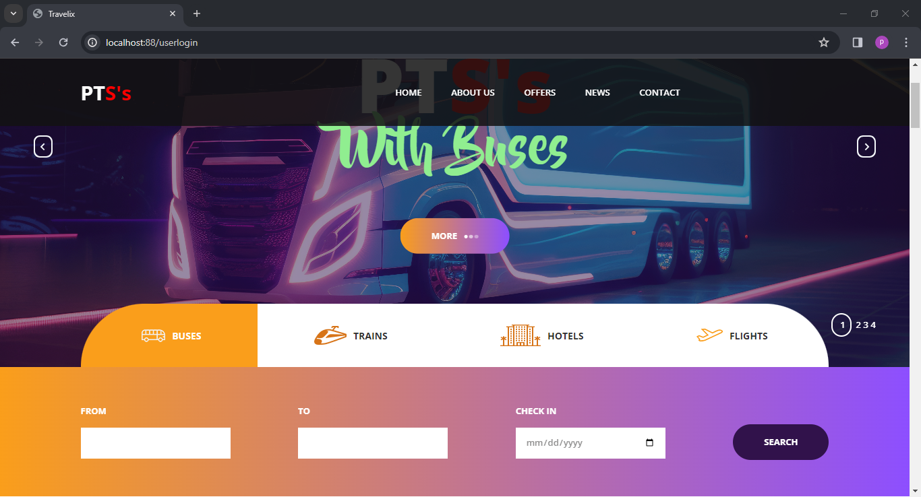

* It is the home page. There user search buses.
  + 1. **Buses List**

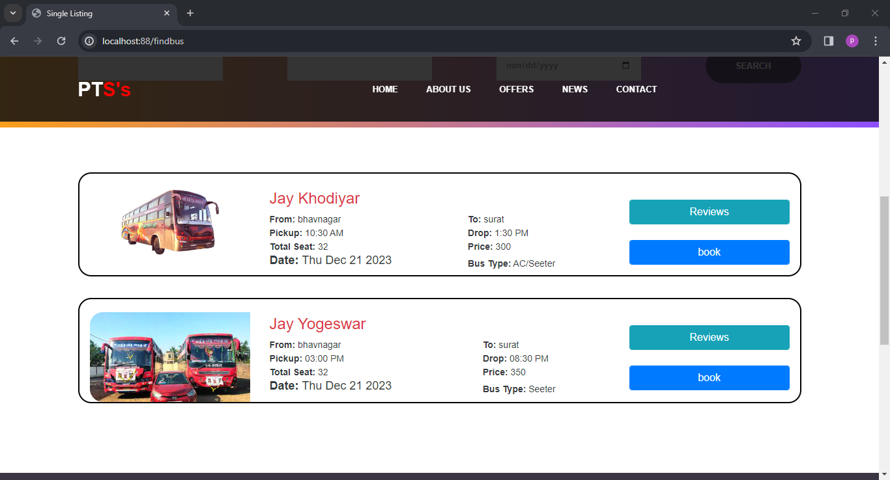

* It is search result page. There is provide list of bus.
  + 1. **Seat List**

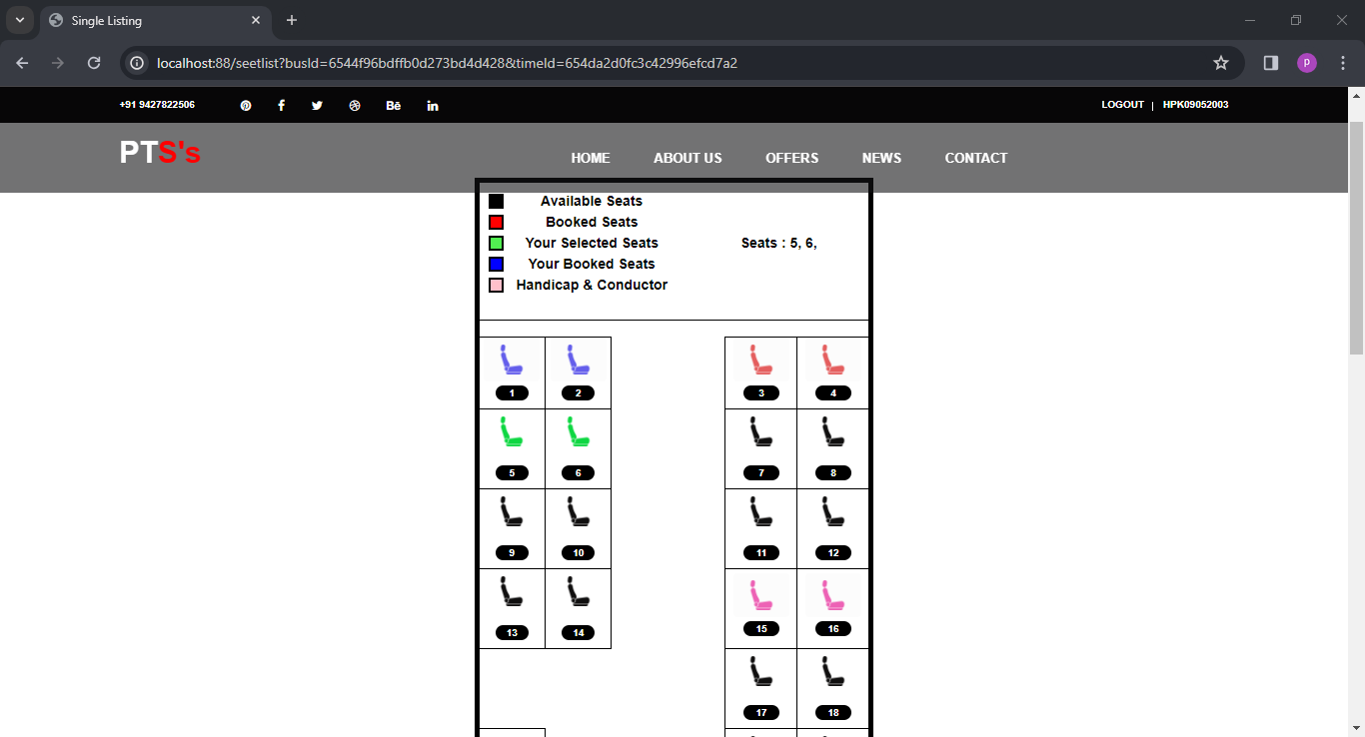

* It is seat list page. There user can get list of all seat those are booked, available, and his seat those booked by him.
  + 1. **Payment**

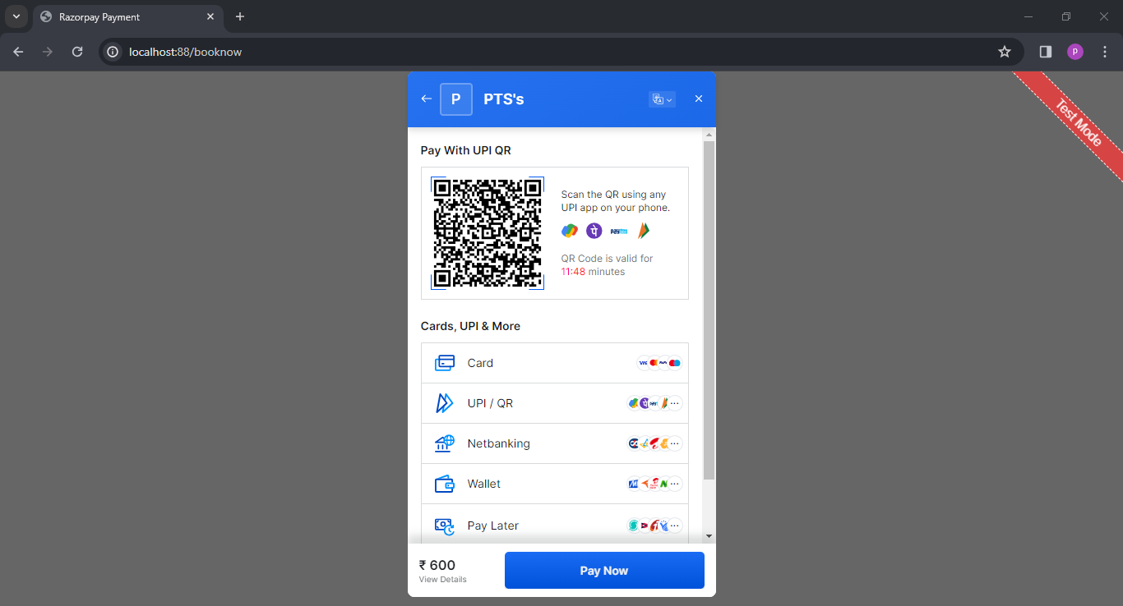

* This is payment page there user can pay amount online.
  + 1. **Cancel**

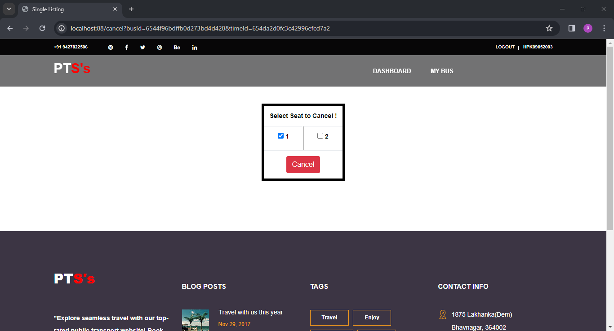

* This is cancel reservation page there user can cancel the his seat.

1. **limitation and future enhancement**

**Limitations:**

* **Limited Connectivity:**
* Limitation: The system's functionality may be impacted in areas with poor network connectivity, potentially leading to delays in real-time updates and user interactions.
* Mitigation: Implement offline capabilities where users can access essential functionalities even without an internet connection and optimize the system to handle intermittent connectivity.
* **User Adoption Challenges:**
* Limitation: Encountering resistance or slow adoption from certain user demographics may limit the system's overall effectiveness.
* Mitigation: Conduct user education campaigns, gather feedback for continuous improvement, and design user interfaces that are intuitive and user-friendly to encourage broader adoption.
* **Data Privacy Concerns:**
* Limitation: Users may have concerns about the privacy and security of their personal data, especially during online transactions and user registrations.
* Mitigation: Implement robust data protection measures, clearly communicate privacy policies to users, and comply with relevant data protection regulations to build trust.

**Future Enhancements:**

* **Augmented Reality (AR) Navigation:**
* Enhancement: Integrate AR navigation features for users to receive real-time navigation guidance, bus stop information, and relevant details through their mobile devices, enhancing the overall user experience.
* **Integration with Smart Infrastructure:**
* Enhancement: Collaborate with smart city initiatives to integrate the public transport system with intelligent infrastructure, enabling better traffic management, optimized routes, and improved overall urban mobility.
* **Personalized Travel Recommendations:**
* Enhancement: Implement machine learning algorithms to analyze user travel patterns and preferences, providing personalized travel recommendations, route suggestions, and real-time updates tailored to individual users.
* **Enhanced Mobile Ticketing:**
* Enhancement: Upgrade mobile ticketing features to support multiple payment options, including digital wallets and contactless payment methods, making the ticketing process more convenient and secure.
* **Integrated Multi-Modal Transport:**
* Enhancement: Extend the system to seamlessly integrate various modes of transportation, such as bike-sharing or ride-sharing services, providing users with a comprehensive and interconnected transport experience.

1. **conclusion and discussion:**

**Conclusion:**

* The public transport system project demonstrates a significant stride towards modernizing urban mobility, offering a comprehensive solution for efficient and user-friendly transportation. Despite certain limitations, the system has successfully addressed key challenges, providing real-time tracking, convenient booking options, and enhanced user experiences. The integration of emerging technologies, such as predictive analytics and mobile ticketing, showcases a commitment to staying at the forefront of innovation.
* The project's current limitations, including connectivity issues and potential user adoption challenges, serve as valuable insights for ongoing improvement. Mitigation strategies, such as offline capabilities and user education initiatives, have been proposed to enhance the system's robustness and user acceptance.
* Looking ahead, a roadmap for future enhancements has been outlined to propel the public transport system to new heights. Augmented reality navigation, integration with smart infrastructure, and personalized travel recommendations stand out as promising features that can elevate the user experience. The incorporation of voice-activated services and blockchain technology further underscores a commitment to cutting-edge solutions and enhanced security.
* Community engagement and sustainable transport initiatives are pivotal components of the envisioned future enhancements, aligning the public transport system with the evolving needs and expectations of the urban population. By fostering a collaborative environment and promoting eco-friendly practices, the system has the potential to become a cornerstone of smart, inclusive, and environmentally conscious urban mobility.

**Discussion:**

* The public transport system project sparks discussion on the transformative impact of technology on urban transportation. The integration of real-time tracking and predictive analytics not only streamlines commuting but also contributes to improved traffic management and resource optimization. The project's focus on accessibility and inclusivity, with considerations for users with disabilities, aligns with the principles of creating smart cities that prioritize the needs of diverse populations.
* The discussion extends to the role of public-private partnerships and collaboration with smart city initiatives. By forging alliances with external stakeholders, the public transport system can tap into additional resources, benefit from shared data, and contribute to the broader goal of creating sustainable and interconnected urban environments.
* Ethical considerations, particularly concerning data privacy and security, are integral to the discourse. As the public transport system collects and processes user data, it must adhere to stringent privacy standards, communicate transparently with users, and implement robust security measures. Blockchain technology emerges as a potential solution, offering a decentralized and secure framework for managing sensitive information.
* Ultimately, the public transport system project underscores the importance of adaptability and continuous improvement. As technology evolves and user expectations shift, ongoing collaboration, feedback mechanisms, and a commitment to innovation will be essential to ensuring that the system remains at the forefront of urban mobility solutions.

1. **REFERENCES:**

* <https://www.w3schools.com/>
* <https://chat.openai.com/>
* <https://stackoverflow.com/>
* <https://codewithharry.com/>