DriftSense
SRS compliance review and Appendices 8.3 and 8.4
BCSE301L Software Engineering | Himesh Allani (24BAI1409)

1. Summary
Every requirement in the SRS (sections 3, 5 and 7) was checked against the code, the tests and real runs. Almost all are met. Three points need to be stated plainly in the report and the viva:
- A regime shift has not been observed on real data. Replaying the detector over about six years of history for all 20 stocks found 310 separate drift episodes: 109 classified Anomaly Spike, 201 No Significant Event and 0 Regime Shift. The Regime Shift path (classification, retraining, promotion gate) is implemented, tested and demonstrated through the Simulation Engine on clearly labelled synthetic data, but acceptance criterion 2 is only met for the anomaly side on real data.
- Forecast accuracy is about a coin flip. Walk-forward direction accuracy averages 50.4% across the 20 stocks (about 600 predictions each). The SRS sets no accuracy target, so no requirement is failed, but the number should be reported honestly.
- Python 3.10 portability is met by inspection, not by test. The code was run on Python 3.12 and 3.13. Two f-strings that needed 3.12 were rewritten; no 3.10 interpreter was available to confirm.

2. Requirement-by-requirement review
Status key: Met = implemented and verified. Met* = met with a note. Partly = only part is demonstrated.
Req | Requirement (short) | Status | Evidence
FR-1 | Ingest historical daily OHLCV via Yahoo Finance | Met | yahoo_ingestor.fetch_historical; 20 stocks, history from 2020-01-02 (about 1,700 rows each)
FR-2 | Baseline model predicts next-day direction | Met | forecasting/train.py (LSTM direction classifier). Accuracy about 50%, see section 1
FR-3 | Poll live data on a schedule into a rolling window | Met* | update_live_window keeps the latest 90 days; scripts/scheduler.py runs all 20 stocks daily at 17:30. It runs only while that process is open; the one-time OS task command is in the README
FR-4 | Statistical drift score, live vs training | Met | drift/detector.compute_drift_score (KS test + PSI), threshold 0.30 in config
FR-5 | Classify Regime Shift vs Anomaly Spike by magnitude, duration, reversion | Partly | drift/classifier.classify_drift with written reasoning. Spike side shown on real data; Regime Shift only on synthetic data (section 3)
FR-6 | SHAP attribution for each drift event | Met | drift/attribution.explain_drift runs for every flagged event; result logged and shown
FR-7 | Retrain only on a Regime Shift | Met | run_daily_cycle calls run_retraining_cycle only when classification is Regime Shift (unit-tested; exercised in the simulator)
FR-8 | Version each model; keep a retraining changelog | Met | models/<ticker>/v<n>/metadata.json, logs/retrain_log.jsonl, and Git tags model/<ticker>/v<n>
FR-9 | Validate a retrained model against a benchmark before promoting | Met | retraining/validator.validate_candidate; never bypassed
FR-10 | Confidence score with every prediction | Met | forecasting/confidence.py, 20 MC-Dropout passes
FR-11 | Abstain below a configurable threshold, shown explicitly | Met | Per-model threshold calibrated from validation data (confidence.abstain_percentile in config); dashboard shows Abstained
FR-12 | Dashboard: predictions, confidence, alerts with cause, retraining history | Met | src/dashboard/app.py (screenshots in 8.4)
NFR-1 | Drift detection within 5 seconds | Met | Measured: mean 1.4 ms, max 2.8 ms over 30 trials
NFR-2 | Stay within Yahoo free-tier limits | Met | ingestion._download spaces requests at least 1 second apart and retries failures with backoff; a 20-stock daily cycle is about 20 requests
NFR-3 | Log every retraining decision and its justification | Met | retrain_log.jsonl: trigger, accuracy before and after, promoted flag, a written justification, and the training-data range
NFR-4 | Dashboard updates within 10 seconds of a new event | Met | The page checks the logs every 5 seconds and reruns when one changes. Measured: refreshed 2 seconds after a log write
NFR-5 | Separate, independently testable modules | Met | ingestion, drift, forecasting, retraining, dashboard, simulation; 88 automated tests
NFR-6 | Measure and report the false-alarm rate | Met | Measured: 2.5% (5 of 200 bootstrap trials)
3.3 | Storage: file-based; versioning via Git tags or DVC | Met | Annotated Git tags model/<ticker>/v<n> carry the model's SHA-256, metrics and data range. Tags are local until pushed with git push --tags. DVC is not used
3.4 | 3 to 5 years of history; rolling live window; artifacts with data range, metrics, promotion decision | Met | About 6.7 years of history; 90-day live window; metadata.json holds all three (backfilled for the 20 existing models and checked against the onboarding logs)
4.4 | Class diagram names DataIngestor, DriftDetector, Forecaster and others | Met* | Implemented as Python modules of functions rather than classes; each named class corresponds to a module. Worth one sentence in the report
5 Reliability | Failures logged and retried, not fatal | Met | Requests retried 3 times; a failed stock is logged to logs/cycle_errors.jsonl and retried once after 5 minutes; one stock failing never stops the others
5 Availability / Maintainability | On-demand dashboard; modular | Met | start_demo.bat starts both apps; module boundaries as in NFR-5
5 Security | No personal data; no secrets in version control | Met | Only public market data; data/, models/ and logs/ are git-ignored; no keys are used
5 Safety | Not-financial-advice disclaimer | Met | On the dashboard footer, the simulator and the README
5 Portability | Python 3.10+, no platform-specific dependencies | Met* | Core code is cross-platform. Tested on 3.12 and 3.13 only; start_demo.bat is a Windows convenience
5 Interoperability | Portable model format (pickle/ONNX) | Met | model.pt (PyTorch pickle) plus model.onnx for all 20 models; ONNX output matches PyTorch to 1e-7 (scripts/export_onnx.py)
7 AC-1 | FR-1 to FR-12 implemented and demonstrable | Met | See rows above and the screenshots in 8.4
7 AC-2 | Distinguish a genuine regime shift from an anomaly spike, with reasoning | Partly | Anomaly Spike with reasoning on real data; Regime Shift on labelled synthetic data only (section 3)
7 AC-3 | Attribution identifies a plausible feature for each flagged event | Met* | SHAP runs for every flagged event; whether the named feature is plausible is a judgement and is shown with its explanation text
7 AC-4 | Abstention demonstrated with a clear low-confidence state | Met | AAPL and GOOG currently abstain; see the screenshot in 8.4
7 AC-5 | Underperforming retrained models never promoted | Met | Promotion gate; covered by tests and the simulator's gate decision display
7 AC-6 | Latency and false-alarm benchmarks measured and reported | Met | See NFR-1 and NFR-6 rows and Appendix 8.3.1
7 AC-7 | Dashboard reflects live predictions, alerts and history in the demo | Met | Watchlist shows each stock's latest call; auto-refreshes (NFR-4)

3. Finding: no regime shift has been classified on real data
This matters because the system's headline behaviour is retraining on regime shifts, and because acceptance criterion 2 asks for a genuine regime shift to be told apart from a genuine anomaly spike.
What was done: scripts/replay_history.py runs the same drift score and classifier the daily cycle uses, one 90-day window at a time, over each stock's real history (every third trading day, after a 250-day warm-up). Nothing is simulated.
Result (20 stocks, about 6 years) | Count
Windows with drift score above 0.30 | 3410
Distinct drift episodes (consecutive windows merged) | 310
Classified Anomaly Spike | 109
Classified No Significant Event | 201
Classified Regime Shift | 0

Why: the classifier measures each day's return against the previous 10 days. During a sustained change those 10 days contain the change itself, so the z-score normalises away; a 10-day z-score also cannot exceed 2.85. Five consecutive days above half the spike threshold only happens when each day's move is larger than the one before (an escalating whipsaw). The April 2025 tariff selloff, for example, was classified Anomaly Spike or No Significant Event for the stocks checked.
What this means for the report: state that the regime-shift path is implemented, unit-tested and demonstrated on synthetic data through the Simulation Engine, and that no real regime shift occurred in the data under the current heuristic. The SRS itself calls the classifier a heuristic, not a verified detector. A volatility-level test (recent volatility sustained well above the baseline's) would be a more faithful definition of a sustained shift, but it changes the classifier's behaviour and is a design decision, so it has not been made.

Examples with the classifier's own reasoning (real data)
Stock | Dates | Peak drift | Classification | Reasoning (from the code)
AAPL | 2022-04-06 to 2022-04-06 | 0.30 | Anomaly Spike | Magnitude 2.71 std exceeded the 2.5 spike threshold; 2/5 of the most recent days stayed elevated. That's within spike_max_duration_days (3), i.e. it reverted quickly — classified as Anomaly Spike, not retrain-worthy.
AAPL | 2024-01-04 to 2024-06-24 | 0.59 | Anomaly Spike | Magnitude 2.57 std exceeded the 2.5 spike threshold; 1/5 of the most recent days stayed elevated. That's within spike_max_duration_days (3), i.e. it reverted quickly — classified as Anomaly Spike, not retrain-worthy.
AAPL | 2021-06-03 to 2021-12-14 | 0.59 | No Significant Event | No day in the live window exceeded the 2.5-std spike threshold.

Appendix 8.3 Sample Reports

8.3.1 Quality-metrics report
Walk-forward backtest: 6 folds of 100 test days each, every fold trained only on earlier data, about 600 predictions per stock. Accuracy is the share of correct UP/DOWN calls; an average near 50% means no measurable edge. UP share is the share of calls that were UP.
Market | Stock | Accuracy | UP share | Predictions
Nasdaq | AAPL | 49.9% | 63% | 599
Nasdaq | MSFT | 49.4% | 51% | 599
Nasdaq | NVDA | 50.3% | 52% | 599
Nasdaq | AMZN | 50.4% | 53% | 599
Nasdaq | GOOG | 49.8% | 49% | 599
Nasdaq | META | 51.1% | 51% | 599
Nasdaq | AVGO | 53.3% | 56% | 599
Nasdaq | TSLA | 51.3% | 52% | 599
Nasdaq | COST | 54.1% | 53% | 599
Nasdaq | NFLX | 49.7% | 49% | 599
NSE | RELIANCE.NS | 49.4% | 51% | 599
NSE | TCS.NS | 46.1% | 50% | 599
NSE | HDFCBANK.NS | 48.1% | 58% | 599
NSE | ICICIBANK.NS | 49.4% | 48% | 599
NSE | BHARTIARTL.NS | 51.3% | 48% | 599
NSE | INFY.NS | 51.4% | 55% | 599
NSE | SBIN.NS | 51.1% | 50% | 599
NSE | ITC.NS | 50.6% | 50% | 599
NSE | HINDUNILVR.NS | 52.3% | 48% | 599
NSE | LT.NS | 49.4% | 49% | 599

Group | Mean accuracy
Nasdaq top 10 | 50.9%
NSE top 10 | 49.9%
All 20 stocks | 50.4% (one standard error about 0.5 points across 11980 predictions)

Drift-detector performance (SRS NFR-1 and NFR-6):
Measure | Result | Target
Detection latency (mean / max) | 1.4 ms / 2.8 ms (30 trials) | under 5 s
False-alarm rate | 2.5% (5 of 200 bootstrap trials on real no-drift windows) | measured and reported
Dashboard refresh after a new log entry | about 2 s (5 s check interval) | under 10 s

8.3.2 Retraining changelog report
The real changelog (logs/retrain_log.jsonl) is empty because no real Regime Shift has occurred (section 3), so no real retraining has been triggered. Every entry has the format below. The sample is from the Simulation Engine on META with injected, clearly labelled SIMULATED data in a throwaway sandbox; the model it produced was discarded.
Field | Sample entry (SIMULATED)
Trigger | SIMULATED Regime Shift
Drift score / threshold | 0.632 / 0.3
Classifier reasoning | Magnitude 2.64 std exceeded the 2.5 spike threshold; 5/5 of the most recent days stayed elevated. That meets the regime_min_duration_days (5) bar for a sustained shift, not a one-off spike — classified as Regime Shift.
Attributed cause (SHAP) | volatility_10d: Drift primarily attributed to 'volatility_10d' (mean |SHAP| = 0.0004).
Candidate vs current accuracy | 42.9% vs 42.9%
Decision | PROMOTED
Justification | Promoted: candidate 42.9% vs current 42.9% on the same benchmark window (required improvement: at least +0.0%).
Training rows | 1764

8.3.3 Model registry report
Each promoted model, with the metadata the SRS (section 3.4) asks for. The SHA-256 identifies the exact model file; the Git tag model/<stock>/v1 marks the code revision that trained it.
Stock | Ver. | Trained | Training data (rows) | Held-out acc. | Promoted | SHA-256
AAPL | v1 | 2026-10-05 | 2020-01-02 to 2026-10-02 (1697) | 48.4% | yes | 62d40c1b0d
MSFT | v1 | 2026-10-05 | 2020-01-02 to 2026-10-02 (1697) | 55.8% | yes | 7c428290ac
NVDA | v1 | 2026-10-05 | 2020-01-02 to 2026-10-02 (1697) | 50.3% | yes | b9686f27a9
AMZN | v1 | 2026-10-05 | 2020-01-02 to 2026-10-02 (1697) | 50.6% | yes | 46a7fba5a9
GOOG | v1 | 2026-10-05 | 2020-01-02 to 2026-10-02 (1697) | 51.6% | yes | e0936edeb3
META | v1 | 2026-10-05 | 2020-01-02 to 2026-10-02 (1697) | 52.9% | yes | 2d86306a83
AVGO | v1 | 2026-10-05 | 2020-01-02 to 2026-10-02 (1697) | 55.1% | yes | cee36e95e8
TSLA | v1 | 2026-10-05 | 2020-01-02 to 2026-10-02 (1697) | 49.7% | yes | f91a623ee9
COST | v1 | 2026-10-05 | 2020-01-02 to 2026-10-02 (1697) | 52.6% | yes | e91e7c2b4b
NFLX | v1 | 2026-10-05 | 2020-01-02 to 2026-10-02 (1697) | 49.7% | yes | 66e7d99838
RELIANCE.NS | v1 | 2026-10-05 | 2020-01-01 to 2026-10-01 (1677) | 48.7% | yes | 6718182f9f
TCS.NS | v1 | 2026-10-05 | 2020-01-01 to 2026-10-01 (1677) | 50.0% | yes | 72434a3634
HDFCBANK.NS | v1 | 2026-10-05 | 2020-01-01 to 2026-10-01 (1677) | 49.7% | yes | ed89f67753
ICICIBANK.NS | v1 | 2026-10-05 | 2020-01-01 to 2026-10-01 (1677) | 47.7% | yes | 58f48bd2a6
BHARTIARTL.NS | v1 | 2026-10-05 | 2020-01-01 to 2026-10-01 (1677) | 49.0% | yes | a1c5f0a814
INFY.NS | v1 | 2026-10-05 | 2020-01-01 to 2026-10-01 (1677) | 46.8% | yes | f779ddbabd
SBIN.NS | v1 | 2026-10-05 | 2020-01-01 to 2026-10-01 (1677) | 52.3% | yes | e4986056f1
ITC.NS | v1 | 2026-10-05 | 2020-01-01 to 2026-10-01 (1677) | 50.6% | yes | a4b142c5da
HINDUNILVR.NS | v1 | 2026-10-05 | 2020-01-01 to 2026-10-01 (1677) | 49.4% | yes | bedb4004aa
LT.NS | v1 | 2026-10-05 | 2020-01-01 to 2026-10-01 (1677) | 49.0% | yes | 566186e0ae

Appendix 8.4 Screen Mockups
These are screenshots of the finished dashboard and Simulation Engine (the finalised wireframe), captured from the running application.
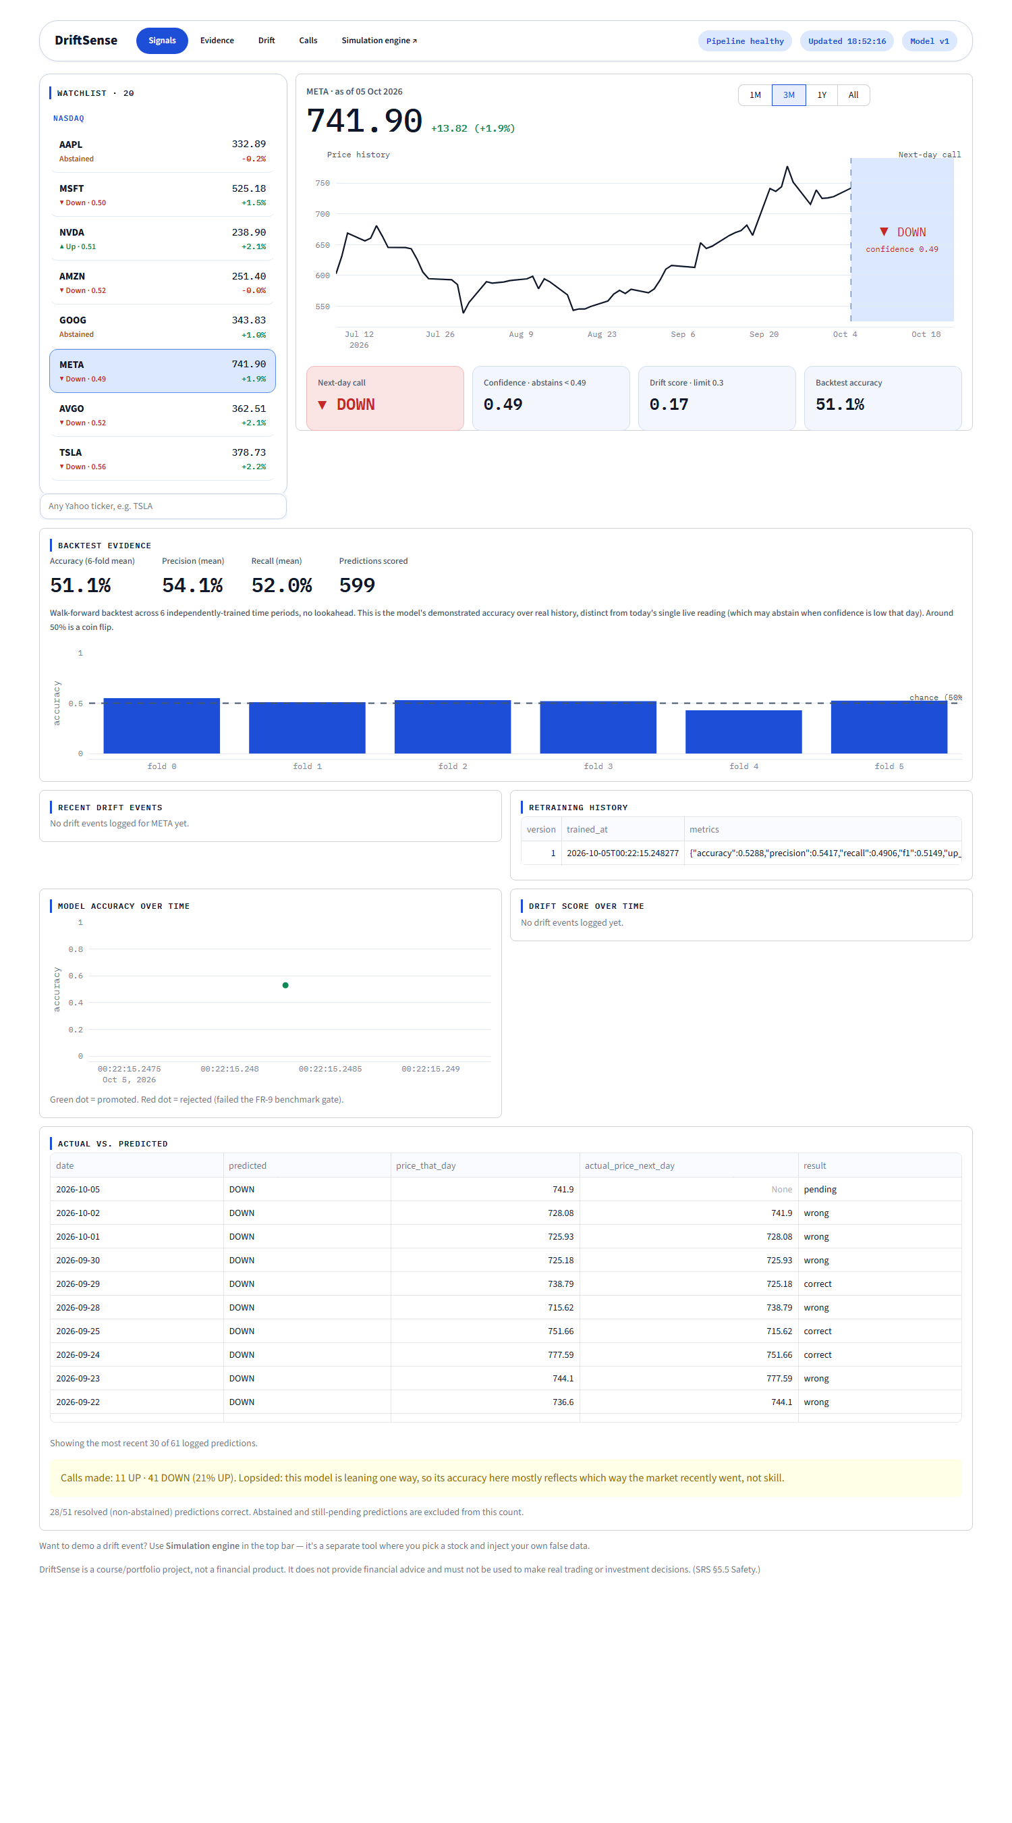
Figure 8.4.1 Monitoring dashboard (META): watchlist of 20 stocks with each stock's latest call, price chart with the next-day call, confidence, drift score, backtest evidence, drift events and retraining history.
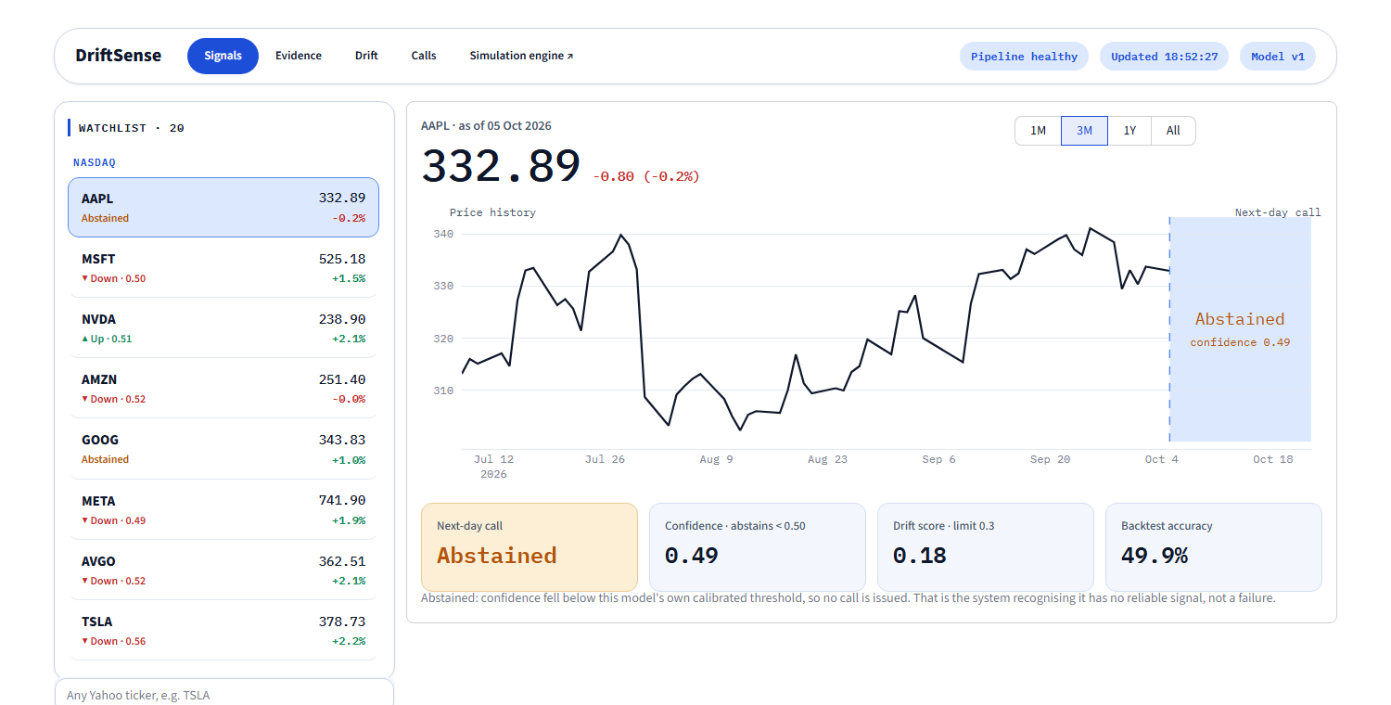
Figure 8.4.2 Confidence-aware abstention (AAPL): the watchlist marks Abstained and the call tile shows the low-confidence state (SRS FR-11).
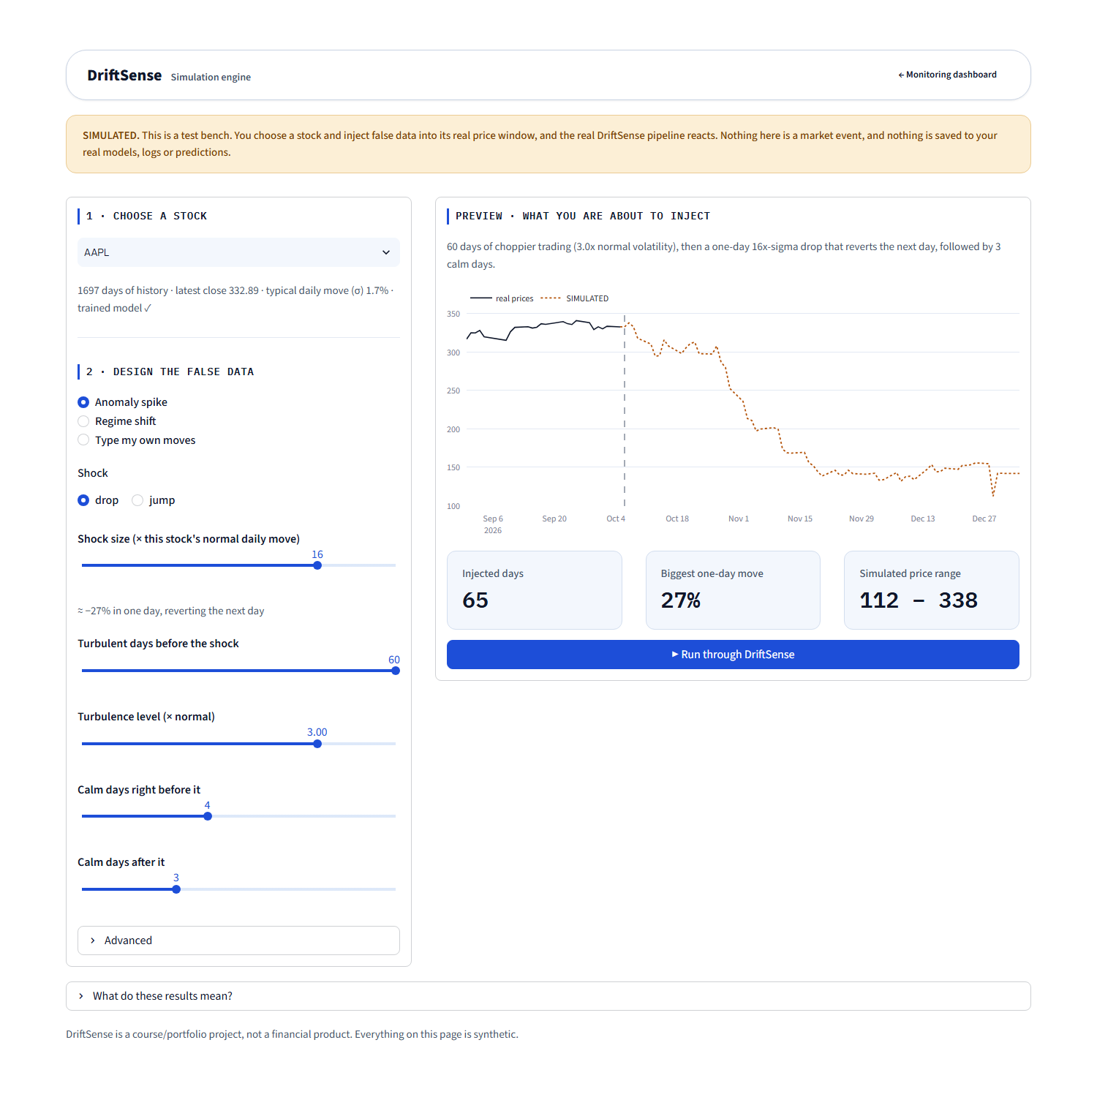
Figure 8.4.3 Simulation Engine: choose a stock, design the false data, preview it, then run it through the real drift pipeline in a sandbox.

