FoodLoop
Intelligent Food Redistribution and Waste Minimisation
using Minimum Cost Maximum Flow, Dijkstra, Greedy and 0/1 Knapsack
Project Report
Course: Design and Analysis of Algorithms
Submitted by
Name | Himesh A
Register number | 24BAI1409
Slot | A2 + TA2
Submitted to | Dr. Pravin Renold A

November 2026

Abstract
Safe surplus food is discarded every day while nearby shelters go short, mainly because there is no quick, reliable way to decide which surplus should go where before it spoils. FoodLoop models this as a graph optimisation problem. Dijkstra’s algorithm gives road distances, a feasibility filter keeps only compatible, reachable and timely lot–NGO pairs, and a Greedy Earliest-Deadline-First step forms urgency tiers. The allocation is solved exactly as a category-wise Minimum Cost Maximum Flow, maximising food redistributed and then minimising transport cost, and a 0/1 Knapsack loads vehicles. To match the base paper’s setting, a fleet mode adds shared vehicles at volunteer hubs, food-ready and delivery time windows, multi-stop routing with split service and joint allocation–routing feedback.
On the base paper’s real Robin Hood Army case in Lucknow, FoodLoop delivered as much food as the paper’s best genetic algorithm in five scenarios and 2.6 times more in the low-fleet scenario, in under one second instead of 10–48 minutes. On 180 rebuilt synthetic benchmark instances it delivered about 87% of the deliverable food but trailed the genetic algorithms, a quality–speed trade-off left as future work. Against a Greedy baseline, MCMF saved 2.6–17.9% transport cost. All 69,499 automated checks passed.
Keywords: food redistribution, minimum cost maximum flow, Dijkstra, greedy scheduling, 0/1 knapsack, vehicle routing, time windows, perishability
Contents
Abstract 2
1. Introduction 5
1.1 Background and motivation 5
1.2 Problem identification 5
1.3 Importance and applications 5
1.4 Research objectives 6
1.5 Main technical contributions 6
1.6 Organisation of the report 7
2. Literature Review 8
2.1 Review of related work 8
2.2 Detailed comparison with the 2023 and 2026 studies 10
2.3 Limitations and research gaps 11
2.4 How FoodLoop addresses the gaps and why it is different 12
3. Proposed Methodology 13
3.1 Overview 13
3.2 Problem formulation 13
3.3 Algorithms and workflow 14
3.4 Fleet mode: the base paper’s setting 16
3.5 Complexity 17
3.6 Hardware and software requirements 17
4. Implementation and Experimental Setup 18
4.1 Development environment and tools 18
4.2 Configuration 18
4.3 Datasets and experimental inputs 18
4.4 Implementation procedure 19
4.5 Experimental conditions and evaluation metrics 20
5. Results and Discussion 21
5.1 Working of the system 21
5.2 Results on the four datasets 25
5.3 Scenario study 26
5.4 Scalability 26
5.5 Real-world case: Robin Hood Army, Lucknow 28
5.6 Base paper’s benchmark: 180 instances 29
5.7 Results compared with the base paper 29
5.8 Correctness 31
5.9 Discussion 31
6. Conclusion and Future Scope 32
References 33

1. Introduction

1.1 Background and motivation
The UNEP Food Waste Index Report 2024 estimates that about 1.05 billion tonnes of food were wasted worldwide in 2022, close to one fifth of all food available to consumers, while more than 780 million people faced hunger in the same period [1]. A noticeable share of this waste comes from restaurants, hostels, supermarkets and event caterers, whose leftovers are still safe to eat for a few hours. Food banks and NGOs are willing to collect such surplus, but cooked food has a very short shelf life, and the coordinator usually decides by hand, calling donors and sending vehicles to the nearest receiver. Manual decisions of this kind are slow and often leave food unused simply because a better match was not noticed in time.
This makes redistribution a natural application for algorithm design. Distances, quantities, deadlines and vehicle limits are all well defined, and classical algorithms from the course syllabus (shortest paths, network flows, greedy methods and dynamic programming) can be combined to make this decision automatically, with a guarantee of optimality for the allocation step.

1.2 Problem identification
Several donors each hold one or more food lots. A lot is a batch of one food item with a quantity in kilograms, a food category (vegetarian, non-vegetarian or vegan) and a number of hours before it expires. Several NGOs each state how many kilograms of each category they need. Every donor owns one vehicle with a capacity, a speed and a running cost. The task is to decide how many kilograms of each lot should go to each NGO, and then how the vehicles should carry them, such that:
- no donor gives more than it has and no NGO receives more than it asked for;
- food only goes to an NGO that accepts its category;
- food is never sent on a route where it would arrive after expiry;
- the total quantity redistributed is as large as possible, and among all such plans the transport cost is the smallest.
A simple rule such as “send each lot to the nearest NGO that still needs it” is easy to apply but can block better plans, because an early choice is never revisited. The project therefore needs an exact method for the allocation and a fair baseline to measure the improvement.

1.3 Importance and applications
A tool that answers this question quickly could help food banks, campus canteens, hotels and volunteer groups. It can reduce wasted food and transport cost, and each decision can be checked against the data that produced it. The same structure could also apply to other perishable goods.

1.4 Research objectives
- Formulate surplus food redistribution as a graph problem with supply, demand, compatibility and expiry constraints.
- Compute shortest road distances and remove every infeasible donor–NGO assignment before optimisation.
- Allocate food exactly with Minimum Cost Maximum Flow, giving the most urgent food the first claim on demand.
- Load vehicles with a 0/1 Knapsack model and re-check expiry for every trip.
- Compare the method with a Greedy baseline on identical data and measure quality, cost and running time.
- Provide an interactive dashboard so that a non-technical user can enter data and see the plan.
- Extend the system to the base paper’s setting (shared fleet, time windows, multi-stop routing, split service) and evaluate it on that paper’s benchmark instances and real case study.

1.5 Main technical contributions
- A category-wise flow network in which each NGO is split into one node per food category, so a single MCMF run respects every dietary restriction.
- A three-level treatment of expiry: a hard feasibility rule on every route, urgency tiers solved in order, and a per-trip expiry check during loading.
- A two-stage design that separates allocation (exact, polynomial) from vehicle loading (exact dynamic programming), instead of one NP-hard routing model.
- An experimental study with a Greedy baseline, seven scenarios, a scalability analysis linked to theoretical complexity, and an independent NetworkX cross-check.
- A working C++ engine with a Streamlit interface for entering donations and NGO requests and inspecting every stage.
- A fleet mode implementing the ten enhancements requested for the base-paper setting: depots and volunteer hubs, shared vehicles, food-ready and delivery windows, arrival/service/departure tracking, load tracking, split service, multi-stop routing and joint allocation–routing feedback, evaluated on the base paper’s own data.

1.6 Organisation of the report
Section 2 reviews related research and compares it with this work, with special attention to the 2023 and 2026 papers closest to it. Section 3 presents the methodology, equations and pseudocode. Section 4 describes the implementation and experimental setup. Section 5 shows the working system through screenshots and discusses the experimental results. Section 6 concludes and outlines future work, followed by the references.

2. Literature Review
Research on donated-food logistics comes mainly from operations research. Most studies either design vehicle routes or decide fair shares among receivers. This section reviews eleven peer-reviewed studies, compares them, and identifies the gap addressed by FoodLoop.

2.1 Review of related work
Davis et al. (2014) [4] studied a food bank that both collects donations and delivers to partner agencies, some of which lie too far away for perishable food to travel safely. They used a capacitated set-covering model to choose satellite delivery points and a periodic vehicle routing model with backhauls to build weekly schedules. Spoilage was handled through distance limits, and the work showed that satellite points reduce inequity in access.
Balcik, Iravani and Smilowitz (2014) [5] considered several vehicles that visit agencies in sequence and must split a limited supply among them. A set-partitioning model designs the routes with equity as the main goal and waste considered implicitly, and a decomposition heuristic handles a route-length limit.
Lien, Iravani and Smilowitz (2014) [6] examined the single-vehicle version, where demand is revealed as the vehicle travels. Using dynamic programming they characterised the policy that maximises the expected minimum fill rate, balancing equity against unused supply, and proposed heuristics for discrete demand.
Orgut et al. (2016) [7] modelled the distribution of donated food by a large North Carolina food bank with deterministic network-flow models. Their objective minimises undistributed food while keeping each county’s share close to a perfectly proportional allocation, under receiving-capacity limits. The models work at county level and do not track individual lots or expiry.
Nair, Rey and Dixit (2017) [8] combined fair allocation with cost-effective routing for food rescue. Utilitarian, egalitarian and deviation-based fairness objectives were blended with routing cost in a goal-programming formulation, and a heuristic was used for realistic instances.
Rey, Almi’ani and Nair (2018) [9] extended this line to envy-free allocations in food-rescue pickup and delivery. They proved the problem NP-hard, solved it exactly with a Benders-based cutting-plane method for moderate sizes, and proposed a greedy-plus-local-search heuristic for larger cases.
Alkaabneh, Diabat and Gao (2021) [10] proposed approximate dynamic programming for multi-product allocation to food-bank agencies, measuring effectiveness by nutritional value, efficiency by agency utility and equity by fairness, and tested it on New York State data.
Dubey and Tanksale (2023) [2] formulated a multi-depot vehicle routing problem with time windows, split pickup and split delivery for surplus food recovery. The model decides how many vehicles to hire at each depot and their routes, minimising hiring cost, routing cost and penalties for unmet demand. Because the problem is NP-hard, it is solved with an elitist Genetic Algorithm and a Genetic Algorithm hybridised with local search, evaluated on 180 modified benchmark instances.
Orgut and Lodree (2023) [11] developed a capacitated, multi-period, multi-product network-flow model for perishable items at a food bank, and showed that allowing small deviations from perfect equity can raise both the quantity and the quality of food distributed while reducing waste.
Akkerman et al. (2023) [12] reviewed supply-chain management in food banks and noted that perishable products, volunteer labour and limited IT support have received little research attention, which motivates simple decision-support tools.
Rampazo et al. (2026) [3] introduced an extended goal-programming model that builds poverty measures into the deviation structure, so that vulnerability becomes an internal weight of the optimisation. It is applied to food-bank logistics in São Paulo with multiple products and planning periods and First-Expired-First-Out stock control.
Table 1. Comparison of existing methods
Ref. | Problem addressed | Technique | Perishability | Solution type | Main limitation for our setting
[4] 2014 | Collection and delivery schedules for a food bank | Set covering + periodic VRP with backhauls | Distance limit for perishables | Exact sub-models, heuristic scheduling | Plans routes and sites, not lot-level shares
[5] 2014 | Multi-vehicle sequential allocation | Set partitioning + decomposition heuristic | Not explicit | Heuristic | No expiry or food categories
[6] 2014 | Single-vehicle sequential allocation | Dynamic programming | Not explicit | Optimal policy + heuristics | One vehicle, no compatibility
[7] 2016 | Equitable county allocation | Network-flow models | No per-item expiry | Exact LP | Aggregated counties, no transport cost
[8] 2017 | Fair allocation with routing | Goal programming + heuristic | Not central | Heuristic | Fairness focus, no exact allocation
[9] 2018 | Envy-free pickup and delivery | Benders cutting plane, greedy + local search | Not central | Exact for small, heuristic for large | NP-hard, slow at scale
[10] 2021 | Multi-product agency allocation | Approximate dynamic programming | Through inventory | Approximate | Complex, data-heavy
[2] 2023 | Food recovery vehicle routing | Genetic Algorithm, hybrid GA | Time windows | Metaheuristic | No optimality guarantee
[11] 2023 | Equitable perishable distribution | Multi-period network flow | Item shelf life | Exact LP | Equity focus, no vehicle loading
[12] 2023 | Review of food-bank supply chains | Literature review | Identified as gap | – | No algorithm proposed
[3] 2026 | Poverty-aware food-bank allocation | Extended goal programming | FEFO over periods | Compromise solution | Fairness focus, no routing or loading

2.2 Detailed comparison with the 2023 and 2026 studies
The two studies closest to FoodLoop are Dubey and Tanksale (2023) [2] and Rampazo et al. (2026) [3]. Table 2 places them side by side with the proposed approach.
Table 2. Dubey & Tanksale (2023) vs Rampazo et al. (2026) vs FoodLoop
Aspect | Dubey & Tanksale (2023) | Rampazo et al. (2026) | FoodLoop (this work)
Journal | Expert Systems with Applications | International Transactions in Operational Research | Course project
Central question | Which routes should hired vehicles follow? | How should a food bank share food fairly across periods? | How many kg of each lot should reach each NGO, and how should vehicles carry them?
Model | Multi-depot VRP with time windows, split pickup and split delivery | Extended goal programming with poverty measures | Category-wise min-cost max-flow network, then 0/1 knapsack loading
Solution method | Elitist GA and GA with local search | Goal-programming solver | Successive shortest paths with Bellman-Ford; Dijkstra; Greedy EDF; DP knapsack
Optimality | Near-optimal, no guarantee | Best compromise among weighted goals | Exact allocation per urgency tier (polynomial); heuristic routing in fleet mode
Objective | Minimise hiring, routing and unmet-demand cost | Meet goals with priority to the poorest | First maximise kg redistributed, then minimise transport cost
Perishability | Time windows at nodes | FEFO inventory across periods | Expiry filter on every route, urgency tiers, per-trip expiry check
Food categories | Not modelled | Several products | Enforced by network structure (VEG, NON_VEG, VEGAN)
Vehicle capacity | Inside the routing model | Not modelled | 0/1 knapsack loading; load tracked after every stop in fleet mode
Routing | Multi-stop routes | Not modelled | Multi-stop routes with split service, fed back to the allocation (fleet mode)
Fairness | Not modelled | Main focus | Not modelled
Data | 180 benchmark instances; Robin Hood Army, Lucknow | São Paulo food bank | Synthetic cities; the base paper’s 180 instances (rebuilt) and its real Lucknow case
Baseline and scaling study | Compared GA variants | Compared GP variants | Greedy and ablation baselines; the paper’s reported GA results; growth exponents vs theory
Running time | 10 min – 6 h per instance (supercomputer) | Not the focus | Under 1 s (Lucknow) to about 1 min (288 customers) on a laptop
User tool | None reported | None reported | Interactive Streamlit dashboard

2.3 Limitations and research gaps
- Heuristic answers. Routing-based models such as [2] and [9] are NP-hard, so large instances are solved by metaheuristics whose results vary between runs and carry no optimality guarantee.
- Fairness over freshness. Allocation studies [3], [7], [8], [11] focus on equity across receivers; per-lot expiry and dietary compatibility are rarely handled together in one exact model.
- Mixed decisions. Most models combine allocation, routing and vehicle capacity in one formulation, which makes them hard to solve and hard to explain.
- Few transparent tools. The review in [12] notes limited IT support in food banks; none of the reviewed studies offers a simple interactive tool, and few compare against a plain greedy rule that coordinators actually use.

2.4 How FoodLoop addresses the gaps and why it is different
FoodLoop does not claim to invent a new optimisation algorithm, nor to be the first to handle expiry or food categories; both appear in earlier work. Its contribution lies in how the problem is framed, decomposed and solved:
- Food first, vehicles second. The 2023 study begins with vehicle routes. FoodLoop first answers “how much of each lot should each NGO receive?” and plans vehicles afterwards. This split turns the hard part into a flow problem that is solvable exactly.
- Exact and repeatable. Where the 2023 work relies on a Genetic Algorithm and the 2026 work on goal programming with weights, FoodLoop’s allocation is a Minimum Cost Maximum Flow, solved in polynomial time. The same input gives the same plan, and the allocation can be checked against an independent library.
- Compatibility built into the graph. Each NGO is represented by one node per food category, and a lot links only to nodes of its own category, so dietary rules need no extra constraints.
- Expiry at three levels. A route is removed if the food would arrive late; urgent lots are allocated first in tiers; and every vehicle trip re-checks expiry and reports any food that cannot be delivered.
- Capacity as its own exact stage. A 0/1 Knapsack decides which crates go on each trip, keeping the most urgent kilograms on board.
- Measured against a baseline. Every run reports MCMF and a Greedy nearest-NGO plan on the same data, and the running time is related to theoretical complexity.
- Interactive tool. A dashboard lets a coordinator add a donation or NGO request and see the updated plan.
FoodLoop therefore sits between the routing-focused 2023 study and the fairness-focused 2026 study: it addresses the daily question of matching perishable surplus to compatible receivers.

3. Proposed Methodology

3.1 Overview
FoodLoop is a pipeline of six algorithmic stages followed by evaluation, as shown in the block diagram below. Each stage produces data used by the next, and the Greedy baseline receives exactly the same feasible pairs as MCMF so that the comparison is fair.
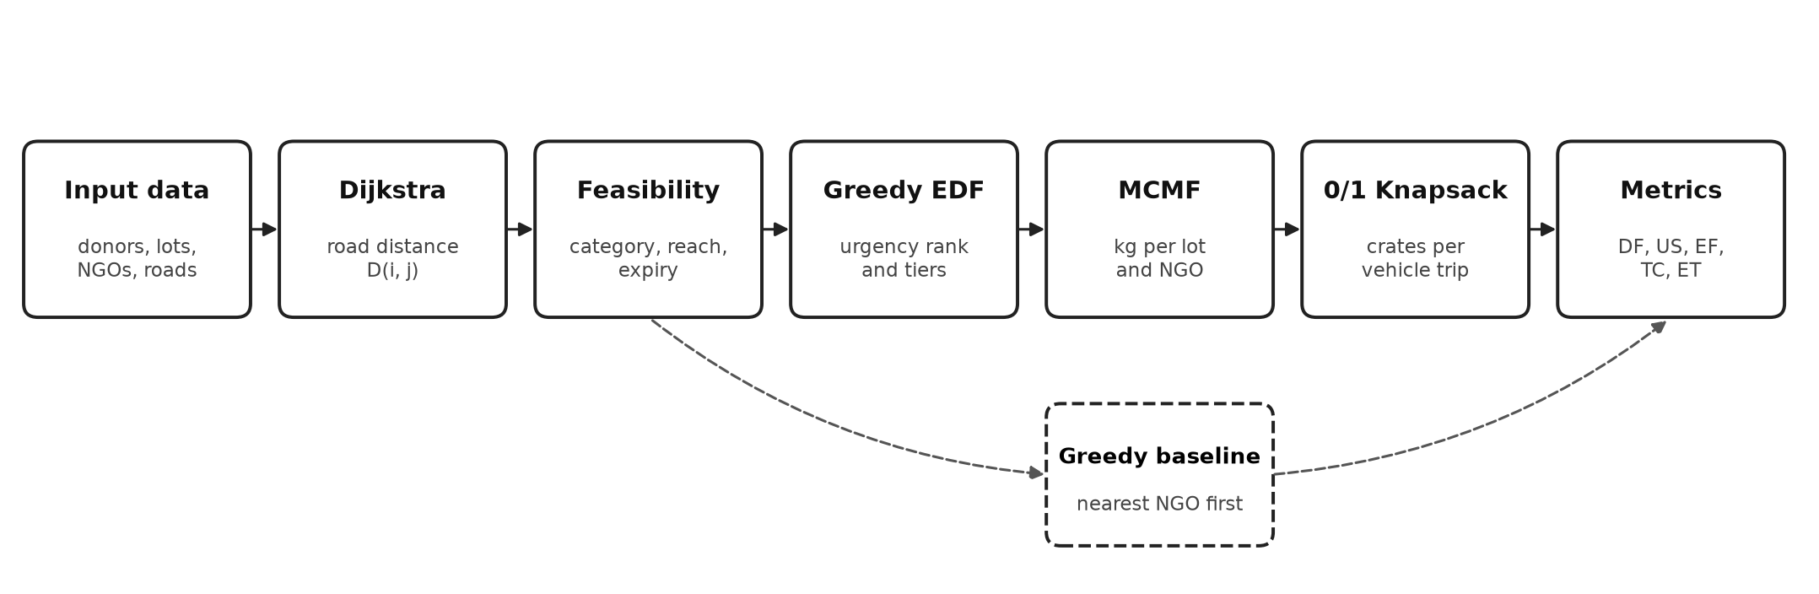
Block diagram of the FoodLoop pipeline
Reading the diagram. Data flows from left to right. Dijkstra computes road distances, the feasibility filter keeps only compatible, reachable and timely pairs, Greedy ranks lots by urgency, MCMF decides how many kilograms go to each NGO, and the knapsack or the multi-stop router turns this into vehicle plans. The dashed path is the Greedy baseline, which uses the same feasible pairs and the same metrics so that both methods are compared on identical data.

3.2 Problem formulation
Let I be the donors, K the food lots and J the NGOs. Lot k belongs to donor d(k), has quantity q_{k} kg, category c(k) and remaining shelf life e_{k} hours. NGO j needs r_{jf} kg of category f. Donor i has a vehicle with speed v_{i}, and a handling time h (0.5 h) is added to every delivery. D(i, j) is the shortest road distance and R (₹0.50 per kg·km) the transport rate.
Cost of moving one kilogram from lot k to NGO j:
$C_{kj} = D(d(k), j) × R$ (1)
Feasibility. A pair (k, j) is allowed only if the NGO needs the category, a road path exists, and the food arrives in time:
$r_{j,c(k)} > 0, D(d(k), j) < ∞, \frac{D(d(k), j)}{v_{d(k)}} + h ≤ e_{k}$ (2)
Decision variable. x_{kj} ≥ 0 is the number of kilograms of lot k sent to NGO j, and x_{kj} = 0 for every infeasible pair.
$\sum_{j}{x_{kj}} ≤ q_{k}$ for every lot k (3)
$\sum_{k : c(k) = f}{x_{kj}} ≤ r_{jf}$ for every NGO j and category f (4)
Objective (lexicographic). First the total redistributed food is maximised; among all plans that achieve this maximum, the transport cost is minimised:
$max \sum_{k}{\sum_{j}{x_{kj}}} , then min \sum_{k}{\sum_{j}{C_{kj} x_{kj}}}$ (5)
Urgency tiers. Lots are split into tier 1 (e_{k} < 6 h), tier 2 (6 ≤ e_{k} < 24 h) and tier 3 (e_{k} ≥ 24 h). Model (3)–(5) is solved for tier 1 first; the demand left over is passed to tier 2 and then tier 3, so perishable food always has the first claim on demand.

3.3 Algorithms and workflow

Stage 1 – Dijkstra shortest paths
The road network is stored as an adjacency list. Dijkstra’s algorithm [14] with a binary heap and lazy deletion is run once from each donor’s junction, giving D(i, j) and the path for every donor–NGO pair.
Algorithm 1. Dijkstra with lazy deletion
DIJKSTRA(G, s):
dist[v] <- INF for all v ; dist[s] <- 0
push (0, s) into min-heap H
while H not empty:
(d, u) <- pop-min(H)
if d > dist[u]: continue // stale entry (lazy deletion)
for each road (u, w, len):
if dist[u] + len < dist[w]:
dist[w] <- dist[u] + len ; parent[w] <- u
push (dist[w], w) into H
return dist, parent

Stage 2 – Feasibility filter
Every (lot, NGO) pair is checked against rule (2) in constant time. Pairs removed for category mismatch, unreachability or late arrival are counted separately, and lots that have already expired are reported.

Stage 3 – Greedy expiry ranking
Lots are sorted by remaining shelf life (Earliest Deadline First); ties go to the larger lot. The sorted list fixes each lot’s urgency tier and is also the processing order of the Greedy baseline.

Stage 4 – Minimum Cost Maximum Flow allocation
For each tier a flow network is built: a source S, one node per lot, one node per (NGO, category) pair with positive remaining demand, and a sink T. The edges are S → lot (capacity q_{k}, cost 0), lot → (NGO, c(k)) for every feasible pair (capacity q_{k}, cost C_{kj} in paise), and (NGO, f) → T (capacity equal to the remaining demand, cost 0). Every edge has a reverse edge with negative cost in the residual graph, which allows an earlier assignment to be undone when that leads to a better plan. The network is solved with successive shortest augmenting paths [13], using Bellman-Ford because reverse edges carry negative costs.
Algorithm 2. Successive shortest path MCMF, solved tier by tier
MCMF(N, S, T):
flow <- 0 ; cost <- 0
loop:
(dist, parent) <- BELLMAN_FORD(residual N, S) // early exit
if dist[T] = INF: break // no augmenting path left
delta <- min residual capacity on the path S -> T
for each edge e on the path:
cap[e] <- cap[e] - delta ; cap[reverse(e)] <- cap[reverse(e)] + delta
flow <- flow + delta ; cost <- cost + delta * dist[T]
return flow, cost

ALLOCATE_BY_TIERS(lots, NGOs):
for tier in 1, 2, 3:
N <- BUILD_NETWORK(lots of this tier, remaining demand, feasible pairs)
MCMF(N, S, T) ; record x_kj from flows on lot -> NGO edges
remaining demand <- remaining demand - kg received
Because every path is a shortest path in the residual graph, the flow after each augmentation has minimum cost for its value, and when no path remains the flow is maximum. All costs are integers (paise), so the computation has no rounding error.

Stage 5 – 0/1 Knapsack vehicle loading
The allocated kilograms are cut into crates of at most 10 kg. Each crate has weight w and value w × ω, where the tier weight ω is 3, 2 or 1. For each trip the most urgent waiting destination is chosen first (one NGO per trip), and a 0/1 Knapsack selects the crates that maximise value within the vehicle capacity W:
$B[i][w] = max( B[i-1][w], v_{i} + B[i-1][w - w_{i}] )$ if w_{i} ≤ w (6)
Algorithm 3. 0/1 Knapsack with traceback
KNAPSACK(crates, W):
B[0][w] <- 0 for w = 0..W
for i = 1..n:
for w = 0..W:
B[i][w] <- B[i-1][w]
if w_i <= w and v_i + B[i-1][w - w_i] > B[i][w]:
B[i][w] <- v_i + B[i-1][w - w_i]
trace back from B[n][W] to list the chosen crates
Before each trip the planner checks that the food still arrives before expiry and that the trip ends within the 8-hour shift. Crates that fail are reported with a reason (expired, shift over or too heavy). Trip cost is 2 × D × vehicle cost per km for the round trip.

Stage 6 – Greedy baseline
The baseline processes lots in the same expiry order and sends each one to its nearest feasible NGO that still needs the category, spilling any remainder to the next nearest. It never revisits a decision, which is exactly the behaviour MCMF is designed to improve.

3.4 Fleet mode: the base paper’s setting
The base paper’s problem uses shared vehicles from several depots, time windows at every pickup and delivery, split service and multi-stop routes [2]. FoodLoop’s fleet mode adds these features while keeping the exact MCMF allocation at its core. A dataset enters fleet mode when it lists depots; all earlier datasets behave exactly as before.
Table 3. The ten enhancements and how FoodLoop implements them
# | Enhancement | Implementation
1 | Independent depots and volunteer hubs | Vehicles start and end at depots instead of belonging to donors
2 | Dynamic assignment of shared vehicles | Any vehicle may serve any request; routing chooses the vehicle
3 | Multi-stop routing | Cheapest feasible insertion of pickup–delivery requests into routes
4 | Food-ready times and pickup windows | A vehicle waits until the food is ready and cannot collect after the window closes
5 | Arrival, service and departure tracking | Recorded at every stop, with NGO windows, service times and expiry
6 | Load tracking | Load after every pickup and delivery, never above capacity
7 | Split service | A lot may be collected in several visits by several vehicles for several NGOs
8 | On-time delivery first, then actual cost | Most kilograms first, then least added distance and hiring cost
9 | Joint allocation and routing | Pairs that cannot be routed are removed from the flow network and MCMF re-allocates
10 | Experimental validation | Base paper’s 180 instances, its real Lucknow case, and ablation baselines

Objective. Plans are compared with the base paper’s objective: routing cost, plus the hiring cost of every vehicle used, plus a penalty for every unit of pickup or delivery left unserved:
$Z = \sum_{r}{c_{r}} + \sum_{v}{f_{v} y_{v}} + φ ( \sum_{k}{π_{k}} + \sum_{j}{σ_{j}} )$ (7)
Here c_{r} is the length cost of route r, f_{v} the hiring cost of vehicle v, y_{v} = 1 if the vehicle is used, φ the penalty per unit (1,000), and π_{k} and σ_{j} the unmet pickup at lot k and unmet delivery at NGO j.
Routing. Each MCMF allocation (lot k to NGO j, q kg) becomes a request. Requests are inserted, most urgent first, at the pair of positions (pickup before delivery) in some vehicle’s route that carries the most food at the smallest added cost. For every route the latest feasible start of each stop is stored, so a candidate position is checked in constant time instead of re-simulating the route. If only part of a request fits, the rest is queued again, which produces split service.
Algorithm 4. Joint allocation and routing with feedback (fleet mode)
PLAN_JOINTLY(data):
best <- none ; blocked <- {}
for each insertion order in (deadline, ready time, size):
repeat up to 8 rounds:
x <- MCMF allocation on feasible pairs minus blocked // exact
R <- insert every request of x into routes (cheapest feasible)
top up: MCMF on leftover supply/demand, insert into R
if Z(R) < Z(best): best <- R
failed <- pairs of x that could not be routed
if failed is empty: stop ; blocked <- blocked + failed // feedback
improve best by ruin and recreate (remove related requests, re-insert)
return best

3.5 Complexity
Table 4. Time complexity of each stage (L lots, N NGOs, J junctions, R roads, D donors)
Stage | Algorithm | Time complexity
Distances | Dijkstra, binary heap, once per donor | O(D · (J + R) log J)
Feasibility | Check every pair | O(L · N)
Ranking | Sort by expiry | O(L log L)
Allocation | MCMF, successive shortest paths + Bellman-Ford | O(P · V · E), P ≤ total kg
Loading | 0/1 Knapsack DP per trip | O(n · W) per trip
Baseline | Greedy nearest NGO | O(L · N log N)

3.6 Hardware and software requirements
Table 5. Requirements
Item | Minimum | Used in this project
Processor | Any 64-bit dual-core CPU | Intel Core Ultra 7 155H
Memory | 4 GB RAM | 32 GB RAM
Operating system | Windows 10/11, Linux or macOS | Windows 11 Home
Compiler | C++14 compiler | g++ 6.3.0 (MinGW)
Python | 3.10 or newer | 3.12.10
Python libraries | streamlit, pandas, altair, matplotlib, networkx | Streamlit 1.66.1, pandas 3.0.5, Altair 6.3.0, Matplotlib 3.11.1, NetworkX 3.7
Browser | Any modern browser | Google Chrome

4. Implementation and Experimental Setup

4.1 Development environment and tools
All algorithms are written in standard C++14 without external libraries, so that every data structure (graph, heap, residual network, DP table) is implemented and explained in the project. The engine is a command-line program that reads CSV files and prints either a text report or JSON. A thin Python bridge writes the user’s data to a temporary folder, runs the engine and returns its JSON to the Streamlit dashboard, which only displays results. Git was used for version control, and NetworkX [15] served as an independent checker.

4.2 Configuration
Table 6. Model parameters (config/params.csv)
Parameter | Value | Meaning
Handling time h | 0.5 h | Loading and hand-over time added to every delivery
Tier boundaries | 6 h and 24 h | Tier 1 < 6 h, tier 2 6–24 h, tier 3 ≥ 24 h
Tier weights ω | 3, 2, 1 | Value per kg in the knapsack
Crate size | 10 kg | Largest indivisible loading unit
Shift length | 8 h | Latest return time of a vehicle
Transport rate R | ₹0.50 per kg·km | Allocation cost rate in equation (1)
Low-load threshold | 20% | Trips below this load are flagged
Hiring cost f (fleet mode) | 500 (250 for two-wheelers in Lucknow) | Cost of using a vehicle, as in the base paper
Unmet penalty φ (fleet mode) | 1,000 per unit | Penalty for unserved pickup or delivery, as in the base paper

4.3 Datasets and experimental inputs
Each dataset is a folder of six CSV files: road junctions, roads, donors, vehicles, food lots and NGOs. Real redistribution records were not available, so the data is synthetic: two hand-built cases and generated cities produced by a seeded generator (the same seed always gives the same city).
Table 7. Datasets
Dataset | Donors | Lots | NGOs | Supply / demand (kg) | Purpose
toy | 2 | 2 | 2 | 16 / 16 | Hand-solved conflict case
demo | 4 | 14 | 5 | 206 / 200 | Realistic small city for the dashboard
city | 12 | 48 | 15 | 842 / 802 | Generated city, seed 7
large | 40 | 166 | 50 | 2,630 / 2,702 | Generated city, seed 11, 20% extra demand
scenarios | 12 | ≈ 50 | 15 | varies | 7 scenarios × 10 seeds = 70 instances
scalability | 5–320 | 21–1,226 | 6–400 | varies | 7 sizes × 3 seeds
base paper (rebuilt) | 24–144 pickups | 24–144 | 24–144 | varies | 180 instances from Cordeau et al. [16] by the paper’s rules
Lucknow (real) | 25 pickup points | 25 | 29 sites | 1,198 / 2,585 (base) | Robin Hood Army case: 3 hubs, 6 scenarios [17]

The base paper’s 180 benchmark instances are available only on request, so they were rebuilt from the public Cordeau et al. multi-depot instances [16] with the paper’s stated rules: the same locations, depots, vehicles, capacities, time windows and service times, demands drawn as fractions (0.1–1.2, 0.3–0.8 or 0.8–1.2) of vehicle capacity, and three supply–demand relations. Where the paper is silent, odd-numbered customers were taken as pickups and even-numbered ones as deliveries, and unbalanced sub-classes differ by one average customer demand. The real Lucknow data (coordinates, service times and demands of 25 pickup points and 29 delivery sites) comes from Appendix B of the base paper’s thesis record [17]; travel is assumed at 20 km/h because the speed is not stated.

4.4 Implementation procedure
- Load and validate the CSV files; inconsistent input (for example an unknown donor or junction, or a negative quantity) is rejected with a clear message.
- Build the road graph and run Dijkstra from every donor.
- Apply the feasibility rule to every lot–NGO pair.
- Rank lots by expiry and assign tiers.
- Build and solve the MCMF network tier by tier; record the allocation.
- Run the Greedy baseline on the same feasible pairs.
- Cut allocations into crates and plan trips with the knapsack and expiry checks.
- Compute metrics for both methods and output the report or JSON.

4.5 Experimental conditions and evaluation metrics
Running time is measured inside the engine with the C++ steady clock. Because the Windows clock ticks about once per millisecond, each stage is repeated until at least 50 ms have elapsed and the average is reported. The following metrics are computed for MCMF and Greedy:
$DF = \frac{allocated kg}{total demand} × 100$ (8)
$US = total supply - allocated kg$ (9)
$EF = \frac{kg delivered before expiry}{allocated kg} × 100$ (10)
$TC = \sum_{k}{\sum_{j}{x_{kj} · D(d(k), j) · R}}$ (11)
ET is the execution time of the allocation stage, and trip cost is the sum of round-trip vehicle costs. Correctness was checked with seven C++ test suites (69,499 checks) covering hand-solved cases, edge cases, random instances and every fleet-mode route, plus the NetworkX cross-check of distances, feasible pairs and per-tier flow and cost on five datasets.

5. Results and Discussion

5.1 Working of the system
The six screenshots below show the workflow in the order a user follows it. The demo dataset is loaded, one donation and one NGO request are added through the forms, and every result page then shows what happened to the new entries first, with the rest of the data folded under a History section.
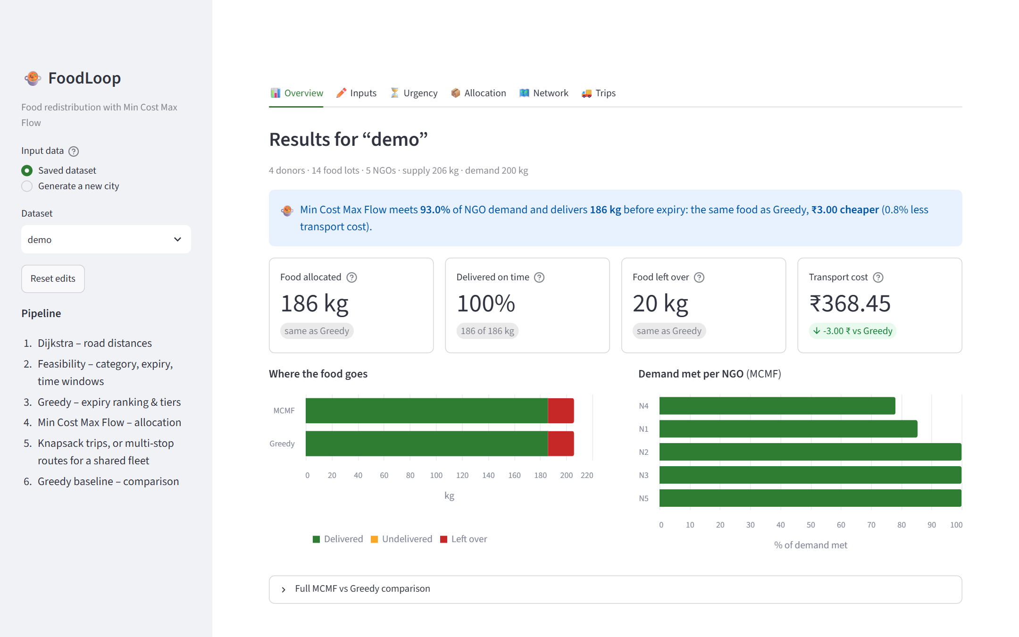
Step 1 – Overview of the demo dataset
The sidebar selects the input data. The main area gives a one-line summary, four key figures compared with Greedy, where the food goes for both methods, and how much of each NGO’s demand is met. Here both methods move 186 kg, and MCMF does it ₹3.00 cheaper.
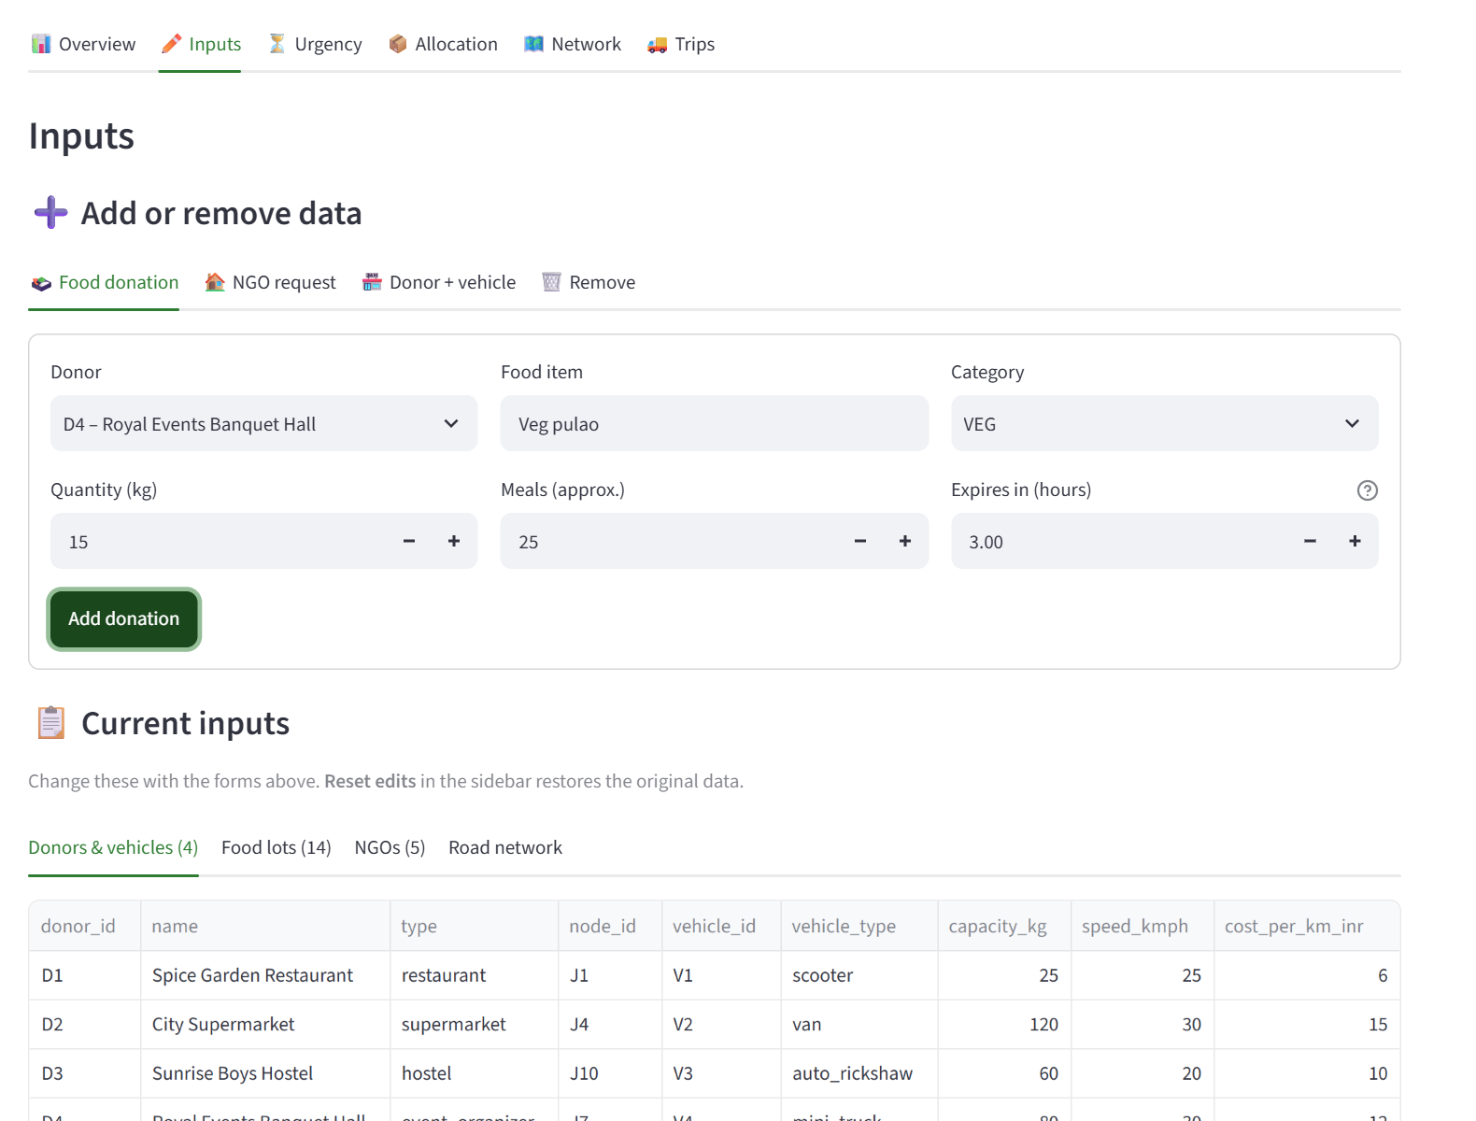
Step 2 – Adding a donation
A coordinator records new surplus with a short form: donor, food item, category, quantity and hours to expiry. A similar form adds an NGO request; in this example Sunrise Shelter asks for 20 kg of vegetarian food.
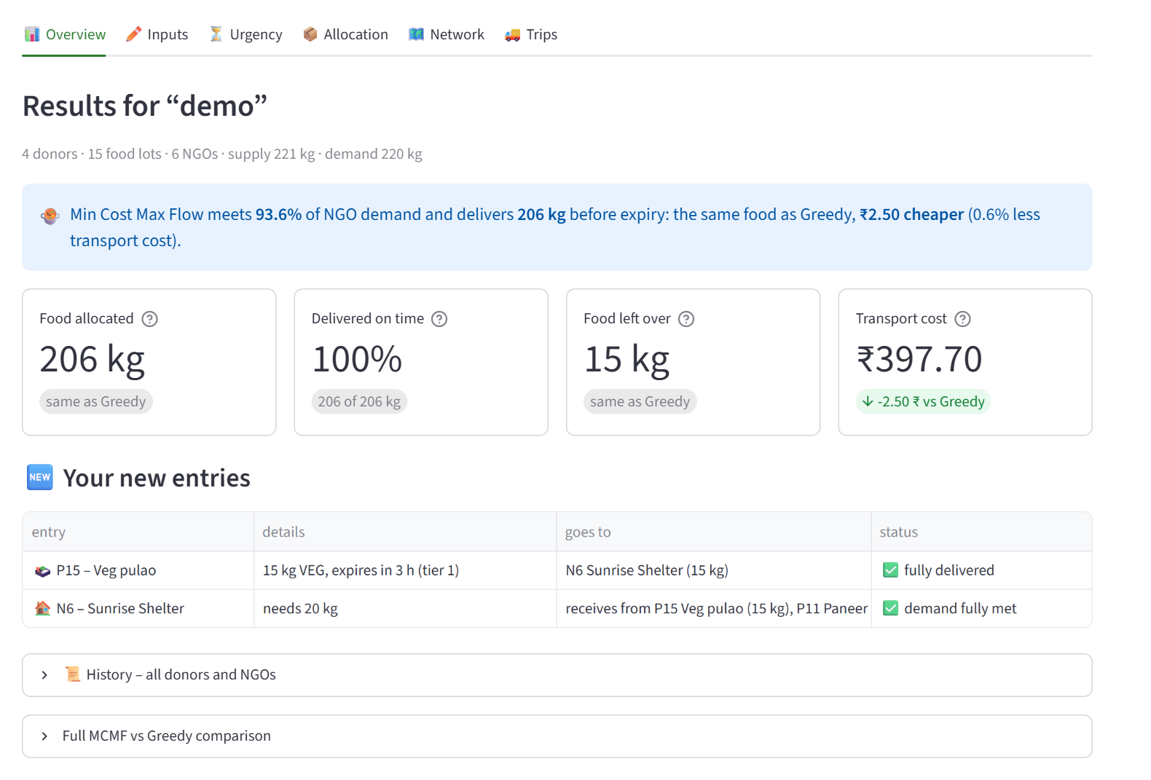
Step 3 – Result for the new entries
The plan is recomputed at once. The table shows that the new 15 kg of pulao goes to the new shelter, and that the shelter’s 20 kg need is completed with 5 kg from the same donor. Earlier data stays under History.
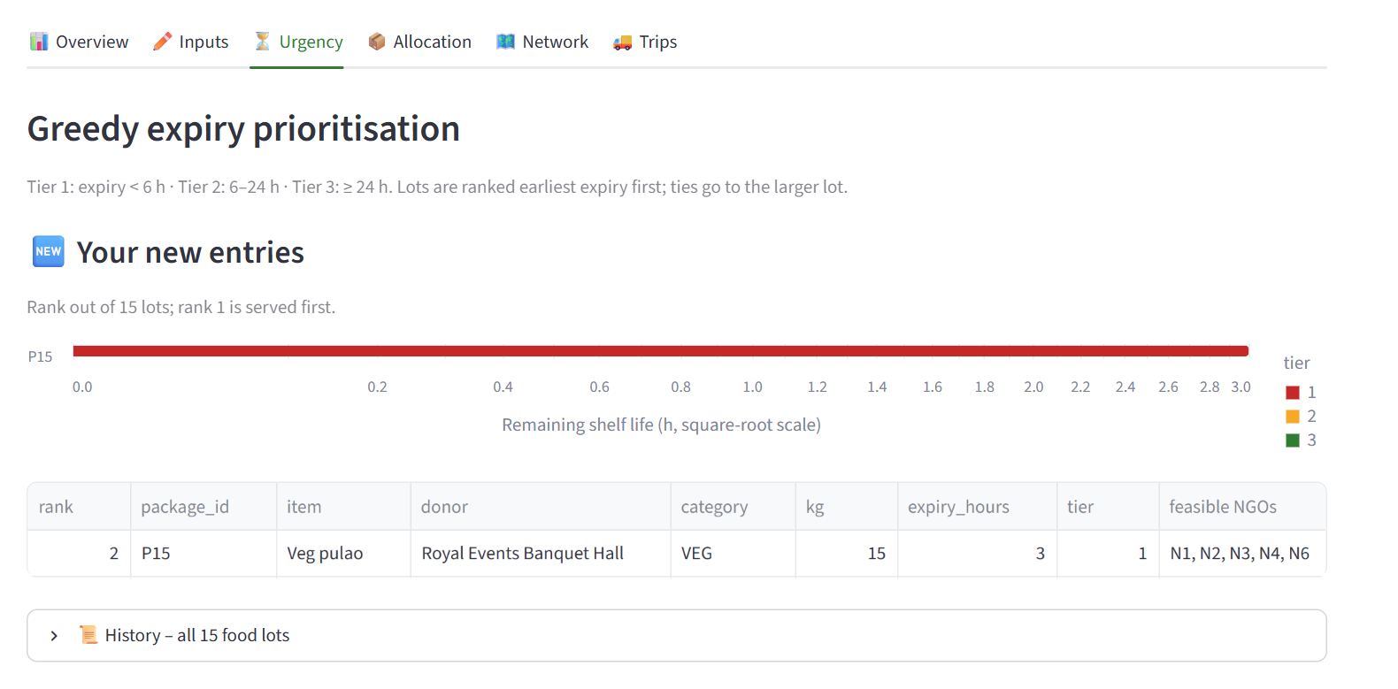
Step 4 – Urgency ranking
Lots are ordered by remaining shelf life. The new lot is second of 15 and in tier 1 (under 6 hours), so it is allocated in the first round.
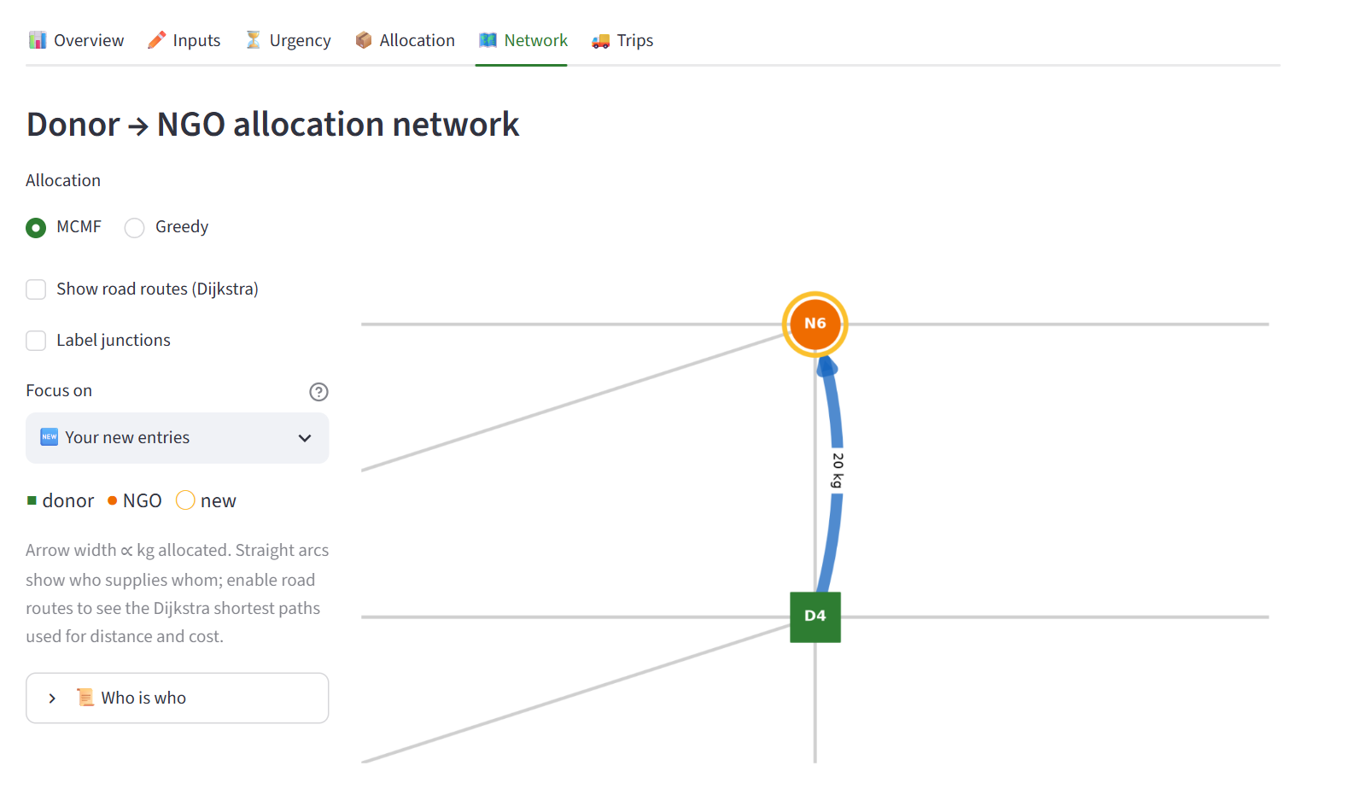
Step 5 – Allocation network
Green squares are donors and orange circles are NGOs on the road map; arrow width shows kilograms sent. The view is zoomed to the new entries, and the gold ring marks the new NGO.
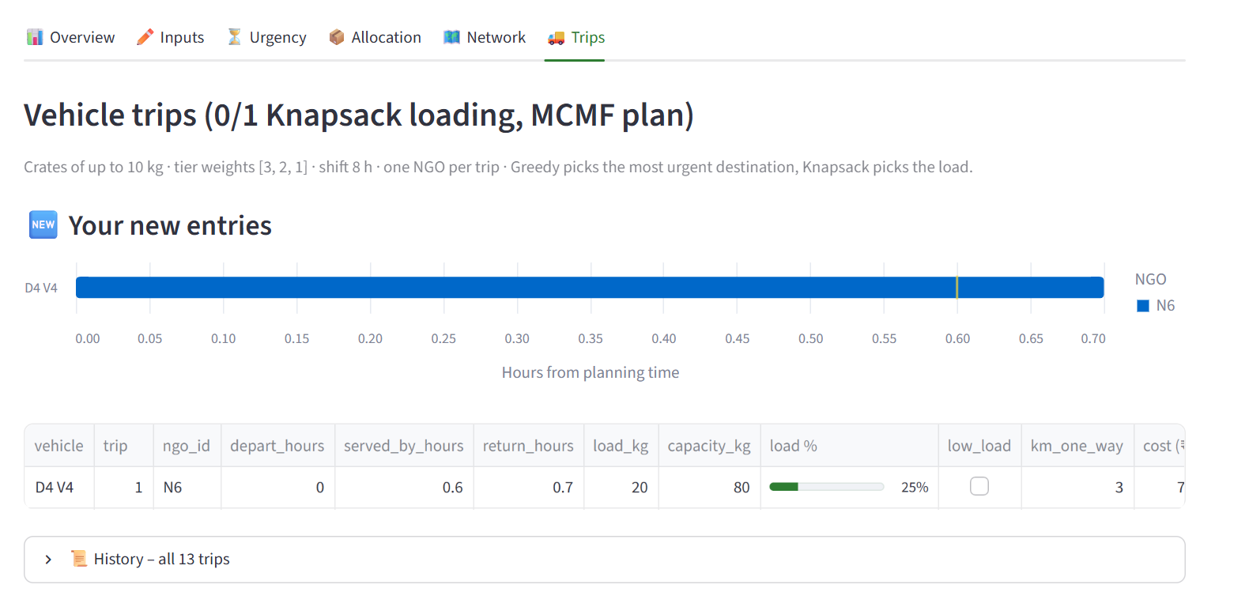
Step 6 – Vehicle trip
Each bar is one trip from departure to return; the tick marks when the food is served. Donor D4’s vehicle carries 20 kg to the new shelter and serves it in about 0.6 hours.

5.2 Results on the four datasets
Table 8. MCMF vs Greedy on the four datasets
Dataset | Method | Allocated (kg) | DF (%) | US (kg) | EF (%) | TC (₹) | Trip cost (₹) | Trips
toy | MCMF | 16 | 100.0 | 0 | 100.0 | 16.00 | 64.00 | 2
 | Greedy | 8 | 50.0 | 8 | 100.0 | 4.00 | 20.00 | 1
demo | MCMF | 186 | 93.0 | 20 | 100.0 | 368.45 | 1,423.20 | 12
 | Greedy | 186 | 93.0 | 20 | 100.0 | 371.45 | 1,423.20 | 12
city | MCMF | 802 | 100.0 | 40 | 94.0 | 3,093.10 | 9,260.40 | 47
 | Greedy | 802 | 100.0 | 40 | 93.5 | 3,300.15 | 10,158.20 | 49
large | MCMF | 2,620 | 97.0 | 10 | 92.0 | 8,168.15 | 29,295.40 | 153
 | Greedy | 2,620 | 97.0 | 10 | 92.3 | 8,847.00 | 30,542.20 | 159

Interpretation. The toy case shows the main strength of MCMF. Lot TP1 is the most urgent, so Greedy sends it to its nearest NGO, TN1. Lot TP2 can reach only TN1 before expiring, finds it full, and is wasted. MCMF first makes the same choice, but on its second search it finds a path that uses the reverse edge TN1 → TP1: TP1 is moved to TN2 and TP2 takes TN1, so all 16 kg are delivered. The extra ₹12 of transport is accepted because redistributing more food comes first in the objective.
On the generated cities there is usually enough choice that both methods place the same kilograms, and the benefit appears as cost: MCMF is 6.3% cheaper on city and 7.7% cheaper on large, and also needs fewer trips. On large, Greedy delivers 8 kg more before expiry (2,418 against 2,410 kg). This happens because the allocation assumes every vehicle leaves at time zero, while later trips leave later; it is reported honestly and listed as future work.

5.3 Scenario study
Table 9. Average results over 10 seeded instances per scenario (12 donors, 15 NGOs)
Scenario | Setting | Allocated kg (both) | TC MCMF (₹) | TC Greedy (₹) | TC saving | Trip-cost saving
Baseline | demand ≈ supply | 697.0 | 2,256 | 2,401 | 6.0% | 5.7%
Surplus | demand = 70% of supply | 500.0 | 1,601 | 1,854 | 13.7% | 11.5%
Shortage | demand = 140% of supply | 734.8 | 1,947 | 2,005 | 2.6% | 4.5%
Strict diets | more veg-only and vegan NGOs | 696.6 | 2,368 | 2,522 | 6.1% | 9.5%
Tight expiry | shelf life × 0.4 | 679.1 | 2,111 | 2,312 | 8.7% | 12.7%
Small vehicles | capacity × 0.4 | 697.0 | 2,256 | 2,401 | 6.0% | 5.5%
Tight + shortage | shelf life × 0.4, demand 140% | 705.7 | 1,825 | 1,901 | 3.6% | 13.6%

MCMF was cheaper in all 70 instances and never allocated less food. Savings are largest under surplus (13.7%), when many NGOs compete for the same nearby donors and Greedy’s first choices are often poor, and smallest under shortage (2.6%), when almost every kilogram must go somewhere and fewer alternatives exist. Tight expiry also raises the saving because fewer routes are feasible and early mistakes cost more.

5.4 Scalability
Table 10. Measured running time per stage (average of 3 seeds)
Donors | Lots | Dijkstra | Feasibility | MCMF | Knapsack trips | Greedy | MCMF ÷ Greedy
5 | 21 | 0.012 ms | 0.008 ms | 0.07 ms | 0.034 ms | 0.025 ms | 3×
20 | 80 | 0.14 ms | 0.11 ms | 1.9 ms | 0.19 ms | 0.15 ms | 13×
80 | 309 | 2.5 ms | 1.2 ms | 86 ms | 0.84 ms | 1.6 ms | 53×
160 | 625 | 10.7 ms | 5.9 ms | 739 ms | 1.9 ms | 7.1 ms | 104×
320 | 1,226 | 49 ms | 24 ms | 11.8 s | 4.5 ms | 33 ms | 360×

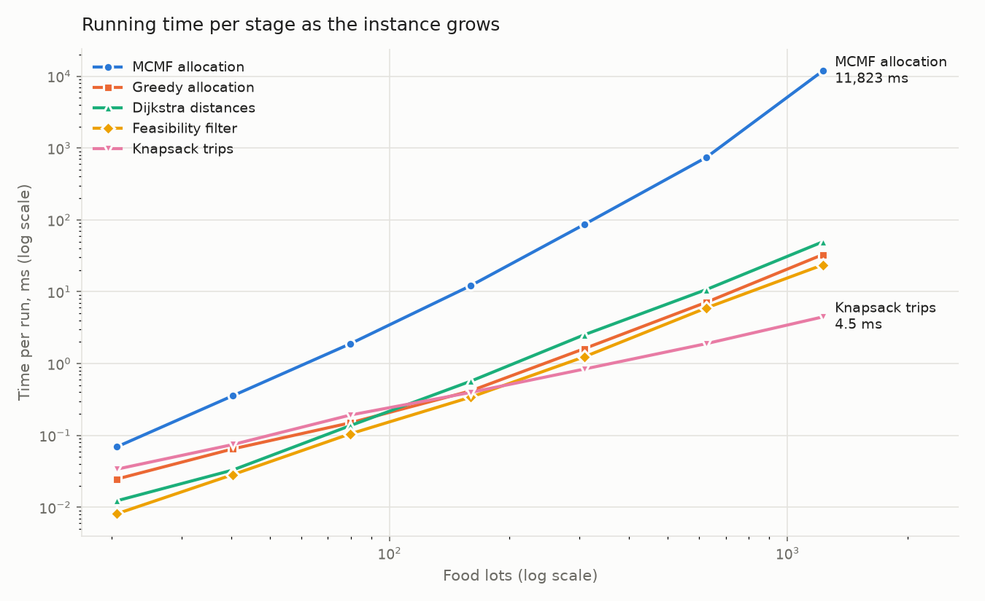
Running time of each stage against the number of lots (log–log)
Reading the chart. Both axes are logarithmic, so a steeper line means faster growth. MCMF grows fastest (slope about 3.2, about 12 s at 1,226 lots); Dijkstra, feasibility and Greedy grow with slope about 2 and knapsack loading about 1, as their complexities predict.
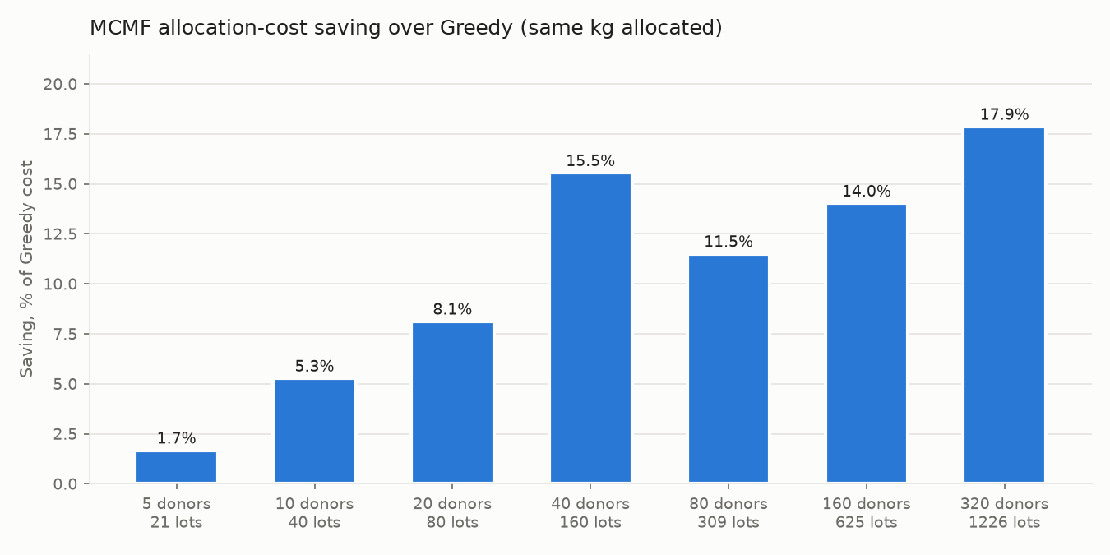
Transport-cost saving of MCMF over Greedy as the city grows
Reading the chart. Each bar is the average transport-cost saving of MCMF over Greedy for one city size, with equal food allocated. The saving rises from 1.7% to 17.9% as the city grows, because a larger network offers more alternative pairings.
A log–log fit gives growth exponents close to theory for the simple stages: Dijkstra 2.15 (predicted about 2), feasibility 2.00, Greedy 1.99 and knapsack 1.15 (predicted 1). MCMF grows as L^3.16, one order below its worst-case bound of L^4, because Bellman-Ford stops as soon as a pass changes nothing and the layered network needs only a few passes. MCMF remains below one second up to 625 lots and takes about 12 seconds at 1,226 lots, which is acceptable for daily planning. In return its cost saving grows with size, from 1.7% to 17.9%, because larger networks offer more alternative assignments for the reverse edges to exploit.

5.5 Real-world case: Robin Hood Army, Lucknow
This is the base paper’s own real-world case [2], [17]. FoodLoop was run with the paper’s fleet (3 two-wheelers and 13 four-wheelers per hub), hiring costs, penalty and 4.5-hour windows on all six scenarios, and compared with the values the paper reports for its three genetic algorithms.
Table 11. Robin Hood Army, Lucknow: food delivered and running time
Scenario | Supply / demand | FoodLoop unmet | Paper best (GA_LS_2) unmet | FoodLoop vehicles | FoodLoop time | GA_LS_2 time
Base (real) | 1,198 / 2,585 | 1,387 | 1,387 | 4 + 3 | 0.6 s | 2,065 s
S-1 | 2,585 / 2,585 | 0 | 0 | 5 + 6 | 0.6 s | 2,725 s
S-2 | 2,651 / 2,585 | 66 | 66 | 5 + 6 | 0.6 s | 2,368 s
S-3 | 1,198 / 1,198 | 0 | 0 | 9 + 1 | 0.6 s | 2,865 s
S-4 | 1,198 / 985 | 213 | 213 | 8 + 1 | 0.6 s | 2,666 s
S-5 (2 + 2 vehicles per hub) | 1,198 / 2,585 | 1,387 (1,198 delivered) | 2,881 (451 delivered) | 4 + 3 | 0.5 s | 987 s

In every scenario FoodLoop serves the maximum possible amount of food, matching the paper’s best algorithm in the first five scenarios. In S-5, where each hub has only two vehicles of each type, it delivers all 1,198 meals while the paper’s best plan delivers 451, about 2.6 times more food; the plan was checked to respect the per-hub vehicle limits and every 4.5-hour window. FoodLoop needs well under a second against 10–48 minutes. Routing costs are not compared because the paper does not state its distance unit.

5.6 Base paper’s benchmark: 180 instances
Table 12. Average results per sub-class on the 180 rebuilt instances
Sub-class | FoodLoop objective | Unmet units | Food delivered | Median time | Paper GA_LS_2 objective
1 (balanced, 0.1–1.2) | 2,378,715 | 2,364 | 88.4% | 9.0 s | 3,282
2 | 2,393,573 | 2,379 | 89.0% | 7.9 s | 76,263
3 | 2,260,204 | 2,246 | 89.5% | 7.4 s | 60,799
4 (balanced, 0.3–0.8) | 1,839,133 | 1,825 | 89.5% | 6.8 s | 3,116
5 | 1,827,220 | 1,813 | 90.0% | 11.9 s | 70,745
6 | 1,843,477 | 1,829 | 90.0% | 10.3 s | 56,033
7 (balanced, 0.8–1.2) | 5,242,048 | 5,227 | 83.4% | 14.4 s | 3,815
8 | 5,151,876 | 5,137 | 84.2% | 14.4 s | 83,681
9 | 5,078,633 | 5,064 | 84.4% | 13.7 s | 66,732

Table 13. Ablation: what each component contributes (average over 180 instances)
Variant | Average objective | Average unmet units
FoodLoop (MCMF + multi-stop routing + feedback) | 3.11 million | 3,098
MCMF + direct trips (no multi-stop routing) | 4.66 million | 4,648
MCMF + routing without feedback | 8.14 million | 8,128
Greedy allocation + routing | 8.93 million | 8,919

Interpretation. Each component helps: feedback between allocation and routing cuts unmet food by 62%, multi-stop routing by 33% compared with direct trips, and exact MCMF beats Greedy allocation by a wide margin; FoodLoop is the best of the four variants on 169 of 180 instances. Against the base paper, however, the picture is the opposite of the Lucknow case: on these synthetic instances, with narrow time windows and demands close to a full vehicle load, FoodLoop leaves about 13% of the food unserved, while the paper’s genetic algorithms, run for 1–6 hours per instance on a supercomputer, serve nearly all of it. FoodLoop needs a few seconds to about a minute on a laptop. Because the paper’s demand draws are not public, averages rather than individual instances are compared; the gap is too large to be explained by that alone. A time-aware allocation cost (penalising pairs whose windows force waiting) was also tried and gave no gain.

5.7 Results compared with the base paper
The table below summarises FoodLoop’s results against the base paper, Dubey and Tanksale (2023) [2], on the paper’s own data; the methods themselves are compared in Table 2. The paper’s 180 benchmark files are available only on request from the authors, which was not possible within the one-week project, so they were regenerated with the paper’s procedure and compared by sub-class averages; the Lucknow data is used exactly as published [17].
Table 14. Results on the base paper’s own data
Data | Measure | GA_LS_2 (paper’s best) | FoodLoop
Lucknow, base (real) | Unmet units / time | 1,387 / 2,065 s | 1,387 / 0.6 s
Lucknow, S-1 | Unmet units / time | 0 / 2,725 s | 0 / 0.6 s
Lucknow, S-2 | Unmet units / time | 66 / 2,368 s | 66 / 0.6 s
Lucknow, S-3 | Unmet units / time | 0 / 2,865 s | 0 / 0.6 s
Lucknow, S-4 | Unmet units / time | 213 / 2,666 s | 213 / 0.6 s
Lucknow, S-5 (few vehicles) | Meals delivered / time | 451 / 987 s | 1,198 / 0.5 s
180 synthetic instances | Objective (sub-class averages) | 3,116 – 83,681 | 1.8 – 5.2 million
180 synthetic instances | Food delivered | Nearly all | About 87%
180 synthetic instances | Time per instance | About 12,000 s average | 7–14 s median

Note on the benchmark data. The base paper’s 180 benchmark instances (its exact randomly generated demands) are not published; the authors state that the data is available on request. Obtaining it from the authors was not feasible within the one-week duration of this course project, so the instances were regenerated from the public Cordeau et al. MDVRPTW set [16] by the procedure the paper describes (same locations, depots, vehicles, capacities, time windows, service times, demand ranges and supply–demand classes). Because the random demand values necessarily differ, the synthetic results are compared by sub-class averages and should be read as indicative rather than instance-for-instance. The real Robin Hood Army (Lucknow) data, by contrast, is published in the thesis appendix and was used exactly as given. Running FoodLoop on the authors’ original instances is planned once they are received.
On the real Lucknow case FoodLoop delivers the same amount of food as the paper’s best algorithm in five scenarios and more in the sixth, and runs in under a second instead of 10–48 minutes. On the regenerated synthetic benchmarks the paper’s genetic algorithms give better solutions; FoodLoop is faster and gives the same result on every run. Routing costs are not compared on Lucknow because the paper does not state its distance unit.

5.8 Correctness
Table 15. Automated verification
Suite | What it checks | Checks
test_day2 | Dijkstra distances and Greedy ranking on hand-solved graphs | 27
test_day3 | MCMF flow and cost, reverse-edge re-routing, tiers | 137
test_day4 | Knapsack against brute force, crates, trips, expiry checks | 230
test_eval | Cost formula, metrics, input validation | 104
test_day6 | 22 scenarios and edge cases, 500 random instances | 1,536
test_fleet | Shared-fleet dispatch: windows, splits, ablation, 300 random instances | 63,351
test_routing | Multi-stop routing and feedback; every route re-verified independently | 2,057
Total |  | 69,499, all passed
NetworkX oracle | Distances, feasible pairs and per-tier flow/cost on 5 datasets | all passed

5.9 Discussion
Advantages. The allocation is optimal within each urgency tier and the plan is the same on every run. Food-category and expiry rules are part of the model itself rather than penalties. Separate stages keep each algorithm small enough to test thoroughly, and the dashboard makes it easy to try what-if cases.
Limitations. On tightly time-constrained synthetic benchmarks the insertion-based routing is clearly weaker than the base paper’s long-running genetic algorithms. Tiers are optimal individually but not jointly, and the allocation–routing coupling is heuristic. Categories must match exactly, so vegan food is not used to fill vegetarian demand. Fairness between NGOs is not modelled, and the travel speed in the Lucknow case had to be assumed.
Practical applications. City food-rescue groups, campus canteens, hotel chains and food banks can use the tool for daily dispatch. The same model fits other perishable goods with compatibility rules, such as blood units by group or medicines by temperature class.

6. Conclusion and Future Scope
This project built FoodLoop, a complete algorithmic system for redistributing surplus food from donors to NGOs. Dijkstra’s algorithm supplies road distances, a feasibility filter removes incompatible, unreachable and late assignments, a Greedy Earliest-Deadline-First step sets urgency tiers, Minimum Cost Maximum Flow computes an exact allocation that maximises redistributed food and then minimises transport cost, and a 0/1 Knapsack loads vehicles trip by trip with expiry re-checks. The engine is implemented in C++, verified by 2,034 automated checks and an independent library, and presented through an interactive dashboard.
The experiments show that MCMF can recover food that a greedy rule wastes (16 kg against 8 kg in the conflict case) and that, when quantities are equal, it consistently lowers transport cost, by 2.6% to 13.7% across scenarios and up to 17.9% in the largest cities. Its running time grows more slowly than its theoretical bound and is practical for city-scale daily planning. Compared with the routing-based 2023 study and the fairness-based 2026 study, FoodLoop’s distinctive choice is to solve the allocation exactly on a category-wise flow network and to treat vehicle loading as a separate, exact stage.
Following the reviewer’s ten enhancements, a fleet mode brings FoodLoop to the base paper’s own setting. On that paper’s real Robin Hood Army case it delivers as much food as the paper’s best algorithm, and 2.6 times more when vehicles are scarce, in under a second. On the paper’s synthetic benchmarks it is a fast, lightweight alternative that serves about 87% of the food but does not reach the quality of the hours-long genetic algorithms. FoodLoop is therefore best suited to day-to-day food rescue, where plans must be produced and revised in seconds on ordinary hardware.
Future scope:
- Strengthen the route improvement (adaptive large neighbourhood search, regret insertion) to close the gap on tightly time-constrained benchmarks, and test on the original 180 instances from the authors.
- Replace Bellman-Ford with Dijkstra on reduced costs (Johnson potentials) to speed up MCMF.
- Solve all tiers in one network with priority costs, and allow substitution between compatible categories.
- Introduce fairness weights for the most vulnerable receivers, following the direction of [3] and [8].
- Calibrate the model with real donation records and deploy the dashboard for a local food bank.

References
[1] United Nations Environment Programme, “Food Waste Index Report 2024,” UNEP, Nairobi, Mar. 2024.
[2] N. Dubey and A. N. Tanksale, “A multi-depot vehicle routing problem with time windows, split pickup and split delivery for surplus food recovery and redistribution,” Expert Systems with Applications, 2023, doi: 10.1016/j.eswa.2023.120807.
[3] R. C. Rampazo, D. F. Jones, L. F. Godoi, M. O. Iamamoto et al., “An extended goal programming framework incorporating poverty measures: application to food bank logistics,” International Transactions in Operational Research, 2026, doi: 10.1111/itor.70252.
[4] L. B. Davis, I. Sengul, J. S. Ivy, L. G. Brock and L. Miles, “Scheduling food bank collections and deliveries to ensure food safety and improve access,” Socio-Economic Planning Sciences, vol. 48, no. 3, pp. 175–188, 2014.
[5] B. Balcik, S. Iravani and K. Smilowitz, “Multi-vehicle sequential resource allocation for a nonprofit distribution system,” IIE Transactions, vol. 46, no. 12, pp. 1279–1297, 2014, doi: 10.1080/0740817X.2013.876240.
[6] R. W. Lien, S. M. R. Iravani and K. R. Smilowitz, “Sequential resource allocation for nonprofit operations,” Operations Research, vol. 62, no. 2, pp. 301–317, 2014, doi: 10.1287/opre.2013.1244.
[7] I. S. Orgut, J. Ivy, R. Uzsoy and J. R. Wilson, “Modeling for the equitable and effective distribution of donated food under capacity constraints,” IIE Transactions, vol. 48, no. 3, pp. 252–266, 2016, doi: 10.1080/0740817X.2015.1063792.
[8] D. J. Nair, D. Rey and V. V. Dixit, “Fair allocation and cost-effective routing models for food rescue and redistribution,” IISE Transactions, vol. 49, no. 12, pp. 1172–1188, 2017.
[9] D. Rey, K. Almi’ani and D. J. Nair, “Exact and heuristic algorithms for finding envy-free allocations in food rescue pickup and delivery logistics,” Transportation Research Part E, vol. 112, pp. 19–46, 2018, doi: 10.1016/j.tre.2018.02.001.
[10] F. Alkaabneh, A. Diabat and H. O. Gao, “A unified framework for efficient, effective, and fair resource allocation by food banks using an approximate dynamic programming approach,” Omega, vol. 100, Art. no. 102300, 2021, doi: 10.1016/j.omega.2020.102300.
[11] I. S. Orgut and E. J. Lodree, “Equitable distribution of perishable items in a food bank supply chain,” Production and Operations Management, vol. 32, no. 10, pp. 3002–3021, 2023, doi: 10.1111/poms.14019.
[12] R. Akkerman, M. Buisman, F. Cruijssen, S. de Leeuw and R. Haijema, “Dealing with donations: supply chain management challenges for food banks,” International Journal of Production Economics, 2023, doi: 10.1016/j.ijpe.2023.108926.
[13] J. Edmonds and R. M. Karp, “Theoretical improvements in algorithmic efficiency for network flow problems,” Journal of the ACM, vol. 19, no. 2, pp. 248–264, 1972.
[14] E. W. Dijkstra, “A note on two problems in connexion with graphs,” Numerische Mathematik, vol. 1, pp. 269–271, 1959.
[15] A. A. Hagberg, D. A. Schult and P. J. Swart, “Exploring network structure, dynamics, and function using NetworkX,” in Proc. 7th Python in Science Conference (SciPy), 2008, pp. 11–15.
[16] J.-F. Cordeau, G. Laporte and A. Mercier, “A unified tabu search heuristic for vehicle routing problems with time windows,” Journal of the Operational Research Society, vol. 52, no. 8, pp. 928–936, 2001.
[17] N. Dubey and A. N. Tanksale, thesis chapter 4 and annexure (Appendix B, Table B-2: Robin Hood Army, Lucknow data), IIT (BHU) Varanasi institutional repository, record “A multi-depot vehicle routing problem with time windows, split pickup and split delivery for surplus food recovery and redistribution”.

